A preliminary guide for the taxonomic identification of diatom (Bacillariophyta) species from coast of Pakistan

* Tahira Naz, Zaib-un-nisa Burhan, Pirzada Jamal Ahmed Siddiqui

Centre of Excellence in Marine Biology, University of Karachi, 75270, Karachi, Pakistan.
Corresponding author, e-mail:* tahiraadnan@yahoo.com

Abstract This paper represents the morphological identifications of pennate and centric diatom species from the coastal waters of Karachi Pakistan. The samples were collected from 1m depth during May, 2002 to July, 2003, July 2007 and November 2008 from inshore waters of Manora Channel, Karachi coast by plankton net tow. Samples were observed through light and scanning electron microscopy. Twenty eight diatom species recorded from Manora Channel, Pakistan coast. Out of these, three species Pleurosigma angulatum, P. salinarum, P. balticum and one species Chaetoceros borealis are new record from Pakistan coast.
[Tahira Naz, Zaib-un-nisa Burhan, Pirzada Jamal Ahmed Siddiqui. A preliminary guide for the taxonomic identification of diatom (Bacillariophyta) species from coast of Pakistan. New York Science Journal 2012;5(3):70-80]. (ISSN: 1554-0200). http://www.sciencepub.net/newyork. 8

Key words: Diatom; species taxonomy; Manora Channel; Pakistan coast; Northern Arabian Sea

INTRODUCTION
Northern Arabian Sea bordered the coast line of Pakistan which is about 885km. The region is facing consistently the influences of Asian monsoon systems (Shameel and Tanaka, 1992). Heavy upwelling is a pronounce feature of the Arabian Sea results from the climatologically winds caused by monsoon (Schiebel et al., 2004). Theses changes have enormous affects on the dynamics and morphology of microbial communities in the area. Diatoms are the photosynthetic micro algae found in almost every aquatic environment. These are found in both benthic and planktonic forms, classified as class Bacillariophyceae and two orders centrales (which are radially symmetrical), pennales (which are bilaterally symmetrical) (Tomas, 1997). Diatoms are the major contributors in phytoplankton communities of the northern Arabian Sea (paper accepted in Pakistan journal of Botany). Previously very few reports are available regarding the taxonomy and morphological studies on diatoms (Saifullah and Moazzam, 1978; Shameel and Tanaka, 1992; Tabassum and Saifullah, 2010; Naz et al., 2010; Naz and Siddiqui, 2012). The present paper represents diatom species identifications on the basis of light and scanning electron microscopy with four new records of diatom species from Pakistan coast.

MATERIALS AND METHODS
Water samples were collected from 1m depth during May, 2002 to July, 2003 using 1.7 liter Niskin bottle from Manora Channel, coastal waters of Karachi (24˚49.77'N 66˚57.85'E) a polluted area with impact from Layari River and mangrove ecosystem (Fig 1). Samples were fixed in Lugol’s solution and used for analysis using an inverted microscope (Olympus, BX-51, Japan). Samples for scanning electron microscopy (SEM) were collected in July 2007 and November 2008 from inshore waters of Manora Channel, Karachi coast (24˚49.77'N 66˚57.85'E) using net tow and cleaned by KMNO₄ oxidation of the organic material (Sournia, 1978). Samples were prepared for SEM by air drying material on clean cover slips. Specimen material was picked up onto a double sticking tape which was then mounted on a stub. Stubbs were gold coated and viewed on a SEM (JSM6380A) Identification of diatom species was based on LM and SEM characteristics describe by Tomas, 1997, Skove et al., 1999.

RESULTS
Two groups, pennate and centric diatoms species were identified on the basis of light microscopy (LM) and scanning electron microscopy (SEM) studies. Following is an account of twenty eight diatom species with micrographs recorded from Manora Channel, Pakistan coast.

Figure 1: Map showing the sampling location.

Observations

Pennate species

Asterionellopsis glacialis (Castracane) Round, 1990
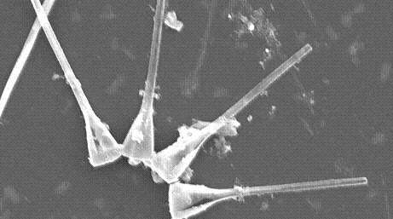

Phylum Bacillariophyta

Order Bacillarialis
Sub order Fragilariineae

Class Fragilariophyceae
Family Fragilariaceae

- Cells are found in star shaped colony and joined foot poles in spiral chains.
- Foot poles angular in girdle view and rounded in valve.
- The foot pole has small areolae and radial striae.

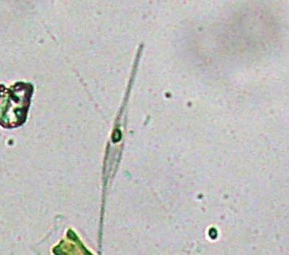

Nitzschia closterium (Ehrenberg) W. Smith 1853

Phylum Bacillariophyta

Order Bacillarialis
Sub order Bacillariineae

Class Bacillariophyceae
Family Bacillariaceae

- Cells are found in solitary form.
- Cells spindle shaped in girdle view.
- Frustule slightly twisted from the apical axis.

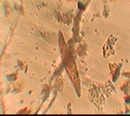
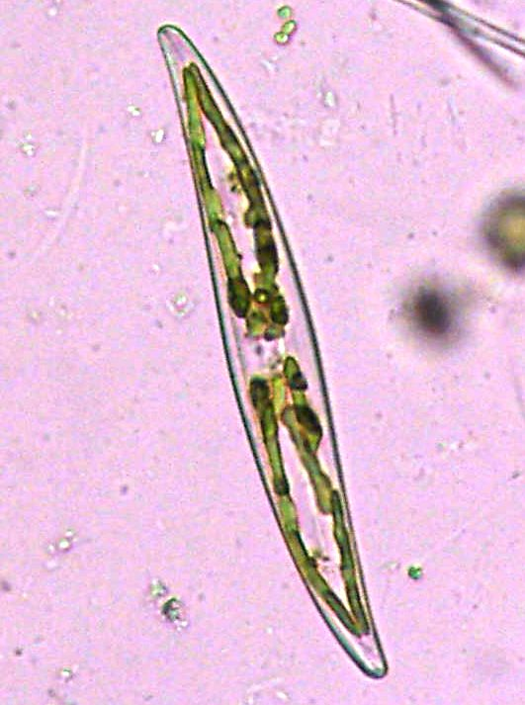

Pleurosigma sp. W.Smith, 1852

Phylum Bacillariophyta

Order Bacillarialis
Sub order Bacillariineae
Family Naviculaceae

- The valves are flattened and sigmoid.
- Raphe is central and sigmoid.
- Two or four chloroplasts. Chloroplasts elongated and convoluted.

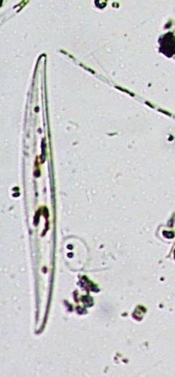
Pleurosigma normanii Ralfs in Pritchard, 1861

Phylum Bacillariophyta

Order Bacillarialis
Sub order Bacillariineae
Family Naviculaceae

- The valves are flattened and sigmoid.
- Valves are broad lanceolate and sigmoid.
- Raphe central sigmoid and dilated transversely.
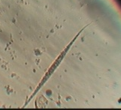

Pleurosigma macrum W.Smith, 1853

Phylum Bacillariophyta

Order Bacillarialis
Sub order Bacillariineae
Family Naviculaceae

- Valve slightly sigmoid near the ends and flat.
- Valves are thin and striation is not visible with light microscope.
- Raphe narrow and not expanded centrally.

Pleurosigma angulatum (Queckett) W. Smith, 1852
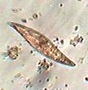

Phylum Bacillariophyta

Order Bacillarialis
Sub order Bacillariineae
Family Naviculaceae

1. Valves slightly sigmoid near the ends and flat.

2. Striae are diagonally cross-hatched.

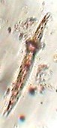
Pleurosigma salinarum var. pusilla (Grunow) Cleve 1894

Phylum Bacillariophyta

Order Bacillarialis
Sub order Bacillariineae
Family Naviculaceae

1. Valves are slightly sigmoid, lanceolate or linear-lanceolate with rather strongly attenuated
2. Relatively flat surface; axial area and raphe slightly sigmoid, becoming slightly eccentric towards the ends.
3. Central area is small, elongate-elliptic or rhombic.

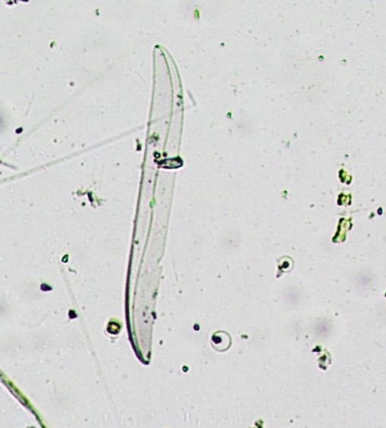

Pleurosigma balticum (Ehrenberg) W. Smith, 1852

Phylum Bacillariophyta

Order Bacillarialis
Sub order Bacillariineae
Family Naviculaceae

1. Valves flattened and sigmoid.
2. Rphe more oe less sigmoid.
3. Curvature of the raphe clearly indicated the resemblance to the Pleurosigma balticum.

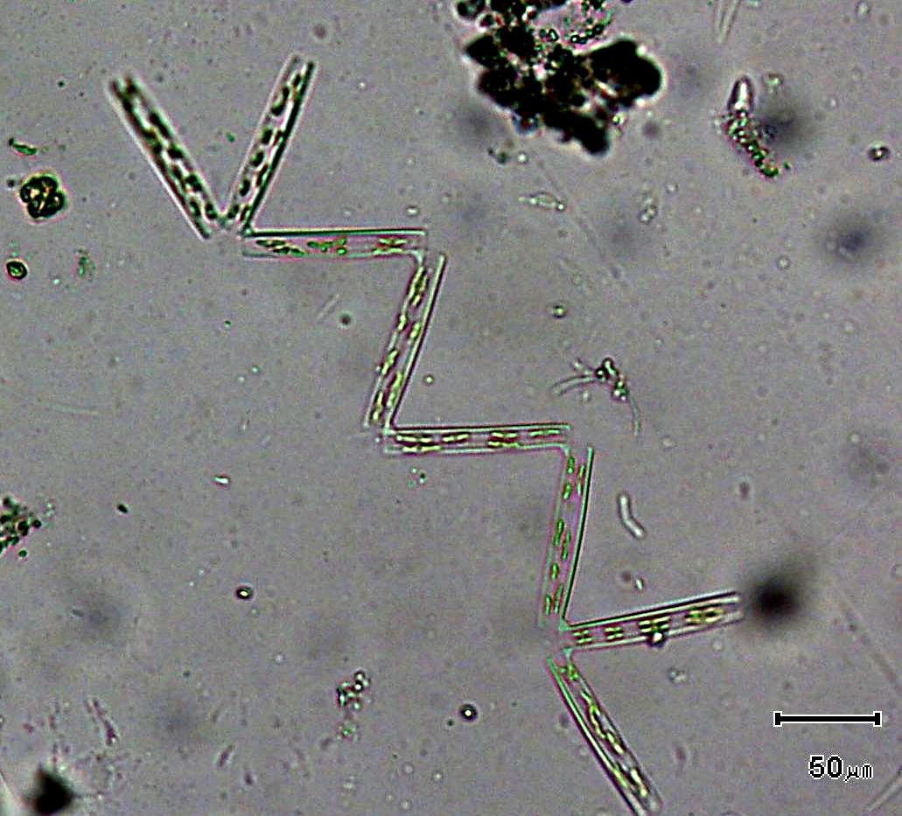
Thalassionema nitzschoides (Grunow) Mereschkowsky 1902

Phylum Bacillariophyta

Order Bacillarialis
Sub order Fragilariineae
Class Fragilariophyceae
Family Thalassionemataceae

- Cells are found as zigzag chain like shape.
- Cells in girdle view rectangular.
- Valve ends similar in width and shape. Valve linear to narrowly lanceolate in outline.

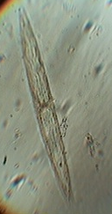
Navicula sp. Bory de Saint-Vincent, 1822

Phylum Bacillariophyta

Order Bacillarialis
Sub order Bacillariineae
Family Naviculaceae

- Valve narrow and lanceolate with subacute ends.
- Striae parallel and uniformly placed throughout the whole valve.
- Each chlororoplast covering the girdle from end to end.

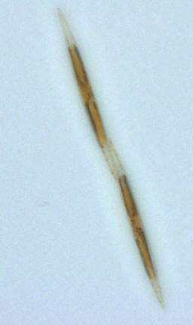
Pseudo-nitzschia sp. Peragallo, 1897-1908.

Phylum Bacillariophyta

Order Bacillarialis
Sub order Bacillariineae
Family Bacillariaceae

- Cells in stepped chains united by shorter or longer overlap of valve ends.
- Chain motile and cells strongly elongate, rectangular or fusiforms in girdle view.
- Stria structure usually too delicate to resolve with LM.

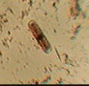
Pinnularia sp. Ehrenberg, 1843

Phylum Bacillariophyta

Order Naviculales
Family Pinnulariaceae

- The cells found in solitary condition and are elongated and elliptical in shape.
- The raphe is not along the whole valve.
- There is a thick central nodule present in the center.

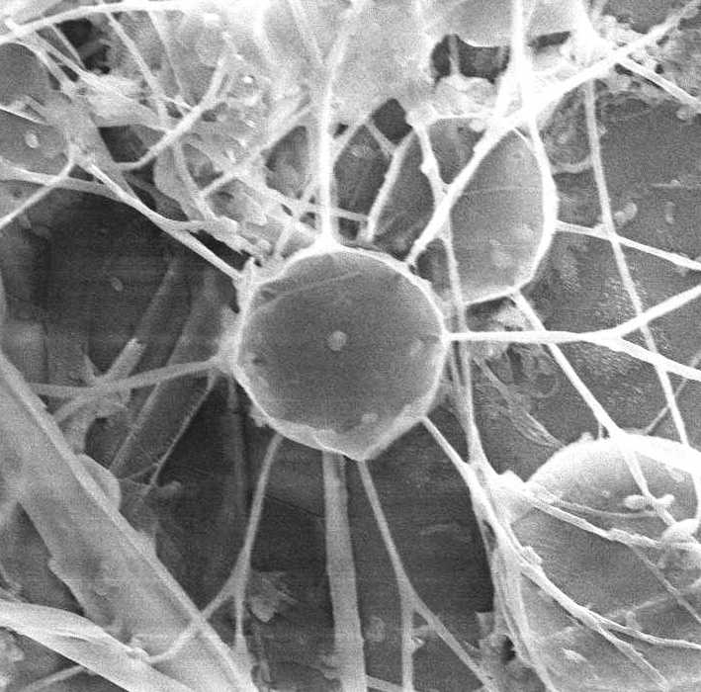
Centric species

Bacteriastrum delicatulum Cleve, 1897

Phylum Bacillariophyta
Order Biddulphialis
Sub order Biddulphiineae
Family Chaetocerotaceae

- Setae are more than one on single valve.
- Terminal setae are branched and are arranged around the margins.
- Terminal setae direction is towards the chain.

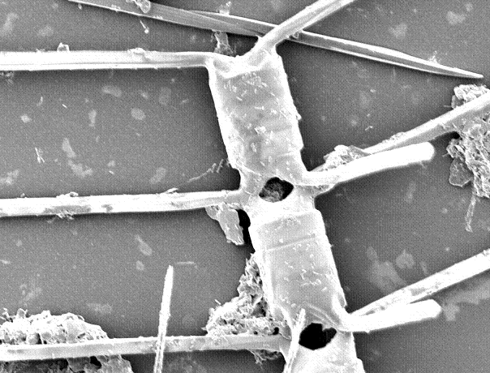
Chaetoceros borealis Bailey, 1854

Phylum Bacillariophyta
Order Biddulphialis
Sub order Biddulphiineae
Family Chaetocerotaceae

- Chain of the cells straight.
- Setae arise from valve margins and crossing each other.
- Cell apertures were elliptical and hexagonal.

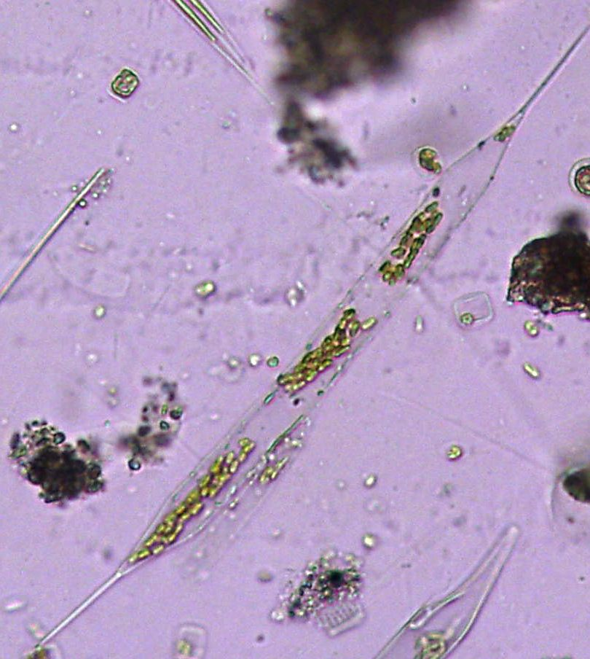
Rhizosolenia setigera Brightwell, 1858

Phylum Bacillariophyta
Order Biddulphialis
Sub order Rhizosoleniineae
Family Rhizosoleniaceae

- Cells are cylinder and can found in chains sometimes with numerous chloroplasts.
- A single process with internal labiate.
- Valve conical and external process long, straight along the whole length.

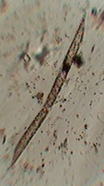
Rhizosolenia imbricate Brightwell, 1858

Phylum Bacillariophyta
Order Biddulphialis
Sub order Rhizosoleniineae
Family Rhizosoleniaceae

- Cell slightly elliptical.
- Valve obliquely conical.
- Basal part of process is swollen.

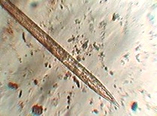
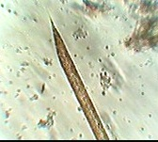
Rhizosolenia styliformis Brightwell, 1858

Phylum Bacillariophyta
Order Biddulphialis
Sub order Rhizosoleniineae
Family Rhizosoleniaceae

- Valve shape is conoidal.
- Apical part ends by one process which opens at the tip related with the cell interiorly by labiate structure.
- Otaria and claspers present.

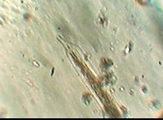
Rhizosolenia alata Brightwell, 1858

Phylum Bacillariophyta
Order Biddulphialis
Sub order Rhizosoleniineae
Family Rhizosoleniaceae

- Valve is rounded and cylindrical.
- Apex of the cell ends into a short, stout truncate proboscis like process.
- Labiate structure not visible in LM.

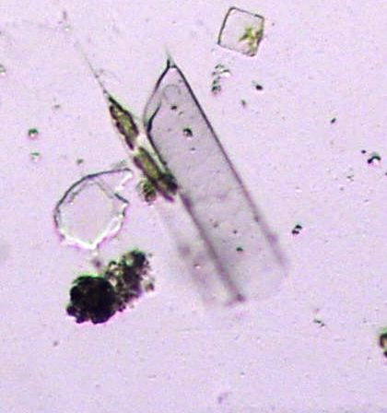
Rhizosolenia striata Greville, 1864

Phylum Bacillariophyta
Order Biddulphialis
Sub order Rhizosoleniineae
Family Rhizosoleniaceae

- Shape of the cellis elliptical.
- Process is triangular.
- Otaria small.

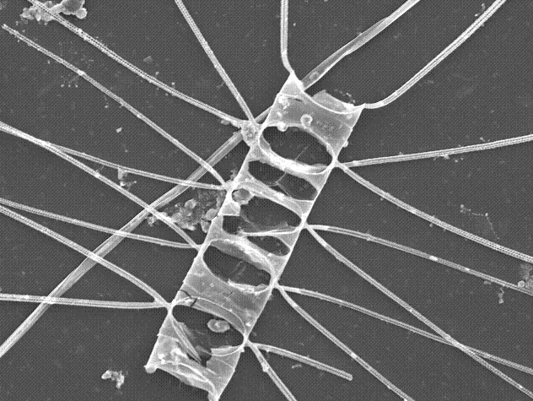
Chaetoceros decipiens Cleve, 1873

Phylum Bacillariophyta
Order Biddulphialis
Sub order Biddulphiineae
Family Chaetocerotaceae

- Chains straight and with valve corner touches adjacent cell.
- Aperture is slit like.
- Terminal setae thick and the others become divergent at the start than bent and become parallel to chain axis

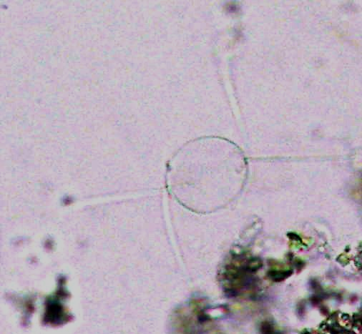
Chaetoceros danicus Cleve, 1889

Phylum Bacillariophyta
Order Biddulphialis
Sub order Biddulphiineae
Family Chaetocerotaceae

- Cells are isovalvate and valve surface flate.
- Setae long, stiff and perpandicular to chain axis.
- Terminal setae perpandicular to chain axis.

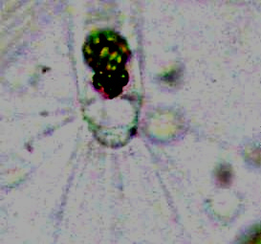
Corthron ceriophilum Castracane, 1886

Phylum Bacillariophyta
Order Biddulphialis
Sub order Coscinodiscineae
Family Leptocylindraceae

- Cells cylindrical solitary with more or less robust and heterovalve.
- Valve with marginal long barbed and short hooked spines.
- Chloroplast numerous rounded or oval.

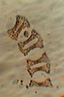
Eucampia zodiacus Ehrenberg, 1840

Phylum Bacillariophyta
Order Biddulphialis
Sub order Biddulphiineae
Family Hemiaulaceae

- Cells are curved in girdle view and chain helically coiled.
- Aperture between cells in chains broad and large.
- Valves face concave in broad girdle view.

Guinardia flaccida (Castracane) H.Peragallo 1892
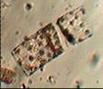

Order Biddulphialis
Sub order Rhizosoleniineae
Family Rhizosoleniaceae

- Cells in chains and straight.
- Star shape chloroplast clearly visible.
- Valve with marginal process.

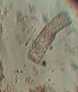
Guinardia striata (Stolterfoth) Hasle in Hasle & Syvertsen 1996

Phylum Bacillariophyta
Order Biddulphialis
Sub order Rhizosoleniineae
Family Rhizosoleniaceae

- Cells are curved and like spiral chains.
- Valve flat and rounded at the edges.
- External process fitting upon the adjacent valve.
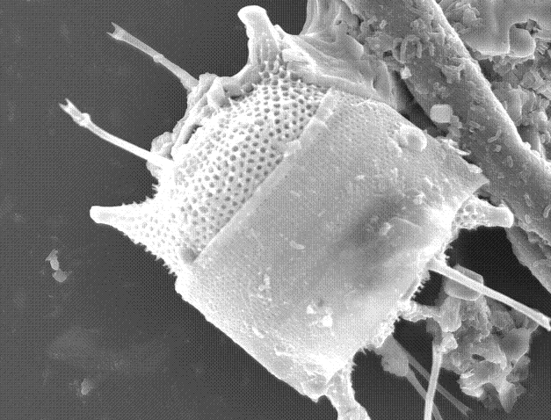

Odontella mobiliensis (Bailey) Grunow. 1884

Phylum Bacillariophyta
Order Biddulphialis
Sub order Biddulphiineae
Family Triceratiaceae

- Valves bipolar (elliptical) with two labiate process per valve.
- Valves face concave and bulging in the middle.
- External tubes of processes and elevations diverging.

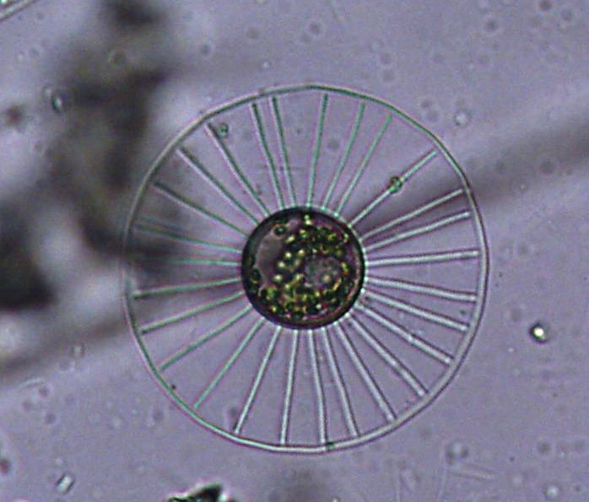

Planktoniella sol (Wallich) Schütt. 1892

Phylum Bacillariophyta

Order Biddulphialis
Sub order Coscinodisciineae

Family Thalassiosiraceae

- Cells discoid usually solitary and connected by a thread from a central strutted process.
- Girdle view seen with a wing.
- Central strutted process and two marginal labiate processes present.

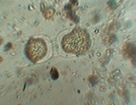
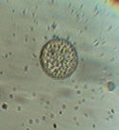

Thalassiosira sp. Cleve
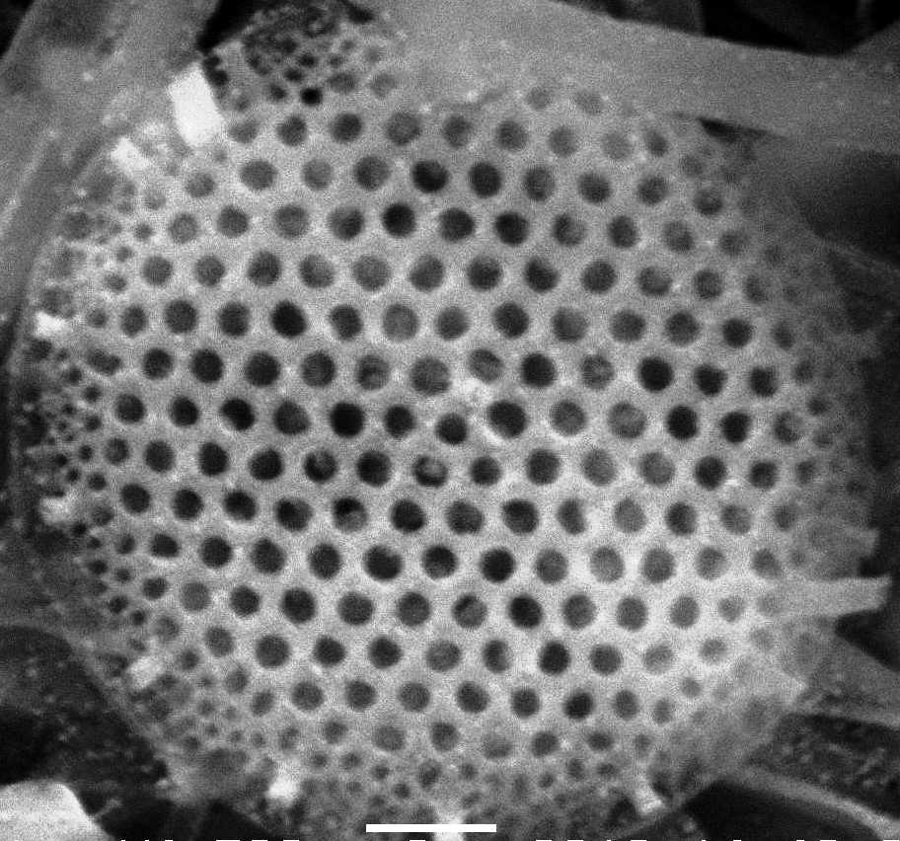
Phylum Bacillariophyta

Order Biddulphialis
Sub order Coscinodisciineae

Family Thalassiosiraceae

- Cells are discoid, solitary or found in Chains
- Marginal strutted process present.
- Labiate process present.

DISCUSSION
In total twenty eight species fourteen centric and eight pennate diatom species with four pennate and one centric genus were identified under light and scanning electron microscopy during the study period from Manora Channel, Karachi coastal waters. With regard to existing literature four new species are the first record from coast of Pakistan.
Presently no proper guide is available for the morphological identification of diatom species. Earlier work shown few reports (Shameel and Tanaka, 1992, Ghazala et al., 2006, Tabassum and Saifullah, 2010), but the author did not present any light microscopy (LM) or scanning electron microscopy (SEM) photographs for the identification. Manora Channel, Karachi coast is one of the major coastal areas of Karachi continuously being threatened by the phenomenon of eutrophication. The effluent discharges from Layari River causing deterioration of water quality. The Manora Channel is also highly affected by oil pollution because of its close location to the oil terminal, wharves, the fish harbor. The species diversity recorded in previous studies (paper accepted in Pakistan journal of Botany) shown lower species richness and diversity in the area caused by the organic loads facing by the Manora Channel. The area is also under the influence of monsoon system. These regional changes have great influence on diatom communities´ s abundance and morphology, which should be regularly monitored.

REFERENCES
- Ghazala, B., R. Ormond and F. Hanna. Phytoplankton communities of Pakistan: I.Dinophyta and Bacillariophyta from the coast of Sindh. Int. J. Phycol. Phycochem. 2006; 2: 183-196.
- Naz, T., Z. Burhan, S. Munir and P.J.A. Siddiqui. Diatom species composition and seasonal abundance in a polluted and non-polluted environment from coast of Pakistan. Asian. J. Water. Environ. Poll. 2010; 7: 25-38.
- Naz, T and P.J. A. Siddiqui. Taxonomy of potentially harmful diatom Coscinodiscus c.f.wailesii Gran et Angst (Coscinodiscales, Bacillariophyta) from Pakistan waters. J. Algal Biomass Utln. 2012; 3 (1): 28 – 31.
- Saifullah, S. M and M.Moazzam. 1978. Species Composition and Seasonal Occurrence of Centric Diatom in a polluted marine environment. Pak. J. Bot. 1978; 10: 53-64.
- Schiebel, R., A. Zeltner, U.F. Treppke, J.J. Waniek, J. Bollmann, T. Rixen and C. Hemleben. Distribution of diatoms, coccolithophores and planktic foraminifers along a trophic gradient during SW monsoon in the Arabian Sea. Mar Micropaleontol. 2004; 51: 345- 371.
- Sournia, A. (Ed). Phytoplankton manual. Monograph on oceanographic methodology 6. UNESCO, Paris. 1978; 1-337.
- Shameel, M and Tanaka. J. A preliminary checklist of Marine algae from the coast and inshore waters of Pakistan. Cryptogamic Flora of Pakistan. 1992; 1: 1-64.
- Skove, J., N. Lundholm., O. Moestrup and J. Larsen. 1999. ICES identification leaflet for plankton Botanical Institute, Department of Phycology, University of Copenhagen Oster Farimagsgade 2D, DK- 1353 Copenhagen K,Denmark. International council for the Exploration of sea, 1999; ISSN 1019-1097.
- Tabassum, A and S.M Saifullah. 2010. The planktonic diatom of the genus Chaetoceros Ehrenberg from the northwestern Arabian Sea. Pak. J. Bot. 2010; 42: 1137-1151.
- Tomas, C.R (Ed). Identifying Marine Diatoms and Dinoflagellates. Academic Press, San Diego.1997; 1- 384.

2/15/2012

