Branch Status Topology Errors Detection in power System State Estimation

S. Ahmed Nagy

Faculty of Engineering, Al-Azhar University, Cairo, Egypt

sayed.nagy@gmail.com

Abstract: In order to run the state estimator, it must be known that how the transmission Lines are connected to the load and generation buses. This information is called the network topology which also determine the bus level network model of a power system based on the te1emetered status of the circuit breakers at the substations. Since the breakers and switches in any substation can cause the network topology to change, a program must be provided that reads the telemetered breaker/switch status indications and restructures the electrical model of the system. Also, any errors in the te1emetered or manually updated status of the circuit breakers will lead to an incorrect bus level network model. This paper presents A pre-processing algorithm for detection of the statues of the suspected lines in electrical power system networks before state estimation solution. an algorihm is domenstrated,which handle the branch status error
[S. Ahmed Nagy. Branch Status Topology Errors Detection in power System State Estimation. New York Science Journal 2012;5(3):86-91]. (ISSN: 1554-0200). http://www.sciencepub.net/newyork. 10

Keywords: State Estimation (SE), Topology Error, Network Topology Processor, Branch Status Error, Substation Topology, DC State Estimator.

- Introduction
Real-time monitoring of power systems in energy control centers requires the processing of analog measurements and status measurements. Status measurements describe the status of circuit breakers in the system and are used by a topology processor to determine the real-time configuration of network elements [1]. The function of such topology processor is therefore to deliver an updated, consistent model of the system in terms of topology and measurements, based on known system connections and parameters and real-time SCADA input.
The security functions used in the Energy Management Systwm (EMS) cannot be directly connected to the SCADA, because they require the state estimator output. Neither can the state estimation algorithm be directly connected to the SCADA, for it requires a topology processor to develop a coherent topological model complete with accurate meter placements [2,3]. State estimation is a mathematical procedure that estimates the states (bus voltages and angles) from the network data and sensor information. It can also be used to calculate system quantities where sensors are not available.
A state estimator generally acquires the measurements in real time and processes them to obtain a snapshot of the power system [4,5]. The data to the state estimator may get updated every few seconds to minutes or whenever there is a change in status of the network. A static state estimator is a steady state estimator that calculates the unknown values based on the most recent measurements. A dynamic state estimator predicts the future states based on the present variations and forecasted loads [6]. Figure 1 depicts the computer environment of the topology processor in relation to system files, static supporting files that contain information about the system's topology and network parameters, and the state estimator [7].
The standard model for topology processors was proposed by Sasson et al. [8]. In Figure 1, a static file is considered as one that is updated manually by control center personnel, with the exception of the temporary file between the topology processor and state estimator. System files are considered as those that involve updated real-time information. TOPOLOGY contains a list of the elements (circuit-breakers, isolators, lines, transformers, and generators) connected to the busbars of each substation, which are required to determine the system’s nodal topology.
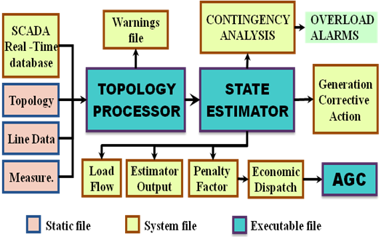

Figure 1– Environment of the topology processor and state estimator

Topological errors arise from the misconfiguration of one or more network elements, as a consequence of erroneous input data to the network configurator concerning the status of circuit breakers and switches. The topology errors must be eliminated in order to obtain acceptable information about the state of a power system [9]. Topology error is one of the different types of anomalous data that may arise during real-time power system monitoring, and cause unexpected change in current power system telemetered quantities (i.e. power flows, power injections, voltage magnitudes and also switches and breakers statuses)[10].
This paper introduces an integrated approach for substation topology identification based on circuit breaker modeling by incorporating the active and reactive power flows and the statuses of the circuit breakers as continuous state variables is presented. The proposed method overcomes some drawbacks of the existing methods, which assume a certain status for each breaker. The proposed method is applied for substation configuration error on Twelve-node system [11], while applied for branch status error on the IEEE14 nodes.

- Roles of State Estimation
In order to identify the current operating state of the system, state estimators facilitate accurate and efficient monitoring of operational constraints on quantities such as the transmission line loadings or bus voltage magnitudes. They provide a reliable real-time data base of the system, including the existing state based on which, security assessment functions can be reliably deployed in order to analyze contingencies, and to determine any required corrective actions, The state estimators typically include the following roles[12]:

- Topology processor: Gathers status data about the circuit breakers and switches, and configures the one-line diagram of the system.
- Observability analysis: Determines if a state estimation solution for the entire system can be obtained using the available set of mea- surements. Identifies the unobservable branches, and the observable islands in the system if any exist.
- State estimation solution: Determines the optimal estimate for the system state, which is composed of complex bus voltages in the en- tire power system, based on the network model and the gathered measurements from the system. Also provides the best estimates for all the line Hows, loads, transformer taps, and generator outputs.
- Bad data processing: Detects the existence of gross errors in the mea- surement set. Identifies and eliminates bad measurements provided that there is enough redundancy in the measurement configuration.
- Parameter and structural error processing: Estimates various net- work parameters, such as transmission line model parameters, tap changing transformer parameters, shunt capacitor or reactor param- eters. Detects structural errors in the network configuration and identifies the erroneous breaker status provided that there is enough measurement redundancy.

- Mathematical Model of SE
For a N-bus system, the state vector $x=[δ^{T} V^{T}]^{T}$ of dimension n =(2N – 1), consists of (N – 1) bus voltage angles δ_{i}, i = 2, 3, . . ., N, with respect to a reference bus, and N bus voltage magnitudes V_{i}, i = 1, 2,., N. The measurement model is:
$z=h(x)+v$ (1)
$E(v)=\text{0,} E({\text{v v}}^{T})=R$ (2)
Whare :
z is the measrment vector of dimension(m×1), h(x) is a (m×1) vector of non linear function relating the measrment to the state vector x, which is the system state vector of dimmension (n×1), ν is the measrment error vector of dimension (m×1) and R is the diagonal measrment covariance matrix.
The wls state estimator will minimize the following objective funcuion
$J(x)=[\text{z-h}(x)]^{T}{\text{ R}}^{\text{-1}} [\text{z-h}(x)]$ (3)
it satisfies the optimality condition ∂J/∂x=0 and it is computed by an iterative scheme
$G(x)^{k}{Δx}^{k}{\text{ = H}}^{T}(x)^{k}{\text{ R}}^{\text{-1}}{Δz}^{k}$ (4)
$\text{k=0,1,2}…\text{.}$

Whare :
${Δx}^{k}{\text{ = x}}^{k+1}{\text{-x}}^{k}$ is the mismatch vector,
H is the jacobian matrix of dimension (mxn) =∂h/∂x.
G is the gain matrix of dim. (nxn)=H^{T} R⁻¹ H.
${Δz}^{k}\text{ = }z\text{-h}(x^{k})$is the residual vector at iteration k.
If the gain matrix G or Jacobian matrix H have full column rank, equations (4) are solvable and the system is defined as observable[13,14].

- Network Topology Processor (NTP)
The bus level network modelof a power systemis determined by the networktopology processor based on the te1emetered status of the circuit breakers at the substations. The statuses of the circuit breakers which are not directly monitored are updated manually by the system operator. Any errors in the te1emetered or manually updated status of the circuit breakers will lead to an incorrect bus level network model. Such errors are referred to as topological errors, and they need to be detectedand identified in order to maintain a reliable data base for the state estimator. Several methods for detecting topology errors have been proposed in the recent years [15-20].
State estimation processes analog and topological measurements to obtain a reliable state estimate of the power system. The analog measurements consist of active and reactive power flows, active and reactive injections and voltage magnitudes. The topological measurements consist of the status of circuit breakers (CB) and they are used by the network topology processor to define the bus/branch network model[11].
Topology errors are broadly classified in two categories[15]:
- Branch Status Errors : Errors affecting the status of regular network branches (lines or transformers).
- Substaion Configuration Errors: Errors affecting CBs whose purpose is to link bus sections within the substation.

- Branch Status Errors
The network elements that can be misconfigured include transmission lines, transformers, and shunt elements. The resulting topology error may involve one or multiple network elements leading to single or multiple topology errors. Topology errors can also be classified as inclusion or exclusion errors depending on whether a network element that is in operation is assumed to be out of operation or vice versa. Multiple topology errors can include both inclusion and exclusion errors [l,9].
To detect the status of the non-zero impedance branch, the branch admittance can be parameterized by status variable called α_{km} . The π model of this suspected branch will be as shown in figure 2.

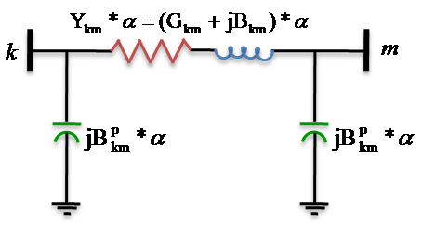

Figure 2– The π model of the suspected branch

Consider the parameterization of every branch admittance Y_{km} by a real parameter α_{km}. The effective branch admittance between nodes k and m is Y_{km} . α_{km}, The idea is to include the variable α_{km} into the state vector for any suspected line.
where α_{km} is determined as follows:
- α_{km} =1, if there exists a connection between nodes k and m under the given operating conditions (i.e. the line is “in service”),
- α_{km} = 0, if there does not exist any connection between nodes k and m under the given operating conditions (i.e. the line is “out of service”), or
- α_{km} = 0.5 , if the status of the connection between nodes k and m is uncertain. The value of 0.5 is chosen as an initial guess in the estimation of all α_{km} corresponding to lines with unknown status.

Now consider the case where the status of the branch connecting nodes k and m, represented by the variable α, is to be estimated. Then, the only rows of the Jacobian related to the new state variable are those corresponding to the respective power Hows, adjacent power injections [15].
The power flows through the branch leaving bus i can be expressed as:
$P_{\text{km}}(α)\text{= }α_{\text{km}}\text{.}P_{\text{km}}{\text{ ,Q}}_{\text{km}}(α)\text{ = }α_{\text{km}}\text{.}Q_{\text{km}}$ (5)
where$P_{\text{km}}$and$Q_{\text{km}}$are the conventional power flows, computed as if α_{km} = 1.
The power injections at bus k can be expressed as a function of α in a similar manner,
$P_{k}(α)=\sum_{i∈\text{k,i}≠m}{P_{\text{ki}}+α P_{\text{km}}}$ (6)

$Q_{k}(α)=\sum_{i∈\text{k,i}≠m}{Q_{\text{ki}}+α Q_{\text{km}}}$ (7)
In the presence of nearby bad data, the estimated value of α; may approach 0.5, in which case the status of the element is indefinite. In order to exclude these potential problems, the quadratic constraint of equation (8) is used to force the estimator to converge toward one of the two feasible statuses.
α (1 - α) = 0 (8)
During building the Jacobian the following new terms will appear in the extra Jacobian column along with their counterparts for node m.
$\frac{∂P_{\text{km}}(α)}{∂α}=\frac{∂P_{k}(α)}{∂α}=P_{\text{km}}$ (9)
$\frac{∂Q_{\text{km}}(α)}{∂α}=\frac{∂Q_{k}(α)}{∂α}=Q_{\text{km}}$ (10)
$\frac{∂[α(1−α)]}{∂α}=1−2α$ (11)

It is also clear from the π model of the suspected branch that, in the remaining columns of the Jacobian, the series and shunt admittance parameters of the suspected branch should be multiplied by α.

- Case study 1
A computer program is made on Matlab environment to the proposed method. It has been applied and tested on the IEEE 14 bus system shown in figure 3. The measurement set is used to estimate α for all the unmetered lines in the system. The results for the case studied without using the quadratic constraints are shown in Table (1). The measurement set of this illustrated example is assumed to have no bad data.

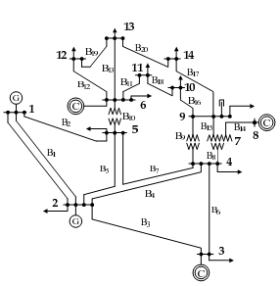

Figure 3– The IEEE 14 Node system

The summary of the case:
Number of state variable (n) = 27 state variable.
Number of measurements (m) = 41 measurements.
Number of suspected lines = 4 lines
Bus number 1 is the swing bus, its voltage magnitude is 1.06 pu. and, initial guess for α =0.5
The standard deviations used in this case were 1% for power flow and power injection, and 0.5 % for voltages. The program is converged after four iterative calculations. The results of estimated value of α are displayed in Table (1).

Table (1) – Estimated value of α for IEEE 14 Bus
Unmetered lines | Actual status | Estimated  values of α
9----10 | Out | 0.0278
2----3 | IN | 0.7487
4----7 | IN | 0.9509
4----9 | Out | 0.0282
13----6 | Out | 0.0166

Table (2) – Estimated value of α using the constraints.
Unmetered lines | Actual status | Estimated  values of α
9----10 | Out | 0
2----3 | IN | 1
4----7 | IN | 1
4----9 | Out | 0
13----6 | Out | 0
When the quadratic constraints are used through the estimation process, the results of estimated value of α are converged to one or zero as shown in Table (2).

- Case study 2
The method proposed in this paper is also applied and tested on the IEEE 30 bus systems shown in figure (4). The measurement set is used to estimate α for all the unmetered lines in the system. The results of estimated value of α without and using the quadratic constraints are displayed in tables (3,4) respectivily.
The summary of the case:
Number of state variable (n) = 59 state variable.
Number of measurements (m) = 134 measurements.
Number of suspected lines = 3 lines
Bus number 1 is the swing bus, its voltage magnitude is 1.06 pu. and, initial guess for α =0.5
By taking an accuracy factor ε = 10⁻⁴ , the program is converged after five iterative calculations.

Table (3) –Estimated value of α for IEEE 30 Buses.
Suspected lines | Actual status | Estimated  values of α
1----3 | Out | 0.4006
2----5 | IN | 1
5----7 | IN | 1

Table (4) –Case 2; Estimated value of α using the quadratic constraints.
Suspected lines | Actual status | Estimated  values of α
1----3 | Out | 0
2----5 | IN | 1
5----7 | IN | 1

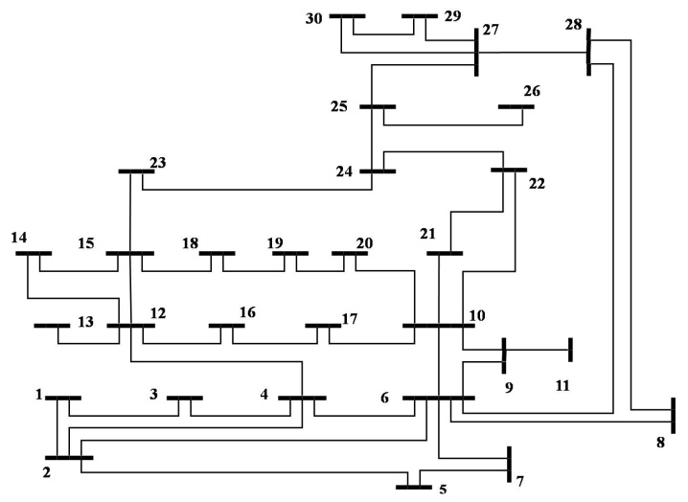

Figure 4– The IEEE 30 Node system

- Conclusion
In this paper a pre-processing algorithm for detection of branch status error in electrical power system networks before state estimation solution is presented. The approach is used to determine the real time configuration of network elements based on the weighted least squares (WLS) technique. It relies on the parameterization of branch admittance by a real parameter α and including this parameter as state variable. According to the estimated value of α, the network topology processor program determine whether the branch is in serviecee or not. The proposed technique is applied on the IEEE 14 nodes and IEEE 30 nodes systems. Using the quadratic constraints leads to adjust the estimated value of the status variable α to either 0 or 1 according to the real branch connecion.

References
- Singh H. and A. L. Alvardo,(1995),"Network Topology Determination using Least Absolute Value State Estimation", IEEE Trans on Power Systems,Vol.10,No.3,pp1195-1165.
- Dy Liacco T. E.,(1990) "The Role and Implementation of State Estimation in an Energy Management System", Electrical Power & Energy Systems, Vol. 12, No. 2, pp. 75-79.
- Mariesa Crow,(2003) “Computational Methods for Electric Power System”, Power Engineering Series, vol. 9, CRC press.
- Schweppe F. C. and J. Wildes,(1970) “Power System Static-State Estimation, Parts I, II, III”, IEEE Transactions on Power App. & Syst., Vol. PAS-89, No. 1, pp. 120-135.
- Schweppe F. C. and E. J. Handschin,(1974), “Static State Estimation in Electric Power Systems”, Proceedings of the IEEE, Vol. 62, No. 7.
- Miller W. and J. Lewis,(1971), “Dynamic state estimation in power systems”, IEEE Transactions on Automatic Control, Vol 16, No 6, pp.841-846.
- Chapman M. A.,(1999), “Adaptation and Installation of a Robust State Estimation Package in The EEF Utility”, M.Sc. Thesis, Virginia Polytechnic Institute and State University, Blacksburg, February 8.
- Sasson A. M., S. T. Ehrmann, P. Lynch, and L. S. V. Slyck,(1973), “Automatic Power System Network Topology Determination,” IEEE Transactions on Power Apparatus and Systems, Vol. PAS-92, pp. 610-618, March/April.
- Costa A.S. and J. A. Leao,(1993), "Identification of topology errors in power system state estimation", IEEE Trans. Power Systems,Vol. 8, pp. 1531-1538, November.
- Souza J. C. S., A. M. L. da Silva, and A. P. A. da Silva,(1998), “Online Topology Determination and Bad Data Suppression in Power System Operation Using Artificial Neural Networks”, IEEE Trans. on Power Systems, Vol 13, pp. 796-803, Aug.
- George N. Korres, petros J Katsikas,(2002), “Identification of circuit breaker status in wls state estimator” IEEE Transactions on power systems ,VOL 17, NO 3.
- Nagy S. A.,(2002), “Bad Data Detection, Identification and Correction in Electric Power Systems” M.Sc. Thesis, Al-Azhar University.
- Mili L., T. Van Cutsem, and M. Ribbens Pavella,(1985), “Bad Data Identification Methods in Power System State Estimation – A Comparative Study”, IEEE Transactions on Power Apparatus and Systems, Vol. PAS-104, No.11, pp. 3037-3049, Nov.
- Xinag N., S. Wang, and E. Yu, (1982), “A New Approach for Detection and Identification of Multiple Bad Data in Power System State Estimation”, IEEE Transactions on Power Apparatus and Systems, Vol. PAS-101, No. 2, pp. 454-462.
- Abur A. and Antonio Gomez Exposito,(2004), “Power System State Estimation: Theory and Implementation,” Text Book of Power Engineering Series, vol. 24, Marcel Dekker, New York.
- Lugtu R. L., D. P. Hackett, K. C. Liu and D. D. Might,(1980), "Power System State Estimation : Detection of Topological Errors," IEEE Trans. on Power Apparand Syst., Vol. PAS-99, No.6, pp. 2406-2411.
- Koglin H. J., D. Oeding and K. D. Schmitt,(1986), "Identification of Topological Errors in State Estimation," Proc. of lEE International Conference on Power system Monitoring and Control ,pp. 140-144, Durham,England.
- Clements K. A. And P. W. Davis,(1988), "Detectionand and Identification of Topology Errors in Electric Power Systems," IEEE Trans on Power Systems, Vol. 3, No.4, pp. 1748·1753, November.
- Koglin H. J. and H. T. Neisius, (1990), "Treatment of Topological Errors inSubstations," Proc. of 10th Power Systems Com putation Conference, pp. 10451053 Graz, Austria.
- Singh N. and H. Glavitsch,(1991), "Detection and Identification of Topology Errors in On-Line Power System Analysis," IEEE Trans. on Power Systems ,Vol. 6, No.1, pp. 324-331.

2/15/2012

