Molluscicidal Activity of Eco-friendly natural compound (Rutin) Gained from Ethanolic Flowers Extract of Calendula officinalis on B. alexandrina, B. truncatus and Lymanea snails

El-Sheikh, Y. W. A. ¹; Eltamny, H. M.²; Soliman, H. A.²; Farag A.A.¹ and El Behary M.H.H²

¹ Pesticide Formulations Department, Central Agricultural Pesticides Laboratory, Agricultural Research Center, Dokki, Egypt ² Suez Canal University Faculty of Science
yasserwahied@yahoo.com

Abstract: Within 3000 intermediate host snails of Schistosomiasis and Fasciolasis were originated from Delta regions at Egypt mainly Beba in Beni Seuf governorate. They were selected on the basis of snails selection Schistosomiasis and Fasciolasis mainly Schistosoma haematobium, Schistosoma mansoni and Fasciola ova. Preliminary screening of C. officinalis flower ethanolic extract showed molluscicidal activity against Biomphalaria alexandrina, Bulenus truncatus and Lymanea snails under studying. Rutin as eco-friendly natural compound was separated from the ethanolic extract of C. officinalis flowers by TLC and column chromatography and was identified by different tools of spectral analysis. Ten snails per one liter water jars were applied. Four serial concentrations of rutin with comparing to the recommended molluscicide niclosamide were prepared as (0.05, 0.1, 0.2 and 0.4 g). Mortality percentages were observed after six, twenty four, forty-eight and seventy two hours. Our study revealed that rutin separated from ethanolic extract of Calendula officinalis flowers can be used in the control of both Schistosomiasis and Fasciolasis in Egypt.
[El-Sheikh, Y. W. A.; Eltamny, H. M.; Soliman, H. A; Farag A.A and El Behary M.H.H. Molluscicidal Activity of Eco-friendly natural compound (Rutin) Gained from Ethanolic Flowers Extract of Calendula officinalis on B. alexandrina, B. truncatus and Lymanea snails. New York Science Journal 2012;5(4):19-27]. (ISSN: 1554-0200). http://www.sciencepub.net/newyork. 4

Keywords: C. officinalis, rutin, snails, Biomphalaria alexandrina, Bulenus truncatus, Lymanea, spectral analysis

1. Introduction:
Recently, a large number of synthetic pesticides have been banned in the world because of their undesired attributes such as chronic and acute toxicity, long degradation periods, accumulation in the food chain and extension of their power to destroy both useful and harmful pests (Barnard et al., 1997). Consequently, there is an urgent need for alternative agents for pest management (Bolkan and Reiner, 1994, Rice et al., 1998). Green plants represent a reservoir of effective chemotherapeutants and can provide valuable source of natural pesticides (Balandrin et al., 1985; Hostettmann and Wolfender, 1997). Reports are available on the use of active agents form higher plants to replace chemical pesticides that are not-phytotoxic, more systemic and easily biodegradable (Fewcett and Spencer, 1970).
Schistosomiasis is a parasitic disease which is considered a worldwide problem in various parts of the world including Egypt. As estimated by WHO (1993) 600 million people are at risk of infection and more than 200 million are currently infected (Mckerrow and Salter, 2002). The importance of the disease lies in the fact that it affects not only the overall health status and fitness of the infected people, but also the human productivity and national economy (El-Garem et al., 1994).
Actually, Schistosomiasis is considered to be the second most prevalent tropical disease and a leading cause of severe morbidity in several foci in Africa, Asia and South America. There are many endemic areas where Schistosomiasis is not yet recognized as an important public health problem and where it receives only a low priority for control. It is estimated that around 200 million people are infected by one or another form of Schistosomiasis parasites throughout the world which are responsible for 800,000 deaths per year (WHO, 1992).
Each of B. alexandrina, B.truncatus and lymanea snails cause serious infectious diseases such as, liver cirrhosis, esophagus varices, renal failure and ascitis due to the infection of either Schistosoma haematobium ,Schistosoma mansoni or Fasciola ova. Successful control of both Schistosomiasis and Fasciolasis should be based on an integrated approach which includes the control of intermediate snail hosts (WHO, 1993).
Pesticides used to control these snails such as niclosamide accumulated in the muscles of fishes are toxic and these molluscicides are not destroyed by freezing or cooking or roasting or salting of the fish, would affect the metabolic enzymes of the human consuming such fishes (Zinada, 2000). As these pesticides affect both of human and environment and reduce the efficiency, potential and economics besides to, the cost of money paid in snails’ control are too much (Joblin et al., 1989). Calendula officinalis (Marigold) has many pharmacological properties for skin disorders, pain and also as a bactericide, antiseptic and anti-inflammatory (Cordova et al., 2002)
This study aimed to separate and identify the effective compound from ethanolic flower extract of Calendula officinalis (Marigold), then the effective compound will be used to control snails under studying and determining its LC₅₀ and LC₉₀ compared with niclosamide as the recommended molluscicide.

MATERIAL AND METHODS
- Collection, Preparation of Plant Material and extraction:
Calendula officinalis flowers were collected at the flowering season from different regions in Egypt. They were kept to dry in open air and away from direct sunlight, then milled well by a mixer miller machine to get a powder sample.
Ground flowers were extracted according to (Kato-Noguchi et al., 1994). Weight of 750 grams flower sample was shacked in a dark vessel with 2.25 liters of hexane, chloroform and ethanol consequently and individually for 8 hours. The ethanolic extract was filtered in dark vessel purified and evaporated under vacuum with rotary evaporator at 40ºC to dryness.

- Separation:
The chemical constituents of the ethanolic flowers extract were isolated by TLC and column chromatography techniques using eluant solvents (petroleum ether 60-80: diethyl ether: ethanol) ratio (7: 2: 1). There were five bands separated. Every band was collected, cleaned up, purified, re-purified and crystallized by a proper solvent (Duke, 1991).

- Preliminary Qualitative of Phytochemical Constituents:
The preliminary phytochemical constituent such as steroids, triterpene, tannins, carbohydrates, flavonoids, alkaloids, saponins and glycosides as a (phenolic, cyanophore, anthraqunone and cardic) were carried out on fraction which exhibited molluscicidal activity according to Claus (1961); Venkatroman (1962); Wall et al. (1964); Balbaa (1981); Zedan (1992) and El Kadi (1997).

4. Chemical identification:
The structure of the effective compound was confirmed by different tools of spectroscopic analysis, elemental analysis, IR Spectra, Mass Spectra and ¹H-NMR. All the analysis was carried out in Elemental Analysis Laboratory, Faculty of Science, Cairo University, Arab Republic of Egypt.

5. Bioassays:
Each of Biomphalaria alexandrina, Bulenus truncatus and Lymanea snails were collected from Delta regions at Egypt mainly Beba in Beni Seuf governorate. They were selected on the basis of snails Schistosomiasis and Fasciolasis mainly Schistosoma haematobium, Schistosoma mansoni and Fasciola ova. The snails were reared under laboratory conditions three days before being used in testing using lettuce plant and algae as daily food and kept in laboratory temperature (20±5°C). Ten snails per liter water jars were applied. Four serial concentrations of effective compound were prepared as (0.05, 0.1, 0.2 and 0.4 g/l). The recommended molluscicide niclosamide was used as a reference for our effective compound with the same serial concentrations which used against the snails under studying. Mortality percent was observed after 6, 24, 48 and 72 hours (Borai et al., 2005).

6. Statistical analysis:-
Morality was scored after 6, 24, 48 and 72 hrs of treatment. Snails were considered dead if they showed no sign of movement. Data were corrected for control morality (Abbott, 1925). The corrected mortality percentage was used to calculate the LC₅₀ values according to Finney (1971). Toxicity index was calculated according to Sun (1950).
$\text{Toxicity Index }=\frac{{\text{LC}}_{\text{50}}\text{ of the most effective sample }}{{\text{LC}}_{\text{50}}\text{ of the sample }}\text{x 100}$

RESULTS
1. Separation:
The crude ethanolic flower extract was separated by thin layer chromatography (TLC) plates to know the number of its chemical constituent compounds. The crude was eluted by a mixture of solvents which appeared five bands under ultraviolet lamp with different R_{F} where the third band was the most intense band. 10 grams of crude extract was separated by column chromatography 1.6 m using silica gel for column and eluted by petroleum ether (60–80), diethyl ether and ethanol in ratio 7: 2: 1. Every fraction was followed up by TLC, collected, purified, re-purified and evaporated by a vacuum rotary evaporator till dryness. Every compound was re-crystallized by a proper solvent and tested against snails under studying.
The data of table (1) illustrated the R_{F}, solvent of crystallization, percentage of yield and molluscicidal effect of the collected separated fractions, which demonstrated that, the third fraction was re-crystallized from ethanol and its % of R_{F} was 55% and the yield percentage was 35%. This fraction showed only molluscicidal activity against the tested snails.

Table (1): The R_{F}, solvent of crystallization, percentage of yield and molluscicidal effect of the collected separated fractions
No. of fraction  Test | 1 | 2 | 3 | 4 | 5
Solvent of crystallization | Benzene | Methanol | Ethanol | Ethanol | Ethyl acetate
% of R_{F} | 80 | 67 | 55 | 35 | 23
% of Yield | 5 | 7 | 35 | 11 | 8
Molluscicidal effect | -ve | -ve | +ve | -ve | -ve
-ve = No molluscicidal effect +ve = molluscicidal effect

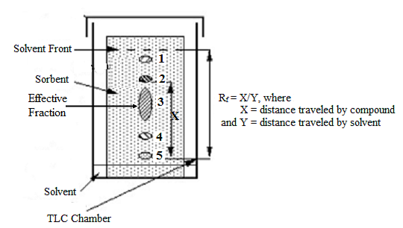

Fig. (1): Diagram showing the TLC separation processes.

2. Phytochemical identification of the effective fraction:
The results obtained from the phytochemical identification of the effective fraction separated from ethanolic flowers extract appear the functional groups of the studied compound which has molluscicidal potency (Table 2). The effective fraction gave +ve test for carbohydrates, flavonoide, phenolic glycosides and hydrolysable tannins as catechol and –ve test for sterols, triterpene, alkaloids, saponin and condensed tannins. Also has –ve test for cyanophore, anthraquinone and cardic glycosids.

Table (2): Phytochemical identification of ethanolic flowers extract of C. officinalis
Test | Result | Test | Result
Carbohydrates | ++ | Glycosides:
Sterols/ Triterpenes | Nd | Phenolic Glycosides | ++
Flavonoide | + | Cyanophore Glycosides | nd
Alkaloid | Nd | Anthraquinone Glycosides | nd
Saponins | Nd | Cardic Glycosides | nd
Hydrolysable Tannins | ++ (Catechol) | Condensed Tannins | nd
nd: not detected | + : Found | ++ : Excess

3. Chemical identification:
The data obtained from spectroscopic tools of analysis showed that:
- The melting point of the effective compound was 209 – 211.5 °C.
- The IR spectra absorption bands in the region of wave length (cm⁻¹): 3400 – 3300 (υ_{OH}); 3010 – 2980 (υ_{CH aro}); 2980 – 2680 (υ_{CH aliph}); 1680 – 1650 (υ_{C=O}) and 1595 – 1575 (υ_{C=C}).
- Correct elemental analysis for the separated compound give the following data (C_{calcu.}/_{found} = 50.81/50.42) and (H_{calcu.}/_{found} = 4.92/4.75).
- The mass spectra of the separated compound revealed molecular ion peak (M⁺/at m/z = 614) with 10.1 % as relative abundance corresponding to C₂₆ H₃₀ O₁₇.
- The strong evidence for the suggested structure of separated compound comes from the ¹H-NMR spectrum where the spectrum showed signals at δ(ppm) = 7.5 – 6.8 (m, 5H, aromatic proton), 5.7 (2d, 2H, tetrahydrobenzopyrane proton), 5.4 (d, 1H, tetrahydropyran C-OH proton), 5.03 (d, 2H, H-C-O tetrahydropyrane proton), 5.0 (S, 4H, 4-OH benzene rings), 3.6 (d, 2H, methylene protons), 3.5 (t, 7H, tetrahydropyrane protons) and 2.0 (s, 7H, 7-OH tetrahydropyrane rings).
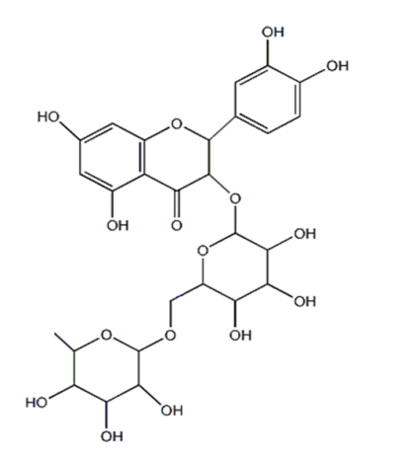
The chemical structure of the effective compound which confirmed by different types of spectral tools and melting, mixed melting point estimated that the compound is rutin

4. Bioassay:
- Molluscicidal effect of the separated compound in comparing with niclosamide against Biomphalaria alexandrina snails after different time intervals of treatment:
Table (3) represents the results obtained from treatment of Biomphalaria alexandrina with rutin concentrations at different time intervals; 6, 24, 48 and 72 hrs in comparison with niclosamide. From which, after all time intervals we found that, the percentage of mortality increased as the concentrations increased. We can also notice that, as the time of exposure to rutin increased the LC₅₀ decreased and accordingly, the effectiveness of the compound increased. The LC₅₀’s of the rutin compound after 6, 24, 48 and 72 hrs of treatment were 0.0885, 0.0555, 0.0379, 0.0272 g/l, respectively. On the other hand, the LC₅₀’s of the recommended molluscicide (niclosamide) were 0.0696, 0.0536, 0.0328 and 0.0352 g/l, respectively at the same time intervals. In comparing the effectiveness of rutin and the niclosamide molluscicide on the Biomphalaria alexandrina snails we found that, niclosamide was found to be more effective on the tested snail than the separated rutin. This note can be approved that the toxicity indexes of Niclosamide were 100 % at all time intervals, where the toxicity indexes of rutin were 78.64, 96.58, 86.54 and 84.62%; respectively at the tested time intervals 6, 24, 48 and 72 hrs after treatment.
The ldp-lines of the rutin and niclosamide at different time intervals against Biomphalaria alexandrina were plotted in Figures 2A and 2B, respectively. From the obtained lines the highest slope recorded for rutin was after 6 hrs of treatment (2.62), while the slopes after 24, 48 and 72 hrs were 2.1, 2.11 and 1.62, respectively. Finally, the highest slope recorded for niclosamide was after 6 hrs of treatment also (2.5) and the slopes after 24, 48 and 72 hrs were 2.03, 1.8 and 1.12, respectively.

Table (3): Effects of different concentrations of rutin on Biomphalaria alexandrina, snails in comparison with niclosamide
 |  | Concentrations (g/l) |  |  |  | LC₁₀ | LC₂₅ | LC₅₀ | LC₉₀ | Toxicity Index | slope
 |  | 0.05 | 0.1 | 0.2 | 0.4
6 hrs | Rutin | 25.79 | 55.54 | 82.34 | 95.69 | 0.0287 | 0.0489 | 0.0885 | 0.2727 | 78.64 | 2.62
6 hrs | Niclosamide | 35.99 | 65.35 | 87.46 | 97.13 | 0.0214 | 0.0374 | 0.0696 | 0.226 | 100 | 2.5
24 hrs | Rutin | 46.19 | 70.46 | 87.92 | 96.41 | 0.0137 | 0.0265 | 0.0555 | 0.2257 | 96.58 | 2.1
24 hrs | Niclosamide | 47.53 | 71.85 | 87.69 | 96.16 | 0.0125 | 0.025 | 0.0536 | 0.2296 | 100 | 2.03
48 hrs | Rutin | 60.03 | 81.31 | 93.62 | 98.39 | 0.0094 | 0.0182 | 0.0379 | 0.1534 | 86.54 | 2.11
48 hrs | Niclosamide | 62.87 | 90.79 | 92.1 | 97.42 | 0.0064 | 0.0139 | 0.0328 | 0.1693 | 100 | 1.8
72 hrs | Rutin | 55.58 | 81.99 | 91.94 | 97.04 | 0.0044 | 0.0104 | 0.0272 | 0.1686 | 84.62 | 1.62
72 hrs | Niclosamide | 56.75 | 69.36 | 80.01 | 55.06 | 0.0025 | 0.0088 | 0.0352 | 0.4953 | 100 | 1.12

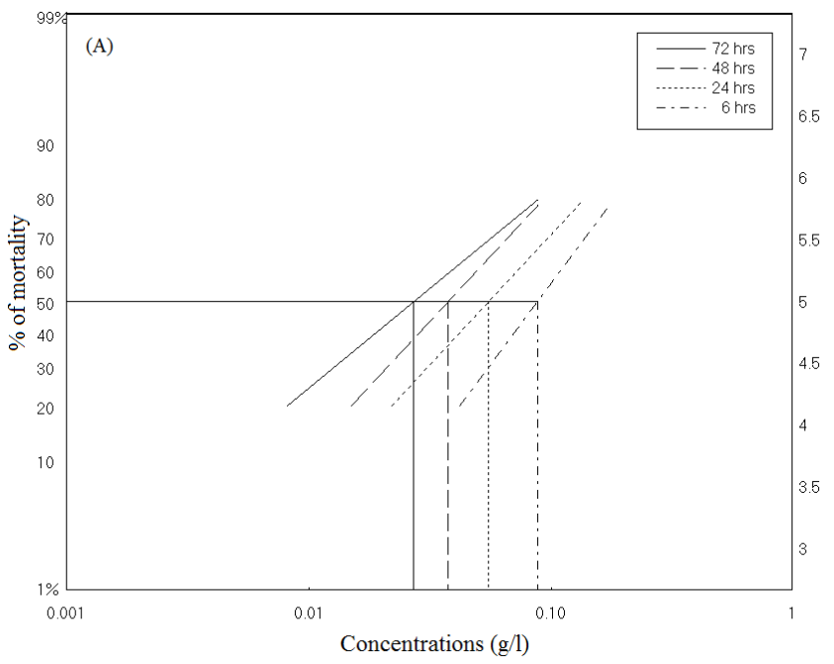
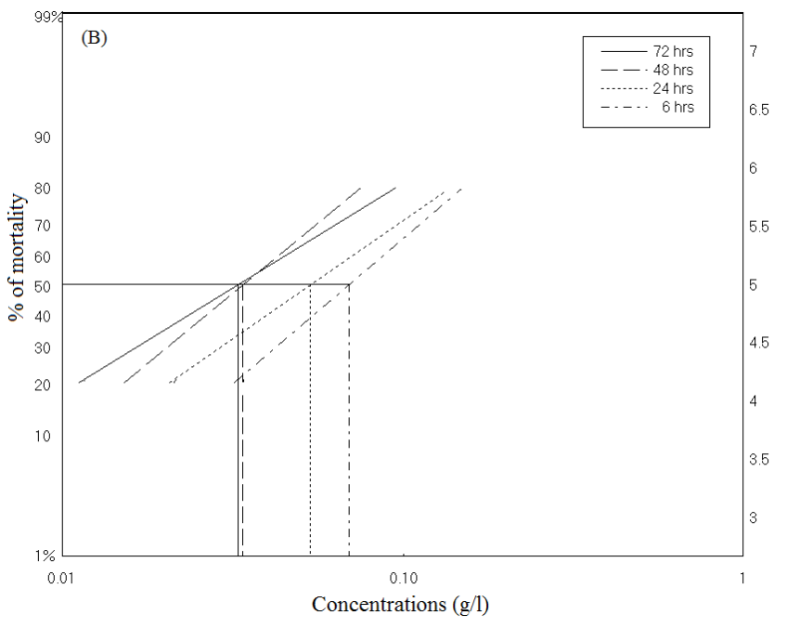

Figure (2): The ldp-lines of the rutin (A) and niclosamide (B) against Biomphalaria alexandrina at different time intervals of treatments.

- Molluscicidal effect of the separated compound in comparing with niclosamide against Bulenus truncatus snails after different time intervals of treatment:
Results obtained from table (4) revealed the high mortality percentage with increasing the concentrations of rutin for the control of Bulenus truncatus snails at all time interval of treatments. The LC₅₀’s registered to be 0.0331, 0.0318, 0.0229 and 0.0347 g/l for rutin, and recorded 0.1414, 0.084, 0.0673 and 0.0517 g/l for niclosamide after 6, 24, 48 and 72 hrs of treatments for all, respectively. In alignment the mortality percentage increased as the niclosamide molluscicide concentration increased at all examined time intervals. In comparing the effectiveness of rutin and the niclosamide molluscicide on the Bulenus truncatus snails we observed that, the rutin was found to be more effective on the tested snail than niclosamide molluscicide used. These results revealed that the toxicity index’s of rutin were 100% at all time intervals of treatment and was in comparison 23.41, 37.86, 34.03 and 78.61% for niclosamide after 6, 24, 48 and 72 hrs, respectively.
The Ldp-lines of rutin and niclosamide are given in figures 3C and 3D, respectively. The slope values for all were approximately convergent. The slope values for rutin were 1.31, 1.59, 1.63 and 1.66; and for niclosamide were 1.22, 1.29, 1.41 and 1.42 after 6, 24, 48 and 72 hrs of treatments, respectively.

Table (4): Effects of different concentrations of rutin on Bulenus truncatus snails in comparison with niclosamide.
 |  | Concentrations (g/l) |  |  |  | LC₁₀ | LC₂₅ | LC₅₀ | LC₉₀ | Toxicity Index | slope
 |  | 0.05 | 0.1 | 0.2 | 0.4
6 hrs | Rutin | 59.27 | 73.56 | 84.73 | 92.22 | 0.0035 | 0.0102 | 0.0331 | 0.3135 | 100 | 1.31
6 hrs | Niclosamide | 29.15 | 42.74 | 57.26 | 70.86 | 0.0125 | 0.0394 | 0.1414 | 1.6007 | 23.41 | 1.22
24 hrs | Rutin | 62.24 | 78.51 | 89.74 | 95.94 | 0.0049 | 0.0119 | 0.0318 | 0.2043 | 100 | 1.59
24 hrs | Niclosamide | 38.58 | 53.89 | 68.64 | 80.89 | 0.0085 | 0.0252 | 0.084 | 0.8288 | 37.86 | 1.29
48 hrs | Rutin | 71.02 | 85.2 | 93.77 | 97.85 | 0.0038 | 0.0088 | 0.0229 | 0.1396 | 100 | 1.63
48 hrs | Niclosamide | 42.75 | 59.59 | 74.81 | 86.3 | 0.0084 | 0.0225 | 0.0673 | 0.5427 | 34.03 | 1.41
72 hrs | Rutin | 60.4 | 77.76 | 89.69 | 96.11 | 0.0059 | 0.0136 | 0.0347 | 0.2048 | 100 | 1.66
72 hrs | Niclosamide | 49.19 | 65.81 | 79.81 | 89.65 | 0.0065 | 0.0173 | 0.0517 | 0.4126 | 78.61 | 1.42

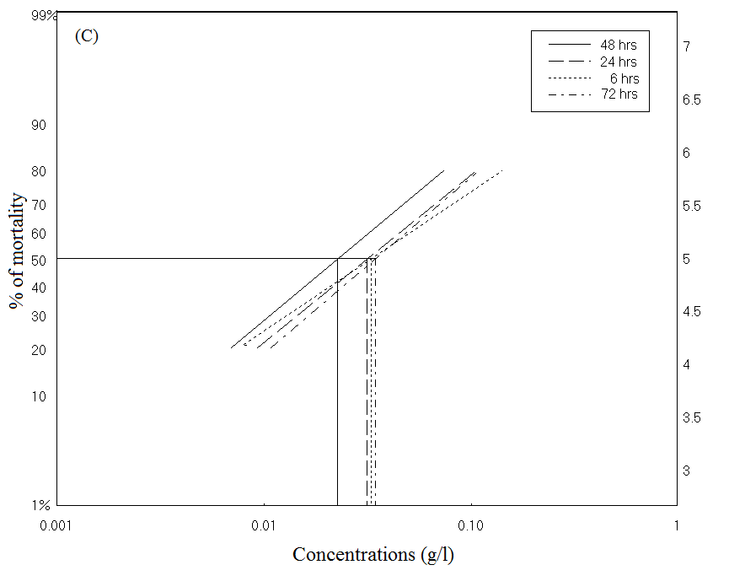
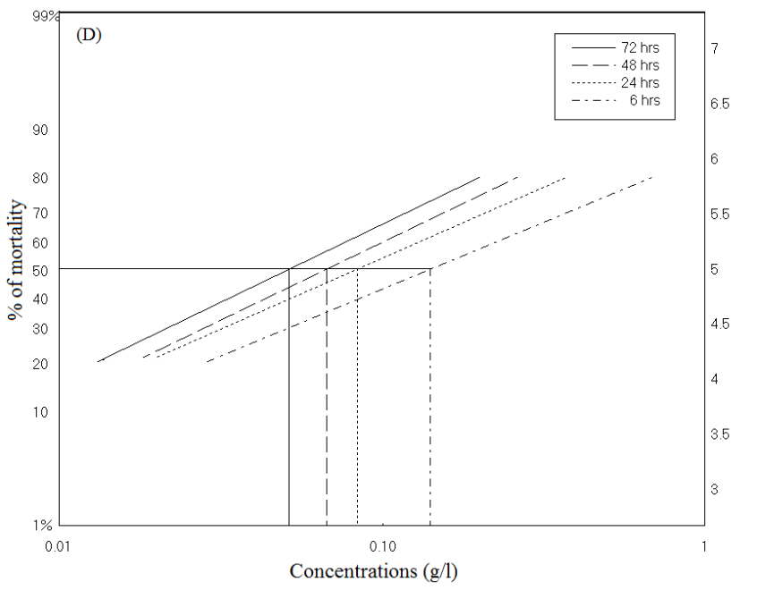

Figure (3): The ldp-lines of the rutin (C) and niclosamide (D) against Bulenus truncatus at different time intervals of treatments.

- Molluscicidal effect of the separated compound in comparing with niclosamide against Lymanea snails after different time intervals of treatment:
The molluscicidal activities of the rutin and niclosamide against Lymanea snails were presented in Table (5). Results obtained from the table revealed the percentage of mortality is directly proportional to the concentrations of rutin and niclosamide when used to treat Lymanea snails at all time intervals. The registered LC₅₀’s for rutin were 0.0212, 0.0.0288, 0.0169 and 0.0121 g/l, and recorded 0.01089, 0.0638, 0.0492 and 0.0352 g/l for niclosamide after 6, 24, 48 and 72 hrs of treatments, respectively. In comparing the effectiveness of rutin and the niclosamide molluscicide on the Lymanea snails we observed that, the rutin was found to be more effective on the tested snail than niclosamide molluscicide used. These results revealed that the toxicity index’s of rutin were 100% at all time intervals of treatment and was in comparison 19.47, 45.14, 34.35 and 34.38% for niclosamide after 6, 24, 48 and 72 hrs, respectively.
The Ldp-lines of rutin and niclosamide are given in figure 4E and 4F, respectively. The slope values for all were also approximately relative to each other. The slope values for rutin were 1.19, 1.09, 1.81 and 1.48 and for niclosamide were 0.9, 1.05, 1.15 and 1.12 after 6, 24, 48 and 72 hrs of treatments, respectively.

Table (5): Effects of different concentrations of rutin on Lymanea snails in comparison with niclosamide.
 |  | Concentrations (g/l) |  |  |  | LC₁₀ | LC₂₅ | LC₅₀ | LC₉₀ | Toxicity Index | slope
 |  | 0.05 | 0.1 | 0.2 | 0.4
6 hrs | Rutin | 67.15 | 78.87 | 87.68 | 93.53 | 0.0018 | 0.0057 | 0.0212 | 0.2533 | 100 | 1.19
6 hrs | Niclosamide | 37.92 | 48.54 | 59.26 | 69.33 | 0.0041 | 0.0196 | 0.1089 | 2.9154 | 19.47 | 0.9
24 hrs | Rutin | 50.23 | 72.11 | 81.93 | 89.23 | 0.0019 | 0.0069 | 0.0288 | 0.4375 | 100 | 1.09
24 hrs | Niclosamide | 45.56 | 58.15 | 69.95 | 79.96 | 0.0039 | 0.0146 | 0.0638 | 1.0491 | 45.14 | 1.05
48 hrs | Rutin | 80.32 | 91.89 | 97.36 | 99.35 | 0.0033 | 0.0072 | 0.0169 | 0.0863 | 100 | 1.81
48 hrs | Niclosamide | 50.31 | 63.84 | 75.82 | 85.24 | 0.0038 | 0.0128 | 0.0492 | 0.64 | 34.35 | 1.15
72 hrs | Rutin | 81.87 | 91.23 | 96.39 | 98.71 | 0.0016 | 0.0042 | 0.0121 | 0.0891 | 100 | 1.48
72 hrs | Niclosamide | 56.75 | 69.36 | 80.01 | 88.06 | 0.0025 | 0.0088 | 0.0352 | 0.4953 | 34.38 | 1.12

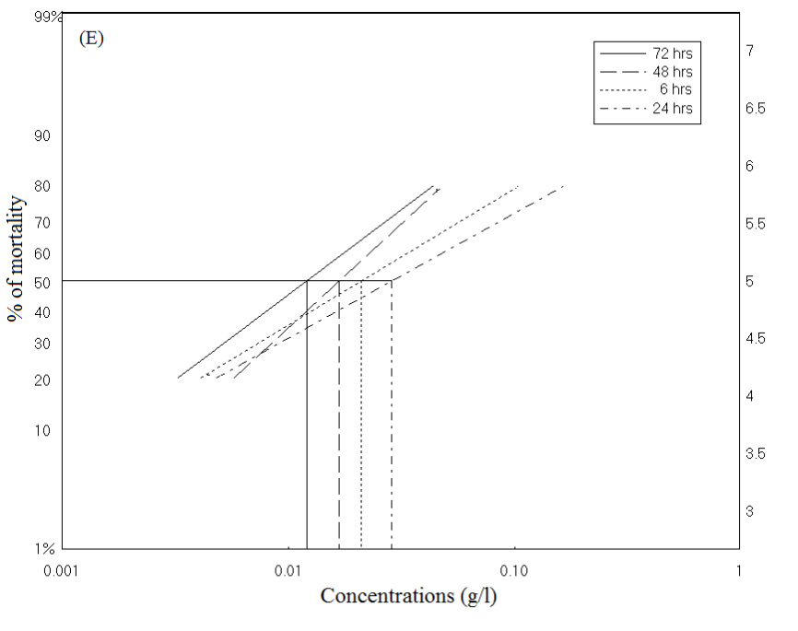
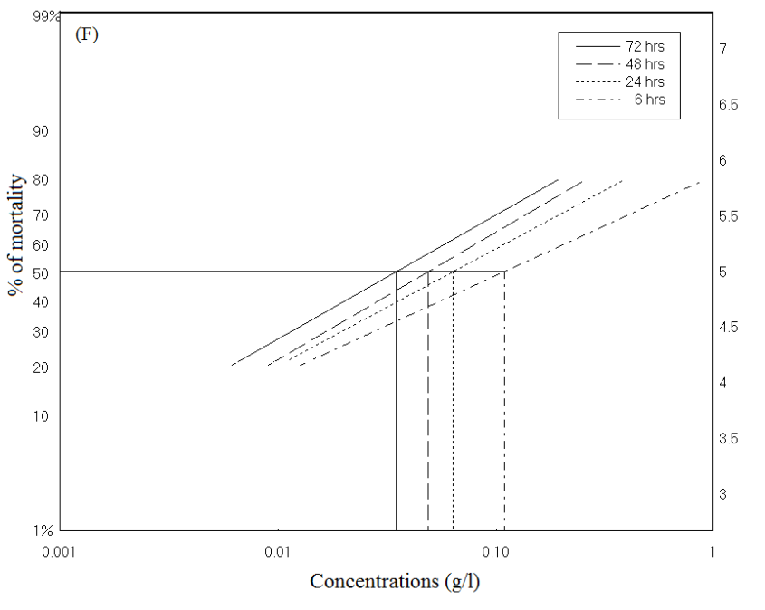

Figure (4): The ldp-lines of the rutin (E) and niclosamide (F) against Lymanea at different time intervals of treatments.

DISCUSSION
Medicinal plants are the most important source of drugs for the majority of the world’s population. Plant secondary metabolites are important naturally occurring substances from renewable sources, which can be used as drugs, fragrances, pigments, food additives and pesticides (Khan et al., 2009).
C. officinalis L. is known for its biological activity, namely antibacterial, antioxidant, inflammatory etc. (Amirghofran et al., 2000) and is widely used in pharmacy. Bilia et al., (2001) identified narcissin, rutin, isoquercitrin, quercetin-3-O-rutinosylrhamnoside, isorhamnetin-3-O-rutinosyl-rhamnoside, isorhamnetin-3-O-glucosylglucoside and isorhamnetin-3-O-glucoside in C. officinalis flowers.
In the last decade C. officinalis is used in tinctures and creams and is valuable for positive effect on skin diseases (Fonseca et al., 2010; Bernatoniene et al., 2011). The flowers of C. officinalis are used for medicinal purposes. Nevertheless, it is believable that also other parts of plants may possess various biological activities. Methanol and ethanol exhibit similar properties as extraction solvents for phenolic compounds. Aqueous alcohols are used in order to obtain higher recoveries of polyphenols, particularly their glycosides.
These previous results were matching according to Borai et al., (2005) who mentioned and proved that eco-friendly extracts of Calendula officinalis flowers used to control Schistosomiasis snails are safely without any toxic action in the environment as they stated that Calendula was tested before for toxicity at Albino rats. So we can apply the optimum concentrations of these highest crude extracts to take them into applied field control of snails.
Also, as shown in bioassay table, we can recommended that application of the used flower extract for finally exposure time up to 72 hours was found to be the best preferred extracts used in comparison niclosamide used. These results matched with El-Sawy et al., (1991) who mentioned that exposure of both Schistosoma haematobium and Schistosoma mansoni to more concentrations of some plant extracts give much efficiency in snails control rather than pesticides used in its control due to the fact that these plants are considered to be used in medical field and they are friendly environmental.
Thus, both Schistosomiasis and Fasciolasis are diseases which remain the major health problem due to the lack of vaccines, the failure to eradicate the mollusc vector and the recent development of parasite resistance to anti-Schistosome drugs (Khalife et al., 2000).
In Egypt, niclosamide has been in use as molluscicides since 1960. At low concentration, it is highly toxic to snails and their egg masses (Green et al., 1996). This study aimed to evaluate the biological activity of different extracts of rutin extracted from Calendula officinalis flowers in control of each Biomphalaria alexandrina, Bulenus truncatus and lymanea snails by comparison with the usual molluscicides used (niclosamide).
Thus, Our results showed that high efficiency of Rutin extracted from Calendula officinalis flowers in the control of each Biomphalaria alexandrina, Bulenus truncatus and lymnaea snails in comparison with the niclosamide used. These were in agreement with that mentioned by Mostafa and Tantawy (2000), who stated that the survival rate of B. alexandrina snails maintained in aqueous solutions of Calendula micrantha decreased gradually with time.
Also results obtained from tables (3, 4 and 5) were agreed with those obtained by Rawi et al., (1996), who stated that both leaves and flowers of calendula plant exhibited marked potency in killing the snail vectors of schistosomiasis and the recorded values showed that C. officinalis was more toxic and fetal to these snails.
Results obtained from all previous tables showed also that the various four concentrations and the pesticide applied gave us mortality near to those obtained from medical plants applied but according to each (EL-Herrawie et al., 1991; Kuumar et al., 1993; Cerone et al., 1995 and Borai et al., 2005) who all agreed , reported and mentioned the fact that these pesticides are all toxic at their any applied doses due to their residues in our bodies, their accumulations because they are not analyzed in our environment.
In conclusion field application of rutin compound separated from Calendula officinalis flowers have the highest ability rather than the applied pesticide in control of each Biomphalaria alexandrina, Bulenus truncatus and lymanea snails which are responsible for acute or chronic diseases called Schistosomiasis and Fasciolasis so these extracts can be used safely without any toxicity in environmental use.
These results obtained from the three mentioned tables were confirmed to (Perez-carron et al., 2002) who reported that Calendula flower extracts are considered to be used in many medical fields such as curing of infectious diseases, inflammations, toxic effects of some drugs, wound healing, antiviral treatment and may be in case of cancer diseases.
So finally field applications of rutin compound separated from Calendula officinalis flowers can be used safely without any toxicity in the environment as Calendula was tested before for toxicity at Albino rats, (Borai et al., 2005) who mentioned and proved that formulated extracts of Calendula officinalis flowers were safe and have no toxic action on albino rats and which are represented to have high potency in control of each Biomphalaria alexandrina, and Bulenus truncatus snails which are responsible for Schistosomiasis in Egypt.

Corresponding author
El-Sheikh, Y. W. A
Pesticide Formulations Department, Central Agricultural Pesticides Laboratory, Agricultural Research Center, Dokki, Egypt
yasserwahied@yahoo.com

REFERENCES
- Abbott, W. S. (1925). A method of computing the effectiveness of insecticide. J. Econ. Ent., 18: 265 – 267.
- Amirghofran, Z.; Azadbakht, M. and Karimi, M.H. (2000). Evaluation of the immu-nomodulatory effects of five herbal plants. Journal of Ethnopharmacology, 72: 167–172.
- Balandrin, M.F.; Klocke, J.A.; Wurtele, E.S. and Bollinger, W.H. (1985). Natural Plant Chemicals: sources of industrial and medicinal material. Science, 228: 1154 – 1160.
- Balbaa, S.I. (1981). Medicinal Plant Constituents. Manual Book. General Organization For University And School Books, Cairo.
- Barnard, M.; Padgitt, M. and Uri, N.D. (1997). Pesticide use and its measurement. International pest control, 39:161 – 164.
- Bernatoniene, J.; Masteikova, R.; Davalgiene, J.; Peciura, R.; Gauryliene, R.; Bernatoniene, R.; Majiene, D.; Lazauskas, R.; Civinskiene, G.; Velziene, S.; Muselik, J. and Chalupova, Z. (2011). Topical application of Calendula officinalis (L.): Formulation and evaluation of hydrophilic cream with antioxidant activity. Journal of Medicinal Plants Research, 5: 868–877.
- Bilia, A.R.; Salvini, D.; Mazzi, G. and Vincieri, F.F. (2001). Characterization of Calendula flower, milk-thistle fruit, and passion flower tinctures by HPLC-DAD and HPLC-MS. Chromatographia, 53: 210–215.
- Bolkan, H.A. and Reinert, W.R. (1994). Developing and implementing IPM strategies to assist farmers: an industry approach. Plant Diseases, 78: 545 – 550.
- Borai, I.H.; Farag, A. A.; Moselhy, S. S. and El-Behary, M. H. (2005). Effect of some formulated plant extracts on snails of Schistosomiasis and study their biological effects. Master degree in Environmental Science Department of Biological & Natural Sciences.
- Cerone, J.J.; Panizo, G.G. and Montes, O. (1995). Toxicological effects in rabbits induced by endosulfan, linden and methyl parathion representing agriculture by products contamination Bull.Environ. Contam.Toxicol., 54:258-265.
- Claus, E.P. (1961). Pharmacognosy. 5th Ed., Pp. 29 And 157, Henry Krimpton, London.
- Cordova, C.A.; Siqueira, I. R.; Netto, C. A.; Yunes, R. A.; Volpato, A. M.; Cechinel, Filho V.; Curi-Pedrosa, R. and Creezynski-Pasa, T.B. (2002). Protective properties of butanolic extract of the Calendula officinalis L. (marigold) against lipid peroxidation of rat liver microsomes and action as free radical scavenger. Redox Rev.,: 7(2): 95-102.
- Duke, J.A. (1991). Handbook of Medicinal Herbs. CRC Press, Boca Raton, pp. 87 – 88.
- El-Garem, A.A.; Kamel, L.M.; Mokhtar, S.; El-Behairi, N. M. and Abdel-Rahman, H. A. (1994). A clinical laboratory and social field study of schistosomiasis in an Egyptian village. Egypt J. Comm. Med.,12:29-32.
- El-Herrawie, M.A.; El-Nattar, F.M.; Farid, M.M. and Salem, H.M. (1991). Acute and subchronic toxicity of pesticides for albinorats. 4Th Arab Cong. of Plant Protection; 1-5 Dec.1991,Cairo, Egypt.
- El-Kadi, A.M.A. (1997). Studies on some natural products as nematicides. Ph. D. Thesis Fac. Of Agric., Cairo University, 129 pp.
- El-Sawy, M.F.; Farag, H.F.; Barakat, R.M.R.; Khairy; A.M. and El-Fiki, S. (1991). Environmental and community studies on the evaluation of Schistosomiasis control in Egypt international development research center, project No.3 p87-0204. Pp.1-156.
- Fawcett, C.H. and Spencer, D.M. (1970). Plant chemotherapy with natural products. Annual Review of Phytopathology, 8:403 – 418.
- Finney, D.J. (1925). Probit Analysis Statistical Treatment of the Sigmoid Response Curve. Cambrige Univ. Press, London, 256 pp.
- Fonseca, Y.M.; Catini, C.D.; Vicentini, F.T.; Nomizo, A.; Gerlach, R.F. and Fonseca, M.J. (2010). Protective effect of Calendula officinalis extract against UVB induced oxidative stress in skin: evaluation of reduced glutathione levels and matrix metalloproteinase secretion. Journal of Ethnopharmacology, 127: 596 – 601.
- Green, G.J.; Tchounwou, P.B.; Takougang, I. and Monkiedje, A. (1996). Field rests of a village-based molluciciding programme for the control of snail hosts of human Schistosomes in Cameron. Trop.Med.Int.Hlth., 1(3): 320-327.
- Hostettamann, K. and Wolfernder, J. (1997). The search for biological active secondary metabolites. Pesticides Science, 51: 471 – 482.
- Joblin, W.R.; Miller, M.J. (ed.) and Love, Ej. (ed.) (1989). The economics of Bilharzia central, parasitic diseases: treatment and control, 129-144.
- Kato-noguchi, h.; Kosemuras Yamamuras Mizutani, J. and Jasegawa, K. (1994). “Allelopathy of oats. i. assessment of allelopathic potential of extract of oat shoots and identification of an allelochemical”. J. Chemical Ecology, 20: 309-314.
- Khalife, J.; Catherine cetre, Christine Pierrot and Monique Capron (2000). Mechanisms of resistance to S.mansoni infection the rat model. Parasitology International., 49: 339-345.
- Khan, M.Y.; Aliabbas, S.; Kumar, V. and Rajkumar, S. (2009). Recent advances in medicinal plant biotechnology. Indian Journal of Biotechnology, 8: 9–22.
- Kumar, R.; Madhavi, N.B.B. and Sharma, C.B. (1993). Biodegradation of Pesticides in rat tissues. Biomedical chromatography; 7(1):20-24.
- Mckerrow, J.H. and Salter, (2002). Invasion of skin by Schistosoma cercariae. Trends Parasitol., 18: 193-195.
- Mostafa, B.B. and Tantawy, A.A. (2000). Bioactivity of Anagallis and Calendula micrantha plants, treated with ammonium nitrate, superphosphate and potassium sulphate fertilizers, on Biomphalaria alexandrina. J. Egypt Soc. Parasitol.; 30(3): 929-942.
- Perez-Carreon J.I.; Cruz-Jimenez G.; Licea-Vega, J.A.; Arce Popoca, E.; Fattel Fazenda, S. and Villa-Trevino, S. (2002). Genotoxic and anti-genotoxic properties of Calendula officinalis extracts in rat liver cell cultures treated with diethylnitrosamine. Toxicol In Vitro., 16(3): 253-258.
- Rawi, S.M.; El-Gendy, H. and Abd El-Kader, A. (1996). New possible molluscicides from Calendula micrantha officinalis and Ammi majus.II. Molluscicidal, physiological and egg-laying effects against Biomphalaria alexandrena and Bulenus truncatus. Ecotoxicol Environ Saf.: 35(3):261-267.
- Rice, M.J., Legg, M. and Powell, K.A. (1998) Natural products in agriculture – a view from the industry. Pesticide Science, 52: 184 – 188.
- Sun, Y.P. (1950). Toxicity Index and improved method of comparing the relative toxicity of insecticides. J. Econ. Entom., 43: 45 – 53.
- Venkatoraman, K. (1962). Methods for determining the structures of flavonoid compounds. In : The Chemistry of Flavonoid Compounds, Ed. Geisaman, T.A., p. 70. the Macmillan Company, New York.
- Wall, M.E.; Krider, M.M.; Kermson, C.F.; William, J.J. and Gentry, H.S. (1964). An organic constituent of higher plants. J. Pharm. Sci., 43: 1 – 5.
- WHO, (1992). The control of Schistosomiasis 1st Report of Who expert Committee Who Techn. Rep., Ser. No. 255.
- WHO, (1993). The control of Schistosomiasis. 2nd Report of Who expert Committee. Who Techn. Rep., Ser. No. 830.
- Zedan, H.A.A. (1992). The pesticidal activity of some Egyptian herbs. Ph. D. Thesis, Fac. Agric., Mansoura Univ., 159 pp.
- Zinada, O. A. A. (2000). Effect of niclosamide on the marketable fish Liza Ramada concerning accumulating in muscles and activities of three metabolic liver enzymes. Journal of Egyptian Society of Parasitology, 30(33): 791-797.

2/22/2012

