Applying Recursive Regression & Rolling Regression Methods for the Study of
Structural Change in Export Demand Function of Iran

Salman Sotoudehnia¹ and Mohammad Daneshnia²
¹Department of Economics, Islamic Azad University Bandar Abbas, Bandar Abbas IRAN
²Visiting Instructor, Islamic Azad University Bandar Abbas, Bandar Abbas IRAN
Mosalanejadr12@gmail.com

Abstract: A considerable percentage of export in Iran is allocated to materials for the reason of lacking in an increase of value to the natural resources, including oil & gas. In fact, the most developing countries have turned into export of material for lacking adequate technology to convert primary materials into industrial goods with a high technology. In this study, the export demand function of Iran has been estimated by ARDL method and the changeability in non-oil export of Iran has been examined through a difference in an income elasticity of demand of export by the structural constancy tests. In this research, CUSUM, CUSUMQ, Recursive Regression, as well as Rolling Regression Tests have been used for the export demand function of Iran from 1350 to 1388. The results show that the export demand function in the period under study has passed a slightly fixed process and model parameters have not had significant changes, which it may be said that its most important reason is lacking of growth in industrial and semi-industrial products in export of non-oil goods of the country.
[Salman Sotoudehnia-Mohammad Daneshnia. Applying Recursive Regression & Rolling Regression Methods for the Study of Structural Change in Export Demand Function of Iran. New York Science Journal 2012;5(4):64-71]. (ISSN: 1554-0200). http://www.sciencepub.net/newyork. 10.

Keywords: Export Demand, ARDL, Structural Constancy, Recursive Regression, Rolling Regression

Introduction
Foreign trade sector always has a great importance as one of the major sectors of the economics in developing plans of countries. Orientation of the development plans in Iran has been toward improving non-oil export and targeting import, too. Export and import, as two basic variables of foreign trade sector, have always played a predominant role in Iran economics. After the revolution, by reason of the necessity for Iran economics, to different kinds of imported goods including capital, consumer and intermediary goods in one hand, and shortage of foreign exchange resources, on the other hand, to supply the requirements and severe oil fluctuations, has increased the importance of these variables.
In 20 year prospect, in order to achieve the first economical, scientific and technological status in the area, the fast and continuous growth of economics and effective and constituent interaction with the world have been emphasized through the development of non-oil export, co-integration and expansion of economic activities containing slightly advantages.
Most countries, after II world war and executing of trade liberalization and joining to WTO, have more increase in trade interchange between themselves and other countries. An increase in co-integration between the world economics have had much benefits, including advances in technology, industrial growth, rapid growth and variety of export as well as an increase in industrial goods in comparison of traditional and agricultural ones. By studying export demand function of these countries and also income demand elasticity and their export price elasticity in a specific period, any changes in structure or export constancy of these countries could be found out. In this article, we are seeking to show whether the demand of export in Iran during the period under study has had any structural changes in a combination of its export goods or not. For the purpose of this study, the export demand function of Iran has estimated through ARDL method and then parameters constancy of the export demand function have been examined by the structural constancy tests.
Rapid movement of the world economics towards basic changes is resulted from successful experiences of leading countries in the economic arena and their attention to the export development and an increase of their role in the world trade. The experience of the most third world countries shows that presence in the world markets and exploitation from foreign trade advantages have been an appropriate solution to the economical development of the developing countries in more recent decades. Also, to make a strategy for the economic development, especially industrial, foreign trade sector and trade policies should be taken into more consideration. Since, at the shadow of determining foreign trade structure of the country, the strategy of economical and industrial development could be evaluated and analyzed. It should be noted that various factors have played role in evolutions made which some of them refer to the structural and long-range (trade liberalization, development of the world and multinational companies and etc.) and others to cyclical fluctuations (a wonderful growth of nominal prices of oil in the world and injection of a very large financial resources to the oil exporting countries), emerging, short-term and ad hoc evolutions. So far, role of non-oil export in trade and low gross national product, and foreign trade have been dependent on oil and resulted from oil incomes, a considerable percentage of Iranian export allocates to materials for the reason of lacking in an increase of value to the natural resources, including oil & gas. In fact, the most developing countries have turned into the export of materials for the reason of lacking adequate technology to convert materials into industrial goods with a high technology. In spite of more actions and endeavors which have been done to reduce the export of materials, the export rate of these goods in total export rate of our country has been increased from 90% in 1990 to 92% in 2003. However, some countries, including Kuwait and Malaysia, have been able to reduce the export of materials and increase the export rate of their industrial products. For example, the export rate of materials in Malaysia, which has been about 46% of its total export rate in 1990, has reduced to 22% in 2003. The following table is given to compare the export share of materials as well as the industrial export of Iran with Malaysia and India:

Table (3-9) Comparison of Materials Share & Industrial Products of Total export product.
Country | Materials Share from Total Export Product |  | Industrial Product Share from Total Export Product |  | Export Share of Industrial Product with a High Technology from Total Export Product
Country | 1990 | 2003 | 1990 | 2003 | 1990 | 2003
Iran  India  Malaysia | 90  28  46 | 92  23  23 | 10  72  54 | 8  77  77 | 2  2  38 | 2  5  58
Resource: International Monetary Fund Statistics Department
By studying the process of non-oil export, major economical parts are separately seen that the agricultural and industrial products have always formed a large part of export in Iran. In spite of variety of export products in the agricultural sector, one or more specific products such as Pistachio, Caviar, Cumin and etc have always had a major share in the agricultural products during different years. Generally, the industrial products, including handmade carpets, have been one of the major export articles for years. In the years under study such as 1980 and 1981 its share of total non-oil export exceeds 50%.1 Statistical study of the industrial export and its share in non-oil export indicates that despite of variety and expansion of the industrial products and importance of this section in the economical growth and development of the country, these kind of products have not been able to allocate a major part in non-oil export sector to themselves. Statistics of Iran export, especially non-oil export, indicates low foreign trade development and its reliance to the traditional and primary products. A considerable part of Iran export relates to oil, gas and oil product that, on the average, includes more than 85% of total export value of the country. Whereas a great part of it relates to the traditional products such as Carpet, Pistachio, and Saffron and almost plant consumer products in non-oil export arena. It is obvious that in such circumstances, export of industrial products is not considerable. This disharmonious ratio in the combination of Iran export shows the reliance of country economics to the primary material export and be non- industrialized export. Iran, with 38th ranking from goods export value viewpoint, only allocates about 0.5 % of the world export to itself in 2004. Of this export value, only 9% relates to the manufactured products.

Some Problems of the Industrial Export:
• Difficulty of accessing our country to the markets of industrialized countries for the reason of lacking membership of Iran in WTO (Turkish and Spain, competitors of Iran in the export of food products, have easy access to the markets of OECD countries).
• A paltry share of our country concerning goods which is known by a trade brand.
• Low technological power of Iran: It has been exported in energy-consuming industries such as chemicals, cement, and/or labors like weaving products and cloths which is faced with a great supply and sever competition in the world market.
• Late attention of the country to the development of industrial export approach for the reason of having oil foreign exchange
• Increasing dependence to the oil incomes, the lucrative privilege, the exclusive structure
• Lacking enough competitive capability in the world market from the quality viewpoint
• Lacking enough competitive capability in the world market from the price viewpoint

So, the government tries to go out of the dependence on oil with reliance to non-oil export development by investing in mine, trade, agriculture as well as services. On this basis, correcting past inappropriate structure and incompatible with the status and role of great human and natural capacities were primary need for Iran economics which it can be in favorable predetermined course and compatible with capacities by a right planning and executing the explained plan and drawing a right path for its future economy.

Estimation of the Export Demand Function
Non-oil export is considered as a function of the world income level and the index of export goods price of Iran to the index of export price of other exporting countries. In addition to the effect of these factors on the non-oil exports, other variables become significant with respect to the nature and conditions of economical, social, and political structures which always affect the volume of non-oil exports.
The given model is as follows:

Equation (1)

Where is the real export of Iran; is the world income; is the index of relative price of export goods of Iran to the price of world export goods; is the virtual variable for the imposed war period (by zero value before 1980 and after 1367 and one value for 1980-1997).
The method used in this thesis is ARDL. This method estimates simultaneously the long-term and short-term relations between the dependent variable and other explanatory variables of the model. Also, this method is able to solve problems regarding the omission of variable and auto-regression. As these models are generally free of serial auto-regression and interior, the resulted estimations would be unbiased and efficient. There is no need to make use of being similar to the co-integration degree of variables in this approach- which is necessary in Angle-Grenger. Methodology of ARDL is applicable in a case that variables are the combination of I(1) and I(0). It means that this method does not have any need to the primary test of unit root on the variables. Its advantage is to give a error correction model in order to examine the modification quality of the short-time imbalance to the long-term balance in addition to the estimation of coefficients related to the long-term model. ARDL model (2,0,1), as the best estimated short-term model in accordance with Bizine-Shuartz criterion, is estimated by Microfit 4.1 software and as follows:

Equation (2)

The long-term model is as follows:

(3) noitauqE (509/9-) (71/21) (797/3-) (243/0-)

With respect to findings of the long-term model (3), it can be said that the world income variables have statistically a significant and positive effect, and the relative prices and war virtual variable have a significant and negative effect on the export demand function, too. In the long-term, one percentage of changes in the world income would increase 0/41 % in export demand function of Iran. This indicates that a considerable percentage of export in Iran allocates to the traditional and primary products for the reason of low development of foreign trade. Also, the income elasticity is low for the primary materials.
Price elasticity of demand, which is considered as a relative change in export and import to a relative change in prices, has a contrary relation with the volume of export demand of non-oil products in the international level and export demand decreases measuring 0/49% in lieu of 1% of change in relative prices of the export goods. Error correction model which shows the short-time relation between dependent & independent variables is given as follows:
as follows:

(4)

The coefficient of error correction model is estimated equaled to -0/3553. Therefore, it can be concluded that about 35% of the resulted imbalance of the dependant variable in each period is modified and wiped out in the next period from its long-term balance values in one period.

Structural Constancy Tests
Cumulative Sum test (CUSUM) and Cumulative Sum of Square (CUSUMQ).
In order to examine the constancy of model coefficients, CUSUM and CUSUMQ tests, which have a long background in econometrics literature, have been used. In these tests, the null hypothesis is examining the parameters constancy in a significant level of 5%. By doing structural constancy test, it would be possible to examine the null hypothesis based on non-existence of structural failure through two statistics CUSUM & CUSUMQ.
Then, if cumulative sum Recursive Residuals and Cumulative Sum of Squares Recursive Residuals diagrams go out of interval of confidence of 95% ,that is, it crosses the interval of confidence, the null hypothesis based on non-existence of the structural failure rejects and the structural failure accepts. Statistic CUSUM is useful for finding the systematic changes in the regression coefficients and statistic CUSUMQ, when the deviation from resistance of regression coefficients is random and unexpected.
This test suggested by Brown, Durbin, and Evans in 1975 for the first time; however, Pesaran & Pesaran suggested using the above mentioned tests to determine the constancy of long-term and short-term coefficients in the error correction model in 1997 [11]. The first test of cumulative sum is called CUSUM and as follows:

t = k+1… n (5)
Where we have:

, (6)
is the estimated criterion derivation and is the cumulative sum and is shown against time. If parameter be constant, then, E(W)=0, however, if they not, W has a tendency to derivate toward the zero average line.

Chart (1-4): CUSUM Test
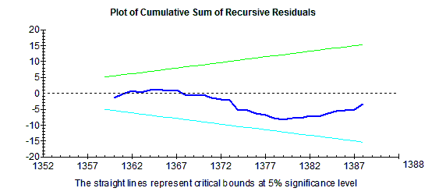
Source: Computer Attachment (Software Output)

Chart (2-4): CUSUM Test 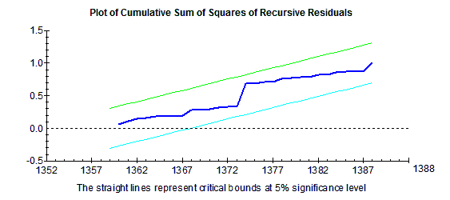
Source: Computer Attachment (Software Output)

Recursive Estimation Test
Undoubtedly, one of the basic aims of estimating regression models is predicating the interior variable in lieu of determined value from the exterior variable. Point predicating of the interior variable is the estimation of a point in space of the exterior variable and in predicating, assumption is on lacking the structural changes in the regression model. In other words, the specified parameters and functional shape of the model are true for the future, too. Under this circumstance, some tests to ensure the constancy of coefficients are required. Recursive estimations² are of these tests which can be used for examining the parameter constancy of the model. The most important point is that on the basis of these regressions, resistance of estimating parameters of the model may be exactly examined in conjunction with an increase in observations.
When data is added, if the given chart becomes outside of interval of confidence, it would be the evidence of the structural changes and non-existence of the parameter constancy. From one hand, if throughout observations, the chart becomes inside the interval of confidence, it indicates the parameters constancy.

Chart (3-4) Recursive Test (LYW)
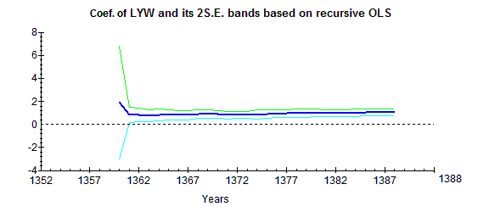
Source: computer attachment (software output)

Chart (4-4) Recursive Test (LREP)
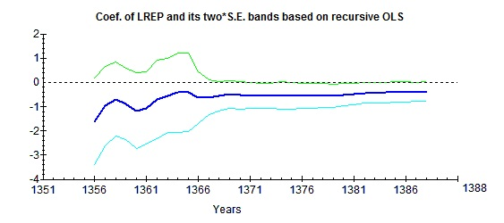
Source: computer attachment (software output)

As the charts show the statistics of these tests are inside the straight lines which this means that the coefficients constancy is in a significant level of 5%.;in other words, the null hypothesis of coefficients constancy in the confidence level of 95% cannot be rejected.

Rolling Regression
In models, the linear regression, during the time, is considered consistent, i.e., the parameters do not change through political, economical developments, and etc. (generally the structural changes), in other words, the economic factors do not change their expectations against these developments, however, there is a great possibility that the estimated econometrics parameters become constant during the time. So, with the changes of political regimes, the economic factors will change their expectation, therefore, the rules of decision making estimated will change, too. Under these circumstances, the existence of an appropriate method to study the parameters changes is essential during the various times. Rolling linear regression, as an appropriate method, examines the parameters changes in different periods. In this test, the null hypothesis tests the parameters constancy in a significant level of 5%, too. The interval of confidence in these two tests is two lines that show the confidence level of 95%. If test statistic be between these two lines, the null hypothesis may not be rejected based on the coefficients constancy. As the charts show, statistics of these tests are inside the lines which this means the coefficients constancy is in a significant level of 5%; in other words, the null hypothesis may not be rejected based on the coefficients constancy in the confidence level of 95%.

Chart (4-5) Rolling Regression Test (LWY)
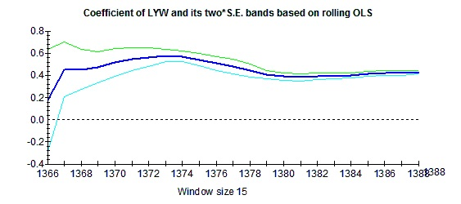

Source: Computer Attachment (Software Output)
Chart (4-6) Rolling Regression Test (LREP)
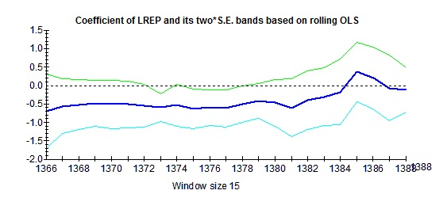
Source: Computer Attachment (Software Output)

Conclusion
The aim of this study has been to examine the effective factors of export, to estimate the export demand function of Iran, and to study the possibility of the structural changes in the export demand function of Iran during 1971-2009. The results show the co-integration and the existence of long-term relation between variables of the export demand and other considered variables in the model and indicate that the world income variable has had a positive effect and relative prices of export goods and the virtual variable of war period has had a negative one on the export demand function of Iran. In the long-term, one percentage of the changes in the world income cause an increase of 0/41% in the export demand function of Iran which shows that more of our export goods are primary materials and the income elasticity is low for the primary products. The demand for export decreases by 0/49% in lieu of 1% of change in relative price of export goods.
ehT coefficient of error correction model is estimated equaling to -0/355, in each period 35% of imbalance created in the dependant variable from its long-term balance values in one period, is modified in the next period and wiped out. In other words, if any shock or imbalance makes in the total export value, it will return to the balanced state after 3 years again.
By studying the non-oil export process, major economical sectors are seen separately which the traditional and agricultural products have always formed a great part of export in Iran. Although a variety of export goods in the agricultural sector during different years one or more specific goods such as Pistachio, Caviar, Cumin, and etc…. have a major role in exporting agricultural products. Traditional products generally include hand-knitted carpets which has been one of the major items of our country export from long ago, too. Also, despite of a variety and expansion of the industrial products and the importance of this sector in economical growth and development of the country, such products could not allocate a major part of non-oil exports to themselves. Statistics related to the export of country, especially non-oil exports, indicates low development of foreign trade and its dependence to the traditional and primary products. This was examined by the structural constancy tests through a change in the income elasticity of the export demand. The result was that the export demand function in two periods under studied has covered a slightly constant process. The model parameters have not had significant changes which the most important reason of it may be stated in non-growth of industrial and semi-industrial products of the country in non-oil products export.

Suggestions
With respect to the estimated relation for the export demand which shows that more of our export products are primary products and the income elasticity is low for them. So, it is suggested that with respect to the importance of export in the development and growth of the country and high income elasticity of the industrial products in the world markets, productions of the country should go towards the production and export of the industrial products and improvement of the industrial export part should be one of the most important aims and economical strategies of the country.
References
- Amadeh, H. & Qazi, M. (2009), “Studying Relation of Energy Consuming and Economical Growth and Employment in Different Sectors of Iran Economics”, Economical Research Magazine, No.86, pp 1-38.
- Abrishami, H. (2001), “Export Demand in Iran Economics with New Approach”, Quarterly Journal of Trade Research, No. 18, pp 107.
- IRI Central Bank, Economic Accounts Department, IRI Foreign Trade Statistics Yearbook for Different Years.
- Shoraka Brothers, Safari, H.R. & S. (1998), “Studying the Export Effect on the Growth of Economic Sectors in Iran (1959-1993)”, Trade Research Magazine, No. 3, pp 55-70.
- Pahlavani, M. & Dehmardeh, N. (2007), “Estimation of the Import & Export Demand Functions in Iran Economics by ARDL Method”, Economical Survey Quarterly Journal, Period 4, No. 3, pp 110-120.
- Teshkini, A. (2005), Applied Econometrics Working with Microfit, Artistic Cultural Institute of Tehran Dibagaran, Tehran.
- Jaafari Samimi, A. & Elmi Z. & Sadeghzade Yazdi, A. (2007), “Studying income distribution Relation & Money Demand in Iran”, Economical Research Magazine, No. 25, pp 35-60.
- Khalilian, M. (2008), “Analyzing the Importance of Export in Iran”, Ehya Quarterly Periodical, No. 23, pp 4-5.
- Dorooti, R. (2000), Successful Export of Services, Translated by Lotfi, M., Tehran: Institute of Trade Researches & Studies, p 1.
- Rahimi Borojerdi, A. (1995), Contemporary International Relation, Theories & Policies, Tehran: Center of Scientific Publication of Islamic Azad University.
- Budget & Planning Organization, Statistical Collection of Time Series of Social-economical Statistics, Different Years, Tehran: Center of Social & Economical Documents & Publication.
- Soleimani B. & Yavari K. (2004), Trade Policies & Economical Growth, Oil Exporting Countries Case, Quarterly Journal of Trade Research, No. 30, p 37.
- Azimi, H. (1995), Non-development Predetermined Course of Iran Economics, Tehran: Nai Publication, p 145.
- Ghasemi, H. (2003), Thesis of Providing a Model for the Developing Non-oil Exports in Iran on the basis of Indexes of Social & Economical Development, Tehran: Publication of Alame Tabatabaei University, June, 2003.
- Karimi, F. & Rashedi, A. (2001), “Studying Reciprocal Product & Export in Iran Economics by Simultaneous Equation Method”, Quarterly Journal of Trade Research, No. 19, pp 49-65.
- Economic Report & Balance Sheet of different Years, Central Bank of Iran
- Naderi, A., Akhavi, A. & Hakimi Shirin (1990), Studying Non-oil Export Problems”, Tehran: Institute of Trade Research, pp 17-33.
- Nofarasti, M. (1999), Unit Root & Co-integration in Econometrics, 1st Edition, Tehran: Rasa Cultural Institute.
- Balaguer, J. and Cantavella -Jordá, M. (2002) Structural change in Exports and economics growth: cointegration and causuality Analysis for Spain (1961- 2000), Applied Economics Letters, 8, 681-85.
- Giesecke, J., (2004), The Extent and Consequences of Recent Structural Changes in the Australian Economy, 1997-2002: Results from Historical/Decomposition Simulations with MONASH, General Working Paper No. G-151, Centre of Policy Studies, Monash University
- Goldstein , M and Mohsin S. Khan, (1978), "The Supply and Demand for Exports: A Simultaneous Approach", Review of Economics and Statistics, 60, pp:275-286
- Hossain , A , A, (2009), "Structural change in the export demand function for Indonesia: Estimation, analysis and policy implications", Journal of Policy Modeling 31, pp:260–271.
- Perron , P., The Great Crash, the Oil Price Shock, and the Unit Root Hypothesis, Econometrica, 57(6): 1361–1401, 1989.
- Perron , P., Further evidence on breaking trend functions in macroeconomic variables, Journal of Econometrics, 80(2): 355-385, 1997.
- Pesaran , M. H., Shin, Y. and R.J. Smith, Bounds Testing Approaches to the Analysis of Level Relationships, Journal of Applied Econometrics, 16(3): 289-326, 2001.
- Pesaran , M. H. and Smith, R., Structural Analysis of Co-integration VARs, Journal of Economic Surveys, 12(5): 471-505, 1998.
- Pesaran , M.H. and Pesaran, B., Working with Microfit 4.0: Interactive Econometric Analysis, Oxford: Oxford University Press, 1997.
- Pesaran , M.H., Shin, Y., Co-integration and Speed of Convergence to Equilibrium, Journal of Econometrics, 71(1-2): 117-43, 1996.
- Sharma, K. (2000), Liberalization and Structural Change Evidence from Nepalese Manufacturing, New York: NOVA Science publishers.

3/25/12

