Spectroscopic characterization and biological activity of bis(benzaldehydediphenylphosphate)-p-phenylenediamine and its complex with Cobalt (II)

Usama M. Gomaa *^{(a)}, Ibrahim A. Sbbahm ^{(b)} and Rabie S. Farag ^{(b)}

(a) Chemistry Department, Faculty of Science, Jazan University, Jizan, KSA.
(b) Chemistry Department, Faculty of Science, Al-Azhar University, Cairo, Egypt.
Osamah.said@yahoo.com

Abstract: Bis(benzaldehydediphenylphosphate)-p-henylenediamine was synthesized and the structure was elucidated on the bases of elemental analysis, ¹H NMR, UV-VIS, IR, and Mass spectroscopy. The Cobalt complex was prepared and its structure was elucidated on the bases of elemental analysis, electronic, IR spectra, TGA, magnetic sus. and conductance measurements. Also, the biological activity of Schiff base, bis(benzaldehydediphenylphosphate)-p-phenylenediamine and its Cobalt complex were studied.
[Usama M. Gomaa, Ibrahim A. Sbbahm and Rabie S. Farag. Spectroscopic characterization and biological activity of bis(benzaldehydediphenylphosphate)-p-phenylenediamine and its complex with Cobalt (II). New York Science Journal. 2012;5(4):72-76]. (ISSN: 1554-0200). http://www.sciencepub.net/newyork. 11.

Keywords: Schiff base; diphenylchlorophosphate; phosphate Schiff base; antifungal; antibacterial

1. Introduction
Schiff base compounds containing the azomethine (imine) group (–C=N–) are usually prepared by the condensation of a primary amine with an active carbonyl compound ^{(1,2)}.It has been often used as chelating agents (ligands) in the field of coordination chemistry and their metal complexes are of great interest for many years. It is well known that O, N and S atoms play a key role at the active sites of numerous metallobiomolecules in the coordination with metals ^{(3).}
Schiff bases are well known for their biological applications as antibacterial, antifungal,anticancer and antiviral agents ^{(4,5)}. Also, Schiff base metal complexes have been widely studied because they have industrial, antifungal, antibacterial,anticancer herbicidal applications, ⁽⁶⁾ antitubercular activities ⁽⁷⁾ and chelating abilities which give it attracted remarkable attention ⁽⁸⁾. A mixture of p-phenylenediamine and benzaldehyde were heated in ethanol until the mixture boiled; the residue on cooling was crystallized from ethanol to give bis(benzaldehyde)-p-phenylenediamine of type (I) ^{(9).}
Schiff base (ethyl 4(2-hydroxybenzylidene-amino) benzoate) and its Cu complex were prepared and X-ray crystal structure of the Schiff base was studied .The nature of bonding in the isolated Schiff base and it’s Cu complex were elucidated by examining the elemental analysis, UV–VIS, IR and molar ratio methods⁽¹⁰⁾.In the present work, bis(benzaldehyde-diphenylphosphate)-p-phenylenediamine of type (II) was prepared by direct reaction of bis(benzaldehyde)-p-phenylenediamine of type (I) with diphenyl chlorophosphate bis(benzaldehydediphenylphosphate)-p-phenylenediamine of type (II) and its Co complex were elucidated by examining the elemental analysis, UV–VIS, IR, TGA and molar ratio methods.

2. Experimental
2.1. Synthesis
2.1.1. Synthesis of bis(benzaldehyde)-p-phenylenediamine of type (I)
A mixture of phenylenediamine and benzaldehyde were heated in 50ml absolute ethanol until the mixture boiled; the residue on cooling was crystallized from ethanol to give solid compound of type (I) ⁽⁹⁾.

2.1.2. Preparation of bis(benzaldehydediphenyl phosphate)-p-phenylenediamine of type (II)

Diphenyl chlorophosphate was added to a well stirred solution of the equimolar amounts of Schiff-base of type (I) in the presence of triethylamine, as a base in 100 ml. of nonpolar solvent such as dry dioxane. After complete addition, the reaction mixture was heated under reflux for 3 hours. The solid formed (Et₃N HCl) was filtered off and the filtrate was evaporated in vacuum gave (II) as crystalline compound ⁽¹¹⁾.

2.1.3. Preparation of Schiff-base metal complex of type (III)
A solution of the metal salt was added to organophosphorus Schiff base derivatives type (II) in 50ml absolute ethanol in (2M: 1L) molar ratio. After the complete addition of the metal salt; the reaction mixture was heated under reflux for about two hrs. The solid compound(III) obtained was filtered off giving products.

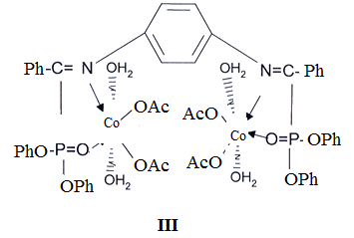

2.2. Samples characterization
2.2.1. Melting Point
The apparatus used to determine the electrothermal melting point was Goffine and Gearge made in U.K.

2.2.2. Infrared Spectra
A Perkin Elmer spectrophotometer 57928 RXIFT-IR system, using KBr technique was used in performing the infrared spectra, Chemistry Department, Faculty of Science, Al-Azhar University.

2.2.3. Nuclear Magnetic Resonance
The ¹H NMR spectra were recorded by a Varian, Gemini 200 MHz at Cairo University.
2.2.4. Spectrophotometric Measurements
The absorption in the UV-Vis region was recorded by a Perkin Elmer Lambda 35 Spectrophotometer at Chemistry Department, Faculty of Science, Al-Azhar University.

2.2.5. Mass Spectra
The mass spectra were performed by Hewlett Packard mass spectrometer model MS 5988 at Chemistry Department, Faculty of Science, Al-Azhar University.

2.2.6. Conductometric Titration and Molar Conductance
Conductance TDS Engineered system, U.S.A, was employed for the conductometric titration at Al-Azhar university, Cairo, Egypt.

2.2.7. TGA Measurements
TGA data were measured from room temperature up to 800ºC at a heating rate of 20ºC/min. The data were performed with a Schimadzu TGA- 50H.

2.2.8. Magnetic Measurements
Magnetic susceptibility measurements were carried out by the Faraday method at room temperature, at Faculty of Science, Cairo University.

2.2.9. Metal analysis
Metal analyses were determined by atomic absorption (AAS Vario6).

3. Results and Discussion
3.1. Infrared spectra
In the ligand (II), the band at 1596 cm⁻¹ may be assigned as υ -CH=N stretching mode of vibrations which is shifted to lower wave length in comparison with parent Schiff-Base ^{(12,13)}. The bands observed at 3038 , 2860 and 1238 cm⁻¹ which belong to CH stretching mode of vibrations of aromatic , aliphatic CH groups υ -C-N stretching mode of vibrations respectively⁽¹⁴⁾. A sharp peak at 1568 cm⁻¹ is due to υ C=C stretching mode of vibrations. The band at 1492 and 1456 cm⁻¹ are due to the CH deformation mode of vibrations of CH bond. The peak at 1186 cm⁻¹ characteristic for υP=O stretching mode of vibrations and 1070 cm⁻¹ may be assigned as υP-O-C stretching mode of vibrations. The IR spectra exhibit a band at 3358 cm⁻¹ in the spectra of Co-L complex, can be attributed to the stretching mode of vibration of water molecules associated with the complex ⁽¹⁵⁾.
The band observed at 2924 cm⁻¹ can be attributed to the stretching mode of vibrations of the aliphatic C-H bonds of the acetate groups. This is further supported by the presence of υC=O band at 1720 cm⁻¹ spectra. The band observed at 1592 cm⁻¹ , can be attributed to the stretching mode of the vibrations of the azomethine group. This band suffers shifts to lower frequencies indicating that the nitrogen atom of the azomethine group participates in the coordination sphere.
The band located at 1488 cm⁻¹ , can be assigned to the inplane bending deformation mode of vibrations of the aromatic C-H-bonds. The band observed at 1456 cm⁻¹ , can be attributed to the stretching mode of vibrations of C-N bond. The band observed at 1232 cm⁻¹ , can be attributed to stretching mode of vibrations of the C-O bonds. The band at 1206 cm⁻¹ can be attributed to stretching mode of vibration of P=O bonds.
The band observed at 1026 cm⁻¹, can be attributed to the stretching mode of vibrations of the P-O-C bonds. The region 1000-700cm⁻¹ is rich of peaks characterizing the out of plane of vibrations of benzene rings.

3.2. Molecular ratios of complexes
In the present investigation, 2 ml of Co⁺² ions kept constant at 1x10⁻⁴ M. while that the ligand (II) was varied from 0.2x10⁻⁴ to 2.2x10⁻⁴ M using ethanol as solvent. The absorbance of the mixed solutions was measured and plotted Vs the molar ratio [ligand] / [metal ion]. The results obtained are represented graphically in figure (1) ⁽¹⁶⁾. Which indicate the formation of the complex by 1:2 ligand to metal.

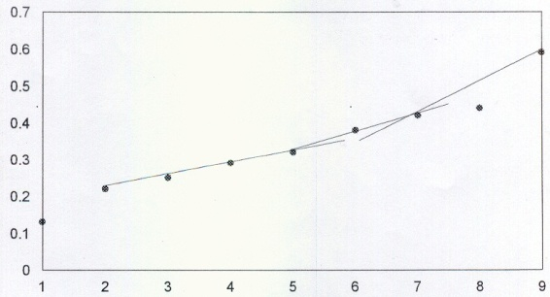

Figure 1. Absorption spectra of Co (II) complex molar ratio method.

3.3 Conductometric titration
The conductometric titration Figure (2) is performed by titrating 25 ml. of l×10⁻³ M Co²⁺ ion solution with increasing volume of l×10⁻³ complexing agent solution bis(benzaldehydediphenylphosphate)
solvent, and the conductance is then rectorded after stirring the solution for about 2 minutes. By plotting the conductance value Vs milliliters of the reagent added, and applying the least square equation the ratio was 2:1 as shown in figure 1 ⁽¹⁷⁾.

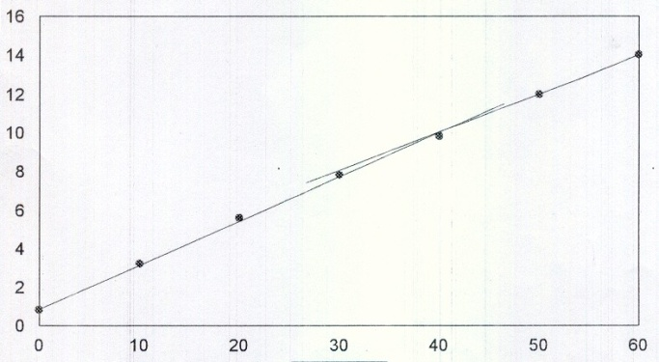

Figure 2. Conductometric titration of ligand (II) with Co²⁺ system.

3.4. Mass Spectra
The gas-mass spectrum of compound (II), exhibits one peak indicating the purity of the compound. The spectrum exhibits many ion peaks where the base peak at m/e, 94 (100%) is due to C₆H₅O. The ion peak at m/e 108 (36.9%) corresponds the M⁺ (C₆H₅P). The ion, peak at m/e = 250 (42.9%) can be attributed to M⁺ (C₁₂H₁₁PO₂) where the intense peak is common for phenyl phosphorus compounds containing more than one phenyl group attached to the phosphorus atom. On the other hand the peak corresponding the phenyl ring was appeared at m/e=77 (23.3%).

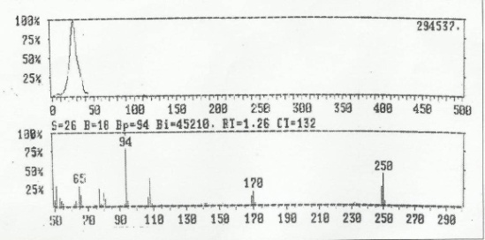

Figure 3. Mass spectra of ligand (II).

3.4. ¹H-NMR
The ¹H NMR spectrum of compound (II) in the region 6-7.8 ppm. The para-disubstituted phenyl ring represent A₂X₂ system in which absorption protons appears as two doublets at $δ$= 6.8 ppm and at $δ$=7.8 ppm. Also another singlet signal at $δ$ =7.1 ppm characteristic for the protons of phenyl ring. While the azomethine protons appeared at $δ$ =8.3 ppm in (the spectrum of the parant Schiff-Base were disappeared due to replacement reaction on this group with eliminated HCl.
3.5. Electronic spectrum
The Electronic spectra of the prepared compound (II) in DMSO as a solvent, exhibits the vibration band at 212 nm correspond to (¹La←¹A) transitions of phenyl ring and vibration band at 240.4 correspond to (¹Lb←¹A) transitions of phenyl ring. Also the band 251 nm correspond to the π- π* transitions of the azomethine groups finally while the band at 297 nm correspond to n- π* transitions.
The electronic spectra (UV- VIS) of the Schiff-base complex (Figure 3) were carried out in DMSO solutions at a concentration of 10⁻³ M. The spectrum of the complex exhibits the absorption bands at λmax = 251 nm corresponds to π-π* transitions of the C=N group. The sharp band at λmax = 321 nm corresponds to n-π* transitions of the acetate group. The sharp band at λmax = 297 nm corresponds to n-π* transitions of the azomethine group. The spectra of the Co-L complex reveals a bands in the long wave length at 463.7 and 505.8nm, can be assigned to the CT from the ligand to the metal atom, and also corresponds to ⁴T_{1g}-⁴T_{1g} (P) in the Co-Lcomplex suggesting the octahedral structure of the complex.

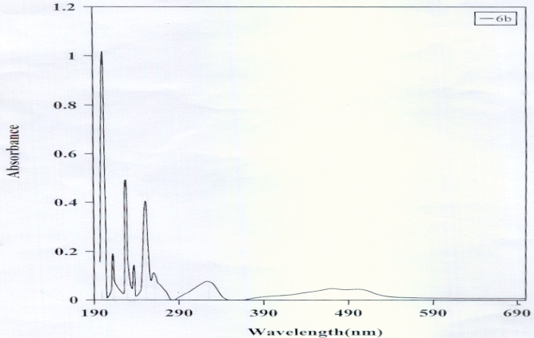

Figure 4. UV spectra for L-Co complex

3.6. Magnetic properties of metal complexes
The Co-L complex exhibits effective magnetic moment μ_{eff} = 4.6 BM higher than the value calculated on the basis of spin only formula of d⁷, can be accepted due to the orbital-orbital interaction in the high spin octahedral field.

3.7. Thermographimetry(TGA method)
The TGA thermogram of Co- L complex exhibits four stages in fig. 4. The first stage corresponds to loss of 6.1% of the weight of the complex at 100-205°C corresponding to the loss of the four coordinated water molecules. The second stage corresponds to the loss of 20.1% of the weight of the complex at 205-270⁰C, can be attributed to the loss of the four acetate groups associated with the complex. The third stage corresponds to the loss of 39.76% of the weight of the complex at 270-450°C, can be attributed to the loss of two diphenylphosphate groups. the residue of Co-L complex is 34.04% of the original weight of the complex and corresponds to molecular weight 399 mass unit, which have thermal stability above 600°C.

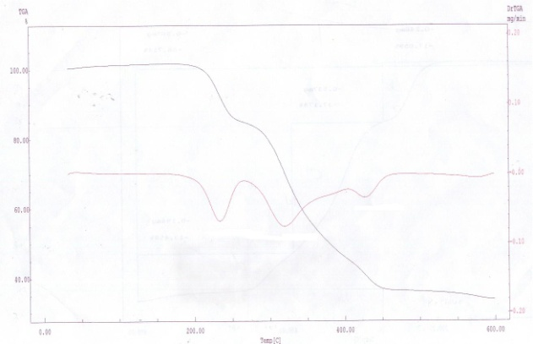

Figure 5. TGA thermal analysis for L-Co complex.

3.8. Antimicrobial activity
In testing antibacterial and antifungal activity of these compounds we used more than one test organism to increase the chance of detecting antibiotic principles in the test materials. The sensitivity of a microorganisms to antibiotics and other antimicrobial agents can be determined by the filter paper dick method ⁽¹⁸⁾.

3.8.1. Antibacterial activity
The antimicrobial activity of the prepared compounds was examined with different species of gram positive (Enterbacter sp. and Sarcina ap.) gram negative bacteria (Salmonella typhi).

3.8.2. Antifungal activity
The antimicrobial activity of the prepared compounds was examined with different species fungi (Aspergillus terreus and Aspergillus flaves). The activity of some compounds against gram positive, gram negative bacteria and fungi are summarized in table (1).

4. Conclusion
A mixture of phenylenediamine and benzaldehyde were heated to give bis(benzaldehyde)-p-phenylenediamine of type (I) which reacted with diphenylchlorophosphate to give bis(benzaldehydediphenylphosphate)-p-phenylenediamine of type (II) which reacted with cobalt acetate as tetradentate ligand two from oxygen and two from azomethine nitrogen. In the case Co-L complex the formula [Co₂ L(H₂O)₄ (OAc)₄] was supported by elemental analysis.. Since the Co-L has molar conductance 8 ohm⁻¹ cm⁻¹ mol⁻¹, So, it is neutral and hence acetate groups are participating in the coordination sphere of the complex. This also is further supported by the IR spectra which indicate the participation of the acetate group. The IR spectra indicate that the ligand acts as tetradentate ligand.UV and magnetic moment support the octahedral arrangement for the Co-L complex. The result of all previous physiochemical measurements show that the structure of 2metal:1ligand complexes. Finally the four compounds I,II and III show biological activity on both bacterial and fungal activity.
Table 1. Antimicrobial activity

Compound No. | Antibacterial activity |  |  | Antifungal activity
Compound No. | S. Sp. | E. Sp. | S. Sp. | A. terrous | A. flaves
I | - | - | + | - | -
II | - | - | + | - | _
III | _ | _ | - | +++ | -
Standard for antibacterial activity Ampicillin 25mg antifungal activity mg costa 30mg.
+ : Less active.
++ : moderate active.
+++ : Highly active.

Corresponding Author:
Usama M. Gomaa
Chemistry Department
Faculty of Science
Jazan University, Jizan, KSA.
E-mail: osamah.said@yahoo.com

References
- A.V. Kurnoskin, J. Macromol. Sci., Rev. Macromol.Chem. Phys.,36, 457 (1996).
- A.N. El-khazandar, Phosphorus, Sulfur, Silicon and the RelatedElements 126(1), 243-255, (1997)
- K. Singh, M.S. Barwa and P. Tyagi, Eur.J. Med. Chem., 42, 394(2007).
- Nath M., Saini P. K. and Kumar, A., Journal of Organometalic Chem., 625, 1353 (2010).
- Cheng L., Tang J., Luo H. Jin X., Dai F. , Yang J., Qian Y., Li X.,and Zhou B., Bioorg. Med. Chem. Lett., 20, 2417 (2010).
- P. G. Cozzi, Chem. Soc. Rev., 33, 410 (2004).
- D. Lednicer. The Organic Chemistry of Drug Synthesis, Vol-III,Wiley Interscience Publication, New York, 90, 283 (1984).
- Jarrahpour A. A. and Motamedifar M, PakshirK ., Molecules, 9, 815 (2004).
- Kozlov,N.S.,andPak,V.D.,Izv.Vysshkh,U.Z.,Khim.Lkhim technol.5,442-4(1962).
- Mohammad A. E., Rabie S. F., Ibrahim A. S., and Abdel-Aziz M.A., New York Science J., 4(9), 78-82(2011).
- Abd Ellah, I., Ibrahim, E. E., and Farag, R., Gazztta chimica 118,141-3 (1988).
- Zahid H. Chohan, Ali U. Shaikh, Abdul Rauf and ClaudiuT Supuran, J. Enzyme Inhibition & Med. Chem., 21(6) 741 (2006).
- R. K. Agarwal, B. Prakash, V. Kumar and A.Aslam Khan, J. Iran.Chem. Soc., 4(1), 114(2007).
- Ardeshir Khazaei', Mohammad Ali Zolfigol and Neda Abedian,Iranian Polymer J., 10 (1) (2001).
- S. S. Sharma J. V. Ramani, D. P. Dalwadi, J. J. Bhalodia, N. K.Patel, D. D. Patel and R. K. patel, E-J. Chem., 8(1), 361 (2011).
- J. Rydbarg, Acta Chem. Second, 13, 2023(1959).
- J. Chalt and H. R. Waston, Journal of Chem. Soc., 2, 545 (1962).
- Epstein, J.A; Folev, E.J; Pevrine I and Lee, S.W; J. Lap. Clin.Med., 29, 314 (1944).

