Bacterial Cellulose of Kombucha Mushroom Tea

Soheir S. Abd El-Salam

Botany Dept.Fac. Sci. Benha Univ. Egypt.
aia_hassan20@yahoo.com

Abstract: Kombucha is composed of yeast and acetic acid bacteria especially, Acetobacter Xylinum which forms a cellulose pellicle on tea broth. The yield and properties of cellulose produced were investigated in this study; the tea broth was fermented naturally for 14 days in the presence of different amounts of black tea and sucrose as nitrogen and carbon sources. 8.7g/L black tea produced highest weight of bacterial cellulose (55.46g/L) and 100g/L sucrose also exhibited high amount of pellicle (63.58g/L). The bacterial cellulose production increased with the increase of surface area and depth of the broth. Temperature was essential factor on growth, where the pellicle was formed at range (20ºC - 50ºC) and higher temperature over 50ºC depressed the bacterial cellulose formation. Bacterial pellicle was separated from kombucha tea preparation and purified; the pellicle was reticulated structure consisting of fine cellulose threads, where it could be detected by carrying out transmission, scanning electron microscope and FT.IR spectroscopy.
[Soheir S. Abd El-Salam. Bacterial Cellulose of Kombucha Mushroom Tea. N Y Sci J 2012;5(4):81-87]. (ISSN: 1554-0200). http://www.sciencepub.net/newyork. 13

Keywords: Acetic acid bacteria Kombusha; Acetobacter; cellulose production; electron microscope; FT.IR spectroscopy

1. Introduction
Kombucha is healthy beverage produced by the fermentation of sweetened black tea by a symbiotic relationship between acetic acid bacteria and yeasts (Durfresne and farnworth, 2000; teoh et al., 2004 ; Malbasa et al., 2011). The microbial composition has well studied, the main acetic acid bacteria include A. acetic, A. xylinum and others (liu et al., 1996; Balentinc, 1997; Teoh et al., 2004), yeasts break sucrose into glucose and fructose (Jonas and farah, 1998), glucose subunit that form the cellulose microfibril are excreted through pores in the cell wall of the acetic acid bacteria as A. xylinum (son et al., 2003; keshk and sameshima, 2005; Mikkelsen et al., 2009; Jung et al., 2010).
Cellulose is the most abundant bio-polymer and has been widely accepted as the excipient in pharmaceutical and industries. It has found its utility in tablet formation (Yu and Atalla , 1996).
The molecular formula of bacterial cellulose (C₆H₁₀O₅)^{n} is the same as that of plant cellulose, but their physical and chemical are different (Yoshinaga et al., 1997; Rezaee et al., 2008) where the bacterial cellulose has not hemicelloulse and lignin .
The main objective of the present study was to investigate the microbial cellulose and affected it by some factor as nitrogen and carbon sources, surface area, depth and temperature during fermentation of a natural broth.
The bacterial cellulose was determined by scanning electron microscope and FT.IR spectroscopy. Also the symbiosis relationship between Acetic acid bacteria and yeasts of kombusha tea were examined by transmission and scanning electron microscopy.

2. Material and Methods
2.1. Microorganism
Kombucha Mushroom tea was obtained from (soheir. S. Abd El-Salam). The tea sample was activated every 2 weeks by the procedure described by (Chen and liu, 2000).

2.2. Culture media and cultivation
Substrate for kombucha fermentation was prepared by adding 70g/L of commercial sucrose to tap water and after boiling 5g/L of dry black tea was added. The tea leaves were steeped for 15minutes and removed by filtration, after cooling to about 30ºC and it incubated under aerobic conditions at 28ºC.

2.3. Effect of different concentrations of black tea on the bacterial cellulose production
Sweetened tea broth was prepared by different concentrations of black tea 4.4, 8.7, 17, 35, 70 g/L. these concentrations of tea were chosen on the wet weight of cellulose produced in g/L.

2.4. Effect of various concentrations of sucrose on the bacterial cellulose formation
Different amounts of sucrose as carbon source were tested on wet bacterial cellulose pellicle formation in g/L, these amounts were 70, 100, 130, 160 and 190g/L.
The bacterial cellulose produced in different concentrations of tea or sucrose was weighed according to the following equation:
- weight of bacterial cellulose (g/L) = total weight of beaker containing cellulose + tea broth – weight of beaker only + tea broth
- the yield of the cellulose:-
yield % = wet weight of bacterial cellulose (g/L)
÷tea or sucrose concentration (g/L)

2.5. Effect of surface area and depth of culture medium on bacterial cellulose production
Tea broth with 100g/L sucrose and 8.7g/L black tea was prepared in different container's size. The bacterial cellulose produced was weighed after 14 days of the fermentation. Then, the effect of surface area and depth of the culture medium on cellulose production was examined.

2.6. Effect of different temperature on bacterial cellulose production
Tea broth was prepared by adding 100g/L sucrose and 8.7g/L black tea and incubated at different temperature (20ºC , 30ºC, 40ºC, 50ºC, 60ºC, 70ºC and 80ºC) and tested their effect on bacterial cellulose formation.

2.7. Purification of bacterial cellulose
After cultivation, the bacterial cellulose was formed at the interface of air; thickened pellicle sinks to the bottom of fermentation vessel. Bacterial pellicle isolated from culture media was washed with distilled water and cut into small pieces, then transferred to flask containing 4% NaoH (W/V) and boiled at 100 + 5ºC for 20 min in order to remove bacterial cells. The alkali treated pellicle was washed with distilled water (Surma – Slusarska et al., 2008) and the bacterial cellulose was bleached with 10% of hydrogen peroxide in order to achieve maximum brightness (Gupta and Johnson, 1991). Bleached product was washed with distilled water and filtered then drying in an oven at 40ºC overnight. The dried product was size reduced in mixer and stored in closed container (Netravali, 2010).

2.8. Electron microscope
Yield % | Wet weight of bacterial cellulose (g/L) | Sucrose concentration (g/L)
45.00 | 31.50 | 70
63.58 | 63.58 | 100
22.65 | 29.45 | 130
16.88 | 27.00 | 160
13.13 | 24.95 | 190
2.8.1. Transmission
The kombucha is known a powerful symbiotic relationship between bacteria and yeast has been investigated by transmission electron microscopy (Jeol Jem - 1010) put a drop of the sample on grid coated carbon then, stained by urinayl acetene and washed by distilled water. The magnification power was 20.000x for yeasts and 25.000x for bacteria.

2.8.2. Scanning
Shape and morphology of bacterial cellulose was studied by using scanning electron microscopy (Jeol JSM – T100). Samples was put on copper support, cover with a 1nm thick layer of gold for 60 second.

2.9. FT-IR spectroscopy
The thin samples of bacterial cellulose were prepared according to (kai and keshk, 1999). FT-IR Spectra were recorded on varian 600 infrared spectrometer (National Research center) IR. Spectrometer lab).

3. Results
Black tea used to have the greatest bacterial cellulose. At concentration of 4.4g/L, the inhibitory affect was observe of but 8.7g/L black tea was exhibited a maximum value of bacterial pellicle compared with another set of three tea concentrations, where the weight of bacterial pellicle decrease with the increase of tea concentrations as in table (1).

Table 1. Effect of different tea concentrations on the yield of bacterial cellulose

Also, the bacterial cellulose depends on the supply of a carbon source, it cannot produce the cellulose. In table (2), the experimental results conducted that the concentration of sucrose at 100g/L produced the highest yield of pellicle and increasing sucrose concentration from (130g/L - 190g/L) produced a gradual decrease in the yield.
Yield % | Wet weight of bacterial cellulose (g/L) | Tea concentration (g/L)
531.82 | 23.40 | 4.4
637.47 | 55.46 | 8.7
164.71 | 28.00 | 17
73.86 | 25.85 | 35
35.14 | 24.60 | 70

Table 2. Effect of different sucrose concentrations on the yield of bacterial cellulose

Results in table (3) shows the amount of bacterial cellulose produced in cultures with different volumes and surface areas, the bacterial cellulose production increased with an increase of surface area. As the metabolic processes of kombucha tea depend on fresh air, it is very important to supply sufficient oxygen. The round container with the greatest surface area (176.6cm²), depth (36.8cm) produced highest bacterial cellulose (85g/L) while, other container has surface area (28.26cm²), depth (40.2cm) produce bacterial cellulose (20.5g/L). Thus, surface area played an important role in the formation of bacterial cellulose than volume and depth.

Table 3. Effect of culture surface area & depth of containers on the bacterial cellulose
Wet weight of pellicle (g/L) | Surface area depth(cm) | Surface area (cm²) | Depth (cm) | Diameter (cm) | No. of container
7.9 | 3.84 | 19.60 | 5.1 | 5 | 1
20.50 | 0.70 | 28.26 | 40.2 | 6 | 2
39.80 | 7.85 | 78.50 | 8.4 | 10 | 3
85.30 | 11.78 | 176.63 | 6.8 | 15 | 4

Bacterial cellulose production was strongly affected by the incubation temperature. A gradual drop occurred in fermentation tea broth with high temperature (60ºC - 80ºC) where the bacterial pellicle was not formed and tea broth was dark brown in colour, odourless and clear table (4).

Table 4. effect of different temperature on the bacterial cellulose of kombucha tea
Odour | Pellicle formation | Clearity | Colour | Temperature (ºC)
+ve | Formed | Turbid | Normal | 20
+ve | Formed | Turbid | Normal | 30
+ve | Formed | Turbid | Normal | 40
+ve | Formed | Turbid | Normal | 50
-ve | Nil | Clear | Normal | 60
-ve | Nil | Clear | Dark | 70
-ve | Nil | Clear | Dark | 80

Kombucha mushroom tea composed of acetic acid bacteria and yeasts (Fig. 1), the symbiotic relationship between yeasts and Acetic acid bacteria was illustrated by transmission electron microscopy at magnification 20.000x, 10.000x (Fig . 2).
While scanning electron microscopy shows that acetic acid bacteria able to form cellulose pellicle which consisting of fine thread like fibrils and densely packed reticulated structure (Fig. 3).

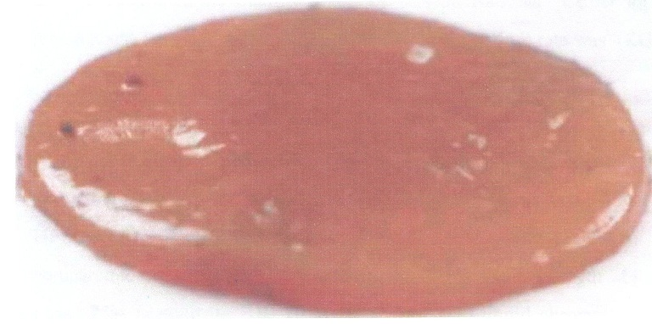

Figure 1. bacterial cellulose pellicle grown in natural tea broth

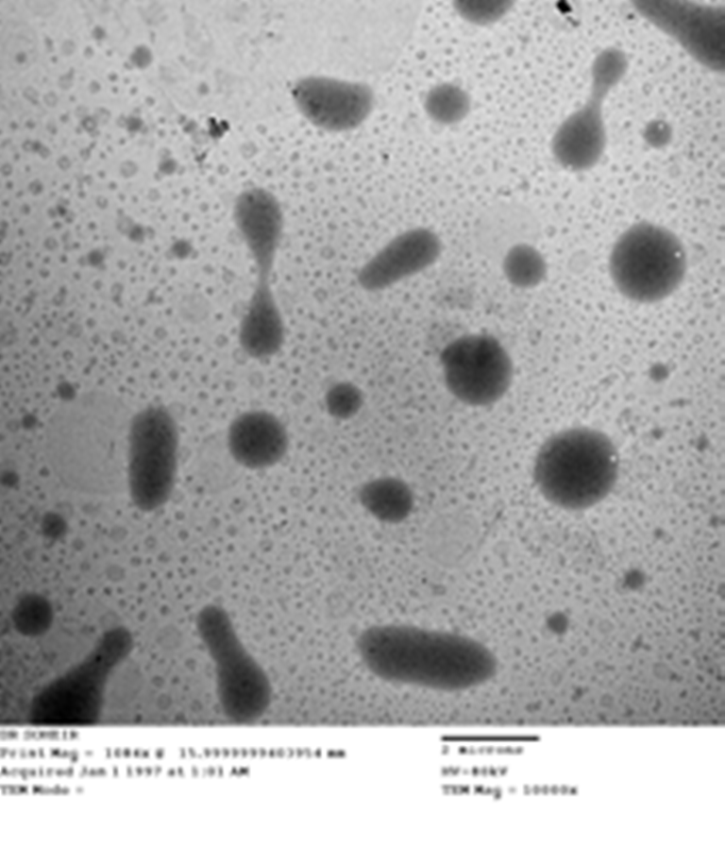
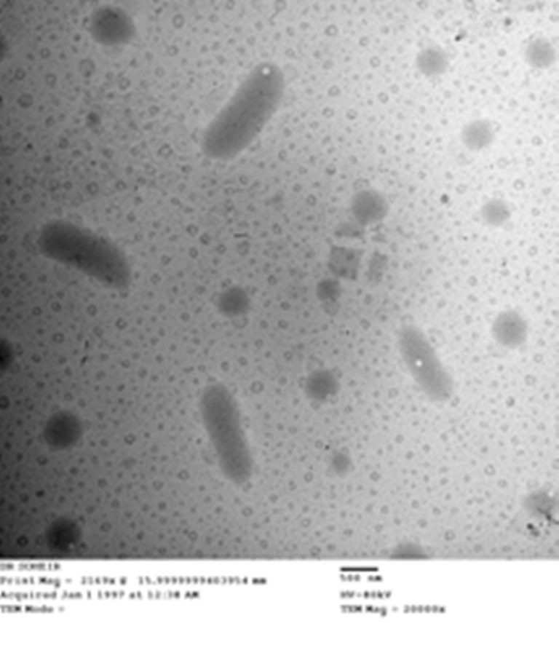
A

B

Figure 2. transmission electron microscopy illustrating symbiotic relationship between acetic acid bacteria and yeasts at magnification (A) 10,000x and (B) 20,000x
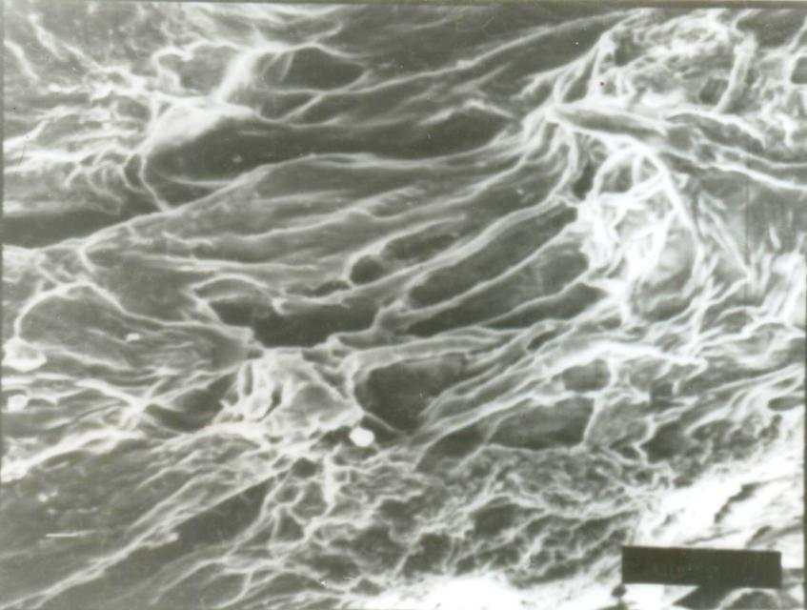
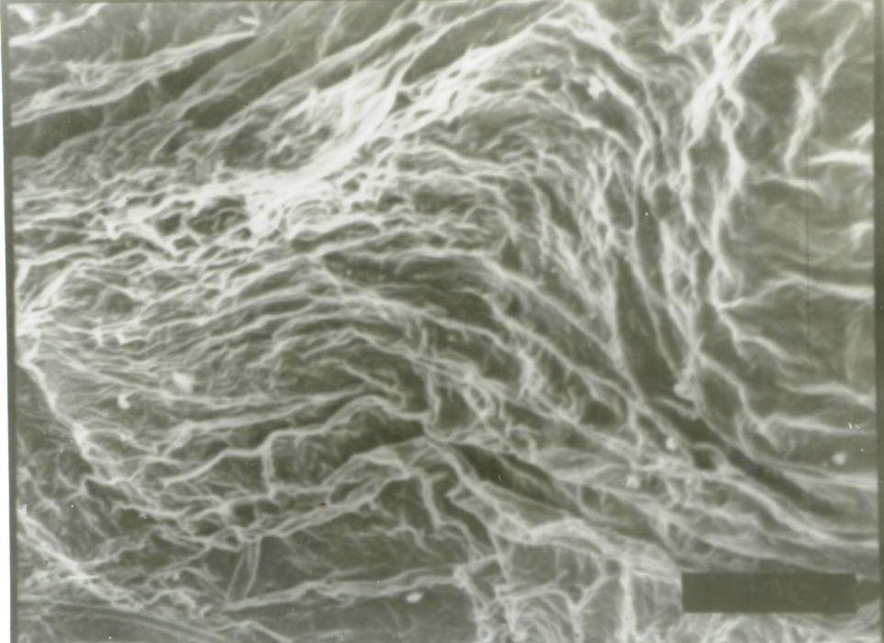
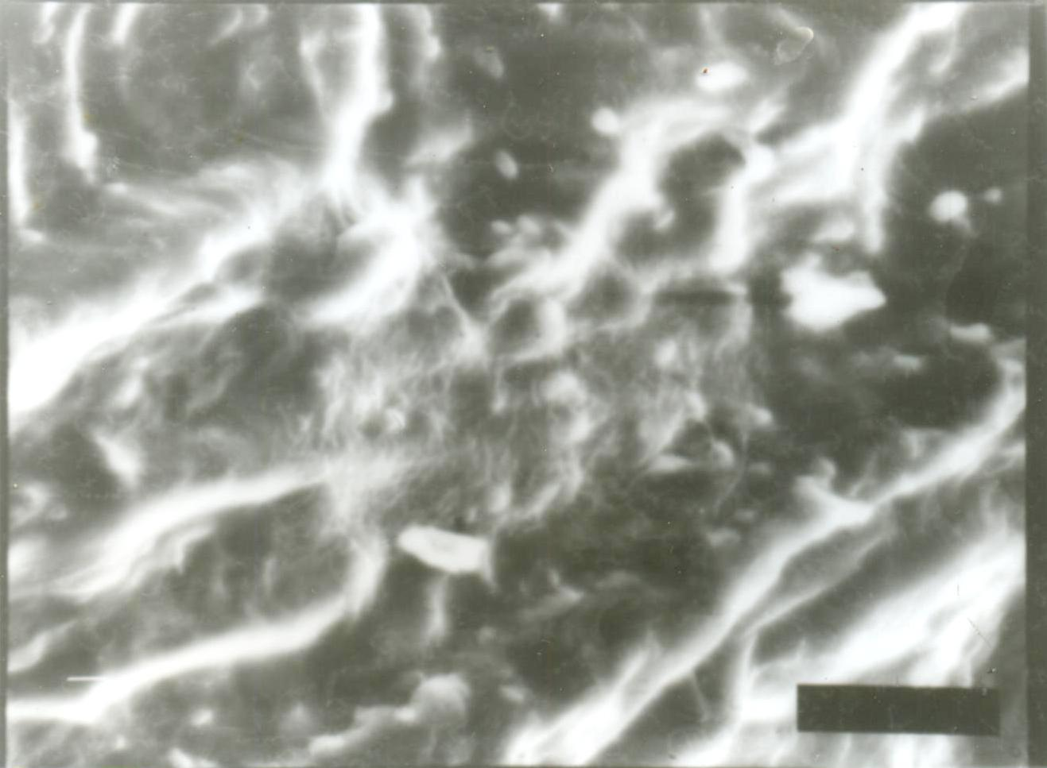
A
B
C

Figure 3. Scanning electron micrographs of the surface structure of the bacterial cellulose at magnification (A) 200x, (B) 400x and (C) 1000x

As shown in (Fig. 4), the conformational characteristics of the bacterial cellulose were determined by FT- IR spectroscopy. The FT-IR spectra showed characteristic cellulose peaks of bacterial cellulose as 3430cm⁻¹ for hydroxyl groups stretching vibration, at 2927 cm⁻¹ for C-H stretching vibration and also at 1433 for C-H bending vibration, at 1045cm which corresponds to C-O-C and C-O-H of the sugar ring.

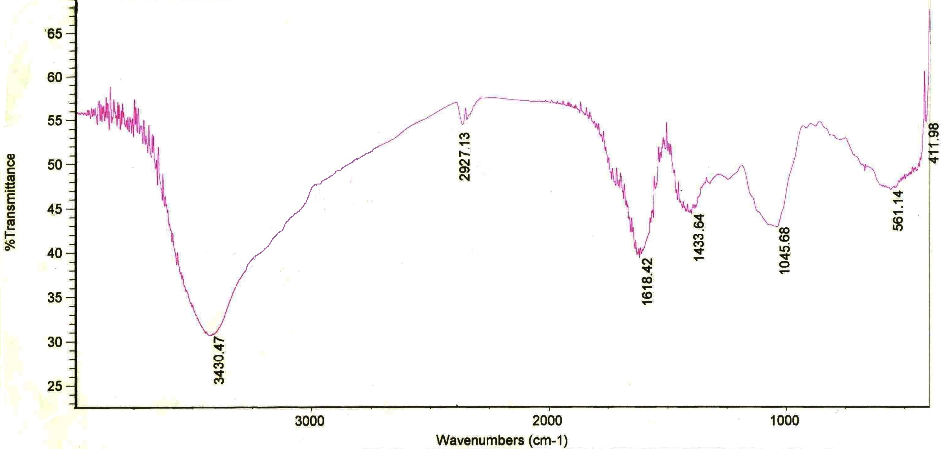

Figutr 4. FT-IR spectroscopy of bacterial cellulose

4. Discussion
Kombucha is a popular beverage among traditional fermented foods across the world. It is symbiotic relationship between acetic acid bacteria and yeasts in a sugar tea , that is confirmed by transmission and scanning electron microscopy in this work (Blanc, 1996; chen and liu, 1997 Teoh et al., 2004).
Cellulose produced during the fermentation by Acetic acid bacteria especially, A-Xylinum appears as thick film on the top of tea broth which enhances the association formed between bacteria and yeasts (Balentine et al., 1997, Green walt et al., 1998).
By scanning electron microscope technique at different magnification in this research, bacterial cellulose layer is constiluted by compact cellulose network structure which attributed to (Klemm , et al., 2001 and Iguchi et al., 2000).
Tea used in different concentrations, the microbial cellulose is obtained at 8.7g/L tea, as (Desilva and saravanapavan 1966) discussed the tea prepared with 10g/L (1%) tea w/v.
In the present study, results conducted that the concentration of sucrose present in the tea broth effects on the synthesis of bacterial cellulose, these results similar to the report by (Masaoka et al., 1993). With increase sucrose concentration produced a gradual decrease in the yield, this is finding agree with an earlier report published by (Embuscado et al., 1994).
According to ( Iguchi et al., 2000 ), in a static culture , the bacterial cellulose pellicle is formed interface of the surface. The present study was conducted to the influence of the surface area and depth of the culture medium on pellicle formation; this is agreed with (Frank, 1995 and Okiyama et al., 1992), who found that a deep container generated a small amount of bacterial cellulose.
Temperature effects on the cellulose pellicle production , where the high temperature prevents the growth of bacterial cellulose and pellicle formation and this is similar to (Jayabalan, 2008).
The position and intensity of absorption bands of a substance are specific. The infrared spectrum by FT-IR ( fourier transformed infrared spectroscopy) is highly characteristic for a substance (Gunzler and Gremlich, 2002) and can be used to identify the microbial cellulose.
In this study, the chemical nature of the microbial cellulose polymer was confirmed by the infrared spectrum, also, microbial cellulose is free lignin or hemicellulose, which is often present in plant cellulose (Bertocchi et al., 1997) and the sample of microbial cellulose as in the polymorphic forms of native cellulose similar to those obtained by plants as indicated spectra, that is according to (Nelson and O' Connor, 1964a).

Corresponding Author:
Dr. Soheir S. Abd El-Salam
Botany Dept.Fac. Sci. Benha Univ. Egypt.
E-mail: aia_hassan20@yahoo.com

References
- Balentine, D.A. (1997): Tea and health critical Reviews in food science and Nutrition 8: 691-692.
- Balentine, D.A; Wiseman, S.A. and Bouwens, L.C. (1977): The chemistry of tea flavonoids. Critical Reviews in food science and Nutrition 37: 693-704.
- Bertocchi, C.D.; Signore, S.; Weng, Z. and Bruschi, C.V. (1997): Characterization of microbial cellulose from a high – producing mutagenized Acetobacter pasteurianus strains. Biochimica et Biophysica Acta 1336:211-217.
- Blanc , P.J. (1996):Characterization of the tea fungus metabolites. Biotechnol. Lett. 18: 139- 142.
- Chen, C and Liu, B. Y. (1997): Studies in Microbiological quality & survival of candida albicans in the tea fungus. Journal of Agriculture & Foresty 46: 53-64.
- Chen, C and Liu, B.Y. (2000): Changes in major components of tea fungus metabolite during prolonged fermentation. Journal of Applied Microbiology 89: 83 4-839.
- Desilva, R.L. and T.V. Saravanapavan (1966): Tea cider – a potential winner Tea Quarterly, (39) 37-41.
- Dufresne, C. and Farnworth, E. (2000): Tea, Kombucha, & health: a review, food research international 33: 409 -421.
- Embuscado, M.E., Marks, J. S. and Bemiller, J.N. (1994): Bacterial cellulose. I. Factors affecting the production of cellulose by Acetobacter xylinum. Food Hydrocolloids 8: 407-418.
- Frank , G.W. (1995): Kombucha – Healthy beverage & natural remedy from the far East, Ninthed. Wilhelm Ennsthaler, Austria, p.p 150.
- Green walt, C, J., R.A. Ledford and K.H. Steinkraus (1998): Determination & characterization of antimicrobial activity of the fermented tea kombucha. Leben. Wiss. Technol. 31: 291-296.
- Green walt, C.J., Steinkraus , K.H. and Ledford R.A. (2000) : Kombucha, the fermented tea: Microbiology composition , and claimed health effects. Journal of food protection 63: 976-981.
- Gunzley. H. and Gremlich, H.V. (2002): IR spectroscopy, an introduction, wiley VCH, Germany, p.p. 361.
- Gupta, M.K. and D.C. Johnson, (1991): Bacterial cellulose having enhanced brightness properties. Publication No. WO, 91/16445.
- Iguchi, M., Yamanaka, S& Budhiono, A. (2000): Bacterial cellulose a masterpiece of nature arts. Journal of Material science 35: 261-270.
- Jayabalan, R., Subathradevi, P., Marimuthu, S., Sathishkamar. M. & Swaminthan, K. (2008). Changes in the free Radical scavenging ability of kombucha tea during fermentation food chemistry 109:227-234.
- Jonas R, Farah LF (1998): Production & Application of Microbial cellulose. Poly. Deg. Stab. 59: 101-106.
- Jung HI, Jeong JH, lee OM, Park GT, Kim KK, Park HC, Lee SM, kim YG, Son JH (2010) : influence of glycerol on production & structural physical properties of cellulose from Acetobacter sp. V6 cultured in shake flasks. Bioresour. Technol. 101: 3602-3608.
- Keshk S, Sameshima K (2005): Evaluation of different carbon sources for bacterial cellulose production.
- Klemm, D., D. Schumann, V. Vdhardt & S. Marsch, (2001): Bacterial synthesized cellulose artificial blood vessels for microsurgery. Prog. Polymer Sci., 26: 1561- 1603.
- Liu, C. -H., Hsu, W. -H., Lee, F. -L. and liao, C . -C. (1996): the isolation & identification of Microbes from a fermented tea beverage, Haipo, & Their interactions during Haipao fermentation. Food Microbiology 13: 407- 415.
- Malbasa, R., Loncar, E.S., Vitas, J.S., `Canadanovic- Brunet, J. M. (2011): Influence of starter cultures on the anti-oxidant activity of kombucha beverage. Food chemistry 127 : 1727-1731.
- Masaoka, S., Ohe, T. & Sakota, K. (1993): Production of cellulose from glucose by Acetobacter xylinum. Journal of fermentation & Bio-engineering 75: 18-22.
- Mikkelsen D, Flanagan BM, Dykes GA, Guidley MJ (2009) influence of different carbon sources on bacterial cellulose production by Glucono acetobacter xylinum strain ATCC 53524. J. Appl. Microbio. 107: 576-583.
- Nelson, M.L. and O'Connor, R.T. (1954): Relation of certain infrared bands to cellulose crystallinity & crystal latticed type. Part I. spectra of lattice types I, II, III & amorphous cellulose. Journal of Applied polymer science 8: 1311- 1324.
- Netravali, A.N., (2010) Bacterial cellulose based green composites. Publication No. Wo/2010/ 135234.
- Okiyama, A., Shirae H., Kano, H. & Yamanaka, S. (1992): Bacterial cellulose. Two stages fermentation process for cellulose production by Acetobacter aceti. Food hydrocolloids 6: 471-477.
- Rezaee, A., J. Derayat, H. Godini & G. Pourtaghi, (2008) Adsorption of Mercury from synthetic solutions by an Acetobacter xylinum biofilm. Res. J. Environ. Sci., 2: 401-407.
- Son HJ, Kim HG, Kim KK, , Kim HS, Kim YG, Lee SJ (2003) Production of bacterial cellulose by Acetobacter sp. V6 in synthetic media under shaking culture conditions. Bioresour. Technol. 86: 215-219.
- Surma-Slusarska, B., S. Presler & D. Danielewicz, (2008) characteristics of bacterial cellulose obtained from Acetobacter xylinum culture for application in paper making. Fibrestext. Eastern Eur., 16:108-111.
- Teoh A.L, Heard, G. and cox, J. (2004) Yeastecology of kombucha fermentation. International Journal of food Microbiology 95: 119-126.
- Yoshinga, F., Tonouchi, K., Watanabe , K. (1997) Research progress in the production of bacterial cellulose by aeration & agitation culture & its applications as a new industrial material . Bioscience Biotechnology & Biochemisity 61: 219-224.
- Yu, X. and R.H. Atalla, (1996) Production of cellulose II by Acetobacter xylinum in the presence of 2, 6-dichlorobenzonitrile. Int. J. Biol. Macromal., 19: 145-146.

2/13/2012

