Estimation of Area under Winter Vegetables in Punjab Districts: through
Remote Sensing & GIS Technology

¹ Singh Avtar, ² Khanduri Kamlesh

¹ Technical Associate, JRF,Forest Survey of India(FSI),Dehradun,India
²D.Phil Research Scholar,Dpt. of Geography,HNBGU,JRF(FSI), Uttrakhand,India
ecnhas@gmail.com

Abstract: The Study area consists of five northern districts (ex.Gurdaspur) of Punjab State, namely, Amritsar, Tarn Taran, Kapurthala, Jalandhar and Hoshiarpur. In this study, Acreage Estimation of Vegetables in northern Punjab is carried out by using Multidate IRS - P6 AWiFS Data sets of seven dates viz., September (30), October (14, 24), November (17), December (25), January (4, 13). The aim of this study is to detect area estimation under winter vegetables in Punjab districts between 2005 - 2008 using satellite images. Vegetable area carried out by decision rule based classification: two models are created, one for acreage estimation of vegetables the other for generation of NDVI of all date satellite data. After classification of the image, classified image is recoded to merge different classes of the single output category in one category. Winter Vegetables have been detected by image processing method in EDRAS imagine9.3, ArcGIS9.3. In study area, as a whole there is positive change (14.9%) in area under vegetable crop. But two districts, namely, Kapurthala and Jalandhar have experienced negative change .But in another three districts Amritsar, Tarn Taran and Hoshiarpur districts have recorded positive change in area under vegetable.
[Singh Avtar, Khanduri Kamlesh. Estimation of Area under Winter Vegetables in Punjab Districts: through Remote Sensing & GIS Technology. New York Science Journal. 2012;5(4):88-93]. (ISSN: 1554-0200). http://www.sciencepub.net/newyork. 14

Keywords: Winter Vegetables, Acreage Estimation, Pixel Classification, GIS, Remote Sensing

1. Introduction
Crop area and production statistics are of vital importance to a country such as India where the agricultural production is highly susceptible to the vagaries of monsoon. In view of agricultural diversification vegetables acreage estimation also has vital importance as crop acreage assessment. In every state of India, timely vegetables are grown to fulfill the dietary and nutritional needs of people but changing vegetable area and production estimation statistics in India is lacking.
The traditional approach of crop estimation in India involves an enumeration for estimating crop acreages based on field surveys, which is time-consuming and costly. Although this approach is comprehensive and reliable, there is a need to reduce the cost and to improve on the accuracy and timeliness of the crop production statistics. Estimation of short-term changing vegetable acreage through the traditional methods is not feasible.
Punjab is an agricultural state in India where more than 75% of geographical area is devoted to cultivations. This is why Punjab is known as granary of India. As well as main crops like wheat, rice cotton etc., potatoes and vegetables are grown for commercial purpose. Vegetables are grown in both seasons (Rabi and Kharif). Different systems of multiple cropping of vegetables and optimum sowing times are evaluated. Potato production is best combined in rotations with carrot and okra, late cauliflower and chilli (Capsicum), okra and early cauliflower, or with muskmelon and radish. In a study of crop sequences are involving other vegetables, cauliflower-tomato-okra, eggplant (Aubergine)-turnip-muskmelon, eggplant-late cauliflower-bottlegourd (Lagenaria siceraria) and pea-squash melon-okra. The agriculture in Punjab is extremely intensive at land, assets, energy, nutrients, agricultural components, water, and so on.
In Punjab, almost half of the total area under vegetables is covered by potatoes. These potatoes are marketed in northern India as staple food and seeds as well. These days Punjab is also known as potatoes seed state vegetables are mainly grown urban fringe belt.

2. Study Area
Study area consists of five districts of Punjab state, namely, Amritsar, Tarn Taran, Kapurthala, Jalandhar and Hoshiarpur. Total geographical area of these five districts is 12,728 sqkm. Study area extends from 74° 29” 30’E to 76°20”72’E Longitude and 32° 4” 93’ N to 30°57”71’N Latitude. These five districts are adjacent to each other. Amritsar and Tarn Taran both districts are sharing the international border with Pakistan and these two belong to Majha region of Punjab and the remaining three districts, Jalandhar, Kapurthala, Hoshiarpur fall in the Doab region of Punjab. Hoshiarpur district is sharing state border with Himachal Pradesh. River Ravi flows along the north – western side of Amritsar district while Beas River flows through the center of study area as given below Figure.1.

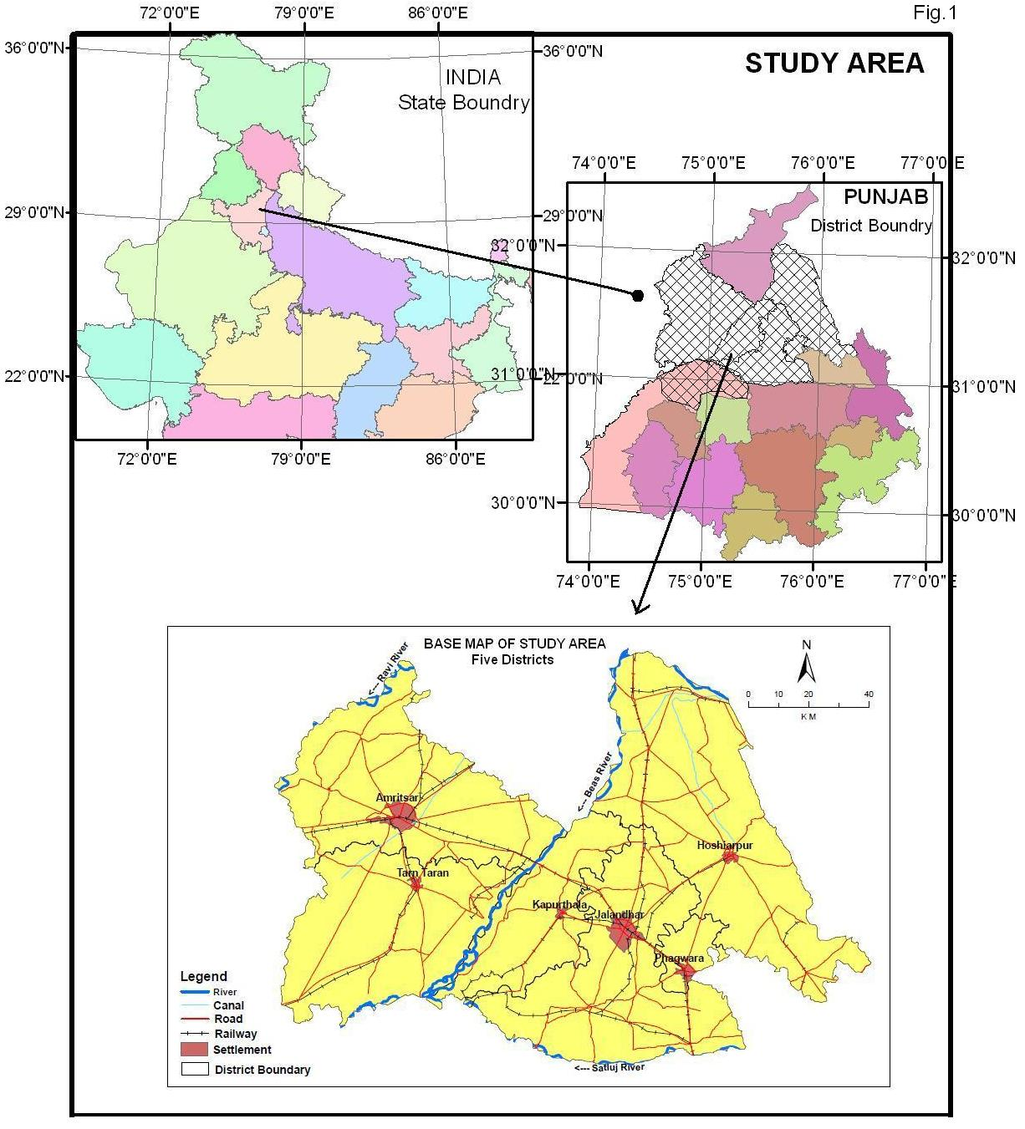

Figure 1. Location Map of Study Area

3. Methodology
The Methodology consists of preparation of geometrically and radiometrically normalized dataset and decision rules based classification. In this study, Acreage Estimation of Vegetables in Punjab State is carried out by using Multidate IRS - P6 AWiFS Data sets of seven dates viz., September (30), October (14, 24), November (17), December (25), January (4, 13). Satellite data is projected using WGS 84 Datum, & Universal Transverse Mercator Projection.

Formula to Calculate the Area from Pixels:

Flow Chart of Methodology

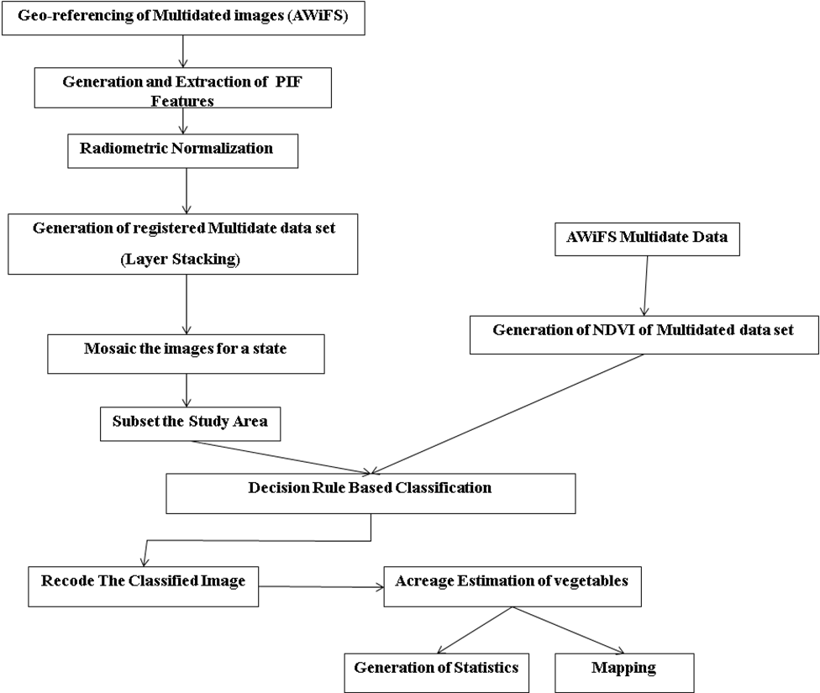

4. Result and Discussion
The study area records 79.5% area under cultivation. Punjab has successfully participated in Green Revolution and move into vegetable gardening. Metros of northern India, NCR in particular offer promising market for vegetables grown in Punjab. Changes taking place in area of crop diversification are equally important for market planners (Food Processing etc.) and state planning machinery. In this study, main focus has been given on Potatoes and other winter vegetables.
4.1 Area under Winter Vegetables - 2005
Table.1 shows Jalandhar maintained largest area under vegetables is 19.4 thousand hectares which account for 42% of the total study area. Hoshiarpur comes at second rank with 10.9 hectares thousand (24%) and Kapurthala comes at third rank with 9.5 thousand hectares area (20%) under vegetables. Amritsar has lowest area under vegetables i.e. 6.4 thousand hectares (14%). Total area under vegetables is 46.2 hectares. Tarn Taran district is a newly created district in year 2006.

Table .1 Areas under Winter Vegetables – 2005
Districts | Area veg.in (‘000ha.) | Geographical area  (%)
Amritsar –  Tarantaran | 6.4 | 1.19
Kapurthala | 9.5 | 5.8
Jalandar | 19.4 | 7.37
Hoshiarpur | 10.9 | 3.23
Total | 46.2 | 3.63
4.2 Area under Winter Vegetables through Acreage Estimation (2007 – 08)
Table2. shows Acreage Estimation of Winter Vegetables for the year 2007 - 08 where Jalandhar has the larger area under vegetables i.e. 15.26 thousand hectares (29%), but the area under vegetables in Jalandhar district itself decreased 21.3%. In Hoshiarpur, when compared with year 2005 statistics area, under vegetables increased by 19.01%. Vegetable area in Tarn Taran district is 3.19 thousand hectares (6%), and it is the lowest among other four districts. Vegetable area has grossly increased in Amritsar district where 13.13 thousand hectares (25%) vegetable area in Amritsar district (because Tarn Taran district was the part of the Amritsar district in 2006) has witnessed 2.55 fold increase in vegetable area from 6.4 thousand hectares to 16.32 thousand hectares. Size of urban population appears to be great driving force for cultivation of vegetable crop.

Table 2. Acreage Estimation of Winter Vegetables for the year 2007 – 08
District | Geographical Area ('000 ha) | Total Pixels | Vegetable Pixels | Vegetable Area ('000 ha)
Amritsar | 267.7 | 853105 | 41849 | 13.13
Tarn Taran | 241.9 | 772168 | 10197 | 3.19
Kapurthala | 163 | 522441 | 26061 | 8.13
Jalandhar | 263.2 | 841938 | 48827 | 15.26
Hoshiarpur | 337 | 1072694 | 41313 | 12.97
Total | 1272.8 | 4062346 | 168247 | 52.71

4.3 Classified Pixels in Different Landuse/Cover
Table no. 3 & Figure.2 show that out of total pixels i.e. 4062346, vegetables pixels are 168247 which represent 4.14% of the study area. Acreage is under main crops like Paddy-wheat, cotton-wheat cover 3060941 pixels i.e. 75.34% of geographical area. 31586 pixels (0.77%) show the water while 580206 pixels (14.28) fall into built-up, fallow land and wasteland category. Forest and plantation covers the 221366 pixels (5.44%) out of total pixels. There are no unclassified pixels in the classified image.

Table .3 Classified Pixels in Different Land Use/land Cover Classes
Land Use | Amritsar | Hosiarpur | Kapurthala | Tarn Taran | Jalandhar | Total Pixel | %Pixels
Water | 4021 | 7348 | 10747 | 7903 | 1567 | 31586 | 0.77
BU,Fallow, Waste Land | 135416 | 158279 | 63108 | 98288 | 125115 | 580206 | 14.28
Forest and Plantation | 9323 | 193857 | 5162 | 6362 | 6662 | 221366 | 5.44
Crop Land | 662496 | 671897 | 417363 | 649418 | 659767 | 3060941 | 75.34
Vegetables | 41849 | 41313 | 26061 | 10197 | 48827 | 168247 | 4.14

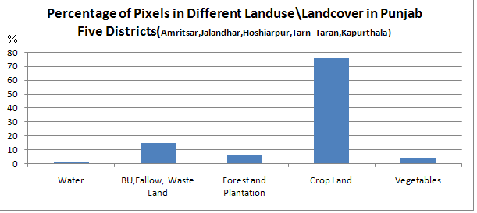

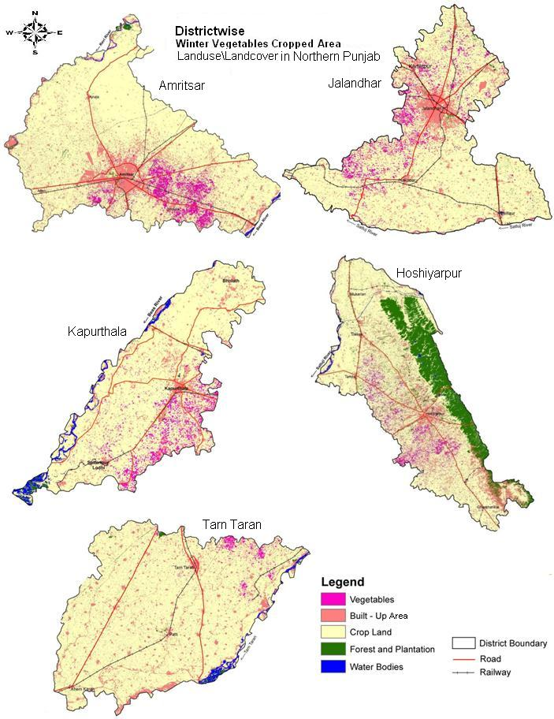

Figure 2.Winter vegetable cropped area in Punjab

4.4 Changes in Area under Vegetables
Table.4 depicts positive and negative change in area under vegetable crop. Vegetable area of the study area recorded 4.14% area under vegetation in 207-08 against 3.63% in 2005. As a whole there is positive change in area under vegetable crop but two districts, namely, Kapurthala and Jalandhar, display negative change. In the remaining three districts (Amritsar, Tarn Taran, and Hoshiarpur) area under vegetable has substantially increased. In Amritsar district has increased by 9.92 thousand hectares. Tarn Taran district was part of Amritsar district in 2006. In Hoshiarpur district, area under vegetables also increased i.e. 2.07 thousand hectares. In the study area, as a whole 6.48 thousand hectares area under vegetable has increased which represent 14.9% growth in three years.

Table.4 Changes in Area under Vegetables (in ha.)
Districts | Area under Vegetables  2005 | Area under Vegetables  2007 - 08 | Change in Area  2005 -08
Amritsar | 6.4 | 13.13 | 155.0
Tarn Taran | 6.4 | 3.19 | 155.0
Kapurthala | 9.5 | 8.13 | -14.4
Jalandhar | 19.4 | 5.26 | -21.3
Hoshiarpur | 10.9 | 12.96 | 19.0
Total | 46.2 | 52.71 | 14.9
Because of perishable nature of vegetable crops the crop acreage finds strong relationship with market forces. Change in vegetable area in spatially complementary. High increase in vegetable acreage of Amritsar district in center balanced by decrease in crop acreage of Jalandhar and Kapurthala districts.

5. Conclusion
Remote sensing technology has been proved as a useful space application for natural resources evaluation and management. IRS P6 AWiFS data is used for the vegetable acreage estimation in dominant vegetable growing areas in Punjab. Results showed that data acquired during near peak vegetative period is optimum for classification of vegetable crop. September - January is the ideal time for planting winter vegetables (peas, carrot, radish, turnip, cauliflower, cabbage, onion, garlic, potato and leafy vegetables). Several successive plantations of radish, spinach, lettuce, peas and beans, which remain in an edible condition for a short time, should be done. November is very ideal month to demarcate the area under vegetables with the help of remote sensing, because in this month vegetables are the only crop grown in the field. Vegetables can easily identify from the image. Potatoes share the more than half part in producing winter vegetables crop. Acreage estimation of vegetables or other crop like wheat, rice etc. through remote sensing is easy and timesaving. Hierarchical decision rule based classification is a pixel based classification. It is very accurate classification than supervised or unsupervised classification.

Acknowledgement
The Authors are grateful to Dr. P.K Sharma, Director PRSC, Dr. Ajay Mathur and Mr. Narinder Singh (Scientist SE, SC) Punjab Remote Sensing Centre, Ludhiana for continuous support and encouragement in bringing out the technical guidelines for the project work in PRSC campus. Special appreciation and thanks to Prof. K. Kumaraswamy, (Dpt. Geography, Bharathidasan University) for has valuable supervision. Authors are thankful to Prof. Kamlesh Kumar (Rtd.),HNBGU,Srinagar for his suggestion and necessary improvement at the final stage of this paper.

Corresponding Author:
Mr. Kamlesh Khanduri
I-264, Nehru Clolony, Dehradun
Uttarakhand, 248001, India
E-mail: ecnhas@gmail.com

References
1. Singh Avtar ,Estimation of area under Winter Vegetables through multi date A-Wifs data using Modular based decision rule Classification ,Bharathidasan University,Tiruchirappalli, Tamilnadu ,M.tech,Unpub. Thesis, 2009.

2. Punjab Remote Sensing Centre (PAU),Ludhiana,India.

3. Honghui Liu, Xiaohuan Yang and Naibin Wang, Remote sensing based estimation system for winter wheat yield in North China Plain ,1998.

4-National Remote Sensing Agency / Project report, “National land use and land cover mapping using Multi temporal AWiFS data” 2006.
5- Khanduri Kamlesh, (2007-2012) A Geographical Study of Hazards & Disaster Management in Uttrakhand : With Reference to Chamoli District, Unpublished D.Phil Thesis, H.N.B.G.University.
6-Khanduri Kamlesh , 2011 ,”GIS & Remote Sensing Technology in Geomorphic analysis of Mandakini River Basin, Garhwal Himalaya, Rudraprayag District, Uttarakhand, India” International journal of Advanced Scientific and Technical Research, Issue 1, Vol 2, pp.138-145.

