Effect of Some Antioxidants on Some Physiological and Anatomical Characters of Snap Bean Plants under Sandy Soil Conditions

Nour, K. A. M¹; Mansour, N. T. S.¹ and Eisa G. S.A²

¹Vegetables research departments, Horticulture Research Institute, Agriculture. Research Center
²Agricultural Botany and Plant Pathology. Department, Faculty of Agriculture, Zagazig University, Zagazig, Egypt.
dr_khaled_nour@yahoo.com

Abstract: Snap bean (Phaseolus vulgaris L.) is one of the most important vegetable crops grown in Egypt for both local consumption and exportation. As they are very rich in protein content which is essential for human nutrition rather than the role of such crops in improving soil fertility. Two field experiments were carried out during two successive summer seasons of 2010 and 2011 at the Experimental Farm, El Kassasein Research Station, Ismailia Governorate, to assess the response of snap bean plants (Phaseolus vulgaris L.) cv. Paulista to some antioxidants treatments on morphological characters, dry weight, yield and chemical constituents as well as leaf anatomy. Aqueous solutions of the antioxidants as foliar spray ;i.e., acetylsalicylic acid (aspirin)at 75and 150ppm, Salicylic acid at 50 and 100 ppm, citric acid at 0.25% and 0.5%, Vitamin E at 75 and 150 ppm and control. Obtained results reflected that Plant growth, total dry weight, yield and its components and chemical constituents of pods were significantly affected by treating snap bean plants with different antioxidants. Moreover, application of antioxidants altered leaflet blade anatomical characters; i.e., increased thickness of leaflet blade, thickness of palisade and spongy parenchyma as well as thickness of midrib region of the leaflet and increased the dimensions of the medvein vascular bundle, except Salicylic acid at 100 ppm that had the opposite effect on these leaflet anatomical characters. In general, the best treatments that gave the highest values were by spraying snap bean plants with citric acid at 0.5% followed by citric acid at 0.25% and vitamin E at 150ppm.
[Nour, K. A. M; Mansour, N. T. S. and Eisa G. S.A. Effect of Some Antioxidants on Some Physiological and Anatomical Characters of Snap Bean Plants under Sandy Soil Conditions. New York Science Journal 2012;5(5):1- 9]. (ISSN: 1554-0200). http://www.sciencepub.net/newyork. 1

Key words: Snap bean, antioxidants, yield, anatomical characters and chemical constituents

1. Introduction:
Antioxidants are a class of nutrients that protect the body from damage caused by different factors (karadenize et al., 2005) which has a prompted research in the fields of food science and horticulture to assess fruit and vegetable antioxidants (Kalt et al., 1999). The majority of the antioxidant capacity of fruits or vegetables may be from some compounds such as falvonoids, isofalvonoids, flavones, anthocyanins, catechins, vitamin C, E or β carotene (Kahkonen et al., 1999). Many of these phytochemicals may help to protect cells against oxidative damage caused by free radicals (Wada and Ou, 2002). Antioxidants intercept free radicals and protect cells from the oxidative damage that leads to aging and disease (Karadeniz et al., 2005). Active oxygen scavengers (antioxidants) could be beneficial in the protection of the structure and function of the photosystems against excess light (Rajagopal et al., 2005). Antioxidants play role in the reduction or prevention of enzymatic browning by inhibiting polyphenol oxidase (Maurice et al., 2000). Acetylsalicylic acid (aspirin; 2-acetoxybenzoic acid) has been used for >100 years for pain (Paterson et al., 2006). It is one of the basic preparations used in the therapy of cardiovascular diseases, leads to irreversible reduction of platelet aggregation (Stejskal et al., 2001). Salicylic acid is widely present in plants and functions as a hormonal mediator of the systemic acquired resistance response. Thus, it is present in a large scale of fruits, vegetables, herbs and spices of dietary relevance. The recognized effect of consuming fruits and vegetables on lowering risk of colon cancer may be partly attributable to salicylates in plant-based foods (Paterson et al., 2006).
Application of acetyl salicylic acid (ASA) at 20 ppm on pea plants enhanced plant growth as indicated by plant height, number of leaves, fresh and dry weights in both seasons. (El-Shraiy and Hegazi 2009). Foliar spray with salicylic acid increased the fresh and dry weight of plant, pod setting and total proteins of leaves and fruits. (Sitaramaiah and Pathak, 1981 on tomato; Jasiswal and Bhambie, 1989 on Vigna radiate; Liu Xini et al., 2000 and Sanaa et al., 2001 on broad bean). Salicylic acid retarded the growth and green pod yield and its components as well as weight of dry seed of common bean (Amer, 2004). Using 150 ppm of salicylic acid as a foliar application gave the highest increment in number of branches, fresh weight and dry weight and total protein. As well as number of pods, pods setting and green pods yield of snap bean (Kmal et al., 2006). Spraying potato plants with salicylic acid at 100 ppm had beneficial effects on vegetative growth characters, total tuber yield and chemical contents of potato tubers (Awad and Mansour, 2007). In addition, increasing SA levels to potato led to decrease in plant height (Youssef and Abd Allah, 2007). On the other hand, SA at 1.0 mM caused a significant decreased in the total yield (ton/fed.). Also spraying tomato plants with salicylic acid at 100 ppm increased vegetative growth, dry weight, yield and its components and NPK content as well as total protein (Ali et al., 2009). 1.5 mM concentration of salicylic acid had a stimulating effect on the growth, dry weight and protein of pepper as compared with other concentrations 5 and 10 mM (Canakci 2011). Ascorbate and salicylic acid decreased effects and damages of drought stresses on okra germination and seedlings growth. In general, adding salicylic acid significantly relieved the harsh effects of drought on okra germination and growth parameters and it seems that salicylic acid were able to enhance the tolerant ability of the plant to drought stress (Baghizadeh and Hajmohammadrezaei, 2011). Citric acid is an organic compound belonging to the family of carboxylic acids. It presents in practically all plants. It is one of a series of compounds involved in the physiological oxidation of fats, proteins and carbohydrates to Co₂ and water. Dark stress decreased the level of nitrogenase (N₂ase) proteins and activities of enzymes involved in carbon and nitrogen assimilation in nodules via increasing O₂ in root zone which causes large decline in leghaemoglobin and antioxidant defenses (Gogoreena et al., 1997), therefore , increasing O₂ in root zone in legume crops led to decrease N₂ase proteins, citrate (> 1.0mM) and inhibiting the rate of Co₂ production and O₂ consumption (respiratory gas exchange) in carrot roots through inhibiting the phosphorylation of fructose 6-phosphate to fructose 1,6-diphosphate which decreased N₂ase proteins (Kato Noguchi, 1997).
Plant height, yield and its components as well as protein content in common bean , pea and faba bean were increased with application of citric acid ( Abd- Allah et al.,2007). Spraying tomato plants with citric acid at 200 ppm increased vegetative growth, dry weight, yield and its components and NPK content as well as total protein (Ali et al., 2009). Vitamin E is considered as highly antioxidant at the membrane site (Hess, 1983) which is a highly effective antioxidant at the membrane site. And has a positive effect on chlorophyll content of bean plants (Schmitz and Noga, 1998). Foliar application of vitamin E at 0.1 ml/l and 0.3 ml/l significantly improved vegetative growth and yield of bean plants compared to control plants especially at the higher concentrations (El-Tohamy and El-Greadly, 2007). This investigation aimed to assess the response of snap bean plants (Phaseolus vulgaris L.) cv. Paulista grown under sandy soil conditions to some antioxidants to improve the growth, anatomical structure, yield and chemical constituents of snap bean plants grown under sandy soil conditions.

2. Materials and Methods
The present work was carried out during two successive summer seasons of 2010 and 2011 at the Experimental Farm, El Kassasein Research Station, Ismailia Governorate. The physical and chemical properties of the experimental soil are given in Table (1).

Table 1: The physical and chemical properties of the tested soil during 2010and 2011 seasons
Chemical properties |  |  | Physical properties
2011 | 2010 |  | 2011 | 2010
0.08 | 0.05 | Organic matter | 95.6 | 96.5 | Sand (%)
64 | 52 | Available K (ppm) | 1.6 | 1.7 | Silt (%)
6.2 | 5.5 | Available P (ppm) | 2.8 | 1.8 | Clay (%)
6.9 | 5.4 | Available N (ppm) | 6.8 | 6.5 | Field capacity
0.26 | 0.18 | Calcium carbonate (%) | 2.5 | 2.4 | Wilting point
8.1 | 8.1 | pH | 4.5 | 4.5 | Available water
 |  |  | 14.5 | 13.8 | Water holding capacity

This experiment included 9 treatments, as follows: -
- Control (untreated),
- Acetylsalicylic acid (ACA) 75ppm,
- Acetylsalicylic acid 150ppm,
- Salicylic acid (SA) 50ppm,
- S A 100ppm, (Alcohol was used as a solvent for ACA and AC),
- Citric acid 0.25%,
- Citric acid 0.50%,
- Vitamin E 75ppm and
- Vitamin E 150ppm
Treatments were arranged in a complete randomized block design with three replicates.
Seeds of snap bean cv. Paulista were obtained from Horticultural Research Institute, Agriculture Research Center, Egypt and sown on March 24th and 21st in 2010 and 2011, respectively. The area of experimental plot was 10.5m². Every plot consisted of 5 dripper lines 3m in length and 0.7m in width. Seeds were sown in hills 20 cm apart on one side of dripper lines and two seeds per hill with about 150 plants in every plot. One dripper line was left between each two experimental plots without spraying as a guard row to avoid the overlapping (contamination) of spraying solution. Two dripper lines (4.2m²) was earmarked for samples and the other three dripper lines (6.3m²) were earmarked for estimating yield and its components. The normal agriculture practices of snap bean under drip irrigation system were followed according to the recommendations of Agriculture Ministry.
The foliar application treatments were sprayed twice during the growth period of plant at 30 and 45 days after sowing. The untreated plants (control) were sprayed with tap water.

Data recorded
Morphological Characters
A random sample of three plants was taken from every plot at 60 days after sowing in both seasons of study for measuring the growth characters of snap bean plants expressed as follows: plant height (cm), number of both leaves and branches / plant, total dry weight (leaves + branches) / plant (g), (the samples were dried in an electric oven at 70ºC till constant weight).
Yield and Its Components
At harvesting stage (aged 70 days for both seasons), 15 bean plants from each treatment were randomly taken to study the yield and its components including:-
Average numbers of pods/plant, average weight of green pods/plant (g), average pod weight (g), green pod yield/fed. (ton) and dry matter of pods (%).
Pod Chemical Constituents
Dried pods were finely ground separately and digested with sulfuric acid and percholoric acid (3:1). Nitrogen, phosophorus and potassium were determined according to the method described by Kock and Mc-Meekin (1924), Murphy and Riley (1962) and Brown and Lilliland (1946).
Total Crude Protein (%)
The previously determined nitrogen of dry pods was used for calculating total crude protein by multiplying N- values by 6.25 (A.O.A.C., 1980).

Anatomical Study
Specimens were taken at the age of 50 days from sowing (flowering stage) during second season of 2011, specimens from the midrib region of the terminal leaflet blade of the corresponding leaf 4th upper on the main stem from various treatments of snap bean plant. These specimens (1 cm long) were killed and fixed for 48 h at least in plant fixative which is known as FAA (formalin acetic alcohol) and is represented by the following formula: 50 ml. ethyl alcohol (95%), 5ml. glacial acetic acid, 10 ml. formaldehyde (37- 40%), 35ml. distilled water. The selected material were washed in 50% ethyl alcohol, dehydrated in a normal butyl alcohol series, embedded in paraffin wax of melting point 52-54 ⁰C. Sections were prepared using EPMA a rotary microtome at 15-17 microns, stained with both safranin and light green, cleared in xylene and finally mounted in Canada balsam (Berlyn and Miksche 1976). Selected sections were examined using light microscope and photographed by using light microscope (Olympus) with digital camera (Canon power shot S80) connected to computer; the photographs were taken by Zoom Browser Ex Program. The dimensions of leaflet blade sections were measured by using Corel Draw program ver.11 (Eisa, et al. 2010).

Statistical Analysis
Obtained data were subjected to the analysis of variance according to Snedecor and Cochran (1980). Duncan`s multiple range test was used for the comparison among treatments (Duncan, 1955).

3. Results and Discussion
Morphological Characters
As shown in Table (2) that spraying snap bean plants with acetylsalicylic acid (ACA), salicylic acid (SA), citric acid and vitamin E at different concentrations had significant effect on number of leaves/plant and total dry weight / plant. Foliar spray of snap bean plants with citric acid at 0.5% significantly increased plant height, number of leaves / plant and total dry weight / plant as compared with ACA, AC or control. Also, vitamin E at150ppm and citric acid at 0.25% increased plant height, number of leaves and dry weight / plant as compared to control without significant differences between the two treatments. On the other hand, using acetylsalicylic acid or salicylic acid with high concentrations significantly decreased plant height. The effectiveness of any given antioxidant in the plant depends on which free radical is involved, and where the target of damage is. Thus, while in one particular system an antioxidant may protect against free radicals, in other system it could have no effect at all, or in certain circumstances, an antioxidant even act a "pro-oxidant" that generates toxic oxygen species (Munne- Bosch and Alegre 2002).
The stimulative effect of citric acid on vegetative growth was also reported by Abdel-Allah (2007) on common bean, pea and faba bean and Ali et al., (2009) on tomato. Regarding vitamin E, obtained results are in harmony with those reported by El-Tohamy and El-Greadly (2007) on snap bean.

Yield and Its Components
As shown in table (3), all citric acid and vitamin E treatments had stimulative effect on yield and its components. Significant increases were observed as a result of spraying with citric acid at 0.25 %, 0.5% and vitamin E at 150ppm. It is also clear that spraying snap bean plants with citric acid at 0.5% was superior which gave the highest values of no. of pods/ plant, average pod weight, green pod yield / plant and total green pod yield/ fed. as well as dry matter of pods (%) in both seasons as compared with other treatments.
These results could be attributed to the role of citric acid which is one of a series of compounds involved in the physiological oxidation of fats, proteins and carbohydrates to C0₂ and water as well chelation of transition metals; e.g., citric
acid. This kind of mode of action depends on the availability of metals in catalyzing amounts. Interference with this process of catalysis by chelation would be expected to have a strong effect on the progress of the radical reaction transition metal ions may either be activated by the chelator increasing the catalyzing potential or may be activated by the change brought depends on the metal and chelator (Smith et al., 1990; Gogoreena et al., 1997 and Abd – Allah et al., 2007). Obtained results are in harmony with those reported by Abd-Allah et al. (2007) on common bean; pea and faba bean and Ali et al. (2009) on tomato.
The increasing in total yield path vitamin E due to the role of this tocopherol radical oxidation in plant metabolism became clear in Arabidopsis mutants, in which the cyclase was either deleted or overexpressed (Kanwischer et al., 2005). Obtained results are in harmony with those reported by El-Tohamy and El-Greadly (2007) on snap bean.

Chemical Constituents of Pods
As shown in table (4); spraying snap bean plants with acetylsalicylic acid (ACA), salicylic acid (SA), citric acid and vitamin E at different concentrations had stimulative effect on N, P, K and protein content % in pods as compared with control , this was true in the two seasons. The best treatments for increasing N%, P% in both seasons and K% in the first season as well as protein content in the two seasons were observed from foliar application of citric acid at 0.5% followed by acetylsalicylic acid at 150 ppm and salicylic acid at 100 ppm. On the other hand, potassium concentration in second season and protein concentration in first season were not significantly affected. These results are in agreement with those reported by Kmal et al. (2006) on snap bean, Youssef and Abd Allah (2007) and Awad and Mansour (2007) on potato, Abdel-Allah et al. (2007) on common bean, pea and faba bean and Ali et al. (2009) on tomato.
Anatomical Study
As shown in Table (5) and fig. (1); spraying snap bean plants with acetylsalicylic acid (ACA), salicylic acid (SA), citric acid and vitamin E at different concentrations had stimulative effect on anatomical characters (thickness of leaflet blade, thickness of palisade and spongy tissue, thickness of midrib region of the leaflet and dimensions of the medvein vascular bundle) except SA at 100ppm which recorded little decrease as compared to control. Also; spraying snap bean plants with citric acid at 0.5 % recorded the highest values of midvein vascular bundle parameters; the increment was mainly due to the increase in thickness by 36.59%, width by 50.02%, xylem zone thickness by 16.74% and phloem zone thickness by 43.14% over the control. Moreover, xylem vessel had wider cavities and number of xylem vessel, being 29.49% and 82.93%, respectively more than the control, it could also notice that there was an increase in leaf blade thickness due to the increase in thickness of both palisade and spongy tissues as compared to control, followed by citric acid at 0.25 % and vitamin E at 150ppm. These results agree with those reported by Faten and Bakry (2005) who showed that, treating papaya plants with citric acid at 2g/l increased thickness of each of epidermis, cortex, phloem zone and xylem zone in cross section of petiole flower. As for vitamin E, spraying tomato plants with vitamin E at 200ppm significantly increased number of branches and leaves per plant, leaf area per plant and leaves dry weight (Mady, 2009) On the other side, spraying snap bean plants with salicylic acid at 100 ppm gave the lowest values of midvein vascular bundle parameters; this decrement was mainly due to the decrease in thickness by 8.7%, width by 17.4%, xylem zone thickness by 14.5%, phloem zone thickness by 17.5% and average diameter of xylem vessel by 1.4% as well as number of xylem vessel by 9.8% less than the control, it could also notice a decrease in leaf blade thickness and that due to the decrease in thickness of both palisade and spongy tissues as compared to control.

Table (2). Effect of antioxidant treatments on Morphological characters and dry weight of snap bean plants during summer season of 2010 and 2011
Treatments | Morphological characters / plant
Treatments | Season 2010 Season 2011
Treatments | Plant height  (cm) | Leaves No. | Branches No. | Total dry weigh (g) | Plant height  (cm) | Leaves No. | Branches No. | Total dry weigh (g)
Control | 48.7a | 19.3e | 4.00a | 7.92e | 50.4bc | 20.7e | 4.33a | 6.56e
Acetylsalicylic acid 75ppm | 46.0ab | 23.7de | 6.33a | 9.68d | 47.3c | 26.0d | 6.00a | 7.32e
Acetylsalicylic acid 150ppm | 43.7b | 28.0b-d | 5.33a | 9.70d | 48.3bc | 35.3ab | 5.67a | 9.27d
Salicylic acid 50 ppm | 47.3ab | 29.3bc | 5.67a | 11.51b | 49.7bc | 27.7cd | 4.76a | 11.56b
Salicylic acid100 ppm | 45.3ab | 32.7ab | 6.00a | 10.67c | 47.0c | 31.3bc | 5.00a | 10.48c
Citric acid 0. 25% | 51.0a | 27.7cd | 5.33a | 11.12bc | 52.7ab | 32.3bc | 6.00a | 10.18cd
Citric acid 0. 5% | 53.3a | 36.3a | 6.33a | 13.17a | 54.3a | 38.0a | 6.33a | 12.87a
Vitamin E 75 ppm | 45.0ab | 32.0a-c | 5.67a | 10.71bc | 51.7a-c | 33.7ab | 6.33a | 10.25cd
Vitamin E 150 ppm | 49.0a | 35.7a | 5.67a | 11.30bc | 52.3ab | 35.0ab | 5.33a | 10.21cd
Values having the same alphabetical letter(s) did not significantly differ at 0.05 level of significance according to Duncan's multiple

Table (3). Effect of antioxidant treatments on yield and its components of snap bean plants during summer season of 2010 and 2011
Treatments | Yield and its components
Treatments | Season 2010 Season 2011
Treatments | No. of pods/plant | Avr. pod Wt.(gm) | Green pods yield |  | Dry matter of pods (%) | No. of pods/plant | Avr. pod Wt.(gm) | Green pods yield |  | Dry matter of pods (%)
Treatments | No. of pods/plant | Avr. pod Wt.(gm) | gm / plant | kg/fed. | Dry matter of pods (%) | No. of pods/plant | Avr. pod Wt.(gm) | gm / plant | kg /fed. | Dry matter of pods (%)
Control | 11.3d | 3.84a | 43.46d | 2608d | 6.37e | 12.7c | 3.62a-c | 45.84c | 2750c | 6.20d
Acetylsalicylic acid 75ppm | 14.7c | 3.36b | 49.23cd | 2954cd | 7.12a-d | 16.3bc | 3.72ab | 61.12bc | 3667bc | 7.24ab
Acetylsalicylic acid 150ppm | 16.3bc | 3.73ab | 61.13bc | 3668bc | 6.35e | 17.3ab | 3.72ab | 64.56ab | 3837ab | 6.13d
Salicylic acid 50 ppm | 18.3ab | 3.32b | 61.00bc | 3660bc | 7.02b-e | 20.0ab | 3.56a-c | 71.41ab | 4285ab | 6.62b-d
Salicylic acid100 ppm | 17.7ab | 3.72ab | 65.78ab | 3947ab | 6.74de | 20.0ab | 3.57a-c | 71.02ab | 4261ab | 6.93bc
Citric acid 0. 25% | 18.3ab | 3.96a | 72.75ab | 4365ab | 7.51ab | 20.0ab | 3.39bc | 67.77ab | 4066ab | 7.17ab
Citric acid 0. 5% | 19.3a | 3.98a | 76.84a | 4610a | 7.42a-c | 20.7a | 3.75ab | 77.41a | 4645a | 7.58a
Vitamin E 75 ppm | 16.7a-c | 3.73ab | 62.33bc | 3740bc | 7.71a | 18.3ab | 3.31c | 60.86bc | 3652bc | 7.23ab
Vitamin E 150 ppm | 17.3a-c | 3.92a | 67.70ab | 4062ab | 6.80c-e | 16.7b | 3.85a | 63.79ab | 3827ab | 6.39cd
Values having the same alphabetical letter(s) did not significantly differ at 0.05 level of significance according to Duncan's multiple range test.

Table (4). Effect of antioxidant treatments on chemical constituents of snap bean pods during summer season of 2010 and 2011
Treatments | Chemical constituents (%)
Treatments | Season 2010 Season 2011
Treatments | N | P | K | Protein | N | P | K | Protein
Control | 3.12c | 0.345d | 2.14d | 19.5a | 3.13d | 0.353d | 2.18a | 19.6d
Acetylsalicylic acid 75ppm | 3.17bc | 0.385bc | 2.21cd | 19.8a | 3.56bc | 0.365cd | 2.41a | 22.3bc
Acetylsalicylic acid 150ppm | 3.36a-c | 0.368cd | 2.21cd | 21.0a | 3.81a | 0.387bc | 2.48a | 23.8a
Salicylic acid 50 ppm | 3.65a | 0.390bc | 2.41a-c | 22.8a | 3.62a-c | 0.392bc | 2.48a | 22.6a-c
Salicylic acid100 ppm | 3.42a-c | 0.468a | 2.61a | 21.4a | 3.71ab | 0.408ab | 2.41a | 23.2ab
Citric acid 0. 25% | 3.56ab | 0.460a | 2.35bc | 22.3a | 3.46c | 0.413ab | 2.55a | 21.6c
Citric acid 0. 5% | 3.74a | 0.415b | 2.41a-c | 23.4a | 3.82a | 0.435a | 2.41a | 23.9a
Vitamin E 75 ppm | 3.48a-c | 0.358cd | 2.35bc | 21.8a | 3.54bc | 0.360cd | 2.30a | 22.1bc
Vitamin E 150 ppm | 3.41a-c | 0.383bc | 2.48ab | 21.3a | 3.78ab | 0.385b-d | 2.45a | 23.6ab
Values having the same alphabetical letter(s) did not significantly differ at 0.05 level of significance according to Duncan's multiple range test.

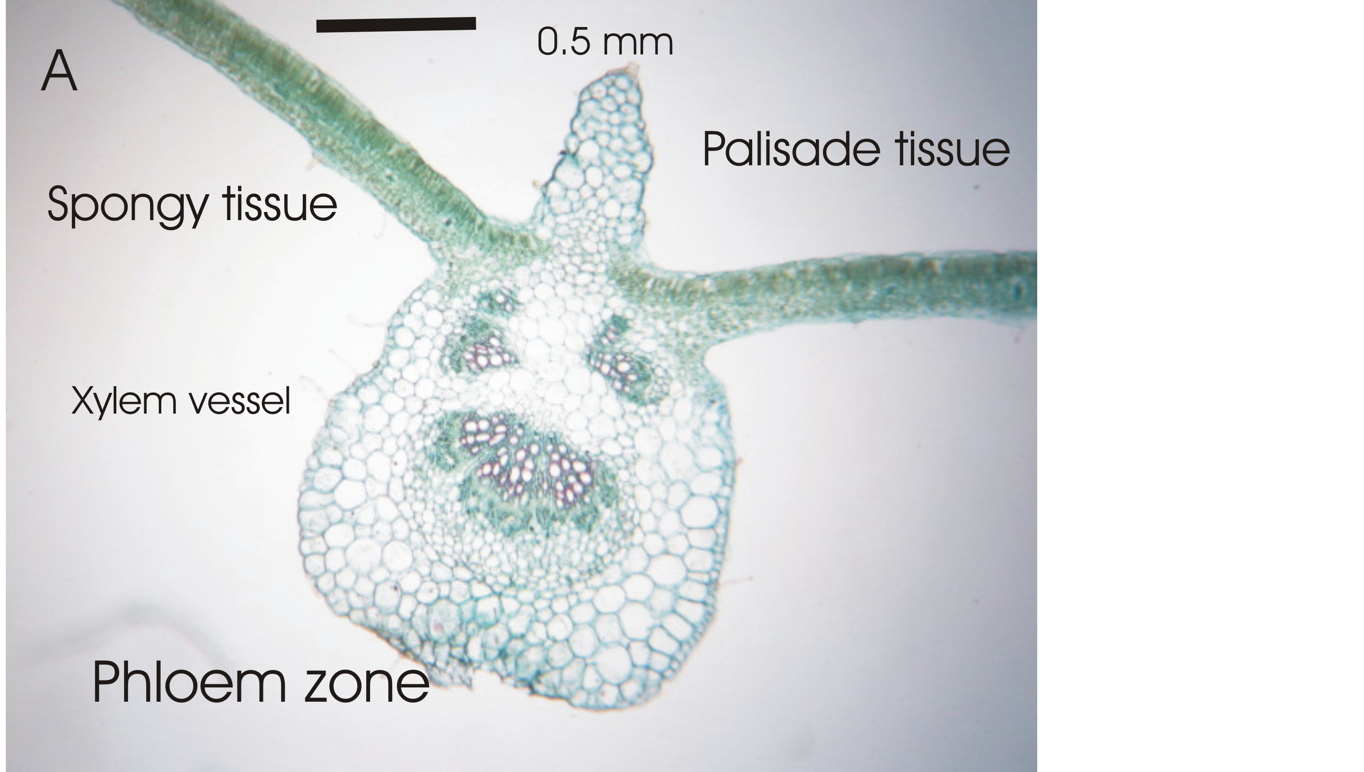
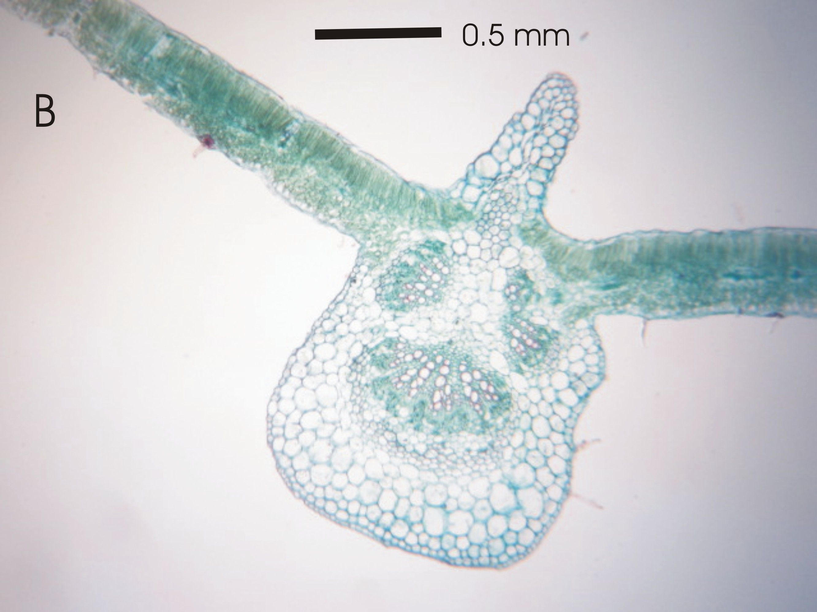
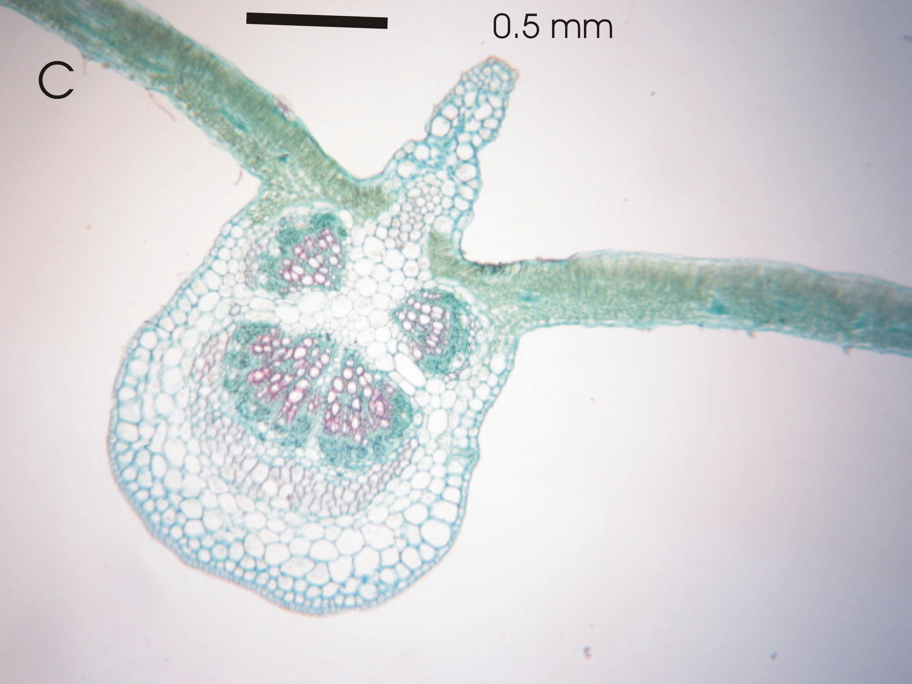
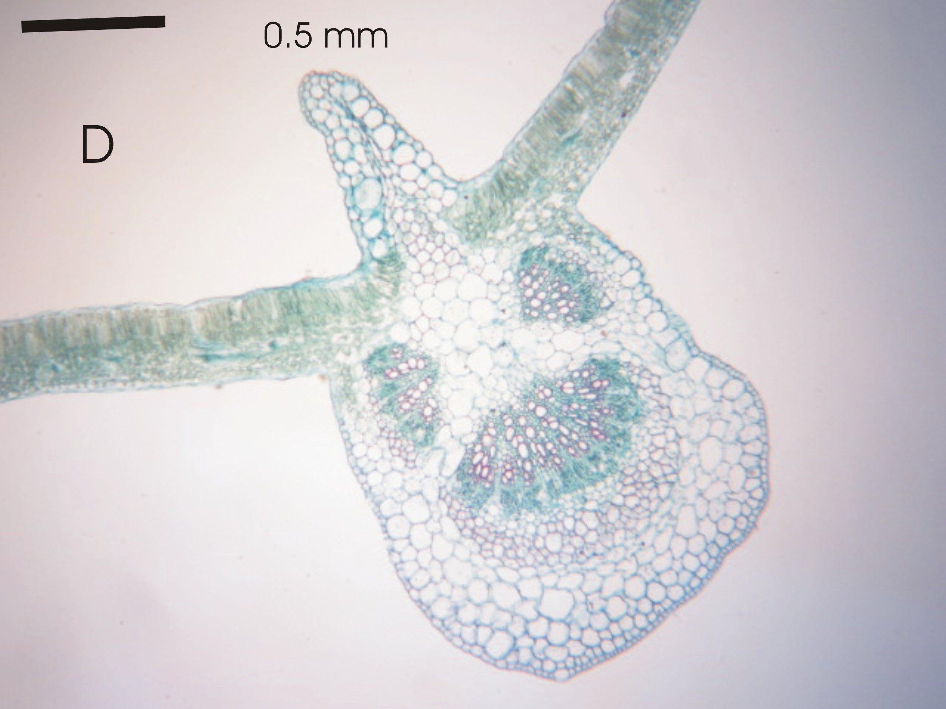
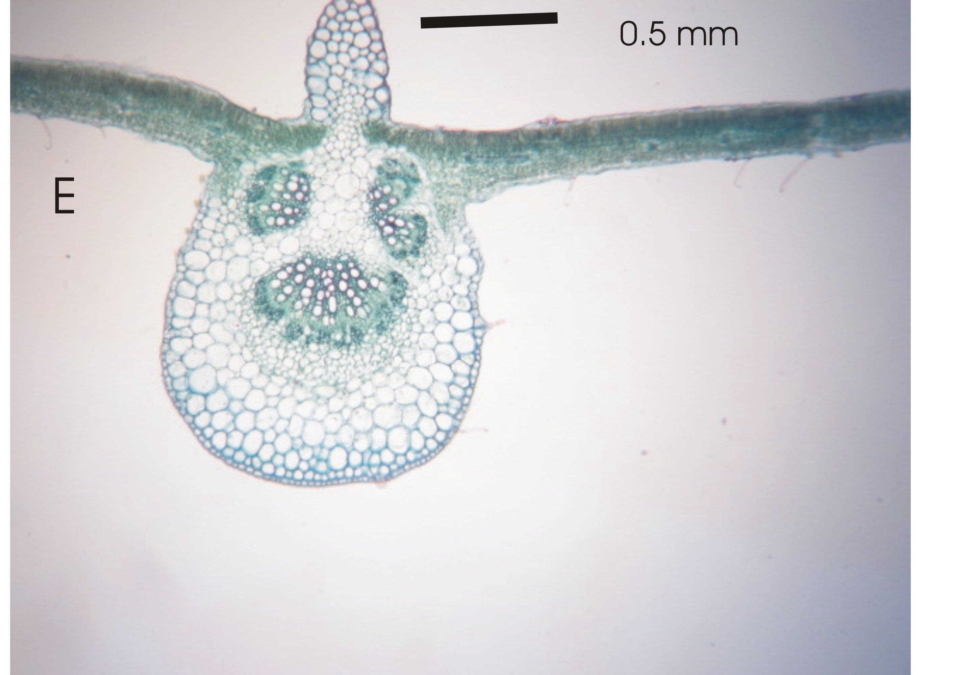
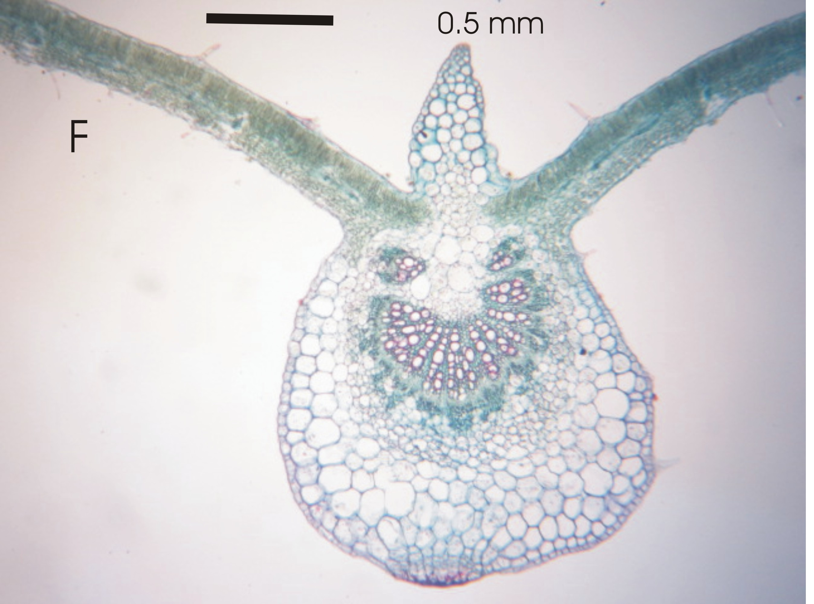
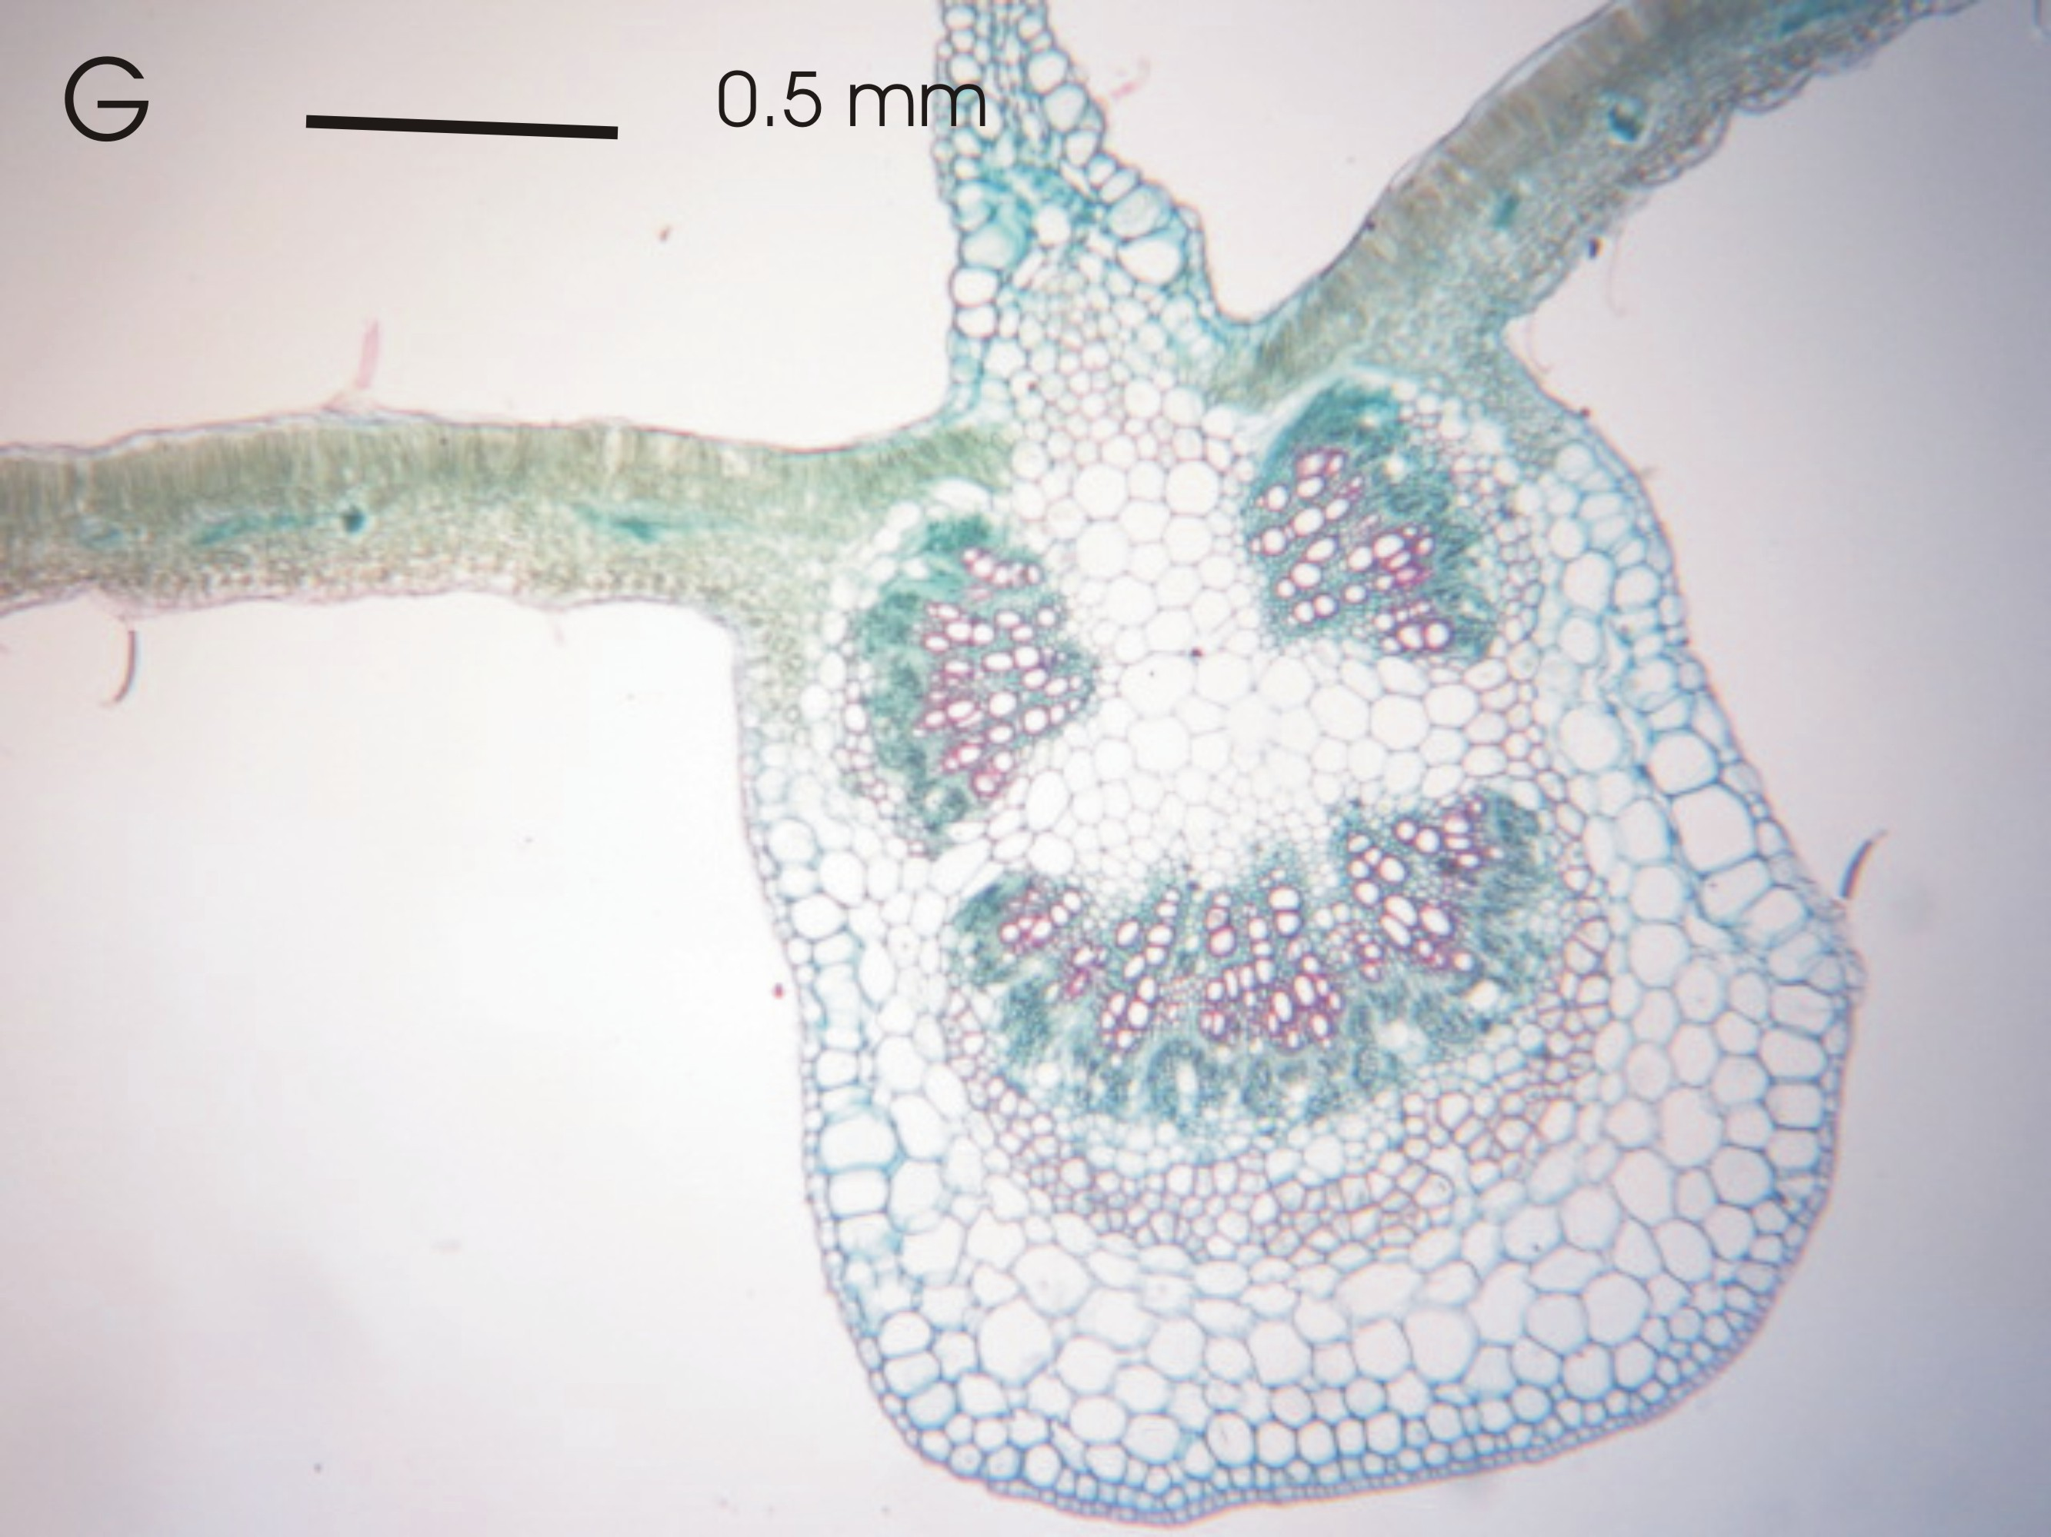
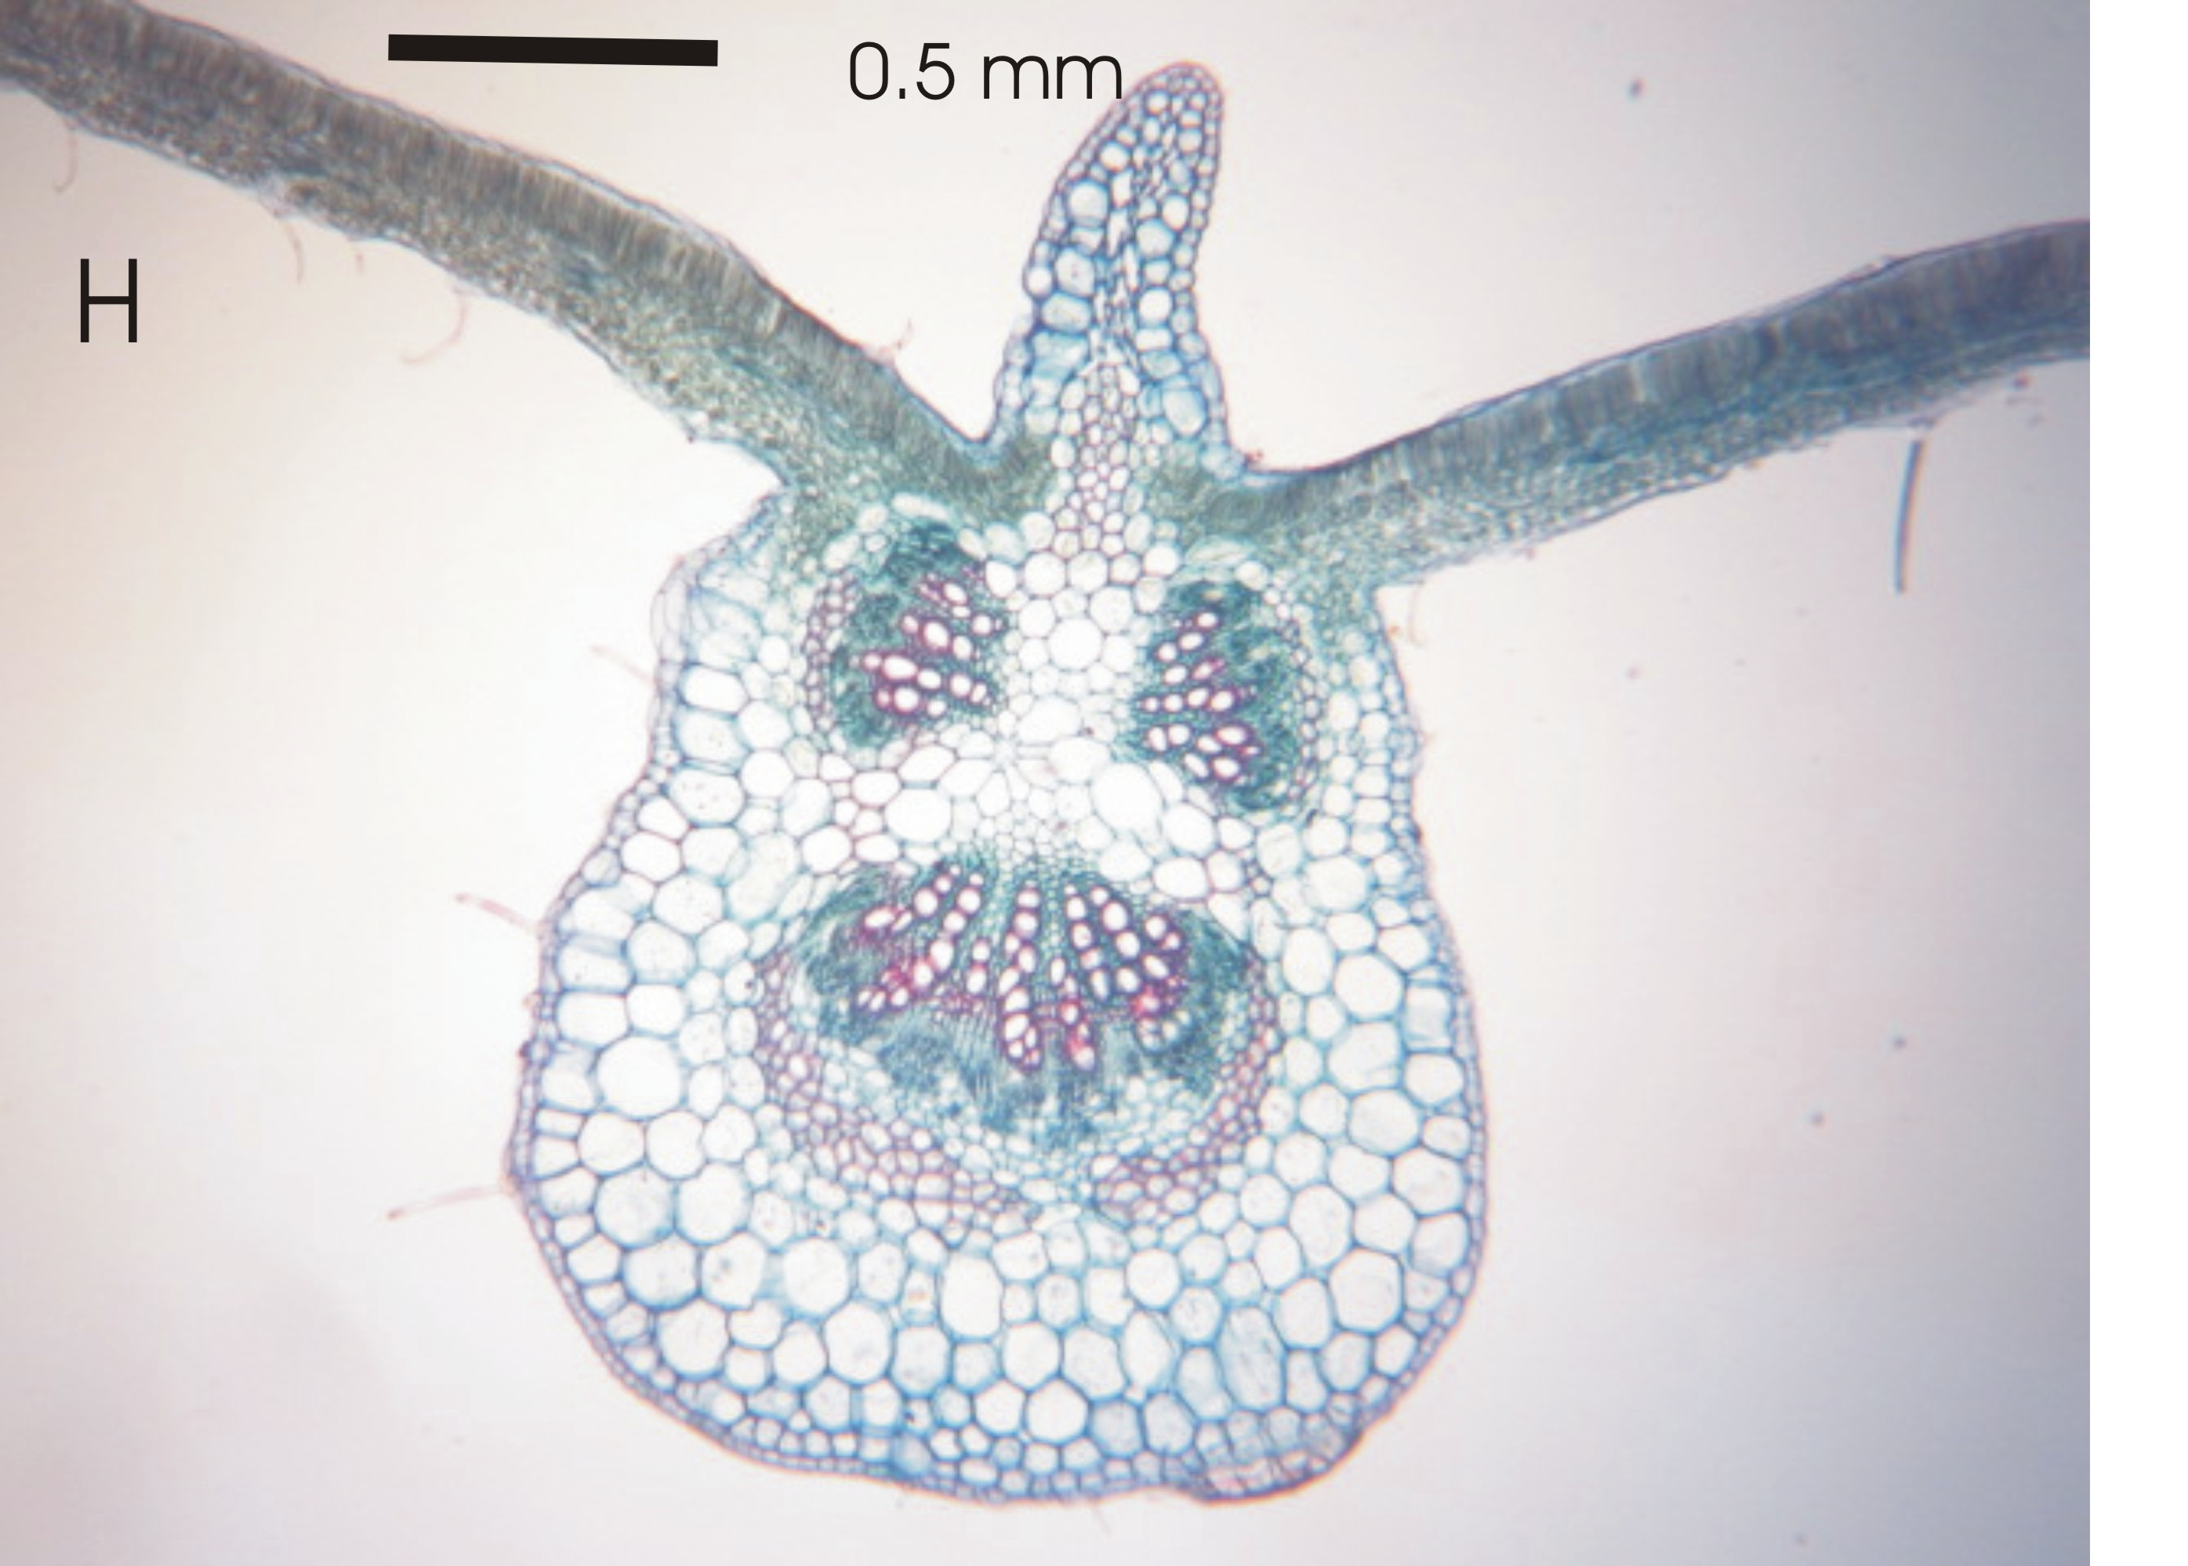
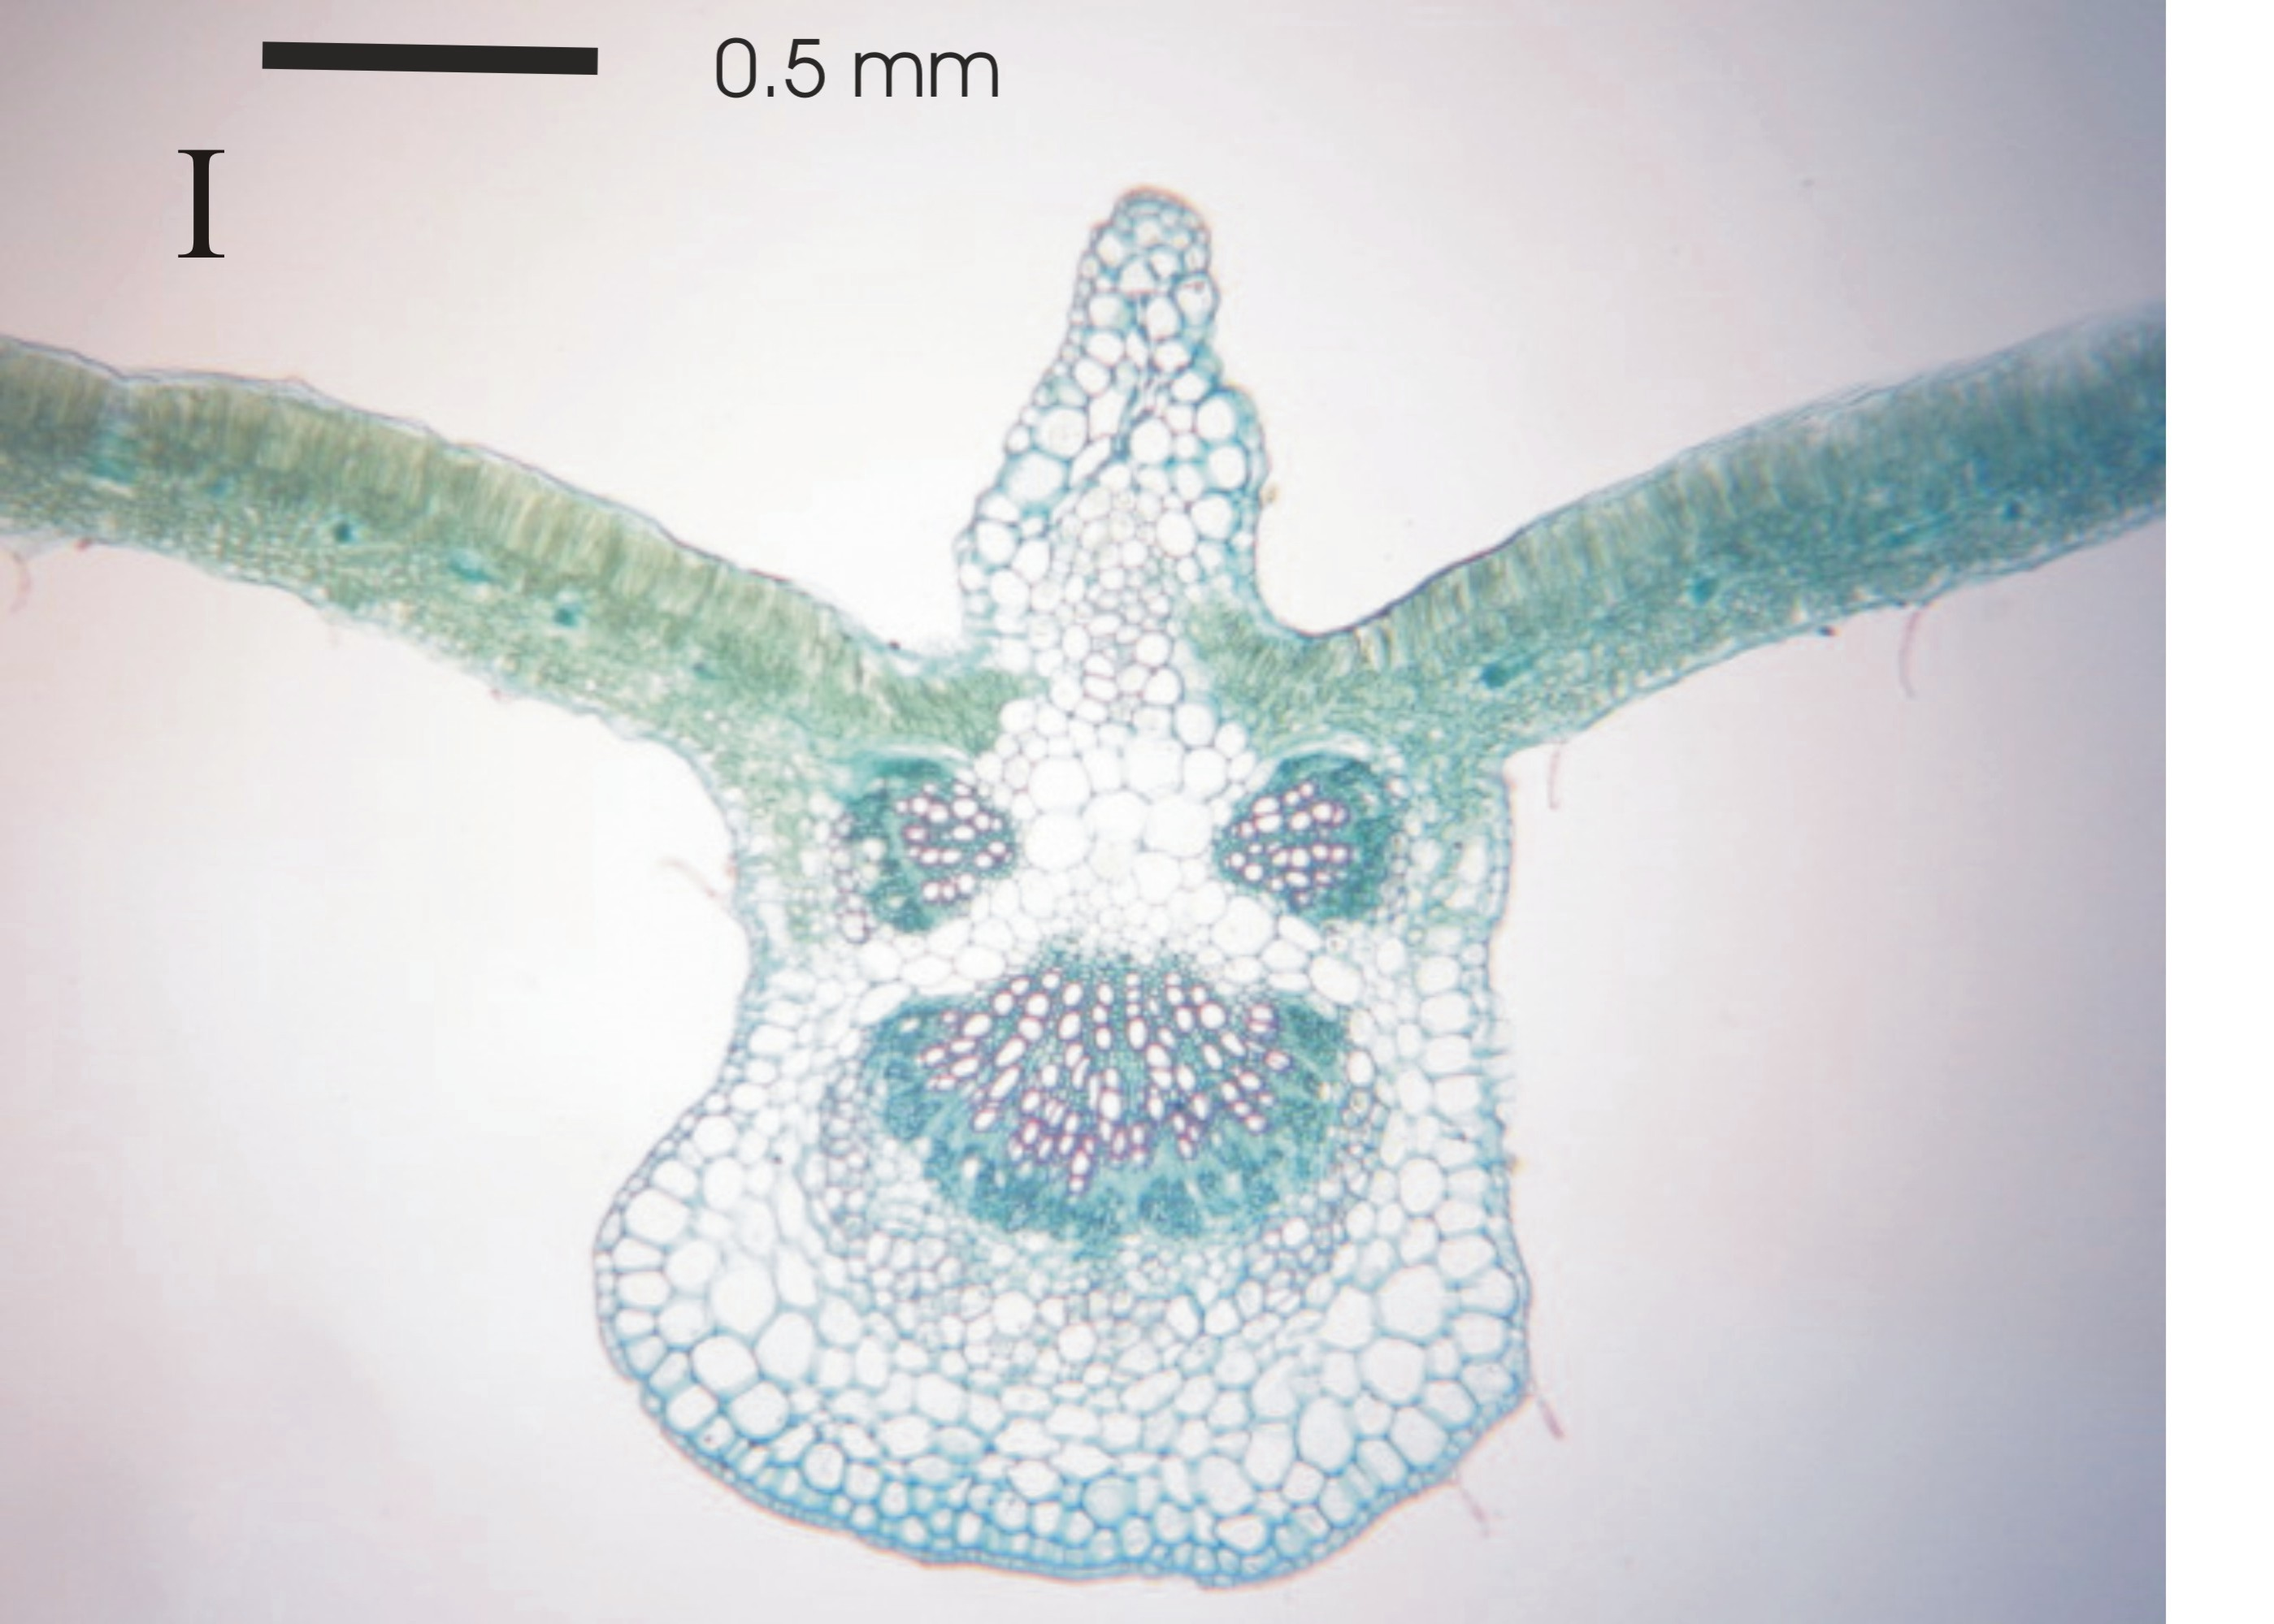

Fig. (1), Shows the effects of antioxidant treatments on measurements of certain anatomical feature in cross section of leaflet blade of snap bean plant (The bar for all plates = 0.5 mm)
A- Control B- Acetylsalicylic acid 75 ppm C- Acetylsalicylic acid 150ppm
D- Salicylic acid 50 ppm E- Salicylic acid 100 ppm F- Citric acid 0. 25%
G- Citric acid 0. 50% H- Vitamin E 75 ppm I- Vitamin E 150 ppm

Table (5). Effect of antioxidant treatments on anatomical characteristics of snap bean plant leaf at 50 days after sowing during second season (means of three sections from three specimens)
Treatments | Parameters
Treatments | Midrib |  |  |  | Lamina
Treatments | Width (µ) | Control as 100 | Thickness (µ) | Control as 100 | Blade thick. (µ) | Control as 100 | Palisade tissue thick. (µ) | Control as 100 | Spongy tissue thick. (µ) | Control as 100
Control | 1321.00 | 100.00 | 1991.57 | 100.00 | 201.57 | 100.00 | 71.00 | 100.00 | 99.14 | 100.00
Acetylsalicylic acid 75ppm | 1131.43 | 85.65 | 1990.86 | 99.96 | 342.00 | 169.67 | 118.43 | 166.80 | 146.57 | 147.84
Acetylsalicylic acid 150ppm | 1322.43 | 100.11 | 2090.00 | 104.94 | 263.86 | 130.90 | 92.00 | 129.58 | 120.00 | 121.04
Salicylic acid 50 ppm | 1328.14 | 100.54 | 2220.43 | 111.49 | 297.14 | 147.41 | 119.43 | 168.21 | 139.71 | 140.92
Salicylic acid100 ppm | 1125.71 | 85.22 | 1770.57 | 88.90 | 201.57 | 100.00 | 70.43 | 99.20 | 90.29 | 91.07
Citric acid 0. 25% | 1490.00 | 112.79 | 2180.86 | 109.50 | 243.29 | 120.69 | 109.14 | 153.72 | 111.29 | 112.25
Citric acid 0. 5% | 1635.57 | 123.81 | 2476.14 | 124.33 | 313.86 | 155.71 | 124.00 | 174.65 | 146.00 | 147.26
Vitamin E 75 ppm | 1455.00 | 110.14 | 2234.00 | 112.17 | 245.86 | 121.97 | 92.14 | 129.78 | 116.57 | 117.58
Vitamin E 150 ppm | 1346.00 | 101.89 | 2070.29 | 103.95 | 318.43 | 157.97 | 128.00 | 180.28 | 145.29 | 146.54

Table (5). Cont.
Treatments | Midvein vascular bundle parameters
Treatments | Width (µ) | Control as 100 | Thick. (µ) | Control as 100 | Xylem zone thick. (µ) | Control as 100 | Phloem zone thick. (µ) | Control as 100 | Av. diameter of xylem vessel (µ) | Control as 100 | No.of xylem vessel | Control as 100
Control | 713.71 | 100.00 | 504.00 | 100.00 | 292.71 | 100.00 | 170.86 | 100.00 | 31.00 | 100.00 | 41.00 | 100.00
Acetylsalicylic acid 75ppm | 638.43 | 89.45 | 510.43 | 101.28 | 292.71 | 100.00 | 160.86 | 94.15 | 31.71 | 102.30 | 39.00 | 95.12
Acetylsalicylic acid 150ppm | 837.14 | 117.29 | 635.43 | 126.08 | 335.86 | 114.74 | 214.29 | 125.42 | 33.14 | 106.91 | 49.00 | 119.51
Salicylic acid 50 ppm | 851.71 | 119.34 | 606.14 | 120.27 | 293.00 | 100.10 | 228.86 | 133.95 | 34.57 | 111.52 | 68.00 | 165.85
Salicylic acid100 ppm | 589.43 | 82.59 | 460.14 | 91.30 | 250.43 | 85.55 | 141.00 | 82.53 | 30.57 | 98.62 | 37.00 | 90.24
Citric acid 0. 25% | 923.14 | 129.34 | 597.00 | 118.45 | 338.86 | 115.76 | 184.29 | 107.86 | 40.00 | 129.03 | 75.00 | 182.93
Citric acid 0. 5% | 1070.71 | 150.02 | 688.43 | 136.59 | 341.71 | 116.74 | 244.57 | 143.14 | 40.14 | 129.49 | 77.00 | 187.80
Vitamin E 75 ppm | 825.14 | 115.61 | 572.29 | 113.55 | 301.71 | 103.07 | 227.43 | 133.11 | 37.14 | 119.82 | 50.00 | 121.95
Vitamin E 150 ppm | 864.29 | 121.10 | 645.00 | 127.98 | 304.00 | 103.86 | 229.29 | 134.20 | 36.57 | 117.97 | 70.00 | 170.73

Obtained results are in harmony with those reported by Uzunova and Popova (2000) and Stoyanova and Uzunova (2001) on barley plants as they reported that, barley leaves treated with different concentrations of salicylic acid (SA, 100 µM - mM) on light microscopy revealed that the thickness of all leaf tissue components decreased in SA treated plants. The effect was most pronounced on the width of the adaxial epidermis and on the size of the bulliform cells. The chloroplast ultrastructure was also affected by SA treatment. Swelling of grana thylakoid s in various degrees, coagulation of the stroma, and increase in chloroplast volume were observed, 1mM SA caused a vast destruction of the whole plastid structure Stoyanova and Uzunova (2001) which found that, treating barley plants with Salicylic acid at a rate of 1.0 mM led to thylakoid destruction and coagulation of the stroma.

Recommendation
From the previous results of this investigation, it could be recommend that spraying snap bean plants grown under sandy soil conditions with citric acid at 0.5 % , 0.25% or vitamin E at 150 ppm significantly enhanced plant growth, dry weight, pod yield and yield components as well as promotive anatomical plant traits.

Corresponding author
Nour, K. A. M
Vegetables research departments, Horticulture Research Institute, Agriculture. Research Center
dr_khaled_nour@yahoo.com

References
A.O.A.C. (1980): Association of Official Agriculture Chemists Official Method of Analysis 13th Ed. Washington, D.C.
Abd-Allah, E. M.; Issa M. A.; Abd El-Kader S. M.; Abd El-Salam H. S.and Abd El-Hakim, W. M. (2007): Effect of some antioxidants treatments on yield,some chemical constituents and antinutrional factors of some vegetable legumes. 1st Intr. Conf. Desert Cultivation Problems and Solutions, Minia Univ., 27-29 March.
Ali, A. A.; Ali T. B. and Nour K. A. M. (2009): Antioxidants and somenatural compounds applications in relation to tomato growth, yield and chemical constituents. Ann. Agric. Sci., Moshtohor, 47 (4): 469-477.
Amer, S. S. A. (2004): Growth, green pods yield and seeds yield of common bean (Phaseolus vulgaris L.) as affected by active dry yeast, salicylic acid and their interaction. J. Agric. Sci., Mansoura Univ., 29 (3): 1407-1422.
Awad, El- M. M.; and Safa A. A. Mansour (2007): Growth, yield and quality of potato as affected by some antioxidants. J. Agric. Sci., Mansoura 32 (8): 6661 6669. Univ.,
Baghizadeh, A. and Hajmohammadrezaei M.(2011): Effect of drought stress and its interaction with ascorbate and salicylic acid on okra (Hibiscus esculents L.) germination and seedling growth. J. of Stress Physiology and Biochemistry, 7(11): 55- 65.
Berlyn, G. P. and Miksche J.P. (1976): Botanical microtechnique and cytochemistry The Iowa State University Press, Ames, Iowa, pp.326
Brown, J. D. and Lilliland O. (1946): Rapid determination of potassium and sodium in plant material and soil extracts by flame photometry. Proc. Amer. Soc. Hort. Sci., 48:341-346.
Canakci, S. (2011): Effects of salicylic acid on growth, biochemica constituents in pepper (Capsicum annuum L.) seedlings. Pakistan J. Bio. Sci., 14: 300-304.
Duncan, B. D. (1955): Multiple range and multiple F-test Biometrics.11:1- 42.
Eisa, G.S.A.; Yousef R.M.M. and Khalafallah A.A. (2010): Water requirements of Roselle (Hibiscus sabdariffa L.) plants under differen rates of organic manures and yeast as relation to leaf anatomical structure. Zagazig J. Agric. Res., 37(1): 81-118.
El- Shraiy, A. M. and Hegazi A. M. (2009): Effect of acetylsalicylic acid, Indole-3- bytric acid and gibberellic acid on plant growth and yield of pea (Pisum sativum L.) Australian J. Basic and Appli. Sci., 3(4): 3514- 3523.
El-Tohamy, W. A. and N.H.M. El-Greadly (2007). Physiological responses, growth, yield and quality of snap bean in response to foliar application of yeast, vitamin E and zinc under sandy soil conditions. Australian J. Basic and Appl. Sci., 1(3): 294-299.
Faten, H. M. Ismaeil and Bakry, KH. A. (2005): Response of papaya plants to some chemical substances and yeast extract treatments. 3rd Scientific Conference (Prospects of Scientific Research in the area of Modern Agriculture): 129-150.
Gogoreena, Y.; Gordon, A. J.; Escured, P. R.; Witty, J. F. and Moran J. F. (1997): N₂fixation, carbon metabolism and oxidative damage in nodules of dark stressed common bean plants. Plant Physiol. 113:1193-1201.
Hess, J.L., (1983): Vitamin E, á-Tocopherol. In: Antioxidants in higher plants. R.G. Alscher and J.L. Hess (eds.). CRC press, Inc., Boca Raton., 111-134.
Jasiswal, P. K. and Bhambie, S. (1989): Effect of growth regulators substances on podding yield of Vigna radiate (L.). Acta Botanical Indica. 17(1):54-58.
Kahkonen, M. M.; Hopia, A. L.; Vuorela, H. J.; Rauha, J. P.; Pihlaja, K.; Kujala, T.S. and Heinonen, M. (1999): Antioxidant activity of plant extracts containing phenolic compounds. J. Agric. Food Chem. 47: 3954 3962.
Kalt, W. C.; Forney, F.; Martin, A. and Prior, R. L. (1999): Antioxidant capacity, vitamin C, phenolics and anthocyanins after fresh storage of small fruits. J. Agric. Food Chem. 47: 4638-4644.
Kanwischer, M. S.; Porfirova, E. and P. Dormann (2005): Alterations in tocopherol cyclase activity in transgenic and mutant plants of arapidopsis affect tocopherol content, tocopherol composition, and oxidative stress. Plant Physiol. 137:713-723.
Karadeniz, F.; Burdurlu H. S.; Koca N. and Soyer Y. (2005): Antioxidant activity of selected fruits and vegetables grown in Turkey. Turk. J. Agric. 29:197-203.
Kato-Noguchi, H. (1997): Effect of citrate on respiratory gas exchange and metabolism in carrot-root tissues. Phytochemistry, 45:225-227.
Kmal, A. K.; Amen E. A.; and Al-Said A. M. (2006): Response of snap bean (Phaseolus vulgaris L.) to some salicylic acid drevativs and selenium under high temberature stress. J. Agric. Sci., Mansoura Univ. 31 (11): 7321-7328.
Kock, F.G. and Mc-Meekin T.L. (1924): The chemical analysis of food and food products. Determination of total nitrogen by Nislar Solution. J. Amer. Chem. Soc.46: 2066.
Liu Xini.; Li Yun and Zhang Shuqiu (2000): Effect of salicylic acid on growth and content of IAA and IPA of broad bean seedlings. Plant communications. 36 (6):512-514. Physiology
Mady, M. A. (2009): Effect of foliar application with salicylic acid and vitamin E on growth and productivity of tomato (Lycopersicon esculentum Mill.) plant. J. Agric. Sci. Mansoura Univ., 34 (6): 6735 - 6746.
Maurice, R. M.; Kim J. and Wei C. I. (2000): Enzymatic browning in fruits, vegetables and seafoods. Food Science and Human Nutrition Department. University of Florida. 65:791-795.
Munne- Bosch, S. and Alegre L. (2002): The function of tocopherols and tocotrienols in plants. Crit. Rev. Plant Sci. 21:31-57.
Murphy, J. and Riley J.P. (1962): A modified single solution method for the determination of phosphate in natural water, Anal. Chim. Acta. 27: 31-36.
Paterson, T. J.; G.Baxter; J. Lawrence and G. Duthie (2006): Is there a role for dietary salicylates in health? Proc. Nutr. Soc. 65 (1): 93-96.
Rajagopal, S.; Joly D.; Gauthier A.; Beauregard M. and Carpentier R. (2005). Protective effect of active oxygen scavengers on protein degradation and photochemical functions during light stress. FEBS.J. 27:892902.
Sanaa, A. M. Z.; Ibrahim S. I. and Eldeen H. A. M. S. (2001):The effect of naphthalene acetic acid (NAA), salicylic acid on growth, fruit setting, yield and some correlated components in dry bean. Ann. Agric. Sci.,Cairo. 46 (2):451 463.
Schmitz, M. and Noga G. (1998): Á- Tocopherol reduced environmental stress and improved fruit quality. Acta Hort., 466: 89-94.
Sitaramaiah, K. and Pathak K. N. (1981): Effect of growth regulators, phenolics and aromatic acid on root knot severity on tomato. Zeitschrift fur pflanzenkrankhten und pflanzenschutz. 88 (11): 651-654.
Stejskal, D.; Proskova J.; Petrzzelova A.; Bartek J.; Oral I.; Lacnak B.; Horalik D. and Sekaninova S. (2001): Application of cationic propylgallate as inducer of thrombocyte aggregation for evaluation of effectiveness of antiaggregation therapy. Biomed. Papers. 145(2):69-74.
Smith, J. B.; Cumano J. C. and Balbs C. F. (1990): Quantitive effects of iron chelators on hydroxyl radical production by the superoxide-driven fenton reaction. Free Radical Res. Comm. 8:101-106. Snedecor, G. W. and Cochran W. G. (1980): Statistical Methods. 7th Ed. The Iowa State Univ., Press, Amer., Iowa, USA.
Stoyanova, D. and Uzunova A. (2001): Effects of salicylic acid on the structure of second leaves of Hordeum vulgare L. Biologia plantarum, 44 (2): 219-224.
Uzunova, A.N. and Popova L.P. (2000): Effect of salicylic acid on leaf anatomy and chloroplast ultrastructure of barley plants. Photosynthetica 38 (2): 243-250
Wada, L. and Ou B. (2002): Antioxidant capacity and phenolic content of Oregon cranberries. J. Agric. Food Chem. 50: 3495-350.
Youssef, N. S. and Abd-Allah E. M. M. (2007): Role of antioxidant treatments in improving potato yield and quality. Bull. Fac. Agric., Cairo Univ., 58:144-158.

4/4/2012

