Preparation And Characterization Of “Organic Solar Cells”

Vani Pawar

Department of Physical Sciences, Banasthali University, Banasthali- 304022, Jaipur, Rajasthan, India.
Email: vaniipawar@gmail.com

Abstract- Bulk hetero junction organic solar cells (OSC) were fabricated with an active polymer P3HT (acts as donor) and fullerene PCBM (acts as an acceptor). In the fabrication of OSC spin coating was used to deposit PEDOT-PSS thin film on ITO layer and P3HT-PCBM on top of PEDOT-PSS. Vacuum thermal evaporation processes were used to deposit Al as back electrode on P3HT-PCBM. The area of the device was 0.06 cm2. The thickness of the polymer layers were optimized using ellipsometric measurements. The calculated efficiency of the devices was found to be 1.3-1.5%.
[Vani Pawar. Preparation And Characterization Of “Organic Solar Cells”. New York Science Journal 2012;5(5):16-17]. (ISSN: 1554-0200). http://www.sciencepub.net/newyork. 3

Keywords: Organic solar cells, P3HT:PCBM, PEDOT:PSS, ITO

PACS: 71.20.Rv, 71.20.Tx, 71.35.-y

INTRODUCTION
As the global energy demand continues to increase every year, the limiting supply of today’s main energy sources (i.e. oil, coal, uranium) is a deep cause of concern. Considering the higher cost of manufacturing on inorganic solar cells, recently research and development work for the organic solar cells has been on an upswing [1]. Organic solar cells are made from electron donor and electron acceptor materials rather than semiconductor p-n junctions. Generally a polymer chain is donor (a conducting polymer e.g. P3HT) and the fullerene derivative such as PCBM acts as acceptor. An organic photovoltaics cell uses organic electronics. We have synthesized an organic solar cell which is discussed below.

EXPERIMENTAL DETAILS
In the fabrication of OSC spin coating and vacuum thermal evaporation processes were used. A conducting substrate ITO was patterned on a specific area for device fabrication. After patterning the deposition of hole transport layer (HTL) of PEDOT:PSS was applied by spin coating at 2000 rpm. The HTL deposited slide was annealed at a temperature of 120ºC for 60 min to dry the film. The deposition of active layer of P3HT:PCBM on PEDOT:PSS/ITO was performed with the help of spin coating at 1000 rpm. The active layer deposited ITO was annealed at 200ºC for 60 min. This annealing slight lowered open circuit voltage and also facilitated significant increment in both short circuit current and fill factor. The final step of fabrication of OSC was the thermal evaporation of Aluminum (electrode) at high vacuum. The schematic diagram of the synthesized device is given in figure 1.

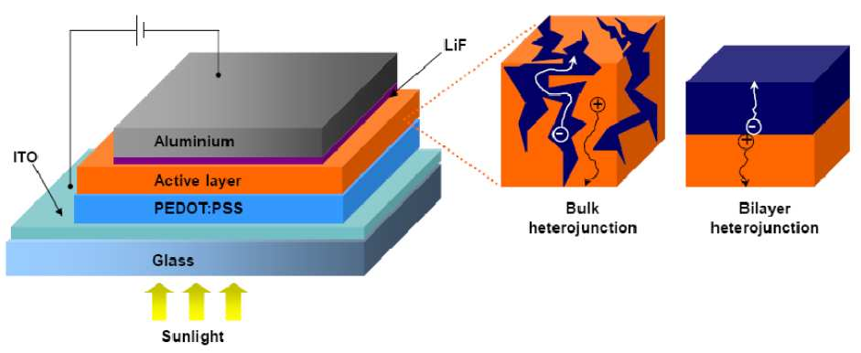
FIGURE 1: Schematic diagram of the structure of the synthesized organic solar cell.

CHARACTERIZATION OF ORGANIC SOLAR CELLS
The final thickness of PEDOT-PSS layer and active layer used in the synthesis were first optimized by depositing organic layers on silicon substrates under the identical conditions. The spinning speed was varied from 500-4000 rpm and the thickness was measured by ellipsometry technique. The transmittance of the samples was measured using UV spectrometer in the visible region of spectrum. We deposited the organic layers for which the transmittance was maximum. It was found that the absorbance of the light increase after annealing the active layer at 120 0C for 60 minutes as shown in figure 2.

FIGURE 2- Active layer (P3HT:PCBM, 1:1 W/W of 20mg/ml) thickness variation at different speeds. Inset shows absorbance of active layer (120nm).
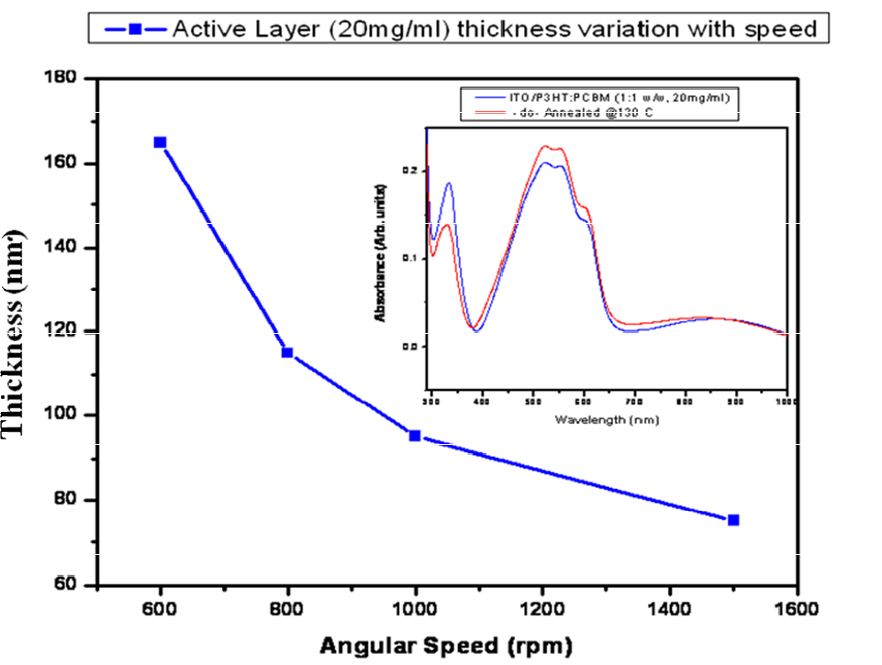

RESULT AND DISCUSSION
A chip of 2.5 x 2.5 cm2 contained 9 solar cells devices each of area 0.06 cm2. We measured short-circuit current (Isc) and open-circuit voltage (Voc) for the 6 devices which are listed in table 1. The corresponding short-circuit density and maximum power are also listed in the table 1. The fill factor FF is defined as-

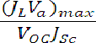

and the power conversion efficiency χ

were calculated from the above equations as shown in table 1. The efficiency was calculated under standard test conditions. The conditions include the temperature of the cell (25°C), the light intensity (1000 W/m2) and the spectral distribution of light (air mass 1.5 or AM1.5, which is the spectrum of sunlight after passing through 1.5 times the thickness of the atmosphere). The calculated efficiency of the solar cell devices was found to vary between 1.3 – 1.5 %. The typical I-V characteristics of the solar cell devices are plotted in figure 3.

Table 1: The measured and calculated parameters.
De  v.N  o. | Isc  (mA) | Jsc (mA/ cm2) | Voc  (V) | Pmax  (mW) | FF | Effi  cien cy (%)
1 | 79.45 | 1.324 | 0.368 | 10.14 | 0.345 | 1.33
2 | 86.27 | 1.437 | 0.385 | 11 | 0.326 | 1.43
3 | 76.1 | 1.268 | 0.428 | 10.13 | 0.311 | 1.34
4 | 67.6 | 1.126 | 0.433 | 9.56 | 0.326 | 1.42
5 | 82.12 | 1.368 | 0.449 | 11.73 | 0.317 | 1.54
6 | 75.77 | 1.262 | 0.392 | 11.414 | 0.392 | 1.51

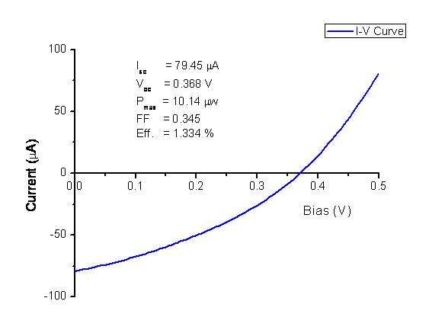
FIGURE 3: Typical I-V characteristics of the devices tested under white light.

ACKNOWLEDGEMENTS
I would like to specially thank Dr. D.K. Aswal, Head Thin Films Devices, Technical Physics Division, B.A.R.C, Mumbai for the guidance and support for the synthesis of solar cell device during my M. Sc. Project at BARC, Mumbai.

REFERENCES
- G Denneler, M. C. Scharaber and C. J. Brabec, Polymer-Fullerene Bulk Hetero-junction Solarcell, Adv. Mater, 21, 1323 (2009).
- Effect of P3HT:PCBM concentration in solvent on performances of organic solar cells- Woon-Hyuk.
- Baek, Hyun Yang, Tae-Sik Yoon, C.J. Kang, Hyun HoLee and Yong- Sang Kim
- An overview on P3HT:PCBM , the most efficient OSC material so far- Solid State Physics - Elbio Dagotto.
- MAYER. A.C, Scully, S.R; Hardin,B.E; Rowell,MW; M.C.Gehee, M.D, “Polymer based solar cells”, material todays; vol.10 NO.11, Nov(2007), PP-28-33.

4/4/2012

