Comparative Study between Damiana and Thyme on Nervous System Impairment during Aging

Neven, M. M¹, Sahar, A. Arafa¹, Nematalla, Kh. M¹ and Abdelaziz, M. H. M²

¹Special Food and Nutrition Department, Food Technology Research Institute, Agricultural Research Centre.
²Department of Molecular Biology, Division of Genetic Engineering, National Research Centre, Giza, Egypt

Abstract: As we age, the brain begins to loose function and memory also concentration can be affected by age. Food has the ability to change the production or release of neurotransmitters, the chemical messengers that carry information from one nerve cell to another, by altering the chemical composition in the brain. The brain generates more free radicals per gram of tissue than any other organ, so brain cells need extra antioxidant protection. This study was aimed to examine the effect of damiana and thyme leaves powders and water extracts on brain oxidative status in aged rats and measure serum levels of neurotransmitters in order to compare between these plants and find out the best source and the most effective way to maintain or improve nervous system functions during aging. A total of 42 Sprague-Dawley aged male rats weighing 370 to 385 g were divided into 7 groups, each group contained 6 rats. The first group fed on basal diet and considered as a control group. The other 6 groups of rats were studied according to the following scheme for 30 days: (1) aged rats fed on basal diet and administered 2 mg aldomet (methyldopa, ), which is an effective antihypertensive drug but with adverse effect on nervous system and adrenergic receptors, Gr.(2) aged rats fed on basal diet + aldomet + 2 mg damiana water extract, Gr(3) aged rats fed on basal diet + aldomet + 2 mg thyme water extract, Gr(4) aged rats fed on basal diet + aldomet + 5% damiana powder, Gr(5) aged rats fed on basal diet + aldomet + 5% thyme powder and Gr(6) aged rats fed on basal diet + aldomet + 2.5% damiana powder + 2.5% thyme powder. Blood samples were taken from each rat. Antioxidant enzymes SOD, GSH and GPx activities were assayed in blood and MDA and neurotransmitters levels in serum were also measured. At the end of the experiment, antioxidant enzymes and malondialdehyde levels were measured in brains which also histopathologically examined. It could be found that thyme water extract achieved the highest increase in antioxidant enzymes SOD, GSH and GPx in aged rats brains. Thyme leaves water extract and powder caused the highest reduction in MDA in rats brains. The highest increase in antioxidant enzymes in serum of aged rats was achieved by using thyme water extract and reached about 66.73%, 62.69% and 25.17% for SOD, GSH and GPx activities, respectively, followed by thyme leaves powder. The highest reduction in serum MDA level was 17.32% by using thyme leaves water extract. Administration of aldomet to aged rats caused a significant increase in serum neurotransmitters: dopamine, serotonin, noradrenaline and adrenaline compared with control aged rats. Studied materials caused significant increase in serum neurotransmitters levels compared with control aged rats, while caused significant decrease compared with control rats administered with aldomet which had a favorable effect on nervous system functions during aging. The most abundant phenolic compounds found in thyme leaves were catechein, pyrogallol, caffeic acid and catechol. Chlorogenic acid and chrisin were not detected in damiana leaves. From chemical, biological and histopathological examination of the studied materials, It could be concluded that thyme leaves were more effective than damiana leaves in achieving the desired results and water extracts were better than powders when administered to aged rats to improve nervous system functions during aging.
[Neven, M. M, Sahar, A. Arafa, Nematalla, Kh. M and Abdelaziz, M. H. M. Comparative Study between Damiana and Thyme on Nervous System Impairment during Aging. N Y Sci J 2012;5(5):50-61]. (ISSN: 1554-0200). http://www.sciencepub.net/newyork. 10

Key words: Damiana leaves, Thyme leaves, Antioxidant enzymes, Neurotransmitters, Brain, Aging.

1. Introduction:
Brain changes caused by aging are very essential in the process of senescence and is very much associated with impairments in cognitive and memory gaps. Age-related conditions such as depression or neurological diseases are possibly due to neurotransmitter chemical imbalance. There are many reasons for age related brain damage, but one of the main reasons is due to decreased circulation and stress. Because the brain has a high concentration of fatty tissues, fats comprise about 60% of each brain cell, it's more susceptible to damage from free radicals caused by oxidation process. Both structural and functional changes in the brain commonly associated with aging can result to an increase in a person's risk towards cognitive, neurologic and psychiatric complications (Plassman et al., 2010). In the central nervous system, tyrosine and tryptophan are converted to aromatic amine modulators (neurotransmitters) such as adrenaline, noradrenaline, dopamine and serotonin (5-hydroxytryptamine). Adrenal glands secrete adrenaline (Ad) (80%) + noradrenaline (NA) and dopamine (DA) (20%), approximately. Sympathetic nerves release NA (80-90%) plus DA (10-20%). Both branches of the peripheral sympathetic activity may act in association or dissociation. These neurotransmitters act via G protein–coupled receptors, which comprise a huge family of about 800 proteins with 7 trans-membrane domains (Goddard and Abrol, 2007).
Markers of human brain dopamine and serotonin metabolism are reported to decline with age. However, the cerebrospinal fluid (CSF) concentrations of homovanillic acid (HVA) and 5-hydroxy indole acetic acid (HIAA), metabolites of dopamine and serotonin, respectively, are reported to decrease in elderly individuals. There is a known natural age–related decrement in HVA and HIAA concentrations and it was found that the rate of HVA delivery from the brain to CSF had a 50% decline in elderly individuals with consistent with other evidence that brain dopaminergic neurotransmission declines with age (Assmann et al., 2002 and Rapoport et al., 2004). Aging results in a decrease in the dopamine and serotonin production and since serotonin plays a critical role in behavior, control of sleep, appetite and neuroendocrine function, a decrease in serotonin levels will have effects on these behaviors. In the presence of stimulants, synaptic levels of monoamine neurotransmitters are elevated in neurons, specifically dopamine, serotonin and nor-adrenaline as a result of blocking transporter–mediated reuptake inhibitors from the synapse (Humphries et al., 2008 and Sofuoglu and Sewell, 2009).
It has been reported that Iron (Fe⁺³) can increase oxidation of monoamine such as serotonin and dopamine also increase the cytotoxicity of dopamine by increasing in its oxidation rate without intervention of monoamine oxidase B enzyme. These observations are relevant to the mechanism by which dopaminergic neurons are destroyed in neurodegenerative disorders. Generally, metals Mn & Co can oxidize monoamines either directly or through oxygen free radicals produced bt irin. Many studies have proposed that iron induces lipid peroxidation and demonstraded in confirmation that iron behaves like oxidants and super oxide radicals. Zn as an essential minerals is found in almost every cell that participates in various activities of approximately 300 enzymes (Velez et al., 1998).
Damiana (Turnera diffusa) is a relatively small shrub. Damiana herb has the ability to act as a tonic and restorative agent on the functioning of the nervous system. It has long been claimed to have a stimulating effect and commonly used to treat nervousness, exhaustion and depression. Damiana contains flavonoids that act on benzodiazepine and gama amino butyric acid receptors which exhibit anxiolytic activity, muscle relaxation and sedation. The flavonoids found in damiana caused an improvement in rat colonic oxidative status, since the infusion of damiana leaves prevented the glutathione depletion that occurred as a consequence of the colonic inflammation (Remick, 2002; Galvez et al., 2006 and Estrada–Reyesb et al., 2009). Thyme herb (Thymus vulgaris) is packed with numerous health benefiting phyto-nutrients, minerals and vitamins that are essential for wellbeing. Thyme functions as a liver decontamination tonic, promotes blood circulation and functions as an exciting stimulant for the entire system. The stimulating action on the nervous system makes the herb a brilliant remedy for physical as well as mental fatigue, alleviating tension, anxiety and sleeplessness. The herb is also effective in treating depression or mood changes (Höferl et al., 2006). Antioxidant fractions from four herb species: rosemary, sage, thyme and hyssop were isolated using supercritical carbon dioxide. The antioxidant activity of the extracts was compared to the activity of butylated hydroxy anisole (BHA). In DPPH radical assay, the order from the strongest to the weakest antioxidant activity was: BHA, thyme, rosemary, sage and hyssop extracts, respectively (Babovic et al., 2010).
Age–related changes in brain functions are caused by imbalances in brain chemistry (neurotransmitters). Brain chemistry can be tested and successfully treated without resorting to drugs by using natural supplements and plants which involves the use of plant extracts or their active components. The aim of this study is to examine the effect of damiana and thyme leaves powders and water extracts on brain oxidative status in aged rats and measure serum levels of neurotransmitters in order to compare between these plants and find out the best source and the most effective way to maintain or improve nervous system functions during aging.

2.Material and Methods
Materials:
The aerial part of damiana (Turnera diffusa), Turneraceae family and thyme leaves (Thymus vulgaris L.), Lamiaceae family were purchased as powdered form from local market of Giza Governorate, Egypt.

Methods:
Chemical Composition:
Crude protein, ether extract, total ash and crude fiber contents of damiana and thyme leaves powders were determined as described in A.O.A.C. (2006). Mineral contents were measured by atomic absorption photometer as mentioned by Usovich et al. (1975). High–performance liquid chromatorgraphy (HPLC) coupled with diode–array detection was used to identify the phenolic compounds in damiana and thyme leaves methanolic extracts as mentioned by Zheng and Wang (2001).

Preparation of Water Extracts:
Water extracts of damiana and thyme leaves were prepared by shaking the dried powders with water for 24 hrs. at room temperature to obtain aqueous extracts. All the plant extracts were stored at –30ºC in the dark until used as described by Lalone et al. (2007).

Animals and Experimental Diets:
A total of 42 Sprague-Dawley aged male rats were obtained from Ophthalmology Research Institute, Giza, Egypt. All rats weighing 370 to 385 g were fed on basal diet for one week (adaptation period). The basal diet composed of casein (15%), cellulose (5%), vitamins mixture (1%), salts mixture (4%), corn oil (10%) and corn starch (65%). The basal diet formulation was performed according to Zamora et al. (1991). The rats were divided into 7 groups, each group contained 6 rats. The first group fed on basal diet and considered as a control group. The other 6 groups of rats were studied according to the following scheme for 30 days: Gr(1) aged rats fed on basal diet and administered 2 mg aldomet (methyldopa), which is an effective antihypertensive drug but with adverse effect on nervous system and adrenergic receptors, Gr(2) aged rats fed on basal diet + aldomet + 2 mg damiana water extract, Gr(3) aged rats fed on basal diet + aldomet + 2 mg thyme water extract, Gr(4) aged rats fed on basal diet + aldomet + 5% damiana powder, Gr(5) aged rats fed on basal diet + aldomet + 5% thyme powder and Gr(6) aged rats fed on basal diet + aldomet + 2.5% damiana powder + 2.5% thyme powder. The mg doses were taken for each rat once daily using a stomach tube before meal, while the percentage doses were added to the diet. Blood samples of rats were taken from orbital plexus venous by using capillary glass tubes. Blood samples were allowed to clot for one min. at 37ºC, centrifuged at 1500 xg for 10 min. and the separated serum was kept frozen at -20ºC until analysis.

Biochemical Analysis:
The activity of superoxide dismutase (SOD) in serum was estimated according to Marklund and Marklund (1974). Glutathione reduced (GSH) was measured as described by Faris and Reed (1987). Glutathione peroxidase (GPx) and lipid peroxidation level (malondialdehyde, MDA) were estimated according to the methods described by Daret and Ching (1996) and Meltzer et al. (1997), respectively. Neurotransmitters: adrenaline, noradrenaline, dopamine and serotonin in serum were extracted and estimated according to the method of Chang (1964) modified by Ciarlone (1978).

Brain Oxidative Status:
Rats were killed at the end of the experimental period, the brains were isolated, weighed and homogenized immediately with ice cold 5% KCL. The supernatant was separated by centrifugation at 5000 rpm for 10 min. and stored at -80ºC until used. Antioxidant enzymes SOD and GPx and lipid peroxidation product MDA and GSH were estimated in the homogenized supernatant.

Histopathological Examination:
The brains were rapidly and carefully excised at the end of the experimental period and then dissected on dry ice glass plate according to the method of Glowinski and Iversen (1966). The brain tissues were wiped dry with a filter paper, weighed, wrapped in plastic films and then in aluminum foil and quickly frozen in dry ice until analysis.

Statistical Analysis:
The standard analysis of variance procedure in a completely randomized design was applied for the present data according to Gomez and Gomez (1984). Least significant difference (LSD) test was done to compare a pair of group means. The level of statistical significance was set at p< 0.05.

3. Results and Discussion
Chemical Composition of Damiana and Thyme Leaves:
Data presented in Table (1) show the chemical composition of damiana and thyme leaves (% fresh weight basis). It was found that thyme leaves contained higher percentage of crude protein 5.56 ± 0.12% and crude fiber 14.34 ± 0.31% than damiana leaves. Ether extract (fat) contents of damiana and thyme leaves were 6.12 ± 0.04% and 6.31 ± 0.06%, respectively. The most abundant constituents of the oils from the leaves of damiana were caryophyllene, cadinene, elemene and 1,8-cineol. A total of 19 compounds have been identified in thyme oil including 25% carvacrol, 23.8% thymol, 19.8% geraniol and 30% linalool of which thymol and carvacrol had antioxidant capacity and could become biologically active compounds for pharmaceutical industry (Goncalves et al., 2010 and Pino, 2010). Table (2) shows the microelements content of damiana and thyme leaves (ppm.). It was found that damiana leaves contained higher amounts of Mg, Mn, Fe and Ca than thyme leaves. Thyme leaves had higher amounts of potassium than damiana leaves, which was in agreement with the results mentioned by Eisenberg et al. (1993) who found that thyme leaves are one of the richest sources of potassium, iron, calcium, manganese, magnesium and selenium.

Table (1): Chemical composition of damiana and thyme leaves (% fresh weight basis).
Chemical composition (%) | Damiana leaves | Thyme leaves
Crude protein  Ether extract  Total ash  Crude fiber | 4.24 ± 0.17  6.12 ± 0.04  0.91 ± 0.03  10.68 ± 0.13 | 5.56 ± 0.12  6.31 ± 0.06  0.82 ± 0.07  14.34 ± 0.31

Table (2): Microelements content of damiana and thyme leaves (ppm.).
 | Mg | Na | K | Mn | Fe | Zn | Ca
Damiana leaves | 2240.16 | 1014.70 | 3871.62 | 42.26 | 425.71 | 27.10 | 7475.75
 | ± 97.33 | ± 58.90 | ± 145.12 | ± 4.09 | ± 31.25 | ± 1.23 | ± 292.05
Thyme leaves | 1678.41 | 1045.73 | 4750.83 | 37.22 | 383.22 | 31.30 | 5838.06
 | ± 79.60 | ± 65.60 | ± 183.60 | ± 3.26 | ± 23.12 | ± 2.34 | ± 264.07

Data presented in Table (3) show phenolic compounds which were identified and quantified in damiana and thyme leaves methanolic extracts using HPLC. Thyme leaves methanolic extract contained more catechein, pyrogallol, POH-benzoic acid, caffeic acid, catechol, syringic acid and caffeine contents than damiana leaves methanolic extract. Chlorogenic acid and chrisin were not detected in damiana leaves. The most abundant compounds found in thyme leaves were catechein, pyrogallol, caffeic acid and catechol. A significant relationship between antioxidant capacity and total phenolic content was found, indicating that phenolic compounds are the major contributors to the antioxidant properties of plants (Dudonnē et al., 2009). A correlation between the antioxidant activity and chromatographic profiles of damiana leaves extracts was established using HPLC and the optimal number of components was five. The HPLC analysis showed the presence of caffeine, arbutine and flavonoids as the main compounds in the active extract. The compound showing the best antioxidant activity was 8-C-beta–[6-deoxy-2-O-(alpha-1-rhamnopyranosyl)–xylo-hexopyranos-3–uloside] and damiana is the only natural source from which this compound has been reported (Pērez-Meseguer et al., 2010 and Garza-Juārez et al., 2011). Regarding the polyphenolic compounds profile of thyme, rosmarinic acid, followed by apigenin, ferulic, carnosic and caffeic acids were the phenolic compounds quantified at the highest concentrations (Maria-Jordān et al., 2009).

Effect of Studied Materials on Body Weight in Aged Rats:
The effect of aldomet, damiana and thyme leaves water extracts, damiana and thyme leaves powders and damiana powder + thyme powder on the loss of weight in aged rats was tabulated in Table (4). The loss in body weight was recorded at equal intervals during experimental period, i.e., at zero time, 15 days and 30 days (the end of the experiment). Body weight of control aged rats for all groups at zero time was not significantly different and also during the experimental period. There was a significant gradual decrease in body weight for all treatment groups from zero time to the end of the experiment. Body weight of treated groups was not significantly different from each other at the end of the experiment but it was statistically significantly different compared with control aged rats and aged rats administered with aldomet. The reduction in body weight was 10.43%, 16.12%, 18.40%, 16.56%, 17.57% and 15.77% for aged rats administered with aldomet, damiana water extract, thyme water extract, damiana powder, thyme powder and damiana powder + thyme powder, respectively compared with control aged rats at the end of the experiment. These results indicate that thyme leaves water extract caused more body weight reduction followed by thyme leaves powder and damiana powder. Thyme leaves caused much effective weight loss compared with damiana leaves.

Effect of Studied Materials on Oxidative Status in Aged Rats Brains:
In the present study, we chose to use aldomet (methyldopa), which is an effective antihypertensive drug but with adverse effect on nervous system and adrenergic receptors. Methyldopa caused sedation, headache, asthenia and psychic disturbances including nightmares, impaired mental acuity and reversible mild psychoses or depression. The adrenergic receptors remain sensitive during treatment with methyldopa. Disorders of tyrosine hydroxylase and of aromatic amino acid decarboxylase lead to decrease in both HVA and 5-HIAA (metabolites for neurotransmitters) and an elevation of the precursors L-dopa and 5-hydroxytryptophan. The L-dopa is further metabolized to form 3-O-methyldopa, which accumulates in cerebrospinal fluid, urine and plasma. 3-O-Methyldopa can be further metabolized to vanillactic acid (Hyland et al., 1992).
Data presented in Table (5) show the effect of studied materials on oxidative status: antioxidant enzymes and lipid peroxidation products in aged rats brains at the end of the experiment. Superoxide dismutase (SOD) activity in rat brain homogenates was significantly increased in all treatment groups compared with control aged rats and control rats administered with aldomet, which were not significantly different from each other. Thyme water extract group achieved the highest increase in SOD activity followed by damiana water extract group. Damiana powder + thyme powder group recorded the lowest increase which was significantly different compared with other treatments. Glutathione reduced levels (GSH) were significantly increased as a result of administering thyme water extract compared with other treatments and the increase reached about 57.12% compared with control aged rats. Control rats administered with aldomet group was significantly different compared with other treatments which were not statistically different from each other except for thyme water extract group.

 | Phenolic compounds
 | Catechein | Pyrogallol | Chlorogenic  acid | POHBenzoic  acid | Caffeic  acid | Catechol | Syringic  acid | Caffeine | Salcilic  acid | Cinnamic  acid | Chrisin
Damiana leaves | 5.56  +  0.13 | 120.67  +  12.36 | N.D. | 1.46  +  0.10 | 3.09  +  0.83 | 3.41  +  0.73 | 15.84  +  2.01 | 3.09  +  0.63 | 26.29  +  4.21 | 1.17  +  0.06 | N.D.
Thyme leaves | 58.52  +  4.06 | 502.01  +  74.16 | 22.12  +  2.08 | 1.93  +  0.17 | 9.89  +  1.66 | 33.12  +  3.24 | 22.65  +  1.06 | 14.31  +  0.26 | 24.61  +  3.08 | 1.12  +  0.02 | 0.52  +  0.03
Table (3): Phenolic compounds content of damiana and thyme leaves methanolic extracts (mg/100g).
N.D. = not detected in the methanolic extract of leaves.

Concerning glutathione peroxidase activity (GPx), the increase as a result of administering treatment materials was about 15.02%, 28.27%, 8.35%, 24.22% and 0.67% for damiana water extract, thyme water extract, damiana powder, thyme powder and damiana powder + thyme powder groups, respectively compared with control aged rats. From these results, it could be concluded that thyme water extract achieved the highest increase in antioxidant enzymes SOD, GSH and GPx followed by damiana water extract, thyme powder, damiana powder and at last damiana powder + thyme powder except for GPx. From Table (5), it could be found that aged rats had higher levels of lipid peroxidation byproducts in brains as a result of aging. Administering aged rats with treatment materials caused a significant reduction in malondialdehyde levels (MDA) except for damiana powder + thyme powder group compared with control aged rats and control rats administered with aldomet which were not significantly different from each other. The reduction in MDA levels reached about 6.54%, 16.23%, 7.80%, 14.09% and 2.94% for damiana water extract, thyme water extract, damiana powder, thyme powder and damiana powder + thyme powder groups, respectively. Thyme leaves water extract and powder caused the highest reduction in lipid peroxidation in rats brains.
Youdim and Deans (2000) found that there were significant declines in superoxide dismutase and glutathione peroxidase activities and the total antioxidant status with age in rat brains. Thyme oil and thymol fed aged rats maintained significantly higher antioxidant enzyme activities and total antioxidant status. The levels of antioxidant enzymes SOD and GPx in the brains of the rats receiving thyme were comparable to enzymes levels of much younger rats. Also, the levels of certain healthy fats, omega-3 fatty acids, were significantly higher in the thyme supplemented rats. Thyme may support brain health. Aging caused a reduced capacity of cellular homeostatic mechanisms that protect the body against oxidative insults and this was very obvious in the age–related decline in glutathione reduced (GSH) levels. Decline in constitutive GSH levels adversely affects cellular thiol redox balance and leaves the cell susceptible to stresses. Conversely, increasing GSH steady-state levels and its rate of synthesis enhanced protection against oxidative insults (Hagen et al., 2002). This was in agreement with the present results, which confirmed that aging caused decline in antioxidant enzymes SOD, GSH and GPx in rats brains and this decline could be enhanced by administering aged rats with damiana and thyme leaves which significantly raised the levels and activities of antioxidant enzymes. Lipid peroxidation inhibition in rat brain homogenates was studied by Nascimento et al. (2006) and Shati and Fahmy (2009), who found that there was very highly significant increase in nitric oxide and malondialdehyde (MDA) levels in liver and brain of mice administered with alcohol. Also, a very high significant decrease in total antioxidant capacity and GPx activity was noticed. Administering these mice with damiana leaves hydroethanolic extract or water extracts of thyme and ginger caused peroxidation suppression and exhibited greater antioxidative activity. Phenolic compounds found in damiana and thyme may be responsible for this antioxidant capacity.

Effect of Studied Materials on Serum Oxidative Status in Aged Rats:
In the aging process, oxidative damage can result when the critical balance between free radical generation and antioxidant defenses is unfavorable. Free radicals if not quenched by antioxidants, will react with and potentially alter the structure and function of several cellular components. Antioxidant enzymes defense system act to prevent radical formation, remove radicals before damage can occur, repair oxidative damage and eliminate damaged molecules (Rock et al., 1996). From Table (6) it could be found that, superoxide dismutase (SOD), glutathione reduced (GSH) and glutathione peroxidase (GPx) activities of control aged rats and control rats administered with aldomet were not significantly different at zero time and during the experimental period. Aged rats groups fed on basal diet and administered damiana and thyme leaves water extracts and powders resulted in an increase in all antioxidant enzymes studied in serum of aged rats. The highest increase was achieved by using thyme water extract and reached about 66.73%, 62.69% and 25.17% for SOD, GSH and GPx activities, respectively compared with control aged rats at the end of the experiment. Thyme water extract caused significant increase in antioxidant enzymes studied compared with damiana water extract followed by thyme leaves powder and the lowest increase was obtained by using damiana powder + thyme powder (1:1) for the three antioxidant enzymes. In a normal diet, intake of 1 g of thyme leaves may therefore make a relevant contribution (<1m mol) to the total intake of plant antioxidants and be an even better source of dietary antioxidants than many other food groups (Dragland et al., 2003). Data presented in Table (6) show that serum of aged rats had higher levels of malondialdehyde (MDA), a by product of lipid peroxidation, as a result of aging. The oxidation of lipids by reactive oxygen and nitrogen species results in by products such as trans–4–hydroxy-2-nonenal, malondialdehyde and crotonaldehyde. These intermediates can react with DNA bases to form exocyclic DNA adducts. Peroxidation of lipids, particularly polyunsaturated fatty acids, can dramatically change properties of biological membranes resulting in severe cell damage and could play a significant role in pathogenesis of diseases (Nair et al., 2007). The highest reduction in MDA levels was about 17.32% by using thyme leaves water extract compared with control aged rats at the end of the experimental period. All studied materials were not significantly different compared with each other for MDA levels, but they were significantly different compared with control aged rats and control rats administered with aldomet which were not different at zero time and during the experimental period. Damiana leaves water extract caused 13.08% reduction in MDA level at the end of the experiment. The aerial part of damiana (Turnera diffusa) extract reduced DPPH levels by more than 50% and showed significant anti-lipid peroxidant effect in vitro by reducing malondialdehyde levels in human hepatoma cell line (Huh 7). The hepatoprotective effects of damiana extract may result from its antioxidative properties (Torres-Gonzalez et al., 2011).

Effect of Studied Materials on Neurotransmitters Levels in Serum of Aged Rats:
Mora et al. (2007) suggested that aging is a physiological process that occurs asynchronously in different areas of the brain and that the role of that process is modulated by environmental factors and related to the neuronal-synaptic-molecular substrates of each area. Data presented in Table (7) show the effect of studied materials on serum neurotransmitters in aged rats. Aged rats were administered with aldomet which had the ability to inhibit dopa decarboxylase and to deplete animal tissues of noradrenaline resides solely in the L-isomer (methyldopa), which raised serum concentrations of neurotransmitters by preventing decarboxylation of neurotransmitters precursors and allows more to enter the brain and prevents catabolism of the neurotransmitters (Blau et al., 2002). From Table (7), it could be noticed that administration of aldomet to aged rats caused a significant increase in all neurotransmitters studied in serum: dopamine, serotonin, noradrenaline and adrenaline compared with control aged rats and all the studied materials at the end of the experimental period. Administering aged rats the studied materials caused significant increase in serum neurotransmitters levels compared with control aged rats during the whole experiment. The highest increase was achieved by using thyme leaves water extract. On the other hand, studied materials caused significant decrease in serum neurotransmitters levels when compared with aged rats administered with aldomet, which had a favorable effect on nervous system functions during aging.
It has demonstrated that the addition of the dopaminergic component produces more robust effects than single or dual-acting compounds. Dopamine may promote neurotrophic processes in the adult hippocampus, as serotonin and noradrenaline do. It is thus possible that the stimulation of multiple signaling pathways resulting from the elevation of all three monoamines may account, in part, for the use of the triple reuptake inhibitors that simultaneously inhibit serotonin, noradrenaline and dopamine reuptake thereby prolonging their duration of action at postsynaptic levels (Guiard et al., 2009). Studies have shown that free serotonin is raised in stressed mammals and severely ill humans under oxidative conditions. Acute exercise associated with oxidative insult raises the blood-brain transport of tryptophan, the precursor of serotonin, thereby increasing the rate of serotonin synthesis and metabolism and it could also lead to an increment in serum levels. Increased circulating catecholamines, i.e., adrenaline, noradrenaline and dopamine are responsible for increased free serotonin during stressful situations such as aging (Lechin et al., 1996 and Placidi et al., 2001). Dopamine is made from the amino acid tyrosine and once produced, it can in turn convert into the brain chemicals noradrenaline and adrenaline. Elevation of dopamine levels may lead to a sleepy state and the propensity to have an addictive behavior. Dopamine is an important brain chemical involved in motor functions, general arousal, the ability to learn and the encoding of stimuli (Parket et al., 2002). Butanol fraction and methanol extract of damiana leaves were found to exhibit significant antianxiety activity for treatment of anxiety neurosis in mice at the dose of 10 mg/kg and 75 mg/kg, respectively. Also, the methanol extract of damiana leaves had highly significant and dose dependent relaxant activity on smooth muscle with vasodilatory effects. Damiana can possibly be short-term monoamine oxidase inhibitor (MAOi), a class of antidepressant drug, it works as an inhibitor of MAO-A and MAO-B enzymes due to its active chemical activity of binding with these enzymes, which are responsible for inactivation of neurotransmitters resulting to treatment of depression and nervous exhaustion (Hnatyszyn et al., 2003; Kumar and Sharma, 2005 and Kumar et al., 2006). Thymol is a monocyclic phenolic compound, the usual natural source being the essential oil of Thymus vulgaris (thyme) and also found in damiana. It is employed as a preservative on the strength of its antimicrobial and antioxidant properties. Thymol was shown to have a direct agonist effect on heterologously expressed human gama amino butyric acid (GABA) receptors. GABA is the chief inhibitory neurotransmitter in central nervous system and plays an important role in the release of the neurotransmitters. It initiates the action of the natural inhibitory transmitter by increasing the permeability to C1 ions, thus decreasing the propability of release of quanta of excitatory transmitter. Thymol resulted in dose-dependent potentiation of the GABA response (Priestley et al., 2003 and Patel et al., 2005).

Histopathological Changes:
A phytochemical investigation of damiana afforded 35 compounds, comprised of flavonoids, terpenoids, saccharides, phenolics and cyanogenic derivatives including luteolin and apigenin. These compounds are also found in thyme leaves. Upon the reactive oxygen species (ROS) insulted primary neurons, luteolin concentration dependently enhanced neuronal cell survival with efficacy higher than and potency similar to vitamin E. Luteolin significantly attenuated the increase in ROS production and prevented the decrease in activities of catalase and glutathione in ROS-insulted primary neurons. Thus, luteolin functions by neuroprotection possibly through a rebalancing of pro-oxidant-antioxidant status and preventing neurodegenerative diseases as well as improving brain aging (Zhao et al., 2007 and Gang et al., 2010). To confirm the results obtained in the present study, we conducted a histopathological examination on rats brains at the end of the experimental period. We studied the effect of administering damiana and thyme leaves water extracts and powders on changes in brain tissues compared with control aged rats and control rats administered with aldomet (Fig. 1). Examined sections of brain tissues of control aged rats showed the cell bodies of different brain cells and its fibers. However, brain of control rats administered with aldomet showed severe pericellular edema around the cell bodies of nerve cells. Brain of rats administered with damiana water extract showed slight edema around some capillaries, while brain of rats administered with thyme water extract showed no histopathological changes from control aged rats. Damiana powder administered to aged rats caused nearly changed brain structure in the examined sections. Brain of rats administered with thyme powder showed some pericellular edema around some cells but most of the structure is unchanged, while brain of rats administered with damiana + thyme powders showed swelling of some cell bodies of nerve cells. Administering aged rats with thyme water extract and powder caused a high significant improvement in the histopathological changes compared with control rats administered with aldomet. In control aged rats which given aldomet, there was severe changes most probably due to destruction of enzymes or coenzymes needed for secretion of dopamine and serotonin in hypothalamus. However, in damiana and thyme groups the structure of brain cells was nearly normal and this may be due to the role of both in production of enzymes for dopamine secretion. Damiana and thyme may contain the precursor substrate for dopamine and serotonin secretion.

Table (4): Effect of studied materials on body weight in aged rats.
Groups | Body weight (g)
Groups | At zero time | After 15 days | At the end
Control aged rats | 373.66A | 377.50A | 380.33A
Control + aldomet | 375.00A | 348.33B | 340.66B
Damiana water extract | 378.33A | 347.63B | 319.00C
Thyme water extract | 381.66A | 344.31B | 310.33C
Damiana powder | 375.66A | 346.66B | 317.36C
Thyme powder | 372.43A | 344.00B | 313.50C
Damiana powder + thyme powder | 379.00A | 352.66B | 320.33C
L.S.D. | 10.11 | 12.76 | 10.32
* Numbers in the same column followed by the same letter are not significantly different at p > 0.05
* L.S.D. for interaction between time and treatments = 14.33

Table (5): Effect of studied materials on oxidative status in aged rats brains.
Groups | SOD  (U/mL) | GSH  (ng/dl) | GPx  (U/mL) | MDA  (n mol/mL)
Control aged rats | 5.23±….A | 6.53±….A | 11.85±….A | 1188.33±….A
Control + aldomet | 5.93 ±….A | 6.80±….A | 11.33±….A | 1160.20±….A
Damiana water extract | 10.77±….B | 8.93±….B | 13.63±….B | 1110.60±….B
Thyme water extract | 11.87±….BC | 10.26±….D | 15.20±….C | 995.44±….C
Damiana powder | 9.63±….B | 8.41±….B | 12.84±….B | 1095.63±….B
Thyme powder | 9.85±….B | 8.65±….B | 14.72±….C | 1020.84±….C
Damiana powder + thyme powder | 7.74±….D | 7.86±….BC | 11.93±….A | 1153.36±….A
L.S.D. | 1.55 | 1.03 | 0.90 | 36.13

* Numbers in the same column followed by the same letter are not significantly different at p > 0.05

Table (6): Effect of studied materials on serum oxidative status in aged rats.
Groups | SOD  (U/mL) |  | GSH  (ng/dl) |  | GPx  (U/mL) |  | MDA  (n mol/mL)
Groups | Zero | End | Zero | End | Zero | End | Zero | End
Control aged rats | 53.51±…A | 46.38±…A | 25.70±…A | 23.83±…A | 145.33±…A | 146.73±…A | 255.63±…A | 257.33±…A
Control + aldomet | 45.53±…A | 53.40±…A | 24.23±…A | 27.65±…A | 151.60±…A | 153.33±…A | 246.26±…A | 248.53±…A
Damiana water extract | 53.60±…A | 64.58±…AB | 27.26±…A | 34.73±…B | 155.38±…A | 167.64±…B | 253.74±…A | 223.66±…B
Thyme water extract | 54.34±…A | 77.33±…C | 26.44±…A | 38.77±…C | 153.43±…A | 183.66±…C | 255.20±…A | 212.77±…B
Damiana powder | 57.43  ±…A | 64.73  ±…AB | 27.53  ±…A | 33.20  ±…B | 148.64  ±…A | 170.30  ±…B | 246.18  ±…A | 228.34  ±…B
Thyme powder | 54.55±…A | 71.48±…BC | 25.64±…A | 35.17±…BC | 152.18±…A | 175.58±…BC | 254.50±…A | 218.67±…B
Damiana powder + thyme powder | 53.73±…A | 61.45±…AB | 25.83±…A | 31.36±…B | 146.63±…A | 165.60±…B | 249.63±…A | 225.52±…B
L.S.D. | 12.32 |  | 3.82 |  | 13.24 |  | 17.15
* Numbers in the same column followed by the same letter are not significantly different at p > 0.05

Table (7): Effect of studied materials on serum neurotransmitters in aged rats.
 | Dopamine  (ng/L) |  | Serotonin  (ng/mL) |  | Noradrenaline  (ng/L) |  | Adrenaline  (ng/L)
Groups | Zero | End | Zero | End | Zero | End | Zero | End
Control aged rats | 45.33±…A | 45.93±…A | 143.30±…A | 145.67  ±…A | 230.83  ±…A | 235.60  ±…A | 132.50  ±…A | 135.46  ±…A
Control + aldomet | 45.88±…A | 81.36±…B | 148.44±…A | 215.64B | 233.40A | 325.40B | 135.66A | 185.73B
Damiana water extract | 44.50±…A | 61.45±…C | 150.60±…A | 185.44±…C | 237.64A | 280.55C | 13037 A | 165.47C
Thyme water extract | 48.64±…A | 66.34±…C | 144.33±…A | 195.63±…D | 240.10A | 289.63C | 133.14A | 172.33C
Damiana powder | 50.40±…A | 60.17±…C | 146.14±…A | 180.16±…C | 237.74A | 260.26D | 136.70A | 157.19CD
Thyme powder | 45.63±…A | 65.20±…C | 143.46±…A | 182.66±…C | 235.66A | 268.35CD | 134.93A | 160.93CD
Damiana powder + thyme powder | 50.37  ±…A | 57.33  ±… CD | 145.50  ±…A | 170.33  ±…E | 231.93  ±…A | 258.46  ±…D | 138.40  ±…A | 155.30  ±…D
L.S.D. | 6.34 |  | 8.60 |  | 12.64 |  | 8.73

* Numbers in the same column followed by the same letter are not significantly different at p > 0.05

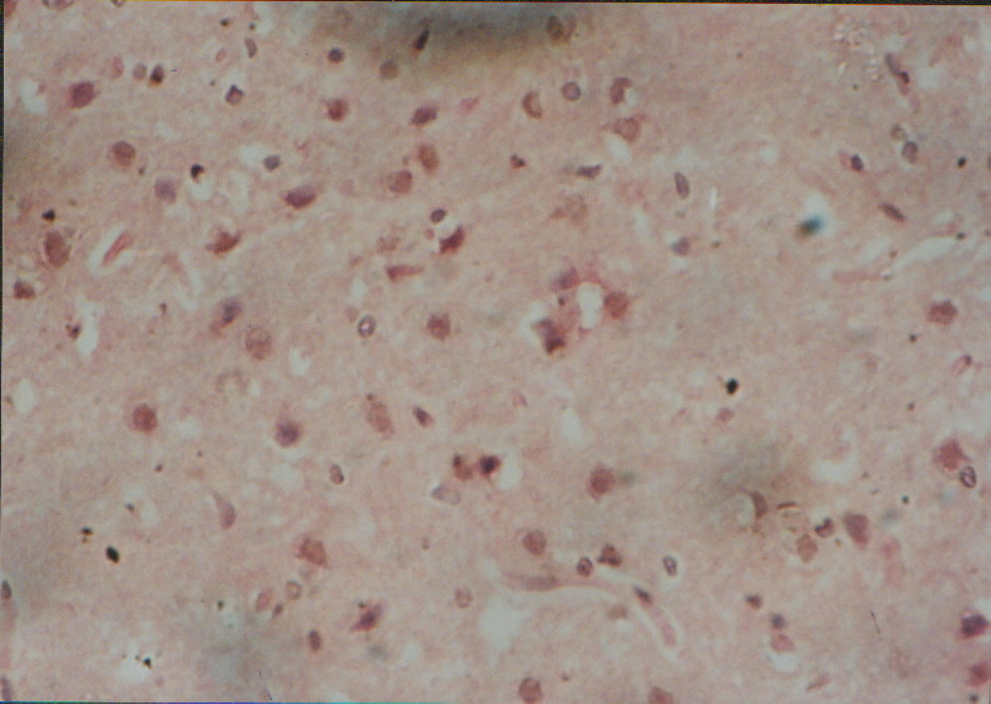
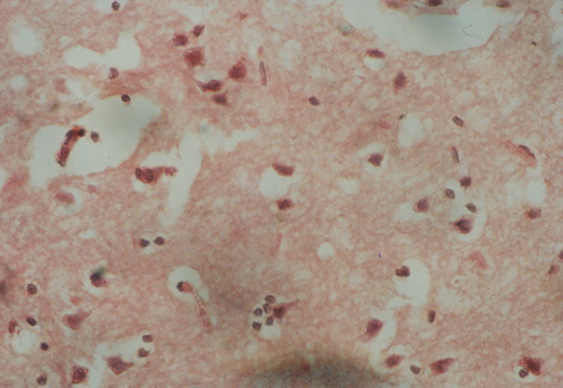
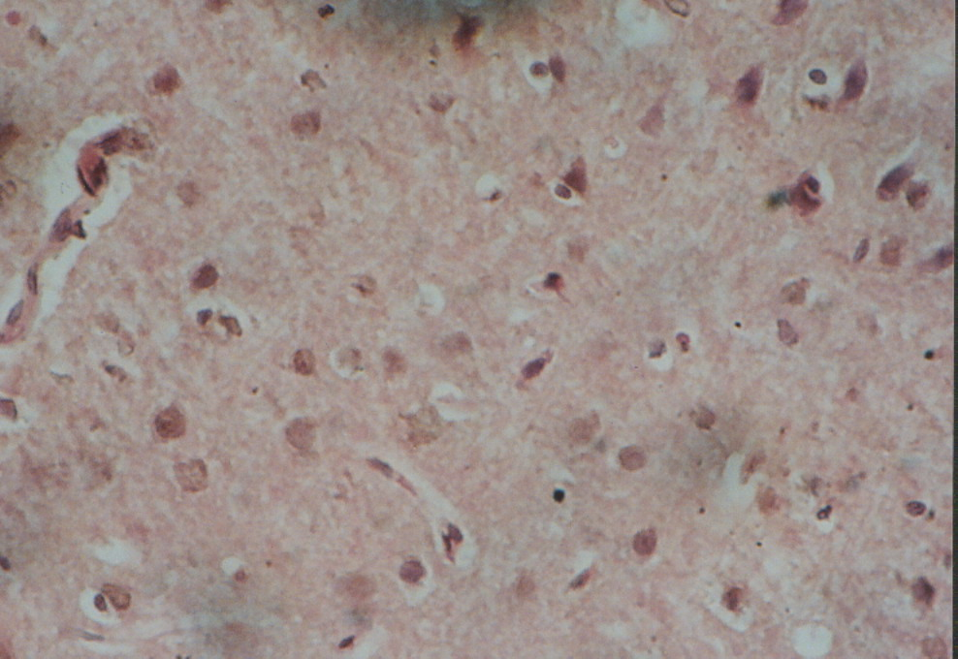
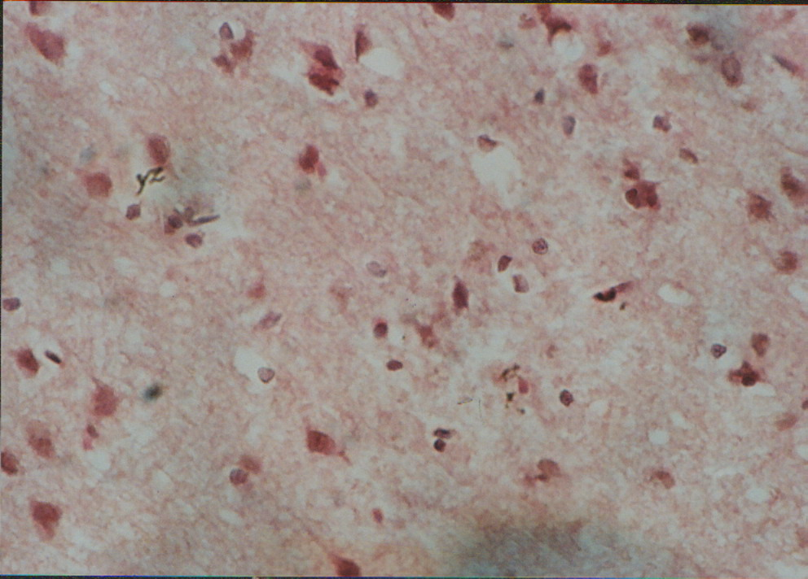
A B C
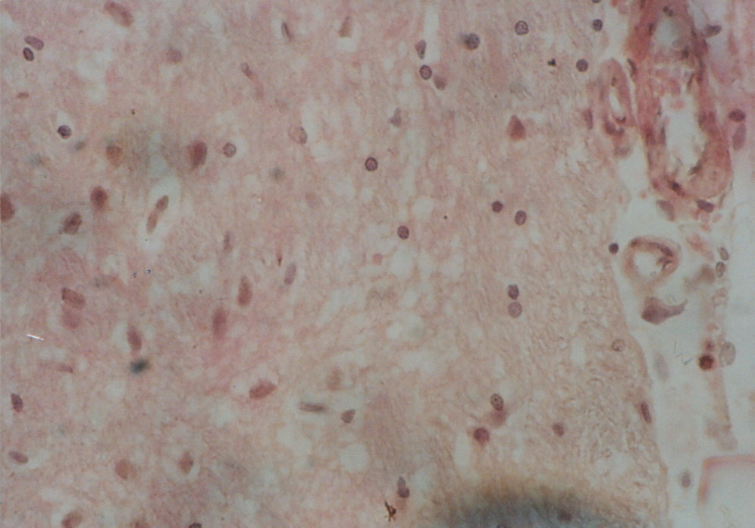
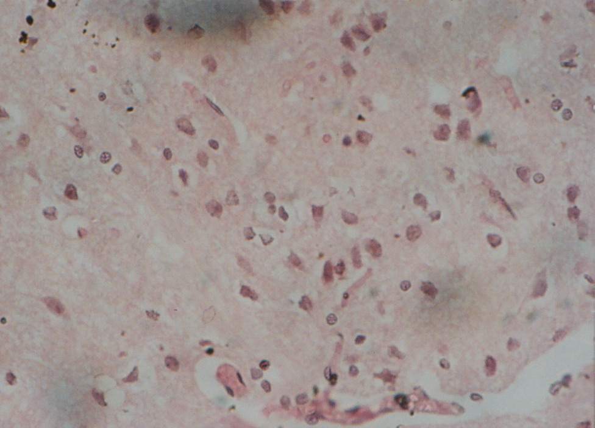
E F G
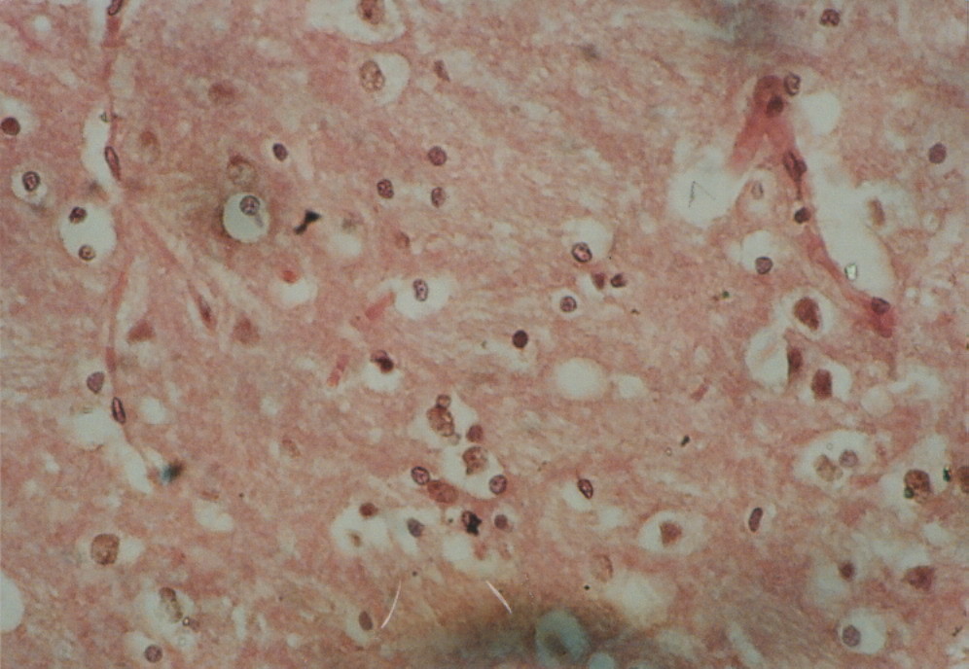

H

Figure 1. Histology result

Conclusion:
From chemical, biological and histopathological examination of the studied materials it could be concluded that thyme leaves were more effective than damiana leaves in achieving the desired results and thyme is preferable due to its cheap price in comparison with damiana, while water extracts were better than powders due to their good absorption when administered to aged rats to improve nervous system functions during aging and these plants should be used in association with drugs in treatment of nervous system impairment which decline with age.

Acknowledgement:
We thank Dr. Anisa S. Mohamed, Department of Histopathology, Ophthalmology Research Institute, Giza, Egypt, for histopathological examination.

Corresponding author
Neven, M. M
Special Food and Nutrition Department, Food Technology Research Institute, Agricultural Research Centre.

References
- A.O.A.C., 2006. Official Methods of Analysis. 18 Edition, Association of Official Agricultural Chemists. Washington D.C., USA.
- Assmann, B., M. Köhler, G.F. Hoffmann, S. Heales and R. Surtees, 2002. Selective decrease in central nervous system serotonin turnover in children with dopa-nonresponsive dystonia. Pediatr. Res., 52(1): 91-94.
- Babovic, N., D. Sonja, J. Milka, V. Vlatka, I. Jasna and Z. Irena, 2010. Supercritical carbon dioxide extraction of antioxidant fractions from selected Lamiaceae herbs and their antioxidant capacity. Inn. Food Sci. Emer. Technol., 11(1): 98-101.
- Blau, N., L. Bonafe and M. Blaskovics, 2002. Disorders of phenylalanine and tetrahydrobiopterin metabolism. In: Physician’s guide to the laboratory diagnosis of metabolic diseases. 2nd ed., Berlin: Springer, pp. 91-106.
- Chang, C.C., 1964. A sensitive method for spectrofluorometric assay of catecholamines. Int. J. Neuropharmacol., 4: 643-649.
- Ciarlone, A.E., 1978. Further modification of a fluoremetric method for analyzing brain amines. Microchem. J., 23: 9-12.
- Daret, K.S.C. and K.C. Ching, 1996. Glutathione peroxidase: activity and steady-state level of mRNA. In: Punchard NA, FJ Kelly, eds. Free Radicals, A Practical Approach. Oxford, New York; pp. 227-231.
- Dragland, S., H. Senoo, K. Wake, K. Holte and R. Blomhoff, 2003. Several culinary and medicinal herbs are important sources of dietary antioxidants. J. Nutr., 133: 1286-1290.
- Dudonnē, S., X. Vitrac, P. Coutiere, M. Woillez and J.M. Mèrillon, 2009. Comparative study of antioxidant properties and total phenolic content of 30 plant extracts of industrial interest using DPPH, ABTS, FRAP, SOD and ORAC assays. J. Agric. Food Chem., 57(5): 1768-1774.
- Eisenberg, D.M., R.C. Kessler, C. Foster, D.R. Calkins and T.L. Delbanco, 1993. Unconventional medicine in the United States. Performance, costs and patterns of use. N. Engl. J. Med., 328: 246-252.
- Estrada-Reyesb, K.R., P. Ortiz-Lopeza, J. Ortiza and L. Martinez-Mota, 2009. ‘Turnera diffusa’ Wild (Turneraceae) recovers sexual behavior in sexually exhausted males. J. Ethnopharmacol., 123(3): 423-429.
- Faris, M.W. and D.J. Reed, 1987. Biochemical analysis of hepatic and serum concentrations of glutathione sulfhydryl and glutathione disulfide. Meth. Enzymol., 143: 101-109.
- Galvez, J., S.J. Gracioso, D. Camuesco, W. Vilegas and A. Zarzuelo, 2006. Intestinal anti-inflammatory activity of a lyophilized infusion of turnera ulmifolia in TNBS rat colitis. Fitoterapia, 77(7-8): 515-520.
- Gang, Z., Y.Y. Chen, Q.G. Wei and G. Li-He, 2010. Luteolin from purple perilla mitigates ROS insult particularly in primary neurons. Neurobiol. Aging, Apr., 2010.
- Garza-Juārez, A., M. LuzSalazar, R. Salazar-Aranda, J. Perez-Meseguer and N. Waksman de Torres, 2011. Correlation between chromatographic fingerprint and antioxidant activity of turnera diffusa (Damiana). Planta Med., 21: 325-327.
- Glowinski, J. and L.L. Iversen, 1966. Regional studies of catecholamines in the rat brain. The disposition of dopamine in various regions of the brain. J. Neurochem., 13: 655-669.
- Goddard, W.A. and R. Abrol, 2007. 3-Dimensional structures of G protein-coupled receptors and binding sites of agonists and antagonists. J. Nutr., 137(suppl. 1): 1528S-1538S.
- Gomes, K.A. and A.A. Gomez, 1984. Statistical Procedures of Agricultural Research. John Wiley and Sons, Inc., USA.
- Goncalves, M.J., M. T. Cruz, C. Cavaleiro, M.C. Lopes and L. Salgueiro, 2010. Chemical, antifungal and cytotoxic evaluation of the essential oil of thymus vulgares. Ind. Crops and Prod., 32(1): 70-75.
- Guiard, B.P., M. El Mansari and P. Blier, 2009. Prospect of a dopamine contribution in the next generation of antidepressant drugs: The triple reuptake inhibitors. Curr. Drug Targets, 10(11): 1069-1084.
- Hagen, T.M., R. Moreau, J.H. Suhand and F. Visioli, 2002. Mitochondrial decay in the aged rat heart. Evidence for improvement by dietary supplementation with acetyl-l-carnitine and lipoic acid. Ann. N.Y. Acad. Sci., 959: 491-507.
- Hnatyszyn, O., V. Moscatelli, J. Garcia, R. Rondina, M. Costa, C. Arranz, G. Ferraro and J.D. Coussio, 2003. Argentinian plant extracts with relaxant effect on the smooth muscle of the corpus cavernosum of guinea pig. Phytomedicine, 10(8): 669-674.
- Höferl, M., S. Krist and G. Buchbauer, 2006. Chirality influences the effects of linalool on physiological parameters of stress. Planta Med., 72(13): 1188-1192.
- Humphries, P., E. Pretorius and H. Naude, 2008. Direct and indirect cellular effects of aspartame on the brain. Eur. J. Clin. Nutr., 62: 451-462.
- Hyland, K., R.A. Surtees, C. Rodeck and P.T. Clayton, 1992. Aromatic L-amino acid decarboxylase deficiency: Clinical features, diagnosis and treatment of neurotransmitter amine synthesis. Neurology, 42: 1980-1988.
- Kumar, S. and A. Sharma, 2005. Anti-anxiety activity studies of various extracts of turnera aphrodisiaca Ward. J. Herb Pharmacother., 5(4): 13-21.
- Kumar, S., R. Taneja and A. Sharma, 2006. Pharmacognostic standardization of turnera aphrodisiaca Ward. J. Med. Food, 9: 254-260.
- Lalone, C.A., K.D. Hammer, L. Wu, N. Leyva, A.K. Solco, G.A. Kraus, K. Kim, K. Seo and D.F. Birt, 2007. Echinacea species and alkamides inhibit prostaglandin E2 production in RAW 264.7 mouse macrophage cells. J. Agic. Food Chem., 55(18): 7314-7322.
- Lechin, F., B. Van der Dijs and M.E. Lechin, 1996. Plasma neurotransmitters and functional illness. Psychother. Psychosom., 65: 293-318.
- Maria-Jordān, J., Rosa-Martinez M., C. Martinez, I. Monino and Jose A. Sotomayor, 2009. Polyphenolic extract and essential oil quality of (Thymus zygis ssp. Gracilis) shrubs cultivated under different watering levels. Ind. Crops and Prod., 29(1): 145-153.
- Marklund, S. and C. Marklund, 1974. Involvement of the superoxide anion radical in the auto-oxidation of pyrogallol and a convenient assay for superoxide dismutase. Eur. J. Biochem., 47: 469-474.
- Meltzer, H.M., M. Folmer, S. Wang, Q. Lie, A. Maage and H.H. Mundal, 1997. Supplementary selenium influences the response to fatty acid induced oxidative stress in humans. Bio. Trace Element Res., 60: 51-67.
- Mora, F., G. Segovia and A. del Arco, 2007. Aging plasticity and environmental enrichment: Structural changes and neurotransmitter dynamics in several areas of the brain. Brain Res. Rev., 55(1): 78-88.
- Nair, J., S. De Flora, A. Izzotti and H. Bartsch, 2007. Lipid peroxidation-derived etheno-DNA adducts in human atherosclerotic lesions. Mutat. Res., 621: 95-105.
- Nascimento, M.A., A.K. Silva, L.C. Franca, J.A. Lopez and M.G. Almida, 2006. Turnera ulmifolia L. (Turneraceae): Preliminary study of its antioxidant activity. Bioresour. Technol., 97(12): 1387-1391.
- Parket, J.W., Y.C. Youn, O.S. Kwon, Y.Y. Jang, E.S. Han and C.S. Lee, 2002. Protective effect of serotonin on 6-hydroxydopamine and dopamine induced oxidative damage of brain mitochondria and synaptosomes and PC12 cells. Neurochem. Int., 40(3): 223-229.
- Patel, A.B., R.A. De Graaf, G.F. Mason, D.L. Rothman and K.L. Behar, 2005. The contribution of GABA to glutamate/glutamine cycling and energy metabolism in the rat cortex in vivo. Proc. Natl. Acad. Sci. USA., 102(15): 5588-5593.
- Pino, J.A., 2010. Essential oil of Turnera ulmifolia leaves from Cuba. Nat. Prod. Commun., 5(11): 1829-1830.
- Pērez-Meseguer, J., A. Garza-Juārez, R. Salazar-Aranda, M.L. Salazar-Cavazos, V. Rivas-Galindo and N. Waksman de Torres, 2010. Development and validation of an HPLC-DAD analytical procedure for quality control of damiana using an antioxidant marker isolated from the plant. J. AOAC. Int., 93(4): 1161-1168.
- Placidi, G.P., M.A. Oquendo, K.M. Malone, Y.Y. Huang and J.J. Mann, 2001. Aggressively, suicide attempts and depression: Relation to cerebrospinal fluid monoamine metabolite levels. Biol. Psychiatry, 50: 783-791.
- Plassman, B.L., J.W. Williams, J.R. Burke, T. Holsinger and S. Benjamin, 2010. Factors associated with risk for and possible prevention of cognitive decline in later life. Ann. Intern. Med., 153(3): 182-193.
- Priestley, C.M., E.M. Williamson, K.A. Wafford and D.B. Sattlle, 2003. Thymol, a constituent of thyme essential oil, is a positive allosteric modulator. Br. J. Pharmacol., 140: 1363-1372.
- Rapoport, S.I., M.B. Schapiro and C. May, 2004. Reduced brain delivery of homovanillic acid to cerebrospinal fluid during human aging. Arch. Neurol., 61(11): 1721-1724.
- Remick, R.A., 2002. Diagnosis and management of depression in primary care: A clinical update and review. CMAJ., 167: 1253-1260.
- Rock, C.L., R.A. Jacob and P.E. Bowen, 1996. Update on the biological characteristics of the antioxidant micronutrients. J. Am. Diet Assoc., 96: 693-702.
- Shati, A.A. and E.G. Fahmy, 2009. Effects of water extracts of thyme (Thymus vulgaris) and ginger (Zingiber officinale) on alcohol abuse. Food Chem. Toxicol., 47(8): 1945-1949.
- Sofuoglu, M. and R.A. Sewell, 2009. Noradrenaline and stimulant addiction. Addict. Biol., 14(2): 119-129.
- Torres-Gonzalez, L., L.E. Munoz-Espinosa, A.M. Rivas-Estilla, R. Salazar-Aranda and P. Cordero-Perez, 2011. Protective effect of four Mexican plants against CCL4-induced damage on the Huh 7 human hepatoma cell line. Ann. Hepatol., 10(1): 73-79.
- Usovich, A.T., N.G. Lavrik and A.P. Mamchich, 1975. Use of flame photometry for the determination of sodium and potassium. Veterinariia, (USSR): 111-116.
- Velez-Pardo, C, DelRio, M.G., Epinger, G and Vauquelin, G., 1998. Monoamine and Iron-related toxicity from serotonin binding proteins to lipid peroxidation and apoptosis in PC 12 cells. Gen. Phamacol. 31(1): 19 -
- Youdim, K.A. and S.G. Deans, 2000. Effect of thyme oil and thymol dietary supplementation on the antioxidant status and fatty acid composition of the aging rat brain. Br. J. Nutr., 83(1): 87-93.
- Zamora, R., F.J. Hidalgo and A.A. Tappel, 1991. Comparative antioxidant effectiveness of dietary ß-carotene, vitamin E, selenium and coenzyme Q10 in rat erythrocytes and plasma. J. Nutr., 121: 50-56.
- Zhao, J., R.S. Pawar, Z. Ali and I.A. Khan, 2007. Phytochemical investigation of Turnera diffusa. J. Nat. Prod., 70(2): 289-292.
- Zheng, W. and S.Y. Wang, 2001. Antioxidant activity and phenolic compounds in selected herbs. J. Agric. Food Chem., 49(11): 5165-5170.

4/22/2012

