Production of Cellulase Enzymes system in culture filtrates of Penicillium variabile Sopp

Akintobi AO¹, Olawale AK², Agunbiade SA¹, Odu NN³, Okonko IO³

¹Department of Microbiology, Lead City University, Ibadan, Nigeria
³Department of Applied Sciences, Osun State Polytechnics, Iree, Osun State, Nigeria;
⁴Department of Microbiology, University of Port Harcourt, East-West Road, PMB 5323; Choba, Port Harcourt, Rivers State, Nigeria;
mac2finney@yahoo.com, iheanyi.okonko@uniport.edu.ng

ABSTRACT: Penicillum variabile Sopp grew in liquid culture media that contained single soluble or insoluble cellulosic carbon sources releasing into the media a complex of cellulase enzymes. The enzymes were also present in infected cocoa bean tissues. Production of cellulase enzymes by P. variabile was optimum at 30°C. Optimum pH for cellulase activity was 5.0. When the cultures were agitated, less cellulase enzymes were produced than when the cultures were stationary. Production of cellulase appeared, at least in part, to be constitutive. The cellulase enzyme complex was separated by molecular exclusion into five components.
[Akintobi AO, Olawale AK, Agunbiade SA, Odu NN, Okonko IO. Production of Cellulase Enzymes system in culture filtrates of Penicillium variabile Sopp. N Y Sci J 2012;5(6):94-104]. (ISSN: 1554-0200). http://www.sciencepub.net/newyork.14

Keywords: Penicillum variabile, cellulose, pectinase, enzymes, molecular exclusion

1. INTRODUCTION
Fungi produce pectinase and cellulase enzymes that break down cellulose and pectin into simpler forms. The ability of filamentous fungi to secrete cellulases and other hydrolyzing enzymes into their culture media has led to the harvesting of these useful enzymes (Berry and Paterson, 1990; Chinedu et al., 2008). Generally, cellulolytic enzyme of some phytopathogenic fungi greatly account for the fungal deterioration of large quantities of cotton textiles in the tropical and subtropical regions of the world-a problem of immense economic importance (Verma and Verma, 1971 cited by Akintobi, 1978).

The cell wall of most plant cells is principally composed of cellulosic substances (Gascoigne and Gascoigne, 1960; Esau, 1965). It has been recognized also that the cellular building blocks of higher plant tissues are cemented together by an interstitial mortar of pectic substances (Codner, 1971). Therefore, the mode of attack of these microbial plant pathogens may be the elaboration of cellulolytic enzyme on uninfected tissue either to serve as morphogenic agents weakening this cellulose-containing cell wall, or as digestive agents which enable the plant cell wall materials to be utilized as sole carbon sources during the intracellular proliferation within the host tissues (Olutiola, 1976).

Many workers using different microscopic fungi have, in fact, attributed destruction of native cellulose to the ability of those microbes to produce extracellular cellulase enzyme in vitro (Akintobi, 1978). Much later, it was shown that culture filtrates from many micro-organisms could hydrolyse only swollen, chemically modified or degraded form of cellulose (Mendels, 1975).

The insoluble cellulosic substrates commonly employed for cellulase production are in three groups. The first group includes dried native fibres (with high cellulose content) such as dewaxed cotton fibres, filter paper and celluloses, though partly degraded, are highly crystalline. Group two comprises of celluloses which though not degraded are extensively degraded and dehydrated, e.g. cellodextrin. Some soluble substrates are also in common use. It was postulated by Reese et al. (1950 cited by Akintobi, 1978) that fungi attacking native cellulose produce an enzyme system attacking partially degraded celluloses and carboxymethylcellulose (CMC), referred to as the Cx system, and a further enzyme system, referred to as C1 which brings about the initial attack on untreated cellulose fibres.

The current trend now is to consider the cellulase system to be composed as follows (Reese, 1975 cited by Akintobi, 1978): endo-β-1,4 glucanase, the old Cx-one of these may be enzyme that acts first on “crystalline” cellulose; exo-β-1,4 glucanase-one (β-1,4 glucanglucohydrolase) to remove single glucose units from the non-reducing end of the chain and another (β-1,4 glucan cellobiohydrolase), removing cellobiose units from the non-reducing end of the chain. This, in particular, is currently being equated with the old C1 enzyme by many investigators; and cellobiase (β-glucosidase) would permit more rapid conversion of cellobiose to glucose and stimulate the hydrolysis of crystalline forms of cellulose more than susceptible forms. This is not unconnected with the synergistic occurring amongst the complex (Selby and Maitland, 1967). Most cellulolytic enzymes have been grouped as being inductive, rather than constitutive (Chapman et al., 1975; Norkrans and Hammerstrom, 1963).

Enzymes that degrade cellulosic substances of primary cell walls and middle lamellae area of major importance in the invasion of plant tissue by pathogenic fungi (Talboys and Busch, 1970; Akintobi, 1978). If more were known about the production and properties of cellulase produced by the respective pathogenic fungi, some means of blocking or delaying hyphal invasion of the host might be possible. In this study, attention is being focused on the cell wall-degrading enzymes produced by phytopathogens of economic importance in Nigeria. The present study is an investigation into the production and activity of cellulolytic enzyme by Penicillium variabile, an area in which information is lacking. Penicillium variabile is among the organisms associated with internal mouldiness of cocoa beans in Nigeria (Oyeniran, 1970). So far there has been no report about the ability of this organism to produce cellulolytic enzyme.

The aim of this study was therefore to investigate production of cellulolytic enzyme by Penicillium variabile and separation of the enzyme components by column chromatography and examination of the activity of the components resolved. Cultural conditions including depth of culture, pH, temperature, cations, type and concentration of substrates have been reported to affect production and activity of cellulolytic enzyme from some pathogenic fungi. Some of these characteristics were therefore examined for cellulolytic enzyme of Penicillium variabile.

2. MATERIALS AND METHODS
2.1. Inoculum and Culture Methods
The isolate (NSPRI.1l4) of Penicillium variabile employed in this study came from the culture collection of the Nigerian Stored Products Research Institute, Ibadan. It was isolated from moulding cocoa beans. Stock cultures were maintained on 1% malt-yeast extract agar slants. Cultures were grown in a basal medium containing NaNO₃ 2.5gm; KH₂P0₄ 1.0gm; MgSO₄ 7H₂0 0.25gm; CuSO₄ 5H₂0, 1mg; ZnSO₄ 7H₂0, 1mg; MnSO₄ 4H₂0, 3.5mg; CaSO₄ 2H₂0, 5.0mg; FeSO₄ 7H₂0, 5.0mg; Nicotinic acid, 0.5mg; Riboflavin, 0.05mg; Thiamine, 0.05mg and Biotin 0.005mg per 1 litre of distilled water. Carboxymethyl cellulose (CM-Cellulose) (Na⁺ salt, D.S. 0.7, B.D.H.), or any other carbon source used was autoclaved separately and added to the basal medium to give a final concentration of 1.0% carbon per each carbon source. When cocoa medium was used, it contained l0g of cocoa beans sliced into pieces plus 50ml distilled water per 250m1 of Erlenmeyer flask. When Whatman No. 1 filter paper was used as the sole carbon source, the medium contained l0g Whatman No. 1 plus 50ml of basal medium. Salts used were analytical grade. The media were adjusted to pH 5.5 after autoclaving as preliminary experiments indicated that this was the optimum growth pH for the organism. Each 250m1 experimental flask containing 50m1 of medium was inoculated with 1ml of an aqueous spore suspension prepared from 30day old cultures and aseptically diluted to contain approximately 8 x 10⁵ spores per ml. All experimental flasks were incubated at 30⁰c as preliminary experiments showed that this temperature supported optimum growth of Penicillim variabile

2.1.1. Preparation of Culture Filtrates
After growth for seven days (except for growth weight, Figure 3), the contents of each flask were filtered through glass-fibre filter paper (Whatman, GF/A). The filtrate was labeled enzyme filtrate. The protein content of the filtrate was measured by the folin-phenol reagent of Lowry et al. (1951 cited by Akintobi, 1978), and the total reducing sugar content was measured by the dinitrosalicylic acid reagent of Miller (1959). The mycelium obtained following filtration was dried to constant weight at 80°C.

2.1.2. Preparation of Extracts From Mycelium and Diseased Tissues
Mycelium and diseased tissues (cocoa beans) were extracted separately by macerating in a cooled (4°C) 0.5M NaCl (1.3 w/v) solution for 2 minutes in a homogenizer (Gallenkamp) followed by centrifugation at l0,000g at 4°C for 30 minutes and labeled enzyme filtrate.

2.2. Assay Methods
2.2.1. Primary Screening for Cellulolysis
The isolates were inoculated on petri dishes containing media with carboxymethylcellulose (CMC) as the only carbon source and incubated at 29 ±1^{O}C for 48 h after which they were stained with congo red for 15 minutes to visualize clearance zones according to the method of Omojasola and Jilani (2008).

2.2.2. Cellulase and Cellobiase
Cellulase and cellobiase activities were estimated by measuring the reducing sugar released in reaction mixtures containing 1ml CM-cellulose (10mg per ml.) (High viscosity, D.S. 0.7, B.D.H.) or cellobiose (0.7mg per ml) in citrate phosphate buffer (pH 5.5) and 0.4 ml enzyme solution. The mixtures were incubated at 30°C for 2 hours and the reducing sugars released measured by the dinitrosalicylic acid reagent (Appendix 2). Enzyme solution autoclaved at 1.05kg/sq cm for 10 minutes served as control. The unit of activity is defined as the amount of enzyme in 1ml of the reaction mixture required to liberate reducing sugar equivalent to l0μg of glucose under the specified conditions of the reaction. Cellulase activity was also assayed viscometrically in an Ostwald Viscometer (BS/U, size C) containing 5ml enzyme solution and 5ml CM-cellulose (10mg per ml) in citrate phosphate buffer (pH 5.5) at 30°C for 1 hour. The activity of the enzyme was expressed as the percentage loss in viscosity of the CM-cellulose using the formula, P= 100 (t_{1 –} t₂)/t₁ - t_{w} where P is the percentage loss in viscosity, t₁ is the initial flow time, t₂ is the flow time after 60min. and t_{w} is the flow time of water.

2.2.3. Effect of Temperature
Penicillium variabile was grown at different temperatures: 20, 25, 30 and 35°C respectively. Cultures were harvested as previously described and the filtrate analyzed for cellulase enzyme activity.

2.2.4. Effect of pH
Citrate phosphate buffer (0.1M) at various pH values were employed for preparing CM-cellulose and used as substrates in enzyme assays.

2.2.5. Effect of shaking
Some of the experimental flasks were continuously agitated in a flask shaker (95 strokes/minute stroke length = 3.8cm). Others were left stationary at the same temperature (30°C). Cultures were harvested for mycelial dry weight after 7 days of growth and their filtrates analysed for cellulase activities.

2.3. Preparation of Culture Filtrate for Gel-filtration

2.3.1. Concentration of Filtrate
The culture filtrate (l000ml) was precipitated with defined amounts of ammonium sulphate (NH₄)₂S0₄ (Analytical grade) between the limits of 40 and 90 percent saturation (Dixon and Webb 1971) as shown in Table 1. Preliminary experiments showed that precipitates obtained above 90% ammonium sulphate saturation had no appreciable cellulase activity. After the addition of each batch of ammonium sulphate, the filtrate was placed in a refrigerator (4°C). After 24 hours at this temperature each precipitate was separated from the supernatant by centrifuging at 15,000g for 15 minutes at 4°C.

2.3.2. Dialysis of the Enzyme Preparation
The enzyme concentrate was dialyzed for 24 hours at 4⁰C against a large volume (12 litre capacity) of phosphate buffer of pH 6.5 for cellulase using acetylated cellophane tubing prepared from Visking dialysis tubing (Gallenkamp). Low molecular weight substances and the ionic radicals of the ammonium sulphate were removed by this process.

Table 1: Preparation of Culture Filtrate for Gel-filtration
Initial Saturation of filtrate (%) | Ammonium Sulphate (g) added per litre of solution | Final Saturation (%)
0 | 243 | 40
40 | 132 | 60
60 | 143 | 80
80 | 77 | 90

2.4. Fractionation of the Culture Filtrate Concentrate on Sephadex G-75 Column
Sephadex G-75 (particle size. 40-l40μ was supplied by Pharmacia, Sweden. Ferritin (mol. wt 480,000), calf catalase (mol. wt. 240,000), aldolase (mol. wt. 450,000), bovine serum albumin (mol. wt. 67,000), egg albumin (mol. wt. 45,000), chymotrypsinogen A (mol. wt. 25,000) myoglobin (mol. wt. 17,800), cytochrome C (mol. wt. 12,400) and DNP-alanine (mol. wt. 55.2) were obtained from Serva-Feinbio-Chemical (D.-69 Heidelberg 1, Germany). The column, a vertical glass tube (2.5cm x 70cm, internal dimensions) equipped with a constant temperature water jacket was supplied by Pharmacia, Sweden.

2.4.1. Preparation of Sephadex G-75 for Column Chromatography
The column was prepared according to the methods of Olutiola (1972) and Olutiola and Cole (1976). The Sephadex was suspended in excess distilled water and stirred gently to expel trapped air bubbles. It was allowed to swell for three days after which the fine particles were removed by decantation. The gel suspension was de-aerated under low pressure. The particles were swollen further by suspension for three days in the eluting buffer containing 5mM NaN₃ (BDH) to prevent microbial contamination. The very fine particles still remaining were removed by decantation. The gel suspension was de-aerated as before and finally thin slurry of air-free gel particles was obtained, suspended in the eluting buffer. Next the vertical glass tube was partly filled with the buffer. The gel was then poured in to bring the liquid to the top of the glass tube, simultaneously allowing the buffer to flow through the growing bed of gel. More gel was added until the column was almost filled to the top. The top of the column was connected to the reservoir and the buffer allowed percolating through. The flow of the buffer through the column was continued even when the column was not in use. After five days, a constant bed height of 60cm was obtained. A sample applicator (Pharmacia Ltd.) was placed on top of the gel to prevent distortion of its top during sample application and by continuous flow of buffer through it. The column was checked for uniform packing before and after each experiment by observing the passage of ferritin, a coloured protein, through it.

2.4.2. Calibration of the Column
The column was calibrated with substances of known molecular weight in a manner similar to Olutiola (1972) and Olutiola and Cole (1976). The substances (5mg each) were dissolved in l0ml of the buffer and the solution was applied to the gel bed. The protein content of the eluted fractions was recorded by continuous measurement of the extinction at 280nm and fractions (5m1 per tube) were collected in an LKB automated fraction collector (7000 A Utra Rac). The relationship between the elution volume of each reference material and logarithm of its molecular weight was close to a straight line over the molecular weight range of 12,000 - 67,000. These observations are in agreement with that of Olutiola (1972).

2.5. Application of the Culture Filtrate to G-75 Column
Ten ml of the culture filtrate concentrate was applied to the column and the column eluates were collected as described above for calibration of the column. The eluting buffer for cellulase was phosphate buffer (pH 6.5) containing NaH₂P0₄ 6.7mM, NaCl 100mM, NaHPO₄ 3.3mM (Olutiola and Ayres, 1973) and NaN₃ 5mM (to prevent microbial contamination). Fractions (5ml per tube) were collected and measured for column calibration. Each fraction was examined for enzyme activity.

3. RESULTS ANALYSIS
3.1. Growth on Cellulosic Substrates
Penicillium variabile was able to grow in a liquid medium which contained CM-cellulose as the sole carbon source (Figure 1). During this period of growth, proteins were released into the medium. The proteins exhibited Cx cellulase activity because the culture filtrate could reduce the viscosity of CM cellulose solution (Table 2).

Table 2: Effect of Source of Carbon on Growth and Production of Enzyme by P. variabile
Carbon source | Mycelial dry weight (mg/ml) | Protein (µg/ml) | Cellulose relative activity
Glucose | 5.52 | 195 | 6.16
CM-Cellulose | 2.50 | 165 | 29.77
Cocoa | 8.60 | 298 | 26.65

Figure 1 shows the growth of P. variabile on CM-cellulose as carbon source and production of cellulase and cellobiase enzymes. The culture filtrate also hydrolysed cellobiose, indicating cellobiase enzyme production (Figure 1). Degradation of cellulose in the growth medium was also indicated by a visible reduction in the viscosity of the CM-cellulose and by a measured increase in the reducing sugars released into the medium. When the CM-cellulose was replaced by What man No. 1 filter paper as the sole carbon source P. variabile grew and released proteins and reducing sugars into the medium, indicating C₁ cellulase activity (Selby and Maitland, 1967 cited by Akintobi, 1978).

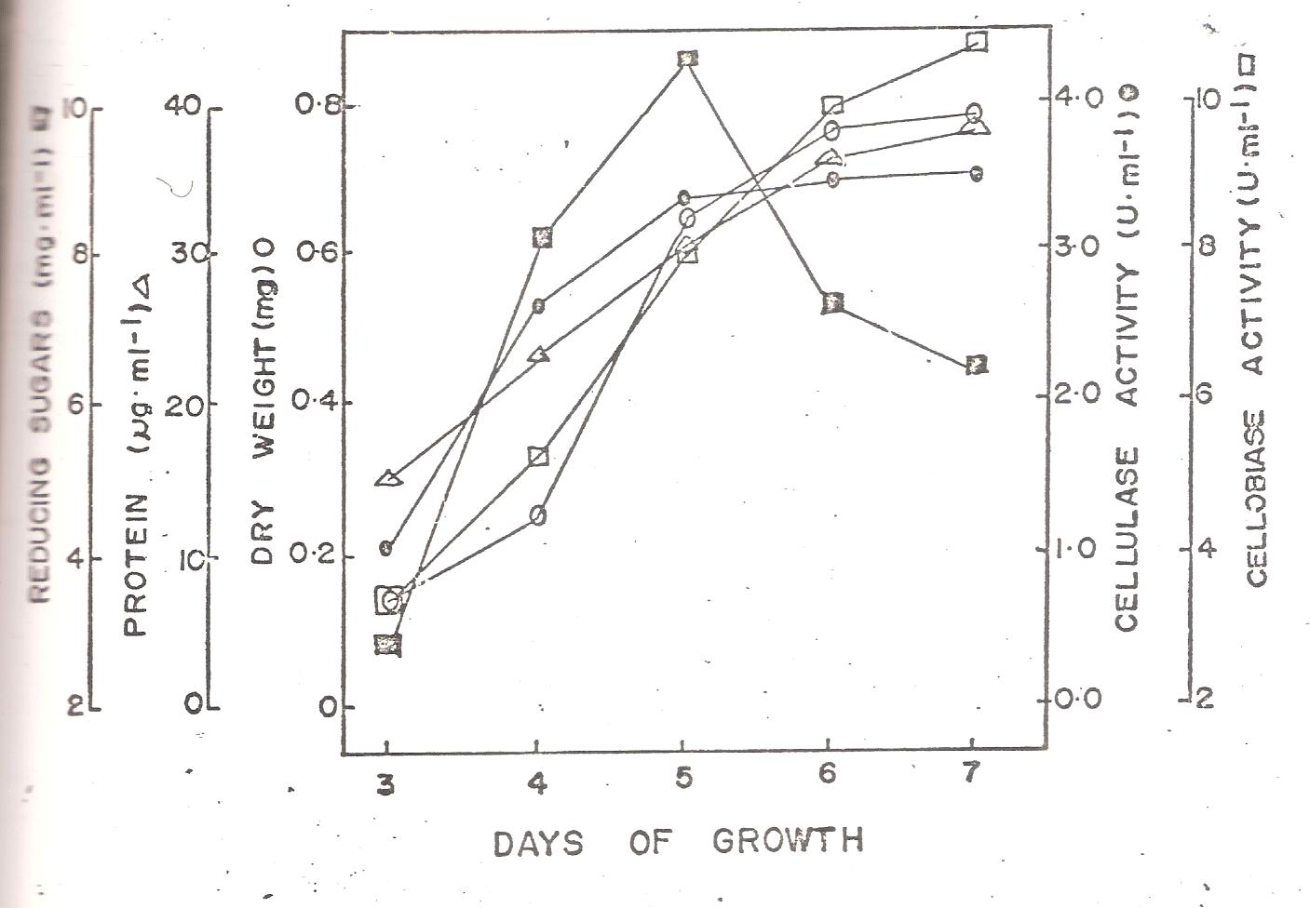
Figure 1: Growth of P. variabile on CM-cellulose as carbon source and production of cellulase and cellobiase enzymes.

Previous work on Aspergillus tamari showed that cellulase complex comprised of eight components of high molecular weight components had the character of C1-cellulase. Much earlier, Selby and Maitland (1965 cited by Akintobi, 1978) had determined the molecular weights of C1 and Cx components of Trichoderma viride, T. koningii, Fusarium solani and Penicillium fumiculosum; they lie in the region 45,000-75,000, with the exception of the low molecular weight Cx component which had a molecular weight of 13,000; smallest Cx yet found had a molecular weight of only 5,000.

3.2. Release of Enzymes during Growth Phase
During growth of P. variabile in a medium containing CM-cellulose as the sole carbon source, there was a rapid increase in mycelial dry weight until the sixth day after which there was only a gradual increase (Figure 1). The pattern of release of proteins into the medium paralleled the growth of the organism, increasing rapidly at first until the sixth day after which there was only a gradual increase. The reducing sugar content of the medium increased gradually until the fifth day after which the level declined sharply.

3.3. Growth and Production of Enzymes on Different Carbon Sources
Experiments were carried out to examine the constitutive or inductive nature of the cellulolytic and pectic enzymes produced by P. variabile. The organism was grown in a medium containing glucose, CM-cellulose, cocoa or pectin as the sole source of carbon. P. variabile was able to grow on each of these carbon sources when employed as the sole carbon source (Table 1). During this process proteins were released into the medium. Growth was best on cocoa, followed by glucose and pectin respectively. The amount of proteins released into the medium paralleled the growth attained on each carbon source. Culture filtrate of the organism grown on each of these media respectively possessed cellulase activity; cellulase activity being best on CM-cellulose while pectin methyl esterase was best on cocoa.

3.4. Effect of Cultural Conditions on Enzyme Activity
A number of cultural conditions are believed to influence cellulase activity (Norkrans and Wahlstrom, 1961; Norkrans and Hammerstrom, 1963). A high rate of shaking was shown to affect badly the concentrations of cellulase enzymes obtained from culture filtrates of Strachybotrys atra (Youatt, 1958 cited by Akintobi, 1978). Depth of the culture and aeration also affect production and activity of cellulases (Norkrans and Wahlstrom, 1961; Norkrans, 1963; Park, 1976).

In this study, cultural conditions greatly influenced the activity of cellulolytic enzymes produced by P. variabile and the nature or pattern of the effect was somehow dependent on the type of enzyme. For example, production and activity of cellulase was favoured in acidic media. Similar results have been reported by other workers (Olutiola and Ayres, 1973).

3.4.1. Effect of Shaking on Enzyme Activity
Figure 2 shows the effect of shaking on cellulase production by P. variabile. During growth in shaken cultures P. variabile grown on CM-cellulose as the sole carbon source caused less observable reduction in the viscosity of the growth medium than in stationary cultures. The protein content of stationary cultures was higher than those of shaken cultures and the ability of the culture filtrate to reduce the viscosity of buffered CM-cellulose was greater in stationary cultures (Figure 2). Thus production of cellulolytic enzymes was less in agitated than in stationary cultures.

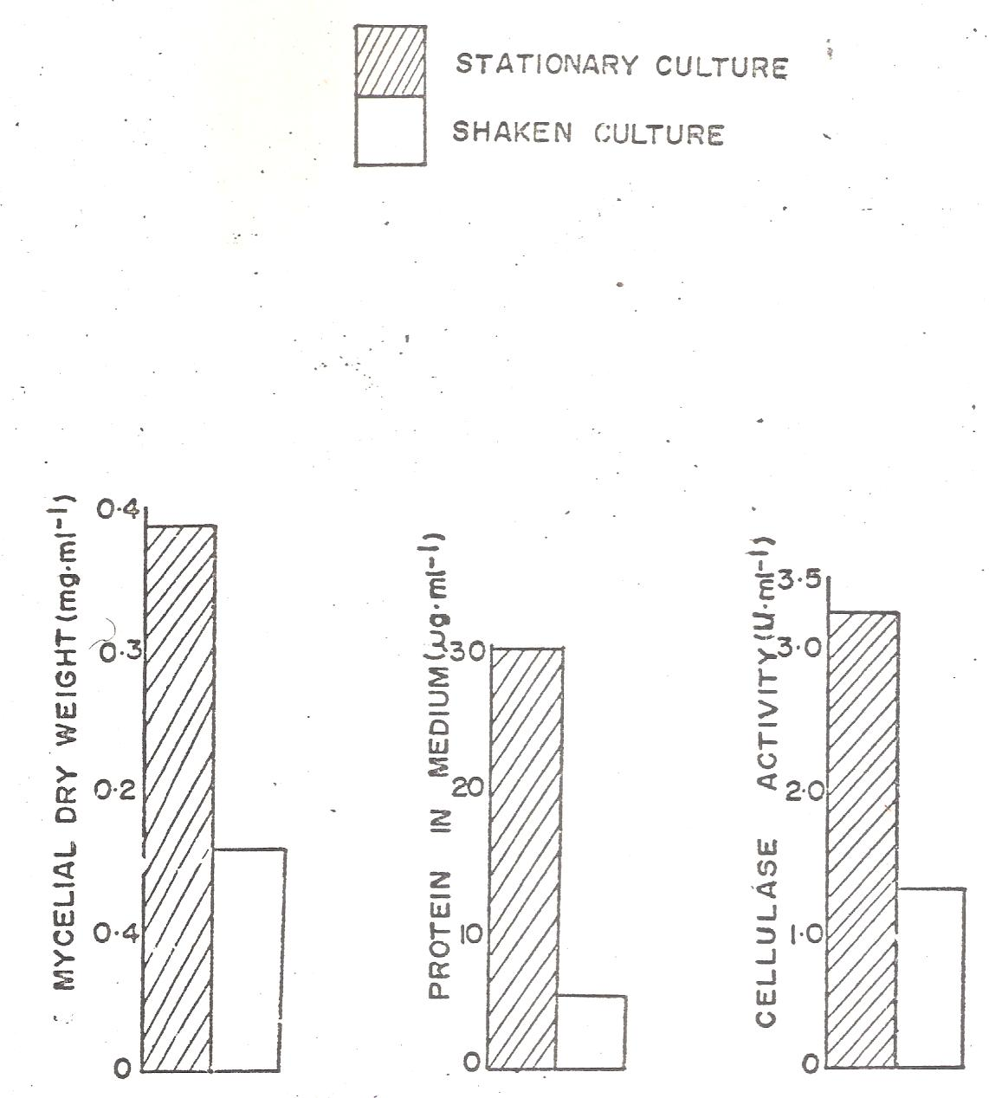
Figure 2: Effect of shaking on cellulase production by P. variabile

Agitation of the culture also exerted considerable influence on the activity of cellulolytic and pectic enzymes produced by P. variabile. Agitated cultures released fewer proteins into the medium than stationary cultures. Also in agreement with this observation is the fact that measured mycelial dry weight and enzyme activity were less in shaken than in unshaken cultures. These results agree with those of earlier workers (Norkrans, l963a; Olutiola, 1972). Norkrans (1963a) reported that shaking in shallow cultures of some fungi resulted in a decrease in mycelial yield, protein synthesis and cellulase activity. Youatt (l958 cited by Akintobi, 1978) working on Stachybotrys atra reported that a high rate of shaking had a deleterious effect on the cellulase concentration and activity of the culture filtrate. It has been suggested that this effect might be partly due to “inactivation” of the cellulase enzyme molecule itself by shaking (Norkrans, 1963a).

3.4.2. Effect of Temperature on Enzyme Activity
Figure 3 shows the effect of Temperature on Cellulase production by P. variabile. The temperature of the medium also affected both growth and enzyme production by P. variabile. Growth of the organism and production of cellulolytic enzymes were optimum at 30°C. Release of proteins into the medium was also optimum at 30°C, Growth and production of enzymes were least supported at 20⁰C and 35°C (Figure 3). Temperature of incubation also affected the release into the medium and activity of cellulolytic enzymes of P. variabile, temperature of 20°C being particularly unfavourable to cellulolytic enzymes. In general, temperature is believed to be the most important physical factor affecting enzyme activity (Dixon and Webb, 1971). The effect of temperature on activity of enzyme reactions may be due to several causes including an effect on the stability of the enzyme itself or to an effect on the enzyme-substrate affinity (Dixon and Webb, 1971; Lehninger, 1973). In nearly all cases the enzyme protein is irreversibly denatured (Dixon and Webb, 1971).

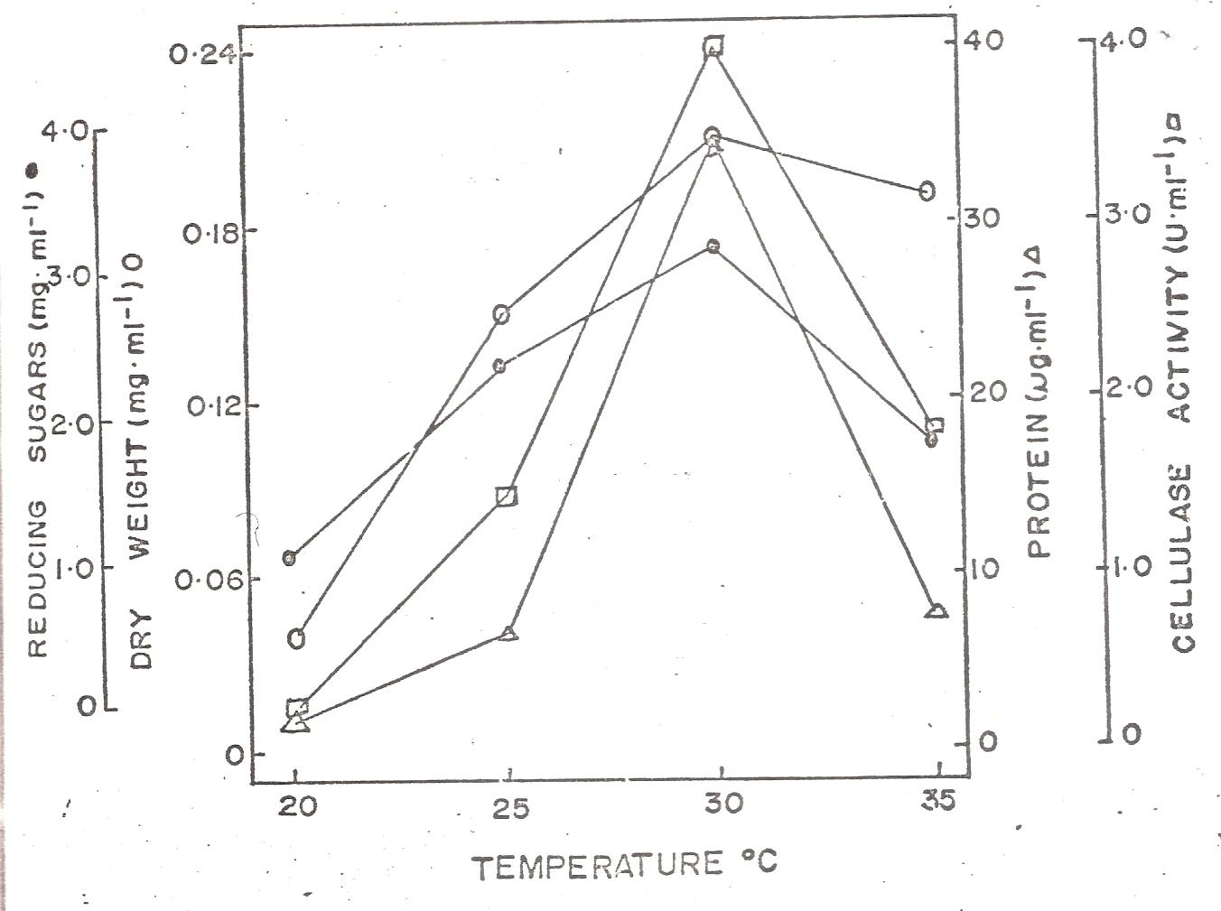
Figure 3: Effect of Temperature on Cellulase production by P. variabile

3.4.3. Effect of pH on Enzyme Activity
Figure 4 shows the effect of pH on cellulase production by P. variabile. Culture filtrate of P. variabile grown in a medium containing CM-cellulose as sole carbon source exhibited optimum cellulolytic activity at pH 5. Alkaline pH (pH 8 and 9) were particularly poor for cellulase activity (Figure 4). The pH of the medium has been reported to play an essential role in the production and activity of cellulase enzymes (Halliwell, 1961, 1965). Wood (1968 cited by Akintobi, 1978) working on cellulase of Trichoderma koningii reported a single peak pH activity curves at around 3.5-5.5. Recent workers (Fernell and Cervone, 1977) on the cellulase production by T. koningii and T. pseudokoningii showed that the cellulase activity had maximal depolymerizing activity at pH 4.0 and was still active at pH 7.0. Generally, most cellulases have optimum activities around pH 3.5-5.5 (Olutiola, 1976). The effect of hydrogen ion concentration on activity of the enzyme in this study, may be explained in part in terms of the relative molecular stability of the enzyme itself (Dixon and Webb, 1971) and in part on the ionizable groups (COO^{-,} OH⁻) of the tertiary protein structure of the enzyme complex (Conn and Stumpf, 1972; Lehninger, 1973).

3.5. Enzyme Activity in Extracts of Diseased Cocoa Beans and Fungal Mycelium
The dialyzed extract of healthy cocoa beans contained no cellulose. On the other hand the dialyzed extracts of cocoa beans infected with P. variabile possessed cellulase.

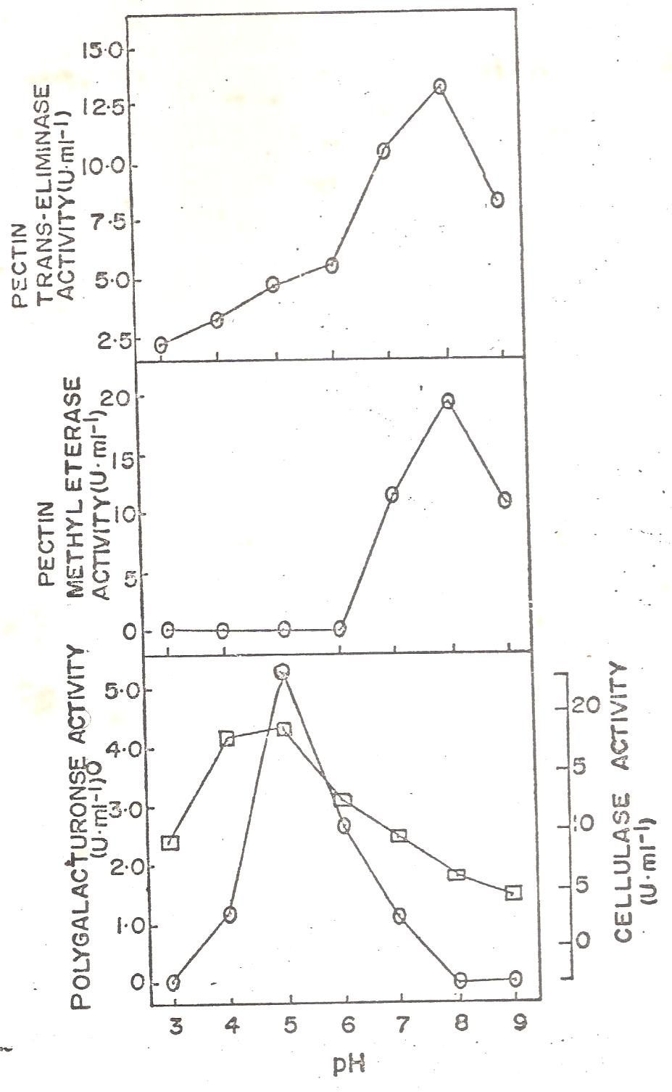
Figure 4: Effect of pH on cellulase production by P. variabile

3.6. Fractionationation of Cellulytic Enzyme on Sephadex G-75 Column
Figure 5 shows the separation by gel-filtration of proteins in concentrated culture filtrate of P. variabile. Fractionation of enzyme concentrate (obtained from culture filtrate of P. variabile grown on cellulose medium) produced five components designated A, B C, D and E. respectively (Figure 5). The approximate molecular weights of these components estimated from their elution volumes were A, 79400; B, 44700; C, 35000; D, 25100 and E, 20000. Components A, B, C and D exhibited cellulase activity while component E lacked cellulase activity.

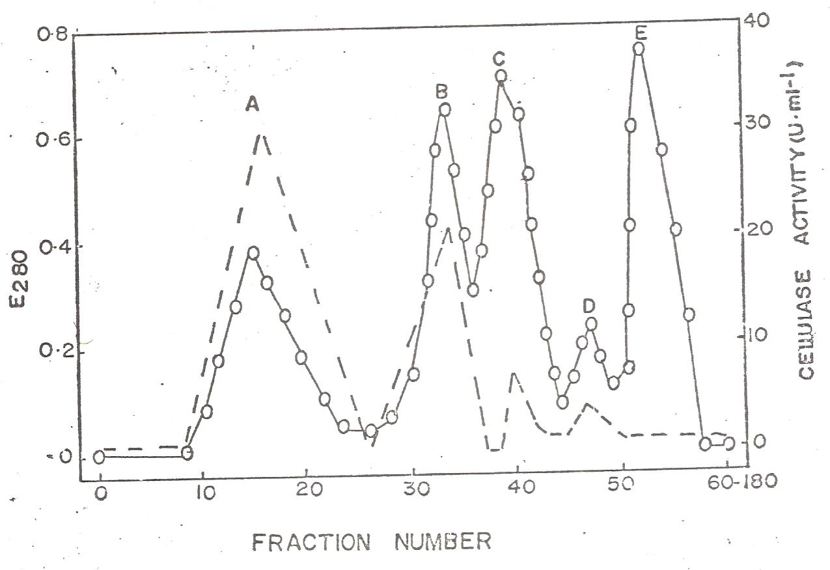
Figure 5: Separation by gel-filtration of proteins in concentrated culture filtrate of P. variabile. Key: --- = Cellulase activity; O―O = Protein (E280)

Several methods have been employed for the determination of the molecular weight of proteins, but gel filtration is probably the most useful because of its simplicity in operation, wide application and equivalence with preparatory procedure (Olutiola, 1972). The use of sephadex gel filtration has been highly recommended for the separation of protein components (Andrews, 1964). In the present study, gel filtration was able to separate cellulase enzyme of P. variabile into five components, four of which exhibited cellulase activity. Thus, when separated on the column of sephadex G-75 the cellulase of P. variabile possessed five components compared with the one component of Myrothecium verrucaria (Whitaker et 1963 cited by Akintobi, 1978), the two components of Rhynchosporium secalis (Olutiola and Ayres, 1973) and the five components of Verticillium albo-atrum (Whitney et al., 1969 cited by Akintobi, 1978). Mendels (1975) in her famous studies on cellulases observed that sizes of particles of cellulosic materials are very important. If particle sizes are large and/or impurities are present, accessibility problems may prevent total hydrolysis even when a complete enzyme complex is present.

4. DISCUSSION
Carboxymethylcellulose (CMC) was a more favourable carbon source for screening the cellulolytic fungi (Shahriarinour et al., 2011; Adeleke et al., 2012). Two screening procedures employed were to select isolates with the highest ability to produce the enzymes (Adeleke et al., 2012). Samira et al. (2011) did likewise to indicate cellulase activities of some bacterial isolates while Adeleke et al. (2012) evaluate the potentials of fungi to produce pectinase and cellulase using orange peels as substrate.

Penicillium variabile was able to grow in culture media containing soluble forms of cellulose as sole carbon sources. The organism also grew in media containing the more ordered insoluble cellulose substrate including viscose cellulose, cellulose powder and Whatman No. 1 filter paper. During growth on both soluble and insoluble cellulosic substrates, proteins which exhibited cellulase activity were released into the medium. Because of the difficulties inherent in investigating the initial steps of cellulose degradation, no attempt was made to establish whether a C₁ component was produced by P. variabile. However, Selby and Maitland (1967 cited by Akintobi, 1978) showed that CMC have no detectable effect alone on natural forms of cellulose, so that the fact that P variabile can utilize insoluble cellulose as sole carbon source is circumstantial evidence for the presence of a C₁ component. C₁ has been reported to be present in the cellulase enzyme complex of certain fungi including some Penicillium species (Olutiola, 1976). Enzymes capable of degrading cellulose substrates have been shown to be either inductive (Chapman et al., 1975) or constitutive (Spalding, 1963 cited by Akintobi, 1978).

Penicillium and Aspergillus are among the most studied cellulolytic fungi (Sukumaran et al., 2005; Favela-Torres et al., 2006; Adeleke et al., 2012). Strains of Penicillium chrysogenum has also been reported to produce significant levels of cellulolytic enzymes (Nwodo-Chinedu et al., 2007; Adeleke et al., 2012). In a study by Al-Hindi et al. (2011), Xylanase, cellulase and α-amylase were detected in the cell-free broth of Fusarium oxysporum (banana and grape), Aspergillus japonicus (pokhara and apricot), Aspergillus oryzae (orange), Aspergillus awamori (lemon), Aspergillus phoenicis (tomato), Aspergillus tubingensis (peach), Aspergillus niger (apple), Aspergillus flavus (mango), Aspergillus foetidus (kiwi) and Rhizopus stolonifer (date). This is consistent with several papers which suggested that xylanases are important pathogenecity factors for spoilage fungi (Dimatteo et al., 2006; Al-Hindi et al., 2011).

Penicillium expansum, the causal agent of blue mould rot in apples, has been shown by Spalding et al. (1973cited by Akintobi, 1978) to produce Cx-cellulase in artificial media and when attacking apples. Bateman (1963) worked on macerating enzyme of Rhizoctonia solani and observed that no cellulase appeared necessary for this process. However, the primary components of macerating enzyme of Rhizoctonia solani filtrates he obtained from the bean stem medium, admittedly, were apparently cellulase. Alabi and Naqvi (1977) noted Meyers (1964) observations that the celluloytic enzyme could act jointly to disintegrate host tissues. It has been shown by a number of workers that a major prerequisite for pathogenicity is the ability of the causal organism to produce enzymes necessary for the breakdown of the cellulolytic components of the cell wall (Olutiola, 1976). Cellulases secreted by these phytopathogens are employed to reduce the large and highly polymerized cellulose into simpler and more utilizable forms of carbon (Whitaker, 1971 cited by Akintobi, 1978).

Recently, Niturea et al. (2008) reported that both acidic and alkaline conditions the organism produced significant levels of inducible xylanase and amylase enzymes and the production of cellulase was lower compared with other enzymes (Al-Hindi et al., 2011). The secretion of pectin degrading enzymes during infection to the plants has been reported from various plant pathogenic fungi such as F. oxysporum, Botrytis cinerea, Sclerotinia sclerotiorum (tenHave et al., 2001; de las Heras et al., 2003; Li et al., 2004; Al-Hindi et al., 2011).

Previous studies reported that the same tested fungi have been produced from several plant cell wall degrading enzymes (Al-Hindi et al., 2011). Genus Fusarium was able to secrete several cell wall degrading enzymes such as cellulase, xylanase, α-amylase and pectinase (Di Pietro et al., 2003; Al-Hindi et al., 2011). F. oxysporum produced high level of xylanase (Simoes et al., 2009; Al-Hindi et al., 2011). Tissues infected by F. oxysporum produced the highest pectolytic enzyme activity among the fungi studied (Bahkali et al., 1997; Al-Hindi et al., 2011).

Filamentous fungi, Aspergillus spp. are widely distributed among the spoilage fruit fungi and also secreted several plant cell wall degrading enzymes (Al-Hindi et al., 2011). Induction of polygalacturonases from A. oryzae by pectin was significantly higher than when rinds of citrus fruits were used as inducer (Malvessi and da Silveira, 2004; Al-Hindi et al., 2011). A. oryzae produced xylanase and polygalacturonase in solid-state and submerged cultures (Oda et al., 2006; Al-Hindi et al., 2011). A. awamori showed high extracellular endoxylanase (100 units/ml) and α-xylosidase activities (3.5 units/ml) when grown on milled sugar cane bagasse as the principal carbon source (Lemos and Nei, 2002; Al-Hindi et al., 2011). A. tubingensis produced xylanase (Bakri et al., 2010) and polygalacturonase (Kester et al., 1996) when synthetic media used as substrates under submerged culture cultivation (Al-Hindi et al., 2011). Also, induction of xylanolytic activity was examined in A. phoenicis grown on synthetic medium (Rizzatti et al., 2008; Al-Hindi et al., 2011).

In this study, production of cellulase enzymes by P. variabile was optimum at 30°C. Optimum pH for cellulase activity was 5.0. Banu et al. (2010) presented similar observations for cellulolytic enzymes, Trichoderma longibrachiatum produced highest amounts of glucose on day 7, pH 5 but at 45^{O}C, optimum glucose using Aspergillus niger was produced at pH 4.5 on day 5 and 45^{O}C while using Saccharomyces cerevisiae, optimum glucose production was produced at pH 4.5 on day 3 and at 45^{O}C (Omojasola and Jilani, 2008).

In the present study, the culture filtrates of P. variabile grown on glucose as the sole carbon source exhibited cellulase activity by reducing the viscosity of CM-cellulose and by releasing reducing sugars from CM-cellulose. Also during growth on this carbon source, the organism secreted a relatively large quantity of proteins into the medium. This will therefore mean that even in the absence of cellulose the organism can produce cellulase enzyme. Thus production of cellulase by P. variabile is constitutive. However, the enzyme activity was higher when a cellulosic substrate was the carbon source than when it was glucose. The results showed that P. variabile produced C_{x} cellulase and cellobiase. It was also suggested that the organism must have been able to produce C₁ enzyme because of its ability to break down insoluble cellulosic substrates.

The pattern for the degradation of cellulosic substrates by P. variabile may therefore take the form suggested below:

Native Cellulose
(insoluble cellulose)
C₁

Soluble cellulose
(polyanhydroglucose chains)

Cx CellulaseCellobiase

Cellobiase

Cellobiose Glucose units

Figure 6: Flowcharts/patterns for the degradation of cellulosic substrates by P. variabile

Also in media lacking cellulose, the culture filtrates although contain fairly large amounts of proteins, exhibited less cellulase activity than cellulose-containing media. Two possibilities are suggested to explain the phenomenon. Firstly, the extra proteins present in non-cellulose media are not necessarily cellulase enzymes and possibly consist of other types of enzymes which are involved in the metabolism of sugars by P. variabile. The second alternative is that the extra proteins could as well be cellulase enzymes but whose activities are somehow inhibited by the presence of sugars, thus an example of catabolite repression of cellulase enzyme synthesis (Dixon and Webb, 1971).

5. CONCLUSION
A large variety of microorganisms have the ability to produce enzymes both intracellularly and extracellularly (Adeleke et al., 2012). Some of the factors which make microbial enzymes strongly attractive in many industrial processes include its eco-friendly nature, reduced energy requirement and easy availability of raw materials for their production (Adeleke et al., 2012).

In the present study, the extracts obtained from Penicillium-infected cocoa beans exhibited cellulase activities. The culture filtrates also possessed similar enzyme activities. Thus, besides producing cellulolytic enzymes in vitro, P. variabile also produces these enzymes in vivo. It is suggested that cellulolytic enzymes may play an important role in the infection of cocoa beans by P. variabile. The possible role of cellulolytic enzymes in pathogenicity has been indicated (Ayesu-Offei and Clare, 1970; Hunter and Elkan, 1975). Most cellulolytic enzymes have been grouped as being inductive, rather than constitutive (Chapman et al., 1975; Norkrans and Hammerstrom, 1963). Production of cellulase in this study, appeared, at least in part, to be constitutive.

Acknowledgement
The authors thank the management and staff of the Nigerian Stored Products Research Institute (NSPRI), Ibadan for their immense assistance and for the culture collection of the isolates (Penicillium variabile NSPRI.1l4) employed in this study.

Correspondence to:
Iheanyi O. Okonko
Department of Microbiology,
University of Port Harcourt, Choba,
East-West Road, P.M.B. 5323, Choba,
Port Harcourt, Rivers State, Nigeria;
Tel.: +2348035380891
Email: mac2finney@yahoo.com;
Iheanyi.okonko@uniport.edu.ng

REFERENCES
- Adeleke AJ, SA Odunfa, A Olanbiwonninu, MC Owoseni. Production of Cellulase and Pectinase from Orange Peels by Fungi. Nature and Science 2012;10(5):107-112
- Alabi, R.O. and Naqvi, S.H.Z. 1977. Production of Cellulolytic and Pectolytic Enzymes by cercospora arachnidicola, Trans. Br. Mycol. Soc. 68(2): 296-298.
- Al-Hindi RR, Al-Najada AR, Mohamed SA. Isolation and identification of some fruit spoilage fungi: Screening of plant cell wall degrading enzymes. African Journal of Microbiology Research, 2011; 5(4): 443-448.
- Ayesu-Offei, E.C. and Clare, B.G. 1970. Processes in the Infection of Barley Leaves by Rhynchosporium secalis. Australian Journal of Biological Science 23:299-307.
- Bahkali AR, A1-Khaliel, AS Elkhider KA (1997). In vitro and In vivo production of pectolytic enzymes by some phytopathogenic fungi isolated front southwest Saudi Arabia. King Saud Univ., 9: 125-137.
- Bakri Y, Masson M, Thonart P (2010). Isolation and identification of two new fungal strains for xylanase production. Appl. Biochem. Biotechnol., 162: 1626-1634.
- Banu A.R., Devi M.K., Gnanaprabhal G.R., Pradeep B.V. and Palaniswamy M. (2010). Production and characterization of pectinase enzyme from Penicillium chysogenum. Indian Journal of Science and Technology, 3(4): 377 – 381.
- Bateman, D.F. 1963. The “Macerating Enzyme” of Rhizoctonia solani. Phytopathology 53:1178-1186.
- Berry D.R. and Paterson A. (1990). Enzymes in food industry. In : Enzyme Chemistry, Impact and applications, 2nd edition. Eds. Suckling C.J. 306 – 351.
- Chapman, E.S. Evans, E. Jacobelli, M.C. & Logan, A.A. 1975. The Cellulolytic and Amylotytic Activity of Papulospora Thermophilia Mycologia 67: 608.
- Chinedu N.S., Nwinyi O.C. and Okochi V.I. (2008). Growth and cellulase activity of wild type Aspergillus niger ANL301 in different carbon sources. Canadian Journals of Pure and Applied Sciences, 2(2): 357 – 362.
- Codner, R.C. 1971. Pectinolytic and Cellulolytic Enzymes in the Microbial Modification of Plant Tissues. Journal of Applied Bacteriology 34(1): 47-160.
- Conn, E.E. & Stumpf, P.K. 1972 Outline of Biochemistry (3rd ed.) John Wiley & Sons, Inc., New York & London.
- De Las Heras A, Patino B, Posada, ML, Martinez MJ, Vazquez C, Gonzalez Jean MT (2003). Characterization and in vitro expression patterns of an exo-polygalacturonas encoding gene from Fusarium oxysporum f.sp. radicis lycopersici. J. Appl. Microbiol., 94: 856-864.
- Di Matteo A, Bonivento D, Tsernoglou D, Federici L, Cervone F (2006). Polygalacturonase-inhibiting protein (PGIP) in plant defence: a structural view. Phytochem., 67: 528-533.
- Di Pietro A, Madrid MP, Caracuel Z, Delgado-Jarana J, Roncero MIG (2003). Fusarium oxysporum: exploring the molecular arsenal of a vascular wilt fungus. Mol. Plant Pathol., 4: 315-326.
- Dixon, M. & Webb, E.C. 1971 Enzymes (2nd ed.) Longmans, London.
- Esau, K. 1965. Plant Anatomy (2nd ed.) John Wiley & Sons.
- Favela-Torres E., Volke-Sepulveda T. and Viniegra- Gonzalez G. (2006). Production of hydrolytic depolymerising pectinases. Food Technol. Biotechnol., 44(2): 221 – 227.
- Fernell, C. & Cervone, F. 1977. Polygalacturonase and Cellulase Production by Trichoderma koningii and T. Pseudokoningii, Trans. Br. Mycol. Soc. 68(2): 291-294.
- Gascoigne, J.A. & Gascoigne, M.M. 1960. Biological Degradation of Cellulose. Butherworths, London.
- Halliwell, G. 1961. The Action of Cellulylytic Enzymes from Myrothecium verrucaria. Biochemical Journal 79: 185-192.
- Halliwell, G. 1965. Hydrolysis of Fibrous Cotton and Reprecipitated Cellulose by Celluulolytic Enzymes from Soil Microorganisms. Biochemical Journal 95: 270-281.
- Hunter, W.J. & Elkan, G.H. 1975. Role of Pectic and Cellulolytic Enzymes in the Invasion of the Soybean by Rhizobium japonicum. Can. J. Microbiol. 21: 1254-1258.
- Kester HCM, Kusters-van Someren MA, Müller Y, Visser J (1996). Primary structure and characterization of an exopolygalacturonase from Aspergillus tubingensis. Eur. J. Biochem., 240: 738-746.
- Lehninger, A.L. 1973. A short Course in Biochemistry Worth Publisher, Inc. New York.
- Lemos JLS, Nei PJ (2002). Influence of some sugars on xylanase production by Aspergillus awamori in solid state fermentation. Braz. Arch. Biol. Technol., 45: 431-437.
- Li R, Rimmer R, Buchwaldt L, Sharpe AG, Seguin-Swartz G, Hegedus DD (2004). Interaction of Sclerotinia sclerotiorum with Brassica napus: Cloning and characterization of endo- and exopolygalacturonases expressed during saprophytic and parasitic modes, Fungal. Gen. Boil., 41: 754-765.
- Lowry, O.H. Rosebrough, N.J. Parr, A.L. & Randal, R.J. 1951. Protein Measurement with the Folin-Phenol Reagent. J. Biol. Chem. 193: 265-275.
- Malvessi E, Silveira MM (2004). Influence of medium composition and pH on the production of polygalacturonases by Aspergillus oryzae. Braz. Arch. Biol. Technol., 47: 693-702.
- Mendels, M. 1975. Microbial Sources of Cellulase. Biotech. Bioeng. Symposium 5: 81-105.
- Meyer, J.A. 1964, The Production of Pectolytic and Cellulolytic Enzymes by Formae of Fusarium oxysporum. Overdruk Uit de Mededelingen Vande Land Bouwhoge School Ende Opzoekings Stations Van de Stoat to Gent Deel XXIX, No. 3: 875-883.
- Miller, G.L. 1959. Use of Dinitrosalicylic Acid Reagent for Determination of Reducing Sugar. Anal. Chem. 31. 426-428.
- Niturea SK, Kumarb AR, Parabc PB, Panta A (2008). Inactivation of polygalacturonase and pectate lyase produced by pH tolerant fungus Fusarium moniliforme NCIM 1276 in a liquid medium and in the host tissue. Microbiol. Res., 163: 51-62.
- Norkrans, B. & Hammerstrom, A. 1963. Studies on Growth of Rhizinia undulate and its Production of Cellulase and Pectin Decomposing Enzymes. Physiol. Plant. 16: 1-10.
- Norkrans, B. & Wahlstrom, L. 1961. Studies on Inhibition of Cellulolytic Enzymes. Physiol. Planta. 14: 651-860.
- Norkrans, B. 1963a. Influence of some Cultural Conditions on Fungal Cellulase Production. Physiol. Planta. 16: 11-19.
- Norkrans, B. 1963a. Influence of some Cultural Conditions on Fungal Cellulase Production. Physiol. Planta. 16: 11-19.
- Nwodo-Chinedu S., Okochi V.I., Smith H.A., Okafor U.A., Onyegeme-Okerenta B.M. and Omidiji O. (2007). Effect of carbon sources on cellulase (EC 3.2.1.4) production by wildtype Penicillium chrysogenum PCL501. African Journal of Biochemistry, 1: 6 – 10.
- Nwodu-Chinedu S., Eni A.O., Adeniyi A.I. and Ayangbemi J.A. (2010). Assessment of growth and cellulase production of wild-type microfungi isolated from Ota, Nigeria. Asian Journal of Plant Sciences, 9(3): 118 – 125.
- Oda K, Kakizono D, Yamada O, Iefuji H, Akita O, Iwashita K (2006). Proteomic analysis of extracellular proteins from Aspergillus oryzae grown under submerged and solid-state culture conditions. Appl. Environ. Microbiol., 72: 3448-3457.
- Olutiola, P.O. 1972. Aspects of the Carbohydrate Physiology of Rhynchosporium secalis (Oudem). Ph.D. Thesis, University of Lancaster.
- Olutiola, P.O. 1976. A Cellulase Complex in the Culture Filtrates of Penicillium citrinum. Can. J. Microbiol. 22: 1153-1159.
- Olutiola, P.O. and Ayres, P.G. 1973. A Cellulase Complex in Culture Filtrates of Rhynchosporium secalis. (Barley Leaf Blotch). Trans. Br. Mycol. Soc. 60: 273-282.
- Olutiola, P.O. and Cole, O.O. 1976. Production of Cellulase Complex in the Culture Filtrates of Aspergillu tamari Associated with Mouldy Cocoa Beans in Nigeria. Physiol. Planta. 37: 313-316.
- Omojasola P.F. and Jilani O.P. (2008). Cellulase production by Trichoderma longi, Aspergillus niger and Saccharomyces cerevisiae cultured on waste materials from orange. Pakistan Journal of Biological Sciences, 11(20): 2382 – 2388.
- Oyeniran, J.O. 1970. Internal Mouldiness of Commercial Cocoa in Ibadan, Western State, Nigeria. Rep. Niger. Stored Prod. Res. Inst. Tech. Rep. No. 2:19-27.
- Park, D. 1976. Cellulase Decomposition by Pythiaceous Fungus. Phythium C₁ Trans. Br. Mycol. Soc. 66: 65-70.
- Rizzatti ACS, Freitas FZ, Bertolini MC, Peixoto-Nogueira SC, Terenzi, HF, Jorge JA, Polizeli MLTM (2008). Regulation of xylanase in Aspergillus phoenicis: A physiological and molecular approach. J. Ind. Microbiol. Biotechnol., 35: 237-244.
- Samira M., Mohammea R. and Gholamreza G. (2011). Carboxymethyl-cellulase and filter-paperase activity of new strains isolated from Persian Gulf. Microbiology Journal, 1(1): 8 – 16.
- Shahriarinour M., Wahab M.N.A., Ariff A. and Mohamad R. (2011). Screening, isolation and selection of cellulolytic fungi from oil palm empty fruit bunch fibre. Biotechnology, 10(1): 108 – 113.
- Simoes MLG, Tornisielo SMT, Tapia DMT (2009). Screening of culture condition for xylanase production by filamentous fungi. Afr. J. Biotechnol., 8: 6317-6326.
- Sukumaran R.K., Singhania R.R. and Pandey A. (2005). Microbial Cellulases-Production, application and challenges. Journal of Scientific & Industrial Research, 64: 832 – 844.
- Ten Have A, Breuil WO, Wubben JP, Visser J, van Kan JA (2001). Botrytis cinerea endopolygalacturonase genes are differentially expressed in various plant tissues. Fungal Gen. Biol., 33: 97-105.

4/5/2012

