New York Science Journal 2012;5(7) http://www.sciencepub.net/newyork

Genetic Diversity of Cultivated and wild-Type potatoes under Potato Spindle Tuber Viroid Infection

Sherin Amin Mahfouze^{*1}, Khalid Abdel Fatah El-Dougdoug², Osama Ezzat El-Sayed¹, Mostafa Ahmed Gomaa¹ and
Esmat Khaled Allam²

¹Genetics and Cytology Department, Genetic Engineering and Biotechnology Division, National Research Center,
Dokki, 12622, Egypt.
²Department of Microbiology (Virology Laboratory), Faculty of Agricultue, University of Ain Shams, Cairo, Egypt. *Corresponding author: Email address: Sherinmahfouze@yahoo.com

Abstract: Potato cultivars and wild species are varying diversity in their response to PSTVd infection. It was found that, all the cultivated potatoes were susceptible to PSTVd infection except (Draga and Spunta), (Hermes) and (Nicola) were tolerant, hypersensitive and low resistant, respectively. On the other hand, all wild species were tolerant except S. etuberosum was immune and S. chacoense was rather moderate resistant. Five of the RAPD and four ISSR primers were used to detect DNA markers for PSTVd-resistant among cultivated and wild potato species. These primers revealed polymorphism depending on bands number and level of detectable polymorphism of primers. Thus, the hypersensitive plants of Hermes appeared (10), the tolerant plants of Draga showed (8) markers with both of RAPD and ISSR, and the resistant plants of Nicola revealed (3) one marker by RAPD and two markers by ISSR. Also, the immune plants of S. etuberosum scored the highest markers for resistant plants to PSTVd (11) markers (one in RAPD and 10 with ISSR), then the resistant plants S. chacoense displayed (1) with RAPD.

[Sherin Amin Mahfouze, Khalid Abdel Fatah El-Dougdoug, Osama Ezzat El-Sayed, Mostafa Ahmed Gomaa and Esmat Khaled Allam. Genetic Diversity of Cultivated and wild-Type potatoes under Potato Spindle Tuber Viroid Infection. N Y Sci J 2012;5(7):9-18]. (ISSN: 1554-0200). http://www.sciencepub.net/newyork. 2

Key words: Potato, Wild-Type, PSTVd-_{EG}, NASH, RAPD-PCR, ISSR-PCR

1. Introduction

Potato Spindle Tuber Viroid (PSTVd) is the type member of the genus Pospiviroid (Family Pospiviroidae). It is a circular single-stranded, RNA molecule, measuring between 356-361 nt in length and un-encapsidated (Schnöelzer et al., 1985; Wang et al., 2011). The wild-type potato inoculated with PSTVd such as Solanum acaule, S. chacoense and S. demissum gave rosette like growth and necrosis of stem petioles or leaves, S. berthaultii showing leaf drop, necrosis and necrotic lesions. Whenever, S. guerreroense and S. stoloniferum showed rosette-like growth, stunted stem and leaves stunted (small leaf diameter) (Singh and Slack 1984). Viroids provide a minimal genetic and biochemical system for the study of the mechanisms controlling host-pathogen interactions and the control of gene expression in plant cells. PSTVd accumulates in the nuclei of infected cells and its lack of mRNA activity suggests that viroids alter host metabolism by direct interaction with one or more host components. Although, viroid infection is not accompanied by gross changes in nucleic acid metabolism, the concentration of various host proteins may change markedly. Increased transcription of defense-related genes has been observed in viroid-infected plants and can be mimicked by the application of ethephon, an ethylene-releasing compound (Harders et al., 1989 and Gadea et al., 1996). The molecular mechanisms of viroid pathogenicity, as well as host response are poorly

understood. Molecular genetic markers such as restriction fragment length polymorphism (RFLP), random amplified polymorphic DNA (RAPD), intersimple sequence repeats (ISSR) and simple sequence repeats (SSR) have been used extensively in genetic studies of potato cultivars. (Granell et al., 1987; Chani, 1997; Itaya et al., 2002).

2. Materials and Methods Potato cultivars
Eight potato cultivars were obtained from (Ministry of Agriculture, Dokki, Giza, Egypt) (Table 3). These cultivars were tested against potato viruses (Potato Virus X, Potato Virus Y and Potato Leaf Roll Virus) using DAS-ELISA (Clark and Adams 1977). Thirteen tubers were virus-tested from each cultivar were planted in Grower mix (Peatmoss pH 5.6 original formula avec perlite-Canada) in black plastic bags (35 x 27 cm). The seedlings Potato at five-to-six-leaf stage from each cultivar were mechanically inoculated with PSTVd isolate. The inoculated and control plants were grown in greenhouse at 25ºC with a photoperiod 16 h. Plants were fertilized with a (19-19-19-N-P-K) solution. PSTVd symptoms were recorded on inoculated plants daily for 8 wks. The plants showing distinct symptoms were tested by dot-blot hybridization. Disease index calculated as described by Tian et al, (1985), using 11 grades of symptoms.

http://www.sciencepub.net/newyork | 9 | newyorksci@gmail.com

New York Science Journal 2012;5(7) http://www.sciencepub.net/newyork

Disease index =

(Number of plants of each grade x Disease grade) x 100

Total number of plants x the highest grade

0= No symptoms, 1= Erect, 2= dark green, 3= Twisting, 4= Epinasty, 5= Rugosity,

6= Systemic necrotic spots, 7= Rosette like growth, 8= Leaves stunting, 9= Stunting,

10= Chlorosis, 11= Leaf drop

Wild-type Potato

True-seed potato species (Table 4) (Centre for Genetic Resources, The Netherlands) were tested against potato viruses (PVX, PVY and PLRV) using DAS-ELISA. Thirty seedlings from all cultivar were transplanted in Grower mix in pots (14 ) and were mechanically inoculated with PSTVd isolate. The inoculated plants and control were maintained in insect-proof greenhouse at 18±2ºC supplemented with 16 daylight. The plants were observed daily at two months for visible symptoms. The results of susceptible cultivars were confirmed by Dot-blot hybridization. Disease index calculated as described above.

Molecular markers DNA extraction

Potato pants immune, resistant, tolerant, hypersensitive and the healthy control were collected and soaked in liquid nitrogen for DNA extraction using the 2% CTAB method modified by (Agrawal et al., 1992). Random amplified polymorphism DNA-polymerase chain reaction (RAPD-PCR) technique.

RAPD-PCR

RAPD is amplification of genomic DNA using five primers as in Table (1) (Kang and Yang 2004). The following components were added to a sterile eppendorof tube placed on ice during pipetting as followed: 2.5 µl 25 mM MgCl₂; 0.5 µl 40 mM dNTPs; 1 µl Taq DNA polymerase (1 unit/µl); 2 µl 0.4 uM 10-mer primer (manufactured by Bioneer, New technology certification from ATS Korea). The volume was completed to 25 µl dsH₂O.

Thirty nanogram from each DNA extracted sample were used for amplification reaction 5 µl of the 10-mers random primer (15 ng /ml) were added to Gene pack PCR tubes kits. The total volume was completed to 25 µl using sterile dsH₂O. The amplification protocol was carried out as follows using PCR Programe (Biometra): Denaturation at 94ºC for 1 min. 35 cycles each consists of the following steps: Denaturation at 94ºC for 30 sec. annealing at 45ºC for 1 min, extension at 72ºC for 1 min and final extension at 72ºC for 5 min.

ISSR-PCR profiles

A total of four primers Ratnaparkhe et al, (1998) and Bornet et al, (2002) (Table 2; Life Technologies, Gaithersburg, Md.). Each 25-µl amplification reaction consisted of 10X PCR buffer (2.5 µl), 25 mM MgCl₂ (2.5 µl), 40 mM dNTPs (0.5 µl), Taq DNA polymerase (1 µl, 1 U/µl) and 0.4 µM primer (2 µl). Amplification was carried out in a DNA thermocycler (Biometra, Göttingen, Germany) under the following conditions: One cycle of 3 min at 94°C followed by 28 cycles of 45 s at 94°C, annealing temperature (Table 2) for 30 s and 72°C for 2 min followed by a final extension for 6 min at 72°C.

Table 1. The sequences of used primers were as follows:

Primer | Sequence
Primer-1 | TCGCTCGTT
Primer-2 | AAC GCG CAA C
Primer-3 | CCC GTC AGC A
Primer-4 | CCA CAG CAG T
Primer-5 | AAG CCC GAG G

Table 2. Sequences and annealing temperatures of the five primers ISSR selected to amplify DNA from potato leaves.
Primer | Sequence |  | TA(ºC)
HB08 | (GAG)₂ (AGA)₂ GG |  | 44
Primer-1 | GAG (CAA)₅ |  | 55
Primer-3 | CTG (AG)₈ |  | 55
Primer-11 | (AG)₈ |  | 49

Amplification product analysis

The amplified DNA (15 µl) for all samples was electrophoresed on 1% agarose containing ethedium bromide (0.5 µg/ml) in 1x TBE buffer (89 mM Tris-HCl, 89 mM boric acid, 2.5 mM EDTA, pH 8.3) at 75 constant volt, and determine with UV transilluminator. The gels were scanned for molecular weight (bp). The different molecular weights of bands were determined against DNA ladder (manufactured by BioRoN) with molecular weights (1500, 1000, 900, 800, 700, 600, 500, 400, 300, 200, 100 bp).

Gel analysis

The gel analysis was applied by programme (UVI geltec version 12.4, 1999-2005, USA).

3. Results

Sensitivity of potato cultivars and wild species to PSTVd infection
Potato cultivars

Eight local potato cultivars free from PVY, PVX and PLRV were tested for sensitivity to PSTVd infection. It was found that, all potato cultivars were

http://www.sciencepub.net/newyork | 10 | newyorksci@gmail.com

New York Science Journal 2012;5(7) http://www.sciencepub.net/newyork

susceptible to PSTVd isolate and no cultivar was resistant. Susceptible reactions of individual plants in eight cultivars ranged from hypersensitivity such as cv. Hermes (55 disease index), tolerant such Draga and Spunta (0 and 12.5 disease index) respectively and susceptible such as: Burren; Cara; Diamond and Lady Rosetta (60.41; 62.50; 46.66 and 100 disease index, respectively). Moreover, Nicola was low resistant, thus eight plants from twelve of cv. Nicola was resistant to infection with PSTVd-isolate (32.22 disease index). These results were confirmed by NASH (Table 3).

Wild species potato

Sensitivity of seven wild species potato free from PVY, PVX and PLRV to PSTVd-EG infection was studied. It is found that, cv. Solanum demissum clone 17783 gave hypersensitivity (58.33 disease index), whereas S. acule 17926; S. berthaultii 18074,

S. guerreroense 18290 and S. stoloniferum 18333 were tolerant and S. chacoense 17901 was rather moderate resistant (16.67 disease index). Whenever, S. etuberosum 17714 was immune to infection with PSTVd isolate. These results were confirmed by NASH (Table 4).

Molecular marker of potato cultivars and wild species under PSTVd-infection
RAPD-PCR

Total numbers of 87 scorable amplified DNA fragments ranging in size from 2090 to 105 bp were observed using the five primers, whereas 58 fragments were polymorphic and the other amplified fragments were monomorphic detected among the three potato cultivars under PSTVd infection (Table 5). The five primers; 1, 2, 3, 4 and 5 showed mean polymorphic percentage of 66%. The polymorphic percentage of primer-3 recorded the highest percentage (73.3%), whereas primer-4 displayed the lowest percentage (57.1%). The other three primers; 1, 2 and 5 showed the polymorphic percentages 70.6, 66.7 and 65% respectively.

Among the 58 polymorphic bands, nine bands were specific markers to the resistance for PSTVd with a total average of 10.2%. The three cultivars were varied considerably in their resistant markers using the five primers, whereas the hypersensitive plants of Hermes revealed the highest number with five markers, followed by the tolerant plants of Draga with four markers, while the resistant plants of Nicola cultivar revealed one marker (Table 5).

On the other hand, a total number of 55 scorable amplified DNA fragments ranging in size from 1300 to 100 bp were observed using the five primers, whereas 47 fragments were polymorphic and the other amplified fragments were commonly detected

among the two potato wild types under PSTVd infection (Table 6). The five primers; 1, 2, 3, 4 and 5 showed mean polymorphic percentage 85.5%, whereas the polymorphic percentage of primer 1 and 4 recorded the highest percentage (75%), while primer-5 displayed the lowest percentage (66.7%). Primer-2 showed the polymorphic percentage was 72.7%, while the primer-3 showed (73.3%).

Among the 47 polymorphic bands, two bands were specific markers to the resistance for PSTVd with a total average of 3.6%. Besides, the two-types were varied considerably in their resistant markers using the five primers, whereas both of the immune plants of S. etuberosum and the resistant plants of S. chacoense revealed one marker (Table 6).

ISSR-PCR

Four random primers; 1, 3, 11 and HB08 were used in ISSR analysis in the uninfected and PSTVd infected plants of three potato cultivars and two wild species.

The results summarized in Table (7) showed that a total number of 47 scorable amplified DNA fragments ranging in size from 1585 to 100 bp were observed using the four primers, whereas 38 fragments were polymorphic. The four primers; 1, 3, 11 and HB-08 showed mean polymorphic percentage of 83%, whereas the polymorphic percentage of primer HB-08 recorded the highest percentage (100%), while primer-11 displayed the lowest percentage (66.7%). The primers; 1 and 3 showed the polymorphic percentages were 71.4 and 77.8% respectively.

Among the 38 polymorphic bands, 11 bands were specific markers to the resistance for PSTVd with a total average of 23.4%. The hypersensitive plants of Hermes appeared the highest number with five markers, followed by the tolerant plants of Draga revealed four. Finally, the resistant plants of Nicola cultivar with two markers (Table 7).

A total of 50 scorable amplified DNA fragments ranging in size from 1290 to 100 bp were observed using the four primers, whereas 40 fragments were polymorphic and the other were monomorphic detected among the two Solanium species under PSTVd infection (Table 7). The four primers; 1, 3, a total average of 20%. The two potato species were varied in their resistant markers using the four primers, whereas the immune plants of S. etuberosum revealed the highest number with 10 markers, while the resistant plants of S. chacoense showed no markers (Table 8).

Primers 11 and HB08 showed mean polymorphic percentage of 80 %, whereas the polymorphic percentage of primer-1 recorded the highest percentage (92.9%), while primer-3 displayed the

http://www.sciencepub.net/newyork | 11 | newyorksci@gmail.com

New York Science Journal 2012;5(7) http://www.sciencepub.net/newyork

lowest percentage (55.6%). The other two primers 11 and HB08 showed 73.3 and 91.7% respectively.
Among the 40 polymorphic bands, 10 bands were specific markers to the resistance for PSTVd The results recorded in Table (9) it was obtained that an overall spectrum of resistant markers to PSTVd infection. The two different markers techniques RAPD and ISSR were combined together as shown in table (9) the obtained results of three techniques revealed a total of 33 markers, whereas Hermes

recorded the highest markers for resistant to PSTVd (10), followed by Draga with (8). However, Nicola displayed the lowest total number of markers with (3). The polymorphic Percentage of the three former cultivars was 47.62, 38.10 and 14.29, respectively.

On the other hand, S. etuberosum appeared the highest markers for resistant to PSTVd (11) markers, then S. chacoense with one marker. The polymorphic percentages of the three former cultivars were 91.67 and 8.33 respectively.

Table 3. Disease severity of PSTVd-isolate in potato cultivars.

 |  | Infectivity | Period | of | Disease | Confirmed
Cultivar | Symptoms | Infectivity | symptoms |  | Disease | index | Type of resistant
Cultivar | Symptoms | assay | symptoms |  | index (%) | index | Type of resistant
 |  | assay | (days) |  | index (%) | (NASH)**
Burren | T,R,LS,Ch | 12/12* | 25-35 |  | 60.41 | + | Susceptible
Cara | R,LS | 12/12 | 25-42 |  | 62.50 | + | Susceptible
Diamond | E,LS,R,T,S | 12/12 | 25-31 |  | 46.66 | + | Susceptible
Draga | NS | 12/12 | - |  | Carrier (o) | + | Tolerant
Hermes | E,DG,SNS,Ld,Ch | 12/12 | 25-31 |  | 55 | + | Hypersensitivity
Lady | R,T,LS,EP,Ch | 12/12 | 25-39 |  | 100 | + | Susceptible
Rosetta | R,T,LS,EP,Ch | 12/12 | 25-39 |  | 100 | + | Susceptible
Nicola | T,E,Ch,Ep,LS | 8/12 | 25-39 |  | 32.22 | + | Low resistant
Spunta | E,DG | 12/12 | 25 |  | 12.5 | + | Tolerant
*No of infected /No. of inoculated plants. NASH**= Nucleic acid spot hybridization

Ch = Chlorosis, LS = Leaf stunting (small leaf diameter), Ld = Leaf drop, DG = Dark green, NS = No symptoms, R = Rugosity, E = Erect, R = Rosette like growth, SNS = Systemic necrotic spots, EP = Epinasty, S = Stunting, T= Twisting of terminal leaflets

Table 4. Disease severity of PSTVd in the wild species potatoes.

 |  | Infectivity | Period of | Disease | Confirmed
Cultivar | Symptoms | Infectivity | examination | Disease | index | Type of resistant
Cultivar | Symptoms | assay | examination | index (%) | index | Type of resistant
 |  | assay | (days) | index (%) | (NASH)**
Solanium acule 17926 | NS | 30/30 | - | 0 | + | Tolerant
S. berthaultii 18074 | NS | 30/30 | - | 0 | + | Tolerant
S. chacoense 17901 | DG | 10/30 |  | 16.67 | + | Rather moderate
S. chacoense 17901 | DG | 10/30 |  | 16.67 | + | resistant
S. demissum 17783 | SNS | 30/30 | 29 | 58.33 | + | Hypersensitivity
S. etuberosum 17714 | NS | 0/30 | - | 0 | - | Immune
S. guerreroense 18290 | Ns | 30/30 | - | 0 | + | Tolerant
S. stoloniferum 18333 | NS | 30/30 | - | 0 | + | Tolerant
DG = Dark green, NS = No symptoms, SNS = Systemic necrotic spots, NASH⁺⁺ = Nucleic acid spot hybridization

http://www.sciencepub.net/newyork | 12 | newyorksci@gmail.com

New York Science Journal 2012;5(7) http://www.sciencepub.net/newyork

M 1 2 3 4 5 6 7 8 9 10 11 12 M 1 2 3 4 5 6 7 8 9 10 11 12
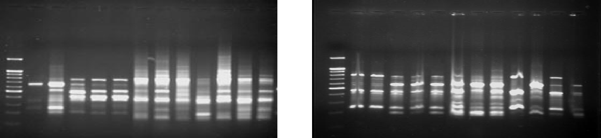

(A) (C)

M 1 2 3 4 5 6 7 8 9 10 11 12 M 1 2 3 4 5 6 7 8 9 10 11 12
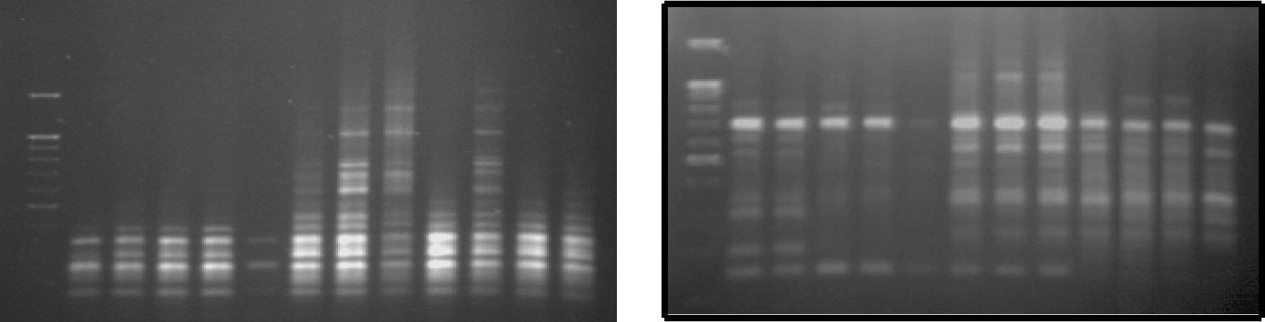

(B) (D)

M 1 2 3 4 5 6 7 8 9 10 11 12
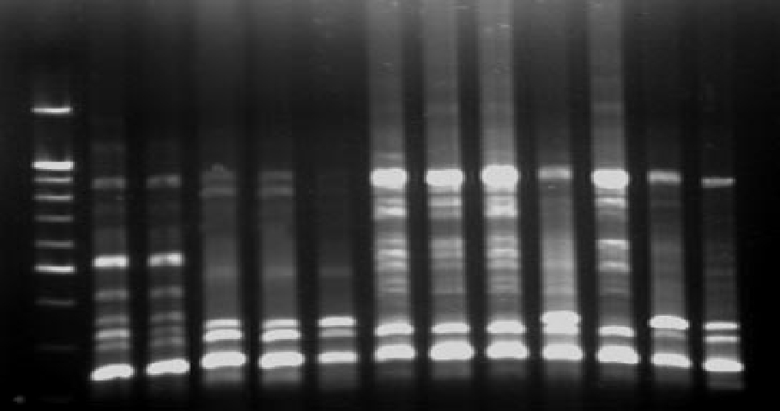

(E)

Figure 1. RAPD analysis of potato cultivas and wild species under PSTVd- infection. Lane M = 100 bp DNA ladder. (A) Primer-1,: (B) primer-2, (C) primer-3, (D) primer-4 and (E) primer-5.
1,2=S. etuberosum plants immune for PSTVd infection and the healthy control, respectively.

3,4,5=S. chacoense plants susceptible, resistant for PSTVd infection and the healthy control, respectively. 6,7,8=Nicola plants susceptible, resistant for PSTVd infection and the healthy control, respectively. 9,10=Draga plants tolerant for PSTVd infection and the healthy control, respectively.

10,12=Hermes plants hypersensitive for PSTVd infection and the healthy control, respectively.

http://www.sciencepub.net/newyork | 13 | newyorksci@gmail.com
Table 5. RAPD amplified bands, polymorphic bands and markers for resistance to PSTVd using five random primers in three potato cultiv
Primer |  | Polymorphism |  |  |  | No. of markers |  |  | Distribution of RAPD markers
name |  | Total |  | P (%) |  | with size (bp) |  | Nicola |  | Draga | Hermes
1 |  | 17 |  | 12 | 1 |  | 1200 | - |  | - | +
1 |  | 70.6% |  |  |  | 5.9% |  | 0 |  | 0 | 1
2 |  | 21 |  | 14 | 1 |  | 105 | - |  | + | -
2 |  | 66.7% |  |  |  | 4.8% |  | 0 |  | 1 | 0
 |  |  |  |  |  |  | 950 |  |  | +
 |  | 15 |  | 11 | 4 |  | 850 |  |  | + | +
3 |  | 15 |  | 11 | 4 |  | 340 |  |  | +
 |  |  |  |  |  |  | 325 |  |  |  | +
 |  | 73.3% |  |  |  | 26.7% |  | 0 |  | 3 | 2
 |  | 14 |  | 8 | 2 |  | 606 |  |  |  | +
4 |  | 14 |  | 8 | 2 |  | 177 |  |  |  | +
 |  | 57.1% |  |  |  | 14.3% |  | 0 |  | 0 | 2
5 |  | 20 |  | 13 | 1 |  | 395 | +
5 |  | 65% |  |  |  | 5% |  | 1 |  | 0 | 0
Total |  | 87 |  | 58 | 9 |  | 10.2% | 1 |  | 4 | 5
 | Polymorphic =66% |  |  |  | 9 |  | 10.2% | 1 |  | 4 | 5
* P = Number of polymorphic bands with polymorphic percentages.
** Total = Total number of amplified fragments.
+ = Presence of marker band.
New York Science Journal 2012;5(7) http://www.sciencepub.net/newyork

4. Discussion

Eight potato cultivars were tested for response to PSTVd infection. All cultivated potatoes were susceptible to PSTVd infection based on disease index. Response of potato cultivars were ranged from hypersensitive such as Hermes; tolerant (Draga and Spunta) and susceptible (Cara;

Diamond and Lady Rosetta) cultivars. As well as, Nicola cultivar was low resistant for PSTVd. In addition, seven wild species of potatoes were tested for response to PSTVd infection. It was found that, Solanum demissum gave hypersensitive, whereas S. acule; S. berthaultii; S. guerreroense and S. stoloniferum were tolerant, whenever S. etuberosum and S. chacoense 17901 was immune and rather moderate resistant, respectively to PSTVd infection depend on results of disease index. These results were confirmed by dot-blot hybridization. Many authers (Singh and Slack 1984) reported that the potato cultivars were susceptible and tolerant to PSTVd-s (severe strain) and no cultivars were immune. As mentioned that disease severity caused by PSTVd-s ranged from mild to severe depending upon the potato cultivar and strain of PSTVd. Moreover, Allam et al., (1989) found that potato cultivars differed in response to PSTVd infection, whereas disease severity caused by PSTVd-s ranged from mild to severe depended upon the potato cultivar. Alpha cultivar was susceptible, Spunta and Kennebic were mediate and Diamond was tolerant. In the first season infection cultivars developed milder symptoms than second and third seasons infections and tolerant cultivars were less affected than susceptible cultivars. Singh (1985) found that two clone of S. berthaultii were resistant to mild and severe strains of PSTVd. Salazar et al.,
http://www.sciencepub.net/newyork | 14 | newyorksci@gmail.com

(1988) detected R_{Pacl} gene in S. acaule responsible on extreme resistant to PSTVd.

Zaitlin and Hariharasubramanian (1972) and El-Dougdoug (1988) reported that viroid infection does not cause any major qualitative or quantitative changes in the nucleic acid profiles of the host, which would indicate a greater coordination of viroid and host nucleic acid synthesis. Nevertheless, some viroid-induced changes in host proteins have been demonstrated for different viroid-host combinations. A comprehensive analysis of gene expression patterns in viroid-infected plants showed further expand our knowledge of host responses to viroid infection. Furthermore, a comparative analysis of host gene expression patterns during viroid and virus infections may enhance understanding of common and unique genes host response to different pathogens. Also, they found that severe strain of PSTVd altered expression of a total of 52 genes. Among these genes 27 were altered only by severe strain of PSTVd and 10 were also altered by mild strain of PSTVd. Notably two genes were specifically induced by mild PSTVd infection. These include a gene homologous to a unknown gene from Medicago sativa (BM556730) was notable, not only because it was specifically induced by PSTVd-m (mild strain) infection, but also because it was induced as carly as five days post-inoculation when most genes were not induced or suppressed by PSTVd-infection. Five genes were induced by PSTVd-s at the late stages of infection. Induction of this genes by viroid infection was reported previous by (Tornero et al., 1994).

New York Science Journal 2012;5(7) http://www.sciencepub.net/newyork

Table 6. RAPD polymorphism using five random primers, number of resistant markers to PSTVd and distribution
 | of markers in two potato wild species.
Primer | Polymorphism |  |  | No. of markers |  |  |  | Distribution of RAPD markers
name | Total |  | P (%) | with size (bp) |  |  |  | S. etuberosum | S. chacoense
1 | 12 |  | 9 | - |  | - |  | - | -
1 | 75% |  |  |  |  | 0% |  | 0 | 0
2 | 11 |  | 8 | - |  | - |  | - | -
2 | 72.7% |  |  |  |  | 0% |  | 0 | 0
3 | 15 |  | 11 | 1 |  | 700 |  | - | +
3 | 73.3% |  |  |  |  | 6.7% |  | 0 | 1
4 | 12 |  | 9 | - |  | - |  | - | -
4 | 75% |  |  |  |  | 0% |  | 0 | 0
5 | 15 |  | 10 | 1 |  | 1230 |  | + | -
5 | 66.7% |  |  |  |  | 6.7% |  | 1 | 0
Total | 55 |  | 47 | 2 |  |  |  | 1 | 1
Polymorphic = 85. 5% |  |  |  |  |  | 3.6% |  | 1 | 1
* P = Number of polymorphic bands with polymorphic percentages.
** Total = Total number of amplified fragments. |  |  |  |  |  | + = Presence of marker band.

M 1 2 3 4 5 6 7 8 9 10 11 12 M 1 2 3 4 5 6 7 8 9 10 11 12
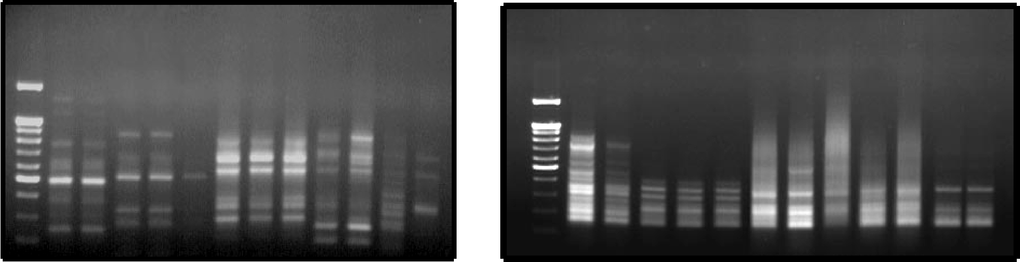

(A) |  | (C)
M 1 2 3 4 5 6 7 8 9 10 11 12 |  | M 1 2 3 4 5 6 7 8 9 10 11 12
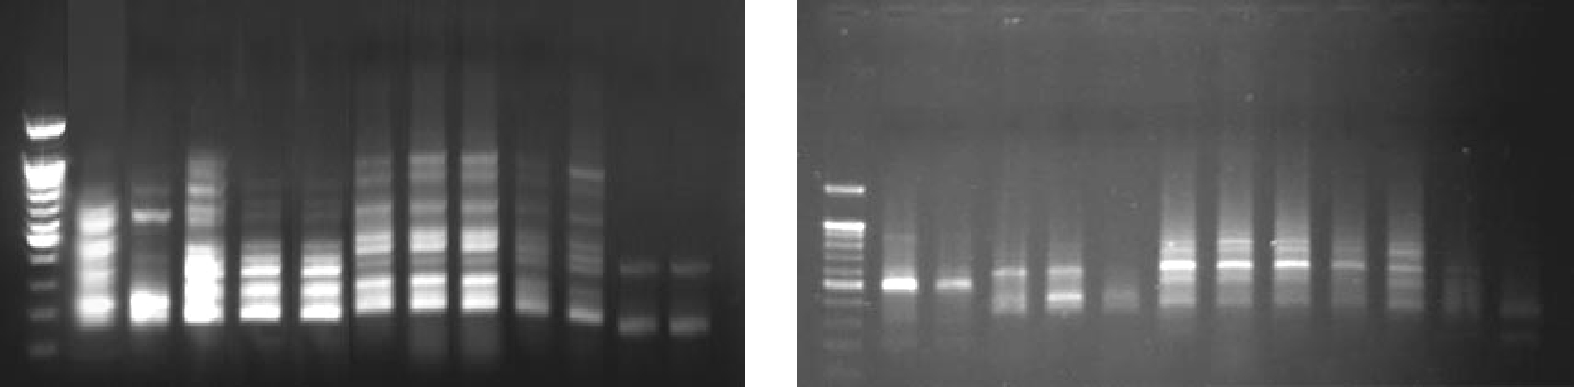
(B) (D)

Figure 2. ISSR analysis of potato cultivas and wild species under PSTVd- infection.

Lane M = 100 bp DNA ladder. (A) Primer-1: (B) primer-3, (C) primer-11 and (D) primer- HB08. 1,2= S. etuberosum plants immune for PSTVd infection and the healthy control, respectively.

3,4,5= S. chacoense plants susceptible, resistant for PSTVd infection and the healthy control, respectively. 6,7,8=Nicola plants susceptible, resistant for PSTVd infection and the healthy control, respectively. 9,10=Draga plants tolerant for PSTVd infection and the healthy control, respectively.

10,12=Hermes plants hypersensitive for PSTVd infection and the healthy control, respectively.

http://www.sciencepub.net/newyork | 15 | newyorksci@gmail.com
New York Science Journal 2012;5(7) http://www.sciencepub.net/newyork

Table 7. ISSR amplified bands, polymorphic bands and markers for resistance to PSTVd using four random primers in three potato cultivars.

Primer | Polymorphism |  |  |  | No. of markers | Distribution of ISSR markers
name | Total |  | P (%) |  | with size (bp) | Nicola | Draga | Hermes
 |  |  |  |  | 975 |  | +
 | 14 |  | 10 | 4 | 740 |  | +
1 | 14 |  | 10 | 4 | 475 |  |  | +
 |  |  |  |  | 375 |  |  | +
 | 71.4% |  |  |  | 28.6% | 0 | 2 | 2
3 | 9 |  | 7 | 0
3 | 77.8% |  |  |  | 0% | 0 | 0 | 0
11 | 9 |  | 6 | 1 | 635 |  | +
11 | 66.7% |  |  |  | 11.1% | 0 | 1 | 0
 |  |  |  |  | 1585 |  | +
 |  |  |  |  | 1160 | +
 | 15 |  | 15 | 6 | 565 |  |  | +
HB-08 | 15 |  | 15 | 6 | 460 |  |  | +
 |  |  |  |  | 335 | +
 |  |  |  |  | 270 |  |  | +
 | 100% |  |  |  | 40% | 2 | 1 | 3
Total | 47 |  | 38 | 11 | 23.4% | 2 | 4 | 5
Polymorphic = 80.9%
* P = Number of polymorphic bands with polymorphic percentages.
** Total = Total number of amplified fragments. |  |  |  |  | + = Presence of marker band.

Table 8. ISSR amplified bands, polymorphic bands and markers for resistance to PSTVd using four random primers in two wild species.

Primer |  | Polymorphism |  |  |  |  | No. of markers |  | Distribution of ISSR markers
name |  | Total |  | P (%) |  |  | with size (bp) |  | S. etuberosum | S. chacoense
1 |  | 14 |  | 13 |  | 0
1 |  | 92.9% |  |  |  |  | 0% |  | 0 | 0
 |  | 9 |  | 5 |  | 3 |  | 1077 | +
3 |  | 9 |  | 5 |  | 3 |  | 590 | +
3 |  |  |  |  |  |  |  | 345 | +
 |  | 55.6% |  |  |  |  | 33.3% |  | 3 | 0
 |  |  |  |  |  |  |  | 1175 | +
 |  | 15 |  | 11 |  | 4 |  | 1036 | +
11 |  | 15 |  | 11 |  | 4 |  | 635 | +
 |  |  |  |  |  |  |  | 290 | +
 |  | 73.3% |  |  |  |  | 26.7% |  | 4 | 0
HB-08 |  | 12 |  | 11 |  | 3 |  | 1030 | +
HB-08 |  | 12 |  | 11 |  | 3 |  | 800 | +
 |  |  |  |  |  |  |  | 680 | +
 |  | 91.7% |  |  |  |  | 25% |  | 3 | 0
Total |  | 50 |  | 40 |  | 10 |  | 20% | 10 | 0
 | Polymorphic = 80% |  |  |  |  | 10 |  | 20% | 10 | 0
* P = Number of polymorphic bands with polymorphic percentages.
** Total = Total number of amplified fragments. |  |  |  |  |  |  | + = Presence of marker band.

http://www.sciencepub.net/newyork | 16 | newyorksci@gmail.com
New York Science Journal 2012;5(7) http://www.sciencepub.net/newyork

Table 9. | Genetic markers in potato cultivars and wild species resistance for PSTVd.
Molecular |  | RAPD & ISSR |  | Potato cultivars |  |  |  | Potato wild species
 |  | RAPD & ISSR |  |  |  |  | S.
markers |  | Primers | Nicola | Draga | Hermes | Total | S. |  | S. chacoense | Total
markers |  |  |  |  |  |  | etuberosum |  | S. chacoense | Total
 |  | 1 | 0 | 0 | 1 |  | 0 |  | 0
RAPD- |  | 2 | 0 | 1 | 0 |  | 0 |  | 0
RAPD- |  | 3 | 0 | 3 | 2 |  | 0 |  | 1
PCR |  | 4 | 0 | 0 | 2 |  | 0 |  | 0
 |  | 5 | 1 | 0 | 0 |  | 1 |  | 0
 |  | Total | 1 | 4 | 5 | 10 | 1 |  | 1 | 2
 |  | 1 | 0 | 2 | 2 |  | 0 |  | 0
 |  | 3 | 0 | 0 | 0 |  | 3 |  | 0
ISSR-PCR |  | 11 | 0 | 1 | 0 |  | 4 |  | 0
 |  | HB-08 | 2 | 1 | 3 |  | 3 |  | 0
 |  | Total | 2 | 4 | 5 | 11 | 10 |  | 0 | 10
 |  | Overall no.= | 3 | 8 | 10 | 21 | 11 |  | 1 | 12
 |  | Polymorphic % | 14.29 | 38.10 | 47.62 |  | 91.67 |  | 8.33

In the present study, three different marker techniques, protein (gene expression), RAPD and
ISSR were used to characterize some cultivars and wild species under PSTVd infection and to detect the resistant markers that could be linked to some resistant genes in potato.

However, no many informative reports could be obtained that establishing any type of PCR markers neither in potato cultivars nor in wild species under PSTVd infection. Consequently, such topics are not well documented yet and this study is the first record in potato.

Five of the RAPD and four from ISSR primers were used to find markers for PSTVd-resistant cultivated and wild potatoes. These primers revealed polymorphism depending on bands number and level of detectable polymorphism. The two different markers techniques (RAPD and ISSR) were combined together. These results were similar with Bornet et al., (2002) who reported that molecular markers based on PCR amplification are efficient tools, quick and easy for plant breeding programs. These markers include RAPD and ISSR techniques. Also, mentioned that ISSR is not need of prior knowledge of the genome sequence; universal; polymorphous; it is more reproducible than RAPD and used for the genetic diversity study of potato.

Many molecular marker techniques are available today. PCR-based approaches are in demand because of their simplicity and requirement for only small quantities of sample DNA (Heldák et al., 2007). Non-anchored (ISSRs) are arbitrary multiloci markers produced by PCR amplification with a microsatellite primer. They are advantageous because no prior genomic information is required for their use. We found that technique stable across a wide range of PCR parameters. Species tested with 2 tri-nucleotide and 2 tetra-nucleotide primers. Thus, non-anchored ISSR markers are a good choice for DNA fingerprinting. Bornet et al., (2002) reported that ISSR-PCR use to assess genetic diversity between cultivated potatoes (Solanum tuberosum subs. tuberosum). ISSR technology rapidly reveals high polymorphic fingerprints and thus determines the genetic diversity among potato cultivars.
http://www.sciencepub.net/newyork | 17 | newyorksci@gmail.com

Corresponding Author:

Dr. Sherin Amin Mahfouze
Genetics and Cytology Department, Genetic Engineering and Biotechnology Division, National Research Center, El-Beehoth street, 12622, Dokki, Giza, Egypt.

E-mail: Sherinmahfouze@yahoo.com

New York Science Journal 2012;5(7) http://www.sciencepub.net/newyork

References

1. Agrawal, GK, Pandey RN, Agrawal VP (1992)

Isolation of DNA from Cheorospondias axillaris

leaves. Biotechnology Letters 2: 19-24.
- Allam, E.K., Sohair A. El-Afifi, M.A. Abou El-Nasr, Kh.A. El-dougdoug (1989). Response of some potato cultivars to potato spindle tuber viroid (PSTVd) infection. 3rd Nat. Conf. of Pests & Dis. of Veg. & fruits in Egypt and Arab Count. Ismailia, Egypt 746-767.

- Bornet, B., Goraguer F., Joly G., Branchard M. (2002). Genetic diversity in European and Argentinian cultivated potatoes (Solanum tuberosum subsp. tuberosum) detected by inter-simple sequence repeats (ISSR_{S}). Genome 45: 481-484.

- Chani, E. (1997). Molecular markers analysis of a segregating monoploid potato family. Ph.D. Thesis, Faculty of the Virginia Polytechnic Institute and State University, pp 6-10.

- Clark, MF, Adams A. N. (1977). Characteristics of the microplate method of enzyme-linked immunosorbent assay for the detection of plant viruses. Journal of General Virology 34, 475-483

- El-Dougdoug, A.E. (1988). Studies on some viroids. Ph.D. Thesis, Faculty of Agric., Ain Shams Univ., Egypt, 135 pp.

- Gadea, J., Mayda M.E., Conejero V., Vero P. (1996). Characterization of definse-related genes ectopically expressed in viroid-infected tomato plants. Mol. Plant Microbe Interact. 9: 409-415.

- Granella, A.; Bellés J.M., Conejero V. (1987). Induction of pathogensis-related proteins in tomato by citrus exocortis viroid, silver ion and ethephon. physiol. Mol. Plant Pathol. 31: 83-90.

- Harders, J., Lukacs N., Nicoud M. R., T.M. Jovin, Riesner D. (1989). Imaging of viroids in nuclei from tomato leaf tissue by in situ hybridization and confocal laser scanning microscopy. EMBO J. 8: 3941-3949.
- Heldák, J., Bežo M., Štefúnová V., Galliková A. (2007). Selection of DNA markers for detection of extreme resistance to Potato virus Y in tetraploid potato (Solanum tuberosum L.) F₁ progenies. Czech Journal of Genetics and Plant Breeding 43 (4), 125-134.
- Itaya, A., Matsuda Y., Gonzales R. A., R.S. Nelson, Ding B. (2002). Potato spindle tuber viroid strains of different pathogenicity induces and suppresses expression of common and unique genes in infected tomato. Molecular plant microbe Interactions, 15(10) 990-999.
http://www.sciencepub.net/newyork | 18 | newyorksci@gmail.com

- Kang, T.J., Yang M.S. (2004). Rapid and reliable extraction of genomic DNA from various wild-type and transgenic plants. BMC Biotechnology 4: 20, 1-12.
- Ratnaparkhe, M.B, Tekeoglu M., Muehlbauer F.J. (1998). Intersimple sequence repeat (ISSR) polymorphisms are useful for finding markers
associated with disease resistance gene clusters. Theor. Appl. Genet. 97: 515-519.

- Salazar, L.F., Hammond R. W., Diener T. O., Owens R. A. (1988).Analysis of viroid replication following Agrobacterium-mediated inoculation of non-host species with potato spindle tuber viroid c-DNA. J. Gen.Virol. 69:879-889.

- Singh, R.P. (1985). Clones of Solanum berthaultii resistant to potato spindle tuber viroid. Phytopathology 75: 1432-1434.
- Singh, R.P., Slack S.A. (1984). Reactions of tuber-bearing solanum soecies to infection with potato spindle tuber viroid. Plant Disease 68: 784-787.
17.Tian, W.H., Cao S.X.; Sun Q., Chang, S.Q., Chang, X.H., Tien, P. (1985). Biological properties of CMV-S51 containing satellite RNA. Acta Phytopathologica Sinica (China) 15: 145-149.

- Tornero, P., Coneyero V., Vera P., (1994). A gene encoding a novel iso-form of the PR-1 protein family from tomato is induced upon viroid infection. Mol. Gen. Genet. 243: 47-53.

- Wang Y., M. Shibuya, A. Taneda, T. Kurauchi, M. Senda, R.A. Owens, Sano, T. (2011). Accumulation of Potato spindle tuber viroid specific small RNAs is accompanied by specific changes in gene expression in two tomato cultivars. Virology 413: 72–83.

- Zaitlin, M., Hariharasubramanian V. (1972). A gel electrophoretic analysis of protein from plants infected with tobacco mosaic and potato spindle tuber viruses. Virology 47: 296-305.

10/4/2012

