Detection of Cryptosporidium Infection among Children with Diarrhea

Nevine S. El-Helalyª, Mona M. Aly^{b}, Samar S. Attia^{b}

ªPediatric and ^{b}Parasitology Departments , Faculty of Medicine, Cairo University, Egypt .
nevo_helaly@yahoo.com

Abstract: Background: Cryptosporidium species are protozoan parasites that cause infection and diarrheal illness in a wild range of mammalian species. There are 20 described species of cryptosporidium of which cryptosporidium hominis and C. parvum are the most frequently detected. C.hominis infection is more common in developing countries. Objective: to detect cryptosporidium infection in clinical samples from pediatric suffering from diarrhea. Patient and Methods: 177 children, in the age group from 1 to 5 years old, suffering from diarrhea, selected from the gastro eanterology outpatient clinic, children Hospital, Cairo University with 35 apparently healthy children in the same age as control group were included in the study. Cases were screened using RIDA Quick Cryptosporidium Coproantigen detection kit. In addition, stool specimens were examined following the kinyoun acid-fast staining method. Results: 27 children in the study group were positive for cryptosporidium infection using antigen detection method (15.3%), while 20 were positive using the acid-fast technique (11.3%). All children in the control group were negative for cryptosporidium infection. Conclusion: cryptosporidium infection is one of the important causes of diarrhea in children below 5 years of age and RIDA Quick antigen detection test proved to be a useful mean for diagnosis in fresh fecal samples.
[Nevine S. El-Helaly, Mona M. Aly, Samar S. Attia. Detection of Cryptosporidium Infection among Children with Diarrhea. New York Science Journal. 2012;5(7):68-76]. (ISSN: 1554-0200). 11

Key words: cryptosporidium – Diarrhea in children – Acid – Fast staining – Coproantigen detection.

1. Introduction:
Cryptosporidium species are protozoan parasites that cause infection and diarrheal illness in a wide range of mammalian species (Priest et al., 2006). Cryptosporidium belongs to the Apicomplexa, which are unicellular organisms possessing at some stage an apical complex; a specialized assembly of organelles believed to be involved in host invasion (McDonald and Kelly, 2005). The genus cryptosporidium contains many species, genotypes and subtypes that infect a wide range of vertebrates including humans. Each may have different sources of infection, transmission routes and pathogencity (Cama et al., 2007).
Cryptosporidium hominis and C. parvum are the most frequently detected. C. hominis infections are more common in developing countries (Molloy et al., 2001). C.parvum is an obligate intracellular parasite that infects the epithelial lining of luminal surfaces of gastrointestinal and respiratory tracts in a wide variety of hosts. In immuno competent individuals, the organism is primarily localized in the distal small intestine and proximal colon, whereas in immuno compromised hosts, the parasite had been identified throughout the gut, biliary and respiratory tracts (Mumtaz et al., 2010).
After ingestion of oocysts, the incubation period is usually 7-10 days then, symptoms of acute enteritis last from 2-26 days or occasionally longer, the main features of the disease are watery diarrhea of variable severity, abdominal pain and mild fever. In otherwise healthy individuals, cryptosporidium infection usually causes a self-limiting diarrheal disease (Hunter et al., 2004).
Laboratory diagnosis of cryptosporidiosis is usually achieved by microscopic detection of cryptosporidium oocysts in stool specimens. Staining techniques including acid-fast stains and immuno-fluorescence. Microscopy is time consuming and requires an experienced observer to identify the organism. Furthermore, it must be performed on three stool samples to increase sensitivity leading to decreased patient compliance and delay in the final diagnosis (Lorente et al., 2002 and Weitzel et al., 2006).
In an attempt to establish sensitive and cost-effective methods to diagnose intestinal infections with cryptosporidium, a number of copro-antigen tests have been developed based on the detection of parasite antigens (Regnath et al., 2006).
Aim of the study: to detection cryptosporidium infections in clinical samples from pediatric patients suffering from diarrhea, using microscopical examination and commercially available rapid Copro-antigen assay.

2. Patients and Methods:
The present study included 177 children, in the age group from 1 to 5 years of age, suffering from diarrhea and attending Gastroenterology outpatient clinic in Children Hospital Cairo University. 35 healthy children with matched age and sex were included as a control group. Children known to have a medical problem affecting the immune system were excluded from the study. A questionnaire containing demographic, clinical and environmental data was obtained from each case. The designed questionnaire was quoted from Da'as, (2010) and Mor et al., (2010). Fresh fecal samples were collected from all patients and controls; a rectal tube was used for collection from infants below 2 years. Samples were collected into a dry, clean, wide mouth plastic container containing no preservatives, with tight fitting lids. Macroscopic examination was conducted at first regarding several aspects: consistency, presence of blood and mucus and macroscopic parasitic elements.
Microscopic examination was then done using direct wet smear technique for the presence of cysts of parasitic protozoa (Garcia, 2007).
Fresh stool samples were then subjected to copro antigen detection for cryptosporidium using RIDA Quick cryptosporidium from R-Biopharm AG, Germany.
Following antigen detection, about 4 gm ($\frac{1}{2}$teaspoon) of stool sample were stained by the kinyoun's Acid-Fast stain (cold method). The slides were examined using the oil immersion lens (100 xs). The oocysts of cryptosporidium stain pink to red to deep purple and appear as oval/round bodies, about 4-5 μm, often with darker staining around the periphery and the background stains blue (Garcia, 2007 and Bailey, 2010).

Statistical methods:
All data were subjected to statistical analysis using SPSS win statistical package version 17. Numerical data were expressed as mean and SD or median range as appropriate. Qualitative data were expressed as frequency and percentage. Chi-square test was used to examine the relation between qualitative variables. For quantitative data, Mann-Whitney test was used. Agreement between antigen detection and acid Fast staining was done using Kappa test. Significance was defined as P < 0.05.

3. Results:
The study was performed on 177 children; with a mean age of 1.6 + 0.9 and their mean weight were 10.1 + 2.3. 107 were males (60.5%) and 70 were females (39.5%) in the patient group while in the control group 21 were males (60%) and 14 were females (40.0%) with no statistical significant difference between both groups.
Statistical analysis of the epidemiologic data revealed that, tap water is the main source of drinking water (97.7%), 49.2% of children drink boiled milk and 79.7% of the mothers wash their hands before feeding their children. Also, it revealed that 14.1% of the children have sheep and/or cows in their house and 7.3% play or have direct contact with pets. While in the control group, mineral water (51.4%) and tap water (45.7%) are the main source of drinking water, 42.9% of children drink boiled milk, and all mothers wash their hand before feeding their children. None of the children have sheep/cows in their house and only 2.9% play or have direct contact with pets.
From a total of 177 children presenting with diarrhea, 78% were also suffering from vomiting, 71.8% from fever, 59.3% from dehydration, 57.6% from cough and 9% from malnutrition.
Cryptosporidium was detected in 27 samples (15.3%) of the 177 patient sample of the study group using the RIDA Quick cryptosporidium copro-antigen detection ICT (Figure 1). Using kinyoun acid-fast stain, cryptosporidium was detected in 20 samples (11.3%) of the 177 patient samples (Figure 2).
Comparison between results of antigen detection and examination of acid fast stained smears for cryptosporidium revealed that seven samples (25.9%) were positive by antigen detection and negative by microscopic examination of acid-fast smears. Relation is highly significant (P < 0.001). Kappa value is 0.829, which means very good agreement between the 2 tests.
A total of 27 positive samples were analyzed according to children's residence, results revealed a wide distribution with 44.4% in urban areas and 55.5% in rural areas. Also infection showed highest rates in march (44.4%), followed by January/ February (37.0%). Highest rates of infection were observed in the age from 1 to 2 years old (88.8%), where 55.6% were males and 44.4% were females. The numeric variables of positive cryptosporidium cases revealed that the mean age of positive cases was 1.3, the duration of diarrhea ranged from 2 to 30 days with a mean of 4.7, only 2 cases suffered from persistent diarrhea (> 14 days). While the number of motions per day varied from 2 to 15 times a day with a mean of 7.9. The mean weight was 9.4. On the other hand, the mean age of negative cases was 1.7, the mean value of duration of diarrhea and number of motions per day was 4.8 and 7.7, respectively and the mean weight was 10.3.
Comparison between numeric variables of the 2 groups revealed significant relation concerning the age and weight (p < 0.05), while the duration of diarrhea and number of motion per day showed insignificant relation (p > 0.05).

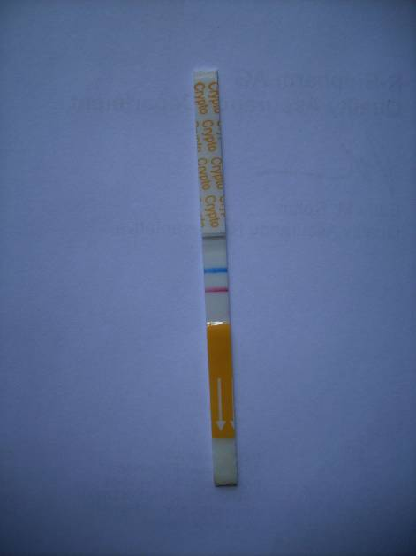 | 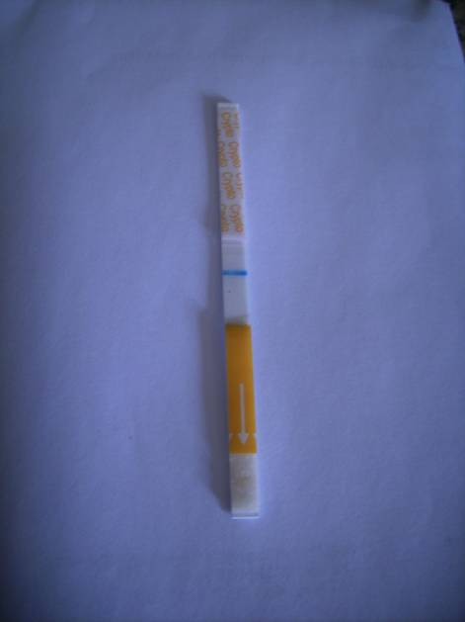
(A) | (B)
Fig. (1) (A) Positive test showing control band (blue band) and test band (red band). (B) Negative test showing control band only

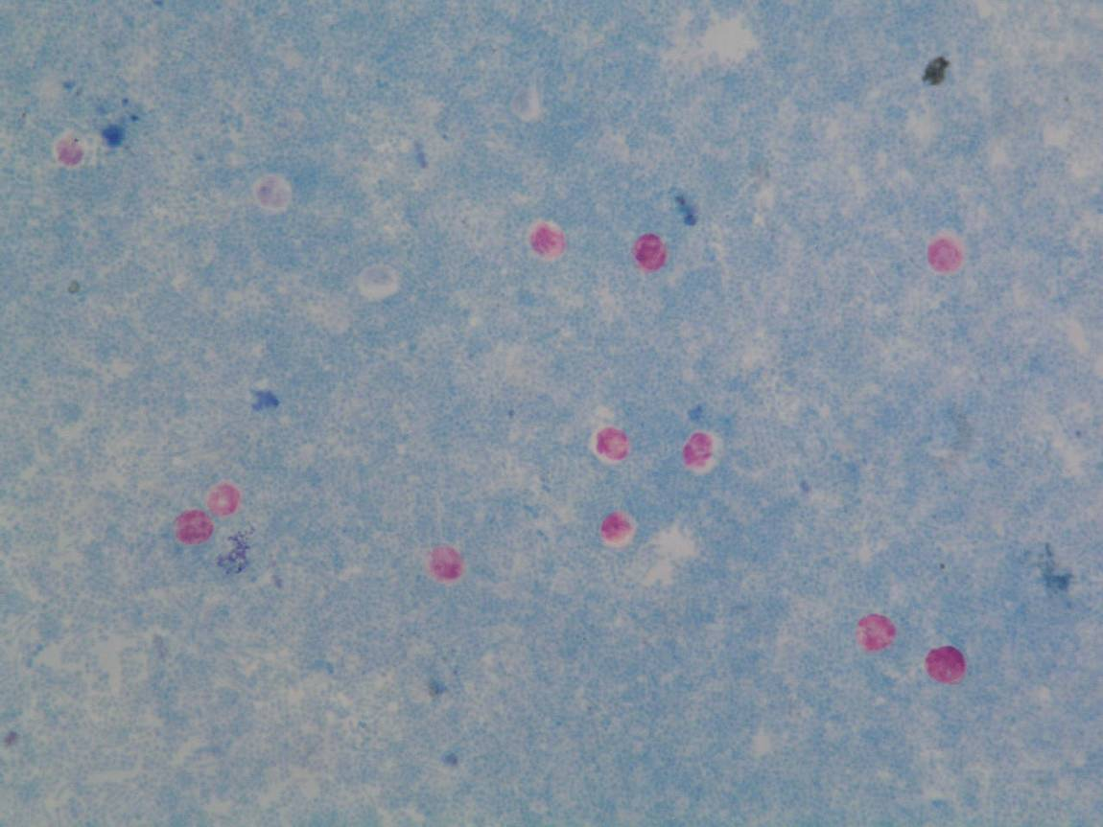
Fig. (2) ): Cryptosporidium oocysts stained with Kinyoun acid fast stain.

Table (1) Consistency and microscopic examination of wet mounts of stool specimens of the study and control groups.
 | Stool Consistency |  |  |  | Pus cells | RBCs | Mucus | Yeast | O&P
 | Watery | Loose | Soft | Formed
Study gp (n=177)
Positive frequency | 49 | 82 | 46 | --- | 46 | 12 | 82 | 29 | 4
Percent | 27.7 | 46.3 | 26.0 |  | 26.0 | 6.8 | 46.3 | 16.4 | 2.3
Negative Frequency | -- | -- | - | - | 131 | 165 | 95 | 148 | 173
Percent |  |  |  |  | 74.0 | 93.2 | 53.7 | 83.6 | 97.7
Control gp (n=35)
Positive Frequency | -- | -- | 1 | 34 | 1 | -- | -- | 4 | 4
Percent |  |  | 2.9 | 97.1 | 2.9 |  |  | 11.4 | 11.4
Negative Frequency | - | - | - | - | 34 | 35 | 35 | 31 | 31
Percent |  |  |  |  | 97.1 | 100.0 | 100.0 | 88.6 | 88.6

Table (2) Comparison between results of antigen detection and examination of acid fast stained smears for cryptosporidium.
Group |  |  |  | Ag_Detection |  | Total
 |  |  |  | -ve | +ve | Total
Study gp | AF_stain | -ve | Count | 150 | 7 | 157
 |  |  | % within AF_stain | 95.5% | 4.5% | 100.0%
 |  |  | % within Ag_Detection | 100.0% | 25.9% | 88.7%
 |  | +ve | Count | 0 | 20 | 20
 |  |  | % within AF_stain | .0% | 100.0% | 100.0%
 |  |  | % within Ag_Detection | .0% | 74.1% | 11.3%
 | Total |  | Count | 150 | 27 | 177
 |  |  | % within AF_stain | 84.7% | 15.3% | 100.0%
 |  |  | % within Ag_Detection | 100.0% | 100.0% | 100.0%

Table (3) Correlation between positive cryptosporidium results and epidemiologic data.

Group | Water source |  |  |  | Milk type |  |  | Hand wash | Sheep/cows | Pets
Ag +ve  (n=27)  Yes  Count %  No  count % | Tap | Mineral | Well | Filter-ed | Breast milk | Boiled | Pasteur-ized | 23  85.2  4  14.8 | 4  14.8  23  85.2 | 4  14.8  23  85.2
Ag +ve  (n=27)  Yes  Count %  No  count % | 26  96.3  --- | 1  3.7  --------- | 0  0  ----- | 0  0  ------ | 16  59.3  ------- | 8  29.6  ------- | 3  11.1  ------- | 23  85.2  4  14.8 | 4  14.8  23  85.2 | 4  14.8  23  85.2
Ag -ve  (n=150)  Yes  Count %  No  Count % | 147  98.0  ---- | 0  0  --------- | 2  1.3  ----- | 1  0.7  ------ | 55  36.7  -------- | 79  52.7  ------- | 16  10.7  ------- | 118  78.7  32  21.3 | 21  14.0  129  86.0 | 9  6.0  141  94.0
*The relation is insignificant as p-value > 0.05

Table (4) Correlation between positive and negative cases with associated clinical manifestations.

Group | Vomiting | Dehydration | Malnutrition | Fever | Cough
Ag +ve  (n=27)  Yes  Count  %  No  Count  % | 19  70.4  8  29.6 | 17  63.0  10  37.0 | 1  3.7  26  96.3 | 19  70.4  8  29.6 | 17  63.0  10  37.0
Ag -ve  (n=150)  Yes  Count  %  No  Count  % | 119  79.3  31  20.7 | 88  58.7  62  41.3 | 15  10.0  135  90.0 | 108  72.0  42  28.0 | 85  56.7  65  43.3
*The relation is insignificant as p-value is > 0.05

Table (5) Consistency and microscopic examination of wet mounts of stool samples of the positive and gative cases in the study group.
 | Stool Consistency |  |  |  |  | Pus cells | RBCs |  | Mucus |  | Yeast | O&P
Ag +ve  (n=27)  Positive  count  %  Negative  count  % | Watery |  | Loose | Soft |  | 11  40.7  16  59.3 |  | 4  14.8  23  85.2 |  | 15  55.6  12  44.4 | 4  14.8  23  85.2 | 0  0  27  100.0
Ag +ve  (n=27)  Positive  count  %  Negative  count  % | 11  40.7  ----- |  | 12  44.4  ---- | 4  14.8  ----
Ag -ve  (n=150)  Positive  count  %  Negative  count  % | 38  25.3  ----- | 70  46.7  ----- |  |  | 42  28.0  ---- | 35  23.3  115  76.7 | 8  5.3  142  94.7 |  | 67  44.7  83  55.3 |  | 25  16.7  125  83.3 | 4  2.7  146  97.3

4. Discussion:
The present study focused on evaluating the current state of cryptosporidium infection in children from 1 to 5 years old over a 5 months period. The results were based on single stool examination.
In the study group (n = 177) cryptosporidiosis was revealed in 27 sample (15.3%) using the antigen detection method and in 20 samples (11.3%) using the acid-fast stain. No cryptosporidium infection was detected in the control group.
In Egypt, the first report on C. parvum was published by Azab et al., (1985), it was detected in an 18 months old child presenting with diarrhea (Youssef et al., 2008). Abdel Messih et al., (2005) reported a prevalence of 17% for cryptosporidium associated diarrhea in 1275 children below 5 years of age using a commercially available ELISA antigen detection test El-Mohamady et al., (2006) found that 15% of children less than 60 months old from Tamiga district of Fayoum governorate, presenting with diarrhea, had cryptosporidium.
Prevalence rates of cryptosporidium infections in children less than 5 years of age in other areas of the world also vary, mainly depending on the method of detection and symptomatic infections.
Al Braiken et al., (2003) found that 32% of the symptomatic children excrete cryptosporidium cysts, while only 4.7% of a symptomatic had cryptosporidium infection. Tumwine et al., (2003) determined the prevalence of cryptosporidiosis in hospitalized children in the same age group at Mulaga Hospital in Kampala, Uganda, over all 25% of the children with diarrhea had C. parvum, compared to 8.5% of children without diarrhea. Also Moyo et al., (2011) determined the age specific etiologic agents of diarrhea in children aged less than 5 years in four major hospitals in Dar EL Salaam, Tanzania, where diarrhogenic E.coli was the most common enteric pathogen (22.9%), followed by C. parvum (18.9%), Rotavirus (18.1%) and Norovirus (13.7).
Lower rates of cryptosporidium infection have been reported in children below 5 years with diarrhea, Mumtaz et al., (2010) in Peshawar, Pakistan (9.0%) and Ajjampur et al., (2010) in India (2.7%).
Concerning study group demographic data, gender distribution of positive cryptosporidium cases revealed 55.6% males and 44.4% females. The relation was insignificant. Similarly Gatei et al., (2006) found that infection rates did not vary with gender distribution. Alternatively Mumtaz et al., (2010) observed high prevalence rate of cryptosporidium in males.
The mean age of the study group was 1.6 year and highest rates of cryptosporidium infection were in children 1 to 2 years old (88.8%). In accordance Gatei et al., (2006) concluded that the prevalence was highest among children 13-24 month of age. Similarly, Areeshi et al., (2007); Ajjampur et al., (2010) and Mumtaz et al., (2010) reported that most cases of cryptosporidiosis occurred particularly in the first two years of life.
On the other hand, Iqbal et al., (2001) found that prevalence of cryptosporidiosis infection at a local hospital in Kuwait was highest (73%) in children above 2 years of age.
As regards the distribution of positive cases according to children's residence, we found a wide rather than a focal distribution of cases; 44.4% in urban areas and 55.5% in rural areas. Youssef et al., (2008) reported that residing in a rural area appears to be a contributing factor to increase C. parvum infection risk (increased exposure to zoonotic infection, low socioeconomic standard and close contact with soil).
In the present study tap water was the main source of drinking water in the study group (97.7%) and also in positive cases (96.3%). In the United States and the developed countries, out breaks of cryptosporidiosis in both adults and children have been linked to improperly treated drinking water, exposure to contaminated recreational water, and contamination of un cooked food items (Priest et al., 2006).
In Egypt Youssef et al., (1998) and Antonios et al., (2001) reported that cryptosporidium oocysts were detected in water samples from uncovered water tanks, canals, fish ponds and tap water.
As regards the history to animal contact (sheep, cows, pets) in the cryptosporidium antigen positive children, our results revealed that only 14.8% had a history of animal contact while the majority of children (85.2%) gave no history of such contact. In contrast Iqbal et al., (2001) suggests contact with infected animals as a possible mode of infection transmission. However, there have been a number of studies that have failed to find an animal association (Khashba et al., 1989; Mikhail et al., 1989 and Youssef et al., 2008).
In our study group, breast feeding was recorded in 83.1% of the children, of these 25 (17%) were positive for cryptosporidium antigen in stool. Tumwine et al., (2003) found no statistically significant difference between breast feed and the who no longer breastfed and had C.parvum infection. On the other hand Abdel Messih et al., (2005) reported that breast feeding had a trend towards protection against cryptosporidium associated diarrhea, as non breastfed children are more exposed to infection through contaminated food and bottles.
In patients with positive cryptosporidium results, the duration of diarrhea ranged from 2 to 30 days, and the number of motion per day varied from 2 to 15 times per day. Associated manifestations included vomiting (70.4%), fever (70.4%), dehydration (63%), cough (63%) and malnutrition (3.7%). Youssef et al., (2008 reported that vomiting, fever, abdominal pain and dehydration were the most common presenting symptoms in 19 studies in Egypt detecting cryptosporidium in individuals with diarrhea. However Cama et al., (2008) on his study on 533 children in Peru showed that C.hominis was associated with diarrhea, nausea, vomiting and general malaise, While C.parvum, C.meleagridis, C.canis and C.felis were associated with diarrhea only. It was concluded that the spectrum of these clinical manifestations can be attributed in part to the different species of cryptosporidium and subtypes of C.hominis.
Upper respiratory symptoms are commonly associated with cryptosporidium infection and have been described in approximately 15% of pediatric cases. Other studies showed higher incidence (40%-50%) but the cause of respiratory symptoms was not investigated. In our study cough was present in 57.6% of study group. However, cryptosporidium infection in the lower respiratory tract appears to be a rare occurrence and is limited primarily to profoundly immuno compromised patients (Huang et al., 2004 and Mor et al., 2010).
Regarding the method of detection of cryptosporidium infection, in the present work, both acid-fast staining method and coproantigen detection (RIDA Quick cryptosporidium ICT) have been used. The number of positive cases was 27 by the antigen detection test and 20 by the acid-fast method. Iqbal et al., (2001) reported that shedding of cryptosporidium oocysts may be intermittent, even in those patients with massive diarrhea, so that microscopical examination must be performed on 3 stool samples to increase sensitivity which may lead to problems concerning patient compliance and delays in the final diagnosis. In accordance El Shazly et al., (2002), found that the ZN stain had the lowest sensitivity in relation to either ELISA coproantigen test or PCR.
Bialek et al., (2002) found sensitivity of antigen EIA and DFA were similar (94% and 95%) and PCR assays did not increase the detection rate.
Garcia et al., (2003); Weitzel et al., (2006) and Regnath et al., (2006) observed that all stool specimens were positive by RIDA Quick assay, weak but visible bands were seen for samples with lower numbers of oocysts and reported that advantages of antigen detection assays include labor, time, and batching efficiencies that may lead to cost reduction. Also Al Hindi et al., (2007) on using ZN stain and ELISA reported positivity of 14.9% and 16.3% respectively.
On the other hand, Katanik (2001) reported false positive reactions with some rapid Cryptosporidium antigen detection assays (pro spec T). These reactions occurred with specimens that were grossly bloody.
Concerning stool analysis data of the antigen positive cases in the present work, 44.4% of fecal specimens were loose and 40.7% watery, 40.7 had pus cells, 14.8% had RBCs 55.6% had mucus and 14.8% had yeast. In stool specimens of the antigen negative patients 3 cases of Giardia Lamblia infection and 1 case of Blastocystis infection were observed, while in the control group 2 cases of Giardia Lamblia infection and 2 cases of H. nana were recorded. Newman et al., (1999), in a study on children with cryptosporidium infection in Brazil, reported that the disease is characterized by a profuse watery diarrhea which may contain occult blood (14% in acute diarrhea and 31% in persistent diarrhea); mucus (21% in acute diarrhea and 19% in persistent diarrhea), leucocytes (28% in acute diarrhea and 38% in persistent diarrhea), and lactoferrin (67% in acute diarrhea and 75% in persistent diarrhea).
5. Conclusion:
Cryptosporidium infection is one of the important causes of diarrhea in children below 5 years of age. The present study revealed a percentage of cryptosporidium positive cases of 15.3% using RIDA Quick ICT and 11.3% using kinyoun acid fast staining. RIDA Quick antigen detection test proved to be a useful mean for diagnosis of cryptosporidiosis in fresh fecal samples. The test is rapid to perform with hands on time 1 to 2 minutes and results are obtained within 9 to 10 minutes. Moreover, it dose not require experienced staff or special technical equipments. On the other hand kinyoun acid fast stain is a valuable method but it may require a skilled microscopist to examine the smears especially in cases with small number of oocysts.

References:
- Abdel Messih IA, Wierzab TF, Abu-Elyazeed R, Ibrahim AF, et al, Diarrhea associated with cryptosporidium parvum among children of the Nile River Delta in Egypt. J. Trop. Pediat 2005, 51 (3) 154-59.
- Ajjampur SS, Liakath FB, Kannan A, Rajendran P. et al., Multisite study of cryptosporidiosis in children with diarrhea in India. J. Clin. Microbiol. 2010; 48 (6): 2075-81.
- Al Braiken FA, Amin A, Beeching NJ, Hommel M, Hart CA. Detection of cryptosporidium amongst diarrhoeic and symptomatic children in Jeddah, Saudi Arabia. Ann. Trop. Med. Parasitol. 2003; 97 (5): 505-10.
- AL Hindi AI, EL Manama AA, Elnabris KJ. Cryptosporidiosis among children attending Al-Nasser Pediatric Hospital, Gaza, Palestine. Turk. J. Med. Sci. 2007; 37 (6): 367-72.
- Antonios SN, Salem SA, Khalifa EA. Water pollution is a risk factor for cryptosporidium infection in Gharbia governorate. J. Egypt. Soc. Parasitol. 2001, 31 (3): 963-64.
- Areeshi MY, Beeching NJ, Hart CA. Cryptosporidiosis in Saudi Arabia and neighboring countries. Ann. Saudi Med. 2007; 27 (5): 325-32.
- Azab ME, Khalil HM, Khalifa AS, Maklouf SA, Habib SM Cryptosporidiosis as a possible cause of diarrhea in children. Egypt J. peadiat 1985; 2: 347-53.
- Bailey JW. The diagnosis of faecal and blood parasites. Course Manual, Liver pool School of Tropical Medicine, UK. 2010.
- Bialek R, Binder N, Dietz K, Joachim A, Knobloch J, Zelck UE. Comparison of fluorescence, antigen and PCR assays to detect cryptosporidium parvum in fecal specimens. Diag. Microbiol. Infect. Dis. 2002; 43; 283-88.
- Cama VA, Ross JM, Crawford S, Kawai V, et al., Differences in clinical manifestations among cryptosporidium species and subtypes in HIV infected persons. J. infect. Dis. 2007; 196: 684-91.
- Cama VA, Bern C, Roberts J, Cabrera L, et al., cryptosporidium species and subtypes and clinical manifestations in children, Peru. Emerg. Infect. Dis 2008; 14 (10): 1567-74.
- Da'as HA. Prevalence of cryptosporidium species among children < 5 years old in North West-Bank, Palestine, cross sectional study thesis for Master degree in public Health, Faculty of Graduate studies, An-Najah National University, Nablus-Palestine 2010.
- El Mohammady H, Abdel Messih IA, Youssef FG, Said M, et al., Enteric pathogens associated with diarrhea in children in Fayoum Egypt. Diag. Microbial. Infect. 2006; 56: 1-5.
- El-Shazly AM, Gabor A, Mohmoud MS, Abdel Aziz SS, Saleh WA. The use of Zhiel-Neelsen stain, Enzyme Linked immunosorben assay and nested polymerase chain reaction in diagnosis of cryptosporidiosis in immuno competent, compromised patients. J. Egypt. Soc. Parasitol. 2002; 32 (1): 155-166.
- Garcia LS. Diagnostic Medical Parasitology, 5thed. ASM Press, Washington D.C. 2007.
- Garcia LS, Shimizu RY, Novak S, Carroll M, Chan F. Commerical assay for detection of Giardia Lamblia and cryptosporidium parvum antigens in human fecal specimens by Rapid-Solid phase qualitative immuno chromatography. J. Clin. Microbiol. 2003; 41 (1): 209-12.
- Gatei W, Wamae CN, Mbae C, Waruru A, et al., Cryptosporidiosis: prevalence, genotype analysis and symptoms associated with infections in children in Kenya. Am. J. Trop. Med. Hyg. 2006; 75 (1): 78-82.
- Huang DB, Chappel C, Okhuysen PC. Cryptosporidiosis in children. Semin pediatr. Infect. Dis 2004; 15 (4): 253-59.
- Hunter PR, Hughess, Woodhouse S, Raj N, et al., Health sequelae of human cryptosporidiosis in immunocompetent patients. Clin. Infect Dis 2004; 39: 504-10.
- Iqbal J, Hira PR, Al Ali E, Philip R. Cryptosporidiosis in Kuwaiti children; seasonality and endemicity. Clin Microbiol. Infect. 2001; 7: 261-66.
- Katanik MT, Schneider SK, Rosenblatt JE, Hall GS, Procop GW. Evaluation of color PAC Giardia/Cryptosporidium rapid assay and prospec T Giardia/ cryptosporidium microplate assay for detection of Giardia and Cryptosporidium in fecal specimens J. Clin. Microbiol. 2001; 39 (12): 4523-25.
- Khashba A, Hilali M, El-Hennawis, Marei M. Cryptosporidiosis among children suffering from diarrhea in Banha, Egypt. J. Egpt. Soc. Parasitol. 1989; 19 (3): 701-05.
- Lorente MT, Clavel A, Varea M, Olivera S et al., Evaluation of an immunochromatographic dip-strip test for the detection of cryptosporidium oocysts in stool specimens. Eur. J. Clin. Microbiol. Infection. Dis 2002; 21: 624-25.
- McDonald V and Kelly MP. Intestinal Coccidia. Topley and Wilson's Microbiology and Microbial infections. Cox, FE, Wakelin D, Gillespie S, Desposmmier D (eds), 10th ed. Hodder Arnold ASM Press 2005.
- Mikhail IA, Hyams KC, Podgore JK, Haberberger RL, et al., Microbiologic and clinical study of acute diarrhea in children in Aswan, Egypt Scand. J. Infect. Dis. 1989; 21: 59-65.
- Molloy SF, smith HV, Kirwan P, Nichols AB, et al., Identification of a high diversity of cryptosporidium species genotypes and subtypes in a pediatric population in Nigeria. Am J. Trop. Med. Hyg. 2010; 82 (4): 608-13.
- Mor SM, Tumwine JK, Ndeezi G, Srinivasan M, et al., Respiratory cryptosporidiosis in HIV-serongeative children in Uganda: potential for respiratory transmission. Clin. Infect. Dis. 2010; 50 (10): 1366-72.
- Moyo SJ, Gro N, Matee M, Kitundu J, et al., Age specific etiological agents of diarrhea in hospitalized children aged less than five years in Dar es Salaam, Tanzania. BMC Pediatrics. 2011; 11: 1-6.
- Mumtaz S, Ahmed J, Ali L. Frequency of cryptosporidium infection in children under five years of age having diarrhea in north west of Pakistan. Afr. J. Biotech. 2010; 9 (8): 1230-35.
- New man RD, Sears CL, Moore SR, Nataro JP, et al., Longitudinal study of cryptosporidium infection in children in northeastern Brazil. J. Infect. Dis. 1999; 180: 167-75.
- Priest JW, Bern C, Xiaol, Roberts JM, et al., Longitudinal analysis of cryptosporidium species-specific immunoglobulin G antibody responses in Peruvian children. Clin. Vac. Immunol 2006; 13 (1): 123-31.
- Regnath T, Klemm T, Lgnatius R. Rapid and accurate detection of Giardia Lamblia and Cryptosporidium Spp. Antigens in human fecal specimens by new commercially available qualitative immuno chromatographic assays. Eur. J. Clin. Microbiol. Infect Dis. 2006; 25; 807-809.
- Tumwine JK, Kekittiinwa A, Nabukeera N, Akiyoshi DE, et al., Cryptosporidium parvum in children with diarrhea in Mulago Hospital, Kampala, Uganda. Am J. Trop Med. Hyg. 2003; 68 (6): 710-15.
- Weitzel T, Dittrich, S. Mohl I, Adusu E, Jelinek T. Evaluation of seven commercial antigen detection tests for Giardia and Cryptosporidium in Stool samples. Clin. Microbiol. Infect. 2006; 12: 656-59.
- Youssef MY, Khalifa AM, El Azzouni MZ. Detection of cryptosporidia in different water sources in Alexandria by monoclonal antibody test and modified Ziehl Neelsen stain. J. Egypt Soc. Parasitol. 1998; 28: 487-96.
- Youssef FG, Adib I, Riddle MS, Schlett CD. A review of Cryptosporidiosis in Egypt. J. Egypt Soc. Parasitol. 2008; 38 (1): 9-28.

