Impact of Oil Disposal in Open Seas
(Abu Qir Desalination Plant)

Safaa M. Soliman

Research Institute for Groundwater, National Water Research Center, El Kanter El Khairia, Kalubia, Egypt
safaa_soliman_m@yahoo.com

Abstract: This study investigates the impacts of oil disposal in open seas on groundwater pollution in coastal aquifers, based on one site specifications. The location of the site is Abu Qir, near Alexandria and the designed plant capacity is 800m³/hr. The major sources of oil are the ships spills. Oil was found in the sea water close to the plant site. Therefore, it was decided to replace sea water by groundwater through beach wells.
To satisfy the desired plant capacity of water, 4 deep groundwater wells are needed with a total capacity of about 800 m³/hr, in addition to 3 wells as stand-by to keep the groundwater discharge as required during emergency conditions. The 7 wells are planned to operate alternatively to keep the groundwater discharge as required. The maximum allowable pumping value is 1200 m³/hr.
Chemical analysis of groundwater indicated the existence of Oil at some locations which calls more investigations on its extent, at present, and in the future with the operation of the wells. Accordingly, a forecast is made to test the impacts of proposed scenarios on the sustainability of the plant capacity of saline water at present and in the future and to investigate the extent of the Oil plume through the aquifer in terms of concentration and extent. This is achieved through the numerical simulation of the aquifer system by Visual MODFLOW 4.2. The results have demonstrated that:1)All scenarios of pumping are accepted if the drawdown does not affect the stability of the project buildings; 2)The extent of groundwater pollution with Oil decreases with depth; 3)Groundwater pollution with Oil will decrease with time and continuous pumping ; 4)The maximum Oil concentration in the model area before pumping is 16 mg/l at 2009 and will be 7 mg/l after 40 years; 5)The maximum Oil concentration in the model area after pumping of 1400 m3/h for 7 wells is 14 mg/l at 2009 and will be 5 mg/l after 40 years at 30 m depth and 6)The maximum Oil concentration in the model area after pumping of 1400 m3/h for 7 wells is 4 mg/l at 2009 and will be 0.9 mg/l after 40 years at 70 m depth.
This primary exercise indicates the safe dependence on saline groundwater in desalination. However, monitoring systems are recommended to ensure the adequacy of the exercise, accompanied by post-auditing of the models.
[Safaa M. Soliman. Impact of Oil Disposal in Open Seas (Abu Qir Desalination Plant). New York Science Journal. 2012;5(7):77-88]. (ISSN: 1554-0200). 12

Key word: sustainability, desalination, Abu Qir, variable density, plume

1. Introduction
A desalination plant is planned to be implemented at Abu Qir coastal area to supply a development project by its fresh water demands. Oil was found in the sea water close to the plant site. Accordingly, it was decided to replace sea water by groundwater through beach wells. Chemical analysis of groundwater indicated that the existence of Oil at some locations which dictates more investigations on its extent, at present, and in the future with operation of the wells. Accordingly, a forecast is planned to investigate the extent of the Oil plume through the aquifer in terms of concentration and extent prior to the implementation of the plant.
To satisfy the desired plant capacity of water, 4 deep groundwater wells will be constructed with a total capacity of about 800 m³/hr. Three more wells will be constructed as stand-by to keep the groundwater discharge as required during emergency conditions.
The area of this study is located between latitudes 31º 10/ – 31º 20/ N and longitudes 30º 05/ – 30º 15/ E, as shown in Figure1 (RIGW, 1994).
The objectives of the present study are:1)Testing groundwater sustainability to satisfy the required input of saline water during the coming 40 years; 2)Optimizing wells locations to minimize drawdown; 3)Predicting the change in groundwater quality within the 40 years; 4)Testing the possibility of Oil plume transport within the desired time and 5)Predicting the Oil plume extent in groundwater.
The proposed methodology that fulfills the study objectives is:1)Selecting suitable numerical package(s) for modeling saline-fresh groundwater flow and transport (variable density); 2)Constructing the groundwater flow and transport model ; 3)Calibrating the model.;4)Testing groundwater sustainability during 40 years with the help of the calibrated model.5) Testing the drawdown of wells within the 40 years;6) Testing the different pumping schemes and 7) Predicting the change in groundwater quality with time during the pumping period (40 years).

2. Physical Setting
General Outline
The aquifer system in the area is part of Alexandria aquifer system. Quantitative and qualitative understanding of aquifer systems and groundwater conditions is portrayed in hydrogeological maps.
Based on the hydrogeological maps (RIGW, 1994), three groundwater bodies could be distinguished in the area comprising Alexandria Governorate (Ahmed R. Khater, 2005; Abdel-Moati M.A.R. 2001; Dorgham M.M. et al, 1987; Dowidar N.M.et al, 1983; EEA., 2006) as shown in Figures 2, 3.
1- The Coastal Plain aquifer.
2- Delta western fringes aquifer.
3- Old Flood Plain aquifer.
1-The coastal plain aquifer, running parallel to the coast, is composed mainly of fine-grained limestone, changing into alluvial deposits near the coast. The thickness ranges between 40 and 60m. The aquifer is naturally recharged from rainfall, in addition to other local sources (leakage from water and sanitary drainage networks). The aquifer contains saline water (~20,000 ppm) and is mainly influenced by the Mediterranean and Lake Mariut. However, a fresh water body (200-1000 ppm) of limited extent is found floating over the saline water (1000-3000 ppm) is found in the alluvial sandy coastal dunes.
2-The Delta western fringes aquifer forms the western extension of the main Nile Delta aquifer system. It covers the area in the vicinity of Mahmudiya and Mamoura canals. The aquifer is semi-confined and consists of graded sand and gravel, changing to fine sand and clay in the north. The aquifer thickness varies between 100 to 400m. The whole thickness of the aquifer is affected by sea water intrusion and contains brackish to saline water. Local recharge partly takes place from excess irrigation water in the agricultural lands between El Mamoura and Ezbet Khorshid.
3- The Old Flood Plain aquifer is located to the south of the Coastal plain aquifer and occupies the area between West Amriya and Sidi Krir. The aquifer consists of coarse sand and gravel of the Moghra formation, changing to clay near the Mediterranean. Groundwater salinity is exceeding 30000 ppm; varying between 3000 to 15000 ppm in the vicinity of Bahig Canal, where local recharge from excess irrigation and very limited natural recharge from rainfall are taking place.

3. Numerical Simulation
3.1 Modeling Package
The Visual MODFLOW program 4.2 package is considered the most suitable package for satisfying the study objectives. The VISUAL MODFLOW PROGRAM 4.2 package is based on the finite difference technique being the most complete and simple technique for modeling environment for professional applications in three-dimensional groundwater flow and contaminant transport simulations. This fully integrated package combines MODFLOW, MODPATH, MT3D, MT3DMS, RT3D, PESST and SEAWAT with the most intuitive and powerful graphical interface available. The model grid input parameters and results can be visualized in cross-section or plan view at any time during the development of the model or while displaying the results (Anderson and Woessner, 1992; Engesgaard P. and. Kipp K.L.1992).

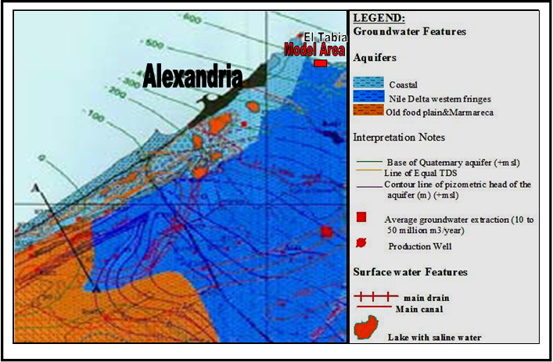
Figure 1: General Location Map of the Model Area

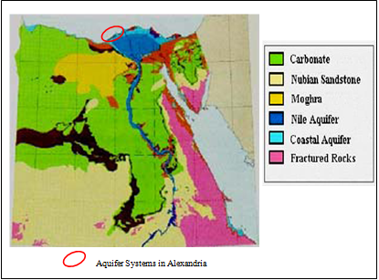
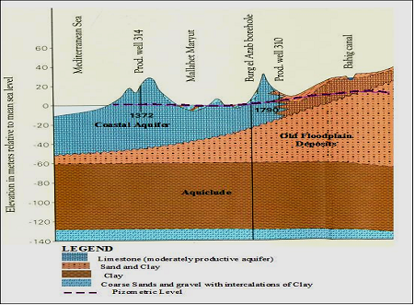
Figure 2: Main Aquifer Systems in Egypt

Figure 3: General Longitudinal Cross-Section along Alexandria

3.2 Modeling Grid and Boundaries
The aquifer is bounded by the Mediterranean Sea in the north (considered as a constant head boundary). The western boundary is considered a no flow boundary (perpendicular on the piezometric head lines). The eastern and southern boundaries are considered general head boundaries, based on the nearest constant head contour. The model grid consists of 6820 cells; relatively small cells were used in the significant areas, the model grid and boundaries are shown in figure 4.

3.3 Model Input
Superimposing the model grid cells on the map of the model area derived the required model input data defining the aquifer system geometry. The ground surface and the base of the aquifer are shown in figures 5, 6. The hydraulic conductivity of the aquifer has been measured by pumping test in some locations, and its average value is about 55 m/day.

The Oil concentrations in groundwater has been measured at some locations at 2009 in different depths to used as an initial concentrations for transport model after model calibration.

3.4 Calibration
To use the model in testing the impact of different scenarios, the model was calibrated for steady state flow conditions in 2009. Calibration trials have been made until an accepted match between observed and calculated groundwater heads is achieved, as shown in Figure 7. During the calibration period, various inputs were adjusted, especially the hydraulic parameters (hydraulic conductivity, specific storage or specific yield distribution), taking into consideration available results of aquifer tests, geological studies and geophysical logs.

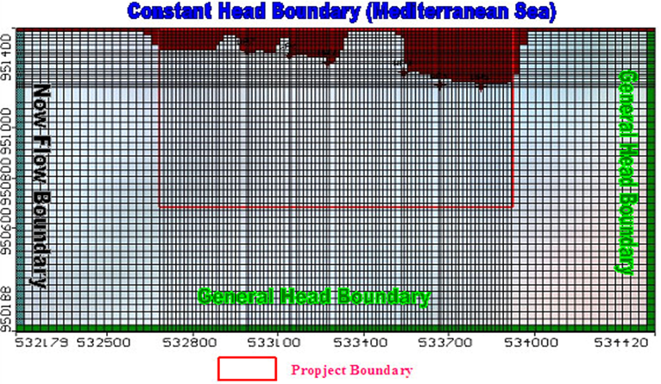
Figure 4: Model Grid and Boundaries

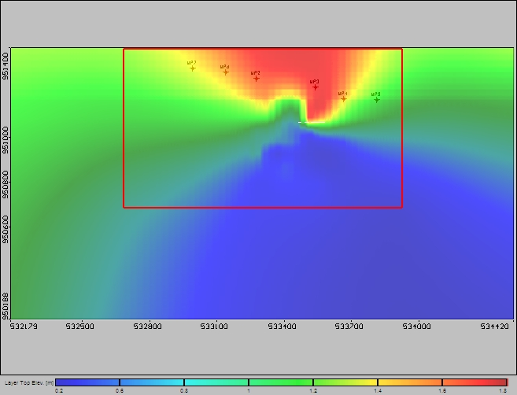
Figure 5: Ground Surface Contour Map

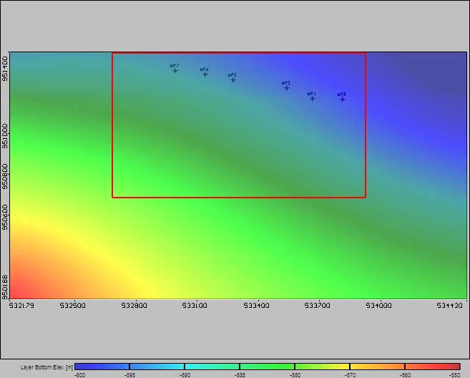
Figure 6: Contour Map of the Aquifer Base

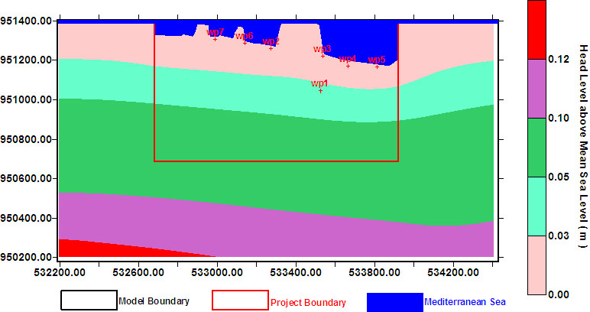
Figure7: Calibrated Piezometric Head Contour Map

3.5 Proposed Scenarios
The aim of simulating groundwater flow in this study is to enable forecasting the future trends in groundwater heads and quality (intruded sea water and Oil) taking into consideration the proposed groundwater pumping scenarios. The calibrated model has been run under the effect of different extraction scenarios for 40 years. In the first scenario, 6 wells are pumped to test the effect of maximum possible capacity needed (1200 m³/hr). In the other four scenarios, 4 wells out of the seven will pump alternatively to select the most suitable wells among the 7 wells aiming at minimizing the pumping impacts on the drawdown. The five tested scenarios are illustrated in the following Table:
Senario No. | Proposed Senario
1 | 6 pumping wells will pump for 40 years, the total extraction is 1200 m³/hr  (Wp2, Wp3, Wp4, Wp5, Wp6, Wp7).
2 | Wp7, Wp2, Wp3 and Wp5 will pump for 40 years with a total extraction 800 m³/hr.
3 | Wp7, Wp6, Wp2 and Wp4 will pump for 40 years with a total extraction 800 m³/hr.
4 | Wp7, Wp2, Wp3 and Wp4 will pump for 40 years with a total extraction 800 m³/hr.
5 | Wp7, Wp6, Wp3 and Wp5 will pump for 40 years with a total extraction 800 m³/hr.

The calibrated model has been run under the effect of the above mentioned five scenarios to predict the drawdown of ground water for a period of 40 years (Figs. 8-12).
The calibrated model has been run under the effect of Oil contamination in the sea for 40 years to predict the Oil concentration in groundwater for a period of 40 years at different depths, before and after pumping of 6 pumping wells (wp2, wp3, wp4, wp5, wp6 and wp7) in addition to the observation and pumping well wp1 (Figs 13-20).

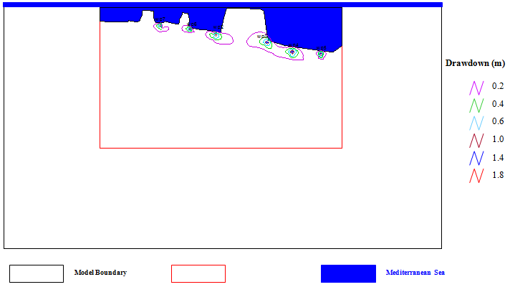Figure 8: Maximum Drawdown after 40 Years (Scenario 1[6 Pumping Wells])
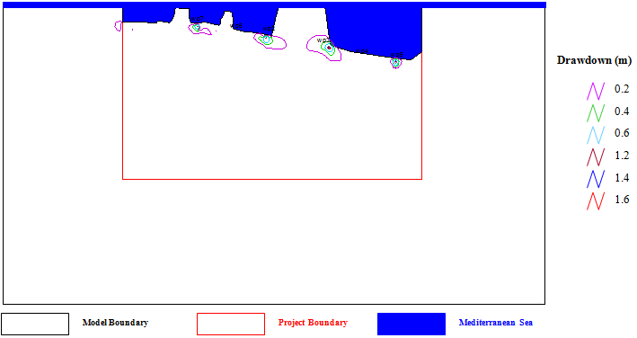Figure 9: Maximum Drawdown after 40 Years (Scenario2 [Wp7, Wp2, Wp3, Wp5])

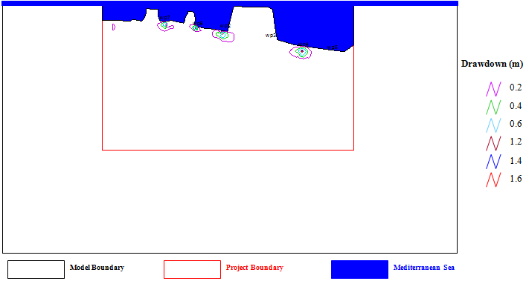Figure 10: Drawdown after 40 Years (Scenario3 [Wp7, Wp6, Wp2, Wp4])
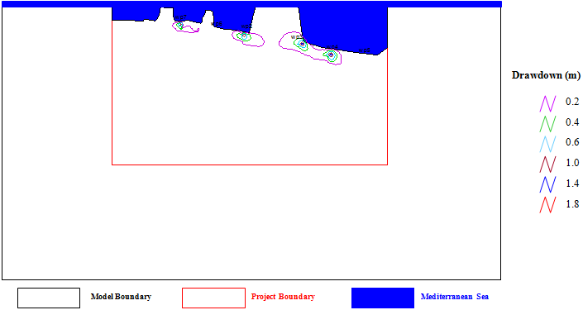Figure 11: Drawdown after 40 Years (Scenario4 [Wp7, Wp2, Wp3, Wp4])

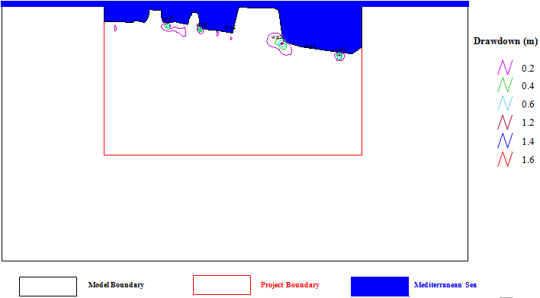Figure 12: Drawdown after 40 Years (Scenario5 [Wp7, Wp6, Wp3, Wp5])
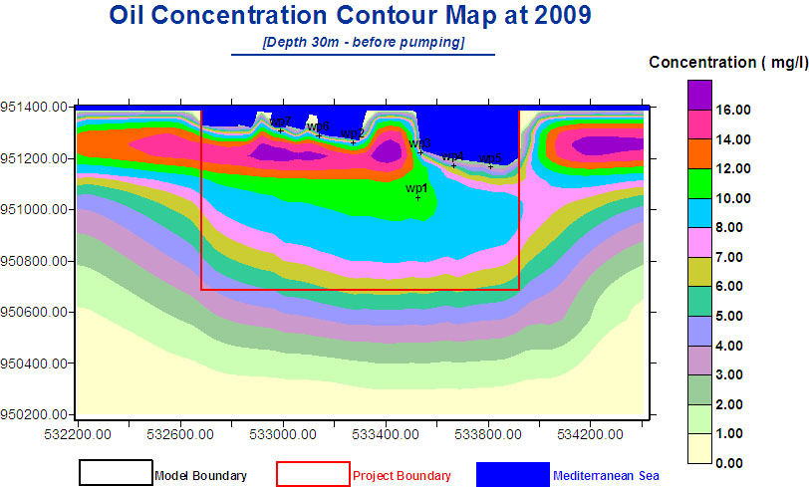
Figure 13

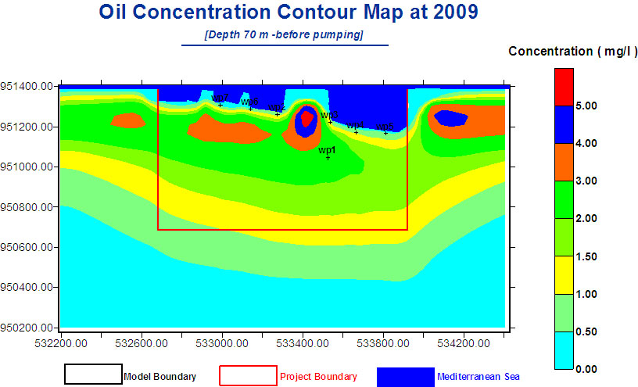
Figure 14

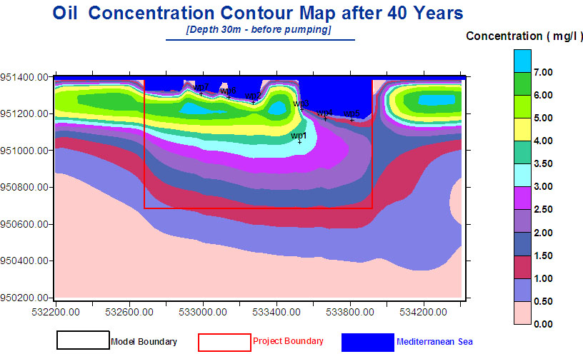
Figure 15

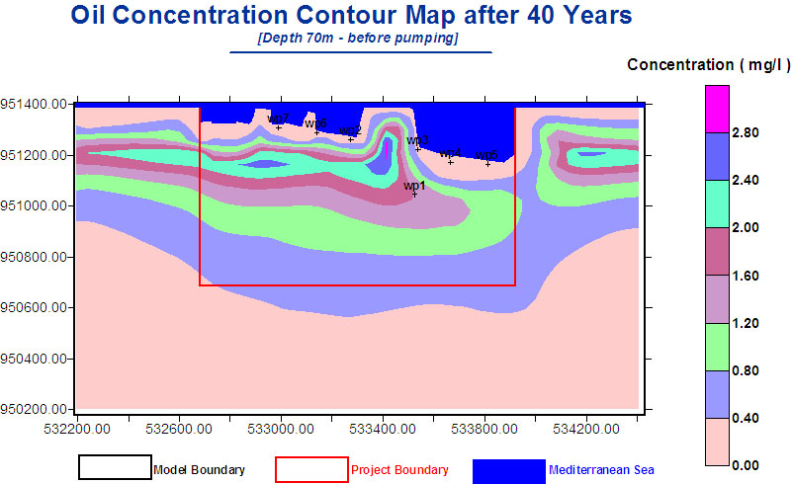
Figure 16
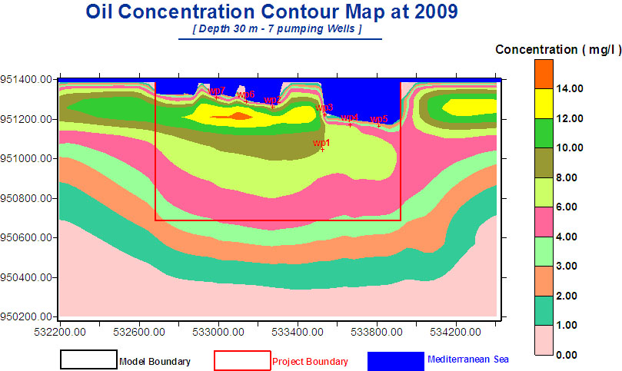
Figure 17

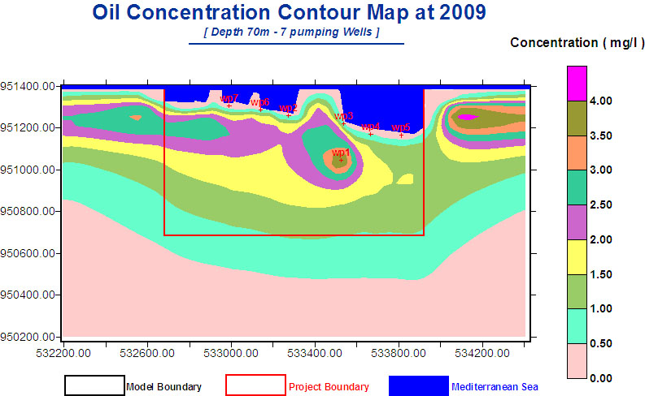
Figure 18

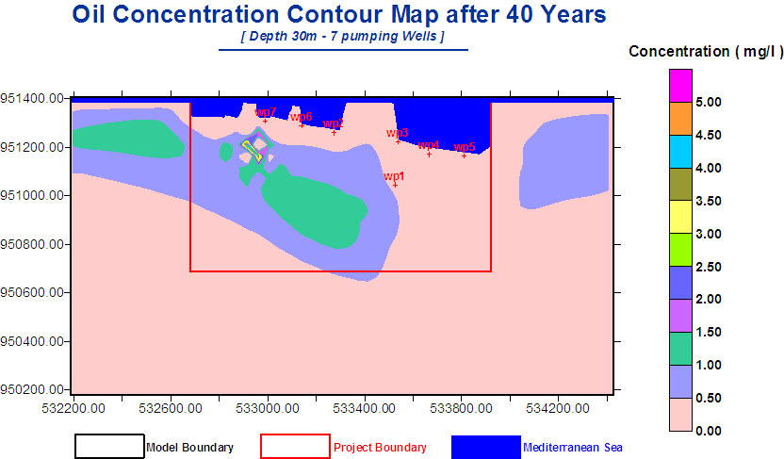
Figure 19

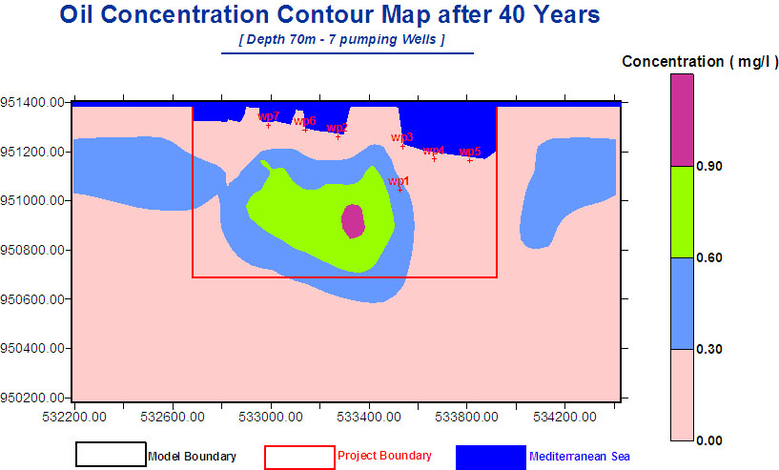
Figure 20

The above figures clarify the following results:
- The expected maximum drawdown after 40 years operation is 1.8, 1.6, 1.6, 1.8 and 1.6 m for the five scenarios respectively (Figs. 8-12).
- Oil concentration in 2009 in the locations of wp1, wp7, wp6, wp2, wp3, wp4 and wp5 are 10, 7, 6.5, 6.5, 6.5, 4.5 and 2.5 mg/l, respectively at 30 m below ground surface (Figure 13).
- The Oil concentration in 2009 in wp1 is 3 mg/l and the maximum Oil concentration in the locations of the other 6 pumping wells is 1 mg/l at 70 m below ground surface (Figure 14).
- Even without any pumping, the Oil concentration is expected to reach 3.5, 3.5, 3, 3, 3, 2 and 1 mg/l at 30 m depth in the locations of wp1, wp7, wp6, wp2, wp3, wp4 and wp5, respectively, after 40 years (Figure 15).
- Even without any pumping, the Oil concentration expected to reach 1.6 mg/l in wp1 and about 0.4mg/l in the locations of wp7, wp6, wp2, wp3, wp4 and wp5 after 40 years (Figure 16).
- With pumping 200 m³/hr/well applied in the year 2009, Oil concentration at 30 m below the surface is 8, 7, 6, 7, 4, 6 and 3 mg/l in wp1, wp7, wp6, wp2, wp3, wp4 and wp5, respectively (Figure 17).
- With pumping 200 m³/hr/well applied in the year 2009, Oil concentration at 70 m below ground surface is 3.5 mg/l in wp1 and the maximum Oil concentration is 0.75 mg/l in the locations of the other 6 pumping wells (Figure 18).
- With pumping 200 m³/hr/well for 40 years, Oil concentration at 30 m below ground surface will be 0.5 mg/l in wp1 and the maximum Oil concentration will be 0.5 mg/l at wp7, wp6, wp2, wp3, wp4 and wp5 (Figure 19).
- With pumping 200 m³/hr/well for 40 years, Oil concentration at 70 m depth after 40 years will be 0.5 mg/l in wp1 and the maximum Oil concentration will be 0.3 mg/l at wp7, wp6, wp2, wp3, wp4 and wp5 (Figure 20).

Conclusions
From the above results, the following can be concluded:
- All scenarios of pumping are accepted if the drawdown does not affect the stability of the project buildings.
- The extent of groundwater pollution with Oil decreases with depth.
- Groundwater pollution with Oil is expected to decrease with the continuous pumping and time.
- The maximum Oil concentration in the model area before pumping is 16 mg/l at 2009 and will be 7 mg/l after 40 years.
- The maximum Oil concentration in the model area after pumping of 1400 m3/h for 7 wells is 14 mg/l at 2009 and will be 5 mg/l after 40 years at 30 m depth.
- The maximum Oil concentration in the model area after pumping of 1400 m3/h for 7 wells is 4 mg/l at 2009 and will be 0.9 mg/l after 40 years at 70 m depth.

Recommendations
According to the above conclusions, it can be recommended to keep the depth of pumping at least at 70 m and to keep the pumping rate in the range of 200m3/hr. However, since this study was based on little available information, it is highly recommended to implement a monitoring system to ensure post-auditing of predictions made in this study.

Corresponding author
Safaa M. Soliman
Research Institute for Groundwater, National Water Research Center, El Kanter El Khairia, Kalubia, Egypt.
safaa_soliman_m@yahoo.com

References
Ahmed R. Khater. (2005): Groundwater Potential in Alexandria. SWITCH-LA Workshop, CEDARI, Cairo, Egypt.
Anderson, M.P. and Woessner, W.W. (1992):Applied Groundwater Modeling: Simulation of Flow and Advective Transport. Academic Press Inc. San Diego, CA. 381 pp.
RIGW, (1994): Hydrogeological Map of Egypt
Engesgaard, P., and K.L.Kipp, (1992): A geochemical transport model for redox-controlled movement of mineral fronts in groundwater flow systems: A case of nitrate removal by oxidation of pyrite. Water Resour. Res. ,28:2829-2843.
Abdel-Moati, M.A.R. (2001): Long-term impact of land based activities on the coastal waters of Alexandria, Egypt. Proceedings of the Fifth International Conference on the Mediterranean Coastal Environment, MEDCOAST 01, Tunisia, 23-27: 463–474.
Dorgham, M.M., EL-Samra, M.I., and Moustafa, Th. (1987): Phytoplankton in area of multi-polluting factors west of Alexadria, Egypt. Qatar University Science Bulletin, 7: 393–419.
Dowidar, N.M., Gerges, M., El-Samra, M.I., and El- Deeb, M.K. (1983): General review of the ecological conditions of Abu Kir Bay. Unesco Reports in Marine Sciences, 20: 124–133.
EEA. (2006): Priority issues in the Mediterranean environment. Report No 4.

