Effect of Hydrophilic Polymer on wetting dimensions, under drip irrigation

Mohammad Habibollahi ¹, Abd al-rahim Hooshmand ¹

¹ Department of Irrigation and Drainage, Shahid Chamran University of Ahwaz, Iran
mhabibollahi2000@yahoo.com

In drip irrigation systems design, wetting patterns is an important feature that should be considered. The use of some materials such as hydrogels, in sand soils, usually reduced hydraulic conductivity (HC), but in heavy clay soil porosity will increased. The final swelling hydrogels in soil is less than the free state. In this study, was investigated effect of A200 super-absorbent on vertical wetting depth under drip irrigation, including the four treatments (control (0), 0.1, 0.2, and 0.3 wt %). the moisture front advance was checked by IDRG SMS-T1 system. The investigation showed that the use of drip irrigation with super absorbent for 4 liters per hour discharge, in loam soil, the soil wetting front penetration depth has been reduced, and water accumulation in the surface layer (layer modified by the super- absorbent) increases. Experiments were performed on four occasions. First up to third irrigation was performed when soil moisture content had reached to neighbor wilting point. But, soil moisture content in fourth irrigation was limited to FC. Because of this, depth of wetting front advance in treatment 0.3 percent less than other treatments and was occurred significant differences between control and treatment. The lowest depth was seen in control and was occurred significant differences between control and treatments 0.2 0.3 percent.
[Habibollahi M, Hooshmand A. Effect of Hydrophilic Polymer on wetting dimensions, under drip irrigation. N Y Sci J 2012;5(8):78-81]. (ISSN: 1554-0200). http://www.sciencepub.net/newyork. 10

Keywords: Hydrogel, Wetting dimensions, Drip irrigation, Sensor

1. Introduction
1.1 drip irrigation
Drip irrigation offers great potential for improving water management by improving crop yield and quality using less water, and by localizing fertilizer and chemical applications to enhance their efﬁcient use and to reduce pollution risk (Or and Coelho, 1996). Drip irrigation systems are usually operated intermittently and consist of point or line source emitters, which are sometimes arraied and interacting (Mmolawa and Or, 2000). During inﬁltration, the soil water content changes both spatially and temporally and redistribution of water in the soil is strongly dependent on the irrigation method, soil type, vegetation root distribution and rates of water application. Therefore, for effective design and use of drip systems, there is a need to predict soil water dynamics taking into account all these dependencies (Merill et al., 1978).
For predicting soil water ﬂow there are a large number of analytical and numerical solutions of the governing ﬂow equations for speciﬁc initial and boundary conditions. These include models based on solving the Richards equation but ere are also more simplistic models that predict water distribution as a function of soil properties. Nevertheless, ere are still a number of difﬁculties to be solved, like the ale transient, multidimensional ﬁeld applications (Abbasi et al., 2004).
Moreover, many input parameters are difﬁcult to measure and they are subject to high spatial variability. Prior to any prediction, it is necessary to monitor soil water dynamics under a drip irrigation system to evaluate the performance of the predictive model, especially when the soil is highly heterogeneous. Accurate estimation of water content is essential for the evaluation and management of drip irrigation systems. Capacitance probe sensors are becoming a popular electromagnetic method for measuring soil water content (Gardner et al., 2000).
Capacitance sensors allow easily monitoring through loggers and are relatively cheap and easy to use. Many authors have successfully used dielectric methods for monitoring soil water on irrigated crops (Paltineanu and Starr, 1997; Fares and Alva, 2000) but little attention has been paid to monitoring soil water ﬂow under drip irrigation systems, mainly because of difﬁculties concerning sensor installation in relation to the emitters.

1.2 super absorbent hydrogel
The term hydrophilic cross-linked polymer or hydrogel itself is rather generic referring to hydrogels used in oil recovery (Emesih et al, 1999), to medical grafting supplements (Ohkawa et al, 1998), in clarification of potable and waste water, mining separations, food processing, personal care products, and laboratory supplies (Barvenik et al, 1994) as well as in agriculture. Special hydrogels i.e., super absorbents absorb and store water hundreds times of their own weights (Bowman et al, 1991). Their performance is determined by the chemistry and formation conditions of hydrophilic polymer and the chemical composition of the soil solution or irrigation water. Water held in the expanded hydrogel is intended as a soil reservoir for maximizing the efficiency of plant water uptake. Three classes of hydrophilic polymers commonly used can be generally classified as natural polymers, semi-synthetic and synthetic polymers (Mikkelsen, 1994). Synthetic hydrophilic polymers usually consist of polyacrylamides (PAM) and polyvinyl alcohols (Mikkelsen, 1994). Fully synthetic polymers are chemically cross-linked to prevent them from dissolving in solution. The uncross-linked PAM is effectively used for soil erosion control, sediment reduction in surface waters, and earthen canal bed stabilization. Hydrophilic polymers potentially influence infiltration rates, density, soil structure, compaction, soil texture, (Helalia, 1989), and evaporation rates (Teyel and El-Hady,1981).

2. Material and Methods
2.1 Drip irrigation experiment
The data presented were obtained from the experimental garden of Irrigation and drainage Department at Shahid Chamran University in Ahvaz, Iran, in February of 2012. Drip irrigation was obtained with 4 liters per hour discharge, In one hour. Particle size distribution and bulk density for the two main soil horizons are given in Table 1.

Table 1 - Particle size distribution and bulk density at the experimental site
Depth (cm) | 0-15 | 15-30
 | 23.68 | 21.70
 | 55.14 | 51.13
 | 21.18 | 27.17
 | 1.39 | 1.47

2.2 Experimental layout
This experiment was designed in a Randomized Complete Block Design. There were four treatments in the experiment and each treatment was replicated three times. Treatments were defined according to the different levels of hydrogel (0, 0.1, 0.2 and 0.3 wt %).
Then was grave Channel with length of 6, within 1 and deep 1 meter. Then the wall was fixed by a wooden cover (to prevent soil loss). There was created holes in the wooden wall, at depths of 5, 18 and 31 cm. there was 4 holes for each depth with 5 cm diameter (Figure 1). The PVC pipe (Length of 30 cm) was immersed in the soil and the soil its inside was removed. Sensors through these tunnels were created in the soil. Figure 2 was modified by the hydrogel according to the soil. Soil moisture was measured at 12 points. Then were reviewed the wetting front advance with draw the potential curves of amount of soil moisture.

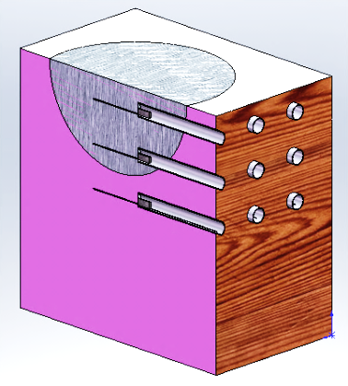

Figure 1 Three-dimensional view of a treatment

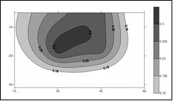
Figure 2 wetting pattern in soil

Experiments were performed on four occasions. First up to third irrigation was performed when soil moisture content had reached to neighbor wilting point. But, soil moisture content in fourth irrigation was limited to FC. Data analysis was performed by the software SPSS 18. Sensors (Proﬁle Probe from Fab-ab Gostar Ltd., Tehran, Iran) were used for soil water content determination.

2.3 Soil moisture data-logging system (IDRG SMS-T1): (from Fab-ab Gostar, ltd, Tehran, Iran)
This system combines high accuracy and low cost. Some features of this system which relies on a FDR sensor are simultaneous soil moisture and temperature measurements, measuring moisture in saline soils, highly independent on soil mixture, and software compensation for temperature effects. This system is equipped with a specialized data-logger which is available through its graphical user-friendly interface with a lot of features.

2.4 Statistical analysis
All collected data were statistically analyzed by analysis of variance. Treatment means that were significantly different were compared using Duncan’s Multiple Range Test (DMRT).

3. Results and Discussions
Water absorption by hydrogel was rapid in distilled water and reached to the maximum in 180 and 120 minute in distilled and saline water, respectively. Water absorption by hydrogel decreased with an increase in water salinity with maximum absorption in distilled water (415 g/g) followed by saline water (63 g/g) during 1st hydration cycle (figure 3 and 4).

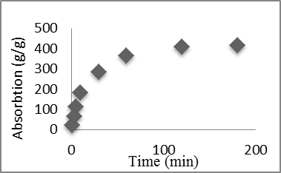
Figure 1. Absorption of distilled water (DW) by gel during 1st wetting and drying cycle

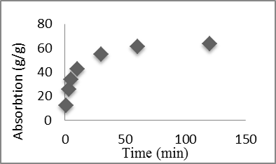
Figure 2. Absorption of saline water (SW) by gel during 1st wetting and drying cycle
Results as to vertical wetted depth can be seen in table 2. These results are average of depth for each treatment. At the first irrigation, there is no specified procedure between treatments. At second and third irrigations, there are maximum vertical wetted depth for control treatment, and minimum for 0.3 treatment. Vertical wetted depth in 0.3 treatment decreased for second irrigation and third irrigation limited to 25%, limited to 31 %, respectively, than control treatment. At fourth irrigation, unlike previous irrigations, there is maximum vertical wetted depth for 0.3 treatment, so that, Vertical wetted depth in 0.3 treatment increased limited to 18%, than control treatment.
Table 2 - Vertical wetted depth for first, second, third and fourth irrigations
Treatment | 1 | 2 | 3 | 4
First Irr. | 19.8 | 20 | 17.5 | 20
Second Irr. | 29 | 26.9 | 24.1 | 21.7
Third Irr. | 33.3 | 30.7 | 28 | 22.7
Fourth Irr. | 25.5 | 26.7 | 29 | 30.2

Statistical results
Duncan test results are given below (figures 5,6,7 and 8). According to their, there is no Significant difference between treatments. At second and third irrigation there are significant difference between control and 0.3 treatments, so that, there is maximum of vertical wetted depth for control treatment. But at fourth irrigation is contrary.

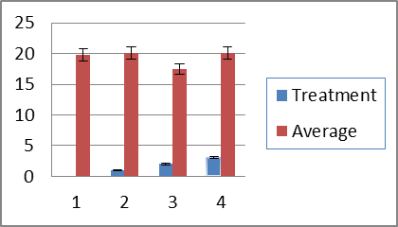
Figure 5. Duncan test results for first irrigation

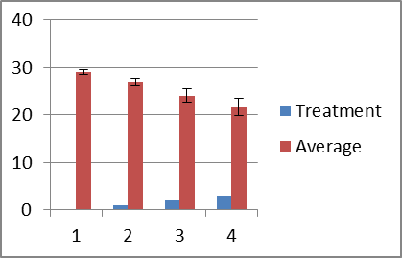
Figure 6. Duncan test results for second irrigation

Figure 7. Duncan test results for third irrigation
Figure 8. Duncan test results for fourth irrigation

This difference caused by soil moisture content, this means that, at first, second and third irrigation, soil moisture content was limited to wilting point, before irrigation. But at fourth irrigation, soil moisture content wad limited to FC. When amendment soil moisture content limited to FC, there is hydraulic conductivity (HC) for 0.3 treatment more than control treatment. But, in wilting point, hydraulic conductivity of amendment soil for 0.3 treatment less than control treatment. So, in wetting soil increased vertical wetting depth.

Corresponding Author:
Mohammad Habibollahi
Department of Irrigation and Drainage
Shahid Chamran University
Ahwaz, Iran
E-mail: mhabibollahi2000@yahoo.com

Acknowledgment
The authors should like to acknowledge the Excellency of Water Sciences Engineering of Shahid Chamran University of Ahvaz (Iran) for their financial support and assistance.

References
- Abbasi, F., Feyen, J., van Genuchten, M. Th., Twodimensional simulation of water ﬂow and solute transport below furrows: model calibration and validation. J. Hydrol. 2004; 290, 63–79.
- Barvenik F.W., Polyacrylamide characteristics related to soil applications, Soil Sci., 1994; 158, 235-243. Bowman D.C., Evans R.Y., Calcium inhibition of polyacrylamide gel hydration is partially reversible by potassium, Horticul. Sci., 26, 1063-1065, 1991.
- Emesih G.C., Moreina R.G., Barrufet M.A., Evaluation of modified starches for improved oil recovery, Appl. Eng. Agric., 15, 237-242, 1999.
- Fares, A., Alva, A.K. Soil water components based on capacitance probes in a sandy soil. Soil Sci. Soc. Am. J. 64, 2000; 311–318.
- Gardner, C.M.K., Robinson, D.A., Blyth, K., Cooper, J.D. Soil water content. In: Smith, K.A., Mullins, C.E. (Eds.), Soil and Environmental Analysis: Physical Methods. Marcel Dekker, New York, 2000; pp. 1–60.
- Helalia A.M., Letey J., Effects of different polymers on seedling emergence, aggregate stability and crust hardness, Soil Sci., 148,199-203, 1989.
- Merill, S.D., Raats, P.A.C., Dirksen, C. Laterally conﬁned ﬂow from a point source at the surface of an inhomogeneous soil column. Soil Sci. Soc. Am. J. 42, 1978; 851–857.
- Mikkelsen R.L., Using hydrophilic polymers to control nutrient release, Fert. Res., 38, 53-59, 1994.
- Mmolawa, K., Or, D. Root zone solute dynamics under drip irrigation: a review. Plant Soil 222, 2000; 163–190.
- Ohkawa K., Kitsuki T., Amaike M., Saitoh H., Yamamoto H., Biodegradation of ornithine-con-taining polylysine hydrophilic polymers, Biomaterials, 19, 1855-1860, 1998.
- Or, D., Coelho, F.E. Soil water dynamics under drip irrigation: transient ﬂow and uptake models. Trans. 1996; ASAE 39 (6), 2017–2025.
- Paltineanu, I.C., Starr, J.L. Soil water dynamics using multisensor capacitance probes: laboratory calibration. Soil Sci. Soc. Am. J. 1997; 61, 1576–1585.
- Teyel M.Y., El-Hady O.A., Super gel as a soil conditioner, Acta Horticul., 119, 247-256, 1981.

7/7/2012

