Response of Some Cantaloupe Hybrids to Water Stress

Refaie, K. M.¹, Hassanein, M. K. K.¹ and Abdelraouf R. E.²

¹The Central Lab.for Agricultural Climate, ARC, Egypt.
² Water Relations & Field Irrigation Dept., N.R.C., Egypt.
Khaled_refaie@yahoo.com

Abstract: The experiment was conducted at Dokki protected cultivation site, Agricultural Research Center, Giza, Egypt during 2010/2011 and 2011/2012 seasons. Four cantaloupe hybrids (Rafigal, Arafa, Primal and Gal 152) were sown on March 5th in both years. Volumetric lysimeter was installed, to estimate water requirements with three water levels of daily water levels at 80, 100, and 120% of Et_{c}. In this respect, a split design with three replicats was implemented. The main plots contained the irrigation treatments and the sub plot included the four cantaloupe hybrids. Actual crop evapotranspiration (Et_{c}) was determined by weighing lyismeter ±1 gm with two plants on its plate surface. Potential evapotranspiration (Et_{o}), utilizing Penman Monteih equation. The effect of water stress, during the different growth stages was studied, in order to determine the optimum water requirements. Obtained results indicated that, the plant vegetative growth was enhanced with 100% (Et_{c}) treatment, the tallest plant was found with Rafigal F₁, the highest leaf number was found on Arafa F₁, compared with the other two levels of irrigation. The water level at 100% (Et_{c}) optimized total yield and fruit quality. While, the lowest total yield with first grade fruit quality was recorded with water level at 80% (Et_{c}). But, water level at 120% (Et_{c}) increased significantly total yield with decreasing fruit quality. The highest total yield was obtained by Arafa F₁ hybrid. While, Primal F₁ hybrid fruits had the highest values of total soluble solids, total sugars, fruit volume and firmness.
[Refaie, K. M., Hassanein, M. K. K. and Abdelraouf R. E. Response of Some Cantaloupe Hybrids to Water Stress. N Y Sci J 2012;5(8):88-95]. (ISSN: 1554-0200). http://www.sciencepub.net/newyork. 12

Key Words: Water stress, Cantaloupe, Yield quality & quantity, hybrids and water level.

1. Introduction

Nowadays determining the optimum crop water requirements is considered one of the most important factors affecting plant productions, especially, with scarce water resources. This may be due to the interrelation between the amount of water added and the ability of plant. Leaching irrigation water leads to rising field water table, which, leads to the ground water pollution with nutrients, especially, nitrates and yield reduction due to the disturbance in water balance in the root zone. Also, leaching of nutrients will affect plant production negatively, while, over use of water, will reduce water use efficiency. Moreover, utilization of extra amounts of fertilizers, which will lead to increase cost of production input, due to the increase in the cost of fertilizers, energy consumption for extra pumping among other factors (Refaie, 2008).
Estimating the exact crop water requirements, it's suitable method for avoiding soil pollution by chemicals. Which protect soil ecosystem and saving water Gaafer and Refaie (2006).
Cantaloupes considered one of the most important vegetables in Egypt, which the majority productions exported to Europe. However, due to its sensitivity to water, irrigation scheduling should be linked with its ability to consume water, therefore, water requirement, must be estimate appropriately in accordance with plant wetted root zone (Badr, 2007 and Badr & Abou Hussein, 2008). Therefore, the aim of this work was to study the effect of water balance, on cantaloupe hybrids during the different growth stages, in order to determine the optimum water requirements, which might give the highest yield and best fruits quality under Egyptian conditions.

2. Materials and Methods

The seeds of cantaloupe F₁ hybrids (Rafigal, Arafa, Primal and Gal 152), were sown on March 5th, during two years (2010-2011 and 2011-2012), to determine the effect of different water levels on plant growth and crop yield under plastic house, at Dokki protected cultivation site, Giza governorate, Egypt. Cantaloupe seedlings of 21-day old were transplanted, under Queenst plastic house shape structure. Plants were randomly distributed on three replicates, twelve treatments were conducted, which reperesnted the interaction, between three irrigation leveles (80, 100 and 120 %) from the actual crop evapotranspiration for all cantaloupe F₁ hybrids. Statistical a split plot experiment desgin was used. Considering the application of water levels were presented in the main plots, while, the sub plots were the cultivars. Soil analysis was conducted (The soil type was clay soil field capacity % = 32.2, permanent wilting point % = 16.1 and pH = 7.5). Each replicate consisted of a plastic lysimeter container (60 cm height and 40 cm diameter) which was used to measure actual water consumption. Water was applied and quantities were adjusted to ensure a drainage rate of 10-20%, according to soil properties. Total amount of water was calculated, by weighing lyismeter ±1 gm which was used, to measure the actual crop evapotranspiration. Fertilization and disease control were applied as commonly followed the IPM standard and recommandation of MLAR Egyptian greenhouse.
The following data were recorded:-
Plant height and number of leaves were measured, after 15, 30, 50, 70 and 90 days from transplanting date. The area of the fifth single leaf from the top of the plant was measured by LI- 3000 portable area meter (standard technique No. 5), Stem diameter, Fresh and dry weights of leaves, Total chlorophyll content of the sixth mature leaf (using Minolta chlorophyll meter Spad – 501) were determined after 60 days from seedling transplanting data.
Weight and volume of fruits, total fruit weight per plant and fruit firmness were measured and recorded. Total soluble solids, total sugars in (mg) were determined by using the method of Somogyi (1952) and Nelson (1974).
The Data were subjected to ANOVA statistical software, SPSS 12.0 for Windows (SPSS Inc., 233 S Wacker Drive, Chicago, IL, USA). Means were separated by Duncan’s multiple range test at P ≤0.05 (Steel & Torrie, 1984).

3. Results and Discussion
As shown in Table (1), the overall results, of monthly climatic conditions and reference evapotranspiration (Et_{o}) under greenhouse conditions, the second season was higher than the first season, which may be due to the lower night temperature (Medany, 1997) also, the month of May was hotter and humid than the other summer monthes. The tabulated data of (Et_{o}) were follow the changes in the climatologically norms, during the growth season. In addition, the values of (Et_{o}) were increased, from the beginning of February to the end of May in both growth seasons. This results are mainly, due to the relatively high temperature, average wind speed, the gradually increase of radiation and low relative humidity at the end of the season. These results, confirmed with the finding of Abo-Hadid et al. (1992) which reported that, the increase of air temperature, light intensity and air movement, as well as low relative humidity, increased the evapotranspiration. The greenhouse provided significant wind speed which was reflected that, the values of Et_{o} on the open field was higher than the greenhouse.
From the collected data which was carried out to predict the important parameter to manipulate irrigation application of cantaloupe plants on (Table 2). The overall results of acual water in second season was higher than the first season thus, the cantaloupe plant in second season was consuming more water, than the first season, which may be due to the differant climatic conditions (Refaie, 2008). In addion, the lowest value of actual water was obtained of using 80% water level as combared with other two irrigation treatments in both growth seasons. This results are in agreement with results obtained by Gaafer and Refaie (2006), who find that for a given irrigation water levels with three hybrids of melon, the values of actual water gradually has increased, with the progress in plant age. Also, the rate of actual water values decreased with the increase in soil water stress. A greater volume of water applied produced higher water content within the root zone, which lead to higher water consumptive use, as also indicated by (Badr & Abou Hussein, 2008 and Soto-Ortiz & Abraham 2006).
As shown in Figure (1), no significant difference was observed, in the plant height due to water treatments, until fifteen days from transplanting. After 50,70 and 90 days from transplanting date the irrigation quantity, highest main stem was recorded with 100% treatment, followed by 80% and 120%. There were no significant differences among the stem hight of the tested F₁ hybrids under such condition of growth after 15 days from transplanting. Rafigal F₁ hybrid has significantly the tallest main stem, than the other tested hybrids after 50,70 and 90 days from transplanting date.
The interaction between irrigation levels and the hybrids indicated that, 100% (Et_{c}) with Rafigal F₁ hypid exhibited the tallest plants, than the other interaction treatments after 70 and 90 days from trasplanting date.
Figure (2) shows that, the application of 100% (Et_{c}), produced the highest number of leaves per plant, after 50, 70 and 90 days from transplanting date, compared to 80% and 120% of water application.
Arafa F₁ hybrid plants has the highest number of leaves, than the other F₁ hybrids after 70 and 90 days. No significant effect was observed, among hybrids after 15, 30 and 50 days from the transplanting date on leaf number. The effect of irrigation levels and F₁ hybrids showed that, the interaction between 100% (Et_{c}) level and Rafigal F₁ hybrid gave the highest leaves numbers than the other combination treatments.
Also, the data collected revealed that, the reduction on leaf number was increased with decreasing the irrigation level. The obtained results are generally similar to, resultes found by Cabello (2009) on cantaloupe, stem height and number of leaves was decreased by decreasing leaching fraction, due to a reduction of the avilable water on active root zone, which caused a disturbance in the physiological processes needed for plant growth. Also, the results could be explained as a result of enhancing cell division and enlargement that need more water supplies (Refaie, 2003 and Seyfi & Rashidi, 2007). The differences among the tested hybrids in growth characters could be due to genetic factors. These results agree with the findings of (Botia, et al., 2005 and Abou El-Yazied et al. 2012), they concluded that, apply three levels of nitrogen effected on three cantaloupe F₁ hybrids, the highest values of stem height and number of leaves was obtained with Galia F₁. In addition, the results coincided with those of (Badr, 2007 and Keshavarzpour, 2011) on stem height and number of leaves of cantaloupe plants.They reported that plants of cantaloupe cultivars differ in their growth characters.
Data in Table (3) indicated that, water level at 100% (Et_{c}), increased significantly the plant leaf area, leaf fresh and dry weight, total clorophyll content and the stem diameter, than the other two irrigation levels in both years. Rafigal F₁ hybrid produced significantly the highest leaves number, than the other three F₁ hybrids in both seasons. The same results, were confirmed on leaf fresh and dry weight and the total leaf chlorophyll. Meanwhile, the stem diameter of Arafa F₁ hybrid was the thickest, than the other three F₁ hybrids in the two seasons.
It is obvious that the leaf area, leaf fresh and dry weight and chlorophyll reading, were increased significantly, than the other interactions in the first season, due to the interaction between 80% (Et_{c}) treatment with Primal F₁ hybrid. Whereas, 100% (Et_{c}) with Rafigal F₁ hybrid ranked the first in the second season. In addition, the interaction between 100% (Et_{c}) with Primal F₁ hybrid gave significantly the highest values of leaf area, fresh and dry weight and the total chlorophyll in both studied seasons.
As shown in Table (4), using, water level at 120% (Et_{c}) significantly increased the average and total fruit weight, as well as, the number of fruits per plant, fruit volume, and flesh thickness, than the other included irrigation water treatments. However, low water level of 80% (Et_{c}), recorded the highest values of fruit total soluble solids, total sugars content and firmness compared to the other tested irrigation water treatments. Not only the Arafa F₁ hybrid significantly increased, the average total fruit weight and fruit number per plant, but, also, increased the fruit flesh thickness in both years.
Regarding, total soluble solids, total sugars, fruit volume and firmness Primal F₁ hybrid proved to be superior compared to Rafigal, Arafa and Gal 152 F₁ hybrids.
The interaction between water treatments and F₁ hybrids showed that, the 120% (Et_{c}) with Arafa F₁ hybrid, obtained significantly the highest average total fruit weight and flesh thickness in both seasons. Meanwhile, total soluble solids was significantly higher with the interaction between Rafigal with 100% (Et_{c}) and Primal with 80% (Et_{c}) in the first and second seasons, respectively.
The same trend with total fruit sugars, was proven in both years of experiment. In addition, the firmest fruits were significantly found with the interaction of Primal and 80% (Et_{c}) than the others combined treatments.
No significant interaction was found, on the number, of fruits per plant in both seasons. The favorable results which was obtained from using both the forementioned levels of irrigation water might be due to adequate available soil moisture within the root zone, this led to increase the various physiological processes as better uptake of nutrients, good plant growth, higher rates of photosynthesis, excess of dry matter accumulation which reflect and led to the best yields and fruit quality (Gaafer & Refaie, 2006; Rashidi & Seyfi 2007 and Simsek & Comlekcioglu, 2011). Also, increase the levels of both auxins and gibberellins, within the biological concentrations, promote cell division and cell size enlargement. Hence, increase vegetative growth in order to yield and fruit quality (Refaie, 2003).
Sugar content is an important factor in the appreciation of the flavour of cantaloupe. In the mean time values of total soluble solids, expressed as precentage of fresh weight, shows high positive correlation, with total sugar content, but was accepted as an important quality characteristic (Gaafer & Refaie, 2006; Long, 2006 and Keshavarzpour, 2011). From the overall results, it could be concluded that yield and quality of fruit were inhanced, when the water level at 100% (Et_{c}) was applied. However, increasing irrigation quantaty up to 120% (Et_{c}), increased total yield, and has negative impact on fruit quality. In addition, Primal F₁ hybrid has the highest fruits quality (TSS, TS and fruit firmness) than other three F₁ hybrids under the same condition.

Correspondind author
Refaie, K. M
The Central Lab.for Agricultural Climate, ARC, Egypt. Khaled_refaie@yahoo.com

Table (1): Monthly average climatic data under plastichouse conditions at Dokki site during seasons of 2010-2011 and 2011-2012.
Climatic factors | First season |  |  |  | Second season
Climatic factors | Feb. | Mar. | Apr. | May | Feb. | Mar. | Apr. | May
Tem. c° | 22.5 | 24.9 | 27.1 | 29.6 | 21.2 | 25.0 | 29.9 | 33.7
RH.% | 65.2 | 72.1 | 70.1 | 72.6 | 68.5 | 70.5 | 69.1 | 80.9
Radiation MJ/m² | 340 | 412 | 383 | 591 | 317 | 428 | 406 | 540
Et_{o} mm/day | 1.6 | 1.9 | 2.9 | 3.6 | 1.8 | 1.8 | 2.9 | 4.4

Table (2): Schedule of water regimes liter per plant of cantaloupe plants at Dokki protected cultivation site.
Water treatments | First season |  |  | Second season
Water treatments | 80% | 100% | 120% | 80% | 100% | 120%
Actual water liter/plant From Feb. to May | 88.0 | 110.0 | 132.0 | 96.8 | 121.0 | 147.4

Table (3). Effect of irrigation treatments, F₁ hybrids and their interaction on some physical and chemical propertis of cantaloupe plant.
Treatment Irrigation % Et_{c} (A) | Average leaf area Cm² | Average leaf fresh weight (g) | Average leaf dry weight (g) | Chlorophyll Spad | Average stem diameter (cm)
First season
80 | 65.93 C | 2.92 C | 0.43 C | 3.00 A | 1.02 B
100 | 92.72 A | 4.03 A | 0.56 A | 3.38 A | 1.14 A
120 | 81.46 B | 3.30 B | 0.48 B | 2.42 B | 0.91 C
LSD at 0.05 | 8.95 | 0.15 | 0.05 | 0.49 | 0.04
F₁ Hybrid (B)
Rafigal | 89.35 A | 3.60 A | 0.53 A | 3.19 A | 0.99 C
Primal | 81.59 B | 3.52 A | 0.50 B | 2.89 B | 1.02 B
Arafa | 69.17 C | 3.12 B | 0.44 C | 2.72 C | 1.06 A
Gal 152 | 60.28 D | 3.10 B | 0.40 D | 2.70 C | 0.90 D
LSD at 0.05 | 5.61 | 0.12 | 0.01 | 0.04 | 0.02
Interaction A*B
80 * Rafigal | 74.58 d | 3.11 g | 0.44 e | 3.25 b | 0.97 f
100 * Rafigal | 73.16 d | 3.01 g | 0.46 d | 2.89 c | 1.01 d
120 * Rafigal | 49.96 e | 2.64 h | 0.37 g | 2.85 c | 1.08 c
80 * Primal | 104.76 a | 4.50 a | 0.62 a | 3.68 a | 1.15 a
100 * Primal | 90.17 ab | 4.06 c | 0.54 b | 3.25 b | 1.14 ab
120 * Primal | 83.13 c | 3.52 e | 0.51 c | 3.20 b | 1.13 b
80 * Arafa | 88.71 bc | 3.20 f | 0.51 c | 2.63 d | 0.84 i
100 * Arafa | 81.46 c | 3.50 e | 0.48 d | 2.53 d | 0.91 g
120 * Arafa | 73.10 d | 3.19 fg | 0.45 e | 2.11 g | 0.98 ef
80 * Gal 152 | 75.58 d | 4.30 b | 0.42 f | 2.33 e | 0.74 k
100 * Gal 152 | 74.16 d | 3.86 d | 0.44 e | 2.23 f | 0.81 j
120 * Gal 152 | 50.96 e | 3.32 f | 0.35 h | 1.81 h | 0.88 h
LSD at 0.05 | 3.69 | 0.17 | 0.02 | 0.06 | 0.02
Second season
Irrigation % Et_{c} (A)
80 | 61.74 C | 3.81 C | 0.54 B | 4.26 B | 1.16 B
100 | 87.97 A | 5.36 A | 0.65 A | 5.16 A | 1.31 A
120 | 72.86 B | 4.46 B | 0.54 B | 3.61 C | 1.06 B
LSD at 0.05 | 5.90 | 0.63 | 0.06 | 0.63 | 0.15
F₁ Hybrid (B)
Rafigal | 80.52 A | 4.94 A | 0.61 A | 4.74 A | 1.14 B
Primal | 77.74 B | 4.75 A | 0.59 A | 4.55 A | 1.17 AB
Arafa | 64.30 C | 3.95 B | 0.51 B | 3.75 B | 1.22 A
Gal 152 | 63.28 C | 3.50 C | 0.44 C | 3.50 B | 0.80 C
LSD at 0.05 | 4.21 | 0.20 | 0.07 | 0.32 | 0.06
Interaction A*B
80 * Rafigal | 65.97 e | 4.11 f | 0.56 e | 4.50 c | 1.11 d
100 * Rafigal | 98.63 a | 6.00 a | 0.70 a | 5.80 a | 1.32 a
120 * Rafigal | 76.97 c | 4.70 c | 0.58 d | 3.91 e | 0.99 f
80 * Primal | 68.30 d | 4.18 f | 0.58 d | 4.30 d | 1.15 c
100 * Primal | 91.30 b | 5.56 b | 0.64 b | 5.36 b | 1.31 a
120 * Primal | 73.63 c | 4.50 e | 0.54 f | 3.98 e | 1.06 e
80 * Arafa | 50.97 f | 3.14 h | 0.47 h | 3.99 e | 1.23 b
100 * Arafa | 73.97 c | 4.52 de | 0.60 c | 4.32 d | 1.29 a
120 * Arafa | 67.97 de | 4.19 f | 0.50 g | 2.94 f | 1.15 c
80 * Gal 152 | 70.58 cd | 4.10 f | 0.40 i | 2.73 gh | 0.94 g
100 * Gal 152 | 69.16 d | 3.66 g | 0.41 i | 2.63 h | 1.01 f
120 * Gal 152 | 45.96 g | 3.12 h | 0.33 j | 2.21 i | 1.09 d
LSD at 0.05 | 3.12 | 0.17 | 0.02 | 0.17 | 0.03
* Similar letters indicate nonsignificant at 0.05 levels.

Table (4). Effect of irrigation treatments and F₁ hybrids as well as their interaction on some physical and chemical propertis of cantaloupe fruits.
Treatment  Irrigation % Et_{c} (A) | Fruit Weight (g) | Fruit weight  (kg/plant) | Flesh thick.  (cm) | No. of  fru./plant | TSS  % | Total sugars | Fru. Vol.  (ml) | Fru. Firm.  (g/cm²)
First season
80 | 945 C | 2.3 C | 3.8 B | 2.7 C | 12.8 A | 10.1 A | 971 C | 78.0 A
100 | 1219 B | 3.4 B | 4.1 A | 3.0 B | 12.5 A | 9.8 A | 1131 B | 68.6 B
120 | 1444 A | 4.4 A | 4.1 A | 3.2 A | 9.1 B | 7.2 B | 1389 A | 64.1 B
LSD at 0.05 | 73 | 0.3 | 0.2 | 0.2 | 0.5 | 0.6 | 115 | 4.4
F₁ Hybrid (B)
Rafigal | 1180 B | 3.3 B | 3.9 B | 3.0 A | 11.2 B | 8.9 B | 1265 B | 70.3 B
Primal | 1137 C | 3.0 C | 3.8 B | 2.9 A | 12.8 A | 10.0 A | 1318 A | 77.5 A
Arafa | 1290 A | 3.6 A | 4.3 A | 3.0 A | 10.4 C | 8.1 C | 909 D | 63.1 C
Gal 152 | 1100 D | 2.9 C | 3.5 C | 2.8 A | 10.1 C | 8.6 B | 1100 C | 60.2 C
LSD at 0.05 | 22 | 0.3 | 0.2 | NS | 0.4 | 0.4 | 38 | 3.9
Interaction A*B
80 * Rafigal | 944 jk | 2.4 e | 3.7 h | 2.8 a | 12.3 b | 9.7 b | 998 e | 81.8 b
100 * Rafigal | 898 l | 2.0 f | 4.0 e | 2.6 a | 14.2 a | 9.7 b | 1068 d | 65.4 f
120 * Rafigal | 993 hi | 2.5 e | 4.0 e | 2.8 a | 12.0 c | 7.2 e | 846 f | 63.8 fg
80 * Primal | 1200 ef | 3.3 d | 3.7 h | 3.0 a | 12.4 b | 11.1 a | 1213 c | 86.7 a
100 * Primal | 1172 f | 3.2 d | 4.1 d | 3.0 a | 14.3 a | 11.0 a | 1287 b | 77.5 d
120 * Primal | 1282 d | 3.5 d | 3.8 g | 2.9 a | 11.0 d | 7.8 f | 893 f | 68.4 e
80 * Arafa | 1394 b | 4.1 bc | 3.9 f | 3.2 a | 9.1 g | 9.5 c | 1582 a | 65.6 f
100 * Arafa | 1342 c | 4.0 c | 4.4 b | 3.2 a | 10.0 e | 8.8 d | 1598 a | 63.0 g
120 * Arafa | 1595 a | 4.9 a | 4.6 a | 3.3 a | 8.3 h | 6.6 g | 987 e | 60.8 h
80 * Gal 152 | 984 i | 2.5 e | 3.9 f | 2.8 a | 12.1 b | 9.4 c | 1028 de | 78.8 cd
100 * Gal 152 | 938 k | 2.0 f | 4.3 c | 2.7 a | 14.1 a | 8.7 d | 1098 d | 62.4 gh
120 * Gal 152 | 1033 g | 2.6 e | 4.0 e | 2.8 a | 10.7 f | 6.5 g | 876 f | 60.8 h
LSD at 0.05 | 31 | 0.4 | 0.1 | NS | 0.3 | 0.2 | 53.6 | 2.7
Second season
Irrigation % Et_{c} (A)
80% | 1094 C | 2.5 C | 4.4 B | 2.5 C | 14.8 A | 11.4 A | 1155 B | 70.2 A
100% | 1422 B | 3.6 B | 4.8 A | 2.7 B | 14.3 A | 11.1 A | 1717 A | 62.7 B
120% | 1692 A | 4.7 A | 4.8 A | 2.9 A | 10.5 B | 8.1 B | 1789 A | 61.1 B
LSD at 0.05 | 87 | 0.3 | 0.3 | 0.2 | 0.6 | 0.5 | 145 | 4.0
F₁ Hybrid (B)
Rafigal | 1376 B | 3.5 BC | 4.5 B | 2.7 A | 13.0 B | 10.0 B | 1694 B | 64.4 B
Primal | 1325 C | 3.3 C | 4.4 B | 2.6 B | 14.7 A | 11.3 A | 1769 A | 70.9 A
Arafa | 1508 A | 3.9 A | 4.9 A | 2.7 A | 12.0 C | 9.5 C | 1192 D | 57.8 C
Gal 152 | 1160 D | 3.1 C | 4.1 C | 2.7 A | 11.5 C | 9.6 C | 1250 C | 62.2 B
LSD at 0.05 | 26 | 0.4 | 0.2 | 0.1 | 0.6 | 0.2 | 51 | 2.8
Interaction A*B
80 * Rafigal | 1093 gh | 2.6 d | 4.3 e | 2.5 a | 14.2 c | 10.9 c | 1188 e | 73.6 b
100 * Rafigal | 1401 e | 3.5 c | 4.6 cd | 2.7 a | 14.3 c | 10.9 c | 1850 c | 58.9 e
120 * Rafigal | 1633 b | 4.4 b | 4.7 c | 2.8 a | 10.5 h | 8.1 g | 2044 ab | 60.6 e
80 * Primal | 1037 i | 2.2 d | 4.2 e | 2.3 a | 16.4 a | 12.6 a | 1272 d | 78.0 a
100 * Primal | 1367 e | 3.5 c | 4.7 c | 2.7 a | 16.1 b | 12.4 b | 1971 b | 69.8 c
120 * Primal | 1571 c | 4.3 b | 4.4 de | 2.8 a | 11.5 g | 8.8 f | 2064 a | 65.0 d
80 * Arafa | 1152 f | 2.7 d | 4.5 d | 2.5 a | 13.8 d | 10.8 c | 1006 fg | 59.0 e
100 * Arafa | 1499 d | 3.7 c | 5.0 b | 2.6 a | 12.7 e | 9.9 d | 1329 d | 56.6 e
120 * Arafa | 1873 a | 5.3 a | 5.3 a | 2.9 a | 9.6 i | 7.5 h | 1259 de | 57.8 e
80 * Gal 152 | 1084 h | 2.7 d | 4.2 e | 2.6 a | 11.9 f | 9.5 e | 1128 e | 58.8 e
100 * Gal 152 | 1038 i | 2.3 d | 4.6 cd | 2.4 a | 13.8 d | 8.8 f | 1198 e | 42.4 f
120 * Gal 152 | 1133 f | 2.8 d | 4.3 e | 2.6 a | 10.5 h | 6.6 i | 976 g | 40.8 f
LSD at 0.05 | 37 | 0.6 | 0.2 | NS | 0.3 | 0.2 | 72 | 2.8
* Similar letters indicate nonsignificant at 0.05 levels.

First season
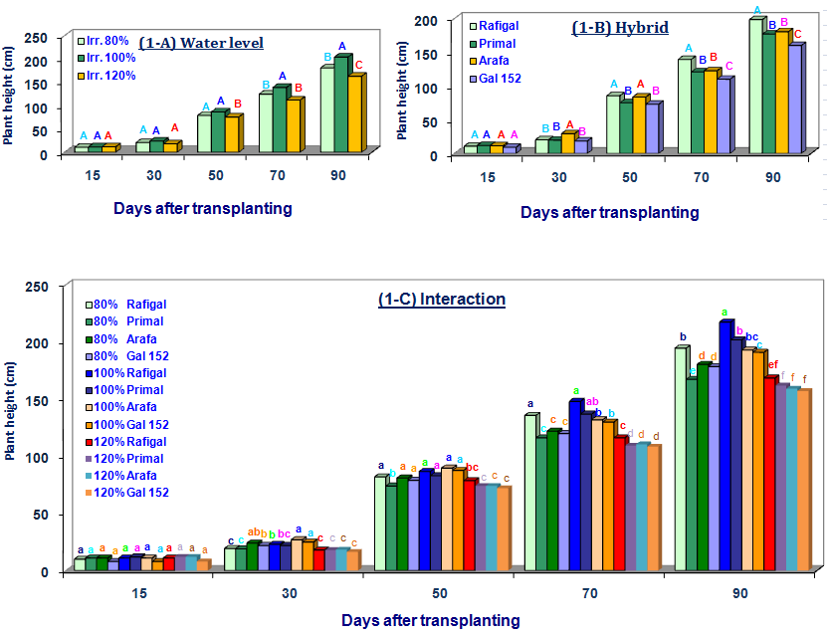

Second season
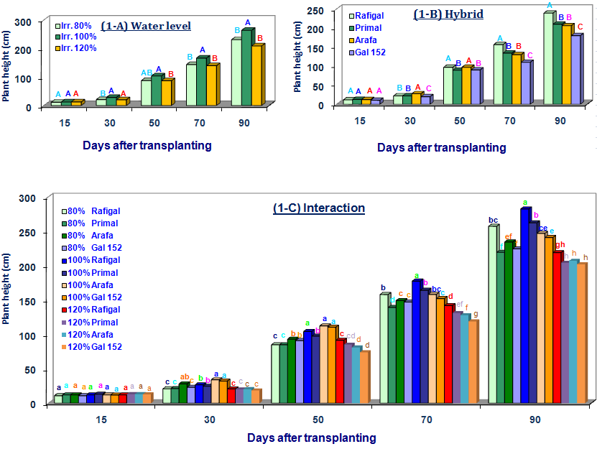
Figure (1):-Effect of water balance on plant height of cantaloupe plant.
* Similar letters indicate nonsignificant at 0.05 levels.

First season
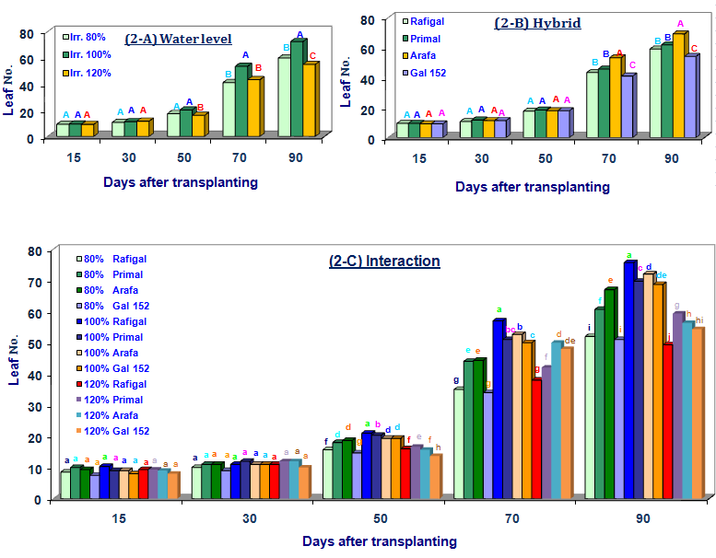
Second season
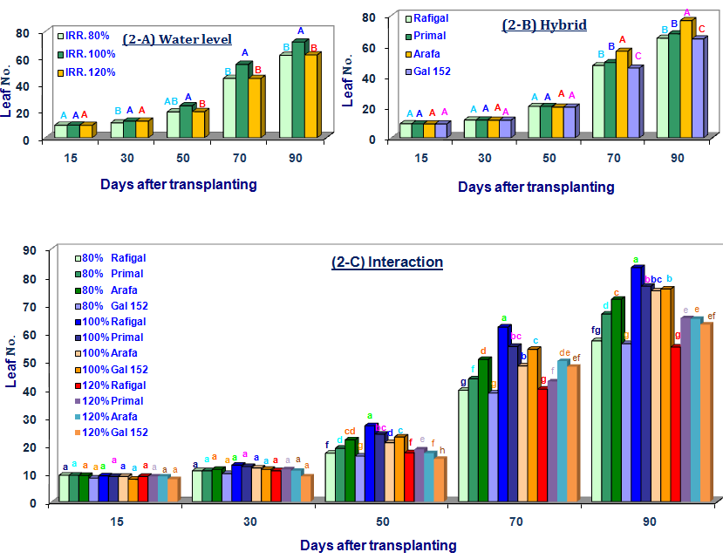
Figure (2):-Effect of water balance on leaf number of cantaloupe plant.
* Similar letters indicate nonsignificant at 0.05 levels.

References
Abou El-Yazied, A.; El-Kassas, A.I.I.; Abdalla, M.Y.H. and El-Moslemany, M.Z.M. (2012). Response of cantaloupe hybrids to nitrogen fertilization levels under natural infection with Monosporascus cannonballus. Aus. J. of Basic and Appl. Sci., 6(3): 1-11.
Abou-Hadid, A.F.; El-Beltagy, A.S.; El-Tantawy, M. and Eissa, A. M. (1992). Lysimetic analysis of crop water consumption patterns in selected vegetables. Acta Hort., Avignon, France. Pp. 67-76.
Badr, M.A. (2007). Spatial distribution of water and nutrients in root zone under surface and subsurface drip irrigation and cantaloupe yield. W. A. Sci. J., 3(6): 747-756.
Badr, M.A. and Abou Hussein, S.D. (2008). Yield and fruit quality of drip-irrigated cantaloupe under salt stress conditions in an arid environment. Austr. J. of Basic and Appl. Sci., 2(1): 141-148.
Botia, P.; Navarro, J.M.; Cerda, A. and Martinez, V. (2005). Yield and fruit quality of two melon cultivars irrigated with saline water at different stages of development. E. J. Agro., 23: 243-253.
Cabello, M.J.; Castellanos, M.T.; Romojaro, F.; Martı´nez-Madrid, C. and Ribas, F. (2009). Yield and quality of melon grown under different irrigation and nitrogen rates. Agri. W. M., 96: 866-874.
Gaafer, S. A. and Refaie, K. M. (2006). Modeling Water effects on growth and yield of Melon (Cucumis Melo cv. Reticulatus). Egypt. J. Appl. Sci., 21 (8B).
Keshavarzpour, F. and Rashidi, M. (2011). Response of crop yield and yield components of cantaloupe to drought stress. W. A. Sci. J., 3: 382-385.
Long, L.R.; Walsh, B.K and Midmore, J.D. (2006). Irrigation scheduling to increase muskmelon fruit biomass and soluble solids concentration. Hort. Sci., 41(2): 369-367.
Medany, M. A. (1997). Studies on cucumber growth models. Ph.D. thesis Fac. of Agri., Ain Shams Univ., Pp. 103.
Nelson, N. (1974). Apholometric adaptation of the Samogyi methods for determination of glucose. Jour. Biology chem., 159 : 375-380.
Phene, C.J.; Davis, K.R.; McCormick, R.L. and Heinrich, D. (1987). Evapotranspiration and irrigation scheduling of drip irrigation cantaloupes. Proc. of the Drip Irrigation Symposium, San Diego, California. American Soci. Pp. 87: 2526-2539.
Rashidi, M. and Seyfi, K. (2007). Effect of water stress on crop yield and yield components of cantaloupe. Int. J. Agric. Biol., 2: 271-273.
Refaie, K. M. (2003). Studies on controlling soil moisture within root zones to minimize water loss to the surrounding environment. M. Sc. Thesis, Institute of Environmental Studies & Research, Ain Shams Univ. Cairo, Egypt, Pp. 85-89.
Refaie, K. M. (2008). Water balance of potato crop under north delta conditions. Ph.D., Thesis, Fac. Agric. Al-Azhar Univ. Cairo, Egypt.
Seyfi, K. and Rashidi, M. (2007). Effect of drip irrigation and plastic mulch on crop yield and yield components of cantaloupe. Int. J. Agric. Biol., 2: 247–249.
Simsek, M. and Comlekcioglu, N. (2011). Effects of different irrigation regimes and nitrogen levels on yield and quality of melon (Cucumis melo L.). African J. of Biol., 10(49): 10009-10018.
Somogyi, M. (1952). Nateson sugar determination. Jour. Biology chem., 195: 19-23.
Soto-Ortiz, R.; Jeffrey C. and Abraham, G. (2006). Crop phenology for irrigated cantaloupes (Cucumis melo L.) in Arizona. http://cals.arizona.edu/pubs/crops/az1419/
Steel, R.G.D. and Torrie, J.H. (1984). Principles and Procedures of Statistics: A Biometrical Approach. McGraw Hill Book Co., Inc., New York, USA.

7/7/2012

