A Survey of Spore Ornamentation in Ectomycorrhizal Fungi – Is Ornamentation an Adaptation for Short Distance Dispersal?

Kumaresan V¹, Ravindran C², Senthilarasu G³ and Veeramohan R⁴

¹PG Department of Plant Science, Mahatma Gandhi Govt. Arts College, Mahe - 673311, India.
²National Institute of Oceanography, Dona Paula, Goa - 403004, India.
³Mycology Group, Agharkar Research Institute, GG Agarkar Road, Pune - 411004, India.
⁴Department of Plant Science, Bharathidasan Govt. Arts College for Women, Puducherry - 605003, India.
vkumaresan36@yahoo.com

Abstract: Survey of spore ornamentation in basidiomycetous ectomycorrhizal fungi revealed that 70% of the species produced ornamented spores. Scanning electron micrograph study showed the possible evidence for the resistance, due to the presence of spore ornamentation, offered by ornamented spores against getting washed off by water, leading us to propose that ornamented basidiospores have advantage over their smooth-spored counterparts, the former adapted for short distance dispersal to retain the spores within the host range.
[Kumaresan V, Ravindran C, Senthilarsu G, Veeramohan R. A Survey of Spore Ornamentation in Ectomycorrhizal Fungi – Is Ornamentation an Adaptation for Short Distance Dispersal? N Y Sci J 2012;5(9):1-4]. (ISSN: 1554-0200). http://www.sciencepub.net/newyork. 1

Keywords: Ectomycorrhiza; basidiospore; spore-ornamentation

1. Introduction
Ectomycorrhizal (ECM) fungi are known to form symbiotic association with roots of higher plants belonging to Betulaceae, Dipterocarpaceae, Fagaceae, Myrtaceae, Pinaceae etc., aiding in mutual benefits. World over a total of ~ 7750 species have been designated as ectomycorrhizal fungi (Rinaldi et al, 2008). Many of the fungi forming ECM association are known to occur in higher altitudes and move between of suitable habitats in disjoint patches; the basidiospores are carried by air flows and allow dispersal between patches. Components of animal kingdom are also known to aid in ectomycorrhizal spore dispersal (Lilleskov and Bruns, 2005). Our survey of ECM spore morphology revealed that many of the species forming ECM association had ornamented spores. These ornamented spores could hold on to the soil substratum thus, avoiding getting washed off in rain water and therefore most of the propagules of ECM fungi remain within the host range. We propose that the ornamentation with respect to the basidiomycetous fungi could have an advantage over their smooth-spored counterparts, the former adapted for short distance dispersal to retain the spores within the host range.

2. Materials and Methods
Survey of literature showed that 167 basidiomycetous fungi formed ectomycorrhizal association (Rinaldi et al, 2008). These fungi were checked for their presence/ absence of ornamentation with the help of description for fungi available in Mycobank (WWW.MYCOBANK.ORG) and for others a comprehensive literature survey was made.
For simulating a condition akin to the deposition of basidiospores in soil, the spores were mixed with talcum powder and scanning electron micrograph pictures were taken.

3. Results and Discussion
Our survey resulted in 7365 species of basidiomycetous ECM fungi, of which, 5123 species (70%) were found to produce ornamented spores and 2242 species produced smooth spores (Table 1 showing only those genera with 5 or more species). Although ornamentation in fungal spores have also been found in other basidiomycetous, ascomycetous and mitoporic fungi, here, we speculate the importance of ornamentation only with respect to the basidiomycetous ECM fungi. It is known that the basidiospores of epigeous basidiomycetes are dispersed by wind. Galante et al (2011) have shown that 95% of the basidiospores fall within 1 m of the cap. Further, in the case of spore dispersal by wind, surface ornamentations only mildly increase drag (Roper et al, 2008), suggesting dispersal by wind is effected in the smooth-walled and ornamented spores equally. This suggests that most of the propagules fall near the host in both smooth and ornamented–spore producing species. The ECM fruiting structures mainly occur during the period of precipitation when the conditions are favourable, and the propagules may also be washed off in rain water along with wind dispersal. But, if the spores are ornamented they could get entangled in soil particles (or pores in the soil particles) as shown with help of a simulated condition similar to that occurring in nature: We found that the ornamented spores cling on to the
Table 1. Fungal genera known to form ectomycorrhizal association

Ectomycorrhizal fungal genera§ | No. of species reported* | Basidiospore ornamentation
Afroboletus | 7 | Ornamented
Albatrellus | 16 | Smooth
Alnicola | 30 | Ornamented
Alpova | 20 | Smooth
Amanita | 500 | Smooth
Amaurodon | 10 | Ornamented@
Amphinema | 6 | Smooth
Arcangeliella | 12 | Ornamented
Aureoboletus | 5 | Smooth
Auritella | 7 | Smooth
Austroboletus | 30 | Ornamented
Austrogautieria | 6 | Ornamented
Austropaxillus | 9 | Smooth
Boletellus | 50 | Smooth
Boletopsis | 5 | Ornamented
Boletus | 300 | Smooth
Byssocorticium | 9 | Smooth
Calostoma | 15 | Ornamented
Cantharellus | 65 | Smooth
Chalciporus | 25 | Smooth
Chamonixia | 8 | Ornamented
Chroogomphus | 18 | Smooth
Clavariadelphus | 19 | Smooth
Clavulina | 40 | Smooth
Coltricia | 20 | Smooth
Coltriciella | 7 | Ornamented
Corditubera | 5 | Ornamented
Cortinarius | 2000 | Ornamented
Cystangium | 7 | Ornamented
Dermocybe | 15 | Ornamented
Descolea | 10 | Ornamented
Destuntzia | 5 | Ornamented
Entoloma | 100 | Ornamented
Fistulinella | 15 | Smooth
Gallacea | 5 | Smooth
Gastroboletus | 10 | Smooth
Gautieria | 25 | Ornamented
Gloeocantherellus | 6 | Ornamented
Gomphidius | 10 | Smooth
Gomphus | 10 | Ornamented
Gymnomyces | 37 | Ornamented
Gyrodon | 10 | Smooth
Gyroporus | 10 | Smooth
Hebeloma | 150 | Ornamented
Heimioporus | 16 | Ornamented
Hydnum | 120 | Smooth
Hygrophorus | 100 | Smooth
Hymenogaster | 100 | Ornamented
Hysterangium | 50 | Smooth
Inocybe# | 500 | Ornamented
Laccaria | 75 | Ornamented
Lactarius | 450 | Ornamented
Leccinellum | 5 | Smooth
Leccinum | 75 | Smooth
Leucogaster | 20 | Ornamented
Leucopaxillus | 15 | Ornamented
Leucophleps | 5 | Ornamented
Lindtneria | 11 | Ornamented
Lyophyllum | 50 | Smooth
Macowanites | 30 | Ornamented
Malajczukia | 8 | Smooth
Melanogaster | 25 | Smooth
Multifurca | 5 | Ornamented
Naucoria | 30 | Ornamented
Octaviania | 15 | Ornamented
Paxillus | 15 | Smooth
Phellodon | 16 | Ornamented
Phylloporus | 50 | Smooth
Piloderma | 6 | Smooth
Pisolithus | 12 | Ornamented
Pseudotomentella | 9 | Ornamented
Pulveroboletus | 25 | Ornamented
Ramaria | 220 | Ornamented
Retiboletus | 6 | Smooth
Rhizopogon | 150 | Smooth
Rozites | 20 | Ornamented
Rubinoboletus | 10 | Smooth
Russula | 750 | Ornamented
Sarcodon | 36 | Ornamented
Scleroderma | 30 | Ornamented
Sebacina | 6 | Smooth
Setchelliogaster | 6 | Ornamented
Sinoboletus | 5 | Smooth
Stephanopus | 5 | Ornamented
Strobilomyces | 20 | Ornamented
Suillus | 50 | Smooth
Thelephora | 50 | Ornamented
Timgrovea | 5 | Ornamented
Tomentella | 75 | Ornamented
Tomentellopsis | 5 | Ornamented
Trechispora | 46 | Ornamented
Tremellodendron | 8 | Smooth
Tricholoma | 200 | Smooth
Tubosaeta | 5 | Smooth
Tulasnella | 46 | Smooth
Turbinellus | 5 | Ornamented
Tylopilus | 75 | Smooth
Xanthoconium | 7 | Smooth
Zelleromyces | 17 | Ornamented
§ Rinaldi et al (2008); * Kirk et al (2008)
@ One species smooth-walled.
# Pegler and Young (1972) reported small rugulosities under electron microscope in both smooth and nodulose-spored species of Inocybe, therefore, spore-wall of Inocybe have been considered ornamented.
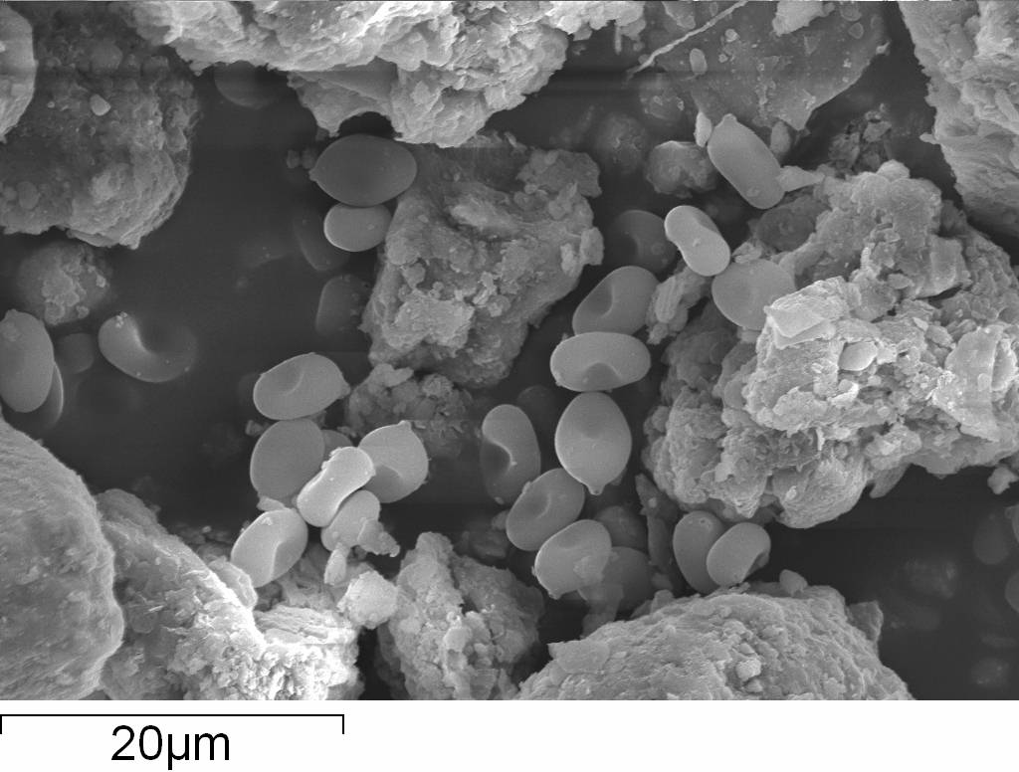
a
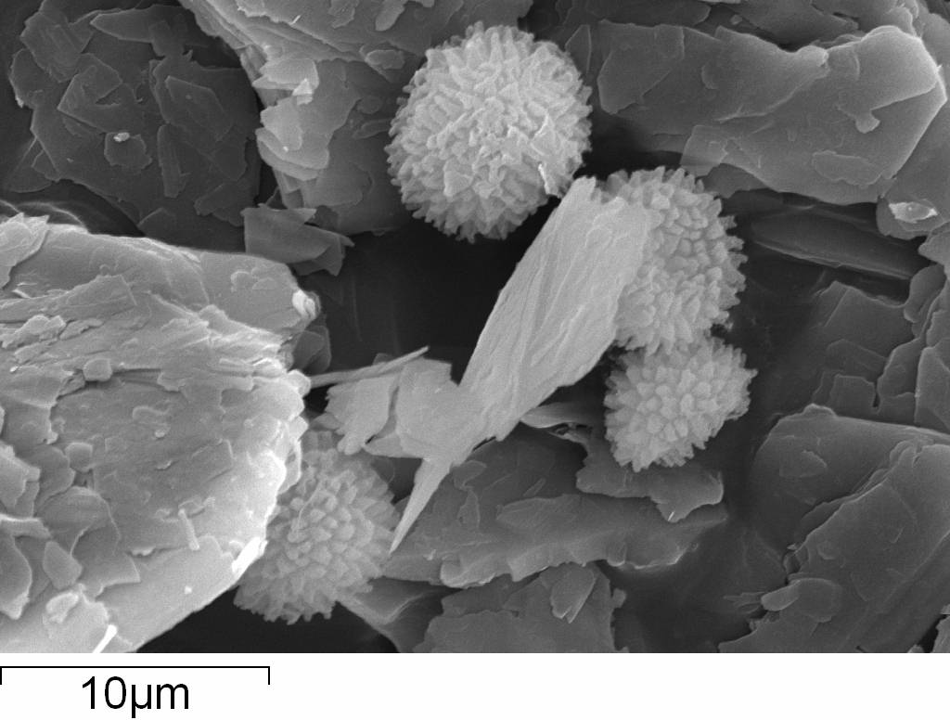
b
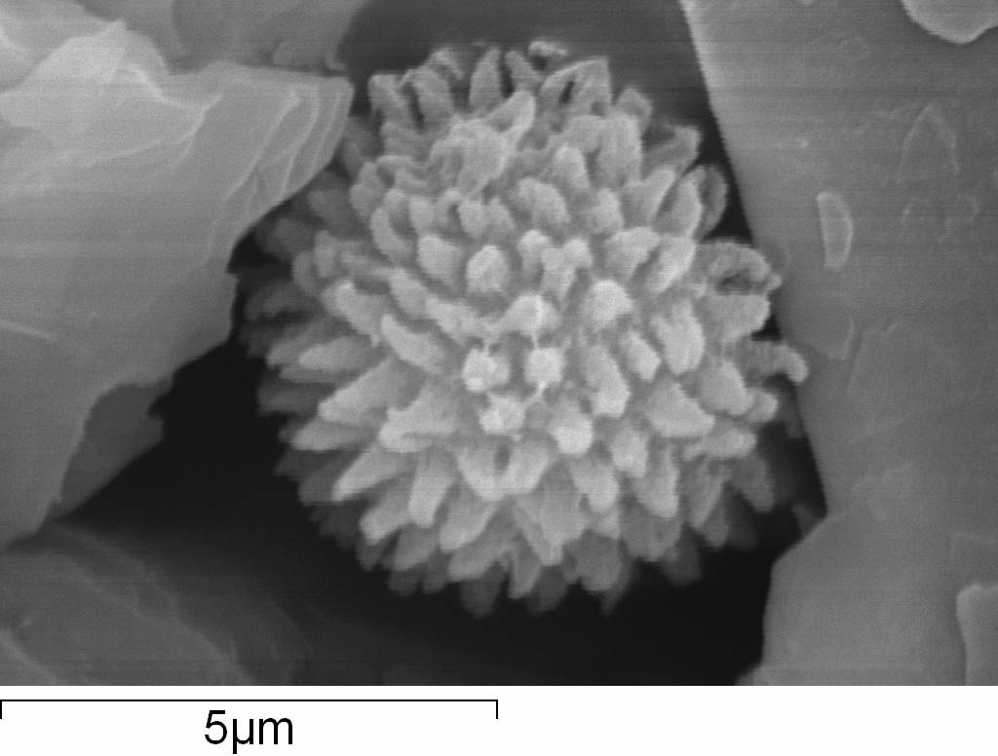
c
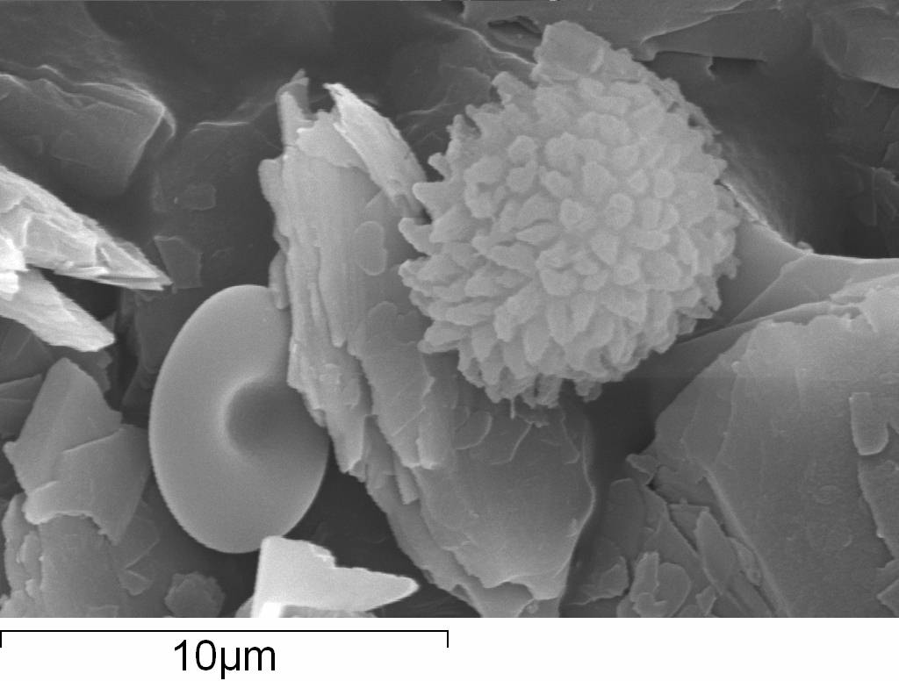
d
Figure 1. SEM photographs of basidiospores placed in talcum powder – a condition similar to that of spores present between soil particle or in soil pores. a. Basidiospores of smooth-walled agaric occurring between particles, b. & c. Ornamented basidiospores of Pisolithus arhizus (Scop.) Rauschert seen entangled between particles of talcum powder, d. Comparison of both smooth-walled and ornamented spores together.

talcum powder particles (Figure 1a-d), but smooth-walled spores get simply placed in the spaces between particles, thus making them vulnerable to running-off with the stream of water. We opine that spore ornamentation is an important adaptation for dispersal within host range/host population since the fruiting structures are formed (and they mature) during rainy period and dispersed/washed along with rain water, in the sloppy terrain, that can carry the spores to long distances if there is no resistance provided by the spores ultimately taking them out of the host range (a wastage of energy). Thus, we propose that ornamentation of basidiospores could have advantage, especially with respect to adaptation for short distance dispersal. Hibbett et al (2000) after studying 161 species for their nuclear and mitochondrial rDNA opine that some of the homobasidiomycetous ectomycorrhizal forms have reversed to free living saprophytic forms and suggesting that mycorrhizae are unstable dynamic association. But, their results show that these reversals have mainly occurred with respect to groups forming smooth walled basidiospores. Further, Amanita muscaria, producing smooth basidiospores, forms association with more than 20 species of host plant (Trappe, 1962; Hibbett et al, 2000), showing wider host adaptability (probably conferred by ability for long distance dispersal due to the presence of smooth spores). Observation made by Vellinga et al (2009) that introduced species of ectomycorrhizae appear to be constrained from spreading to novel habitats and associate only with their introduced hosts, could be a support to our proposal.

Acknowledgements:
We thank Mr. V.D. Khedekar, NIO, Goa for help rendered in taking SEM Photographs.

Corresponding Author:
Dr. Kumaresan V.
PG Department of Plant Science
Mahatma Gandhi Govt. Arts College, Mahe
P.O. New Mahe (UT of Puducherry)-673311, India
E-mail: vkumaresan36@yahoo.com

References
- Rinaldi AC, Comandini O, Kuyper TW. Ectomycorrhizal fungal diversity: separating the wheat from chaff. Fungal Diversity 2008; 33: 1-45.
- Lilleskov EA, Bruns TD. Spore dispersal of a resupinate ectomycorrhizal fungus, Tomentella sublilacina, via soil food webs. Mycologia 2005; 97: 762-9.
- Galante TE, Horton TR, Swaney DP. 95% of basidiospores fall within 1m of the cap: a field-and modeling-based study. Mycologia 2011; 103: 1175-83.
- Roper M, Pepper RE, Brenner MP, Pringle A. Explosively launched spores of ascomycete fungi have drag-minimizing shapes. Proc Nat. Acad. Sci. 2008; 105: 20583-8.
- Kirk PM, Cannon PF, Minter DW, Stalpers JA. Ainsworth and Bisby’s dictionary of the fungi. CAB International, Wallingford, UK. 2008.
- Pegler DN, Young TWK. Basidiospore form in the British species of Inocybe. Kew Bull.1972; 26: 499-537.
- Hibbett DS, Gilbert L-B, Donoghue MJ. Evolutionary instability of ectomycorrhizal symbioses in basidiomycetes. Nature 2000; 407: 506-508.
- Trappe JM. Fungus associates of ectotrophic mycorrhizae. Bot. Rev. 1962; 28: 538-606.
- Vellinga EC, Wolfe BE, Pringle A. Global patterns of ectomycorrhizal introductions. New Phytologist 2009; 181: 960-973.

7/12/2012

