Effectiveness of Exercises and Ozone Cabinet Forankle Sprain Injuries Male in Kuwait

Nawaf Hajji Saad qatwan

Physiological Center, Ministry of Education, Kuwait
nhsq1@hotmail.com

Abstract: The most commonly injured ligament in about 70% of ankle ligament injuries, only this ligament disrupts. Ankle sprain is one of the most spreader injuries of athletes. The aim of this study is to evaluate the efficiency of therapeutic exercises and medical ozone for rehabilitation of foot, injured with internal distortion of second degree 8 volleyball players, 18-24 years. on the following variables degree by physiological analysis' using Foot Maxx, the range of movement of foot joint, foot diameter, physiological variables (Potassium, creatine, Phosphokinase). The statistical protocol was used Mean, Standard deviation, Analysis of Differences, Welkacson test, Percent changes, The result of the study , that exercise rehabilitation programs may lead to increased in muscle force working on the injured joint and increase range of motion and that it help in prevention of recurrences of injury in the future. The researchers recommended Using medical ozone plus rehabilitation exercises program in curing ankle joint injury.
[Nawaf Haji saad qatwan. Effectiveness of exercises and ozone cabinet forAnkle sprain injuries male in Kuwait. N Y Sci J 2012;5(9):26-32]. (ISSN: 1554-0200). http://www.sciencepub.net/newyork. 5

keywords: Exercise; Ozone; Cabinet; Forankle; Sprain; Injurie; Male; Kuwait

Introduction
The Foot is the principal base of human body and obtain its equilibrium, its soundness is considered a key stone of clever movement. Any injury in the foot can weaken balance and physical performance. The sensory nerve ending and ligaments of muscles nourish the nervous system with information for equilibrium stability. (Mohamed Hassanin, 1995).
Ankle Joint is a hinge uniaxial joint, its movement in contraction, relaxation, adduction, abduction and rotation. The normal range of movement is dorsal flexion around 20 degree, and for planter flexion 45-55 degree (Thompson and Floid, 1998).
Injuries of the ankle joint are deferent and are sprained between athletes and non athletes and they are of the most predominant among the different sport activities stated that the more predominant injuries of athletes is distortion of ankle sprain and represent 60% of injuries in sport field. 85% of ankle sprain injuries are due to distortion of inferior foot (Mervat, 2001; Vicenzina et al, 2002).
(Gran and Newton, 1988:1669) . showed that injury of the ligament of ankle joint can induce pain swelling, limitation of the range of motion and disturbance in balance of the ankle joint as well as general body balance, such symptoms are exaggerated according to the severity of the injury, furthermore many of sprain ankle patients are subjected to recurrent ankle sprain due to such disturbed balance.
In addition, injury of ankle joint due to distortion, may affect neuromuscular structures concluded that if such injuries are not treated, chronic instability could affect physical performance and the injury may be recurrent, (Rozzi et al 1999: 478-486).
(Hintermann ,1999:459) confirmed that in some ankle sprain injuries, the ligaments might not return to the normal state, which affect negatively the joint stability, which lead to recurrent distortion with pain and edema in the same place .(Watson, 1999:36-63) also confirmed that 40% of the curried ankle joint distortion might's be recurrent, leading to a true problem to the athlete .
Therefore, the majority of modern researches are directed to the application of additional methods beside the classical therapeutic methods for treatment and rehabilitate injuries in general and ankle joint in particular, one of the important method beside therapeutic treatment is Ozone, as a scientific trial for rehabilitation of the distorted foot. Some of the studies have used medical ozone as an additional therapeutic trial in rehabilitation or treatment of choice or adjunctive treatment (Rasha, 2004; Reham 2002; Iman 2000; Jake, 2001; Safaa, 2007).
Therapeutic exercises best known as one of efficient complex methods in treatment of different injuries as it helps healing of injured tissues and get rid of swellings and prevent bleeding and restoration of injured muscles and joints to their function in the least possible time (Al kashef, 1990:20-21) .
Ozone plays an efficient role in the rapid restoration of human biological functions, it is known as oxidant (o3),it contains three atoms of oxygen instead of two of oxygen (o2),it has many therapeutically and physiological applications, as it contains physicochemical and natural properties as an oxidant agent to cells, bacteria, fungi, and powerful stimulant to metabolism ( Bocci, 2002152).
The beneficial effects are extended to the Sport field and athletes, as oxygen percent increase to tissue and ATP production and Energy output and in a prove rehabilitation (Thomas, M, 2000: 623).
The methods of applications are: through skin (Sauna) in a Cabinet, with the head out of the cabinet in a temperature between 37- 40 degree, centigrade, the body absorb 03 in 20 min. time (Azmy,S.T,2007: 47) .
So, this trial is an attempt of the two researchers, to use a modern therapeutic method to the therapeutic exercises programs and compare the results with the classic methods in sport rehabilitation depending on ozone properties. Since there are different strategies, in curing such injuries, such as rest without treatment, or the use of ice, pain killers or heat or stability or drug treatment, rehabilitation or Ozone. There are discrepancies between rehabilitation centers in this process (Shata, M.A, 1976 :7) .
The researchers view is the problem does not depend on the best method selected for rehabilitation and the speed of curing the cases, but how to prevent the recurrent of injury. Foot Maxx instrument was Chozen by the researchers as it help stability and balance the foot and the distribution of body load on foot particles after the distortion of the ankle joint and sprain of the external ligaments.

This study is one of the research trials which link between the use of:
- Ozone cabinet for rehabilitation of distortion of ankle joint of second degree
- Foot Maxx instrument to evaluate curing grade of the injury after treatment.
- Biochemical analysis of CPK to determine the healing rate of the tissues. Potassium was used as pain indicator
The aim of this study is to evaluate the efficiency of therapeutic exercises and medical ozone for rehabilitation of foot, injured with internal distortion of second degree of soccer players on the following variables:
1-Biomechanical analyses of foot which involve (pressure on toes of foot, maximal pressure on sole of foot, time of fulcrum , heel strike.
2-Range of movement of foot joint in contraction, relaxation and circumference of injured foot.
3-Biochemical analyses of CPK and potassium

Terminology of the study:
Therapeutic exercises:
They are rehabilitation physical exercises, one of the most compound method which affect injured athletes with a defect in body system (Alaa uddin, 2005).
Ozone :
Is a pure gas, that contain 3 atom of oxygen O3 (Mawsouf, M.A, 2001).
Ozone cabinet:
Is a cabinet of Fiberglass, triangle in shape its base is rectangle, its length 150cm, Breadth 75cm, 100m height. With a stable chair made of wood, with a cover which permit the head protrusion, and internal openings for medical ozone gas (Khaled, R.A, 2002).
Creatine Phosphokinase ('CPK):
One of transporter enzyme, which hasten reaction for ATP production of CP, ATP is composed of ADP+P. It is a marker of healing of destroyed tissues which is accompanied with CPK level (Abdelzaher, M.M, 2002).
Potassium:
One of the salts needed for several functions, the body contains 270 gram potassium. It is a marker of pain sensation, which affect potassium level (Nawer, Tespy, 2005).
Foot Maxx instrument:
Is a sample of analyses of force plate form constructed for analyses of this forces of the foot, in Torento, Canada. One of the benefit of the instrument, to discover balance instability and its defects during walk, registration of the distribution of body pressure upon foot, in the three phases of leaning and its time . The length of the instrument is 50cm, its breadth 30cm, and its base is connected to a computer with windows 95 system, which translate the electric waves from the instrument to a curve, which divide the plantar of the foot to identical squares, with 6 colours, due to pressure loads of the foot on the instrument surface, each colour represent a pressure cost known as paskal = (1kg-CM: IKPA).
Related Studies:
1- The study of (Iman Awad , 2000) entitled "Ozone gas is a gift of god for Nerves physicians" . The aim was to investigate the benefits of ozone to Nervous disease, and direct medical education of ozone for curing many diseases such as mental troubles, the results were positive without side effect due to the use of ozone .
2- The study of (Rasha Riad , 2004) entitled " The effect of aerobic training and ozone gas on physical efficiency and antioxidant of the mental retarded person" 20 student were used as sample, they were affected with simple mental retardation, aged 10-12 yrs, the results were positive as ozone and training program help in elevation of physical efficiency and improve antioxidants levels .
3- The study of (Riham Hamed, 2002) entitled " the effect of medical ozone on the muscle healing" and the level of performance in artistic training, 20 students, were used for experimental group, they performed artistic exercises, the results indicated the ozone gas posses a positive impact in rehabilitation and on the level of physical movement of artistic purformence, Lactate decreased due to the effect of Ozone.
4- The study of (Mohamed El Nagar, 2005) entitled the effect of rehabilitation exercises on the functional stability of ankle joint after destruction of the external ligament, to investigate the effect of the rehabilitation exercises on balance, muscle force the range of movement. The experimental method was used on a sample of 10 injured athletes. The results indicated that rehabilitation exercises helped to restoration of normal functions of the joint with high efficiency.
5. The study of (Safaa Tawfik , 2007) entitled. The effectiveness of exercises and some modern curative methods on the muscle cramp of the neck muscles of the ladies 25-30yrs, 30 females were injured with neck cramp, They were divided to 3 groups (10 each), the researcher reach the following: increase in the range of motion of the neck of the therapeutic exercise group, than the other groups, the decrease of pain in the ozone group was significant even after two weeks of therapeutic program stop .
6. The study of (Thomas.M , 2000) entitled "ozone as an oxidant and this influence on free radical activity and health". 4 patients of Wembeldon – London clinic, they received ozone intra-anal, they analyzed percent of free radical four times, the results indicated a decreased free radical percent, also unpredicted result that ozone continue to elevate in the first 24hrs, free radical decrease in the second and third dose was lower than the first dose, patients 2, 3 results were better in relation of the effect of ozone on free radicals and get rid of them.
7. Study of (Muto , 2004) entitled "Treatment of herniated lumber disc by intradiscal of ozone the aim is to get rid of pain caused by lumber disc on 175 patients, and follow up for 6 monthes, the results revealed beneficial effects in 80% cases .
8. Study of (Hertel , 2000) entitled " Functional instability following lateral ankle sprain", the purpose of the study was to investigate the causes behind instability after injury, post injury caused sprain in ligaments and muscles, Nerves also to tendon of joint, Ligaments injuries might relaxer around joint, in case of nerves and muscles, decreased balance might occur also decreased nerve signal and decreased superficial sensation and range of motion and more muscle weakness, so it is important to have a good evaluation of the injury. The purpose of cure must lean on the return of the nerve and muscle function and natural mechanical movement of the joint.
Sample of the study:
8 volleyball affected with lateral sprain ankle of second degree in season 2010 divided to two groups: the first (n=4) therapeutic exercises program, the second (n=4) therapeutic exercises program plus medical ozone, Aged between 18-24 years.
The Suggested Program:
The Program was designed after reference and scientific studies, and through analysis of previous therapeutic rehabilitation program, and after the suggestion of specialist in physical education and physical therapy and bones specialist. We arrived to the view:
- Time table for the execution of the program (8) weeks, (4) time a week, this will be (32) exercises unit.
- As for ozone, (3) time weekly, in an independent day in phase one and two, and once in the third phase of program
- Time of ozone medication (o3) 20 min and the cabinet temperature of ozone 37-40°c.
- The Players were in negative rest in the first stage of the program and in positive rest during the second and third stages.
Statistical design:
The following statistical, tests were used:
- Mean 2. Standard deviation
3. Analysis of Differences 4.Mann Whitney test (u)
5. Welkacson test 6.Percent changes %
3. Results:
Table (1) indicated that Skrewness (+3-3)

Table (1): Statistical analysis of the two groups in some anthropometric variable using Mann Whitney (u)
Variables | Group 1 |  |  | Group 2 |  |  | Uvalue | Sig.
Variables | Mean | SD | Skrew | Mean | SD | Skrew | Uvalue | Sig.
Age (yrs) | 17.30 | 2.51 | 0.25 | 17.0 | 2.33 | 0.26 | 17.55 | 0.732
Height (cm) | 163.90 | 7.10 | -0.49 | 163.42 | 7.58 | 0.57 | 13.0 | 0.324
Weight (kg) | 56.41 | 5.33 | -0.42 | 55.98 | 5.11 | 0.45 | 19.50 | 0.534
SD= standard deviation P < 0.05

Instrument used:
1. Foot Maxx for biomechanical of the injured foot through: (Pressure on toes of foot, max pressure on sole of foot, heel strike, time of fulcrum by pressing through the injured foot
2. The use of ozone cabinet
3. geniometer for the range of motion measurement of the injured ankle in contraction and relaxation
4. Measurement band for the circumference of the injured foot
5. Spectrophotometer and kits for (CPK)
Table (2) indicated that the Skrewness (+3,-3) meaning non sig. changes between the two groups.
One stated "there are a positive effect of the proposed therapeutic exercises program with medical ozone for rehabilitation of the injured foot with internal distortion of 2nd degree for all variables. About the biomechanical analysis of foot:
Table 2, 3 showed that there was a significant difference before and after the program in [pressure of toes] of the foot, pressure on sole surfaces of foot , heel strike and time of support (fulcrum) of both groups, pressure percent on phalanges of foot decreased and pressure percent on plantar surface of foot increased, also on heel . Time of support was elevated. The researchers views that this is a proof on the positive effect of the therapeutic exercises for improving the normal function of the foot to reach normal level due to increased load on plantar region of foot and heel and decreased pressure on phalanges, This was obvious in decreased support time as in case of injury the subject cannot support on the injured foot and lean on the sound foot.

Table (2) Statistical analysis of the two groups before the program in different variables using (U) n=4
Variables | Group I |  |  | Group 2 |  |  | (U)  Value | Sig.
Variables | Mean | SD | Skrew | Mean | SD | Skrew | (U)  Value | Sig.
Pressure on toes of foot | 27.12 | 0.830 | 2.13 | 26.98 | 0.845 | 1.86- | 4.00 | 0.221
Max. Pressure on sole surface of foot | 6.70 | 0.800 | 0.64- | 7.00 | 0.807 | 0.67 | 11.50 | 0.195
Heel Strike | 37.01 | 6.00 | 2.42 | 36.90 | 8.77 | 2.23 | 1.00 | 2.246
Time of Fulcrum | 1.40 | 0.032 | 0.260 | 1.32 | 0.037 | 0.251 | 2.00 | 0.590
Circumference of foot | 13.10 | 2.01 | 0.411 | 12.99 | 1.83 | 0.433 | 10.00 | 0.289
Range of motion in relaxation | 9.75 | 1.70 | 0.753 | 9.25 | 1.70 | 0.753- | 7.00 | 0.770
Range of motion in contraction | 26.75 | 1.89 | 1.65- | 27.50 | 1.29 | 1.46 | 6.50 | 0.655
CPK | 63.00 | 3.82 | 0.855 | 64.25 | 1.50 | 0.370 | 6.00 | 0.559
Potassium | 5.17 | 0.22 | 0.482- | 5.37 | 0.170 | 0.753 | 4.00 | 0.243
* Sig. at 0.050

Table (3) Statistical analysis of the two groups in the different variables by using Wilkocson method n=4
Variables | Group I |  |  | Group 2
Variables | Mean | SD | Skrew | Mean | SD | Skrew
Pressure on toes of foot | 1.81 | 0.016* | 25% | 1.85 | 0.019* | 34%
Max. Pressure on sole surface of foot | 1.85 | 0.019* | 76% | 1.83 | 0.021* | 79%
Heel Strike | 1.82 | 0.023* | 54% | 1.85 | 0.019* | 89%
Time of Fulcrum | 1.81 | 0.016* | 9% | 2.00 | 0.024* | 23%
Circumference of foot | 2.0 | 0.024* | 3% | 1.82 | 0.023* | 14%
Range of motion in relaxation | 1.84 | 0.022* | 18% | 1.84 | 0.022* | 43%
Range of motion in contraction | 1.85 | 0.019* | 19% | 1.84 | 0.22* | 42%
CPK | 1.82 | 0.023* | 28% | 1.82 | 0.023* | 57%
Potassium | 1.85 | 0.019* | 20% | 2.00 | 0.024 | 32%
* Sig. at 0.05

Table (4) Statistical analysis of the two groups in case of post programs in different variables using Mann Whietney method (11)
Variables | Group I |  |  | Group 2 |  |  | (U)  Value | Sig.
Variables | Mean | SD | Skrew | Mean | SD | Skrew | (U)  Value | Sig.
Pressure on toes of foot | 20.44 | 1.03 | -0.55 | 17.80 | 1.93 | 1.00 | 9.00 | *0.024
Max. Pressure on sole surface of foot | 50.13 | 2.63 | -0.67 | 61.14 | 1.10 | 0.74 | 11.50 | *0.022
Heel Strike | 57.20 | 4.90 | 2.17 | 70.01 | 0.95 | 1.60 | 10.00 | *0.022
Time of Fulcrum | 1.53 | 6.63 | 2.54 | 1.62 | 8.13 | 2.04 | 2.00 | *0.019
Circumference of foot | 12.80 | 2.71 | 0.96 | 11.20 | 1.50 | -0.78 | 2.50 | *0.020
Range of motion in relaxation | 11.50 | 1.73 | -1.54 | 13.25 | 0.957 | -0.855 | 2.50 | *0.011
Range of motion in contraction | 31.75 | 1.70 | 0.753 | 39.25 | 2.50 | -0.560 | 1.00 | *0.021
CPK | 45.25 | 3.40 | 1.19 | 27.75 | 6.55 | -1.90 | 1.00 | *0.021
Potassium | 4.12 | 0.009 | -0.855 | 3.67 | 0.170 | 0.753 | 1.50 | *0.020
*Sig. at 0.05

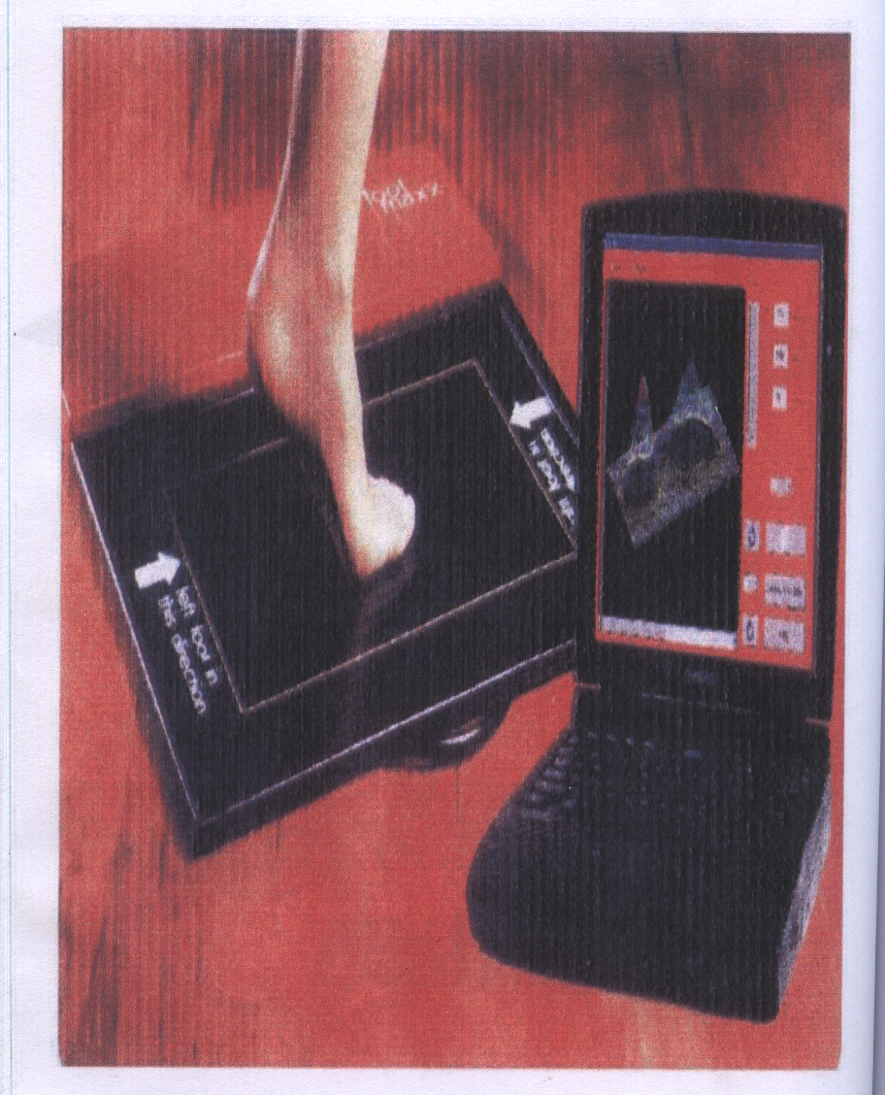
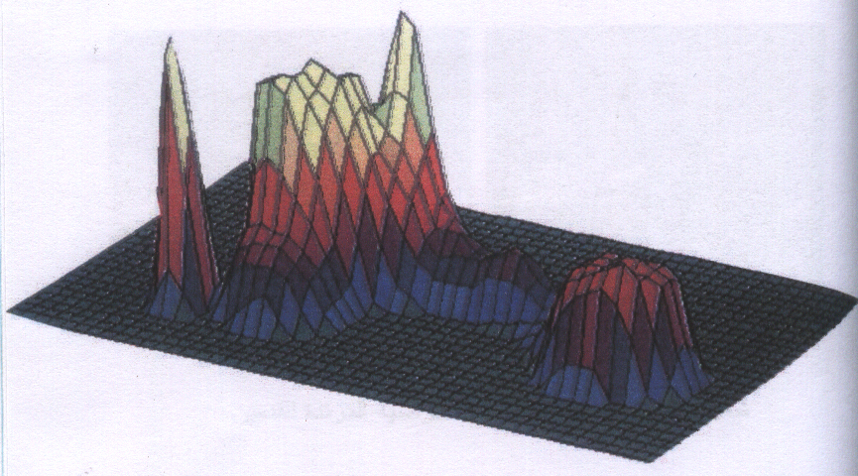
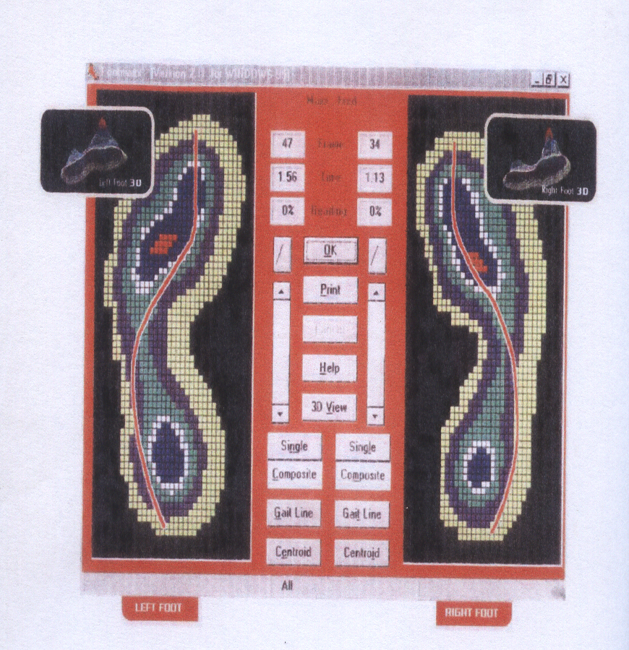
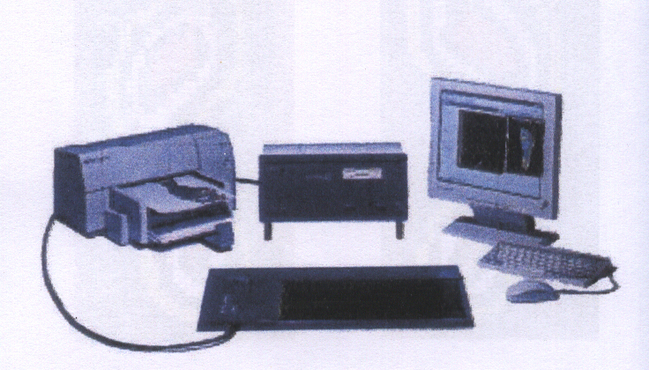

Fig (1) Foot maxx and Graphic analysis of the pressure feedback, Compared the distribution of pressure for the feet.

The result of the study is in agreement with those of Mohamed El Nagar (2005), Vicenzino et al., (2002), Lofnenberg et al, (2001) that exercise rehabilitation programs may lead to increased in muscle force working on the injured joint and increase range of motion and that it help in prevention of recurrences of injury in the future.
The understanding of the injury is shifted from stability program to reach better results (14,26,28) . Also the results agreed with those of (Gauffin and Tropp, 1998:141-144; Verhage , 2004:1385) that the use of balance training in rehabilitation program has an effective influence in preventing the recurrence of injury of the distortion ankle joint and better distribution of pressure on different foot areas and fulcrum time.
Range of motion in contraction and relaxation and circumference of foot Table (2,3) revealed a significant difference pre-post test of both groups for the advantage of post test the increased range of motion and decreased circumference of foot due to the rehabilitation exercise program which decreased the edema of foot and infiltration in joint, leading to increased range of motion. This was in accordance with ( Mohamed Bakry, 2000:56). Also with (Docherty et al.,1998: 310-314) which indicated that strength training developed strength, and the feeling of improve motion of joint to different direction. Also the study of ( Kern and Kelsey,1999:282-287) which showed the improved in range of motion and return of the joint to its normal functions without pain after the rehabilitation exercises to the injured joint .
Biochemical changes:
*Potassium
Table (2,3) indicated a significant differences in potassium concentration before and after the program of the two groups, as potassium decreased. (Ahmed Nasr,1993:65) showed that potassium assists sodium in regulation the involuntary movement of muscles during sport activity, also regulates osmotic pressure and balance the power to practice physical activities.
Din (Yehia Alaa El Din, 2005:19) stated that potassium is one of biggest ions in the cell and is distributed inside body fluids and tissues it is found in vegetables and the body needs (4 grams) of potassium daily . (Ganong , 2006 :10) added that potassium has an important role in pain sensation as its name is (P) factor, pain factor .
The researchers showed that the cause of the decrease in potassium can return to the influence of rehabilitation exercises program, principally, which led to improvement of function of ankle joint and enforce the active muscle of the foot, added to that the healing of destroyed tissues and absorption of the infiltrations, which led to edema and decreased the pressure induced inside the joint, and this was reflected on decreased sensation of pain and elevation of efficiency of the body in toleration of pain in the injured place.
Creatine Phosphokinase (CPK):
Table (2,3) showed a decrease in CPK in the post program estimation compared to pre program of the two groups (Chatterge, 2006:563-569; Abdel Zaher, 2002:90) indicated that CPK change CP +ADP to ATP+C, and that CPK concentration is high in muscle and heart and brain, it is not found in liver, kidney and Rbc, also in smaller amount in Lung, thyroid, adrenal glands, the normal level of CPK 40- 60 unit /L. in 37°c, and increased due to injuries and physical effort. CPK must be analyzed directly after blood with drawal.
(Murray and Peter ,1990:663-669) assured that CPK is elevated in serum due to injuries of muscles and heart and brain as in muscle diseases, inflammation, also in decreased thyroid secretion. Abdel (Abdel Zahar, 1996:80) stated, that in normal condition, CPK is found in small quantity in the blood, but due to physical effort, the enzyme activity increase as in case of injury and muscle pain. The researchers views that the increased level of CPK is of the important markers of tissue healing.
The third hypothesis, inquest that there are difference between therapeutic exercises program group only and therapeutic exercises program accompanied with medical ozone group for rehabilitation of the injured foot with internal distortion of 2nd degree for the sake of the second group.
Table (2,4) indicated a significant difference between the two groups in post program biomechanical variables, range of motion of ankle joint in contraction and relaxation.
The researchers opinion is that the increase percent range of motion could be due to the use of ozone cabinet which has a benefit action, which is in accordance with (Riham Hamed, 2002; Thomas,2000) they stated that ozone acts to restore the biological action of the body and that its natural properties give the ozone high power as oxidant agent to cells and bacteria, fungus and metabolism cycles and rehabilitation time, also it decreases edema and bruises and pain after injuries and healing process .
The results are in accordance with the results of (Iman Awad , 2000:66 ; Jake , 2001:23-29) which insure the positive role of the use of ozone in activation the circulatory system and biological power of the body and increase oxygen percent for the body tissues and ATP production which is reflected on increase benefit percent due to ozone cabinet utilization .
It is also in accordance with (Safaa Tewfik, 2007:98-102) she found significant difference due to ozone benefit incurring neck pain as a result of muscle cramp in the neck, as ozone might get rid of lactate leading to muscle relaxation, and restoring the range of motion, she also recommend to use rehabilitation exercises and ozone as a method to keep the benefit standard and decrease pain.
Table (2,4) indicated a decreased potassium and CPK enzyme in post program in both groups and the decrease was more obvious in Rehabilitation exercises plus ozone compared to exercises alone, and the researchers indicated that the antioxidant ozone led to decreased free radicals which led to elimination of pain sensation or increased cardiac output to the injured places and provide more oxygen which help to restore joint action and related muscles to the normal level.
This was also proved by Mohamed Mawsouf, 2000:98; Renate, 2002:35) that medical ozone possess the power to relax muscles and pain reliever.

Conclusions
According to the study aims and sample the following could be concluded: Rehabilitation exercises program induced an improvement of all biomechanical parameters Pressure on toe of foot, maximal pressure on sole of foot, heel strike, fulcrum time, range of motion of ankle joint in contraction and relaxation, circumference of foot, also improvement of biochemical variables decreased level of pain and potassium, and decreased CPK level.
Medical ozone plus rehabilitation exercises program led to improvement of all parameters.

Corresponding author
Nawaf Haji saad qatwan
Physiological Center, Ministry of Education, Kuwait
nhsq1@hotmail.com

References
- Abdel Zaher, M . M. (2002). The effect of some recovery means on the activity of lactate dyhydrogenase. Criatine kinase for Atheletic. Dissertation, collage of physical education for boys, Helwan university.
- Al kashef, E. M. (1990). Qualification exercises for athletes and heart patients. Al Nahde Al Mesriah library, 20-21.
- Alaa uddin, Y. (2005). The effect of preparation and competence periods on Aldostron hormone in blood and some physical, physiological variables for hand ball players. Dissertation, collage of physical education. Assut University.
- Awad, E M (2000). Ozone is a gift from good for neurologists. Mester degree faculty medicine, shams university.
- Azmy, S. T. (2007). The effect of exercises and some modern therapeutic means on getting rid of neck pains for ladies (25-30) years old, Master degree college of physical education for girls, Helwan university.
- Bakry, M.K. (2000). Atheletic injury, Kinetic therapy and massage. collage of physical education , Helwan university.
- Bocci, Al, 2002: "The use of ozone in medicine rent Viebahn Haensler" 4th English Edition.
- Chatterge M, Raiiass, 2006: "Medical biochemistry JAWPEE", India, sports Exerc, 563-569.
- Docherty C, Moore J, & Arnold B, 1998:"Effects of strength training on strength development and joint position sense in functionally unstable ankles", Athl Train, 310-314.
- El- Rakaway, M. 1990: "A natomy of lower limp, ", El-Nasser El- Hadesa Library Cairo.
- Ganong, W., 2000:" Medical physiology", Lange, New York, USA, 169-174.
- Gauffin H, & Tropp H, 1998 :" Effect of ankle disk training on postural control in patients with functional ankle instability of the ankle joint", Sports Med, Z 988 (9) 141-144.
- Gran, SN & Newton, RA., 1988: "Kinesthetic awareness in subjects with multiple ankle sprains", Phys, There 68: 1669.
- Hassanin, M. S. 1995. Measure and evaluation in physical and atheletic education. Car Al fekr Al arabi first part, second edition.
- Hertel, J. 2000: "Functional Instability following lateral ankle sprain", Sports Med, May, 29 (5), 361-71.
- Hintermann, B. 1999: "Biomechanics of unstable ankle joint and clinical. Implications", Med, SCI sports Exerc, S 459.
- Jakl, J. 2001: "Effect of Ozone treatment in sport Med", SP, 23-29.
- Kern, S. & R. Kelsey, D., 1999: "Strategy of Exercise prescription using an unloading technique for functional rehabilitation of an ankle with an inversion ankle sprain", J Orthop Sports Phys, 282-287.
- Khalek, R A, 2002. The effect of medical ozone of muscle recovery and performance level in technical spontaneous exerxises. Dissertation, collage of physical education for girls, Helwan university.
- Lofnenberg, R. Karrholm, J. & Sundelin, G., 2001: "Prolonged reaction time in patients with chronic lateral instability of the ankle", Sports Med, M 23 (4), 414-7.
- Mawsouf, M.N. 2001. Pain, causes, benefits and recovery. Dar Al shab for printing and publication.
- Metwaly, Z. A. 1999. The story of ozone. general book affairs press, Cairo.
- Murray, R. & Peter, M., 1990: "Harpers Biochemistry". 12th Ed, a lange Medical book, 663-669.
- Muto, M., 2004: "Andreulal Treatment of herniated lumber disc by untradiscal and in Iraforaminal oxygen", Ozone Oj injection.
- Nar, E .A, Tespy 2005. Food and nutrition principles. Dar Al Masrif, Alex.
- Nasruddin, A 1993. Sodium and potassium concentration in blood when physical activity. Assut Magazine for science and Art, faculty of physical education assut university.
- Renate, M 2002: "The use of Ozone in medicine", 4th English Edition, Viebahm.
- Riyadh, R. M. 2004. The effect of Aerobic exercise and ozone on rising physical efficiency and raising antioxidants for mental disability people . Dissertation, collage of physical education for girls, Helwan university.
- Rozzi, SI.; Lephart SM. & Sterner, RK. 1999:" Balance training for persons with functionally unstable ankles", J Orthop Sposts phys ther, 478-486.
- Shata, M.A. 1976: Lembs deformities and atheletic massage. Egyptian general a ffair for book, Alexandria.
- Steven J, Anderson, 2004: "Acute ankle_ sprain" , J, the physician and sports medicine, 30 (12) 1. -.
- Tawfik, M. A. 2005. The effect of qualification exercises on the ankle function stability after tear of exterior ligament. Master degree. collage of physical education for boys, Helwan university.
- Thomas, M., 2000: "Ozone as an oxidant and its influence on free radical activity and health", Manifold, wimbledon clinic of natural medicine, London, MK.
- Thompson CW, Floyd, 1998: "Manual of structural Kinesiology", 13th, Ed. Dubuque, 1 A: WCB/McGRAW - Hill.
- Verhagen, E. et al., 2004: "The Effect of a proprioceptive balance board training program for the prevention of ankle sprains prospective controlled trial ", sports Med, sept: 32 (6) 1385-93.
- Vicenzino, B. Oleary, S. & Jull, 2000: "A prospective study of ankle sprain and outcome measures". ECSS, Athens, Greece, 2002/ medicine, London, MK.
- Watson, T., 1999: "Anthropometic variables and ankle sprains", J. SP. Med: 36-63.
- William E, prentice, 1994.: "Rehabilitation Techniques in sports medicine", 2nd Ed,C.V. Mospy company, U.S.A.
- Yousef, M. A, 2001. Peoblems of atheletic medicine.

7/2/2012

