Assessment of the Impact of Municipal Solid Waste Landfill on Groundwater using Neighbouring, Opposite and Cross Methods of Electrical Impedance Tomography (EIT): Case study of Solous III, Lagos, Nigeria

A.S. Ogungbe*, C.O. Ogabi and A.A. Umar

Department of Physics, Lagos State University, Ojo, Lagos, Nigeria
*Email: ogungbea@yahoo.co.uk

Abstract: The contaminant impact of a Municipal Solid Waste (MSW) landfill on groundwater at Solous III landfill site, Lagos, Nigeria was investigated with the aim of identifying the presence of any possible contaminants at the site. Two (2) profiles, each employing the Neighbouring, Opposite and Cross methods of Electrical Impedance Tomography (EIT) were conducted at 15m locations on the site. EIT is an imaging technique which calculates the electrical conductivity distribution within a medium from electrical measurements made at a series of electrodes on the medium surface and has been principally used in medical applications. The inversion of the data was accomplished using the Electrical Impedance and Diffuse Optical Reconstruction Software (EIDORS) version 3.0 toolkits for MATLAB to obtain three – dimensional conductivity profiles called tomograms. The EIDORS package utilizes a finite element model for forward calculations and a regularized nonlinear solver to obtain a unique and stable inverse solution. The scheme utilized in this work is a forward solution solved with a mesh of 768 finite elements with 205 nodes. The reconstructed conductivity images reveal zones of local potential contaminant plume with conductivity > 1000 mS/m and non-conductive zones with negative conductivity response which could be associated with the presence of landfill gases. From the results of all the profiles, the opposite and the cross methods have more uniform current density distribution and therefore good sensitivity over the entire region. In the neighbouring method, the measured voltage is at a maximum with adjacent electrode pairs with higher noise level. In this method also, the current is non-uniform and there is low current density and therefore does not yield good sensitivity over the entire region. This is evident in the conductivity values obtained on all the profiles of the neighbouring method which are lower than those obtained on the profiles of the opposite and cross methods. From this result, it shows that there has not been much impact of leachate on the groundwater at Solous III landfill site. It is however, observed that in the absence of a properly designed leachate collection system, uncontrolled accumulation of leachate at the base of the landfill poses potential contamination risk to groundwater resource in the very near future [Ogungbe AS, Ogabi CO, Umar AA. Assessment of the Impact of Municipal Solid Waste Landfill on Groundwater using Neighbouring, Opposite and Cross Methods of Electrical Impedance Tomography (EIT): Case study of Solous III, Lagos, Nigeria. N Y Sci J 2012;5(9):86-92]. (ISSN: 1554-0200). http://www.sciencepub.net/newyork. 10

Keywords: Electrical impedance tomography; municipal solid waste; leachate contaminant; groundwater; landfill site

1. Introduction
The disposal of wastes generated by human activities within a municipality is generally an urban problem. Municipal solid waste (MSW) disposal is a global concern, most especially in developing countries across the world, as poverty, population growth and high urbanization rates combine with ineffectual and under-funded governments to prevent efficient management of wastes (Cointreau, 1982; Doan, 1998, Aderemi et al., 2011). Landfilling is the simplest, cheapest and most cost effective method of disposing of waste in both developed and developing nations of the world (Barrett and Lawlor, 1995). However, in most developed nations there has been a reduction in the number of landfills as well as the amount of MSW landfilled over the years. According to USEPA (2008), the total amount of MSW going to landfills in the United States dropped by about 5 million tons, from 142.3 million tons in 1990 to 137.2 million tons in 2007. The number of landfills in the United States also declined steadily from 7,924 in 1988 to 1,754 in 2007 (USEPA, 2008).
Leachate can broadly be defined as liquid produced from the decomposition of waste and infiltration of rainwater in the landfill (Keenan et al., 1984). Generation of leachate occurs when sufficient moisture, enough to initiate a liquid flow enters a landfill of refuse and dissolves the contaminants in the landfill into liquid phase. Leachate varies from one landfill site to another with fluctuations to variation in climate, hydrogeology and waste composition (Speight, 1996).
The need for socio-economic advancement has led to rapid expansion of the industrial sector in developing countries like Nigeria. These waste disposal sites and landfills are neither properly designed nor constructed. They are often not lined nor basement prepared for selective adsorption of toxic substances. Therefore, it is prone to release contaminants to nearby water and to the air through leachate and landfill gases respectively. Industrialization, population growth and un -planned urbanisation have partially or totally turned our environment to dumping sites for waste materials ( Ikem et al, 2002). After some years a dumpsite undergoes biologically, chemically, geologically and hydro geologically mediated changes resulting in a weathering process consequently, it becomes point source for pollution of the aquiferous units close to them (Arienzo et al., 2001; Manjunatha et al., 2001)
Lagos, one of the largest cities in Nigerian is experiencing the problem of municipal waste management, principally as a result of unplanned development, rural urban migration and natural increase in human population within the city (Olowofela et al 2012). Demographic expansion and increased industrial and commercial activities have caused an astronomical increase in the volume and diversity of solids wastes generated. Solous III landfill site is one of the most commonly used landfill in Lagos State and it gets wastes through household dumps, industrial wastes, nearby markets and biological wastes.
Originating from medical imaging, Electrical Impedance Tomography (EIT) is a non-invasive tomography technique that provides alternative solution in fulfilling the needs of medical, industrial and geophysical processes. The general idea of EIT is to exploit the differences in the passive electrical properties of targeted object and generate tomographic images (Metheral, 1998). The Electrical Impedance Tomography involves the injection of current into a body using circular electrode arrangements or configuration patterns to image the internals of the medium under investigation. The method has been principally used in the medical field to image organs of interest. It allows the generation of two or three - dimensional images of electrical conductivity for a given profile or volume of ground. The technique is suitable for non-invasive investigation of landfill sites due to its sensitivity to high electrical contrasts as caused by changes in material types, fluid saturation and ion concentration levels. Most waste fluids are highly conductive due to their elevated ion concentrations. Electrical images, or tomograms, can provide valuable insight on the distribution of waste and waste fluids within landfills as well as identity potential flow paths.
Groundwater been the major source of potable water supply in the study area and Lagos in general, its contamination is a major environmental and health concern. This study, was therefore, undertaken with the objective of assessing the possible impact of leachate contamination on groundwater quality in the vicinity of an unlined MSW landfill at Solous III in the Lagos metropolis.

1.1Site Description and Accessibility
The landfill is located at the extreme east-west area of metropolitan Lagos, operated by Lagos Waste Management Authority (LAWMA) and referred to as Solous III. The landfill site is along the LASU – Isheri expressway and is located close to Igando General Hospital (Figure 1). Its geographical locations are 6.48ºN, 3.29ºE and it is located on about 6 hectares of land. The site has witnessed rehabilitation which includes construction of roads for ease of spreading and tipping of waste. The construction work was ongoing during the field work at the site. The site receives waste from entire Lagos metropolis and is accessible by tarred road. It is surrounded by residential, commercial and industrial set-ups and the waste stream is made up of domestic, market, commercial, industrial and institutional origins. The wastes are of different types, ranging from organic to inorganic, hazardous and non-hazardous. Waste brought here by PSP (Private Sector Partnership) collection trucks from different parts of the city are dumped haphazardly without segregation. The site is characterized by landfill fires mostly due to spontaneous combustion which are prevalent in the dry season.

1.2 Hydrogeology and Geology of the Study Area
Two principal climatic seasons can be easily distinguishable; the dry season which is usually from November to March and the wet season which starts from April and ends in October, with a short dry spell in August. Average annual precipitation is put at about 1,700m³ and serves as a major source of groundwater recharge (Jeje, 1983). The hydrogeological condition of the landfill site is consistent with the regional hydrogeological setting of Lagos area as depicted by Longe et al. (1987). The sub-surface geology of the landfill consists of clay intercalated with lateritic clay which is capable of protecting underlying confined aquifers but not water table aquifers from leachate contamination (Longe et al., 1987).

2. Materials and Methods
2.1 Data Acquisition
This requires providing a perfect circular layout for the electrode positions. This was achieved by using the thick white thread marked out at 10m distance each for 16 electrodes. The circular layout showed where to plant electrodes on a circumference of 160m. PASI terrameter (model 16 GL) was used for the acquisition of data.

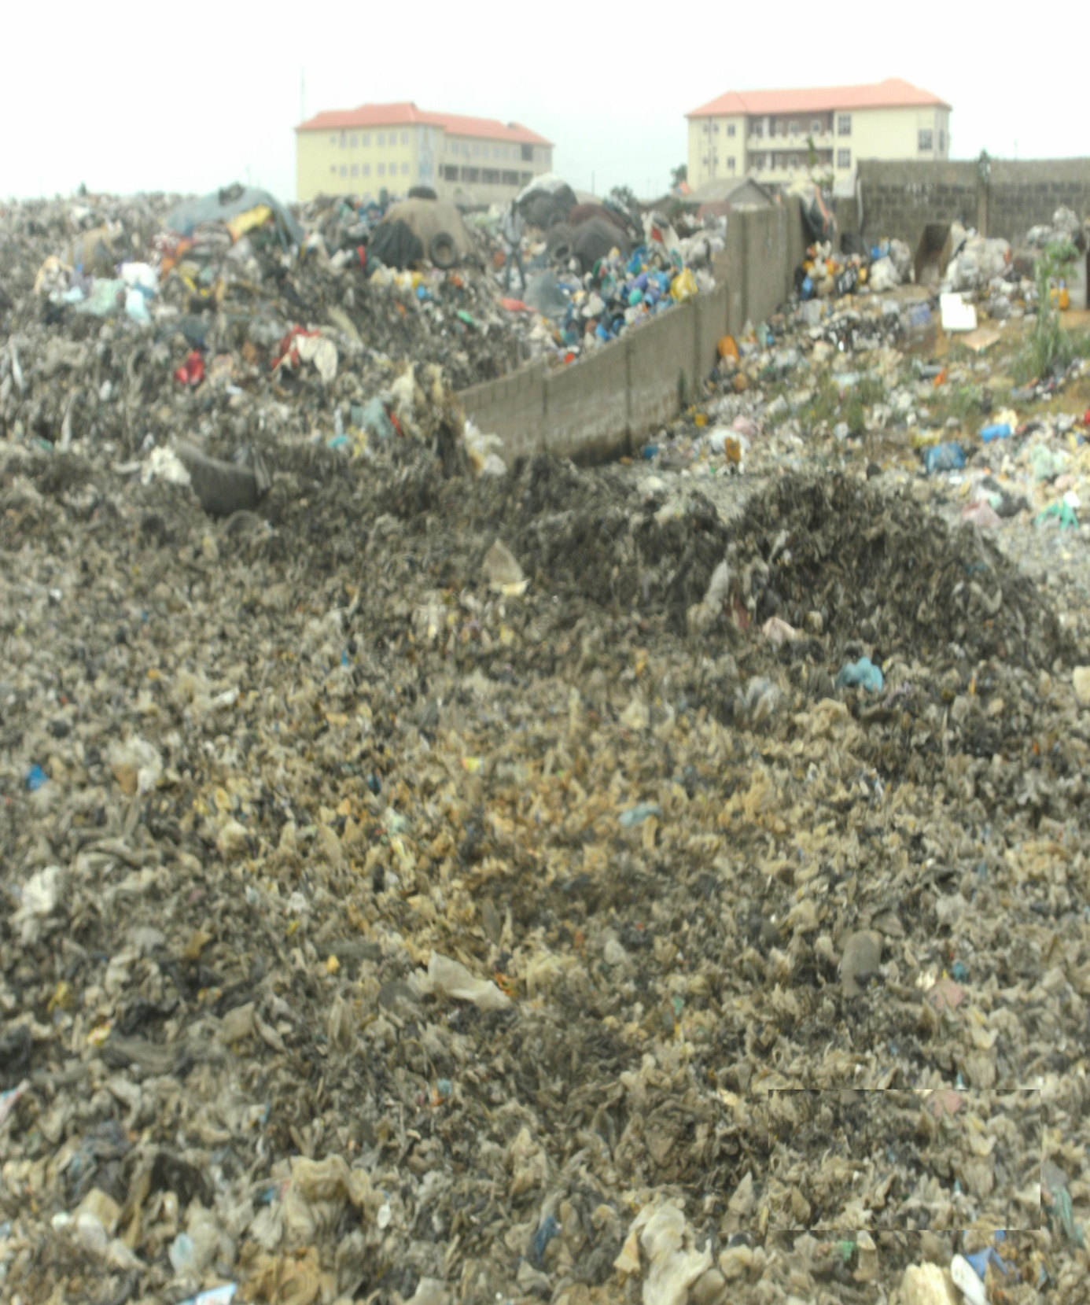
Figure 1: A section of Solous III landfill site in Lagos, Nigeria

In the Neighboring method (Brown and Seagar, 1987) current was applied through neighboring electrodes and the voltage was measured successively from all other adjacent electrode pairs. Here we applied current through electrodes 1 and 2 (Figure 2) and the voltage was measured successively with electrode pairs 3-4, 4-5, 15-16. From these 13 voltage measurements were obtained. All these 13 voltage measurements are independent. The next set of 13 voltage measurements was obtained by feeding the current through electrodes 2 and 3. This continued until current was fed into 16 and 1. For our 16 electrode arrangement, 16×3 = 208 voltage measurement was obtained.

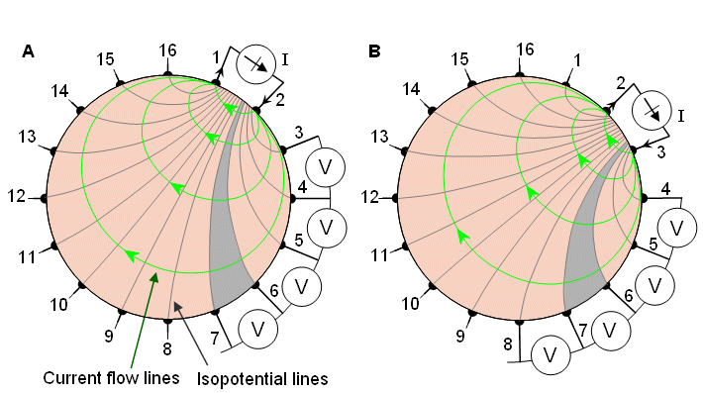

Figure 2: The Neighbouring method of impedance data collection with 16 equally spaced electrodes
(A) The first four voltage measurements for the set of 13 measurements.
(B) Another set of 13 measurements is obtained by changing the current feeding electrodes

Under the Opposite method (Hua et; al, 1987), current is injected through two diametrically opposed electrodes (Figure 3). We first applied current through electrodes 16 and 8. The electrode adjacent to the current –injecting electrode (electrode 1) was used as the voltage reference. Voltage was then measured from all other electrodes except from the current electrode, yielding 13 voltage measurements. The next set of 13 voltage measurements was obtained by selecting electrodes 1 and 9 for current electrodes. This was followed by 2 and 10, 3 and 11,… ,8 and 9. With our 16- electrode arrangement, this method yielded 8 x 13 = 104 data.
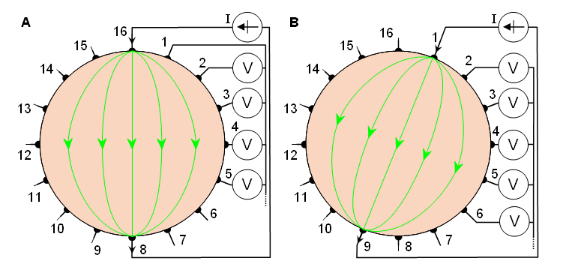
Figure 3: The Opposite method of impedance data collection.

In the Cross method of Impedance measurement (Figure 4) adjacent electrodes were first selected for current and voltage reference electrodes, respectively. Here electrode numbers 16 and 1 were first selected for current and voltage reference electrodes respectively (Hua et; al, 1987). The other current electrode, electrode number 2 was first used. The voltage was measured successively for all other 13 electrodes with electrode 1 as a reference. The current was then applied through electrode 4 and the voltage was again measured successively for all other 13 electrodes with electrodes 1 as a reference. The procedure was repeated using 6, 8, ----14; which gave 7 x 13 = 91 measurements. The measurement sequence was then repeated using electrodes 3 and 2 as current and voltage reference electrodes, respectively. We then applied current first to electrode 5 and then measured the voltage successively for all other 13 electrodes with electrode 2 as a reference. The procedure was again repeated by applying current to electrode 7, 9, 11 ----, 1 and measuring the voltage for all other 13 electrodes with 2 as a reference to obtain another 91 measurements. From the cross method, we obtained a total of 182 voltage measurements.

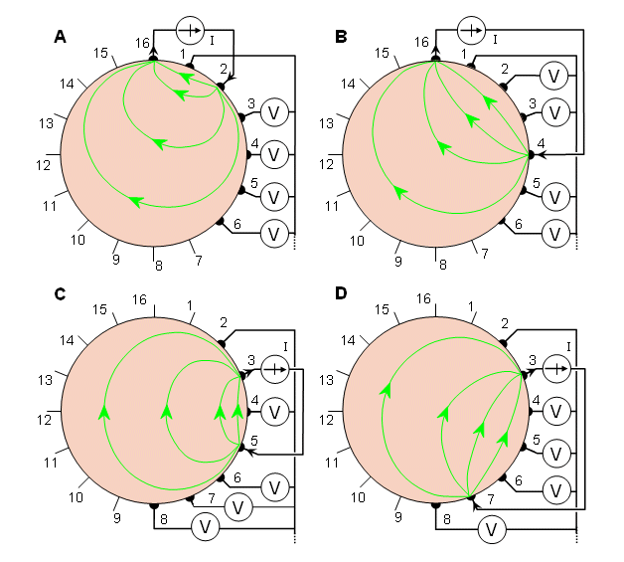
Figure 4: The Cross method of impedance data collection. The four different steps of this procedure are illustrated in A through D.

The same procedure was applied for all the three (3) other profiles which were carried out 15m away on the dumpsite. Because of reciprocity, those measurements in which the current electrodes and voltage electrodes were interchanged yielded identical measurement results. Figure 5 shows the Base map of the study area.

Figure 5: Base map of the study area

2.2. Data Processing and Inversion

The inversion of the EIT data was done using the EIDORS version 3.0 toolkit for MATLAB (Polydorides, 2002; Polydorides and Lionheart, 2002).The toolkit is essential because of the challenges in solving an EIT inversion problem which is nonlinear, ill – posed and is very intensive computationally. The package utilizes a finite element model for forward calculations and a regularized nonlinear solver to obtain a unique and stable inverse solution. It is equipped with a mesh generator, a graphical output and supports three – dimensional EIT systems. However, some modifications were made to the EIDORS package to use it in conjunction to our hardware in this research work. The scheme utilized in this work is a forward solution solved with a mesh of 768 finite elements with 205 nodes as shown in Figure 6. The programme then calculated the linear inverse solution iteratively by using a weighted image prior of the homogeneous solution.

3. Results and Discussion
The scheme utilized in this work is a forward solution solved with a mesh of 768 finite elements with 205 nodes.

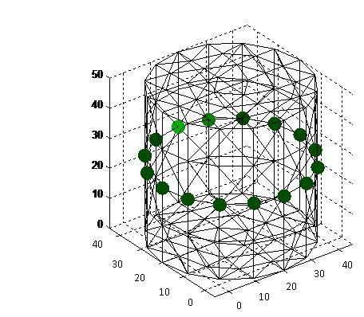
Figure 6: Mesh diagram with 768 elements and 205 nodes

Figure 7-12 show the tomograms of electrical conductivity at four separate locations on the dumpsite. The bs in these figures show contaminant plumes at various depths.

(a)
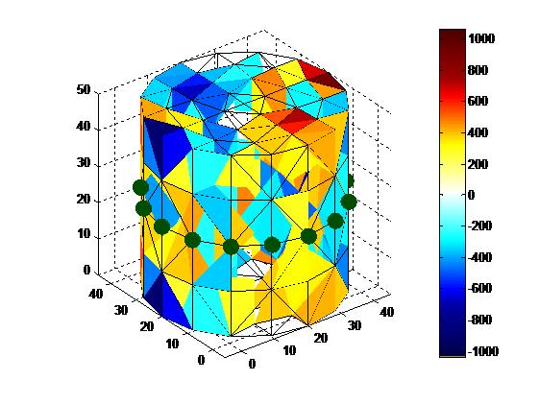
(b)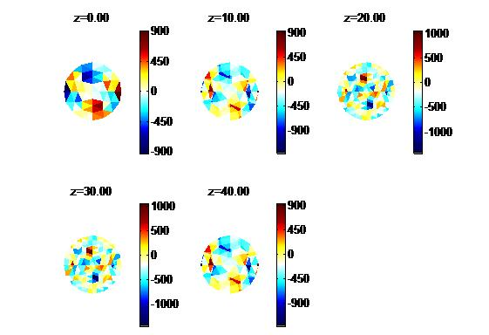
Figure 7: (a) neighbouring method reconstructed conductivity profile 1 (b) contaminant plumes at different depths (in mS/m)

(a)
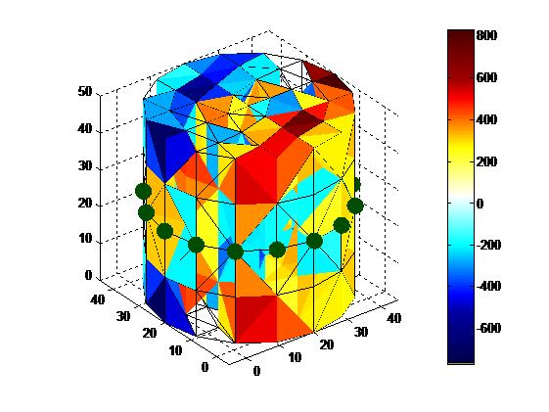
(b)
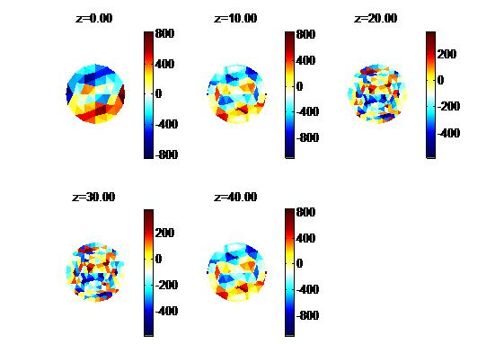
Figure 8: (a) neighbouring method reconstructed conductivity profile 2 (b) contaminant plumes at different depths (in mS/m)

(a)
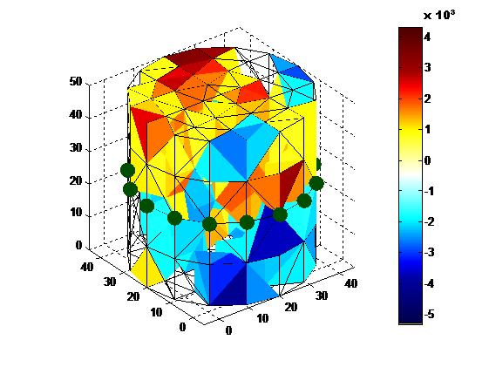
(b)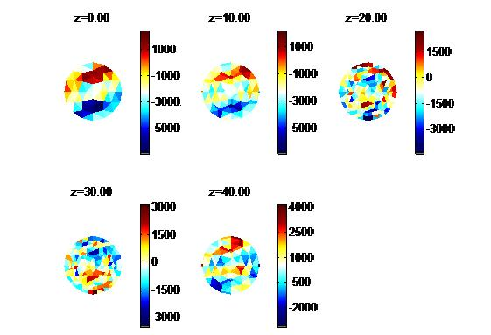
Figure 9: (a) opposite method reconstructed conductivity profile 1 (b) contaminant plumes at different depths (in mS/m)
(a)
(b)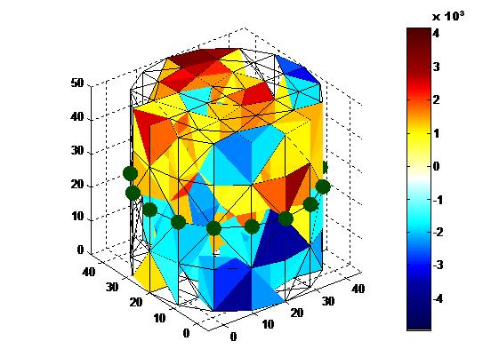
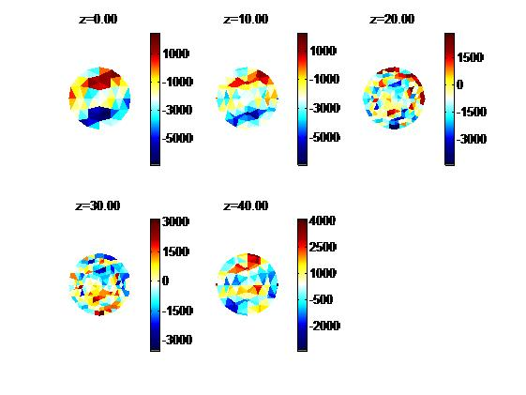
Figure 10: (a) opposite method reconstructed conductivity profile 2 (b) contaminant plume at different depths (in mS/m)
(a)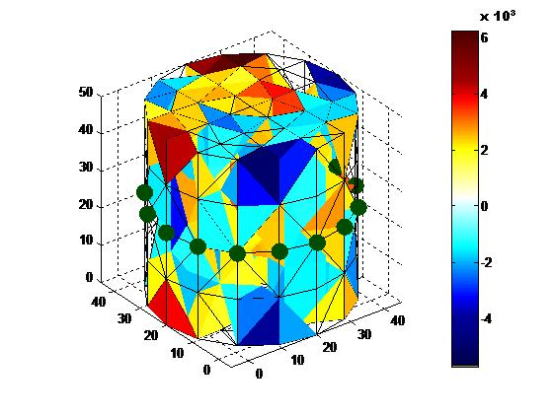
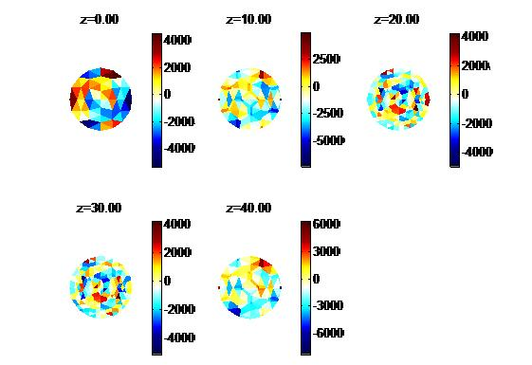
Figure 11: (a) cross method reconstructed conductivity profile 1 (b) contaminant plumes at different depths (in mS/m)
(a)
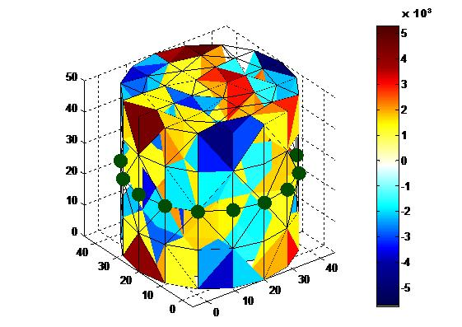
(b)
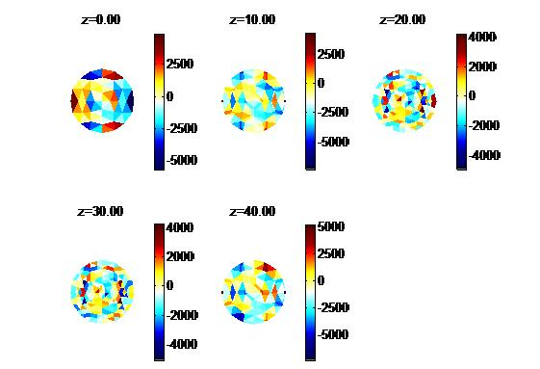
Figure 12: (a) cross method reconstructed conductivity images profile 2 (b) contaminant plumes at different depths (in mS/m)

Figures 7 and 8 are the neighbouring method tomograms at two separate locations (15m apart). It was observed that the highest conductivity value for these figures ranges from 400 mS/m to 1,000 mS/m on both tomograms. These are potential polluted zones or could be due to the presence of clayey materials which may be responsible for protecting the underlying aquifer from leachate invasion from the surface. For these profiles, the dispersion of potential contaminant plume is mainly towards the southeastern part of the tomograms and the potential area of leachate migration could also be observed from the surface of the site and is spreading downstream. The colour scaling changing from light to deep blue with conductivity in the range of -1,000 mS/m to -200 mS/m represents non-contaminant zones which are likely due to landfill gases or as a result of fresh dry waste.
In figures 9 and 10, which are the reconstructed conductivity profiles of the opposite method, we observe a near surface low conductivity response. This may be as a result of landfill gases generated as a result of the anaerobic decomposition of the landfill municipal waste and also as a result of continuous burning being carried out on the landfill site. But at deeper sections of the tomograms from 20m up to 50m depth, there is relative high conductivity response of <1,000 mS/m dominating most of these sections which may be due to clay and lateritic clay materials. Some local higher conductivity response of between 3,000 mS/m to 4,000 mS/m was also observed in some sections of the profiles which may be due to some conductive materials dumped in the waste.
Figures 11 and 12 depict the reconstructed conductivity images of the cross method. They show dispersion of both conductive and non-conductive zones in every section of the profiles up to 50m depth, with varying conductivity values. The non conductive zones are probably due to dispersion of landfill gases which have been displaced to various degrees with respect to depth due to their lower densities to the groundwater and pressure build-up within the landfill site while the conductive zones are probably a mixture of clayey materials and waste, with conductivity value of <2,000 mS/m in most part of the profiles. Some local response of relatively high conductivity of between 4,000 mS/m and 6,000 mS/m were observed on some parts of the tomogram especially in the northern section. This could be as a result of some conductive materials such as iron, lead etc in the dump.
From the results of all the profiles, the opposite and the cross methods have more uniform current density distribution and therefore good sensitivity over the entire region. Background noise is also less in these methods. In the neighbouring method, the measured voltage is at a maximum with adjacent electrode pairs with higher noise level. In this method also, the current is non-uniform and there is low current density and therefore does not yield good sensitivity over the entire region. This is evident in the conductivity values obtained on all the profiles of the neighbouring method which are lower than those obtained on the profiles of the opposite and cross methods. These observations agree with previous studies by Szczepanik and Rucki, 2000, Ruzari et; al, 2003 and Kauppinen et; al, 2006. This shows that the improvements in resolution are dependent on the drive pattern. From this result, it shows that there has not been much impact of leachate on the groundwater at Solous III landfill site. This may likely due to the age of the site which is less than two and half years.
4. Conclusion
The impact of the Municipal Solid Waste at Solous III on groundwater using Neighbouring, Opposite and Cross methods of Electrical Impedance Tomography has been investigated. The study has revealed that there has not been much impact of leachate on the groundwater at the study area. From the results of all the profiles, the opposite and the cross methods have more uniform current density distribution and therefore good sensitivity over the entire region. In the neighbouring method, the measured voltage is at a maximum with adjacent electrode pairs with higher noise level. In this method also, the current is non-uniform and there is low current density and therefore does not yield good sensitivity over the entire region. This is evident in the conductivity values obtained on all the profiles of the neighbouring method which are lower than those obtained on the profiles of the opposite and cross methods. It is however, observed that in the absence of a properly designed leachate collection system, uncontrolled accumulation of leachate at the base of the landfill pose potential contamination risk to groundwater resource in the very near future.
Liner materials are hereby suggested for leachate management in the study area since continuous release of waste in the landfill site could constitute hazards in the nearest future. The need for monitoring should also be considered as top priority by the Lagos State Government of Nigeria.

References
- Aderemi, AO, Oriaku, AV, Adewumi, GA and Otitoloju AA. Assessment of groundwater contamination by leachate near a municipal solid waste landfill. African Journal of Environmental Science and Technology. 2011; Vol. 5(11), 933-940.
- Arienzo, M, Adamo, P, Bianco, MR and Violante, P. Impact of land use and urban run-off on the contamination of the Samo river basin in southwestern Italy. Water Air Soil Pollut., 2001;131 (1-4), 349-366.
- Barrett A and Lawlor J. The Economics of Waste Management in Ireland, Economic and Social Research Institute, Dublin.1995.
- Brown, BH. and Seagar AD. The Sheffield Data Collection System. Clini Phys. Physiol Measurement 8 (Suppl. A). 1987; 91 – 97.
- Cointreau, SJ. Environmental management of urban solid wastes in developing countries: A project guide, Urban Development Dept, World Bank. 1982. http://www.worldbank.org/html/fpd/urban//solid-wm/techpaper5.pdf.
- Doan PL. Institutionalizing household waste collection: the urban environmental management project in Cote d’Ivoire. Habitat Int. 1998; 22(1): 27-39.
- Hua P., Webster, JG., Tanpkins WJ. Effect of the Measurement Method On Noise Handling and Image Quality of EIT Imaging. In Proc. Ninth Int. Conf. IEEE Eng. In Med. And Biol. Society. 1987;Vol. 2, Pg. 1429 – 1430, LEEE, New York, N. Y.
- Ikem, A., Osiobanjo, O, Sridhar, MKC. and Sobande, A. Evaluation of ground water quality characteristics near two waste sites in Ibadan and Lagos, Nigeria. Water, Air and Soil Pollut. 2002; 140, 307-333.
- Jeje, LK.. Aspects of Geomorphology in Nigeria. In. Geography of Nigeria. Heinemann Educational Books, Nigeria. 1983; 17-44.
- Kauppinen, P., Hyttinen, J and Malmivuo, J. International Journal of Bioelectromagnetism. 2006;Vol.8, no 1, VII/1-VII/9.
- Keenan, JD., Steiner, RL., Fungaroli, AA. Landfill leachate treatment. J. Water Poll. Contr. Fed. 1984; 56(1), 27-33.
- Longe EO, Malomo S, Olorunniwo MA. Hydrogeology of Lagos metropolis. J. Afr. Earth Sci. 1987; 6(3):163-174
- Manjunatha, BR.; Balakrishna, K., Shanker, R., Mahalingam, TR. Geochemistry and assessment of metal pollution in soils and river India components of a monson –dominated environment near Karwar, southwest Coast. Environ. Geol. 2001; 40 (11-12), 1462-1470.
- Metheral, P. Three Dimensional Electrical Impedance Tomography of the Human Thorax. Ph.D Thesis University of Sheffield. 1998.
- Olowofela, JA, Akinyemi, OD and Ogungbe, AS. Imaging and Detecting Underground Contaminants in Landfill Sites Using Electrical Impedance Tomography (EIT): A Case Study of Lagos, Southwestern, Nigeria. Research Journal of Environmental and Earth Sciences. 2012; 4(3): 270-281
- Polydorides, N. Imaye reconstruction algorithms for soft-field tomography. Ph.D. Thesis, UMIST.2002.
- Polydorides, N. and Lionheart, WRB. A MATLAB toolkit for three-dimensional electrical impedance tomography; A contribution to the EIDORS Project. Measurement Science and Technology. 2002; 13: 1871 – 1883.
- Ruzairu, AR, Liew, YH, Chan, KS, Pang, JF and Leong, CL. Initial Result on Electrical Impedance Tomography. Jurnal Teknologi. 2003; 39(D) Dis. 105-113
- Speight, JG. Environmental Technology Handbook. Applied Energy Technology Series. Taylor and Francis. 1996
- Szczepanik, Z and Rucki, Z. Frequency Analysis of Electrical Impedance Tomography system. IEEE Transaction on Instrumentation and Measurement. 2000; 49;4.
- United States Environmental Protection Agency (USEPA). Municipal Solid Waste Generation, Recycling and Disposal in the United States: Facts and Figures for 2007, EPA-530-F-08-018. 2008; 12 pp. Retrieved June 28, 2009 from http://www.epa.gov/osw//nonhaz/municipal/pubs/msw07.pdf.

7/28/2012

