Internet in Supply Chain Management: A Review about Indian Companies

Dr. Venkatesh. J¹ ; Aarthy. C²; Thenmozhi. S³; Dr.Balasubramanie. P¹

¹ School of Management Studies, Anna University Chennai, Coimbatore Regional Office, Coimbatore, India
² Scholar in Computer applications, Kongu Engineering College, Erode, India
³ Department of Computer Science and Engineering, Kongu Engineering College, Erode, India
venkijv@gmail.com; mailtoaarthy@gmail.com

Abstract: The dawn of the Internet and e-commerce has empowered companies to be more approachable to their customers. Though, the uses of the same technical innovations in business-to-business supply chain management are altering the marketplace itself. Effective supply chain management entails a change from handling discrete functions to assimilating events into the significant supply chain process. The benefits are far more than the efforts involved in accessing the final product, a unified chain that controls gracefully and aids the perfect value chain by brief up communication between customers and their suppliers, refining service quality, and decreasing costs. In this article, the author confers how the Internet is being used in the supervision of various areas of supply chain by Indian companies.
[Venkatesh. J ; Aarthy. C; Thenmozhi. S; Balasubramanie. P. Internet in Supply Chain Management: A Review about Indian Companie. N Y Sci J 2012;5(11):7-10]. (ISSN: 1554-0200). http://www.sciencepub.net/newyork. 2

Keywords: internet, supply chain, vendor order, transportation, order processing

1. Introduction
Recent advances in technology, including the Internet and the World Wide Web has expanded the scope of business. Nowhere have these variations been more apparent than in supply chain functions. Supply chain management has stimulated from a low profile, supplementary concern to a familiar strategic component with concrete, positive impact on the organization’s extremity. Manufacturing is giving way to assembling on shop floors since firms no longer find it either reasonable or quality smart to be integrated. At the same time, another main ailment is taking place in all industries around the world: the appearance, in the post-net economy, of the real global marketplace. This is turnoff the predictable insight of supply chain management upside down in many incidents. In the past, a great supply chain intended long term affairs with vendors, with the firm and the supplier working together to progress proposal, lift quality, reduce costs, and stake the benefits.
Supply chain managers have been spending in labor demanding countries with low cost business origins. But, even there, the hypothesis was that the associations are meant to be elongated. But now, it has converted faster, low-cost and, by inference, smarter to shop generally, using the Net. The supplier could be dissimilar each time since assessing of Net-based contacts is becoming supple, being determined more by demand and supply at the definite time you want to make your purchase fairly by any fixed-pricing strategy on the part of the vender. The Internet hysteria affected more than just technologically skilled individuals. Many companies observed the Internet as a new, inert channel for reaching a focused and desirable market segment. However, providing too diminutive information or presenting it in an uninspired manner, could turn off potential customers. Conversely, providing too much data could be devastating and result in time-consuming searches. Failure to keep the site rationalized could also reduce its efficacy. As companies were considering the Internet as a marketing tool, something happened to their internal IP (Internet Protocols) Wide Area Networks (WANs). They instigated into “intranets”. Users once adapted to gathering the related information available on the Internet’s World Wide Web, also initiated to experiment with developing and publishing their own Web content.
The consequence of these two factors is that the supply chain can no longer be the warily refined, long-term relationship-driven construct that it needed to be. As an alternative, finding the right supply chain, given your deliberate needs, will be a persistent matter of choosing the right possibilities from a list of options which is itself in a constant state of change. Few tasks are tougher, mostly since this will not allow you to abandon past performs like just-in-time supplies or collective design. That’s why race in tomorrow’s markets will, essentially, be a smash between competing supply chains clearing up why your supply-chain can be a source of reasonable. Competitive advantage flows from the capability of a company to achieve events on the industry’s value chain planning, or manufacturing, or repairing, for instance - in a way that offers greater worth to the customer than those of participants. In this reviewed value chain, major value addition is done not by the producer and the marketer, but by those who fund the machineries and raw material. A car manufacturer, thus, cannot expect to offer value to its customers from the way that it assembles its vehicles. Instead, it must ensure that its suppliers perform their tasks such that the specific component that each manufactures can offer greater value to the customer. So, the accumulation of the exclusive customer value that a firm can extract from its entire supply chain can provide it with a decisive advantage.

2. Supply Chain Development
The supply chain has developed, at a slow pace, over the years. The individual parts of the supply chain were established first. Initially, the supply chain for conveyance module was developed and later on this development process incorporated warehousing, end products inventory, materials management, packaging, customer service procuring, and finally, raw materials portfolio. The objectives of the Supply Chain development method were speckled, e.g. cost minimization, amplified levels of provision, increased flexibility in terms of conveyance and response time, and enhanced communication among supply chain firms. The capability of the companies to realize these goals have remained partial, in the last four spans, because the communication and data associations in the prevailing supply chains were not able to appeal together all of the vital databases. Also, firms up the supply chain were less eager to share data, with each other. This was due to a range of factors like risk of losing customers to opponents, the alleged threat of giving away reasonable gain to other firms, and the allocation of subtle information such as account levels and assembly schedules with other channel members. But the condition is changing now. This transformation is due to a range of factors, which include just-in-time programs, electronic data swap, and point-of-sale data distribution platforms.
2.1 How the Supply Chain is changing:
Consequence of Web:
(1)Early pricing is giving way to public sale centered order for the best price.
(2)Tracking is becoming comprehensive as contractors all over the world sell on the Net.
(3)Long-term conglomerates with salespersons are making room for deal-to-deal affairs.
(4)Consumers are being enforced to ample with one another to safe the best and low-priced suppliers.
Outcome of Policy:
(1) If customization is the differentiator, suppliers must be chosen for their adaptability.
(2)When customer-preferences are fast shifting, the supply chain has to be quicker and supple.
(3)Companies in established markets are building extensive supply-chains and only labeling the invention.
(4)Firms that complete on cost in the market place are assessing dealers on the basis of value.
Consequence of Excellence:
(1)Consumers are describing quality values that the whole supply chain must come across.
(2)Dealers are compatible to their buyer's JIT and lean manufacturing systems.
(3)Producers are associating their salespersons in defining strategies and product provisions upfront.
(4)Companies that contest on cost in the market are gathering dealers on the basis of cost.
Effect of Cost Controlling:
(1)Demand prediction tools are being used to micro-tailor missions for provisions.
(2)Records are being destroyed as companies are obtaining on a need-based system.
(3)Producers are setting objective costs for their dealers as a substitute of asking for prices.
(4)Firms are serving their wholesalers lower their manufacture costs so as to pay lesser prices.

3. Purpose of the Study
In order to regulate to what level Indian firms are using the Internet in the processes and administration of their supply chains, we accompanied a review of firms that appeared in the list of few companies published by a leading business daily in India. The objectives of the study were to determine: whether firms use the Internet in their supply chains; how and to what level the Internet is used in buyer service; how and to what extent the Internet is use in procuring to what extent the Internet is castoff in material management systems; to what extent the Internet is employed in the conveyance processes and management of shipping fleet.

4. Methodology
Few concerns that seemed in the list of 500 companies collected from a leading magazine were sent an e-mail questionnaire. The research questionnaire enclosed all features of supply chain management. On the whole 120 completed forms were returned via e-mail, though this is pretty low response rate, the number of yields may be reimbursed by the extreme heterogeneity of the businesses and companies signified by the defendants. Apart from the major supply chains decision areas, the questionnaire also addressed Extranet and Intranet usage. All of the supply chain scopes addressed in the questionnaire were examined using cross tabulation and percentage analysis. Internet, extranet, and intranet convention was also explored by conflicting the size of the firm.

5. Findings
A total of 60 per cent of the respondents specified using the Internet in some part of their supply chain management. This result should be observed with cautiousness due to the self-selection bias intrinsic in this type of survey. The firms who use the Internet for SCM, the most prevalent application was for the management of their conveyance systems. The Internet was least used in the area of inventory management. The research exhibited that the most popular use of the Internet for SCM is in order handling, followed by production planning, procurement, customer service, coordination with vendors and transportation, (Fig.1). This is explained by the level of functional activity in each area, i.e. shipment frequency, the number of orders received, and the level of expenses made by firms to support each one.
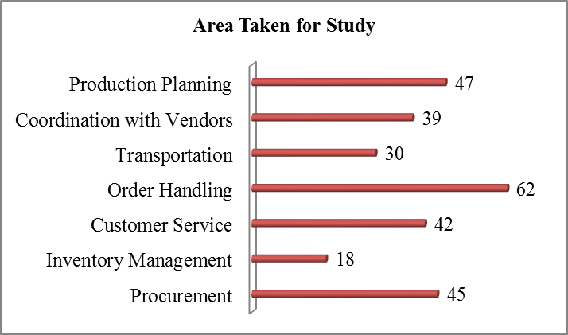
Figure.1 Factors for Review
The use of the Internet in buyer service, inventory management, and production planning and scheduling will become more popular as the technology develops. Few aspects which are considered for study are depicted in Table 1. The study proves that the Internet is employed in a variety of procurement applications including the communication with vendors, inspecting vendor price quotes, and purchases from vendor directories. Among the above mentioned factors proper communication with vendors plays a vital role (39%). One of the most costly aspects of supply chains is the management of inventory.

Table 1: Aspects for Study
VARIOUS ASPECTS FOR STUDY | % OF USAGE
Communication with vendors | 39
Stock Out | 34
Customer Complaints | 33.6
Backup Notices | 31.9
Online Purchase | 33
Receiving Queries from Vendors | 26.4
Dispensation of Yield and Impaired Goods | 22.5
Production Planning | 41
Schedules with Overseas | 18.6
Intranet Usage | 60.4
Extranet Usage | 42

The research has shown that the most popular use of the Internet in this area is the announcement of stock-outs by clients to vendors, or the report of stock-outs by businesses to their clients (34%). The broad benefit of the Internet to companies in controlling inventory in their supply chains is to hold portfolio levels low, diminish overall holding costs, and still offer high levels of customer service. The research showed that the inspecting on time arrivals is the utmost prevalent application of the Internet in this area of conveyance. This permits transportation managers to make sure that the engine carriers they use are meeting their sworn arrival times.
The foremost common use of the Internet in supply chains is in order handling applications (Fig.2). The most frequent use of the Internet here is in order placement and order status (42%). Majority of the firms use the Internet for this drive. This has totally minimized the costs of order processing, which before the Internet accounted for roughly 15 per cent to 22 per cent of the total cost of managing a supply chain system. The drop in order-cycle time, or the time within the orders is placed and the time it is acknowledged by a customer has been reduced to great extent. The study revealed that the most recurrent rate of usage of the Internet in order handling was accuracy of pricing (36 %) with the skill to check seller prices on-line formerly an order is placed. The Internet widely provides the customers with the skill communicate the firm regarding services issues. The study shows that 33.6 % of the companies use the Internet to collect customer complaints, while 31.9 % consume it for backup notices. The inclusive effect has led to reduced response times and perseverance of customer service difficulties.

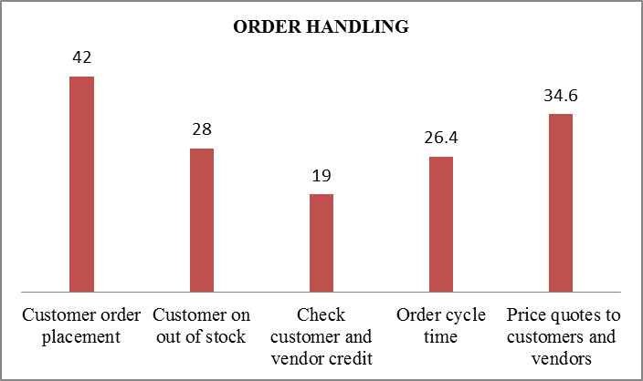
Figure.2: Order Handling

The Internet has proven itself to be an important communication link with vendors. The study showed that the prevalent use of the Internet vendor relationship is in purchasing from on-line catalogs (33 %), receiving queries from vendors (26.4 %), and the dispensation of yield and impaired goods (22.5 %) were all controlled by the Internet. The Internet has facilitated Indian companies to reduce the trouble in their production scheduling by refining a proper channel between sellers, companies and customers, this plays second predominant role in usage of internet in SCM. The study showed that 41 per cent of the firms are beginning to use the Internet to synchronize their production plans with their vendors. This message is not only done internally, but worldwide as well, with over 18.6 per cent of the firms directing their assembly schedules with multiple overseas spots. The study showed that 60.4 per cent of the companies specified they use an intranet for communication purposes. The use of an extranet was also discovered, with 42.1 per cent of those using the Internet for SCM demonstrating that they also use an extranet. Substantial results for those using an extranet comprised those in inventory management results where extranet users were more likely to use the Internet to communicate with customers on out-of-stock; those who were more likely to notify customers on order shipping delays. Those who used the extranet were also more likely to use the Internet for scheduling pickup at regional distribution centers; receive customer complaints; and receive information queries from vendors.

6. Conclusion:
The beginning of the Internet has altered industries and redefined the rules of rivalry. The ancient rules still exist, but they have also given way to new channels and info mediaries, and transformed the nature of affairs between industries and between businesses and their clients. Given current trends the Internet’s impact will continue to grow into the predictable future as businesses work together with dealers and associates; source, produce and dispense products and services worldwide. The Internet will persist to offer managers with fast and exact information from a wide range of operational areas including transport, inventory, procuring, customer service, production planning, order processing, and vendor operations to enable them to develop productivity of their supply chain. On a persistent basis, the Internet will enable logistics managers to screen their supply chain tasks and reduce costs when inadequacies arise. The effects of this will continue to affect the profitability of firms dramatically.

REFERENCES
[1] Bowerson, D.J. and Daugherty, P.J. (1995), “Logistics paradigms: The Impact of Information Technology”, Journal of Business Logistics, Vol. 16 No. 1, pp. 65-80.
[2] Business Today (1999 a), “The e in e-commerce Will Go Away”, Business Today, 7 December, pp. 105-11.
[3] Business Today (1999b), "The New supply Chain Management", Business Today, 7 December, pp. 86-99.
[4] Business Today (2000b), "b2b in India? It's different", Business Today, 6 October, p. 78.
[5] Deeter-Schmetz, D.R., Bizzari, A., Graham, R. (2001), “Business-to-business online purchasing: Suppliers Impact on Buyer’s Adoption”, Journal of Supply Chain Management, Vol. 37, pp. 4-10.
[6] Fliedner, G. (2003), "CPFR: an emerging supply chain tool", Industrial Management & Data Systems, Vol. 103 No. 1, pp. 14-21.
[7] Harvey, M.G. and Richey, R.G. (2001), “Global supply chain Management”, Journal of International Management, Vol. 7 No. 2, summer, pp. 105-28.
[8] Kehoe, D. and Boughton, N. (2001), "Internet based supply chain management: a classification of approaches to manufacturing planning and control", International Journal of Operations & Production Management, Vol. 21 No. 4, pp. 516-25.
[9] Lee, HI, Padmanabhan, V. and Whang, S. (1997), “Information distortions in a supply chain: the bullwhip effect”, Management Science, Vol. 43 No. 4, pp. 546-58.
[10] Reynolds, J. (2000), “E-commerce: a critical review”, International Journal of Retail & Distribution Management, Vol. 28 No. 1, pp. 417-44.
[11] Venkatesh. J and Aarthy. C, “An Innovative Surge of Internet and Extranet Strategy”, Global Journal of Arts and Management (GJAM), Volume 2, Issue 1, March 2012, ISSN: 2249-2658 (Online): 2249-264X (Print), pp. 61-65.
[12] Williams, L.R., Esper, T.L. and Ozment, J. (2002), "The electronic supply chain: its impact on current and future structure of strategic alliances, partnerships and logistics leadership", International Journal of Physical Distribution & Logistics Management, Vol. 32 No. 8, pp. 703-719.

9/1/2012

