Climatic Changes and Their Impact on the Behaviour of Some Maize Varieties in Egypt

Samia, M., El-Marsafawy¹; M. K. Hassanein²; H. El-Ramady³ and Namait Allah, Y. Mokhtar¹.

¹Soil, Water and Environment Research Institute (SWERI), Agricultural Research Center (ARC).
²Central Laboratory for Agricultural Climate (CLAC), ARC.
³Faculty of Agriculture, Kafr El-Sheikh University.
samiaelmarsafawy797@hotmail.com

Abstract: This study employed the DSSAT and CropWat simulation models to measure the adverse impacts of climate change on some maize varieties in Egypt. Field experiments were done at different agroclimatological zones in 2009 and 2010 seasons to calibrate and validate the model. Changing planting dates, excess or deficit irrigation water amounts, changing interval days between irrigation and skipping irrigation at different growth stages were studied under future climatic changes. Simulations were carried out on data covering 25 - 30 years under the normal weather conditions and climate change conditions. Results of maize simulation studies indicated that climate change could decrease national production of maize crop ranging between 40 to 44 % at Gemmiza area, 12 to 27 % at Sids area and 43 to 47 % at Mallawy area. The highest sensitive variety was found for V₆ (-47 %) under Mallawy conditions which declining productivity from 12780 kg/ ha (under current conditions) to 6820 kg/ ha (under future climatic changes). However, the highest tolerant variety was obtained for V₃ (-12 %) under Sids conditions which dropped from 7340 kg/ ha to 6451 kg/ ha. Results indicated also that increasing temperature 1.5°C increased maize water consumption around 3.5 %, and 8.5 % with a 3.5°C increase. Regarding adaptation strategies, results showed that select appropriate variety with optimum sowing date for the region can achieve maximum benefit from this variety. In this connection, the suitable varieties which can be used under future climate are V₆ at Gemmiza area with sowing date of 20th May, V₄ at Sids area with sowing date of 10th May and V₂ at Mallawy area with sowing date of 1 May. In addition, shortening interval days between irrigation without increasing in total amounts of irrigation water applied under future climate change conditions will lead to reduce the negative impact of climate change on productivity of different maize varieties. Also, increasing amount of irrigation water applied 10 % could achieve the same result. However, skipping irrigation at different growth stages may be resulted in more reduction in grain yield with all varieties and areas under study.
[Samia, M., El-Marsafawy; M. K. Hassanein; H. El-Ramady and Namait Allah, Y. Mokhtar. Climatic Changes and Their Impact on the Behaviour of Some Maize Varieties in Egypt. N Y Sci J 2012; 5(11):83-99]. (ISSN: 1554-0200). http://www.sciencepub.net/newyork. 14

Key words: Climate change, adaptation, maize varieties, agroclimatological zones, irrigation water.

This study is a part of the project under the title of "Climate change risk management in Egypt" UNJP/EGY/022. This project was funded from FAO and IFAD.

1. Introduction
Climate change has the potential to affect agriculture through changes in temperature, rainfall (timing and quantity), CO₂, solar radiation and the interaction of these elements (Chrispeels and Sadava, 1994, Fraser, 2009). Agriculture can both mitigate and worsen global warming. Some of the increase in CO₂ in the atmosphere comes from the decomposition of organic matter in the soil, and much of the methane emitted into the atmosphere is caused by the decomposition of organic matter in wet soils such as rice paddies (Brady and Weil, 2002a). Further, wet or anaerobic soils also lose nitrogen through denitrification, releasing the greenhouse gasnitric oxide (Brady and Weil, 2002b). Changes in management can reduce the release of these greenhouse gases, and soil can further be used to sequester some of the CO₂ in the atmosphere. (Brady and Weil, 2002a).
Climate change may affect food systems in several ways ranging from direct effects on crop production (e.g. changes in rainfall leading to drought or flooding, or warmer or cooler temperatures leading to changes in the length of growing season), to changes in markets, food prices and supply chain infrastructure. (Gregory et al. 2005).
The impacts of climate change on agriculture activities have been shown to be significant for low input farming systems in developing countries in Africa (Rosenzweig and Parry, 1994; McGuigan et al.,2002). Furthermore, tropical regions in developing countries are usually characterized by poor marginal soils that cover extensive areas, making them unusable for agriculture, leaving the developing countries particularly vulnerable to potential damage from environmental changes (Mendelsohn and Dinar, 1999).
Abou Hadid (2009) indicated that food security in the Arab world has experienced a long history of environmental and socio-economic pressures. The dominant arid conditions, limited water resources, erratic cropping patterns, low knowledge and technology levels are the main factors presently affecting food production systems in the Arab world. Most recent assessments have concluded that arid and semi-arid regions are highly vulnerable to climate change (IPCC, 2007a). On the other hand, at a high level conference of the Food and Agriculture Organization (FAO) held in Rome in June 2008, the delegates asserted that agriculture is not only a fundamental human activity at risk from climate change, it is a major driver of environmental and climate change itself. The projected climatic changes will be among the most important challenges for agriculture in the twenty- first century, especially for developing countries and arid regions (IPCC, 2007a).
By the end of the 21st century, the Arab region will face an increase of 2 to 5.5ºC in the surface temperature. This increase will be coupled with a projected decrease in precipitation up to 20%. These projected changes will lead to shorter winters and dryer summers, hotter summers, more frequent heat wave occurrence, and more variability and extreme weather events occurrence (IPCC, 2007b).
Egypt appears to be particularly vulnerable to climate change, because of its dependence on the Nile River as the primary water source, its large traditional agricultural base, and its long coastline, which is already undergoing both intensifying development and erosion (Rosenzweig& Hillel, 1994).
Enhancement of adaptive capacity is a necessary condition for reducing vulnerability, particularly for the most vulnerable regions, nations, and socioeconomic groups. Activities required for the enhancement of adaptive capacity are essentially equivalent to those promoting sustainable development. Climate adaptation and equity goals can be jointly pursued by initiatives that promote the welfare of the poorest members of society- for example, by improving food security, facilitating access to safe water and health care, and providing shelter and access to other resources. Development decisions, activities, and programs play important roles in modifying the adaptive capacity of communities and regions, yet they tend not to take into account risks associated with climate variability and change. Inclusion of climatic risks in the design and implementation of development initiatives is necessary to reduce vulnerability and enhance sustainability (IPCC, 2001).
In the same direction, Eid and EL-Marsafawy (2002) studied vulnerability and adaptation of climate change on some main crops in Egypt. They found that climate change could decrease national production of many crops (ranging from-11% for rice to -28% for soybeans) by the year 2050 compared to current production. At the same time, water needs for summer crops will be increased up to 16 % for rice by the year 2050 compared to their current water needs.
The simulation studies considered on-farm adaptation techniques such as use of alternatives existing varieties and optimization of the timing of planting, increasing water and/or nitrogen fertilizer amounts as well as modifying plant population in the field, fortunately these on-farm techniques that may imply few additional costs to the agricultural system, can partially up to completely compensate for the yield losses or increase more the benefit in case of cotton crop improvement with the warmer climate. They may also improve the crop water-use efficiency. In general, there are crop changes that can be considered as adaptation alternatives to climate change. The recent policy of crop liberalization is giving the farmers the possibility of adapting to more suitable crops in each area
Eid et al. (2006) evaluated the potential impact of climate change on crop seasonal evapotranspiration (ET) using the CROPWAT model. Wheat, maize and cotton were selected for the study since they represent different growing seasons and water needs. The evaluation was carried out in the three main agricultural regions of Egypt: Nile Delta (Lower Egypt), represented by Kafr El-Sheikh Governorate; Middle Egypt, represented by Giza Governorate; and Upper Egypt represented by Sohag Governorate. According to the study, the effect of climate warming on the water use of wheat, maize and cotton increased in the three selected locations. Wheat evapotranspiration increased by about 10.8%, 11.4% and 10.3% for Kafr El-Sheikh, Giza and Sohag, respectively, compared with the current conditions; maize evapotranspiration by 7.8%, 7.8% and 8.0% for these three regions respectively; and cotton evapotranspiration by 8.4% and 7.6% for Kafr El-Sheikh and Sohag respectively. At the same time, increasing temperature under climate change simulations caused some yield reduction, particularly at the third growth stage with the summer crops (maize and cotton).
The study objectives follow the general objectives as set by FAO and IFAD project "Climate change risk management" UNJP/EGY/022. These redefined objectives are as follows:
- Impact of climate change on some main food crops in Egypt.
- Calibration and validation tests for the crop under study.
- Simulation of the impact of climate change on the crop productivity through the data covering 25 - 30 years under the normal weather conditions and climate change conditions.
- Mitigate the potential effects of climate change on crop yield through adaptation strategies.
2. Methods
Vulnerability studies (Simulation studies):
Vulnerability studies were made to assessment the potential impacts of climate change on crop yield and water consumptive use (crop evapotranspiration, ETcrop). The potential impact of climate change on the yield and ETcrop were carried out through DSSAT3.5 models and CropWat4.3 model, respectively.
Input data
Climatic data and climate change scenarios
Daily maximum and minimum temperatures, precipitation, and solar radiation for Lower Egypt (Nile Delta), represented by Gemmiza and Sakha areas (1975 to 1999) and Middle Egypt, represented by Mallawy and Sids areas (1960 to 1989) were used to simulate the impact of climate change on maize varieties in Egypt. All data were collected from Soil, Water & Environment Res. Institute, SWERI, and Central Laboratory for Agricultural Climate, CLAC, ARC, Ministry of Agriculture, unpublished data).
Using 2GCMs, the observed climate data were modified to create climate change scenarios. The general circulation models (GCMs) were developed by the Canadian Climate Center Model (CCCM) (Boer et al., 1992) and the GFD3 model from the Geophysical Fluid Dynamic Laboratory (Manabe and Wetherald, 1987) were used. The Intergovernmental Panel on Climate Change (IPCC) Technical Guidelines for Assessing Climate Change Impacts and Adaptations endorse this approach (IPCC, 1994). The two equilibrium general circulation models used in this study to create the climate change scenarios at the high level end of the IPCC range (1.5ºC to 3.5ºC).
Crop models
Crop yield was estimated with the CERES-Maize model(Ritchie et al., 1998) imbedded in the Decision Support system for Agrotechnology Transfer DSSAT3.5 (Tsuji et al.,1998).
Calibration and validation sites
The CERES models were validated by comparing measured data (field data) of maize crop; flowering date, grain yield (kg/ ha), number of grain/ m², number of grains/ ear to simulated values (predicted values by the model) to calibrate and validate the models to the conditions of the study.
Crop water Use
Water consumptive use or Evapotranspiration (ETcrop) for maize crop was determined using a computer program named CROPWAT4.3 model (Derek et al., 1998).
Adaptation Studies
Studies of adaptation strategy evaluation to climate change were carried out using DSSAT3.5 simulation model. To identify appropriate crop management strategies, maximize benefits and minimize risks associated with maize crop production, the following treatments were suggested:
- Sowing dates: To select the optimum sowing date under climate change conditions, four sowing dates in addition to the base sowing date have been tested, these are:
- Base sowing date (6th June at Gemmiza and Mallawy and 28th May at Sids areas).
- Sowing on 1st May
- Sowing on 10th May
- Sowing on 20th May
- Sowing on 10th June
- Irrigation water amounts: To determine the impact of excess or deficit irrigation under future climate the following treatments were examined:
- Base amount
- Base amount -5%
- Base amount +10%
- Base amount +5%
- Fixed interval days between irrigation: To identify the optimum interval days between irrigation, four treatments tested using the same amount of applied irrigation water under current conditions, these are:
- Base treatment (irrigation every 14 days)
- Irrigation every 8 days
- Irrigation every 12 days
- Irrigation every 16 days
- Irrigation every 20 days
- Skipping one irrigation at different growth stages: To predict the reduction of yield under different water deficit at different growth stages, and determined the stages are more vulnerable to water deficit, following treatments were studied:
- Base treatment (without skipping).
- Skipping the second irrigation (life irrigation).
- Skipping the third irrigation.
- Skipping the fourth irrigation.
- Skipping the fifth irrigation.
- Skipping the sixth irrigation.
- Skipping the seventh irrigation.
- Skipping the eighth irrigation.

3. Results and Discussion
Crop model validation
The results of the validated experiment presented in Tables 1-3 indicated that the observed data (measured data or field data) of flowering date, grain yield (kg/ ha), number of grains/ m², and number of grains/ ear were very close to the corresponding simulated values (predicted values). According to these results, CERES-Maize model is validated for the conditions of the study and could be used correctly to find out the impact of climate change on crop yield at the selected sites.
Vulnerability studies (Simulation studies):
The potential impacts of climate change on maize crop were evaluated by simulating crop productivity and ETcrop (crop evapotranspiration or water consumption) under different climatic scenarios.
Yield under GCM climate scenarios
Results as presented in Tables 4 – 6 indicated that the two climate change scenarios considered resulted in simulated decrease in maize yield varieties at the selected sites. The change percent in maize grain yield at Gemmiza area reached about -41, -44, -44, -43, -44, and -40 % for V₁ up to V₆, respectively (Table 4). The results show also that the most sensitive varieties to high temperature under future climate were found for V₂, V₃ and V₅. However, the variety of V₆ showed carrying relatively higher temperature increase compared to other varieties.
As to Sids area, results of simulation studies as tabulated in Table 5 that the six varieties under study decreased under future climatic changes compared to current conditions. The reduction in yield ranged between 12 to 27 %. The highest reduction was registered for V₆ (-27 %) and the lowest one was found for V₃ (-12 %). Meanwhile, the results showed that despite the decrease in the productivity of V₄ reached about 13%, this variety registered the highest yield, so, it can therefore be recommending cultivation of this variety under future climate conditions at Sids area.
With respect to Mallawy area, results as presented in Table 6 illustrated that future climatic changes could decrease maize grain yield at Mallawy area ranging between 43 to 47 %. The highest and lowest reduction percent was found for V₆ and V₁, respectively. Results indicated also that, the superior variety was found for V₂ (7691 kg grains/ ha), which increased by 10.3, 7.3, 11.5, 3.5 and 12.8 % as compared with V₁, V₃, V₄, V₅, and V₆, respectively.

Table 1: Results of Calibration / validation test of maize varieties at Gemmiza area.
Variable | Varieties*
Variable | V₁ |  | V₂ |  | V₃ |  | V₄ |  | V₅ |  | V₆
Variable | Predicted | Measured | Predicted | Measured | Predicted | Measured | Predicted | Measured | Predicted | Measured | Predicted | Measured
Flowering date | 63 | 60 | 63 | 61 | 63 | 61 | 63 | 61 | 63 | 61 | 63 | 62
Grain yield | 12296 | 12290 | 11246 | 11250 | 11652 | 11660 | 11821 | 11800 | 10840 | 10870 | 12875 | 12850
Grain no. | 3599 | 3694 | 3340 | 3224 | 3340 | 3836 | 3340 | 3963 | 3340 | 3774 | 3645 | 3519
Grains/ ear | 631 | 623 | 586 | 544 | 586 | 618 | 586 | 626 | 586 | 643 | 640 | 648
*Varieties
V₁: SC10 V₂: SC120 V₃: SC122 V₄: SC123 V₅: SC124 V₆: SC129

Table 2: Results of Calibration / validation test of maize varieties at Sids area.
Variable | Varieties*
Variable | V₁ |  | V₂ |  | V₃ |  | V₄ |  | V₅ |  | V₆
Variable | Predicted | Measured | Predicted | Measured | Predicted | Measured | Predicted | Measured | Predicted | Measured | Predicted | Measured
Flowering date | 66 | 66 | 66 | 65 | 66 | 68 | 66 | 65 | 66 | 63 | 62 | 62
Grain yield | 8435 | 8480 | 7943 | 7950 | 7336 | 7340 | 8525 | 8520 | 7413 | 7410 | 8458 | 8460
Grain no. | 2459 | 3694 | 2510 | 3224 | 2238 | 3836 | 2541 | 3963 | 2431 | 3774 | 2466 | 3915
Grains/ear | 431 | 623 | 440 | 544 | 393 | 618 | 446 | 626 | 627 | 643 | 433 | 648
*See footnote in Table 1.

Table 3: Results of Calibration / validation test of maize varieties at Mallawy area.
Variable | Varieties*
Variable | V₁ |  | V₂ |  | V₃ |  | V₄ |  | V₅ |  | V₆
Variable | Predicted | Measured | Predicted | Measured | Predicted | Measured | Predicted | Measured | Predicted | Measured | Predicted | Measured
Flowering date | 65 | 63 | 65 | 62 | 65 | 62 | 65 | 62 | 65 | 61 | 65 | 60
Grain yield | 12108 | 12150 | 14132 | 14100 | 13403 | 13350 | 12957 | 12880 | 13666 | 13750 | 12747 | 12780
Grain no. | 3261 | 3224 | 3713 | 3750 | 3718 | 3750 | 3718 | 3323 | 3718 | 3249 | 3718 | 3421
Grains/ear | 572 | 572 | 651 | 651 | 652 | 651 | 652 | 577 | 652 | 581 | 652 | 600
*See footnote in Table 1.

Table 4: Simulation of maize grain yield under climate change conditions compared to current conditionsat Gemmiza area.
Maize varieties | Current Conditions (season 2009) | Climate change | Change %
V₁ | 12290 | 7305 | -41
V₂ | 11250 | 6322 | -44
V₃ | 11660 | 6545 | -44
V₄ | 11800 | 6690 | -43
V₅ | 10870 | 6099 | -44
V₆ | 12850 | 7668 | -40

Table 5: Simulation of maize grain yield under climate change conditions compared to current conditions at Sids area.
Maize varieties | Current Conditions (season 2009) | Climate change | Change %
V₁ | 8480 | 7341 | -13
V₂ | 7950 | 6910 | -13
V₃ | 7340 | 6451 | -12
V₄ | 8520 | 7399 | -13
V₅ | 7410 | 6473 | -13
V₆ | 8460 | 6151 | -27

Table 6: Simulation of maize grain yield under climate change conditions compared to current conditions at Mallawy area.
Maize varieties | Current Conditions (season 2009) | Climate change | Change %
V₁ | 12150 | 6971 | -43
V₂ | 14100 | 7691 | -45
V₃ | 13350 | 7167 | -46
V₄ | 12880 | 6897 | -46
V₅ | 13750 | 7430 | -46
V₆ | 12780 | 6820 | -47

From the previous results it can be concluded that, climate change could decrease national production of maize crop ranging between 40 to 44 % at Gemmiza area, 12 to 27 % at Sids area and 43 to 47 % at Mallawy area. The highest sensitive variety was found for V₆(-47 %) under Mallawy conditions which decrease from 12780 kg/ ha (under current conditions) to 6820 kg/ ha (under future climatic changes). However, the highest tolerant variety was obtained for V₃(-12 %) under Sids conditions which decrease from 7340 kg/ ha to 6451 kg/ ha.
In this connection, climate is the most important dominating factor influencing the suitability of a crop to a particular region. The yield potential of the crop mainly depends on climate. More than 50 percent of variation of crops is determined by climate. The most important climatic factors that influence growth, development and yield of crops are solar radiation, temperature and rainfall. The importance of temperature for plants is:
- Important for growth and development
- Optimum temperature is required for maximum dry matter accumulation.
- High night temperature – growth of shoot
Low temperature affects several aspects of crop growth viz., survival, cell division, photosynthesis, water transport, growth and finally yield.
High temperature adversely affects mineral nutrition, shoot growth and pollen development resulting in low yield.
- High temperature stress causes reduction in absorption and subsequent assimilation of nutrients.
- Absorption of calcium is reduced at temperature of 28º C in Maize.
- Nutrient uptake is affected by both soil and air temperature in rice.
- Nitrate reductase activity decrease under high temperature.
- High temperature, even for short period, affects crop growth especially in temperate crops like wheat.
- High air temperature reduces the growth of shoots and in turn reduces root growth.
- High soil temperature is more crucial as damage to the roots is severe resulting in substantial reduction in shoot growth.
- High temperature at 38º C in rice reduced plant height, root elongation and smaller roots.
- High temperature during booting stage results in pollen abortion.
- In wheat, temperature higher than 27ºC caused under-development of anthers and loss of viability of pollen.
- A temperature of 30ºC for two days at reduction division stage decreased grain yield by drastic reduction in grain set.
- High temperature lead to dehydration and leaves are scorched.
- High temperature disturbs the photosynthesis and respiration.
- The symptoms are noticed on young seedlings due to high soil temperature. The seedlings are killed.
- High soil temperature causes stem scorches at the ground level (eg) cotton.
(www. Agrometeorology Temperature and Plant Growth.mht).

Simulation of maize water consumption (evapotranspiration, ETcrop) under current and future Climate change conditions.
Crop water use, also known as evapotranspiration (ET), is the water used by a crop for growth and cooling purposes. This water is extracted from the soil root zone by the root system, which represents transpiration and is no longer available as stored water in the soil. Consequently, the term "ET" is used interchangeably with crop water use. All these terms refer to the same process, ET, in which the plant extracts water from the soil for tissue building and cooling purposes, as well as soil evaporation.
The evapotranspiration process is composed of two separate processes: transpiration (T) and evaporation (E). Transpiration is the water transpired or "lost" to the atmosphere from small openings on the leaf surfaces, called stomata. Evaporation is the water evaporated or "lost" from the wet soil and plant surface (Al-Kaisi and Broner, 2011).
Factors such as soil salinity, poor land fertility, and limited application of fertilizers, the presence of hard or impenetrable soil horizons, the absence of control of diseases and pests and poor soil management may limit the crop development and reduce the evapotranspiration. Other factors to be considered when assessing ET are ground cover, plant density and the soil water content. The effect of soil water content on ET is conditioned primarily by the magnitude of the water deficit and the type of soil. On the other hand, too much water will result in water logging which might damage the root and limit root water uptake by inhibiting respiration. (Allen et al., 1998).
Simulation of water consumption (crop evapotranspiration, ETcrop) under current and future conditions were carried out using CropWat4.3 model Scenarios of current temperature +1.5°C and current temperature +3.5°C were examined to represent future climatic changes. Results indicated that climate change will led to increase ETcrop in varying degrees according to the agroclimatological zones in Egypt. Results as tabulated in Table 7 and Figs. 1 and 2 showed that an increase in temperature of 1.5°C would slightly increase seasonal ETcrop at the three locations under study. More increase of ETcrop would happen if the temperature increased by 3.5°C.
The change percent of ETcrop under future climate change scenarios compared to current ETcrop are presented in Figs. 3and 4. Results could be summarized as follows:
- Under 1st sowing date: an increase in temperature of 1.5°C would increase ETcrop by 3.6, 3.3 and 3.6 % at Gemmiza, Sids and Mallawy areas, respectively compared to current ETcrop. However, with a 3.5°C increase, ETcrop would increase by 8.5, 7.8 and 8.1 %, respectively.
- Under 2nd sowing date :ETcrop would increase by 3.8, 3.5 and 3.7 % for Gemmiza, Sids and Mallawy, respectively, if the temperature increased by 1.5°C, and by 9.0, 8.3 and 8.4 % with a 3.5°C increase as compared with current ETcrop.
From the previous results it can be concluded that, increasing the temperature 1.5°C increases the maize ET around 3.5 %, and around 8.5 % with a 3.5°C increase. In the same direction, increasing temperature from 1.5°C to 3.5°C could be increased ETcrop by 136, 136 and 125 % under 1st sowing date and 137, 137 and 127 % under 2nd sowing date at Gemmiza, Sids and Mallawy areas, respectively.
In this connection, Smith (2002) indicated that precise knowledge on crop response to water is essential in a range of applications for policies and investment strategies at national and regional level, as well as in practical management tools at basin, scheme and farm level, as follows:
- To assess the impact of drought, rainfall variability and climatic change on yield, production and environment;
- to evaluate water use efficiency and crop water productivity under prevailing rain patterns and traditional farm practices and define with farmers options for improvement and appropriate strategies to optimize yields and to reduce risks of crop failure related to crop choice, planting time, soil cultivation and crop cultural practices (weeding, density, fertility) and to define options for water conservation and supplemental irrigation;
- to define under irrigate crop conditions water supply strategies for optimal crop production and economic returns under conditions of reduced water supply and to advise farmers to optimize timing and application rate of crop irrigation for optimal yields and income also under limited water supply;
- to define national and regional policies, plans and strategies to meet food requirements under conditions of drought and limited water supply in rainfed and irrigated agriculture;
- to identify research programmes in crop improvement and natural resources management for improved water productivity in both rainfed and irrigated crop production, including identifying opportunities for biotechnology.

Table 7: Seasonal water consumption (ETcrop) for maize crop under current and future climatechange conditions at different locations under study.
Scenarios | Sowing date | Seasonal water consumptive use (ETcrop, mm)
Scenarios | Sowing date | Gemmiza area | Sids area | Mallawy area
current | 1st sowing date | 511.97 | 639.26 | 617.9
current +1.5 | 1st sowing date | 530.26 | 660.57 | 640.26
current +3.5 | 1st sowing date | 555.73 | 689.16 | 668.16
current | 2nd sowing date | 447.09 | 569.96 | 545.57
current +1.5 | 2nd sowing date | 463.88 | 590.03 | 565.68
current +3.5 | 2nd sowing date | 487.14 | 617.4 | 591.54
Notes: 1st sowing date: 6th June at Gemmiza and Mallawy, and 28th May at Sids. 2nd sowing date: 1st July at 3 areas.

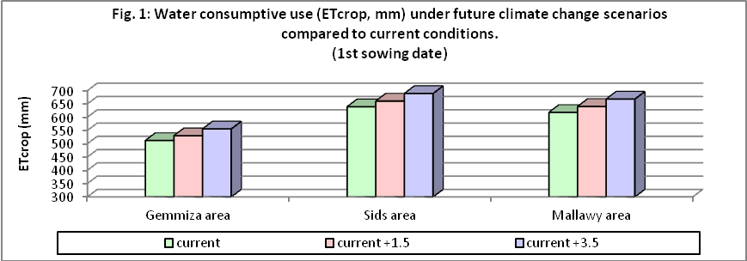

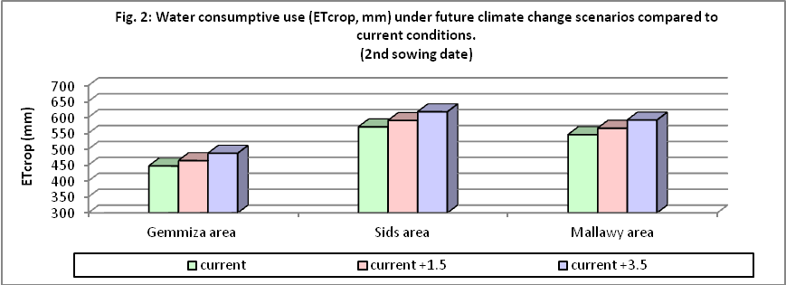

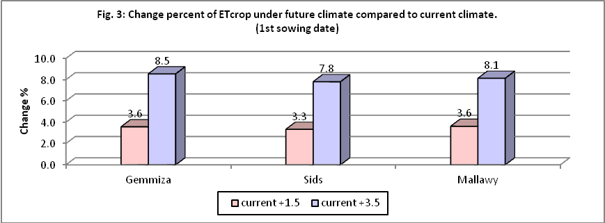

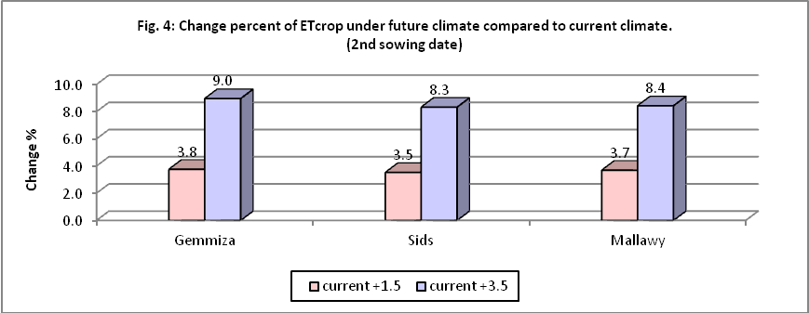

Adaptation Studies for maize crop under future climate.
Adaptation under different sowing dates Four sowing dates (1st May, 10th May, 20th May and 10th June) with base sowing date (6thJune at Gemmiza and Mallawy, and 28th May at Sids) were examine under future climate. The aim of choosing these dates are that most of the area of maize grown in summer while the nili occupies less area. Summer season sown during May and June while nili season sown in July and August.

Effect of simulated sowing dates on maize crop at Gemmiza area
Results as recorded in Figs. 5 and 6 showed that sowing maizethrough10thto 20thMay improved grain yield about 3 to 5 % as compared with base sowing date under future climate (6th June). While, sowing on1st May or 10th June caused decrease grain yield from 5 % to 7 % more than base sowing date. It is clear that planting through mid of May is the optimum planting date for maize crop under future climate at Gemmiza area. At the same time, the optimum variety gave the highest grain yield under climate change conditions was found for V₆ when sown on 20th May (8205 kg/ ha). However, the minimum one was obtained for V₅ when sown on 10th June (5418 kg/ ha).
Effect of simulated sowing dates on maize crop at Sids area
Results as presented in Figs. 7 and 8 indicated that sowing maize through 1stto 10th May caused increase grain yield from 2 to 6 % as compared with base sowing date(28th May) under future climate. While, sowing through 10th June resulted in more reduction in grain yield reached up to 6 % as compared with base sowing date under future climate.
The most sensitive variety at Sids area was V₆, which registered more reduction under different sowing dates, however, the highest one was found for V₄ when sown on 10th May which revealed an increase in grain yield about 1, 7, 15, 14 and 21 % as compared with V₁ up to V₆, respectively.
Effect of simulated sowing dates on maize crop at Mallawy area
Changing sowing date under future climatic changes from 6th June to 1st May could be revealed an increase in grain yield up to 8 % (Figs. 9 and 10).Results indicated also that there are clear differences in the productivity of maize varieties under future conditions at this area, for example under the optimum sowing date (1st May), V₂ superior by 24, 8, 12, 4 and 13 % as compared with V₁, V₃, V₄, V₅ and V₆, respectively. Generally, it can be concluded that the suitable varieties could be used at Mallawyarea under climate change conditions are V₂ followed by V₅ with sowing date 1st May.

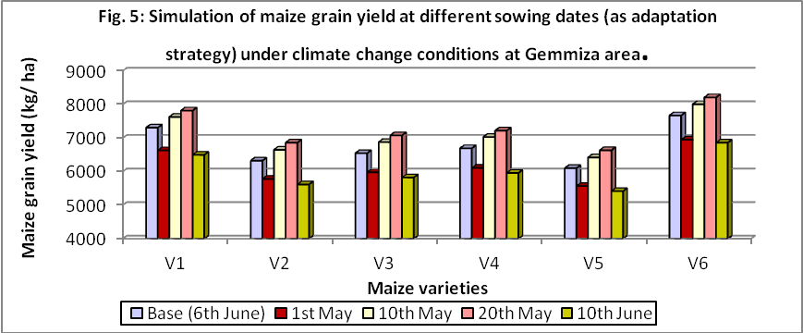

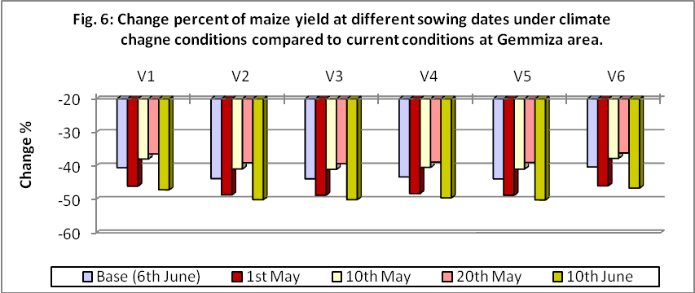

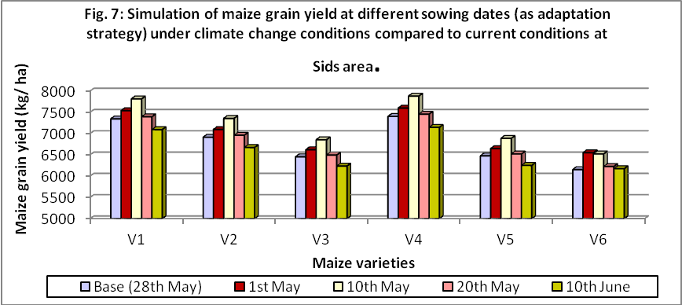

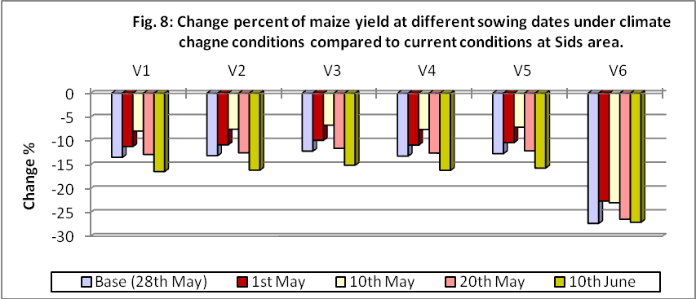

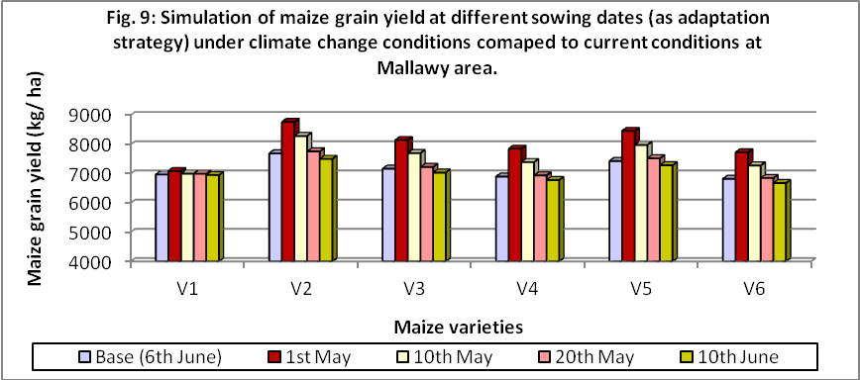

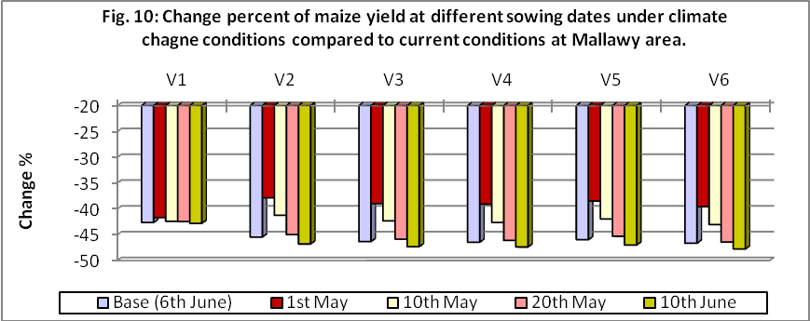

From the previous results it can be concluded that the success of crop growth in any region depends on prevailing weather conditions in this region. In addition, select appropriate variety with optimum sowing date for the region can achieve maximum benefit from this variety. In this connection simulation results found that the suitable varieties which can be used under future climate change conditions are V₆ at Gemmiza area with sowing date of 20th May, V₄ at Sids area with sowing date of 10th May and V₂ at Mallawy area with sowing date of 1 May.
In this connection, plants grow best when daytime temperature is about 10 to 15 degrees higher than nighttime temperature. Under these conditions, plants photosynthesize (build up) and respire (break down) during optimum daytime temperatures and then curtail respiration at night. Temperatures higher than needed increase respiration, sometimes above the rate of photosynthesis. Thus, photosynthesisis used faster than they are produced. For growth to occur, photosynthesis must be greater than respiration.
Daytime temperatures that are too low often produce poor growth by slowing down photosynthesis. The result is reduced yield (i.e., fruit or grain production). (www.Plantgrowthandtemperature.mht).

Adaptation under different irrigation water amounts:
Effect of simulated irrigation water amounts on maize crop at Gemmiza area
Results as presented in Figs. 11 and 12 indicated that different irrigation water amount (excess or deficit) affect maize productivity. Under deficit irrigation, the reduction in grain yield ranging from 51% up to 56 %. The most sensitive varieties to water deficit at Gemmiza area under future climate were V₂, V₃, and V₅, which registered more reduction in grain yield. The main reasons for the drop in productivity under conditions of water deficit, is increasing in crop evapotranspiration under conditions of high temperature and decrease nutrients absorption and the shortening of the growing season length.
However, under excess of irrigation water applied, maize grain yield will be increased 7 – 8 % with +5% excess of irrigation water applied, and 23 – 31 % with 10 %, as compared with base treatment under future climate.

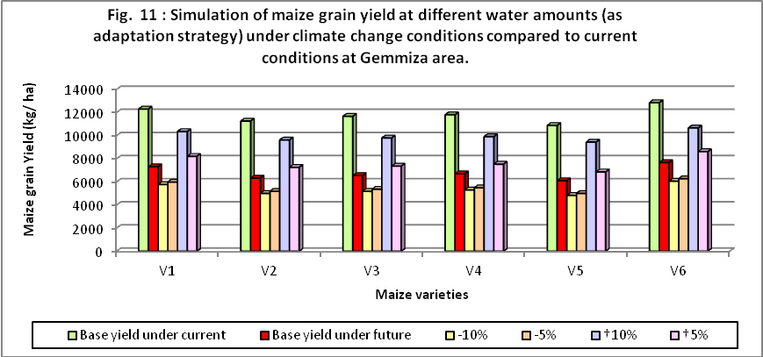

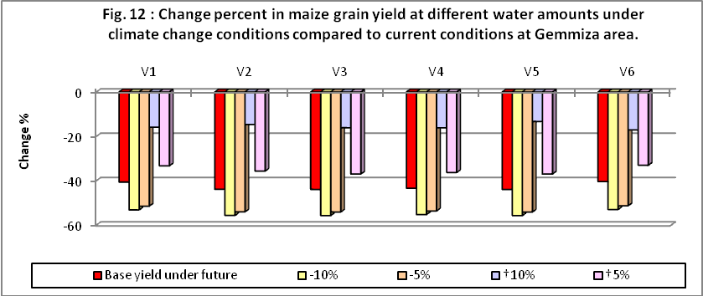

In this connection, Doorenbose and Kassam (1986) indicated that the effect of limited water on maize grain yield is considerable and careful control of frequency and depth of irrigation is required to optimize yields under conditions of water shortage. Where water supply is limited it may therefore be advantageous to meet, as far as possible, full water requirements (ETm) so as to achieve near maximum yield from a limited acreage rather than to spread the limited water over a larger acreage.
Effect of simulated irrigation water amounts on maize crop at Sids area
Increasing amount of irrigation water applied could be achieved a clear increase in maize productivity under climate change conditions at Sids area (Figs. 13 and 14). Increasing amount 5 % could increase yield up to 5 % as compared with base yield under future, and up to 8 % with increasing amount 10 %. However, decreasing amount of irrigation water applied 5 to 10 % could decrease yield from 42 % up to 69 %. The varieties that excelled under conditions increase the amount of irrigation water applied were V₃ and V₅, while, V₆ is the lowest variety under future climate.
Effect of simulated irrigation water amounts on maize crop at Mallawy area
Impact of increasing amount of irrigation water applied on maize grain yield at Mallawy area take the same trend at Gemmiza and Sids areas. Results as presented in Figs 15 and 16 clearly show that increasing water amount +5 % or +10 % could increase grain yield from 5 % to 11 %. However, under decreasing water amount -5 % or -10 %, the reduction in grain yield ranging from 72 to 75%. The optimum variety under increasing amount of irrigation water applied was found for V₁.
Adaptation under fixed interval days between irrigation:
Effect of simulated irrigation interval days on maize crop at Gemmiza area
Shortening interval days between irrigation under future climate change conditions will lead to reduce the negative impact of climate change on productivity of different maize varieties. Results as presented in Figs. 17 and 18 indicated that use fixed irrigation every 8 days under future climate at Gemmiza area led to a significant increase in the productivity of different maize varieties reached about 28 % as compared with base treatment (irrigation every 14 days). Also, fixed irrigation every 12 days could increase grain yield up to 16 %. On the other hand, the use of long intervals between irrigation will lead to further negative impact of climate change on crop productivity and will arrive approximately 62 % with irrigation every 16 days and 78% with irrigation every 20 days. The highest grain yield under the least interval days (every 8 days) was found for V₆ followed by V₁.
Effect of simulated irrigation interval days on maize crop at Sids area
Change interval days between irrigations from 14 days (base treatment) to 8 days can achieve an increase in the productivity of different maize varieties at Sids area with rates ranging from 3 to 15 % (Figs. 19 and 20). In the same direction, fixed irrigation every 12 days could achieve an increase in productivity ranging from 1 to 10%. On the other hand, prolonged irrigation every 16 days or 20 days can reduce productivity rates ranging from 37 to 81 %. Generally, the best varieties that have achieved high productivity under conditions of short periods of irrigation are V₁ followed by V₂, V₃, V₄ and V₅.
Effect of simulated irrigation interval days on maize crop at Mallawy area
Results as presented in Figs 21 and 22 clearly show thatt shortening the duration of irrigation from 14 days (base treatment) to 12 days or 8 days can achieve an increase in the productivity of different maize varieties at rates ranging from 4 to 8 % with irrigation every 12 days and 19 to 25 % with irrigation every 8 days.
While prolonged irrigation every 16 days or 20 days can achieve reduction in crop productivity rates ranging from 54 to 87%. The results also indicated that the varieties they excelled under conditions of short periods of irrigation are V₂ followed by V₅ then V₃.
Adaptation under skipping irrigation at different growth stages
Effect of simulated skipping irrigation on maize at Gemmiza area
Skipping irrigation at any stage of plant growth or prolong the period between irrigations under future climate change conditions will cause major shortfalls in crop productivity (Figs. 23 and 24). The highest reduction in maize productivity found for skipping at 3rd irrigation followed by skipping at 4th irrigation which skipping in these stages resulted in reduced crop productivity ranging from -75 % to -77 %.
In addition, the less shortage in crop productivity happened when skipping was done at last irrigation (8thirri.) followed by 7thirri.. The sensitivity of different varieties almost the same
Effect of simulated skippingirrigation on maize at Sids area
With respect to the impact of skipping irrigation at different growth stages at Sids area under climate change conditions, results as recorded in Figs 25 and 26 indicated that skipping irrigation at 5thirri., followed by 4th and 3rdirri. could reduce crop productivity ranging from 70 to 82 %. Results indicated also that skipping irrigation at the last irrigation or at 7th irrigation caused reduce of crop productivity less than the other skipping irrigation treatments.
Effect of simulated skipping irrigation on maize at Mallawy area
Concerning Mallawy area, results as presented in Figs 27 and 28 clearly show that skipping irrigation at 5th followed by 3rd and 4thirri. could reduce crop productivity ranging from -83 % to -89 %. Results show also that, skipping irrigation at last irrigation (8thirri.) followed by 7thirri take the same trend at Gemmiza and Sids areas which recorded less reduction compared with the reduction under others skipping..

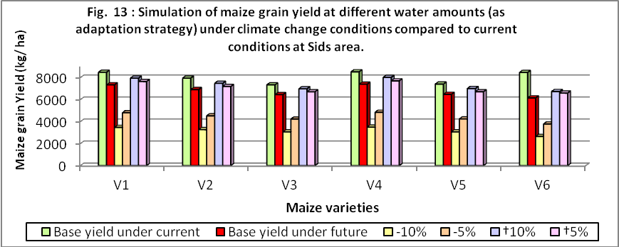

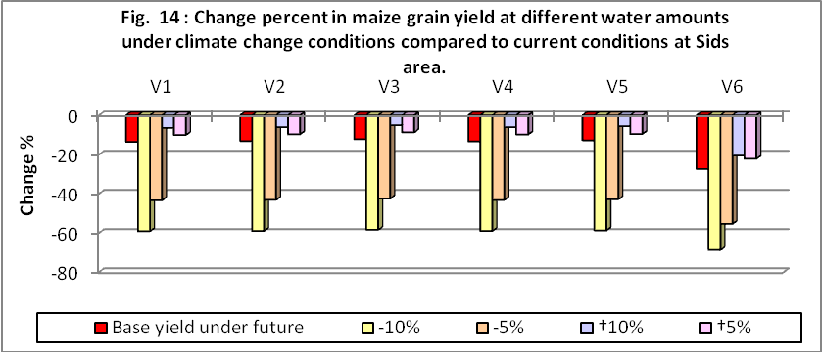

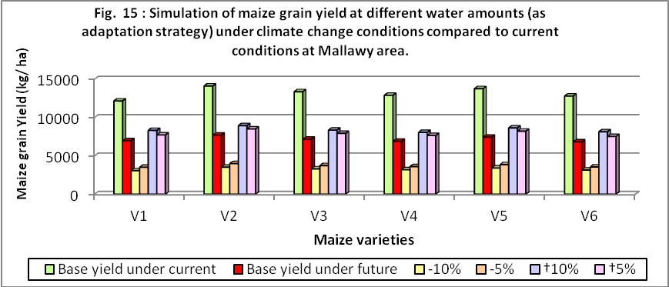

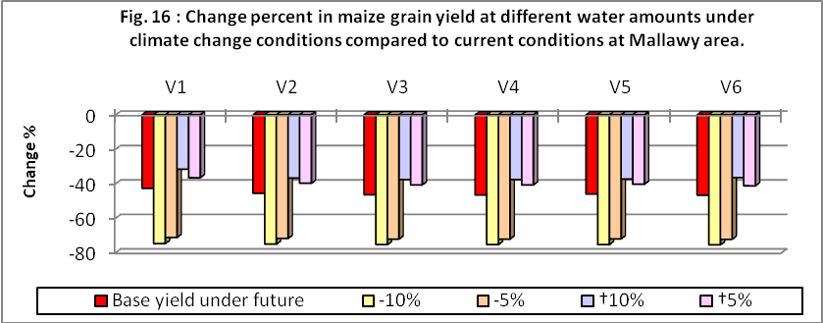

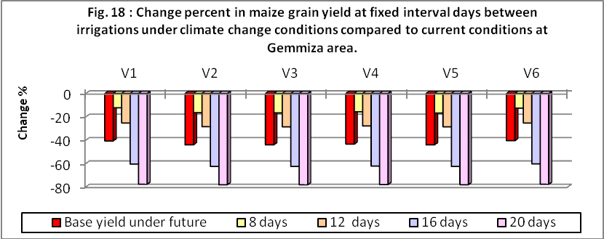

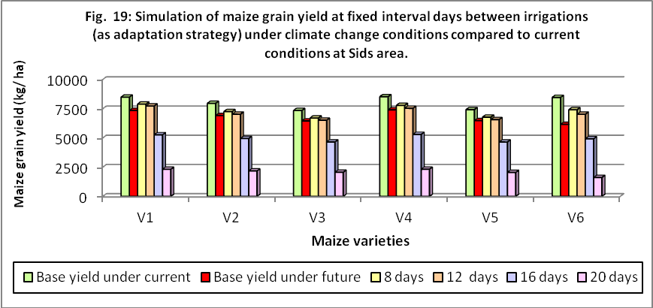

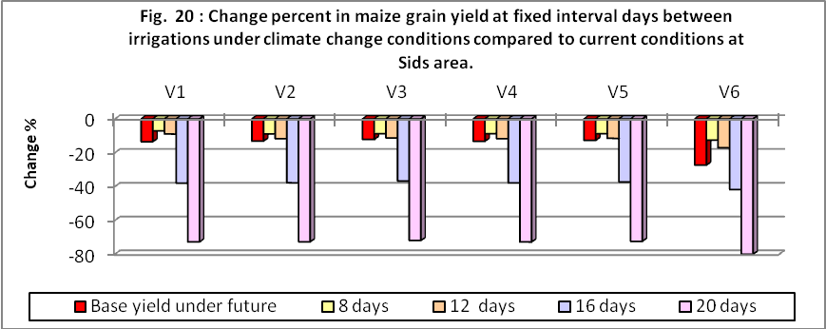

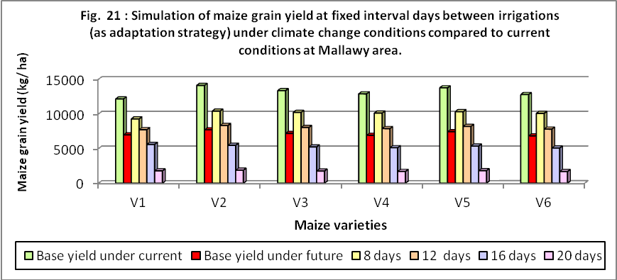

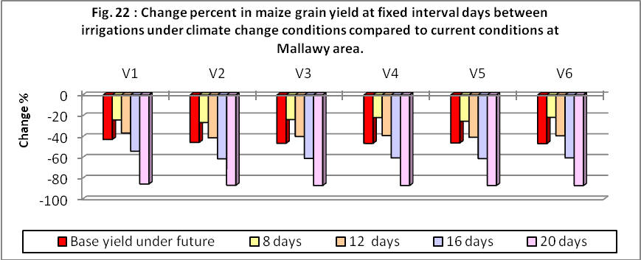

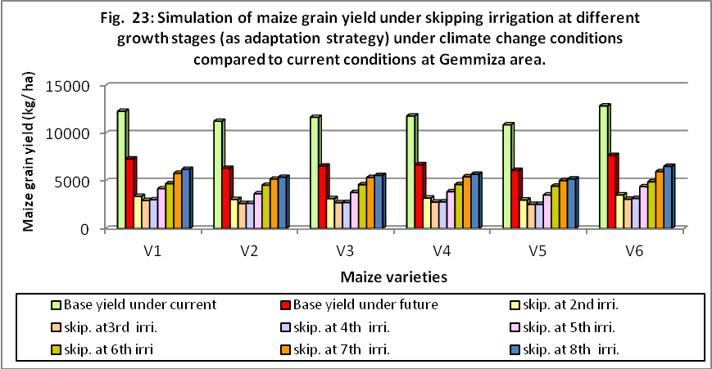

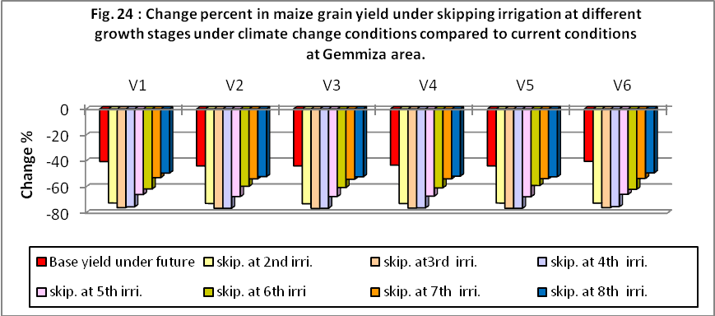

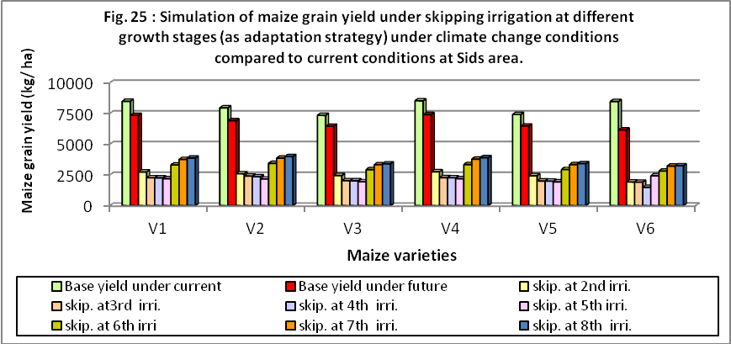

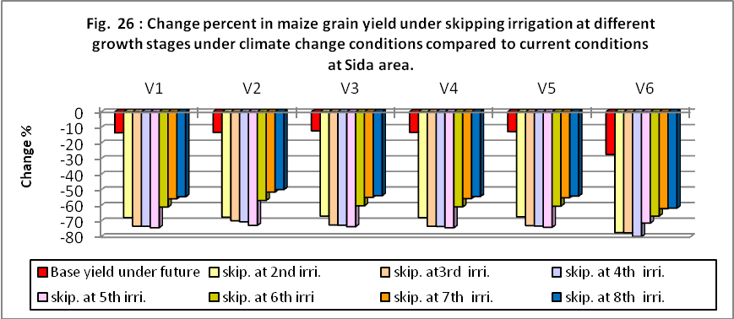

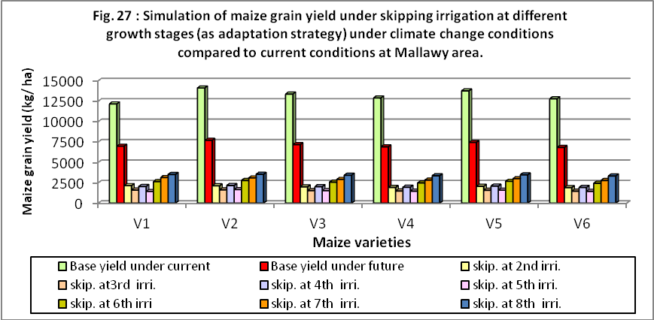

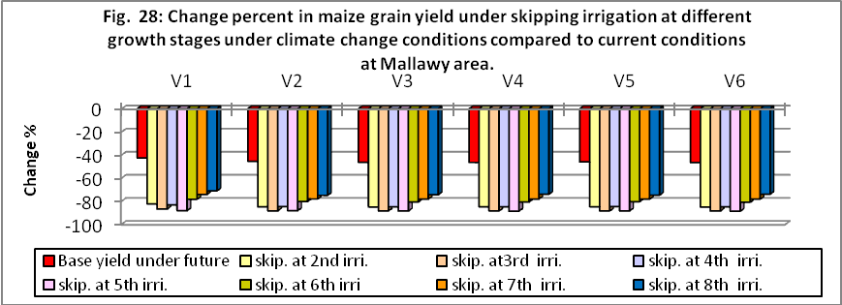

Conclusions And Policy Suggestions
The potential impact of climate change on maize and that water consumption was evaluated by simulating under different climatic scenarios in the main agroclimatic zones in Egypt. Under GCM climate change scenarios, yield of maize decreased in comparison to current climate conditions at all areas under study. At the same time, water consumptive use will be increased for all varieties. According to the present simulation study, the impact of climate change on maize would be severe in comparison with current climate conditions.
Future adaptation strategies to climate change could defeat the adverse impact of climate change on crops production. Results of adaptation studies illustrated that the suitable varieties, suitable sowing date, shortening interval days between irrigation or increasing 10 % of amounts of irrigation water could be reduced the harmful impacts of climate change on crops production.

References
- AbouHadid, A. F., 2009. Arab environment: climate change. Impact of Climate Change: Vulnerability and Adaptation. Chapter 5.
- Al-Kaisi M. M. and I. Broner 2011.Crop water use and growth stages.www. Ext. colostate.edu/pubs/crops/04715.htm.
- Allen G. R., L. S. Pereira, D. Raes and M. Smith, 1998.“Crop evapotranspiration”. Guidelines for computing crop water requirements. FAO Irrigation and Drainage paper No. 56. Rome.
- Boer GJ, NA., McFarlane and M. Lazaro 1992. Greenhouse gas induced climate change simulated with the CCC second generation general circulation model. Bull Am Meteorol Soc., 5:1045-1077
- Brady, N.C. and R.R. Weil. 2002a. "Soil Organic Matter" pp.353-385 in Elements of the Nature and Properties of Soils. Pearson Prentice
Hall, Upper Saddle River, NJ.
- Brady, N.C. and R.R. Weil. 2002b. "Nitrogen and Sulfur Economy of Soils" pp.386-421 in Elements of the Nature and Properties of Soils.
Pearson Prentice Hall, Upper Saddle River, NJ.
- Chrispeels, M.J.and D.E. Sadava. 1994. "Farming Systems: Development, Productivity, and Sustainability". pp. 25-57 in Plants, Genes, and Agriculture. Jones and Bartlett, Boston, MA.
- Derek, C.; M. Smith and K. El-Askari ,1998."CropWat for Windows".Model for crop water requirements calculation using Penman Monteith method.FAO.
- Doorenbos, J. and A. H. Kassam ,1986. Yield response to water. Irrigation and Drainage Paper, FAO No. 33, Rome, Italy.
- Eid H. M. and Samia, M. El-Marsafawy, 2002. Adaptation to climate change in Egyptian Agriculture and water resources. 3rd International Symposium on sustainable Agro- environmental Systems: New Technologies and Applications (AGRON 2002), Cairo, Egypt, 26-29 October.
- Eid H. M. ,Samia, M. El-Marsafawy and Samiha A. Ouda, 2006b.Assessing the impact of climate change on crop water needs in Egypt: The CROPWAT analysis of three districts in Egypt. CEEPA Discussion Paper No. 29. Special Series on Climate Change and Agriculture in Africa, July 2006
- Fraser, E.:2009. “Crop yield and climate change” (http:/ / www. vulnerablefoodsystems. com/ ), Retrieved on September 14, 2009.
- Gregory, P.J , J.S.I Ingram and M Brklacich. 2005. Climate change and food security. Philosophical Transactions of the Royal Society. http://rstb.royalsocietypublishing.org/content/360/1463/2139.full
- IPCC (Intergovernmental Panel on Climate Change), 1994. IPCC Technical Guidelines for Assessing Climate Change Impacts and Adaptations.Editors, Carter TR, Parry ML, Harasawa H &Nishioka S. WMO & UNEP (World Meteorological Organization & United Nations Environment Programme), Intergovernmental Panel on Climate Change. Centre for Global Environmental Research, University College London, UK.
- IPCC, 2001.Climate Change 2001. Synthesis Report A Contribution of Working Groups I, II, III, IV to the Third Assessment Report of the Intergovernmental Panel on Climate Change. Cambridge University Press: Cambridge.
- IPCC, 2007a. Climate Change 2007: Impacts, Adaptation and Vulnerability. Contribution of Working Group II to the Fourth Assessment Report of the Intergovernmental Panel on Climate Change, Cambridge University Press, Cambridge, UK, 1000pp.
- IPCC, 2007b. Climate Change 2007: The Scientific Basis, Summary for Policymakers Contribution of Working Group I to the IPCC Fourth Assessment Report, 2007.
- Manabe S and RT Wetherald, 1987. Large scale changes in soil wetness induced by an increase in carbon dioxide. J Atmos Sci., 44:1211-1235
- McGuigan C, R. Reynolds and D. Wiedmer, 2002. Poverty and climate change: Assessing impacts in developing countries and the initiatives of the international community. London School of Economics Consultancy Project for the Overseas Development Institute.
- Mendelsohn R and A. Dinar, 1999.Climate change, agriculture, and developing countries: Does adaptation matter? The World Bank Research Observer, 14: 277–293.
- RitchiJ. T., U. Singh, D. C. Godvin, W. T. Bowen, P. W. Wilkens, B. Baer, G. Hoogenboom and L. A. Hunt, 1998. Generic CERES3.5. International Fertilizer Development Center, Michigan State University & University of Georgia.
- Rosenzweig, C. and D. Hillel, 1994. Egyptian Agriculture in the 21st Century. Collaborative Paper CP – 94 - 12.International Institute for Applied Systems Analysis, Luxemburg, Austria.
- Rosenzweig, C. and M. L. Parry, 1994. Potential impact of climate change on world food supply. Nature, 367:133-138.
- Smith, M. ,2002. FAO methodologies on crop water use and crop water productivity. Regional Climate, water and Agriculture: Impacts on and Adaptation of Agro-ecological systems in Africa. CEEPA, 4-7 December 2002.
- Tsuji, G. Y., J. W. Jones, G. Uhera, and S. Balas (eds.), 1998. Decision Support System for Agrotechnology Transfer, DSSAT3.5 V 3.5. IBSNAT. University of Hawaii, Honolulu,
- www. Plant growth and temperature, Botany Course, Master Gardener Training, Extension Service, Oregon State University.mht
- www. Agro meteorology Temperature and Plant Growth.mht.
- www. The climate change – Agriculture conundrum.

9/2/2012

