Isolation And Characterization Of Triterpene Lup-20-EN-3-Ol And 1,3-Hexyloxacyclotridec-10-EN-2-One From The Root Of Grewia Mollis

¹ Efiom, O.O., and ² E. Oku

¹ Department of Chemistry University of Abuja, Abuja, Nigeria
² Department of Agriculture, University of Abuja, Abuja, Nigeria
otuefiom@yahoo.com

Abstract: Two new additional compounds type characterized as Triterpenes lup-20-en-3-ol and 1,3-hexyloxacyclotridec-10-en-2-one were isolated from n-Hexane extract of root of Grewa mollis (Twaceae). The structures of the new compounds were identified on the basis of spectral interpretation.
[ Efiom, O.O, E. Oku. Isolation And Characterization Of Triterpene Lup-20-EN-3-Ol And 1,3-Hexyloxacyclotridec-10-EN-2-One From The Root Of Grewia Mollis. N Y Sci J 2012;5(11):138-141]. (ISSN: 1554-0200). http://www.sciencepub.net/newyork. 20

Keywords: Grewa mollis, Triterpenes, n-Hexane extract, Isolation, Spectra.

1. Introduction
Hanan and co-worker have investigated extensively the genus Grewa mollis (Twaceae) which the following compounds, 7-(1-0-β-D galact turoniole-4-(1-0- β -glucopyranesyl-3,4,5,7 tetrahydroxyflavone, lutelion, 7-β-hydroxy-2,3-en-deoxojessic acid, 7-β-hydroxy-2,3-deoxojessic acid , -sitesterol and β-sitosterol-3-o-glucoside, have been isolated from the aerial part of the plant^{1,2}. Biological evaluations of the isolated compounds were not left out in the investigation.^{1,2} In our continuing search for new compounds in plants that are highly prized in African traditional medicine, the isolation of the interesting group of compound, combined with our taxonomic interest in the Tiliceae stimulated further investigation of the root of Grewa mollis. Two new compounds triterpene lup-20-en-2-ol and 1,3-hexyloxacyclotridec-10-en-2-one, have been Isolated. The structures of the new compounds were elucidated on the basis of spectra-data interpretation.

3. Materials And Methods
The roots of Grewia mollis used in this investigation were collected in October 2011 from Niger State, Nigeria and were authenticated by Mallam Hamza of the Herbaruim unit of National Institute of Pharmaceutical Research and Development (NIPRD). Idu, Abuja, Nigeria and voucher specimen was deposited at the (NIPRD) Herbarium. Column chromatography 100ml, merk kiesel gel 60 (230-400) mesh, Aldrich chemical of Analytical grade, TLC on TLC aluminum sheet 20x20cm, pre coated with silica gel, TLC spot detectors: (366nm) lamp. IR and Nijol as internal reference on/3010 spectrometer and GC-MS Of 2010 plus shumadzu japan were carried out at NAICT, Zaria Nigeria, EI source at 250ºc and 70ev. mR (relative intensity, %)

2. Extraction And Isolation Of Plant Materials
The powdered root (500g) was successfully extracted with n-hexane by cold maceration for 72hours and concentrated to dryness using rotary evaporator to give (10.25g) of residue. The column was packed with silica gel. 6g of the residue was mixed with dried silica gel and placed on top of silica gel and eluted with n-hexane followed by varying the percentage of n-hexane and acetate. A total of 20 fractions of 100ml porting were collected. The fractions were combined on the basis of Rf valves to give fraction EG₁ and EG₂. The fractions were further purified using TLC silica gel (n-hexane/ethylacetate (3:1) to give brown gum 200mg EG₁ and EG₂ a yellow gum (150mg) respectively

4. RESULTS
The result of the n-hexane extract of the root of Grewa mollis led to the isolation of two compounds, after column chromatographs separation and purification of the fraction. The two isolated compounds were subjected to spectral analysis as follow:

Compound 1: A brown gum(200mg), R_{f} =0.65 IR λmax 3421cm⁻¹(O-H), 2931cm⁻¹ (C-H) and GC-MS m/z 426(26), 411(22), 315(43), 234(48), 218(30), 201(43), 187(43), 161(48), 1641cm⁻¹(C=C),136(43), 121(43), 107(87) 95(87), 81(8), 69(72), 55(62), 41(43).
Compound 2: yellow gum (150mg) R_{f}=0.72 IR λmax 2923 cm⁻¹ (O-H) 1728cm⁻¹ (C=O) 1022cm⁻¹ (C-O) and 1613 cm⁻¹ (C=C) EIMs (relative intensity) m/z 280(14), 166(9), 137(11), 112(11), 98(100), 95(23), 81(34), 67(43), 67(43), 55(57), 41(51).

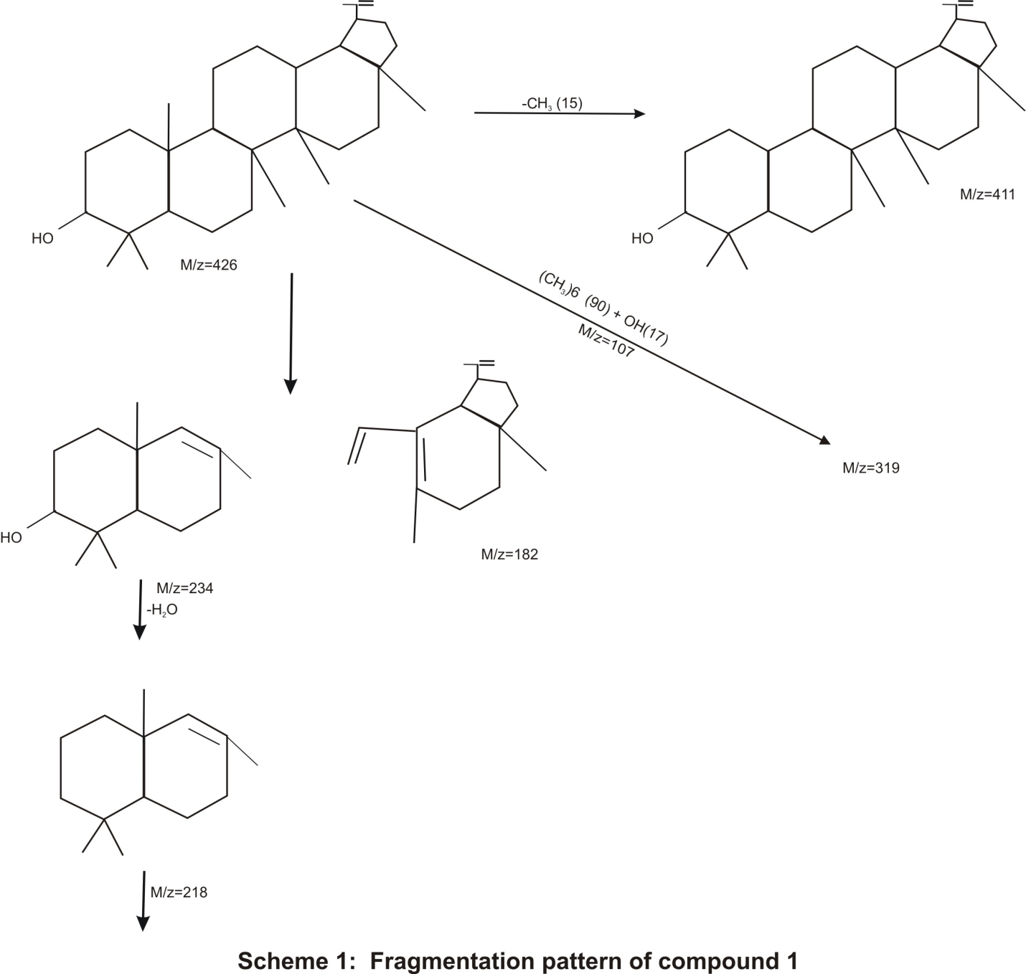

5. Discussion
Compound 1:
The identification of triterpenes lup-20-en-3-ol from n-hexane extract was based on spectroscopic evidence and comparison of retention index and mass spectrum with the stored laboratory mass spectral library data. The IR spectrum showed a characteristic band and a peak due to O-H stretching vibration was observed at 3421cm⁻¹, a band at 2931cm^{-1,} indicative of C-H, 1647cm⁻¹ indicative of C=C band showing the presence of alkenes molecule. The GCMS analysis gave a molecular ion peak at m/z 426 in the spectrum corresponding to a molecular formula of C₃₀H₅₀O. The base peak of m/z 107 was calculated by detachment of (CH3)₆-90+OH-(17). The highest fragment ion of m/z 411 represents the loss of methyl radical (M⁺-CH₃) that is (426-15) from the molecular ion. The fragmentation at m/z 218 is as result of further losing of H₂0 from molecular ion (m/z 234-18). The fragmentation pattern is consistent with that of triterpene lup-20-en-3-ol as shown in scheme 1. The fragmentation shown in fig 2 by matching molecular weight and structure information derived from fragmentation procedure with compound found in grewia mollis suggests the compound to be triterpenes lup-20-en-3-ol^{3,4}

Compound 2:
This was obtained as yellowish gum. Its molecular composition was C₁₈H₃₂O₂ as determined from the combined analysis of GCMs and IR spectra. The result of IR spectrum obtained from TLC showed absorption 2934cm⁻¹ indicative of C-H stretching, 1727cm⁻¹ indicative of the presence of lactones ring, 1613cm⁻¹ indicative of C=C, and1135cm⁻¹ indicative of C-O stretching. The presence of lactone ring indicates the presence of compound under flavonoid or coumarins^{5,6}. The GCMS profile of the compounds gave a molecular ion peak at m/z 280 and base peak at m/z 98. The compound also displays four prominent fragment ion at m/z 166, 137, 81 and 55. The M/S fragmentation pattern was in good agreement with the stored laboratory library mass spectral data both in quality and quantity. The results of the GCMS, IR and library search data suggest the compound to be identified as 1,3-hexylxacyclotridec-10-en-2-one.

5. Conclusion
The results of the work has gone a long way to confirm the need to study the chemistry of the root of Grewia mollis that have before now not been investigated as such studies could also be chem taxonomically significant.

References
- Hanan, M., Al-Shaface, Musarat, A. and El-shafe, A.M. (2012). Biological evaluation of constituents from Grewia mollis. Journal of Chemical and Pharmaceutical Research. 4(1). 508 - 518.
- Okwu. D.E and Ohenhen, O.N. (2009) Isolation characterization and antibacterial activity of lanostane triterpenoid from the stem bark of Stachyterpheta Famaicensis inn vah. Journal of Chemical Society of Nigeria, 34(2)31 - 37.
- Ekpendu, T.O.E., Adesomoju, A.A. and Okogun J. (2001) Chemical studies of mitracarpus villosus(SW)DC A medical rubiacarpus weed. Journal of Chemical Society of Nigeria. 26(1)69 - 74.
- Gabriel, A.F. and Okwuta, S.K. (2009) Isolation and characterization of Lup-20(29)en-3-one and Disononyl phthalate from antimicrobial Pterocarpus Ennaceus pure stem bark. Journal of Chemical Society of Nigeria, 34(2)156 - 161.
- Barths, M. and Bucar, F. (2006) Antioxidant activity of Nigeria Satira essengtial oil. Phytother. Research. 14(5)323 - 328.
- Balakumbaham, R. and Rajamani, K. (2010) Effect of biostimulants on growth and yield of senna (Cassia angustifolia var. KKM.1), journal of Horticultural Science and Ornamental Plant 2(1)16 - 18
- Xiano, H.B., Krucker, M., Putzback, K. and Albert, K. (2005) Capillary liquid chromagraphy microcoill H nuclear magnetic resonance spectroscopy and liquid chromatography ion trap mass spectrometry for online structure elucidartion of isoflavones in Radix astragali. Journal of Chromatography, 1067, 135 - 143.

10/5/2012

