Relationship between the firm size, growth opportunity level, profitability and the tangible assets combination and long term and short term debts in drug companies in Iran.

Iman Azadvar

Department of Accounting, Abadan Branch, Islamic Azad University, Abadan, Iran
Email: Azadvar.acc@gmail.com

Abstract: Generally, companies believe that financing resources consist of shareholders' liabilities and equity and different factors can affect the ratio of either of these two financing methods. The effects must be examined in the frequent periods of time. Due to their repayment priority and specific amount and due date as well as interest rate matters, creditors believe that liabilities have lower risks than capital. Therefore, short term and long term liabilities will be investigated and their variations according to company size, growth opportunities, tangible assets and profitability will be studied in this research.
[Iman Azadvar. Relationship between the firm size, growth opportunity level, profitability and the tangible assets combination and long term and short term debts in drug companies in Iran. N Y Sci J 2012;5(12):38-41]. (ISSN: 1554-0200). http://www.sciencepub.net/newyork. 6

Keywords: company size, profitability, assets tangibility, growth opportunities, short term and long term liabilities.

Introduction
The literature of financing in companies contains wide range of researches carried out about identification test and determinative and effective parameters affect capital structure. Companies know well enough that there are some limitations in benefiting from foreign resources with different financing costs. In such a condition, companies try to adjust their liabilities and capital levels in order to reach an optimized point in capital structure (Alan Bevan and Jo Danbolt).
Problem Statement
Capital structure is among problems which different studies have been carried out about it. Theoretical discussions about capital structure seek for an optimum combination of two main financing resources, i.e. shareholders' liabilities and equity. The main purpose is to maximize the value of company shares and in contrast, to minimize financing costs. This research attempts to measure the relationship between company size and growth opportunities rate or investment and company's profitability as well as the relationship between assets tangibility ratio and capital structure. Then, the relationship would be analyzed dynamically.
Research Background
The research of Alan Bevan and Jo Danbolt [2009/9, 2009/2] is among the researches which have been carried out on capital structure and its effective factors. This research which was carried out on 882 U.K. companies found a positive and significance relationship between companies' leverages and assets tangibility & sales logarithm. They also found a negative significance relationship was obtained between companies' leverages and growth opportunities and profitability level. The same research was carried out by Rojan and Zingelz [1995] with the same results. Francisco Mira [2000] analyzed Spanish small and medium companies and obtained a positive correlation between companies' size as well as their capital structures and companies' leverages.
Definitions of Operational Variables
- liability structure indices (the independent variables of x)
TLIBAS: total long term and current liabilities as the total sum of liabilities
TLYD: total long term liabilities (repayable, more than one year) including banking long term borrowing.
BBGT: borrowed budget repayable in more than one year
LNP: long term notes payable (non-bank repayable in more than one year)
TCL: total current liabilities (repayable in less than one year) including commercial credits or equivalents as well as financing which is repayable in less than one year.
OCL: other current liabilities
BLRT: borrowed liabilities which are repayable in less than one year including banking short term borrowing.
SNT: short term notes (repayable in less than one year)
ESP: Earnings per Share, payable

- Dependent Variables
- Total asset to company size (TA/SIZE)
SIZE=Log (Sales) = Ln (Sales)
- Tangibility; Which is obtained from dividing fixed assets by total assets:
Tangibility = FA/TA
- Growth opportunity; is measured by MTB index and is obtained from the ratio of market value to book value of assets [Alan Bevan and Jo Danbolt 2009/9].

$$\text{MTB}=\frac{\text{TA}−\text{ECR}+\text{MV}}{\text{TA}}$$
ECR (Earning Credit Rate) = book value of notes and shareholders' equity
MV= market value of shareholders' equity

Research Hypotheses:
Hypothesis 1: there is a relationship between liability structure and TA/SIZE ratio variables.
Hypothesis 2: there is a relationship between liability structure and profitability
Hypothesis 3: there is a relationship between liability structure and tangibility
Hypothesis 4: there is a relationship between liability structure and growth opportunities.

Research Scope:
This research is performed on the factors affecting capital structure by emphasizing on liabilities as well as using the data of medicine companies registered in stock exchange organization from 2007 to 2010 by using data of audited financial statements.

Statistical Analysis Methods
In the deductive part of this research, since the purpose of this study is to evaluate the relationship between the independent variables of company size, profitability, tangibility and growth opportunities and the liability structure indices of companies and since both dependent and independent variables are more than one variable, canonical correlation analysis is used to evaluate main hypothesis of the research.

Results of Hypotheses
The following results were obtained based on the performed statistical examinations and analyzing them: the related tables are provided in the appendix.

- Growth opportunities
There is no significant relationship between this variable and the components of short term liabilities and it remained intact over all periods while it has a negative relationship with long term liabilities. The mentioned results are ambiguous to some extend but it could be argued that in general, companies with higher growth opportunities use lower liabilities the reason of which may be the fact that growth opportunities are less collaterally valuable. The obtained results confirm previous studies results.

- Company Size
There is a positive relationship between short term liabilities and company size. Also, there is no negative relationship between long term liabilities and company size. The mentioned relations are positive and significance over the considered period. Therefore, it could be concluded that in the selected samples, compared with small companies larger companies show higher tendency to use liabilities whether short term or long term while small companies fall in trouble in the event of using long term liabilities. The mentioned conclusion confirms results of Rajan and Zingalz (1995) and Taitman and Wezles (1998). According to Majlo and Mayerz's theory (1984), larger companies have less information symmetry. Thus, individuals outside the company know more information about them which accelerates the process of taking out a loan for the companies.
- Tangibility
There was seen no negative relationship between short term liabilities and tangible assets. Also, there is no positive relationship between long term liabilities and tangible assets. Unlike the results of previous studies, which had derived a positive relation, the collaterally of assets show no positive relationship with long term liabilities which was unexpected. Of course, in 2004 liabilities were confirmed in three components and in summary, the hypothesis was approved.
- Profitability
The existence of negative relationship was rejected in this hypothesis and higher levels of profitability result in tendency to use higher levels of liabilities which is in contrast with the mentioned preferable theory while it could be confirm with the business theory described in chapter 2.
However, reviewing the changes occurring during the mentioned period implies another situation. Of course, except some cases, the average values of the years laid inside the selected period is almost surely equal the results of whole the period. Although the rejection or confirmation of hypotheses is almost the same, relationship intensity show changes in 2006 compared with 2000. In the first hypothesis, the relationship between total current liabilities and growth opportunities during the study period was always negative and its intensity has been decreased in 2006 compared with 2000. The intensity of its relationship with other current liabilities has been decreased in 2006 compared with 2000.
For short term accounts and note payables this intensity has been increased and the trend is the same for short term received facilities. The same changes are seen in the third, fourth, sixth and seventh hypotheses as well.

Appendix

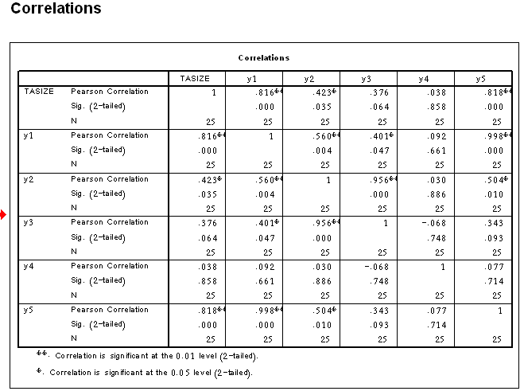

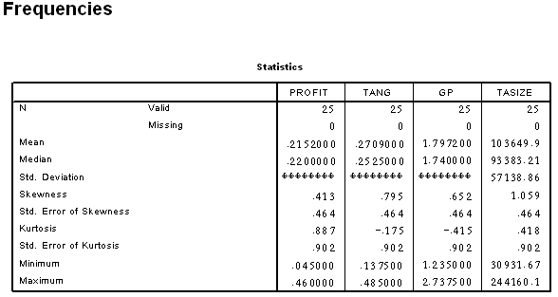

Research limitations
Although it was tried to form the statistical sample by considering all groups, inaccessibility as well as information shortage of some industries results in some shortcomings. Regarding the study period which is a five years period, some companies of the statistical population suffered from information shortage problem.

Recommendations
According to the results obtained from this study, companies and loan holders are proposed to consider in their calculations the role of their companies' size and assets. Also, high profitable companies are proposed to consider internal resources in their investment plans.

Recommendations for further researches
Other factors affect the formation of liability orientation capital structure including changeability of cash currents, non-liability tax shields, product monotony, bankrupting risks and other factors with investigation backgrounds in other countries and they could be statically or dynamically be studied in future.

References
1- Malekipour arabi, 1987, The effect of financial leverage on the profitability of the firms cited, Master Thesis, Shahid beheshti University
2- Bakhtiari parviz, 1991 Financial Management. Publishing Industrial Management
3- Modares, Ahmad and Farhad Abdollahzadeh, 1989 Financial Management, Vol.2
4- Samia, Habinallah, 2005, The effect of capital structure on profitability Commerce Bank Thesis, MA, Higher Institute of Banking.
5- Afshari, Asadallah, 1989-90, Financial management theory and practice, Volume II, Tehran, Soroush Publications.
6- Afshari, Asadallah, 1989-90, Financial management theory and practice, Volume II, Tehran, Soroush Publications.
7- Delavari, seid Javad,1988, Effects on the efficiency and equity financing companies in the Stock Exchange, (Master's thesis), Tehran University.
8- The determine of dutch capital structure choice Linda H. chem and george J Jiang 2001.
9 What are the determinants of the capital structure? Some evidence for Switzerland wolfgang drobetz rogerfix 2003 .
10- The determinant of capital structure for Japanese multinational and domestic corporations shumi akhtar barry oliver .
11- Australian multinational and domestic corporations capital structure determinants shumi akhtar. 12- the dynamics of capital structure : evidence from Swedish micro and small firms . almas heshmati 2001 .
13- what do we know about capital structure? Rajan & zinales some evidence from international data.
14- theory of capital structure – A Rewiew stein frydenbery 2004 .
15- the theory and practical of corporate finance john R Graham Campbell R Harvey usiness press .

5/9/2012

