Analysis of the factors influencing the adoption of rice versus sugarcane plantations by farmers’ association in Gasaka marshland, Gakenke district, Rwanda

Alphonse Nahayo,*,Marcellin Sebahire, Young Mo Kim

Higher Institute of Agriculture and Animal Husbandry (ISAE)-Busogo; Department of Forestry and Nature Conservation; P.O. Box 210 Musanze, Rwanda

Abstract: The present study was conducted in Muhondo sector of Gakenke district from25th May to 25th July 2012, where the farmers’associations carrying out their agricultural activities in Nyabarongo valley are growing rice since 2009 on 3 hectares of land. The main purpose was to know the factors that influenced the farmers to replace the sugar cane by rice plantations in Gasaka marshland located in Muhondo sector. This objective was achieved by identifying and analyzing social, economic and ecological factors, through the survey done over 68 farmers, selected from 17farmers’associations. The results indicated that the most important reasons influencing the farmers to leave the sugarcane plantation were the change in marshland use by Government policies and thefts against sugarcane in fields before harvesting period with mean ranks of 1.93 and 2.29 using 5 point Lickert scale. Friedman test showed also that the topography of land associated with the soil conditions and available water resources are main factors that luckily influenced the farmers in Gasaka marshland to adopt rice as their new plantation choice with mean ranks of 2.29 and 2.91 respectively using 5 point Likert scale. The comparison between Net income from sugarcane to that one from rice, through Cost-Benefit analysis showed that the annual Net Income from sugarcane were 939,000Rwf, smaller compare to that one generated by rice; 1,150,400 Rwf per ha per year. The planting of rice in the Gasaka marshland was influenced by the availability of sufficient water within plots because the farmers have declared the shortage of water within plots as the main challenges and constraints lowering the yield of rice. The rice is more profitable than sugarcane. It was recommended to work into cooperatives in order to get agricultural credits, training inputs, and to respect the advice and recommendations given by extension workers and local authorities for the best use of the marshland.
[Nahayo A, Sebahire M, Kim YM. Analysis of the factors influencing the adoption of rice versus sugarcane plantations by farmers’ association in Gasaka marshland, Gakenke district, Rwanda. N Y Sci J 2012;5(12):42-53]. (ISSN: 1554-0200). http://www.sciencepub.net/newyork. 7

Keywords: Sugarcane production, rice production, Gasaka marshland, Rwanda

1. Introduction
About 90% of the country’s population is still engaged in agricultural activities and approximately 92,000 of the total 165,000 hectares of Rwandan marshlands are used for agriculture (MINAGRI, 2006). That agriculture provides livelihood for 84% of the population in the country and contributes 34% of the gross domestic production, GDP. Traditionally, a considerable portion of the marshes and river valleys was used by local subsistence farmers (MINAGRI, 2009). In 2005, the Government, aiming to encourage more intensive forms of agriculture to supply the new markets, passed a new land low bringing all marshes and river valleys under the state control, and this forms part of new legal framework that provides incentives for investors to exploit such land commercially. Most of Rwanda marshlands are under traditional cropping, however some have been reclaimed increasingly for rice and sugarcane production (MINAGRI, 2006).
In 1997, a Ugandan-based enterprise, the Madhvani Group, acquired control over the country’s sole sugar mill and it grows sugarcane its self in 3,100 hectares of land leased by the state and also buy cane from out growers, including farmers’ associations in Gasaka marshland in Nyacyonga and Nyabarongo marshes. Around 1,100 farmers remains as out growers, and Madhvani Group is only the buyer and the price it pays are not negotiable then the company determines when the cane is ripe and out growers are not allowed to see the harvest being weighed. Madhvani complained of a shortage of sugarcane supplies, due to frequent floods and changes in course of Nyabarongo River, which leads to the cane rotting before they reach the maturity. Besides of these two challenges, farmers’ associations in Gasaka marshlands had left sugarcane plantation due to the low yield, theft and land use planning prepared by local government (Muriel et al., 2011).
In 2002, the farmers’ associations and individuals having the plots of land in Nyabarongo valley were obliged to choose a commercial production and they have chosen the sugarcane plantation. The varieties that they grew were Nyakabingo, Pindari and according to their high adaptation to that ecological zone. Since 2009, the land use consolidation at the national level was revealed that the marshland may be used for maize and rice where possible, and that policy has allowed the farmers’ associations in the Gasaka marshland to move from the sugarcane to rice plantation but the challenges still the water availability, low skills of farmers and insufficiency of inputs. The varieties of rice under grown by these farmers’ associations are Kigoli and WAT 1276-22-2 on about 3 hectares of land by 23 associations, while the 11remaining associations are growing the maize until the problem of water shortage will be solved (Muhondo sector, 2012).
The majority of the Rwandan population relies of agriculture and they represented 90%. The Rwandan Government launched the policies to promote the agricultural sector, to transform the traditional agriculture practiced several years, but without remarkable contribution to the national economy, in order to satisfy the food needs and to contribute to the increase in income of the population (MINAGRI, 2009).
Since 2002, the farmers in Gasaka marshland located in the Nyabarongo Valley were growing the sugarcane as a commercial plantation they have chosen according to the new low of using marshlands and valleys, and sold their production mainly to Kabuye sugar works, as out growers.
In 2009, these farmers left to grow sugarcane and begun to grow rice. There are facts that influenced those farmers to leave sugar cane plantation and to adopt rice plantations. The reason why I have conducted my study based on survey in that area to know and analyze the factors that influenced these farmers to replace the sugarcane by rice. After identifying and analyzing these factors, I should be able to know if new land use is more profitable than the old one to those farmers and to draw some recommendations for better exploitation of Gasaka marshland. The specific objectives of this study were the following: (i) to determine the household characteristics amongst farmers; (ii) to estimate the production costs for sugarcane per ha of land for rice and sugarcane; (iii) to compare the Net Income from sugarcane production to the one from rice; (iv) to identify the challenges/constraints encountered by the farmers’ associations for sugarcane and rice productions; (v) to determine the main ecological factors that influenced the farmers to grow rice instead of sugarcane plantations.
2. Material and Methods

Study area description
Muhondo Sector is one of the sectors making Gakenke District, Northern Province of Rwanda. It is bordered by Southern Province with Muhanga District by Nyabarongo River and in the West with Ruli Sector by Mungwato watercourse, in East it is bordered by Rulindo District and in the North with Muyongwe Sector by Nyamugaga watercourse.
Muhondo Sector has temperate climate in North and South, the plain region with hot climate. The rainfall ranges between 1000 and 1500 mm per year with two rain seasons and two dry seasons. The annual average temperature is around 23°C. The relief of Muhondo Sector is composed of mountains. The highest mountain is Buzinganjwiri with the altitude of 2250 m. It is known in Rwanda history as King Sekarongoro Mutabazi residence. Muhondo sector has different streams like Nyamugaga which is a limit between Muhondo and Muyongwe Sectors in the North, Mugwato limiting Muhondo sector in the West and in South there is Nyabarongo River in the limitation bound to South Province.
The soil of Muhondo Sector is general poor under the action of multiple unfavorable factors which can be geographic, climatic and particularly human factors in soil conservation. There is a range quarry such as gravels, sand and stones for building. The clay is also exploited for making bricks, tiles and pots. The natural vegetation is Eragrotis sp. which is in general covering the mountain flame. Exotic species include Eucalyptus sp., Cupressus sp. and Pinus sp. The perennial crops which cover the larger space are banana and coffee.
Muhondo sector has a surface of 55.1 km². It accounts for 9 administrative cells namely Ruganda, Gihinga, Busake, Gasiza, Bwenda, Musagara, Huro and Rwinkuba with total population of 19,345 inhabitants. Like most of the country, the population of Muhondo sector has an economy based on agriculture (Gakenke district, 2009). The lands are mainly agro-salvo-pastoral. The inappropriate cultivable lands are covered by woods and localized at the top and on the flame of hill.
In general, the food crops have known the degradation due to different causes notably climatic risks but the most dominant is the rain irregularity; there are also non rotation practice and small quantity of organic matter. The example of food crops in Muhondo Sector are sweet potatoes, cassava, climbing beans, and maize.
Among industrial crops in Muhondo Sector, there are sugar cane and coffee. The coffee has the 1st place with two washing stations in Muhondo Sector.
The animal husbandry consists of different species of animals such as the cattle, sheep, goats, pigs, rabbits, turkey hens and duck. The method used in animal husbandry is permanent keeping in sheds where animals are fed (Gakenke district, 2009).

Methods
Focus group discussion with local leaders and elderly people was done in order to understand the historical background on cropping systems in the area, followed by a survey questionnaire. The questionnaire was prepared in English and Kinyarwanda languages. A multi stage sampling techniques including purposive sampling method was used to select farmers from large community of farmers’ associations in Nyabarongo valley to 17 in Gasaka marshland. In the first stage, we have selected the farmers’ associations growing the rice in Gasaka marshland in order to reduce the travel costs. We also used the proportionate sampling to determine the number of farmers to interview in each association according to the number of members included in each association. The total number of farmers in 17 associations was 217, including 17 key informants, who helped us to know the number of association’s members. From 200 farmers left, we have taken 51 farmers to interview. The number of farmers to interview within each association was selected randomly by using names’ list of members obtained from key informants of interested association. Pre-testing was also used in order to have thorough idea about the situation, other types of agriculture-based researches that were conducted, to test the attitude of farmers to respond to questions and the strategies that we should use to collect information from them. The total number of respondents was 68. Data were analyzed by using Statistical Package for Social Sciences (SPSS) software with Friedman test and T-test.
3. Results and discussion

3.1 Farmers’ characteristics
The following results have been found by discussing with 68 farmers actively involved in association growing the rice in Gasaka marshland and the objective was to know the social factors influencing the farmers in rice and sugarcane plantations.
Distribution of farmers according to their age and sx.

Table 1: Distribution of respondents according to the age and sex
 | Age |  |  |  |  |  | Sex
 | <21 | 21-35 | 36-55 | 56-65 | >65 | Total | Male | Female | Total
Frequency | 2 | 22 | 32 | 9 | 3 | 68 | 27 | 41 | 68
Percentage | 2.9 | 32.4 | 47.1 | 13.2 | 4.4 | 100.0 | 39.7 | 60.3 | 100.0

The results presented in the table 1 show that the majority of populations (73.5%) in Gasaka marshland are between 21 to 55 years, an active population; 2.9% people are younger than 21 years and a small portion of farmers are older than 55 years. These results indicate that the people under twenty one years are engaged in education, and people who are physically active are engaged in development activities. According to the sex distribution, the number of interviewed farmers was very low for male with 39.7% as compared to the female accounting for 60.3%. This big number of female is justified by the presence of many females in agricultural associations compared to men. The men are engaged in mining activities nearby the marshland, looking for the money for secondary school fees and others leave their families to look for other different jobs in town.

Marital status
Table 2: The marital status of the interviewed farmers
Marital status | Frequency | Percentage%
Single | 9 | 13.2
Married | 44 | 64.7
Widows | 12 | 17.7
Divorced | 3 | 4.4
Total | 68 | 100.0

The distribution of farmers according to the marital status shows that the majority of farmers forming associations growing rice in Gasaka marshland were married (64.7%), and only 13.2% of interviewed farmers were single. The percentages of widowed and divorced people are 17.7% and 4.4% respectively. This variable may have an implication on the ability of farmers to engage in agricultural activities and other related economic activities. The youth (unmarried people) do not prefer to participate in agriculture-based associations. Therefore, the mobilization is required for youth people in rural areas especially for joining different agriculture cooperatives because they have enough energy.

Education level
Education contributes to general awareness and exposure of information which should favour the farmers to adopt improved farming techniques and varieties. This was measured by schooling levels.
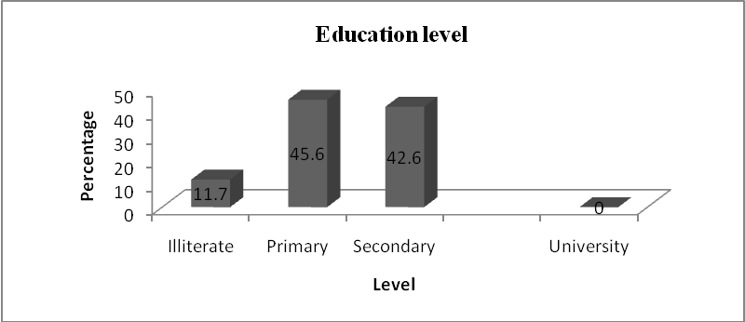
Figure 1 : Distribution of farmers according to their education level

The above figure 1 of education level indicates that 45.6 % of the farmers have primary level of education, 42.6% have attained the secondary education including secondary schools and other post primary trainings. Among 25% who have frequented secondary schools, none was selected to attain post- secondary education and 11.7% did not get any formal education. Most farmers interviewed in Gasaka marshland have achieved primary schools, meaning that a large number of farmers in Gasaka marshland know to read and to write, which will positively affect the agricultural improvement through adoption of new agricultural production systems and facilitate trainings in domains related to agricultural production.

Household size
Table 3: Distribution of farmers according to their household size
Household size | Frequency | Percentage
1 person | 2 | 2.9
2-3 persons | 9 | 13.2
4-7 persons | 56 | 82.4
8-10 persons | 1 | 1.5
Greater than10 persons | 0 | 0
Total | 68 | 100.0

Concerning the household size, 82.4% of respondents affirmed that their families are composed of 4 to 7 persons per family; 13.2% said 2 to 3 persons; 2.9% are orphans; 1.5% have a large family (8 to 10 persons) and no interviewed farmers with a family greater than 10 persons.

Farmer’s occupation
Table 4: Distribution of farmers according to their occupation
Activity | Frequency | Percentage
Agriculture | 50 | 73.5
Animal husbandry | 4 | 5.9
Education/(Teacher) | 7 | 10.3
Function of state | 5 | 7.4
Commerce/busness | 2 | 2.9
Total | 68 | 100.0

According to the farmer’s occupation as presented in table 4, 73.5% of interviewed are full farmers, 10.3% are teachers at Musagara secondary school; 7.4% are working in various public services; 5.9% are rearing animals and 2.9% are working in small scale commercial activities (shopping and cloth selling in local markets).
The farmers in Gasaka marshland are active, with a high participation of women, and a large number of people usually work in agricultural activities. Considering this human resources, we have found that age, education level and different occupations of famers have influenced positively the adoption of rice plantations.

3.2. Ecological factors

Soil types
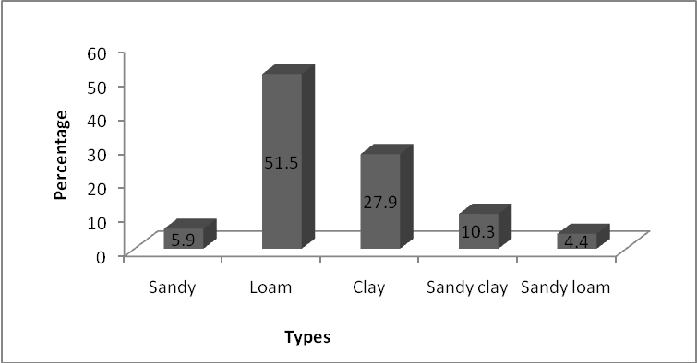
Figure 2: Distribution of farmers according to the soil types

According to the figure 2, most farmers, greater than a half (51.5%) responded that they grow crops over the loamy soils in Nyabarongo marshland. This is due to the water erosion carrying out the soil from the surrounding hills and depositing it in valley. The 27.9% of respondents affirmed that the soils used for agriculture is clay. This is the normal type of marshland soils. The small portion of farmers affirmed that they are growing the rice over sandy soil, soils which have been carried in their fields by Mugwato flooding in April 2007. The 16.2% of interviewed farmers have the mixture soils. This is due to the sandy, alluviums filled in farmers’ fields nearby Nyabarongo banks during flooding.

Water availability within plots
Table 5: Water availability within plots
Availability of water | Frequency | Percentage
Non water available | 15 | 22.1
Insufficient water in fields | 38 | 55.9
Enough | 6 | 8.8
Excess water | 9 | 13.2
Total | 68 | 100.0

The water sources are in the upper part of the marshland; hence 13.2% of interviewed farmers having land plots in that location of marshland encounter the excess of water. While 55.9% are growing rice with small amount of water; some time disappear during dry season, 8.8% have enough water for rice growing; and the 22.1 have no water all year rice season: they are growing the rice variety which depends on rainfall, WAT1276-22-2.

Challenges for sugarcane plantation
Table 6: Friedman’s test for challenges for sugarcane plantation
Extent of dependency | Mean Rank | Test statistics
Pest and diseases | 3.39 | N 68
Low skills | 2.91 | Chi- Square 57.673
Lack of specific inputs | 3.13 | Degree of freedom 4
Flooding and erosion | 2.29 | Asymptotic. Significance 0.000
Drought | 3.28

The table 6 shows that the main challenges encountered by farmers for sugarcane plantation in Gasaka marshland were flooding due to Nyabarongo over flows and runoff from surrounding hills with mean rank of 2.29; low skills of farmers related to sugarcane crop management with 2.91; lack of specific fertilizers mainly KCl and insufficient organic manure with mean rank of 3.13; drought due to long dry season with3.28 and then pests and diseases with mean rank of 3.39. These challenges are statistically different since the probability P-value (0.000) is less than the significance level. Analysis done using a 5 point Likert scale ranging from 1- very important through 5-least important and according to this scale, the lower the mean rank, the higher risk attached by farmers to a given challenge. The most important challenges encountered by farmers for sugarcane productions in Gasaka marshland were flooding and erosion and the low skills of farmers.

Challenges encountered by farmers for rice plantation
Table 7: Friedman’s test for challenges for rice plantation in Gasaka marshland
Extent of dependency | Mean Rank | Test statistics
Pests and diseases | 4.52 | N 68
Low skills of farmers | 2.23 | Chi-square 194.637
Lack of specific inputs in local area | 4.12 | Degree of freedom 5
Flooding and erosion | 2.23 | Asymptotic significance 0.000
Drought | 4.92
Water shortage | 2.98

The table 7 shows that the main challenges encountered by farmers during rice plantation are: low skills of farmers for rice cultivation practices and management ranked with 2.23; flooding from Nyabarongo, Cyacika and Mugwato overflows and runoff from surrounding hills ranked by 2.23; water shortage within blocks 2.98; lack of required inputs in local markets nearby like pesticides with mean rank of 4.12 pests and diseases with mean rank of 4.52 and the drought due to long dry season with mean rank of 4.92. We have hypothesized that the low skills of farmers and flooding are the main challenges encountered by farmers in Gasaka marshland for rice production.
To verify this hypothesis, the Friedman’s test was used, in which challenges were ranked, and rated using 5-point Lickert scale. Since the probability value, P is less than the significance level (P<0.05), we conclude that there is a statistical significance difference between challenges, and we need to know the most important challenges using a 5-point scale. Since low skills of farmers and flooding have the lowest mean score, we affirm that the main challenges for rice plantation in Gasaka marshland are low skills of farmers and flooding associated to erosion.We can also note the water shortage which is another factor hindering farmers for rice production.
The table 8 indicates that the factors that influenced farmers to leave sugarcane plantation were the change in national land use policies for the agricultural exploitation of marshes represented by 1.91 followed by thefts of sugarcane by “street boys” and unserious mining companies’ workers ranked with 2.29; unlucky sale of production with mean rank of 4.65; insufficient manure to apply to sugarcane during plantation (4.71); low yield of sugarcane in 2007 and 2008 with mean rank of 4.81; long time to harvest (4.81) and higher costs of production for fertilizers and time consuming for management (weeding) ranked with 4.81. Friedman’s test shows that these reasons are significantly different since the P value is less than significance level (P<0.05) and the most important reasons are the change in land use by government and thefts of sugar canes in the field as they present the lowest mean scores at 5-point Lickert scale.

Reasons why farmers leave sugarcane plantation
Table 8: Reasons why farmers leave sugarcane production
Variables | Mean Ranks | Test statistics
Low yield | 4.81 | N 68
Thefts  Inappropriate market of production | 2.29  4.65 | Chi- square 274.829
Lack of specific inputs | 4.81 | Degree of freedom 6
Long life cycle in field | 4.71 | Asymp. significance 0.000
Higher production costs | 4.81
Change inland use by Government | 1.93

Ecological factors influencing the farmers to grow rice
Table 9: Friedman’s test for ecological factors influencing farmers to row rice
Extent of dependency Mean Rank
Available water within plots | 4.6 | N 68
Soil conditions | 2.91 | Chi-square 174.325
Climate | 4.23 | Df 5
Topography of land | 2.29 | Asymp. Sig. 0.000
Rainfall | 4.67
Water resource for irrigation | 2.29

The table 9 shows that the factors that influenced farmers to grow rice were available water rising from water table in upper part of marshland with mean rank of 4.6, soil conditions (loamy to sandy-clay soil, easy to ploughing and taking long time to dry out) with 2.91; climatic conditions (mean temperature, weak wind ) with 4.23, land flatness with 2.29, light rainfall with 4.67 and water sources (Nyabarongo river and Mugwato water course) that can be used for watering (irrigation) to supplement available water in blocks and during critical periods with mean rank of 2.29. We have hypothesized that the rice plantation in Gasaka marshland was influenced by land topography, soil conditions and available water within plots. To verify this hypothesis, the Friedman’s test is used in which ecological factors are ranked, and rated on a 5-point scale.
Since the P value is less than the significance level, (P<0.05), we conclude that there is a statistical significance, and we need to know the most important ecological factors using a 5-point Likert scale. Since the topography of land and soil conditions have the lowest mean scores, we conclude that the land topography and soil conditions are viewed as the most important ecological factors that influenced farmers to grow rice in Gasaka marshland, but not water available within plots. Water resources for irrigation were also noted as another main important factor considered.

3.3. Production factors
The production factors that we have considered during our study are land, agriculture inputs, sources of labour days and capital to run farm activities and the use of production.

Land holdings
Table 10: Size of land
Size of land (acres) | Frequency | Percentage%
<1 | 0 | 0
1-5.9 | 15 | 22.1
6-10.9 | 21 | 30.9
11-15.9 | 3 | 4.4
16-20 | 19 | 27.9
>20 | 10 | 14.7
Total | 68 | 100.0
The results presented in table 10 show that there is no association lending land less than 1 acre, 22.1% are using land plots ranging between 1 to 5.9 acres, 30.9% are lending land size between 6 to10.9 acres, 4.4% are using land plots between 11 to 15.9 acres; 27.9% for 16 to 20 acres while 14.7% of respondents said they are using a land size greater than 20 acres for farming activities. It is very meaningful that the size of land influences the adoption of rice plantation. If the size of land becomes small, the adoption becomes difficult.

Land tenure

Table 11: Land tenure
Land tenure | Frequency | Percentage
Rent | 68 | 100.0
Bought | 0 | 0
Inherited | 0 | 0
Given as gift by government | 0 | 0
Total | 68 | 100.0

The table 11 shows that 100% of interviewed farmers responded that each association must pay the annual land rent to the local Government before carrying their farm activities. These farmers added that each acre of land is paid 400Rwf per year.

Agriculture inputs
The following table 12, tells us the inputs used and implement tools used to run farm activities.

Table 12: The use of agriculture inputs
Inputs |  | Frequency | Percentage
Selected seeds |  | 0 | 0
Organic matter |  | 8 | 11.8
Mineral fertilizers |  | 40 | 58.8
Pesticides |  | 6 | 8.8
Implement tools | Hand hoe | 68 | 100.0
Implement tools | Tractor | 0 | 0

The table 12 above shows that11.8 % of interviewed farmers use only organic matter, 58.8% use mineral fertilizers, 8.8% use pesticides to control pests, none of them practice mechanized agriculture using tractor, but all use hand hoes.

Source of labours
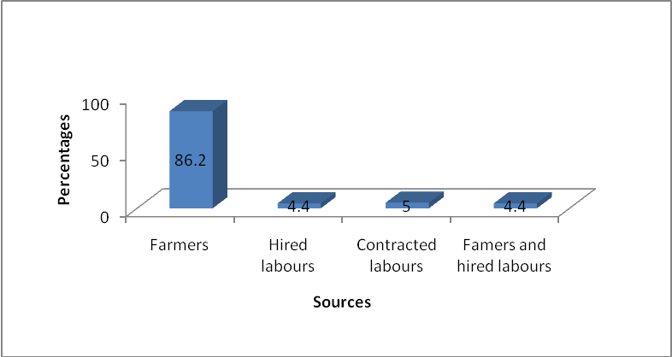
Figure 3: Sources of labour days used in farm activities

As shown in figure 3, most of farmers’ associations use members themselves as source of labours, as responded by 86.2% of interviewed farmers. About 4, 4% were found to hire labour while 4.4% used both family labour and hired one. Farm- contracted labour was 5%.

Source of capital to run farm activities

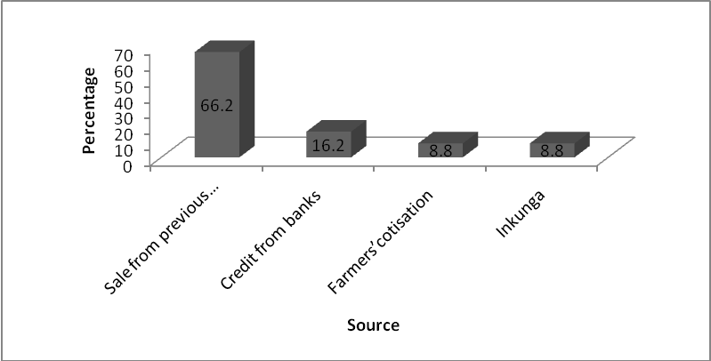
Figure 4: Source of capital to run farm activities

The figure 4 shows that 66.2% of interviewed farmers were using the money obtained from the sale of previous production, 16.2% were using credits from banks, 8.2 % were using the contribution of farmers and 8.8% were using money given by sponsorship from CARITAS to HIV/AIDS seropositives.

Main users/ buyers of sugar cane produced by farmers’ associations
The figure 5 shows that all interviewed farmers affirmed the main buyer of their sugarcane was Madhvani group, 30.9 % said they sold the sugarcane to mining company staffs on surrounding; 16.2% added that there are children who purchased sugar cane and selling them in local markets and centers during holidays; 23.5% added they consumed sugarcane at home during harvesting period; 4.4% farmers said that they use for next season as seed plants.
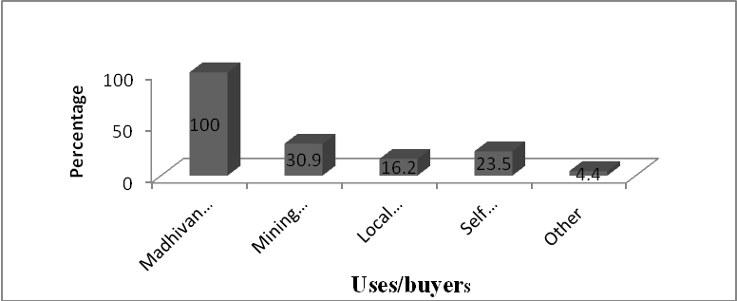
Figure 5: Main buyers of sugarcane

The main uses of rice produced by farmes’ association

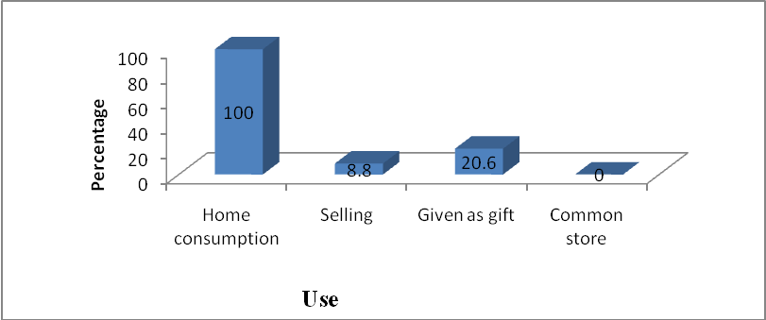
Figure 6: Use of rice

The figure 6 shows us that 100 % of respondents affirmed that a large amount of their rice production is used for self consumption at home after processing; 8.8% added they sell in local market as well as in local centres; 20.6% said that there is an amount of rice given to friends as gift; and no common store was created to safely store the production, as an alternative set by government policy to keep quality of post harvest products. Taking into account the production factors, land ownership, sources of capital to run farm activities, distribution of land plots among farmers’ associations, availability and level of using agricultural inputs and the use of production , we found that these economic factors have influenced positively the farmers in land use change. Farmers were advised to create agricultural cooperatives and to implement land consolidation in order to increase production, by making groups to get easily agricultural inputs, credits and trainings; facilities for monitoring the outbreak of major pests and diseases that affect productivity in rice and birds control and crop management.

Suggestions of farmers for better exploiting Gasaka marshland
The table 13 shows that a larger number of farmers (100%) interviewed proposed the technical assistance at farm level and making available the agricultural inputs especially fertilizers, improved seeds, pesticides in local markets and 82.3% of interviewed prefer demonstration fields to improve their planting techniques and field school; and 60.3% of interviewed farmers propose the accessibility to agricultural credits, but above all they must form cooperatives and hold the land fragments together.

3.5. Net Incomes and production costs for sugarcane and rice production

Net Income from sugarcane production
The following table14 illustrates the main activities, inputs, services, and economic transactions involved in net income determination for sugarcane production in Gasaka marshland, through Cost- Benefit analysis.

Table 13: Approaches for better use of Gasaka marshland
Approach | Frequency | Percentage%
Demonstration fields | 56 | 82.3
Access to agricultural credit | 41 | 60.3
Technical assistance at farm level | 68 | 100.0
Availability of agricultural inputs in local market at time | 68 | 100.0
Availability of cheaper equipment in local market | 30 | 44.1

Table 14: Cost-Benefit analysis for Sugarcane
Item | Unit | Quantity of input /labour |  | Unit cost | Total cost (Rwf)
Ploughing | Labour days | 100 | M | 600 | 60,000
Ridges formation | Labour days | 40 | M | 600 | 24,000
Manure | Kg | 25,000 |  | 5 | 125,000
Manure transport | Labour days | 60 | HL | 600 | 36,000
Manure spreading | Labour days | 30 | M | 600 | 18,000
Fertilizer DAP | Kg | 130 |  | 600 | 78,000
Fertilizer Urea | Kg | 300 |  | 470 | 141,000
Fertilizer KCl | Kg | 250 |  | 650 | 162,500
Preparation of land | Labour days | 60 | M | 600 | 36,000
Seed | are | 100 |  | 1,000 | 100,000
Seed transport | Labour days | 5 | M | 600 | 3,000
Land Spreading and Planting | Labour days | 40 | M | 600 | 24,000
Water management | Labour days | 60 | M | 600 | 36,000
Earthling up | Labour days | 80 | M | 600 | 48,000
Weeding | Labour days | 180 | M | 600 | 108,000
Pest control | Kg | 0.5 |  | 8,000 | 4,000
Land rent | Ha | 1 |  | 40,000 | 40,000
Supervision and Mgt | Month | 9 | HL | 7,000 | 63,000
Temporal fencing | Ha | 1 |  | 7,000 | 7,000
Cutting Charges | Labour days | 40 | M | 1,000 | 40,000
Hired transport | Labour days | 40 | HL | 500 | 20,000
Total Production Costs |  |  |  |  | 1,173,500
YIELD |  | 65,000 Kg per hectare per year
Farm gate price (Lowest) |  | 30Rwf per kilo
Farm gate price (Highest) |  | 35Rwf per kilo
Gross Income (Lowest) |  | 1,950,000Rwf
Gross Income (Highest) |  | 2,275,000Rwf
Average Gross Income |  | 2,112,500Rwf
Net Income (Profit)- Lowest |  | 776,500Rwf
Net Income (Profit)- highest |  | 1,101,500Rwf
Average net income |  | 939,000Rwf
Source: Results (2012) M: Member labour days; HL: Hired labour days

4.5.2. Net Income from rice production
The following table16 illustrates the main activities, inputs, services, and economical transactions involved in net income determination for rice production in Gasaka marshland.

Table 15: Cost / Benefit Analysis for Rice production in Gasaka marshland
Item | Quantities | Labour | Unit cost(Frw) | Total Cost (Frw)
Land rent | 1 Ha |  | 40,000 | 40,000
Seeds | 70 Kg |  | 350 | 24,500
Pesticides | 0.5 Kg |  | 5,000 | 2,500
Fertilizer DAP | 100 Kg |  | 600 | 60,000
Fertilizer Urea | 100 Kg |  | 470 | 47,000
Manure | 10,000 Kg |  | 5 | 50,000
Seed bed preparation | 20 Labour days | M | 600 | 12,000
1st ,2nd, 3rd ploughing | 190 Labour days | M | 600 | 114,000
Planting | 60 Labour days | M | 600 | 36,000
Weeding | 160 Labour days | M | 600 | 96,000
Water channelling | 30 Labour days | M | 600 | 18,000
Pesticide application | 5 Labour days | M | 600 | 3,000
Fertilizer application | 10 Labour days | M | 600 | 6,000
Bird / vermin control | 180 Labour days | HL | 1,000 | 180,000
Harvesting | 120 Labour days | M | 600 | 72,000
Transports | 10 Labour days | HL | 600 | 6,000
Drying | 30 Labour days | M | 600 | 18,000
Weighing | 6 Labour days | M | 600 | 3,600
S/ Total production cost |  |  |  | 788,600
Hired transport | 3,700 Kg | HL | 300/50 Kg | 22,200
Processing | 3,700 Kg |  | 6 | 166,500
Total Production Costs |  |  |  | 977,300
Yield |  | 4,500kg of paddy rice ( 2,700 kg of polished rice) per ha per season
Unit price (Lowest) |  | 550Rwf per Kg
Unit price (Highest) |  | 600Rwf per kg
Gross Income (Lowest) |  | 1,485,000Rwf
Gross Income (Highest) |  | 1,620,000Rwf
Average Gross Income |  | 1,552,500Rwf
Net Income (Profit) for lowest |  | 507,700Rwf
Net Income (Profit) for highest |  | 642,700Rwf
Average Net Income |  | 575,200Rwf
Source: Results (2012) HL: Hired Labour days M: Member labour days

1 kg of paddy rice gives 0.55 to0.65 kg of polished rice according to variety grown.
According to the data presented in the table 14, representing the detail of production costs for sugarcane production in Gasaka marsh by farmers ‘associations per one hectare, we see that the estimated production costs is 1,173,500Rwf, estimated sale of production is 2,112,500Rwf supposing the average yield 65,000 kg of canes per ha. As the net income is the gross income minus the total production costs invested, hence the net average income were 939,000Rwf with average 32.5Rwf per kg at the field. There is an additional amount of cash coming from the crop residues sold, used to feed livestock and/or used as mulch by people having banana and coffee plantations on surrounding of marsh.
According to the data presented in the table 15, representing the detail of production costs for Rice production in Gasaka marsh by farmers ‘associations per one hectare, we see that the estimated production costs is 977,300Rwf, including 788,600Rwf invested in paddy production plus 188,700Rwf, additional amount to give the white or polished rice. The average rice value of polished rice is 1,552,500Rwf with estimated average yield of paddy per hectare in Nyabarongo valley of 4,500kg (≈4,500 mironko). The net income is the gross income minus the total production costs invested; hence the net average income is 575,200Rwf with average 575Rwf per kg of polished rice. The variability of price depends on rice varieties; Kigoli is sold at 550Rwf while WAT 1276-22-2 is sold at 600Rwf at famer’s home.
It has hypothesized that the annual Net income from rice is higher than that one that farmers were getting from sugar cane plantations in Gasaka marshland. A simple comparison test using Cost/benefit analysis shows that the sugarcane is more profitable than the rice. This statement is justified by Net Income to farmers from sugar cane which is greater than that one from rice plantations, in the order of 939,000Rwf and 575,200Rwf per ha respectively.
However, the sugar cane is grown once a year due to its long life cycle of 12 to18 months, while rice is grown twice a year (its life cycle ranges between 120 to 160 days depending on climate and varieties grown), hence the annual farmers’ income for sugarcane remains 939,000 Rwf while the rice is doubled to 1,150,400 Rwf per ha. We have concluded that the annual income from rice is greater than that one from sugarcane productions.

Production costs for sugarcane
Gross margin for sugarcane
The following table 16 shows the main costs involved in sugarcane production, total gross incomes and their corresponding values in Gasaka marshland.

Table 16: The main costs involved in sugarcane production and total gross incomes
Item | Quantity | Unity | Frw/unity | Total Rwf
Gross income
Sugarcane sold | 65,000 | Kg | 32.5 | 2,112,500
Other income | 1 | Ha | 10,000 | 10,000
Total gross income |  |  |  | 2,122,500
Production costs
Labour days | 655 | Labour days | 600 | 393,000
Fertilizers | 1 | Ha | 506,500 | 506,500
Seeds | 100 | Are | 1,000 | 100,000
Pesticides | 0.5 | Kg | 8,000 | 4,000
Management&control | 1 | Ha | 70,000 | 70,000
Harvesting | 40 | Labour days | 1,000 | 40,000
Hired transports | 40 | Labourdays | 500 | 20,000
Land rent | 1 | Hectare | 40,000 | 40,000
Processing |  |  |  | 0
Total production costs |  |  |  | 1,173,500
Gross margin |  |  |  | 949,000

According to the table17, the results reflects that the sugar cane production is profitable as the Gross margin is greater than 0.

Costs of production for rice
Gross margin for rice production per hectare
The following table 17 shows the main costs involved in rice production, total gross incomes and their corresponding values in Gasaka marshland.

Table 17: The main costs involved in rice production and total gross incomes
Items | Quantity | Unity | Frw/unity | Total Rwf
Gross income
Harvested grains | 3,700 | kg | 375 | 1,552,500
Other income | 1 | Ha | 2,000 | 2,000
Total gross income |  |  |  | 1,554,500
Production costs
Labour days | 521 | Labour days | 600 | 312,600
Fertilizers | 1 | Ha | 157,000 | 157,000
Seeds | 70 | Kg | 350 | 24,500
Pesticides | 0.5 | Kg | 5,000 | 2,500
Management&control | 180 | Labourdays | 1,000 | 180,000
Harvesting | 120 | Labour days | 600 | 72,000
Hired transports | 3,700 | Kg | 300/50Kg | 22,200
Land rent | 1 | Ha | 40,000 | 40,000
Processing | 3,700 | Kg | 45 | 166,500
Total production costs |  |  |  | 977,300
Gross margin |  |  |  | 577,200

The results in table 17 show that the rice production is profitable as the Gross margin is greater than 0. As shown in the tables 16 and17, the costs involved in production, from ploughing to selling or ready for household consumption, are classified in 5 groups. In the first group, labour days used in various field activities for sugarcane costs 80,400Rwf greater than that one’s invested in rice production; The second group refers to inputs (fertilizers, pesticides and seeds), where the sugarcane costs 426,500Rwf are greater than the one invested in rice production. This is due to higher requirements of sugarcane in manure, urea and Kcl; The third group consists of crop security in field, where the sugarcane costs 110,000Rwf less than that the one invested in rice production. This is due to a high investment in bird control from flowering to harvesting, while sugarcane needs a temporal fencing and theft control at maturity stage of canes. At fourth place comes harvesting and processing, including all activities involved in removing products from fields, hired transports and processing costs. In this category of costs, sugarcane costs 200,700Rwf less than that one used in rice processing. This difference is explained by the high hired transport of paddy and processing payments, while cutting of canes in the fields, transport them to the roads, and dumping them in vehicles are only activities involved in sugarcane harvesting and processing. We have hypothesized that the farmers in Gasaka marshland are using the lower production costs for rice compare to that one they were using for sugarcane production. To test this hypothesis, we have used the paired sample tests.

Table 18: Paired sample test for sugarcane and rice productions
 | Paired difference
 | Mean | Standard deviation | Standard Error | 95% confidence interval of Difference |  | t | df | Sig.(2 tailed)
 |  |  |  | Lower | Upper | t | df | Sig.(2 tailed)
Pair1 Sugarcane& Rice | 2.180E4 | 146155.243 | 48718.414 | -90544.865 | 134144.865 | 0.447 | 8 | 0.666

The Null hypothesis according to t-test is that there is no difference between two production costs. Since the calculated t value (0.447) is less than the read t value on table (2.306), we accept the null hypothesis and we conclude that there is no statistical significant difference between the production costs. Since the mean comparison of productions costs using one sample statistics shows that the mean of costs for sugarcane production is greater than the one for rice production, (the mean of production costs for sugarcane and rice productions are 1.30x10⁵ and 1.09 x10⁵ respectively), we affirm that the farmers in Gasaka marshland are using the lower production costs for rice compare to that one they were using for sugarcane production.

Table 19: Mean comparison of production costs using one sample test’s statistics
 | N | Mean | Std. Deviation | Std. Error Mean
Rice | 9 | 1.09E5 | 102621.531 | 34207.177
Sugarcane | 9 | 1.30E5 | 185908.542 | 61969.514

The profitability of the rice production in Gasaka marshland as well as in other rice perimeters in the country could be greatly enhanced if farmers themselves use some of the agronomic practices shown above to reduce costs such as seedling preparation, birds control and manure transport (Rucibigango et al., 2003).

Conclusion
The main objective of this study was to analyze the factors influencing the adoption of rice instead of sugar cane plantations by farmers’ associations by means of knowing social, economic and ecological factors influencing the adoption of rice instead of sugarcane plantations by in Nyabarongo valley, Gasaka marshland in Muhondo sector of Gakenke district in Rwanda. Results showed that the change in land use of the marshes by the government, the problem of sugarcane thefts, the high costs and lack of appropriate agricultural inputs in local areas, less annual revenue of sugarcane compared to that one from rice, availability of water to be used for irrigation, climatic and soil conditions, are the main factors that influenced these farmers to leave sugarcane plantation and adopt rice production. Rice planting is the best production compared to sugar cane because the Net income per ha per year for rice is higher compared to the one of sugarcane, and the rice is produced twice a year while sugar cane is being produced once in whole year, and some time takes a year and half for its growth cycle, explaining high risk to climatic changes and high management costs. Unfortunately, we have seen that the major challenges encountered by farmers who produce less are low level of farmers’ skills, lack of specific and timely inputs in local areas; different natural disasters like flooding caused by Nyabarongo overflows and water erosion from surrounding hills, drought and capital resources for investments. Farmers need to get the technical assistance at farm level by agronomists, due to inadequate skills to grow rice, especially fertilization, pest control and watering within plots, access to agricultural credits, field demonstration schools and trainings, and specific inputs (fertilizers and pesticides) and equipments in local areas.

Acknowledgements:
We acknowledge the financial and technical supports provided by the Higher Institute of Agriculture and Animal Husbandry (ISAE)-Busogo for the completion of this study.

*Corresponding author
Alphonse Nahayo
Higher Institute of Agriculture and Animal Husbandry (ISAE) – Busogo; Department of Forestry and Nature Conservation; P.O.Box 210 Musanze, Rwanda; Mobile phone: +250 725 806 305; Email: nahayo1@yahoo.fr

References
1. MINAGRI, 2006. Politique Nationale Agricole. Kigali, Rwanda. 89pp.
2. MINAGRI, 2009. Strategic plan for transformation of agriculture in Rwanda. Phase II, Final report, 114pp.
3. MINAGRI, 2009. Rwanda Agriculture and Development. MINAGRI, Kigali, Rwanda.49pp.
4. Monographie du district de Gakenke, 2009.19pp
5. Muhondo sector, 2012. Raporo y’ubuhinzi bwo mu gishanga cya Gasaka. Saison A 2012.15pp
6. Muriel V., RCN Justice and Démocratie Marco Lankhorst, 2011. Socio-economic impact of commercial exploitation of Rwandan marshes: A case study of sugar cane production in rural Kigali. 211pp
7. Rucibigango M., Jagwe J.N., G. Okoboim, P. Hakizimana, J. Tuyisinge, 2003. Marketing Survey of the Rice sub-sector in Rwanda. International Institute of Tropical Agriculture (IITA FOODNET), Institut des Sciences Agronomiques du Rwanda, 53pp.

9/29/2012

