Effect of some meteorological factors on seasonal abundance of Idioscopus nitidulus (Walker) (Hemiptera: Cicadellidae) in mango orchards of Haridwar (India)

P.C. Joshi and Sanjay Kumar

Insect Biodiversity Laboratory, Dept. of Zoology and Environmental Sciences,
Gurukula Kangri University Haridwar
(Emai: kumarsanjaynitin2011@gmail.com)

Abstract: Present study deals with the effect of meteorological factors on seasonal abundance of mango hoppers in mango orchards of Haridwar. The mango Idioscopus nitidulus (Walker) (Hemiptera: Cicadellidae) is serious pest of mango in district Haridwar. Pest population remains low during winter and starts appearing with the panicle emergence. The damage is mainly caused by the hoppers due to sucking of sap from inflorescences, leaves and tender shoots. Meteorological factors viz. temperature, humidity and rainfall affect the mango hopper population. Peak hopper population (5.57) was recoded in May on temperature range of (37.10ºC) as maximum, whereas, relative humidity was very, low (48%). With the increase in temperature and decrease in relative humidity, hopper population raised. Thus, temperature positively affected the hopper population, whereas, relative humidity had negative effect, but rainfall showed no significant effect, as it was fluctuating. Experiments on influence of meteorological factors on the incidence of mango hopper were conducted at mango orchard of Haridwar. The mango hoppers correlated positively with temperature(r= 0.9383) on other hand negatively and significantly with relative humidity (r= - 0.1313) and non-significantly with rainfall (0.3530).
[P.C. Joshi and Sanjay Kumar. Effect of some meteorological factors on seasonal abundance of Idioscopus nitidulus (Walker) (Hemiptera: Cicadellidae) in mango orchards of Haridwar (India).
N Y Sci J 2012;5(12):101-103]. (ISSN: 1554-0200). http://www.sciencepub.net/newyork. 15

Key words-Meteorological factors, seasonal abundance, Idioscopus nitidulus

INTRODUCTION
Mango is one of the major fruit crops of south Asia from ancient time and at present it is prominent horticulture crop of India. It is grown in India in large extent and is considered as a king of all the fruits. The largest producer state of mango is Uttar Pradesh. In proportion to its area of cultivation, its production is very low due to insect pests. Among the mango pests, mango hoppers are most serious and widespread pests throughout the country. I. clypealis (Leth.) is most common and destructive species of hoppers, which cause heavy damage to mango crop. Large number of nymphs and adults of the hoppers puncture and suck the sap from tender shoots, inflorescence and leaves of mango crop, which cause non-setting of flowers and dropping of immature fruits, thereby reducing the yield. Hoppers also excrete a secretion, called honey dew. In moist weather, it encourages the development of fungi like Meliola mangiferae (Earle), resulting in growth of sooty mould on dorsal surface of leaves, branches and fruits. This black coating interferes with the normal photosynthetic activity of the plant, ultimately resulting in non-setting of flowers and dropping of immature fruits. This damage is called as Honey Dew Disease. Mango hoppers were found colonized during both vegetative and reproductive phase of the crop. Hoppers remain active throughout the year in cracks and crevices of mango trunk (Babu et al., 2002) but they are recorded on twigs, when young leaves and inflorescence are available Patel et al., 1994). Many workers have provided data on seasonal incidence and influence of weather paramters on the development of the hoppers (Sood, et al., 1971, Dalvi and Dumbre 1994, Hiremath and Hiremath 1994, Dwivedi, et al., 2003, Anitha et al., 2009). The study on influence of abiotic factors on the incidence of hopper and chemical control strategies in mango orchards was carried out by Anitha et al.,(2009). Hence detailed studies were carried out to determine the effect of some abiotic factors on population buildup of Idioscopus nitidulus (Walker) in District Haridwar of Uttarakhand.

MATERIALS AND METHODS
In the present study hoppers were collected from mango orchard of district Haridwar of Uttarakhand(India). Hardwar district covering an area of about 2360 sq. km. is in the Western part of the Uttarakhand state of India. Its latitude and longitude are 29º 58 N and 78º 13 E respectively. Five trees from mango orchard were selected and were named A, B, C, D and E and observations were taken on the inflorescence of respective trees at two weeks interval. The hopper populations were recorded from January to April through bagging trap methods as suggested by Varghese and Rao, 1987). In this method the terminal part of inflorescence was covered with a polythene bag (60×30 cm), provided with a cotton swab and soaked in ethyl acetate. After the trapping of mango hoppers, bags were brought to the laboratory, and nymph and adults were separated. During the month of May to December, the population of adults was abundant as compared to nymph. This time another method (Sweeping) was applied for collection of hoppers. Meteorological data from April 2008 to March 2009 on temperature, relative humidity was derived by using thermo-hygrometer on sampling dates and data on rain fall of selected site was collected from Meteorological Station, Roorkee (Haridwar). To study the seasonal incidence of mango hoppers study site was selected with employing any plant protection measures.

RESULTS
It was observed (Table 1) that in the month of January when no hopper was seen on the mangoes trees in the research sites, the mean maximum temperature (14.5⁰C) was very low, while, the relative humidity was (67%) and rainfall was also very low (3.09mm). During the month of February when the hoppers started appearing, mean temperature (21ºC) and also started rising; whereas, the relative humidity (RH) showed slight decline (50%). However, rainfall (RF) showed fluctuation in its value (28.09 mm). The increase in the hopper population (HP) was found to be associated with the flushing of inflorescence, as this species of hoppers bred only on inflorescence. The peak of hopper population (5.57, 5.14) was recorded in the month of May, June respectively in the study areas and it was seen that at this time mean temperature (37.10⁰C and 34..60ºC) were extremely high. However, relative humidity was very low (48%). On the other hand rainfall was not showed great fluctuations (27.50 mm). From July onwards hopper population started declining (4.41) with that mean maximum temperature (31.80ºC) also decreased; whereas, relative humidity increased (80.00%) and rainfall showed fluctuations (290 mm). The data on correlation coefficient between meteorological factors and hoppers revealed that the correlation between temperatures and hopper population was positive (0.9383) and significant (Figure 1 and Table 2). The correlation between relative humidity was negative (-0.1313) and significant (Figure 2 Table 2). The correlation between rainfall and hopper population was positive (0.3530) and non-significant (Figure 3 and Table 2). Kannan and Rao (2006) reported that there was negative relationship between the incidence of the hopper and minimum temperature, evening relative humidity and rainfall. It has been reported that the hopper population was positively correlated with maximum temperature and negatively with relative humidity Pushpalatha 2008).

Table 1- Effect of abiotic factors on population buildup of Idioscopus nitidulus (Walker) in different environmental conditions of Haridwar (2008)
S.N. | Months | Temp(ºC) | Humidity (%) | R.F. (mm) | H.P.
1. | Jan | 14.5 | 67.00 | 3.90 | 0
2. | Feb | 21 | 50.00 | 28.90 | 1.57
3. | Mar | 28 | 72.00 | 4.70 | 3
4. | Apr | 30.40 | 50.00 | 17 | 4.42
5. | May | 37.10 | 48.00 | 27.50 | 5.57
6. | Jun | 34.60 | 55.50 | 36.60 | 5.14
7. | Jul | 31.80 | 80.00 | 290.80 | 4.41
8. | Aug | 29.5 | 95.00 | 280.50 | 4.00
9. | Sep | 26.40 | 84.00 | 96.50 | 3.20
10. | Oct | 28.30 | 76.00 | 19.60 | 2.71
11. | Nov | 22 | 74.00 | 14.20 | 2.85
12. | Dec | 12.80 | 70.00 | 0.8 | 1.42

Table 2- Correlation coefficients between meteorological factors and mango hoppers
S.N. | Meteorological factors | Correlation coefficient
1. | Temp. | 0.9383
2. | Hum. | - 0.1313
3 | Rainfall | 0.3530

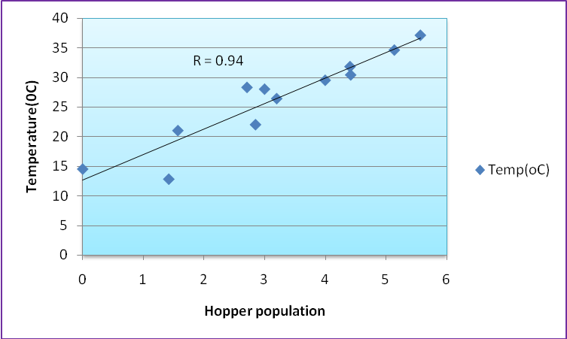
Figure 1- Showing correlation between temperature and hopper population

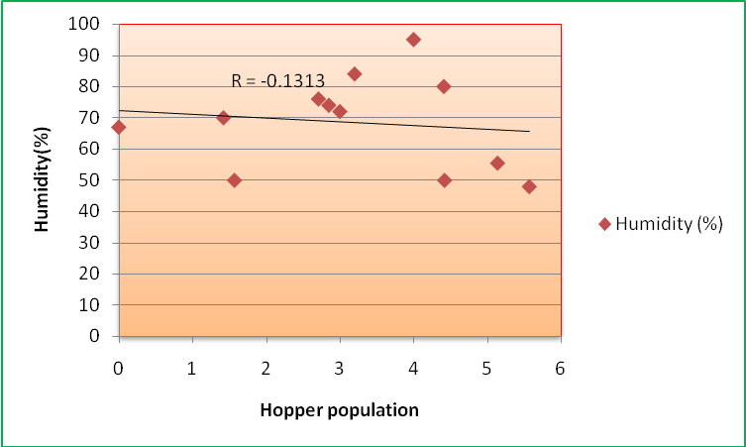
Figure 2- Showing correlation between humidity and hopper population

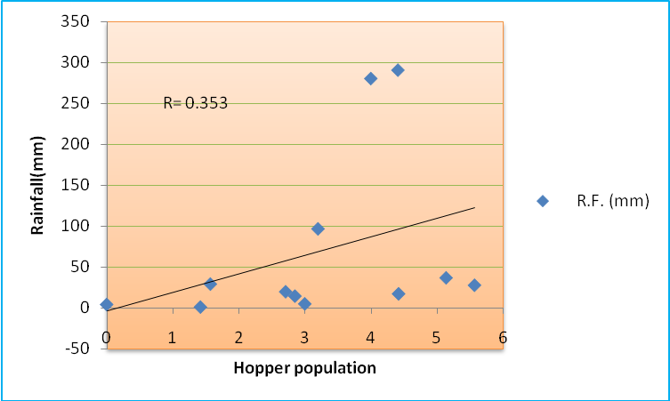
Figure 3- Showing Correlation between rainfall and hopper population

DISCUSSION
From these observations, it can be concluded that population of Idioscopus nitidulus (Walker) is strongly affected by temperature and relative humidity, which is in accordance to the findings of many workers(Dalvi and Dumbre 1994), (Dwivedi et al., 2003), (Palo and Garcia 1935), ( Fletcher and Dangerfield 2002). It was reported that the mean maximum and mean minimum temperature have positive effect on hopper population (Babu et al 2002), Patel et al., (1994), Sood 1971).Relative humidity has negative effect on hopper population, which is in conformity with the findings of Tandon et al., 1983, Hiremath and Hiremath (1994) and Pezhmanand and Radjabi (2002).

ACKNOWLEDGEMENTS
Authors are very thankful to UGC, New Delhi for providing financial assistance and to department for laboratory facilities.

REFERENCES
1. Babu, L.B., Maheshwari, T.M. and Rao, N.V. (2002): Seasonal incidence and biology of the mango hoppers. Entomon, 27, 35-42.
2. Patel, J.R., Shekh, A.M. and Ratanpara, H.C. (1994): Seasonal incidence and effect of minimum temperature and vapour pressure on the population of mango hoppers in middle Gujarat. Guj. Agric. Uni. Res. J., 20, 5-8.
3. Sood, N.K., Singh, K. and Rathore, V.S. (1971): Correlation of population fluctuation of Idioscopus clypealis (Lethierry) (Homoptera: Jassidae) with weather conditions. Ind. J. Hort., 28, 169-171.
4. Dalvi, C.S. and Dumbre, R.B. (1994): Breeding and seasonal incidence of mango hoppers. Bull. Entomol. 35, 1008-1010.
5. Hiremath, S.C. and Hiremath, I.G. (1994): Studies on seasonal incidence and nature of damage of mango hoppers. Bull. Entomol., 35, 78-83
6. Dwivedi, S.C., Singh, S.M.K. and Katiyar, R.R. (2003): Seasonal incidence of insect pests associated with mango crop. Ann. Plant Protect. Sci., 16, 159-162.
7. Anitha Kumari, D., Lakshmi, B. K. M. , Sathyanarayana Reddy G. and Lakshminarayana Reddy, M. (2009): Influence of abiotic factors on the incidence of hopper and chemical control strategies in mago orchards.Karnataka J. Agri. Sci., 22(3- Spl. Issue), (601-602).
8. Verghese, A. and Rao, G.S.P. (1987): Determination of relevant critical stages for the management of mango hopper Idioscopus clypealis (Lethierry). Ind. J. Hort., 4, 280-283.
9. Kannan, M. and Rao, N.V., (2006): Ecological studies on mango hopper, Amritodes atkinsoni in Andhra Pradesh as a basis for IPM. Crop Res., 32: 235-238.
10. Pushpalatha, S., Kathirvelu, C. and Nachiappan, R.M. (2008): Correlation of seasonal incidence of mango hopper, Amritodes atkinsoni and weather parameters on certain varieties of mango. Indian J. Trop. Biodiver., 15: 81-83.
11. Palo, M.A. and Garcia, C.E. (1935): Further studies on the control of leaf hoppers and tip borers on mango inflorescence. Phillipine J. Agric., 6, 425-464.
12. Fletcher, M.J. and Dangerfield, P.C. (2002): Idioscopus clypelis (Leth.) a second new leaf hopper pest in Australia (Hemiptera: Cicadellidae: Idiocerinae). Aust. J. Entomol., 41, 35-38.
13. Sen, A.C. and Prasad, D. (1954): Experiments with new synthetic insecticides for the control of mango hoppers in Bihar. Ind. J. Entomol., 16, 234-246.
14. Tandon, P.L., Lal, B. and Rao, G.S.P. (1983): Prediction of the mango hoppers Idioscopus clypealis (Leth.) population in relation to physical environmental factors. Entomon, 8, 257-261.
15. Pezhman, H. and Radjabi, G.H.(2002): Study on biology of handle hopper, Idioscopus clypealis (Leth.) (Homoptera : Cicadellidae) in honnozgon province. Appl. Entomol. Phytopath., 5, 7.

10/5/2012

