Biological control of coffee antestia bugs (Antestiopsis lineaticolis) by using Beauveria bassiana

Alphonse Nahayo^{1,}*, Joseph Bayisenge¹

- Higher Institute of Agriculture and Animal Husbandry (ISAE)-Busogo; Department of Forestry and Nature Conservation, P.O.Box 210 Musanze, Rwanda, email: nahayo1@yahoo.fr

Abstract: This study was conducted in order to contribute to the production of quality coffee free of pest damage and pesticide residues. Antestia bug is reported among insect pests that reduce coffee yield and quality as well. It is supposed that the use of natural enemies do not disturb ecosystem. With the same perspective, this study aiming at controlling coffee antestia bug “Antestiopsis lineaticolis’’ using Beauveria bassiana fungus» was carried out in Rwanda Agricultural Board, Rubona station labolatories with CG432 strain in the period between the 1st July and 31st September, 2011. During this research, we multiplicated Beauveria bassiana on synthetic cultural media (PDA and NA); we tested the viability rate of newly produced and old inoculum of B. bassiana and we tested the efficacy of bio-insecticide produced from B. bassiana to control coffee antestia bug. The results showed that Potato Dextrose Agar (PDA) with controlled temperature (28ºC) and in liquid medium favors mass multiplication of B.bassiana. The produced fungus spores (2kgs) were viable at 95% against 40% of old fungus spores. The average of died antestia bugs per day due to Dursban and B. bassiana produced as bio-insecticide showed that they are in the same homogenous group. With the last results, it is possible to substitute Dursban by bio-insecticide produced because it conserves the ecosystem more than the first one. Considering the fast antesia bugs, Dursban showed high significant difference to eliminate them. We found that it is necessary to pay attention while applying B. bassiana as bio-insecticide because it loses rapidly its viability rate with time and it requires the adequate good temperature to normally work. It is recommended to all coffee stakeholders to set different measures which can promote the use of natural enemies’ especially B. bassiana to control antestia bug and other different insect pests in order to conserve the agro- ecosystem.
[Nahayo A, Bayisenge J. Biological control of coffee antestia bugs (Antestiopsis lineaticolis) by using Beauveria bassiana. N Y Sci J 2012;5(12):106-113]. (ISSN: 1554-0200). http://www.sciencepub.net/newyork. 17

Keywords: Biological control, Antestiopsis lineaticolis, Beauveria bassiana, Coffee

1. Introduction
Coffee is one of the important traditional cash crops in the Rwandan economy and it is classified in major export crops for Africa contributing some US$ billion annum⁻¹(10% of the total) to the foreign exchange earnings in the continent (FAO, 2000). Coffee farming in Rwanda is an important activity that highly contributes to the economy in terms of production, employment and income especially for the small holder farmers. Coffee has been grown in Rwanda since its introduction by German Missionaries as early as 1904. In 1998, coffee production occupied around 6.3 percent of the total cultivated land (OCIR, 1998); and in 2004, there were some 400,000 producers of coffee in Rwanda in different districts (OCIR, 1998). Global coffee production in 2001 was 115.4 million bags of which 60% was from Coffee arabica and 39% Coffee robusta, whereas production has many times doubled since 1970. African’s share of total production declined from 30% to less than 15% (FAO, 2000). Average yields are very low ranging from 0.3 to o.38t per ha (FAO, 2000).The low coffee productivity in most farms is attributed to poor cultural practices, a high incidence of pests and diseases (and associated costs of control) and old coffee trees and other stress (SAP, 2OO2).
Coffee insects are estimated to cause losses of about 13%, but in Africa the yield losses can be higher up to 96% (Waterhouse and Norris, 1989). In different coffee plantations, there are four major pests of economic loss which include white stem borer Anthores leuconatus, antestia bug Antestiopsis sp, coffee berry borer (CBB) Hypothenemus hampei and coffee leaf miner (CLM) Leucoptera meyricki. Other coffe pests have low economic damage.
Researchers in the world for the past several years have been working very hard in trying to identify effective, economic, acceptable and sustainable pest control measures particularly for coffee insect pests (Masaba, 1995). Therefore, in view of contributing to research alternatives for increasing coffee quality and quantity by coffee protection against insects, this study entitled «Biological control of coffee antestia bug “Antestiopsis lineaticolis’’, using Beauveria bassiana fungus» has been carried out in Rwanda Agricultural Board (RAB), Rubona station labolatories. Antestia bug is one of the major pests of coffee in our country. The presence of 2-3 bugs per tree in the field can cause about 45% crop loss (Anonyme, 1997). For pest control, insecticides have been evaluated and recommended for major insect pests of coffee including coffee antestia bugs. However, the synthetic pesticides have been reported to reduce populations of natural enemies of some pests (Wanjara, 1976). In the view of the interactive effects of pesticides, it has now become necessary to establish the effect, on non-target components of the coffee pest complex as well as on the indigenous natural enemies (Masaba, 1995). Therefore, continued use of broad-spectrum chemical pesticides on farms to reduce damage to coffee has led to a number of problems which damage the ecosystem: In some cases the application of broad-spectrum insecticides can lead to an increase in pest levels, by killing off the beneficial insects (natural enemies) which normally keep pests in check; The breakdown products of chemicals applied in coffee pests control are very persistent and in some systems may remain in the environment for several months after its application and then lead to the environmental hazards. Those chemicals are also relatively poisonous to mammals, including humans, and very toxic to fish; the monetary cost of diseases and pests control is very high. A large proportion of these costs are associated with fungicides and insecticides brought.
Thus, it becomes very essential to find out other alternative means for industrial pesticides substitution that were many years ago used for coffee pests and diseases control. With this study, we have tested biological control using Beauveria bassiana as one of the available opportunities which may reduce the relevant problems.
The global objective consists of evaluating Beauveria bassiana as a biological control agent against the antestia bug of coffee “Antestiopsis lineaticolis’’. To achieve this goal, the specific objectives are the following: (i) to set up the strategies for the Beauveria bassiana mass multiplication on synthetic cultural media; (ii) to test the viability rate of Beauveria bassiana spores; (iii) to determine the efficacy of coffee antestia bug management using biopesticide from B. bassiana. Upon the completion of this study, the following hypotheses should be tested and verified: (i) Beauveria bassiana grows easily on PDA and NA synthetic cultural media; (ii) all produced and existed spores of Beauveria bassiana are viable; (iii) Beauveria bassiana can be used as a biopesticide against coffee antestia bug.

2. Material and Methods
Study area description
Rwanda agricultural Board (RAB) is a Rwandan public institution with legal personality under the technical supervision and administration of the Ministry of Agriculture and Animal Resources (MINAGRI) and under the financial supervision of the Ministry having Finance in its attributions. RAB consists of five research centers and 15 stations. The RAB Rubona station where we conducted our research activities is localized in the central plateau region in the Southern province of Rwanda, Huye District, in Rusatira sector at 15 kilometers from Huye city.

Materials
Table 1: Used Materials
Solid way | Liquid way
- Balance of precision  - Graduated bechers (400ml)  - Beauveria bassiana strain  - Bukets (containers)  - Small bottles to capture antestia bugs  - Distilled water,  - Syringe  - Ingredients of PDA  - Ingredients of NA  - Agar  - Palafilm  - Petri dishes  - Alcohol  - Laminar flow | - Petri dishes  - Test tubes (400µm)  - Tips  - Pipette  - Aluminum paper  - Micropipette (1µm)  - Micropipette (10µm)  - Distilled water,  - Balance of precision, Ingredients of NA;  - Ingredients of PDA, Alcohol;  - Agar product, Antibiotic tablet;  - Palafilm  - Syringe  - Laminar flow  - Autoclave  - Micro onde

Methods
The multiplication was conducted into solid rice and liquid culture media as follows:

Mass multiplication by solid rice
Directly the solid rice containing Beauveria bassiana strain have been submerged in the different synthetic culture media and then incubated during 12 days, one part under controlled temperature (28⁰c) and other part under ambient temperature.

Culture media preparation
The mass multiplication of B. bassiana in solid rice was conducted in laboratory on two types of medium. We have tested the mass multiplication on DPA and NA culture medium. The PDA (Potato Dextrose Agar) contains required essential minerals, micro minerals sucrose growth regulators and requires Agar as gelling agent. On the other side NA (Nutrient Ager) is composed of Beef extract 1.0, yeast extract 2.0, Pectose 5.0, Sodium Chlorine 5.0, and Agar 15.0 as gelling agent at 6.8 pH. The recommended dose to use is 39grams of DPA in 1liter of medium and 28 grams of NA in 1liter of medium. For us we have needed 1/5 of liter in to side means that we have needed 1/5 of 39 grams of PDA in 200ml of distilled water and 1/5 of 28 grams of NA in 200ml of distilled water. The prepared medium has been left 4 days to check if there is no other undesired contamination may occur.

Mass multiplication by solid rice
During mass multiplication by solid rice, we have considered two factors as source of variation such as: Two types of different culture media (PDA and NA) and temperatures (controlled temperature at 28⁰c and ambient temperature). Both these media were kept on different temperatures (controlled at 28⁰c in incubator and uncontrolled temperature).

Experimental design used
The test has considered two treatments (ambient and controlled temperature). The experiment has been conducted in Petri dishes containing each 2.0; 5.0 and 10.0 grains of rice infected with Beauveria bassiana.

Table 2: Used experimental design
Blocs | PDA culture media |  |  |  |  |  | NA culture media
Blocs | Ambient temperature |  |  | Controlled temperature(28ºc) |  |  | Ambient temperature |  |  | Controlled temperature(28ºc)
B₁ | T₁B₁ | T₂B₁ | T₃B₁ | T₁B₁ | T₂B₁ | T₃B₁ | T₁B₁ | T₂B₁ | T₃B₁ | T₁B₁ | T₂B₁ | T₃B₁
B₂ | T₂B₂ | T₃B₂ | T₁B₂ | T₂B₂ | T₃B₂ | T₁B₂ | T₂B₂ | T₃B₂ | T₁B₂ | T₂B₂ | T₃B₂ | T₁B₂
B₃ | T₃B₃ | T₁B₃ | T₂B₃ | T₃B₃ | T₁B₃ | T₂B₃ | T₃B₃ | T₁B₃ | T₂B₃ | T₃B₃ | T₁B₃ | T₂B₃

In the table 2 the T₁ represents the first treatment where was only one solid rice containing B. bassiana in a petri dish, the T₂ represents the second treatment of two solid rice in a petri dish and the T₃ was the third treatment where tree solid rice were in petri dish. All those treatments were arranged in tree blocs.

Fungus harvesting
After 10–12, fungus was harvested by flooding the petri dishes with sterile dH₂O. The inoculums from the same condition were put together to form biopesticides to be suspended on sterilized rice sprayed on captured antestia bug. The microscopic observations were done in order to be sure that we harvested Beauveria bassiana instead of other living organisms.

Multiplication of Beauveria bassiana
The harvested inoculums were diluted in distilled water and the sterilized rice in autoclave was submerged in the solution containing the B.bassiana and mixed during about 5 minutes and waited that the rice being dried on ambient temperature and put in adequate containers. Finally the next inoculums of B. bassiana were found. All these activities were conducted in laminar flow to avoid other contaminations.

7) Beauveria bassiana efficacy testing

Antestia bugs collection
We have organized 2 days of bug collection in ISAR coffee plantations. The bug collection action was done in the morning because they do not like high temperature and light from the sun. The collected bugs were sufficient. The collection was done by hands carefully to avoid that they may be killed.

Antestia bugs handling
The collected bugs were put in appropriate containers (transparent bottles and perforated), and not mature coffee berries were put in it in order to procure food to them. They were conserved in cool temperature and shaded area.

Spraying strategies

We have put in each container the not mature berries to procure food to the antestia bugs. The containers had equal number of antestia bugs (5). These containers were transparent in other to observe the result without opening. The containers were perforated in order to permit the air exchange. For the spraying action we have used syringe apparatus. We sprayed equal quantity in each bottle containing these bugs needed to be sprayed and be sure that the biopesticide touch on them. The coffee berries were sprayed too. To get the variation source, 50 grams of inoculums of fungus in 200ml/water (F1) were compared with Dursban as a positive control (F2) of 22.5 ml/l as concentration and other negative control (F0). Here, each treatment was repeated 3 times.

8) Mass multiplication in liquid medium

B. bassiana inoculums were isolated from 5grms of rice by washing it in 10ml of water and the fungi spores suspension were incubated during 12 days on cultural media at different concentrations. The mass multiplication has considered two factors and one sub factor as source of variation such as: Two types of different culture media (PDA and NA); antibiotic containing or not and different solutions as sub factor and different concentrations as sub factor. A half of both these culture media was treated with antibiotic in other to avoid that the invasion of some bacteria may occurs.

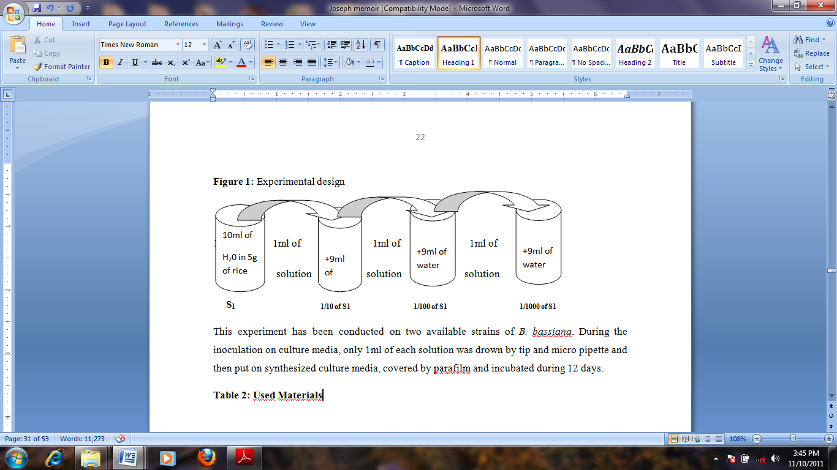
Figure 1: Experimental design

This experiment was conducted on the available strain (CG432) of B. bassiana. During the inoculation on culture media, only 1µm of each solution was drown by tip and micro pipette and then put on synthesized culture media, covered by parafilm and incubated during 12 days.

9) Viability rate testing
To test the viability rate of inoculums, each grain taken randomly was emerged in 40µm of distilled water and from that solution we have taken 1µm which was put on prepared culture media, sealed it. In one treatment we made three replications. We have waited 12 days observing if germinations occur. This test was conducted in controlled conditions on PDA culture media under incubator at 28⁰c.

10) Data analysis
ANOVA was used to analyze the significance differences between the two types of temperatures, culture media on sporulation of fungal pathogens and efficacy testing using Genstat program after arranging them in Microsoft Excel program. This program was preferred because of its efficacy to give good computer output which has helped us easily to take adequate decisions while testing established hypotheses.
3. Results

3.1 Mass multiplication

Table 3: Results after 30 days from solid rice
 | PDA culture media |  |  |  |  |  | NA culture media
 | Ambient  temperature |  |  | Controlled temperature(28ºc) |  |  | Ambient temperature |  |  | Controlled  temperature(28ºc)
Results | 0gr. | 0gr. | 0gr. | 0gr. | 0gr. | 0gr. | 0gr. | 0gr. | 0gr. | 0gr. | 0gr. | 0gr.

The results from the table 3 have shown us that B. bassiana is not multiplicated by using solid rice on culture media and that the method is not efficient because there was no result (Beauveria bassiana was not multiplicated). The PDA treatments without antibiotic in both cases (controlled and not controlled temperatures) have shown the ambiguous results because the other contaminations with dark color were dominant on whole surface of culture media. For this reason, all these treatments were rejected. For the NA treatments only different contaminations with various colors were observed in controlled conditions and in ambient temperature only unrecognized fungus with dark color was observed. By the liquid medium, we have seen the appearance of white mycelia of B. bassiana fungus covered all surface of culture media. Those mycelia were observed on PDA culture media at controlled temperatures and ambient temperature not on the NA culture media. All those results were clearly observed respectively on S₁ (initial solution), 1/10, 1/100 and 1/1000 solutions.

Table 4: Total harvested inoculums
 | Ambient temperature |  |  |  |  |  |  |  | Controlled temperature (28ºC) |  |  |  |  |  |  |  | Total
C. media | PDA/Antibiotic |  |  |  | NA/Antib. |  |  |  | PDA/Antibiotic |  |  |  | NA/Antibiotic |  |  |  | Both
Solutions | A | B | C | D | A | B | C | D | A | B | C | D | A | B | C | D
Yields/gr. | 0.42 | 0.14 | 0 | 0 | 0 | 0 | 0 | 0 | 11.5 | 8.1 | 5.7 | 3.2 | 0 | 0 | 0 | 0 | 29.06
Total | 0.56 |  |  |  | 0 |  |  |  | 28.5 |  |  |  | 0 |  |  |  | 29.06

In this table 4, A represents S1 (initial solution), B represents dilution at 1/10, C represents solution of 1/100 and then, the notation D represents dilution at 1/1000. With the Nutrient Agar culture media, the results showed that there is no result from it in both ambient and controlled temperatures. The total harvested inoculums were 29.06 grams from PDA in controlled and ambient temperatures. By this reason, the nutrient agar was rejected from the tested culture media used to multiplicate Beauveria bassiana.
The ANOVA used is split plotted design where temperature was the main factor; culture media was main split plotted factor and dilution was sub split plotted factors.

Table 5: ANOVA for the total harvested inoculums
Source of variation | Degree of freedom | Sum square | Mean square | Value ratio | F probability
Replication’s stratum | 2 | 0.0176 | 0.0088 | 0.29
Replication controlled stratum T controlled | 1 | 32.7601 | 32.7601 | 1091.85 | <.001
Residual | 2 | 0.0600 | 0.0300 | 0.22
Repetition of controlled solution Stratum | 3 | 6.7979 | 2.2660 | 16.73 | <.001
Treatment of controlled solution | 3 | 5.4913 | 1.8304 | 13.52 | <.001
Residual | 12 | 1.6252 | 0.1354
Total | 23 | 46.7520

The results of table 5 showed that the difference between the two culture media was highly significant for mass multiplicating of Beauveria bassiana at the range of significance of 5% which is greater than F probability found of 0.001. This means that B. bassiana can be multiplicated on PDA synthetic culture media which has given us more harvested inoculums than NA culture media. According to the temperature condition, we seemed that the difference remained highly significant where it gave the total harvested inoculums of 0.56 grams from PDA with not controlled temperature and 28.50gr from PDA in controlled temperature. Also the F probability (˂0.001) is less than the rate of significance of 5%.

Separation of harvested inoculums due to temperature
The results of means separation of harvested inoculums from PDA and Nutrient Agar in ambient and controlled temperatures (28ºc) is presented in the below table 6.
Considering temperatures as main factor, culture media and different solutions as sub factors, the results of table 6 showed us that they were ranged in 4 homogeneous groups. The homogeneous group’s results showed us that there were no significant difference between the 4th solution and the 3rd; the 3rd and the 2nd. The significant difference has been observed between the 4th and the 2nd, the 4th and the 1st, the 3rd and the 1st and the 2nd and the 1st solutions.
The 1st solution (initial solution) has presented the highest mean which means that if you want to multiplicate Beauveria bassiana, the first solution from treated rice is the best. This is due to the high concentration of spores of fungus than the other much diluted solutions.

Table 6: Homogeneous groups based on solution
Solutions | Means | Homogeneous groups
4 | 0.550 | A
3 | 0.950 | AB
2 | 1.373 | BC
1 | 1.987 | D

Rice inoculation
At the end of our study, we have produced 2 kg of rice as source of B. bassiana fungus new produced inoculums from only existed 30grs of inoculated rice.

Beauveria bassiana spores viability’s test
According to the results from the viability test, we found that the spores of B. bassiana germinated were from 6 treatments out of 10 considered treatments of existing inoculums. For the new produced inoculums we found that B. bassiana germinated on 9 treatments out of 10 considered. Considering that, we found that the total germinated treatments were 15 out of 20 tested treatments.

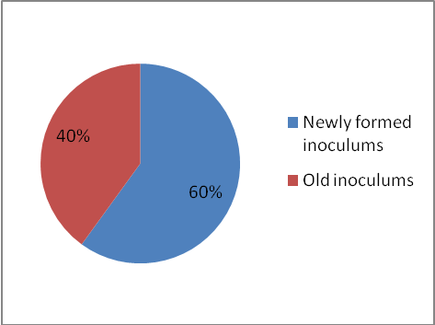
Figure 2: Rate of germinated treatments

This figure 2 considers the number of treatments where one replication in each treatment represents the total germination of treatment. Its results show us that the newly produced inoculums have germinated at rate of 60% while the old inoculums have germinated at rate of 40%. With the results, we have seen that the viability rate of new produced inoculums is greater than the old inoculums and that the germination capacity is lost with time.
The results of figure 3 showed that all germinated replications are 35 in which the germination rate of newly produced inoculums is 63% against 37% of old inoculums.
The results of figure 4 showed us that 9 treatments out of 10 for the newly produced inoculums have germinated which makes rate of germination 90% while 6 treatments out of 10 have germinated from the old inoculums which makes rate of germination equal to 60%.

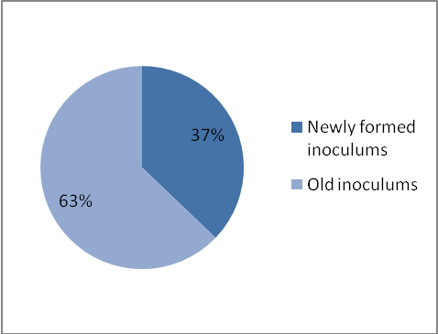
Figure 3: Rate of germinated replications

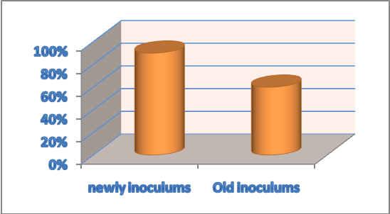
Figure 4: Rate of germination in each treatment

3.3 Beauveria bassiana efficacy testing
We have compared biopesticide produced from the new inoculums, Dursban and negative control. All these treatments were handled in the same condition. After 2 days we added the new coffee berries in order to procure food to the insects. The produced Inoculums were sprayed on live adult insects placed on perforated petri dishes and incubated at ambient temperature until insect death.

Table 7: Died antestia bugs in period of 5 days
Repe-titions | Biopesticide of Beauveria bassiana |  |  |  | Dursban as positive control |  |  |  | Negative control
 | Died on  2nd  day | Died on 3rd day | Died on  4th day | Died on  5th day | Died on 2nd day | Died on 3rd day | Died on 4th day | Died on 5th day | Died on 2nd day | Died on  3rd day | Died on 4th day | Died on  5th day
1 | 0 | 2 | 2 | 1 | 5 | 0 | 0 | 0 | 0 | 0 | 0 | 0
2 | 1 | 1 | 3 | 0 | 4 | 1 | 0 | 0 | 0 | 1 | 0 | 0
3 | 0 | 1 | 1 | 3 | 5 | 0 | 0 | 0 | 0 | 0 | 1 | 0
4 | 0 | 0 | 2 | 2 | 5 | 0 | 0 | 0 | 0 | 1 | 0 | 0
Total died | 1 | 4 | 8 | 6 | 19 | 1 | 0 | 0 | 0 | 2 | 1 | 0

The results from the table 7 showed us that 95% of considered antestia bugs in all replications were killed by Beauveria bassiana during 5 days and that 100% of tested antestia bugs with dursban were died in two days. Considering the negative control, only 3 antestia bugs were died during the same period of 5 days.

Table 8: ANOVA of B. bassiana efficacy
Source of variation | Degree of freedom | Sum square | Mean square | Value ratio | F probability
Repetition stratum | 3 | 0.0833 | 0.0278 | 0.07
Rep. units stratum pesticide | 2 | 11.3750 | 5.6875 | 14.53 | <.001
Days | 3 | 10.4167 | 3.4722 | 8.87 | <.001
Pesticide and days | 6 | 62.4583 | 10.4097 | 26.60 | <.001
Residual | 33 | 12.9167 | 0.3914 | - | -
Total | 47 | 97.2500 | - | - | -

The analysis of variance made from results obtained during the study of pesticides effect as main fact and days as sub factor ranged in RCBD two ways showed us that there is highly significant difference between produced bio-insecticide, Dursban and negative control in controlling coffee antesia bug in a given time because the F probability (<.001) is very low comparing to the significance rate of 5%. Many antestia bugs were died after 4 days with bio-insecticide while a big number of died antestia bugs were observed after 2 days with Dursban chemical and after 3 days in negative control. For the negative control, the antestia bugs died are those which seemed to be very old.

Table 9: Results of means separation of pesticides efficacy
Treatments | Means | Homogeneous groups
Negative control (3) | 0.1875 | A
Beauveria bassiana (1) | 1.1875 | B
Dursban (2) | 1.2500 | B

The results of the table 9 showed that there was a significant difference between negative control and the produced bio-insecticide and between negative control and Dursban. There was no significant difference between produced bio-insecticide and Dursban. This means that, without considering the additional advantages of biological control like ecosystem conservation and not predicted effect concentration, the two pesticides (Dursban and Beauveria bassiana), can be used to control coffee antestia bugs at around the same level and comparing the additional advantages of Beauveria bassiana, it can substitute Dursban in controlling coffee antestia bug.

4. Discussion
The conducted study on Beauveria bassiana fungus to control coffee antestia bug have shown promise; but even if it affects other wide variety of insect groups, the variability of control of any one insect can be large and depends on environmental factors, timing of sprays, and the stage of the insect, as well as the insect’s inherent susceptibility to the fungus. Here the problem is to fix the good time to control them and the ideal growth stage of insect to be controlled. The viability rate test have shown that it is fast lost. It is then difficult to the farmers to conserve it because they do not have all their required conditions.
According Wraight and Ramos (2002, a good control means statistically significant reductions in pest numbers or damage of 75% or more, compared to an untreated control. To him, a fair control includes those with significant reductions of 50-74%, and any non-significant reductions of over 50%. The poor control group includes any results with less than 50% reduction. This research has shown that B. bassiana biopesticide can control until 95% which means that it reduces significantly coffee antestia bugs.
The highest efficacy of B.bassiana CG432 was observed on the 5th day but around 80% of this efficacy was observed after the 2nd day of its treatment and for best results, applications should be made during the early growth stages of the insect before much damage has occurred, as it may take several days for the insect to die (Kucera, 1971). In our study, we have seen that a big number of died antestia bugs was observed on 4th day followed by 5th day where died antestia bugs are respectively 8 and 6. The problem which remains here is to know the age of insects and hatching period in order to control them effectively.
Vandenberg et al., (1998) have stated that field trials have indicated that fair to good season long control of the caterpillar complex on cabbage can be achieved with multiple sprays. According to Kovach and English-Loeb (1997), the conducted Studies in the mid-1990s on a major pest of strawberries, the tarnished plant bug (TPB), indicated that TPB populations and their damage could be reduced to about half by four applications of a product containing B. bassiana. For us, we did not spray on coffee plantations because we were sure that all treated insects are in direct contact with the used natural enemy. This requires necessarily other similar studies which must be conducted in the coffee plantations and test the real control of B. bassiana once applied on field in natural conditions.

5. Conclusion
Fighting against insect pests of different crops was conducted long time ago using synthetic insecticides as the only means of effective protection crops. However, the use of these chemical insecticides have led to various adverse effects (problems of residues and their accumulation in organisms through the food chain) following the use of toxic and persistent insecticides, and that develops the phenomenon of insect resistance to insecticides. The other risks associated with their application. We are assisting to the increase of quality of agriculture products by using other alternative means including biological control or organic farming. In this regard, the obtained results of our conducted study have shown that the established objective was achieved and that all alternative hypotheses are verified. These results are promising that Beauveria bassiana can contribute to coffee antestia bug control. We have seen that the effective mass multiplication of Beauveria bassiana fungus uses PDA as culture media once it is treated with antibiotic in order to avoid the bacteria invasion. According to the temperature, our study has shown that Beauveria bassiana fungus growth on controlled temperature surrounding on 28⁰c. To the viability rate the study has shown the good result with currently formed inoculums. This means that they require the adequate saving conditions. The rate of germination of those spores was 60% and the not germination of 40%. To the newly formed inoculums the rate of germination was 90%. In the other hand of repetitions, the rate of germination of existed inoculums was 43.3% and 73.3% for the recently formed inoculums. According to the formed biopesticide, the results have shown us that there was no significance difference between considered chemical pesticides (Dursban) and formed biopesticide from Beauveria bassiana fungus. It seems that Beauveria bassiana can control pests at 95%.

Acknowledgements
We acknowledge the financial and technical supports provided by the Higher Institute of Agriculture and Animal Husbandry (ISAE)-Busogo for the completion of this study.

*Corresponding author
NAHAYO Alphonse
Higher Institute of Agriculture and Animal Husbandry (ISAE)- Busogo; Department of Forestry and Nature Conservation; P.O.Box 210 Musanze, Rwanda; Email: nahayo1@yahoo.fr

References
1. Anonyme, 1997. Beneficial Insects. 1st ed. PP.249.
2. FAO, 2000. FAOSTATS statistics database. Found and Agriculture Organisation of the United Nations. http//appr.fao.org
3. Kucera, M. (1971). Toxins of the entomophagous fungus Beauveria bassiana. II. Effect of nitrogen sources on formation of the toxic protease in submerged culture. Journal of Invertebrate Pathology, 17, 211-215.
4. Masaba S. and V. C. Murrell. 1995. Evaluation of organically-acceptable pesticides against the Green Peach Aphid (Myzus persicae). Plant Protection Conf. 1999: 75-79.
5. OCIR, 1998. Coffee management unit.,1996. Ministry of Agriculture. Coffee production Processing and Marketing, 1976-1995 in overviews.
6. SAP, 2000 and TCB, 2001. USDA National Organic Program Regulations, 7CFR 205.206(e)
7. Vandenberg, J.D., A. M. Shelton, W.T. Wilsey and M. Ramos. 1998. Assessment of Beauveria bassiana sprays for control of diamondback moth (Lepidoptera: Plutellidae) on crucifers J. Econ. Entomol. 91:624-630.
8. Wanjara M., 1976, Entomophthorous Fungi Parasitic on the Spotted Alfalfa Aphid, Hilgardia, Sept 1957.
9. Waterhous, J. and Norris V. 1989. Testing the efficacy of Mycotrol ES, Beauvaria bassiana, on tarnished plant bugs, Lygus lineiolaris, in New York Strawberries.
10. Wraight, S.P. and M. E. Ramos. 2002. Application factors affecting the field efficacy of Beauvaria bassiana foliar treatments against the Colorado Potato Beetle Leptinotarsa decemlineata. Biological Control. 23(2):164-178.

10/12/2012

