Clinicopathological, histopathological and immunolog1ical studies on animals exposed to lead and cadmium under experimental conditions

Randa, A. Hassan¹; Dawlat M. Amin¹; Nariman A. Rahmy¹; Hatem, M.E.² and Dessouky, M.I.³

¹ Pathology Dept., Animal Health Research Institute, Giza, Egypt.
² Microbiology Dept., Faculty Veterinary Medicine, Cairo University, Egypt
³Clinical Pathology Dept., Faculty Veterinary Medicine, Cairo University, Egypt
mogdasamei@yahoo.com

Abstract: Lead and cadmium are recognized as the most toxic environmental pollutants. The effect of lead acetate (Lead acetate) and cadmium chloride (Cd Cl₂) poisoning on the clinicopathological, histopathological and immunological parameters in guinea pigs was investigated. The possible protective role of cod liver oil as a natural supplement of vitamins (E, A, D) and omega 3 nutrients was also studied. The animals were divided into five groups, control and four experimental groups. The second and the third groups were administrated Lead acetate (5.5 mg Lead/kg b.w), while the fourth and fifth groups were administrated Cd Cl₂ (2.5mg Cd/Kg b.w) orally three times a week. Cod liver oil was given to the third and fifth groups orally three times per week at a dose of 0.35 ml/ animal two weeks before and continued simultaneously to the administration of the chemical pollutants through the experiment. Guinea pigs were kept under observation for 9 weeks. Most of the guinea pigs administrated pollutants showed loss of body weight and weakness. Mortality rate reached 33.3% in Lead acetate group and 39.4% in Cd Cl₂ treated group. Exposure to Lead acetate or Cd Cl₂ induced oxidative damage to erythrocytes leading to observation of normocytic normochromic anemia, lymphopenia and toxic neutrophils. Increased activity of serum enzymes ALT, AST and ALP, and elevation of urea and creatinine values reflected liver and kidney damage which was proven histopathologically. Gradually increased hyperglycemia was observed in Lead and Cd groups. Significant decrease of total protein due to hypoglobulinemia was observed in Cd group. Gradual increase in Lead and Cd levels in serum was recorded compared with control. Antibody titer decreased specially in Cd group. Viability of lymphocytes was reduced in Lead and Cd groups. Simultaneous administration of cod liver oil was reduced the mortality rate, hematological changes, hepatic biochemical alterations, decreased slightly the level of serum Lead and Cd and improved immune status of guinea pigs.
[Randa, A. Hassan; Dawlat M. Amin; Nariman A. Rahmy; Hatem, M.E. and Dessouky, M.I. Clinicopathological, histopathological and immunolog1ical studies on animals exposed to lead and cadmium under experimental conditions. N Y Sci J 2012;5(12):120-136]. (ISSN: 1554-0200). http://www.sciencepub.net/newyork. 19

Keywords: Clinicopathological; histopathological; immunolog1ical; cadmium

1. Introduction:
Pollution of the ecosystem with industrial, traffic, agricultural and sewage effluents results in contamination of air, food and water with toxic agents such as heavy metals which constitute a major public health hazard. Lead and cadmium are recognized as the most toxic environmental pollutants and exposure to it seems to be unavoidable for those who live in industrialized countries (Dhavale et al., 1988 and Szymanska and Laskowska-Klita, 1993).
Once a pollutant reaches the environment it may be bioaccumulated so that concentration within the tissues of an organism may be greater than that in the environment (Hernberg, 1979).
Lead and cadmium alter a number of parameters of the host’s immune system and increased its susceptibility to infections, autoimmune diseases and allergic manifestations. A number of studies documented that heavy metals are not only toxic for the organism but also may modulate immune responses (Fujimaki et al., 1983 and Krocova et al., 2000). It has been reported also that lead and cadmium have carcinogenic effect in animals and man (Lansdown, 1996 and Levkutova et al., 1998).
Lead is a cumulative poison, reduce function or completely break down kidney, liver and brain tissues. Increased concentration of lead in organs results in dangerous public health hazard including nephrotoxicity, hypertension, gastrointestinal and neurological dysfunction (Forstner and Wittman, 1988 and Lokith, 1993). Lead is more toxic to newly born animals and human (Galhoom et al., 2000).
Cadmium inhibits growth and has toxic effects on the kidneys, liver, lung, testes, placenta and the erythropoietic system. It may pass placental barriers and accumulate in fetal brain, liver and heart (Trottier et al., 2002), and it has a teratogenic effect to the growing embryo. Moreover, cadmium-induced blood- brain barrier dysfunction (Shukla et al., 1996). Chronic cadmium intoxication is characterized by renal proximal tubular dysfunction, general osteomalacia with severe pains and anemia (Horiguchi et al., 1996).
Antioxidants help reduce the oxidizing effect of pollutants and act as conjugators to remove the pollutants from the body. A deficiency of dietary vitamins and minerals increased sensitivity to adverse effects of drinking water contaminants (Vodela et al., 1998). Vitamin E is the primary liposoluble antioxidant which may have an important role in scavenging free oxygen radicals and in stabilizing the cell membranes, thus maintaining its permeability (Bjorneboe et al., 1990 and Navarro et al., 1999). Pretreatment with vitamin E exhibited a protective role on the toxic effects of cadmium on the hematological values, as well as on enzymatic and non-enzymatic components of antioxidant defense system (Ognjanovic et al., 2003). Sufficient intake of vitamin C can reduce the toxic effect of cadmium on the immune system (Kubova et al., 1993). Also, moderately large doses of zinc can prevent immune alterations produced by exposure to low doses of cadmium (Chowdhury et al., 1987).
The present study, therefore, was designed to investigate the toxic effects of lead and cadmium and the role of cod liver oil which comprises vitamin E, A, D and omega 3 nutrients for the protection of cells from the destructive effect of pollutants. The following aspects were investigated:
1. Studying the effect of lead and cadmium pollutants on the hematological and serum biochemical parameters of experimentally exposed guinea pigs.
2. Studying the histopathological alterations in liver, kidney, spleen and brain.
3. Studying the immunomodulatory effect of lead and cadmium pollutants.
4. Studying the possible protective influence of cod liver oil against lead and cadmium toxicity.
2. Material and Methods
1-Experimental Design:
One hundred and fifty two guinea pigs of both sex with an initial weight of 270 - 330 grams were used. The animals were divided into five groups, control of 20 animals and 4 experimental groups, each of thirty three guinea pigs. Each 5 animals were placed in a separate cages.
Two doses of washed chicken RBCs (each of 0.3 ml per animal) were given intramuscularly to all groups of the experimental animals during the 2 weeks acclimatizing period. One dose at the beginning and a second booster dose at the end of the 2nd week (Stites et al., 1982).
After acclimatization, the experimental groups were given either lead (as lead acetate) or cadmium (as cadmium chloride) dissolved in distilled water 3 times per week for 9 weeks. The second and third groups were administered lead acetate orally at a dose of 5.5 mg lead/kg body weight (Sierra and Tiffany, 1992). The fourth and fifth groups were administered cadmium chloride orally at a dose of 2.5 mg cadmium/kg body weight (Kubovã et al., 1993). The control group received distilled water.
Cod liver oil was given to the third and the fifth groups orally 3 times per week at a dose of 0.35 ml per animal. Administration of the oil was started two weeks before, then simultaneously to the administration of the pollutants throughout the experiment (Fox et al., 1984).
Guinea pigs were kept under observation for 9 weeks during which clinical symptoms, body weight and mortality rate were recorded. Hematological and serum biochemical changes, lead and cadmium levels in serum and immunological examinations were done on 5 guinea pigs from each group at the 3rd, 5th, 7th and 9th weeks post administration of the chemical pollutants. Autopsy, weight of liver and spleen and histopathological changes of liver, kidney, spleen and brain were recorded at the previously stated times.
2. Experimental animals:
One hundred and fifty two guinea pigs with weight of 270 - 330 grams were purchased from a commercial source. The animals were kept under suitable conditions of feeding and rearing. All animals were supplied with a daily dose of 10 mg/kg body weight ascorbic acid in drinking water (Fox et al., 1984).
3. Chemical pollutants:
- Lead acetate trihydrate [Pb (CH₃COO)₂. 3H₂O] Sigma, Germany.
- Cadmium chloride hydrate (CdCl₂. 2.5 H₂O) Winlab, England.
4. Cod liver oil:
Seven seas ® Health Care, England (a pure and natural cod liver oil) was given to animals as a protective immunostimulant supplement.
5. Chicken RBCs:
Washed chicken RBCs (1%) was used as an antigen to monitor the immune competence of the experimental animals (Stites et al., 1982).
Diagnostic kits:
Commercial diagnostic kits from Bio-Merieux, France were used for the determination of serum total protein, albumin, urea, creatinine, glucose and the activity of aspartate and alanine aminotransferases and alkaline phosphatase.
6. Reagents and equipment for lymphocyte blastogenesis assay:
- Heparin (20 IU/ml blood) to avoid clotting of blood samples.
- MTT [3, (4,5-dimethylthiazol-2-yl)-2,5 diphenyl tetrazolium bromide]. Filtered solution (5 mg/ml) in PBS was stored at –20°C for up to 6 months.
- Solubilizing solution : HCl 0.1 N in isopropanol-Triton X-100 (10%) (v/v).
- RPMI-1640 tissue culture medium (Sigma).
- RPMI-20 tissue culture medium containing 20% foetal calf serum (FCS) in addition to L. glutamin and antibiotics.
- Triton X-100 1% (v/v) in RPMI-1640 (Sigma).
- Ficol-isopaque medium (for lymphocyte separation). Density = 1.075 – 1.079 (Sigma).
- Trypan blue stain (0.4% in saline).
- Antigen (Sonicated RBCs).
- 96-well flat-bottom tissue culture plates.
- Sterile screw capped tubes.
- Sterile Pasteur pipettes.
- ELISA reader, (Bio-Tek instruments EL 311, USA).
- CO₂ incubator, (Haraeus, Germany).
- Virsonic 475 (Virtis Company Gardiner N.Y., USA).
7. Samples:
a) Blood samples:
Five guinea pigs from each group were investigated at the 3rd, 5th, 7th and 9th weeks post-exposure to the pollutants. Blood samples were obtained via heart puncture. Each sample was divided into three portions. The first one was anticoagulated with dipotassium ethylene diamine tetra acetic acid (EDTA) for studying the hemogram. The second portion was anticoagulated with heparin for immunological evaluation (cell mediated immunity using MTT assay). The third portion was allowed to clot for serum separation for determination of blood biochemical parameters, humoral immunity using hemagglutination inhibition test as well as lead and cadmium levels.
b) Tissue specimens:
Macroscopical appearance of the organs (liver, kidney, spleen and brain) was recorded after the animals had been sacrificed. Weight of liver and spleen was recorded to calculate relative body weight organs ratio. Culled specimens from the same organs were fixed in 10% neutral formalin for routine histopathological examination (Bancroft et al., 1994).
8. Hemogram:
The hemogram of guinea pigs including values of hemoglobin, packed cell volume, total erythrocytic and leucocytic counts was performed using automatic cell counter (All-System-Germany). Differential leucocytic count was performed manually according to Bernard et al. (2000).

9. Serum biochemical values
Serum anaylsis included serum total proteins (Burtis and Ashwood, 1999), albumin using the method of Doumas et al. (1971), globulin was determined by subtraction of albumin from total protein (Reinhold, 1953) and A:G ratio was calculated according to the results of albumin and globulin. Serum AST and ALT enzymatic activities were determined colorimetrically according to Reitman and Frankel method (1957) and Alkaline phosphatase according to Belfield and Goldberg (1971). Serum urea concentration was measured according to Tietz (1995), creatinine according to Kroll (1987) and Glucose according to Trinder (1969).
10. Quantitative determination of lead and cadium in serum (Meret and Henkin, 1971):
Serum samples were diluted with n-butanol in water (6:94 by volume). 0.5 ml of each sample of serum was diluted with 4.5 ml of the diluents. Diluted sample were analyzed for their lead and cadmium content by using Unicam 969 Atomic absorpitionspectrophotometer.
11. Immunological evaluation (Lashgari, 1983):
- Hemagglutination inhibition (HI test):
Preparation of chicken RBCs (1% suspension):
Whole chicken blood (3 parts) was collected in a clean sterile bottle containing 3.8% sodium citrate solution (one part) to prevent blood clotting. The blood was washed with PBS, pH 7.4 and centrifuged at 1700 rpm for 10 minutes (this step was repeated three successive times till a clear supernatant was observed). One ml of the washed RBCs (in the bottom of the tube) was resuspended in 100 ml PBS pH 7.4 to make a suspension of 1%. This suspension was kept in the refrigerator at 4°C till used.
- Lymphocyte blastogenesis by MTT assay: (Hudson and Hay, 1980)
This assay is a quantitative colorimetric method for assessing cell growth and survival. Active mitochondrial dehydrogenases in living cells converts the pale yellow tetrazolium salt (MTT) to a dark blue formazan product, which shows concentration proportional to the number of viable cells. This assay was used to evaluate the proliferative responses to the inhibitory effect of lead or cadmium salts and was performed only on the 9th week of the experiment.
Isolation of blood lymphocytes:
- Heparinized blood samples collected under sterile conditions were carefully layered over an equal volume of ficol-isopaque medium without disturbing the interface in sterile tubes.
- Samples were centrifuged at 2400 rpm for 20 minutes (without using the brake). The lymphocytes separated in a layer just below the interface of the plasma.
- The white cell layer at the interface was collected with sterile Pasteur pipette and transferred to another tube containing 2 ml of RPMI-1640 and mixed.
- The collected cells were washed three times with RPMI-1640 and centrifuged at 2000, 1500 and 1000 rpm, respectively, each for 5 minutes.
- The washed cells were suspended in 1 ml of RPMI-20.
- Cells were counted and checked for their viability by trypan blue solution and resuspended in RPMI-20 at 10⁶ cells per ml.
12. Histopathological studies:
Specimens for histopathological examination were fixed in 10% neutral formalin solution and embedded in paraffin. Sections of 4 – 6 micron thickness were prepared and stained by Hematoxylin and Eosin after Harris (1989).
13. Statistical analyses:
Data obtained were statistically analysed using SPSS 11 (2002).
3. Results and Discussion
Once a pollutant reaches the environment it may be bioaccumulated so that concentration within the tissues of an organism may be greater than that in the environment (Hernberg, 1979). Currently, lead is an accumulative poison, increased concentration of Lead in organs results in a dangerous public health hazard including nephropathy, hypertension, gastrointestinal and neurological dysfunction (Forstner and Wittman, 1988 and Lokith, 1993).
Cadmium, is another example of chemical injurants that has extreme accumulation in the organism. The highest accumulation occurs in kidney and liver, and the biological half-life of Cd in these organs is long approximately 20-30 years (Kubova et al., 1993). Long term exposure to Cd contamination causes toxic effect in the liver, renal dysfunction, bone changes and slight anemia as recommended by WHO (1980).
Mortality rate recorded in this work was 33.3% in Lead acetate group and 39.4% in CdCl₂ group. In groups given cod liver oil, deaths began late and the mortality rate decreased to 21.2% in case of Lead and 30.3% in case of Cd. In his experiment, Forshow (1977) reported that deaths occurred due to prostration and respiratory failure as a result of injection of experimental animals with large intravenous dose of Cd indicating that Cd has a depressant action at the neuromuscular junction.
The body and organ weights and the general health condition of the experimental guinea pigs were examined in the present work as selected biomarkers of health. Animals received Lead acetate alone or incombination with cod liver oil showed significant decrease of body weight at the 3rd and 5th weeks of the experiment. All animals treated with CdCl₂ revealed decrease of body weight throughout the experiment which was significant at the beginning of the experiment. Co-administration of cod liver oil improved body weight in case of Lead acetate than in CdCl₂. The present findings are parallel to that of Kubova et al. (1993) in CdCl₂- exposed guinea pigs and Browning (1969) also reported that Cd toxicity induced anemia and loss of body weight in mammals. On the contrary, Edwards and Beatson (1985) in guinea pigs did not report significant changes in body weight due to Lead poisoning. Similar results were reported by Thomas et al. (1985) and Karmakar et al. (2000) in adult female, and in male mice exposed to Cd toxicity, respectively.
In the present study, hematological changes in all treated groups of guinea pigs showed significant decrease of RBCs, Hb and PCV values with normal values of MCV and MCHC indicating presence of normocytic normochromic anemia. An exception was the significant increase of MCV in the CdCl₂ group at the 7th week and all groups at the 9th week of the experiment (Table, 1). The present results agree with Wright et al. (1977) in sheep, McMurry et al. (1995) in rats, Gallhom et al. (2000) in cattle, Karmakar et al. (2000) in mice and Mona et al. (2001) in cattle. Webb (1977) attributed anemia due Lead to short life span of red cells. EPA (1986) explained that the anemia which occurred in Lead poisoning results from two basic defects, shortened erythrocyte life span and impairment of heme synthesis. Shortened life span of RBCs is thought to be due to increased mechanical fragility of cell membrane. Taketani et al. (1985) explained that heme biosynthesis at the level of protoporphyrin utilization is inhibited by Lead, the enzymatic reduction of Fe³⁺ to Fe²⁺ within mitochondria results in reduced availability of Fe³⁺ for heme production. They added that this effect of lead was restricted to erythrocytes precursor cells than to mature cells.
Anemia has been a common finding in Cd administrated mammals. Cadmium induced hemolytic anemia as stated by Itokawa (1973). It has been reported that the RBCs membrane skeleton is initially altered by exposure to Cd in rats, followed by deformation of the cell, thus promoting intrasplenic hemolysis resulting in anemia (Hamada et al. 1998). Microscopical examination of Cd group showed focal haemorrhagic areas with diffuse hemosiderosis in the spleen (Fig., 1). Kostic et al. (1993) explained Cd- induced anemia by decrease in the level of iron in blood. Shukla et al. (1996) and Hamada et al. (1998) were of the opinion that the decrease of hematocrit value in hemolyzed plasma of rats exposed to Cd indicates increased destruction of erythrocytes. Horiguchi et al. (1996) found that rats administered Cd for 6 and 9 months showed anemia with low levels of plasma erythropoietin (EPo) as well as biochemical and histological renal tubular damage, and also hypoinduction of EPo mRNA in the kidneys.
Pathological results of the kidney in the Cd group at the 9th week in the present experiment revealed swelling in the lining endothelial cells of the glomerular tuft of the hyperemic glomeruli associated with hypereosinophilia in the cytoplasm of some epithelial cells lining the renal tubules as well as diffuse fibroblastic cells proliferation in between the tubules. Focal extravasation of red blood cells was detected in the corticomedullary junction. The observed histopathological lesions in the kidney may support Horiguchi et al. (1996) explanation of anemia. Pavlovic et al. (2001) and Ognjanovic et al. (2003) reported that treatment with Cd in rats induced loss of membrane function by enhancing of lipid peroxide concentration, oxidative damage of erythrocytes and anemia.
On the contrary to the present results, Pond et al. (1973) observed microcytic hypochromic anemia in rabbits with Cd toxicity.
The present investigation revealed RBCs with basophilic stippling in animals received Lead acetate. Humphreys (1988) reported that Lead induced hematological changes including anisocytosis, poikilocytosis, immature red cells and basophilic stippling cells. Our findings are in accordance with Hans et al. (1999) who described that Lead accumulates in erthrocytes, interacts with different stages of hemoglobin synthesis and inhibits ferrochelatase activity. This enzyme catalyzes the incorporation of iron into the porphyrin ring to form heme. Its inhibition contributes to the development of anemia and leads to increased protoporphyrine concentration in the erythrocyte. Jones and Hunt (1997) added that Lead causes anemia and basophilic stippling occurs in almost all species of animals and human but regularly large numbers of nucleated red blood cells are observed in peripheral circulation. Lead inhibits two enzymes involved in hemoglobin synthesis d- aminolevulinic acid dehydrase and ferrochelatase.
From the present results, pretreatment with cod liver oil showed improvement of RBCs, Hb and PCV values in Lead and Cd exposed groups of animals (Table, 1). These findings are in agreement with Ognjanovic et al. (2003) who reported that vitamin E pretreatment decreased the toxic effects of Cd on the hematological values and has a protective role in anemia.
Leucogram of treated guinea pigs with Lead acetate or CdCl₂ showed leucopenia with lymphopenia (Table 2). These changes may be attributed to the direct toxic effect of heavy metals on blood cells or indirectly on the hemopoietic organs. Similar results were reported by Groten et al. (1991) and McMarry et al. (1995). A similar argument was also stated by Karmakar et al. (2000) who recorded that the value of WBCs count decreased significantly in the 14th and 21st days post- treatment. Neutrophil value increased progressively significantly at each of the previous time points.
In the present work, repeated administration of cod liver oil with Lead acetate and CdCl₂ improved WBCs count at the 9th week of the experiment (Table, 2). Wershana (2001) reported that vitamin E supplementation exhibited moderate improvement in leucogram defects induced by CdCl₂.
Examination of stained blood smears of animals received Lead acetate showed toxicity of neutophils in the form of coarse granules at the 3rd week (36% of neutrophils), the 5th week (69%), the 7th week (70%) and the 9th week of the experiment (73% of neutrophils). In the group received Lead acetate and cod liver oil, 30% of neutrophlis contained toxic granules at the 3rd week. The percentage decreased at the 5th, 7th and 9th weeks. White blood cells in CdCl₂ group showed toxic neutrophlis with coarse granules at the 3rd and 5th weeks (25%), at the 7th week (35%), and about 69% at the 9th week post CdCl₂ administration. Animals administered cod liver oil with CdCl₂ revealed low percentage of nentrophils with course granules at 7th and 9th weeks of the experiment.
In the present study, liver function was monitored as the liver plays an important role in detoxifying xenobiotics (Bishayee et al., 1997). Activities of serum enzymes (transeferases and alkaline phosphatase) (Graph, 1) showed elevation in different groups of animals exposed to both pollutants. Several authors reported similar results in different species of animals. Groten et al. (1991) found retardation in growth rate, increased sGOT and sGPT and alteration of iron accumulation in rats fed CdCl₂ for 8 weeks. Ahmed et al. (1999) added that Cd induced injury to liver cells demonstrated by significant rise in AST, ALT and ALP activities. Karmakar et al. (2000) revealed that subchronic Cd administration for alternate days in mice resulted in time- dependent elevation in sGOT, sGPT and hepatic ALP activity after 7, 14 and 21 days of treatment. The results clearly indicated the cumulative effect of Cd. Pathological results of Cd group, showed severe dilatation in the hyperplastic bile duct with appearance of eosinophilic material and finger like projection of the lining epithelial cells in the ductal lumen. Also, the periductal tissues showed fibrosis and inflammatory cells infiltration (Fig., 2) nine weeks post administration which may have been contributed to the observed elevation of ALP activity. Kurata et al. (2001) found that CdCl2 treatment in rats induced increases in osteoid volumes of the femur cortex and trabeculae. This change was accompanied by an increase in the volume of iron deposition at the mineralization front of the trabeculae and a reduction in mineral density. Abnormalities of bone metabolic parameters were increases in the blood calcium, inorganic phosphorous and bone- specific ALP. On the other hand, Theocharic et al. (1991) reported that after intraperitoneal injection of CdCl₂ in rats, AST and ALT activities showed maximum increase at 12 hour, contrary to ALP that showed a permanent decrease by time. The same result was reported by Nagyova et al. (1994a) in guinea pigs treated with Cd, where ALT and AST were significantly elevated while ALP activity was significantly decreased at the 12th week of Cd administration.
In the group of animals received Lead acetate, elevation of ALT, AST and ALP activities may be attributed to the toxic effect of Lead on liver cells (Hays, 1994 and Mona et al., 2001). Johes and Hunt (1997) stated that toxic hepatitis and nephropathy were known under conditions of Lead poisoning.
In the present work, significant hypoalbuminemia and decreased A/G ratio were noticed at the 9th week in Group 2 and 3 received Lead acetate. Liver of guinea pigs administered lead acetate for 9 weeks showed necrosis of the hepatocytes (Fig., 3). Blood et al. (1983) attributed that to toxic effect of Lead on liver cells resulting in impaired synthesis of albumin. The levels of total protein, albumin and A/G ratio were significantly decreased in cows from 2 farms adjacent to the heavily traffic roads (Ibtisam, 1998).
Histopathological examination of kidney in Lead group at the 9th week showed mononuclear leucocyte inflammatory cells infiltration between the renal tubules and glomeruli (Fig., 4) associated with swelling in the lining endothelial cells of the hyperemic glomerular tuft in addition to degeneration with necrobiotic change in the lining epithelial cells of renal tubules (Fig., 5). Focal hemorrhages in the periglomerular tissues were observed. Renal lesions may have contributed to hypoalbuminemia observed.
In the present study, hypoglobulinemia was observed at the 3rd week in group 2 (animals received Lead acetate) and 5th week in group 3 (animals received Lead acetate and cod liver oil). The same groups showed hyperglobulinemia at the 9th week. Similar results were reported by Gouda et al. (1985) who studied changes in some kidney functions in Lead poisoned goats and showed increased levels of urea, uric acid and creatinine with hypoproteinemia and hypoglobulinemia. Ibtisam (1998) recorded significant decrease of globulin in cows from two farms adjacent to the heavily traffic roads.
According to the present study, groups 2 and 5 (animals exposed to CdCl₂) revealed significant decrease of total protein and globulin at the 3rd and 5th weeks. The present results are supported by the results of HI test and histopathology of the liver. The liver is known to play an essential role in the synthesis of plasma protein and some globulins. Also, kupffer cells of the liver are known for their antigenicity as they phagocytose antigens. The toxicity of Cd may involve a reaction of reactive oxygen species (ROS) as described by Manca et al. (1991). Activated neutrophils produce ROS during inflammatory reactions and if neutrophils accumulate, tissue would be exposed to large quantities of potentially injurious neutropil content (Rollet- Labella et al., 1998).
A plausible mechanism may involve Cd concentration in hepatic tissue following exposure. Cadmium concentration may exceed the intracellular metallothionein and glutathione concentration enabling Cd to interact with the cellular organelles which could disrupt biochemical processes. Sub- chronic administration of Cd to mice resulted in a hepatic injury due to disruption of DNA replication, RNA synthesis and mitochondrial metabolism (Karmakar et al. 2000). Luckey et al. (1975) recorded that Cd induced impaired renal tubular reabsorption of serum protein which contribute in part to hypoproteinemia. Pathological results of Cd group at the 9th week revealed hypereosinophilia in the cytoplasm of some epithelial cells lining the renal tubules as well as diffuse fibroblastic cells proliferation in between the tubules (Fig., 6). Focal extravasation of red blood cells was detected in the corticomedullary junction.
In the present investigation, kidney function tests showed elevation in urea and creatinine in all treated groups (Graph. 2) starting from the beginning of the experiment. The results are in agreement with that reported by Gouda et al. (1985) in goats, Nagyova et al. (1994b) in guinea pigs. Ibrahim (1983) mentioned that the toxic effect of Lead on the renal tissues was clear as level of creatinine and urea in serum increased. The elevation in the two parameters was due to nephrotoxic effect of Lead on renal tubules and glomeruli. Also, Kuda et al. (1988) found significant elevation in serum creatinine concentration in Cd intoxicated rats. They added that creatinine metabolism was thought to reflect the amount of glomerular filtration. Nagwa et al. (1996) and Wafaa (1996) reported that significant elevation in creatinine and urea nitrogen level in guinea pigs intoxicated with Cd may be recorded in acute or chronic renal insufficiency and renal failure. Kjalf et al. (2001b) stated that the effect of CdCl2 was represented by significant and persistent elevation of serum creatinine, urea, uric acid, calcium and phosphorous concentration with decrease in serum sodium and potassium concentration. Microscopical examination of the kidney five weeks post Cd administration showed focal as well as diffuse mononuclear leucocytes inflammatory cells infiltration in between the degenerated renal tubules associated with severe dilatation of the intertubular blood vessels. There was focal fibrosis as well as focal extravasation of the red blood cells in between the degenerated renal tubules (Fig., 7).
Data of Leffel et al. (2003) suggest that short- term exposure to Cd may result in a type of autoimmune reaction since the mice is able to produce antinuclear antibodies after 4 weeks of exposure and there is immune- complex deposition in the kidney. Long – term exposure to Cd appears to result in the exacerbation of autoimmune disease as indicated by the development of proteinuria and continued presence of immune complexes in the kidney. The mechanism may involve increased production of IgG₂, which is capable of forming immune complexes and causing autoimmune glomerulonephritis.
Hyperglycemia was observed in the present work in all treated groups at different times of the experiment. Results agree with that reported by Rajanna et al. (1984) and Manal (1999) in rats. Meali and Singhal (1977) reported that subacute Cd toxicity in rats disturb glucose homeostasis producing hyperglycemia and glucose intolerance, enhance hepatic gluconeogenic potential and depress hepatic glycogen as well as pancreatic insulin secretory activity. They also added that orally administrated Cd produced hyperglycemia, enhanced the activities of pyruvate carboxylase, phosphoenol pyruvate carboxykinase, fructose 1, 6 diphosphatase and glucose 6 phosphatase, the four key enzymes involved in glucose synthesis. The authors also showed that Cd suppress pancreatic insulin synthesis and/ or release.
Simultaneous administration of cod liver oil in the present work improved hepatic biochemical abnormalities, but renal biochemical abnormalities and hyperglycemia were partially controlled as compared to animals receiving the pollutant only.
The role of oxidative stress in chronic heavy metal toxicity and its prevention by co-treatment with antioxidants was investigated. Tandon et al. (1992) reported that simultaneous administration of vitamin E (5 mg/ kg, intramuscularly for 7 days) reduced Cd induced biochemical alterations in rats. Shaikh et al. (1999) found that co-administration of vitamin E (100- 150 mg/ kg subcutaneously) with Cd, starting from the early phases of Cd exposure, controlled Cd- induced lipid peroxidation and protected the animals against hepatic and renal toxicity. Choi and Rhee (2003) noticed tubular epithelial cell edema in chronic Cd- poisoned rats. Such pathological changes were improved with vitamin E supplementation (400 mg/ kg of diet). On the other side, Senturk et al. (1994) reported that daily co- administration of selenium, vitamins A, C. E did not reverse the adverse effect of Cd on kidney function.
In the present investigation, both groups of guinea pigs received Lead acetate or CdCl₂ revealed an increase in Lead and Cd levels in serum with time compared with control. Co-administration of cod liver oil decreased serum levels compared with groups administrated heavy metal alone. The findings are supported by that reported by Tandon et al. (1992) who stated that accumulation of Cd in blood, liver and kidney decreased significantly upon co- exposure to vitamin E. Trottier et al. (2002) found that maternal blood concentration of pregnant guinea pigs exposed by inhalation to CdCl₂ increased by 127 and 223% than control at 1 and 5 days of exposure, respectively.
The evaluation of parameters of humoral immunity in experiments with animals brought controversial results. Some authors observed a stimulatory effect of Cd on immunity (Malave and De Ruffino, 1984), others did not observe any influence (Lawrence et al., 1987), while still others determined a humoral immunity suppression (Borgman et al., 1986). This controversy of results has sometimes been obtained depending on the dose or duration of exposure, the route of administration and the strain used.
In the present study, Lead acetate and CdCl₂ groups revealed a decrease in the values of antibody titer at different times of the experiment (Graph, 3). The least values of antibody titer recorded in animals receiving CdCl₂ alone. The results agree with Ohsawa et al. (1988) who reported that when mice were primed with sheep red blood cells after exposure to CdCl₂, a significant suppression of the antibody forming response was observed in animals fed 300 ppm CdCl₂, but not in those fed 3 ppm of the same salt. Daum et al. (1993) mentioned that CdCl₂ exerted an early inhibitory effect on B- cell activation. This was attributed to the inhibition of RNA, DNA and antibody synthesis. However, selective effects on the production of specific Ig isotypes by these metals may influence the ability of B-cells to mount effective immune responses to pathogens. Lead has been shown to enhance humoral immune responses (Lawrence, 1981), whereas Cd has been shown to inhibit B-cell cycle entry and humoral immunity.
Lymphocytes in CdCl₂ group in the present work revealed a significant decrease. Karmakar et al. (2000) reported highly significant depleted value of lymphocytes in the 21st day post exposure of mice to subcutaneous injection with CdCl₂ (2.5 mg/ kg body weight). By measuring the hemagglutination titer and delayed type hypersensitivity response, the results of Lall and Dan (1999) indicated the involvement of adrenal hormones in Cd induced immunosuppression suggesting that Cd activates the corticosteroid associated immunoregulatory circuit. Dong et al. (2002) mentioned that Cd stimulated and increased beta adrenoreceptor density of rat splenic cell membrane. The immunotoxicity of Cd showed that the proliferation of T- lympocytes was inhibited and the subsets of T-cells (CD₄ +, CD₈ +, CD₄+ / CD₈+) were changed. A decrease in antibody production and of antibody-forming cells in the spleen was seen in mice given cadmium in drinking water (Koller et al., 1975).
C-administration of cod liver oil during the present study improved the immune status at different times of the experiment. In the present investigation, at the 9th week post-pollutants administration, the viability of lymphoctes (Graph, 4) was reduced as compared to the control group and the least value was observed in CdCl₂ group. Reszyk et al. (1998) reported that activity of lymphocytes was depressed in 35% of cows and the mean value was at the lower limit of the physiological range in extremely high content of lead (214 mg/kg) in stable dust. Antioxidants help reduce the oxidizing effect of the pollutants and act as conjugators to remove the pollutants from the body. A deficiency of dietary vitamins and minerals increased sensitivity to adverse effects of contaminants (Vodela et al., 1998). Vitamin E is the liposoluble antioxidant, which may have an important role in scavenging free oxygen radicals and in stabilizing the cell membranes, thus maintaining its permeability (Bjorneboe et al., 1990 and Navarro et al., 1999). Pretreatment with vitamin E exhibited a protective role on the toxic effects of cadmium on hematological values, lipid peroxide concentration as well as on enzymatic and non-enzymatic components of antioxidant defense system (Ognjanovic et al., 2003).
In the present study, liver of guinea pigs administered Lead acetate or CdCl₂ showed more or less similar histopathological changes but varied in severity throughout the experiment. Lesions appeared as dilatation of the central veins and sinusoids, diffuse kupffer cells proliferation and focal necrosis in the hepatocytes. The portal area also showed heavy mononuclear leucocytes, inflammatory cells infiltration and hyperplasia of the bile ducts. Meanwhile, hemosiderosis and hemorrhages in between the hepatocytes were also a prominent findings in some cases. These findings are in concurrence with Milhaud and Mehennaouis (1988) who reported similar findings in cattle reared in pollutant area of Lead and Cd, and with the findings of Kramakar et al. (2000) and Manal (1999) who reported similar histopathological changes in liver of mice following Cd treatment. Kamiyama et al. (1995 b) mentioned that kupffer cells are stimulated to produce cytokines such as TNF and IL-6 after Cd administration and these cytokines are responsible for certain manifestation of liver damage by Cd.
Degenerative changes in the neuronal cells of the hyperemic ventricular tissues at 3rd week and focal gliosis at 5th week (Fig., 8) were noticed in the cephalic tissue in lead treated group. Severe hyperemia in the blood vessels and capillaries of the cerebrum with perivascular and pericellular oedema on the 3rd week post lead administration (Fig., 9). Hyperemic blood vessels and oedema in the meninges with dilatation of the cerebral blood capillaries on the 7th week post Lead administration (Fig., 10). The bases for the neurotoxic effects of lead are probably multiple. Some patterns of neuronal injury suggest an effect on blood vessels, leading to the development of ischemic necrosis. Experimentally, it has been shown that low levels of Lead can modestly elevate blood pressure, and in part this may be a direct vasomotor effect. Direct interference with neuronal function may relate to altered Ca⁺⁺ availability, effects on cell enzymes essential for neuronal function and mitochondrial and membrane effects. There is also considerable evidence that astroglia and oligdendroglia are primary targets for Lead toxicity (Summers et al., 1995).
Histopathological examination performed in this experiment demonstrated that treatment with cod liver oil protected the guinea pigs from the toxic effects of Lead or Cd. Choi and Rhee (2003) recorded the improvement of histopathological changes occurred with the highest level of vitamin E supplementation. Tandon et al. (1992) reported that administration of vitamin E reduced the Cd damage on the liver and kidney functions. Wershana (2001) reported that administration of vitamin E improved Cd induced renal and hepatotoxicity as well as the hematological and biochemical parameters.
In conclusion, exposure to lead and cadmium has been shown to have toxic effects on the hemogram, hepatic and renal biochemical parameters, humoral and cell mediated immunity as well as the histopathology of organs. It is recommended that industries producing lead and cadmium must be associated with appropriate methods of waste disposal to decrease risk of human and animals exposure to heavy metals. Administration of a pharmacological dose of cod liver oil (as a natural supplement of vitamins) may be given to valuable animals in places at high risk of Lead and Cd pollution. This may partially prevent or control some known toxic effects of heavy metals.

Table (1): mean values ± S.E of erythrogram of different experimental groups of guinea pigs at different times of the experiment.
Group | Treatment | Weeks post exposure | RBC_{S} (× 10⁶ / µ L) | Hb  (g/dl) | PCV  (%) | MCV  (fL) | MCH  (pg) | MCHC  (g/dL)
1st | Control | 3 | 5.51 ± 0.091 | 14.96 ± 0.172 | 38.76 ± 0.266 | 70.37 ± 1.285 | 27.17 ± 0.654 | 38.61 ± 0.554
1st | Control | 5 | 4.76 ± 0.239 | 14.30 ± 0.339 | 39.24 ± 0.117 | 83.25 ± 4.058 | 30.41 ± 1.865 | 36.44 ± 0.830
1st | Control | 7 | 4.79 ± 0.132 | 15.48 ± 0.383 | 39.72 ± 1.027 | 83.15 ± 3.490 | 32.41 ± 1.383 | 38.98 ± 0.274
1st | Control | 9 | 5.08 ± 0.122 | 14.72 ± 0.609 | 39.28 ± 1.113 | 77.42 ± 2.374 | 28.94 ± 0.658 | 37.51 ± 1.334
2nd | Lead acetate | 3 | 4.08 ± 0.075 | 11.15 ± 0.147 | 28.82 ± 0.324 | 70.71 ± 1.310 | 27.39 ± 0.647 | 38.71 ± 0.504
2nd | Lead acetate | 5 | 3.88 ± 0.259 | 11.36 ± 0.722 | 32.18 ± 1.472 | 83.44 ± 2.321 | 29.41 ±1.355 | 35.24 ± 1.216
2nd | Lead acetate | 7 | 4.03 ± 0.072 | 11.16 ± 0.223 | 32.64 ± 0.545 | 81.00 ± 0.289 | 27.72 ± 0.659 | 34.23 ± 0.880
2nd | Lead acetate | 9 | 3.50 ± 0.75 | 11.24 ± 0.308 | 31.88 ± 0.646 | 91.10 ± 0.525 | 32.11 ± 0.481 | 35.24 ± 0.385
3rd | Lead acetate + cod liver oil | 3 | 4.19 ± 0.152 | 11.48 ± 0.470 | 29.58 ± 0.949 | 70.76 ± 1.409 | 27.42 ± 0.640 | 38.76 ± 0.508
3rd | Lead acetate + cod liver oil | 5 | 4.33 ± 0.291 | 13.18 ± 0.852 | 36.66 ± 1.838 | 85.19 ± 2.120 | 30.50 ± 0.570 | 35.88 ± 1.028
3rd | Lead acetate + cod liver oil | 7 | 4.53 ± 0.123 | 12.54 ± 0.372 | 37.42 ± 1.275 | 82.59 ± 1.416 | 27.75 ± 1.073 | 33.62 ± 1.272
3rd | Lead acetate + cod liver oil | 9 | 4.20 ± 0.093 | 12.58 ± 0.370 | 38.24 ± 0.741 | 90.99 ± 0.538 | 29.82 ± 0.470 | 32.78 ± 0.601
4th | Cadmium chloride | 3 | 3.73 ± 0.215 | 10.44 ± 0.713 | 26.73 ± 1.933 | 71.51 ± 1.359 | 27.98 ± 0.584 | 39.13 ± 0.418
4th | Cadmium chloride | 5 | 3.88 ± 0.178 | 11.22 ± 0.592 | 33.51 ± 1.041 | 86.72 ± 1.472 | 28.91 ± 0.291 | 33.39 ± 0.797
4th | Cadmium chloride | 7 | 3.52 ± 0.168 | 11.32 ± 0.572 | 31.82 ± 1.067 | 90.69 ± 1.403 | 31.91 ± 0.987 | 35.21 ± 1.163
4th | Cadmium chloride | 9 | 3.89 ± 0.120 | 12.78 ± 0.227 | 33.48 ± 0.711 | 86.34 ± 2.484 | 32.93 ± 0.556 | 38.21 ± 0.680
5th | Cadmium chloride + cod liver oil | 3 | 4.45 ± 0.132 | 12.59 ± 0.443 | 32.01 ± 1.168 | 71.97 ± 1.148 | 28.29 ± 0.338 | 39.33 ± 0.467
5th | Cadmium chloride + cod liver oil | 5 | 4.25 ± 0.227 | 12.14 ± 0.850 | 32.32 ± 1.442 | 76.59 ± 3.973 | 28.50 ± 0.933 | 37.65 ± 2.548
5th | Cadmium chloride + cod liver oil | 7 | 4.21 ± 0.152 | 12.24 ± 0.240 | 35.24 ± 0.741 | 84.18 ± 3.629 | 29.16 ± 0.699 | 34.82 ± 1.178
5th | Cadmium chloride + cod liver oil | 9 | 4.04 ± 0.127 | 13.36 ± 0.240 | 35.84 ± 0.898 | 88.88 ± 0.706 | 33.19 ± 0.841 | 37.33 ± 0.787
LSD |  | 3 | 0.460 | 1.432 | 5.282 | -- | -- | --
 |  | 5 | -- | 2.160 | 4.344 | -- | -- | --
 |  | 7 | 0.500 | 1.320 | 3.420 | -- | 3.250 | 3.764
 |  | 9 | 0.388 | 1.300 | 3.436 | 4.764 | 2.292 | 2.462
LSD = Least significant difference, P < 0.05 = non significant

Table (2): mean values ± S.E. of Leucogram (absolute values ×10³ / µ L) of different experimental group of guinea pigs at different times of the experiment.
Group | Treatment | Weeks | WBCS | Neutrophils | Lymphocytes | Monocytes | Eosinophils | Basophils
1st | Control | 3 | 4.10 ± 0.199 | 1.49 ± 0.068 | 2.53 ± 0.148 | 0.05 ± 0.089 | 0.02 ± 0.097 | 0.07 ± 0.066
1st | Control | 5 | 4.12 ± 0.332 | 1.19 ± 0.093 | 2.77 ± 0.241 | 0.13 ± 0.024 | 0.03 ± 0.019 | 0.10 ± 0.098
1st | Control | 7 | 4.12 ± 0.169 | 1.40 ± 0.104 | 2.59 ± 0.139 | 0.07 ± 0.019 | 0.06 ± 0.078 | 0.01 ± 0.010
1st | Control | 9 | 4.54 ± 0.186 | 1.79 ± 0.189 | 2.48 ± 0.131 | 0.11 ± 0.020 | 0.06 ± 0.048 | 0.07 ± 0.080
2nd | Lead acetate | 3 | 3.18 ± 0.128 | 1.96 ± 0.184 | 1.08 ± 0.149 | 0.08 ± 0.011 | 0.05 ± 0.014 | 0.02 ± 0.014
2nd | Lead acetate | 5 | 4.34 ± 0.308 | 1.76 ± 0.161 | 2.42 ± 0.190 | 0.10 ± 0.020 | 0.02 ± 0.019 | 0.03 ± 0.015
2nd | Lead acetate | 7 | 7.14 ± 0.464 | 1.91 ± 0.251 | 4.93 ± 0.463 | 0.21 ± 0.051 | 0.06 ± 0.057 | 0.03 ± 0.015
2nd | Lead acetate | 9 | 3.32 ± 0.449 | 1.64 ± 0.307 | 1.58 ± 0.253 | 0.08 ± 0.021 | 0000 | 0.03 ± 0.024
3rd | Lead acetate + cod liver oil | 3 | 2.62 ± 0.146 | 1.31 ± 0.080 | 1.26 ± 0.063 | 0.04 ± 0.094 | 0.06 ± 0.060 | 0.06 ± 0.062
3rd | Lead acetate + cod liver oil | 5 | 2.70 ± 0.095 | 1.21 ± 0.071 | 1.41 ± 0.140 | 0.05 ± 0.013 | 0.04 ± 0.011 | 000
3rd | Lead acetate + cod liver oil | 7 | 4.94 ± 0.374 | 1.63 ± 0.203 | 3.17± 0.313 | 0.08 ± 0.036 | 0.03 ± 0.025 | 0.02 ± 0.013
3rd | Lead acetate + cod liver oil | 9 | 6.40 ± 0.748 | 1.27 ± 0.081 | 4.91 ± 0.789 | 0.21 ± 0.052 | 0.02 ± 0.032 | 000
4th | Cadmium chloride | 3 | 3.94 ± 0.508 | 1.86 ± 0.248 | 1.98 ± 0.323 | 0.06 ± 0.024 | 0.02 ± 0.016 | 0.02 ± 0.095
4th | Cadmium chloride | 5 | 3.12 ± 0.240 | 1.57 ± 0.195 | 1.43 ± 0.161 | 0.07 ± 0.022 | 0.04 ± 0.014 | 0.05 ± 0.048
4th | Cadmium chloride | 7 | 3.84 ± 0.323 | 2.01 ± 0.174 | 1.66 ± 0.130 | 0.09 ± 0.026 | 0.02 ± 0.034 | 0.06 ± 0.030
4th | Cadmium chloride | 9 | 4.20 ± 0.502 | 1.73 ± 0.197 | 2.31 ± 0.342 | 0.07 ± 0.013 | 0.05 ± 0.047 | 0.04 ± 0.029
5th | Cadmium chloride + cod liver oil | 3 | 3.31 ± 0.395 | 1.37 ± 0.251 | 1.83 ± 0.369 | 0.06 ± 0.033 | 0.05 ± 0.017 | 0.02 ± 0.018
5th | Cadmium chloride + cod liver oil | 5 | 4.20 ± 0.371 | 1.19 ± 0.017 | 2.87 ± 0.338 | 0.05 ± 0.026 | 0.07 ± 0.037 | 0.01 ± 0.012
5th | Cadmium chloride + cod liver oil | 7 | 2.92 ± 0.107 | 1.31 ± 0.176 | 1.53 ± 0.135 | 0.05 ± 0.038 | 0.08 ± 0.056 | 0.02 ± 0.048
5th | Cadmium chloride + cod liver oil | 9 | 5.46 ± 0.649 | 1.84 ± 0.234 | 3.40 ± 0.403 | 0.11 ± 0.092 | 0.07 ± 0.025 | 0.04 ± 0.099
LSD |  | 3 | 1.320 | -- | 0.728 | -- | -- | --
 |  | 5 | 1.000 | 0.378 | 0.988 | -- | -- | --
 |  | 7 | 1.100 | -- | 0.926 | 0.121 | -- | --
 |  | 9 | 1.860 | -- | -- | 0.102 | 0.068 | --
LSD = Least significant difference, P < 0.05 - = non significant

Graph (1): Serum ALT activity of guinea pigs at different times of the experiment.

Graph (2): Serum creatinine value of guinea pigs at different times of the experiment.
Graph (3): Geometric mean titre of HI of guinea pigs at different times of the experiment.
Graph (4): Results of MTT test of guinea pigs of different experimental groups 9 weeks after exposure to pollutants.

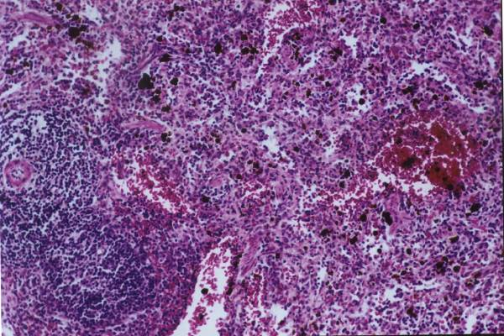  1 | 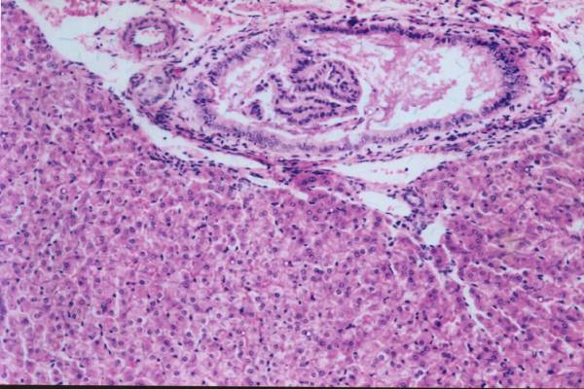  2
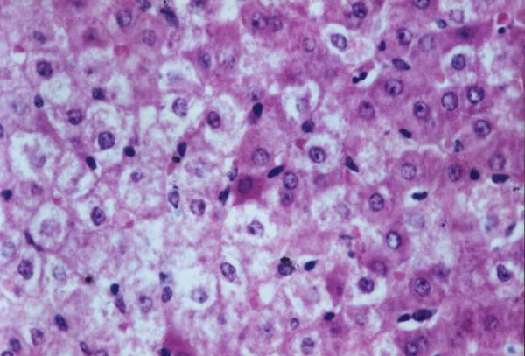  3 | 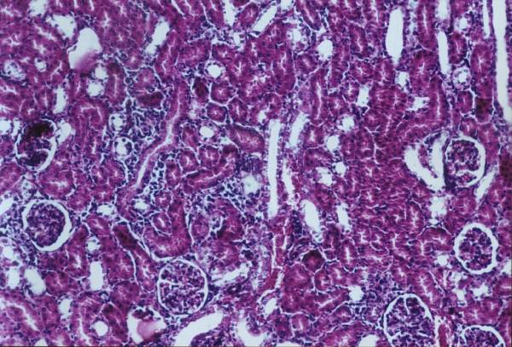  4
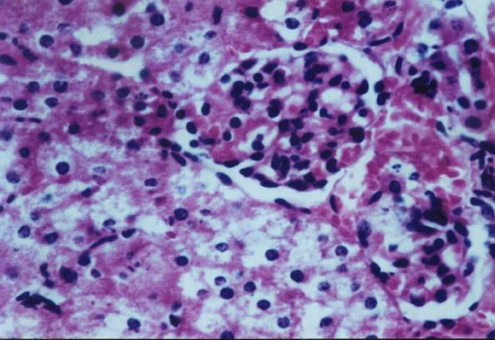  5 | 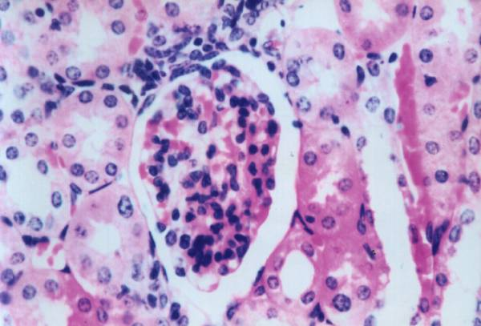  6

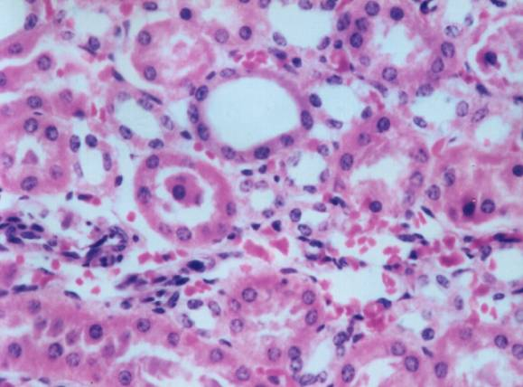  7 | 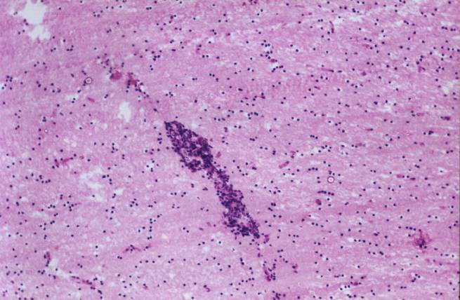  8
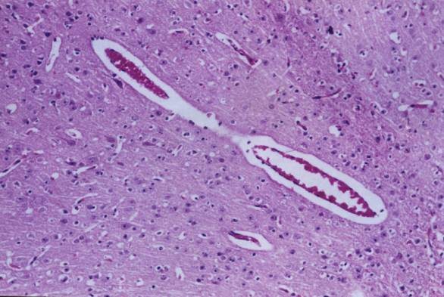  9 | 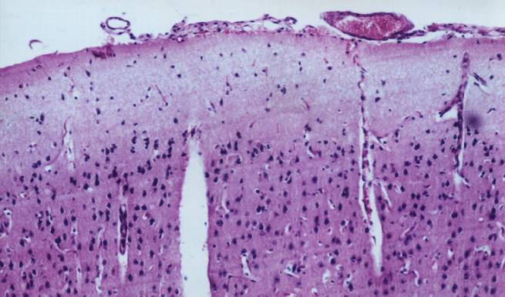  10

Fig. (1): Spleen of guinea pig 7 weeks post-cadmium chloride administration showing focal hemorrahgic areas with diffuse hemosiderosis (H & E X 40).
Fig. (2): Liver of guinea pig 9 weeks post-cadmium chloride administration showing diffuse kupffer cells proliferation in between the hepatocytes associated with severe dilatation of the hyperplastic bile ducts in the portal area besides periductal fibrosis and mononuclear leucocytes inflammatory cells infiltration (H & E X 40).
Fig. (3): Liver of guinea pig administered lead acetate for 9 weeks showing necrosis of the hepatocytes (H & E X 160).
Fig. (4): Kidney of guinea pig administered lead acetate for 9 weeks showing focal mononuclear leucocytes inflammatory cells infiltration in between the renal tubules and glomeruli (H & E X 40).
Fig. (5): Kidney of guinea pig administered lead acetate for 9 weeks showing degeneration with necrobiotic change in the lining epithelial cells of the renal tubules with swelling of the endothelial cells lining the glomerular tuft (H & E X 160).
Fig. (6): Kidney of guinea pig 9 weeks post-cadmium chloride administration showing swelling of the endothelial cells lining the hyperemic glomerular tuft associated with hypereosinophilia in the cytoplasm of some lining epithelial cells of the renal tubules with few fibroblastic cells proliferation in between (H & EX160).
Fig. (7): Kidney of guinea pig 5 weeks post-cadmium chloride administration showing focal fibrosis as well as focal extravasation of red blood cells in between the degenerated tubules (H & E X 160).
Fig. (8): Brain of guinea pig administered lead acetate for 5 weeks showing focal gliosis (H & E X 40).
Fig. (9): Brain of guinea pig administered lead acetate for 3 weeks showing severe hyperemia in the blood vessels and capillaries of the cerebrum with perivascular and pericellular oedema (H & E X 40).
Fig. (10): Brain of guinea pig administered lead acetate for 7 weeks showing hyperemic blood vessels and oedema in the meniniges with dilatation of the cerebral blood capillaries (H & E X 40).

Acknowledgment
I would like to thank Dr mohamed Reffeat said
Assc. prof of clinicalpathology, Pathology Dept., Animal Health Research Institute, Giza, Egypt

References
- Ahmed, K.; Haleem, H. and Aly, A. (1999): "Effect of copper and ascorbic acid in restriction of cadmium toxicity." J. Egypt. Vet. Med. Ass., 59 (5): 1549-1575.
- Bancroft, D.J.; Cook, C.H.; Stirling, R.W. and Turner, D.R. (1994): "Manual of histological techniques and their diagnostic application." Churchill Livingstone, Edinburgh, England.
- Belfield, A.; Goldberg, D.M. (1971): "Revised assay for serum phenyl phosphatase activity using 4- amino- antipyrine." Enzyme, 12, 561- 573.
- Bernard, F.; Joseph, G. and Nemi,, C. (2000): "Schalm's Veterinary hematology." 5th ed Lippino Cott Williams and Wilkins Co. Philadelphia, Blatimore, New York, London, Hong Kong, Tokyo.
- Bishayee, A.; Banik, S.; Marimuthu, P. and Chatterjee, M. (1997): "Vanadium mediated suppression of diethylnit- rosamine- induced chromosomal aberrations in rat hepatocytes and its correlation with induction of hepatic glutathione S- transferase." Int. J. Oncol., 10, 413- 423.
- Bjorneboe, A.; Bjormeboe, G.E.A. and Drevon, C.A. (1990): "Absorption, transport and distribution of vitamin E." J. Nutr, 120, 233-242.
- Blood, D.; Radostits, O. and Henderson, J. (1983): "veterinary Medicine." 6th edition, Williams and wilking Co., Blatimore, Baillier, Trindall, USA.
- Borgman, R.F.; Au, B. and Chandre, R.K. (1986): "Immunopathology of chronic cadmium administration in mice." International Journal of Immunopharmacology, 8 (7): 813-817.
- Browning, E. (1969): "Toxicity of industrial metals." 2nd, London, Bullerworth.
- Burtis, C.A. and Ashwood, E.R. (1999): "In TIETZ Text- book of Clinical Chemistry- Edition W.B." Saunders Co.
- Choi, J.H. and Rhee, S.J. (2003): "Effects of vitamin E on renal dysfunction in chronic cadmium- poisoned rats." Journal of Medicinal Food, 6 (3): 209-215.
- Chowdhury, B.A.; Friel, J.K. and Chandra, R.K. (1987): "Cadmium- Induced immunopathology is prevented by zinc administration in mice." Journal of Nutrition, 177: 1788-1794.
- Dan, G.; Lall, S.B. and Rao, D.N. (2000): "Humoral and cell mediated immune response to cadmium in mice." Drug and Chemical Toxicology, 23 (2): 349-360.
- Daum, J.R.; Shepherd, D.M. and Noelle, R.J. (1993): "Immunotoxixology of cadmium and mercury on B- lymphocytes- I- Effects on lymphocyte function." International Journal of Immunopharmacology, 15 (3): 383-394.
- Dhavale, D.M.; Masurekar, V.B. and Gridhar, B.A. (1988): "Cadmium induced inhibition of Na⁺/ K⁺ Atpase activity in tissues of crab Scylla serrata (forskal)." Bull. Environ. Contam. Toxicol., 40, 759- 763.
- Dong, S.; Li, D. and Yu, G. (2002): "Effect of cadmium on the beta- adrenoreceptor of splenic cell of rats and its immunotoxicity." Wei sheng yan jiu, 28 (4). 203-205.
- Doumas, B.T.; Watson, W.A. and Biggs, H.G. (1971): "Albumin standards and the measurement of serum albumin with bromocresol green." Clinica Chimica Acta, 31: 87-96.
- Edwards, M.J. and Beatson, J. (1985): "Effects of lead and hyperthermia on prenatal brain growth of guinea pigs." Teratology, 30 (3): 413-421.
- EPA (1986): "Air quality criteria for lead." Research Triangle Park, NC, US Environmental Protection Agency, 1986 (Report NO. EPA-600/8-83/028cF).
- Forshow, P. (1977): "The inhibitory effect of cadmium on neuromuscular transmission in the rat." Eur Journal of pharmacology, 4: 371-377.
- Forstner, N. and Wittman, G.T. (1988): "Metal pollution in the aquatic environment." Springer, verlag. Berlin.
- Fox, J.G.; Cohen, B.J. and Loew, F.M. (1984): "Laboratory Animal Medicine Ed., Academic Press, INC (Harcourt Brace Jovanovich)."
- Fujimaki, H.; Shimizu, F.; Kawamura, R. and Kubota, K. (1983): "Inhibition of delayed hypersensitivity reaction in mice by cadmium." Toxicology Letters, 19 (3): 241-245.
- Gallhom, K.I.; Saad, A.H.; Ranmi, N.A. and Abd EL- Hakeem, E. (2000): "Heavy metals residues in milk, drinking water and tissues and its impaction on animal health." Egyptian Journal of Comparative Pathology and Clinical Pathology, 13 (2): 198-215.
- Gouda, L.; Abdel- Aziz, L.M. and Soliman, M. (1985): "Changes in some kidney function in lead poisoned goats." Archive of experiments, Vet. Med., Lip-zing, 39,2, 305-311.
- Groten, J.; Senkeldan, E.; Muys, T.; Luten, J. and Bladareu, P.J. (1991): "Interaction of dietary Cd, P, Mg, Mn, Cu, Fe, Zn and Se with accumulation and oral toxicity of cadmium in rats." Food and Chemical Toxicology, 29 (4): 249-258.
- Hamada, T.; Tanimoto, A.; Arimal, N.; Ide, Y.; Sasaguri, T.; Shimajiri, S. and Sasaguri, Y. (1998): "Altered membrane skeleton of red blood cells participates in cadmium- induced anemia." Biochemistry and Molecular Biology International, 45 (4): 841-847.
- Hans, M.; Siegfried, S.; Roger, M. and Frank, W. (1999): "Toxicology." Academic Press, San Diego, London, Boston, New York, Sydney, Tokyo, Toronto.
- Hays, W.A. (1994): "Principles and methods of toxicology." 3rd edition edited by A. Walke Hays, Raven Press, Ltd, New York.
- Hernberg, S. (1979): "Occupational medicine principles and practical applications." Zinc C. (ed) Chicago Year Book Medical Publisher.
- Horiguchi, H.; Sato, M.; Konno, N. and Fukushima, M. (1996): "Long- term cadmium exposure induces anemia in rats through hypoinduction of erthropoietin in the kidneys." Archives of Toxicology, 71 (1-2): 11-12.
- Hudson, L. and Hay, F.C. (1980): "Practical Immunology." Blackwell Scientific Publications, UK.
- Humphreys, D.J. (1988): "Veterinary toxicology." Third edition, Bailliere Trindell London, Philadelphia, Toronto, Sydney, Tokyo.
- Ibrahim, M.S. (1983): "Toxicity resulting from lead compounds in veterinary practice." Ph. D. Thesis, Fac. Vet. Med., Cairo University.
- Ibtisam, M.G. (1998): "Clinicopathological alteration in cattle exposed to air pollution." Egypt. J. Comparative Pathology and Clinical Pathology, 11 (2): 33-42.
- Itokawa, Y. (1973): "Experimental cadmium poisoning." Japanese Journal of Hygiene, 28, 243-253.
- Jones, T.C. and Hunt, R.D. (1997): "Veterinary pathology." 8th edition, Lea and Febiger, Philadelphia.
- Kamiyama, T.; Miyakawa, H.; Li, J.P.; Akiba, T.; Liu, J.H.; Liu, J.; Maruno, F. and Sata, C. (1995 b): "Effects of one-year cadmium exposure on livers and kidneys and their relation to glutathione levels." Res. Commun. Mol. Pathol. Pharmacol., 88: 177-186.
- Karmakar, R.; Bhattacharya, R. and Chatterjee, M. (2000): "Biochemical, haematological and histopathological study in relation to time-related cadmium- induced hepatotxicity in mice." BioMetals 13: 231-239.
- Kjalf, A.; Mohamed, G. and Manal, S. (2001b): "The Protective effect of selenium and zinc against cadmium nephrotoxicity in albino rat." Assuit Vet. Med. J., 45 (90): 220-233.
- Koller, L.D.; Exon, J.H. and Roan, J.G. (1975): "Antibody suppression by cadmium." Arch. Environ. Health 30: 598- 601.
- Kostic, M.; Ognjanovic, B. and Zivkovic, R. (1993): "Cadmium induced changes of antioxidant and metabolic status in red blood cells of rats in vivo effects." Eur Journal of Hematology, 51 (2): 86-92.
- Krocova, Z.; Macela, A.; Kroca, M. and Hernychova, L. (2000): "The immunomodulatory effect (S) of lead and cadmium on the cells of immune system in vitro." Toxicology In vitro, 14, 33-40.
- Kroll, M.H.; Roach, N.A.; Poe, B. and Elin, R.J. (1987): "Mechanism of interference with the Jaffe reaction for creatinine." Clin- Chem.; 33 (7): 1129- 1132.
- Kubova, J.; Tulinska, J.; Stolcova, E.; Mosatova, A. and ginter, E. (1993): "The influence of ascorbic acid on selected parameters of cell immunity in guinea pigs exposed to cadmium." Z Ernahrungswiss, 32 (2): 113-120.
- Kuda, T.; Handa, R. and Tsuritani, I. (1988): "Progress of renal dysfunction in inhabitants environmentally exposed to Cd." Arch Evi. Health, 43: 213- 217.
- Kurata, Y.; Katsuta, O.; Hiratsuka, H.; Tsuchitani, M. and Umemura, T. (2001): "Intravenous 1 ∝ 25 (OH)₂ Vitamin D₃ (calcitriol) pulse therapy for bore lesions in a murine model of chronic cadmium toxicosis." Int. J. Exp. Path., 82, 43-53.
- Lall, S.B. and Dan, G. (1999): "Role of corticosteroids in cadmium induced immunotoxicity." Drug and Chemical Toxicology, 22(2): 401-409.
- Lansdown, A.B. (1996): "Physiological and toxicological in the skin resulting from the action and interaction of metal ions." Crit Rev Toxicology, 25 (5): 397-462,
- Lashgari, M.S. (1983): "Development of a hemagglutination test for detection of corona virus respiratory infections of chickens." Dissertation Abs. Int., B 43 (11): 3500-3504.
- Lawrence, D.A. (1981): "Heavy metal modulation of lymphocyte activities." Toxic. Appl. Pharmacy., 57, 439-451.
- Leffel, E.K.; Wolf, C.; Poklis, A. and White, K.L. (2003): "Drinking water exposure to cadmium, an environmental contaminant, results in the exacerbation of autoimmune disease in the murine model." Toxicology, 188 (2-3): 233-250.
- Levkutova, M.; Revajova, V.; Levkut, M. and Leng, L. (1998): "Subpopulations of lymphocytes in cattle naturally infected with papillomavirus." Acta Veterinary Hung, 46 (1): 13-18.
- Lokith, G. (1993): "Perspectives on lead toxicity." Clin. Biochem., 26: 371-381.
- Luckey, T.; Venugopal, B. and Hutcheson, D. (1975): "Heavy metal toxicity." 1st ed Geory Thieme publishers, Stuttgart, Academic Press, Inc, New York, San Francisco, London.
- Malave, I. and De Ruffino, D.T. (1984): "Altered immune response during cadmium administration mice."Toxic. Appl. Pharmac., 74, 46-56.
- Manal, M.M. (1999): "Toxicological studies on some heavy metals as environmental pollutants." Ph. D. Thesis, Toxicology Dept., Vet. Sci. Med., Suez Canal University.
- Manca, D.; Ricard, A.C.; Trottier, B. and Chevalier, G. (1991): "Studies on lipid peroxidation in rat tissues following administration of low and moderate doses of cadmium chloride." Toxicol., 67: 303-323.
- McMurry, S.; Lochmiller, L.; Chandra, S. and Qualls, R. (1995): "Sensitivity of selected immunological hematological and reproductive parameters in the cotton rats to subchronic lead exposure." Journal of Wild Life Disease, 31 (2): 193-204.
- Meali, Z. and Singhal, L. (1977): "Long term effects of orally administrated cadmium on neonatal rats." Proc of the 1st International Congress on Toxicology, Held March, 30 April, in Toronto, Canada.
- Milhaud, G.E. and Mehennaouis, S. (1988): "Indication of lead, zinc, cadmium exposure results in cattle in a polluted areas." Vet. Hum. Toxicol. 30, 513- 517.
- Mona, S.Z.; Saad, M.A., Faten, S. and Shalaby, M.N. (2001): "Some clinicopathological and microbiological studies in lead toxicity on cows and bulls." Egyptian Journal of Comparative Pathology and Clinical Pathology, 14 (1): 29-35.
- Nagwa, E.; Hagag, A.; Emad, M. and Amma, A. (1996): "Protective effects of zinc and vitamin C supplementation against renal toxicity of cadmium in guinea pigs." Journal of Egyptian Society of Toxicology, 17, 1-8.
- Nagyova, A.; Galba, V.S. and Genter, A.C. (1994 a): "Cadmium hepatotoxicity in guinea pigs with different ascorbic acid intake: Histomorphological and biochemical changes." Biologica Bratislova, 49 (3): 399-404.
- Navarro, F.; Arroyo, A.; Martin, S.F.; Bello, R.I.; DE Cabo, R.; Burgess, J.R.; Navas, P. and Villaiba, J.M. (1999): "Protective role of ubiqinone in vitamin E and Selenium- deficient plasma membranes." Biofactors, 9, 163-170.
- Ognjanovic, B. I.; Pavlovic, S. Z.; Maletic Zikic, R.V.; Stajn, A.S.; Radojicic, R.M.; Saicic, Z.S. and Petrovic, V.M. (2003): "Protective Influence of vitamin E on antioxidant defense system in the blood of rats treated with cadmium." Physiological Researches, 52, 563-570.
- Ohsawa, M.; Takahashi, and Otsuka, F. (1988): "Induction of anti- nuclear antibodies in mice orally exposed to cadmium at low concentrations." Clinical and Experimental Immunology, 73 (1): 98-102.
- Pavlovic, S.Z.; Ognjanovic, B.I.; Stajn, A.S.; Zikic, R.V.; Saicic, Z.S. and Petrovic, V.M. (2001): "The effect of coenzyme Q₁₀ on blood ascorbic acid, Vitamin E and lipid peroxide in chronic cadmium intoxication." J. Environ. Pathol. Toxicol. Oncol. 20: 133- 144.
- Pond, W.G.; Walker, E.F. and Kirttand, D. (1973): "Cadmium induced aneamia: Protective effect of oral or potential iron." Journal of Animal Science, 36, 1122-1133.
- Rajanna, B.; Hobsen, M.; Reese, J.; Sample, E. and Chapatwala, K. (1984): "Chronic hepatic and renal toxicity by cadmium in rats." Drug Chemical Toxicology, 7 (3): 222-241.
- Raszyk, J.; Toman, M.; Gajda Skova, V.; Nezeda, K.; Ulrich, R.; Jaeosova, A.; Docekalova, H.; Salava, J. and Pala, C J. (1998): "Effects of environmental pollutants on the porcine and bovine immune systems." Veterinary Medicine (Praha), 42 (11): 313-317.
- Reinhold, J.C. (1953): "Standard Methods in clinical chemistry." Academic Press, New York.
- Reitman, S. and Frankel, S. (1957): "Am. J. Clin. Path., 28, 56.
- Rollet- Labella, E.; Grange, M.J.; Elbim, C.; Marouetty, C.; Gougerot- Picadalo, M.A. and Pasquier, C. (1998): "Hydroxyl radical as a intracellular mediator of polymorphonuclear neutrophil apoptosis." Free Radic. Biol. Med. 24, 563- 572.
- Senturk, U.K.; oner, G. and Lzgut- Uysal, V.M. (1994): "Cadmium induced lipid peroxidation in kidney function." Journal of Basic and Clinical Physiology and Pharmacology, 5 (3-4): 305-313.
- Shaikh, Z.A.; Thanhtam, T.Vu. and Zaman, K. (1999): "Oxidative stress as a mechanism of chronic cadmium-induced hepatotoxicity and renal toxicity and protection by antioxidant." Toxicol. Appl. Pharmacol., 123: 89-96.
- Shukla, A.; Shukla, G.S. and Srimal, R.C. (1996): "Cadmium – induced alteration in blood- brain barrier permeability and its possible correlation with decreased microvessel antioxidant potential in rat." Human and Experimental Toxicology, 15 (5): 400-405.
- Sierra, E.M. and Tiffany- Castiglioni, E (1992): "Effects of low- level lead exposure on hypothalamic hormones and serum progesterone levels in pregnant Guinea pigs." Toxicology, 72 (1): 89-97.
- Stites, D.P.; Stobo, J.D.; Fudenberg, H.H. and Wells, J.V. (1982): "Basic and clinical immunology." 4th Edition, Large Medical Publications, California, USA.
- Summers, B.A.; Cummings, J.F. and De Lahunta, A. (1995): "Veterinary Neuropathology." Mosby-Year Book, Inc., Printed in the United States of America.
- Szymanska, E. and Laskowska- Klita, T. (1993): "Effect of cadmium (CdCl₂) on lipid peroxidation and activities of antioxidant enzymes." Acta Biochim. Pol. 40, 144- 146.
- Taketani, S.; Takena, A. and Tokunoga, R. (1985): "Reconstitution activity from ferric ion and prophyrines and the effect of lead on the activity." Archive of Biochemistry and Biophysiology, 242: 291-296.
- Tandon, S.K.; Singh, S. and Dhawan, M. (1992): "Preventive effect of vitamin E in cadmium intoxication." Biomedical and Environmental Sciences, 5 (1): 39-45.
- Theocharis, S.E.; Mrgeli, A.P.; Ghiconti, I.K. and Varonos, D. (1991): "Liver thymidine kinase activity after cadmium. Induced hepatotoxicity in rats." Toxicological Letters, 63 (2): 181-190.
- Thomas, P.T.; Ratajczak, H.V.; Aranyi, C.; Gibbons, R. and Fenters, J.D. (1985): "Evaluation of host resistance and immune function in cadmium- exposed mice." Toxicology and Applied Pharmacology, 30, 80 (3): 446-456.
- Lansdown, A.B. (1996): "Physiological and toxicological in the skin resulting from the action and interaction of metal ions." Crit Rev Toxicology, 25 (5): 397-462,
- Tietz, N.W. (1995): "Text book of clinical chemistry." W.B. Saunders Company, Philadelphia, London, Toronto, Tokyo.
- Trinder, P. (1969): "Determination of Glucose in Blood using Glucose with an alternative oxygen acceptor." Ann. Clin. Biochem., 6: 24.
- Trottier, B.; Athot, J.; Ricared, A.C. and Lafond, J (2002): "Maternal- fetal distribution of cadmium in the guinea pig following a low dise inhalation exposure." Toxicology Lett., 129 (3): 189-197.
- Vodela, J.K.; Renden, J.A.; Lenz, S.D.; McElhenney, W.H. and Kemppainen, B.W. (1998): "Drinking water contaminants (arsenic, cadmium, lead, benzene, and trichloroethylene). 1. Interaction of contaminants with nutritional status on general performance and immune function in broiler chickens." Poultry Science, 76 (11): 1474-1492.
- Waffa, M. (1996): "Comparative study on the protective effect of zinc and vitamin C against cadmium induced toxicity in rats." Journal of Egypt Soc. Toxicol., 17, 9-20.
- Webb, M. (1977): "Clinical Chemistry and chemical toxicology of metals." El-Sivre / North Holland, Biomedical press, Amsterdam, New York, Oxford.
- Wershana, Karima Z. (2001): "Cadmium Induced Toxicity on Pregnant Mice and Their Offspring: Protection by Magnesium or Vitamin E." The Sciences 1 (4): 179-186.
- WHO (1980): "Technical report series Recommended Health- Based Limits in Occupational Exposure to heavy metals report of WHO study Group." Technical Report. Series No. 647.
- Wright, F.C.; Palmer, J.S.; Riner, J.C. and Mebeth, C.A. (1977): "Effects of dietary feeding of cadmium to cattle and sheep." Journal of agriculture and feed chemistry, 25, 293-297.

10/11/2012

