Synthesis of Dy- doped CaSrS Nanophosphors and Characteristic Glow peak study

Talaat. S. A.¹ H. S. Hafez ¹ , H. S. A. Aly ², Naglaa. Y.A ¹, Hosnia. M. A ² and Basyouni. A. Henaish ¹

¹Radiation Protection Department, Nuclear Research Center, Atomic Energy Authority.
²Physics Department, College for Women (Arts, Science and Education), Ain Shams University
shokryhanaa@yahoo.com

Abstract: Calcium strontium sulphide (CaSrS) has been prepared by the solid state diffusion reaction and characterized by Transmission Electron Microscopy (TEM), which shown the formation of compound in ring like structure with average particle size 24nm. The effect of different concentration of calcium and strontium has been studied. The optimum was found to be Ca_{0.65} Sr_{0.35} S which increases TL-sensitivity 15 times than previous work. The dysprosium (Dy) doped to CaSrS by different concentrations for the sake of improving the TL-sensitivity. The optimum concentration of dysprosium was found to be (0.22wt %). CaSrS:Dy (0.22wt%) has five glow peaks at (117.5, 185, 345, 410 and 430 ˚C). High gamma doses as TL-sensitization method have been used. By these means the TL-intensity of treated samples proved about 24 times enhancement, which make it very promising detector and dosimeter suitable for ionizing radiation.
[Talaat. S. A. Hanaa. S. Hafez , H. S. A. Aly , Naglaa. Y.A , Hosnia. M. A and Basyouni. A. Henaish . Synthesis of Dy- doped CaSrS Nanophosphors and Characteristic Glow peak study. N Y Sci J 2012;5(12):148-151]. (ISSN: 1554-0200). http://www.sciencepub.net/newyork. 22

Keywords: Thermoluminescence, Nanomaterials, Sensitization, Dysprosium and CaSrS.

1. Introduction:
Thermoluminescence (TL) is the emission of light from semiconductor or an insulator when it is heated after its exposure to radiation^{(1.2)} Thermoluminescence is one of the long investigated fields. Various aspects of TL have been theoretically as well as experimentally studied till date. CaSO₄:Dy and LiF-TLD100 are a couple of good thermoluminescent phosphors. Tissue equivalence, reusability, stability, high sensitivity, a simple glow curve structure and dose linearity are some of the characteristics of an ideal TL material. The most widespread applications of TL phenomenon is the radiation dosimetery, in health physics, biological sciences and radiation protection. Besides this TL is a tool to study the defects and traps structure inside the host lattice⁽³⁾. The quality of TL materials depend on the used doping, on their concentration and on other factors. The lanthanids, R (rare earth), play a unique role in the production of high sensitivity reliable TL dosimeters⁽⁴⁾. Since no phosphor can behave in an ideal way hence there have always been attempts to prepare new phosphors with improved TL characteristics or improve upon the already existing phosphors ⁽³⁾.
Recently, researchers interest towards nanomaterials has increased because they exhibit enhance optical, electronic and Structural properties. They have potential as efficient phosphors in display applications such as new flat panel displays with low energy excitation sources, solar energy converters, optical ampliﬁers and TLD phosphors. Many new physical and chemical methods of preparations have also been developed in the last two decades, nanoparticles and nanorods (powders) of several ceramic materials have been produced^{(5,6)}. This study focus on the preparation of CaSrS in nanostructure form by solid state diffusion method. The products were characterized by using transmission electron microscopy (TEM). The improving of TL- sensitivity of CaSrS performed by doping with dysprosium, treated with different courses gamma dose sensitization.

2. Material and Methods
2.1Preparation of CaSrS
The solid state diffusion method was carried out to synthesize CaSrS nanocrystalline phosphorus. Calcium sulphate (CaSO₄), Strantium sulphate (SrSO₄), Soudium thiosulphate(Na₂S₂O₃.5H₂O), and carbon powder were the starting materials. Sodium thiosulphate acts as a flux for the reaction. Carbon reduces sulphate to sulphide at high temperature. Calcium sulphate and Strantium sulphate were soaked separately with nitric acid and kept overnight. They were heated for half an hour to ensure that all metallic impurities were converted into their respective nitrates. These soluble nitrates were eliminated by repeated washing in warm distilled water. Carbon powder was boiled in excess of distilled water for half an hour and filtered. The residue in filter paper was repeatedly washed with warm distilled water, dried in an oven and finally collected in bottle⁽⁷⁾. Growing of Ca_{1-x}Sr_{x}S as a function of x (wt) has been studied. Calcium sulphate (with 1-x wt), Strantium sulphate (with x wt) and Soudium thiosulphate were taken and mixed thoroughly with help of an agate pestle and mortar. The charge was placed in clean platinum crucible and thin layer of carbon powder are speared over it. This crucible was placed in other large platinum crucible contain carbon powder. The charge was fired at 950˚C for 2h using Stuart scientific furnace. After 2 hr the charge was taken out and crushed while red hot with the help of pestle and mortar^{(7,8,9)}. Soudium thiosulphate and carbon powder concentrations were studied where we get that the optimum concentration of both are 15%Wt.
The different samples were annealed at 400˚C for 30 min and then quenched on a metallic plate at room temperature. The samples packed in light proof capsule and exposed to 10Gy γ-ray from a ⁶⁰Co-γ-cell unit at Cyclotron department, NRC, AEA with dose rate 1 Gy/s at (2006). Harshaw 3500 series TLD reader have been used to read out the samples with heating 4˚C/s and recorded their glow curves. The optimum sample was characterized by TEM and determined its particle size.
2.2. Growing of CaSrS:Dy
Deferent concentration of dysprosium doped the optimum concentration of CaSrS nanophosphorus as follow: dysprosium oxide solution was prepared by dissolving 50mg of dysprosium oxide in concentrated nitric acid and distilled water making total volume 50 ml. volumes of 1.5, 1.8, 2, 2.2, 2.5 and 3ml were mixed with different batches of 0.65gm of calcium sulphate, 0.35gm of strontium sulphate, 0.15gm of sodium thiosulphate and carbon powder and reappeared as mentioned above. These different volumes of dysprosium oxide solution produced different batches of Ca_{0.65} Sr_{0.35} S doped with dysprosium of concentrations1.5, 1.8, 2, 2.2, 2.5 and 3% by wt respectively^{(10,11)}.

2.3.Gamma dose Sensitization
Samples of the optimum condition of the product nanophosphorus Ca_{0.65}Sr_{0.35}S:Dy(0.22%) have been exposed to ϒ-ray source ⁶⁰Co with different doses (500, 1000, 3000, 5000, 7000 and 9000Gy). The samples have been pre-annealed and then exposed to a test dose of 10Gy ϒ-ray of ⁶⁰Co source. The samples have been read out , with heating rate 4 ˚C/sec^{(12,13,14)}.

3. Results
3.1.Thermoluminescence Studies
Thermoluminescence characteristics of gamma ray irradiated Ca_{1-x} Sr_{x}S as a function of x (0.25, 0.30, 0.35, and 0.40) have been investigated. Figure (1) shows the effect of changing in Ca:Sr concentration on the TL-sensitivity of CaSrS exposed to 10Gy of ϒ-ray. From this figure we can see that, as the concentration of Sr increase the TL intensity increase until reach concentration 35wt% of Sr after which the TL- intensity decreases, this mean that the optimum concentration of Sr is 35wt% which increase TL-sensitivity ≈ 15 times than previous work⁽⁷⁾.

Figure (1). The effect of changing in Ca:Sr concentration on the TL-sensitivity of CaSrS exposed to 10Gy of gamma ray.

Figure (2). The effect of different dysprosium concentration on the TL- intensity of CaSrS after exposed to test dose 10Gy.

3.2. TL vs. activator concentration
Figure (2). Represents the effect of different dysprosium concentration on the TL- intensity of CaSrS after exposed to test dose 10Gy. It can be seen from figure (2) that the TL intensity firstly decreases for concentration 0.15wt% after that gradual increases is observed from concentration 0.18wt% to 0.22wt%. followed by a decrease from concentration 0.25wt%. The decrease in the intensity at concentration 0.15wt% may be due to generation of new energy levels which might result in generation of non-radiative traps more than radiative traps after that as the concentration increase as the radiative traps might be increase than non-radiative trap until reach to 0.25wt concentration the non-radiative traps increase than radiative trap which lead to decrease in TL-intensity again. from this result the optimum concentration of Dy is 0.22wt% which improved the TL- sensitivity about three folds.

3.3.Gamma dose Sensitization
Figure (3) shows the effect of gamma-dose sensitization on the TL-intensity of CaSrS:Dy (0.22wt%) after exposed to test dose 10Gy. From this figure we can shown that the TL sensitivity of CaSrS:Dy(0.22wt% ) unchanged when exposed to pre doses (500 Gy and 1000 Gy) then gradual increase is observed from pre- dose 3000 Gy to pre- dose 9000 Gy then decrease again. So that the optimum pre-dose is 9000Gy which indicated another 3 folds of improved sensitivity.

Figure (3). The effect of gamma-dose sensitization on the TL-intensity of CaSrS:Dy (0.22wt%) after exposed to test dose 10Gy.

3.4. Characteristic glow curve study
Figure (4) represents the characteristic glow curves of Ca_{0.65} Sr_{0.35} S after exposed to 10Gy of gamma ray, in this figure we can see that Ca_{0.65} Sr_{0.35} S has four peaks, low temperature peak at (126 ˚C) and three high temperature peaks at ( 404˚C, 425 ˚C and 4450 ˚C). figure (5) shows the characteristic glow curve of CaSrS:Dy (0.22wt%). There are five TL peaks appeared at (117.5 ˚C -185 ˚C – 345 ˚C – 410 ˚C – 430˚C) which reflect the presence of five kinds of trapping centers. The peak position of CaSrS:Dy (0.22wt%) doesn’t exchange after exposed to gamma sensitization dose but the TL- intensity increase by factor 3 as showed in figure (6).

Figure (4). The characteristic glow curve of Ca_{0.65} Sr_{0.35} S.

Figure (5). The characteristic glow curve of CaSrS:Dy (0.22wt%).

Figure (6). Comparison between Characteristic glow curve of Ca_{0.65} Sr_{0.35} S, CaSrS:Dy (0.22wt%) and CaSrS:Dy (0.22wt%) after gamma dose sensitization
TEM pattern
Figure (7). Shows the TEM pattern for Ca_{0.65} Sr_{0.35} S :Dy (0.22 wt%). , TEM shows the ring shape like structures with an average particle size 24 nm.

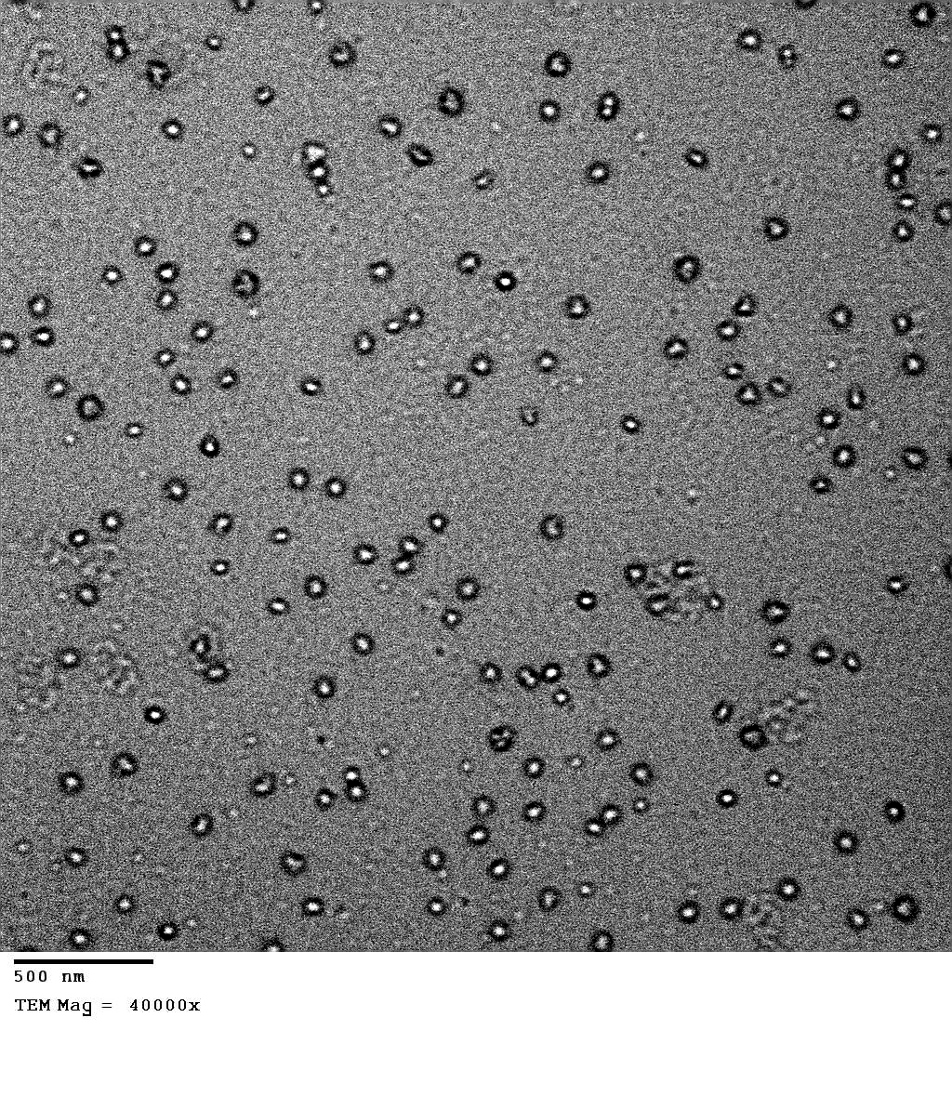
Figure (7). The TEM pattern for Ca_{0.65} Sr_{0.35} S :Dy (0.22 wt%).

Conclusion
CaSrS was synthesized via solid state diffusion method. TEM micrograph shows ring like structure of the nanoparticles with an average diameter of 24nm. The effect of changing in the concentration of Calcium sulphate and strontium sulphate have been studied. The optimum concentration of Calcium sulphate and strontium sulphate is 65%:35%. Different concentrations of Dy were added to Ca_{0.65} Sr_{0.35} S, the results showed that the optimum concentration of Dy doped to Ca_{0.65} Sr_{0.35} S is (22wt%). CaSrS:Dy (0.22wt%) has five glow peaks at (117.5˚C – 185 ˚C – 345 ˚C – 410 ˚C – 430 ˚C). High gamma dose sensitization have been used to increase sensitivity of CaSrS:Dy (0.22wt%). The optimum pre- dose of gamma ray is 9000 Gy . It is worth indicating that the TL- sensitivity is improved as 24 times by using the optimum doping concentration and the optimum gamma dose sensitization.

Refrences
(1) Mckeever, S. W. S; Chen, R.(1997). Theory of Thermoluminescence and Related Phenomena. World scientific, Singapore.
(2) Mckinlay, A.F. (1981). Medical Physics Handbook of Thermoluminescence Dosimetry. Adam Higler Ltd, Bristol in collaboration with the Hospital Physicists’ Association.
(3) Geeta Sharma, Puja Chawla, S. P. Lochab, Nafa Singh Chalcogenide letters. 6: 705- 712 (2009).
(4) Gscheidner, K.A., Jr and Eyring, L.(2000). “ Handbook on the Physics and Chemistry of Rare Earths”. Elsevier Science B.V.
(5) Yu.V. Malyukin. journal of Radiation Measurements. 45: 589-593 (2010).
(6) Salah Numan Radiation Physics and Chemistry. 80, : 1-10 (2010).
(7) Vijay Singh, T.K. Gundu Rao, Jun-Jie Zhu, Manoj Tiwari Material Science and Engineering.131:195- 199 (2006).
(8) Geeta Sharma, S.P. Lochab, Nafa Singh (2010) “TL behavior of Ca_{o.5}Sr_{o.5}S:Ce nanophosphors” Journal of Alloys and Compounds. 508:L9-L12.
(9) Puja Chawla , S.P. Lochab, Nafa Singh. Journal of Alloys and Compounds. 494: L20-L24(2010).
(10) Naglaa. Y.A. (2009). M.Sc thesis, Al-Azhar University, “ Preparation and Properties Study of TLD Nanophosphores Zinc Oxide Doped with Dysprosium for Application in Radiation Dosimetry”.
(11) Shreyas S. Pitale, Suchinder K. Sharma, R.N. Dubey, M.S. Qureshi, M.M. Malik Journal of Luminescence 128, 1587-1594 (2008).
(12) Koury, H.J., Guzzo, P.L., Souza, L.B.F., Farias, T.M.B., Watanaba, S. Radiation measurements.43: 487-491 (2008).
(13) Soliman, C., Nuclear Instruments and Methods in Physics Research.263: 429-435 (2007).
(14) Zimmerman, J.. Physics. 4: 3265- 3276 (1971).

10/10/2012

