Hypsometric Properties Of Drainage Basins In Karnataka Using Geographical Information System

Ramu¹ and B.Mahalingam²

¹Course Coordinator, ²Faculty, Department of Geography (GIS), Maharaja's College, University of Mysore, Mysore 560 005 Karnataka. mahabose.geo@gmail.com. , drramumysore@gmail.com.

Abstract: This study has been conducted to analyze the hypsometric properties of drainage basins in Karnataka. In constructing the hypsometric integral curve, a Digital Elevation Model (DEM) with 300 m spatial resolution has been created based on the Triangulated Irregular Network (TIN). The topographical map has been used as a base map for generating contours to create the TIN model. The hypsometric integral curve results, derived from the DEM, show that six drainage basins are in Maturedly Dissected Landforms while the South Ponnar basin is in an old state of dissection. The result of hypsometric curve shows that the drainage basins are significantly different from each other. The Moran’s I shows a negative spatial autocorrelation between the drainage basins and it indicates that HI values are random in the study area.
[Ramu and B.Mahalingam. Hypsometric Properties Of Drainage Basins In Karnataka Using Geographical Information System. N Y Sci J 2012;5(12):156-158]. (ISSN: 1554-0200). http://www.sciencepub.net/newyork. 25

Key Words: Digital Elevation Model, Triangulated Irregular Network, Hypsometric Integral, Hypsometric Curve, GIS.

- Introduction
Drainage basin is an area from which all precipitation flows to a single stream or a set of streams. There are a number of quantitative analyses used to calculate the topography of the drainage basin; and the analysis could be prepared from a single drainage basin to the entire country. Comparing the results from different drainage basins would be difficult without a suitable technique. Hypsometric Integral and Hypsometric Curve are the best method to analyze the topography of a drainage basin. It was devised by Strahler (1952) as a dimensionless (percentage) measure of subsurface volume of a drainage basin, referred to the 100 per cent value given by “a solid bounded on the sides by the vertical projection of the basin perimeter and on the top and base by parallel planes passing through the summit and mouth respectively” (Strahler, 1952: 1119; Richard, 1959: 566). Hypsometry refers to a frequency distribution of elevations. The hypsometric curve represents a fraction of the basin area below a given height, usually reported in non-dimensional terms by normalizing the elevations relative to the total elevation range in the area of interest. The hypsometric integral is an area under the normalized curve, which by deﬁnition must lie in the range 0 to 1 (Harrison et al., 1983).
- Study Area
Karnataka is a state in southwest India situated on a tableland, where the Western and Eastern Ghats ranges converge into the Nilgiri hill complex, the state is bordered by the Arabian Sea to the west, Goa to the northwest, Maharashtra to the north, Andhra Pradesh to the east, Tamil Nadu to the southeast, and Kerala to the southwest. The State covers an area of 5.83 percent of the total geographical area of India. There are seven main river systems in Karnataka with their tributaries, the names of these rivers are: i) Krishna ii) Cauvery; iii) Godavari; iv) North Pennar; v) South Pennar; vi) Palar; and vii) West Flowing Rivers. These seven river drainage basins have been analyzed in this study and the details of the river basins are as following:
River Krishna is an inter-State river, rises in the Western Ghats at an altitude of 1,337 m. It flows across the whole width of the peninsula, from west to east, for a length of about 1400 km. The principal tributaries of the Krishna in Karnataka are Ghataprabha, Malaprabha, Bhima and Tungabhadra.
The river Cauvery is one of the major rivers of the Peninsula, flowing east and running into the Bay of Bengal. The Cauvery rises at an elevation of 1,341m above mean sea level. The principal tributaries of Cauvery in Karnataka are the Harangi, the Hemavathy, the Lakshmanathirtha, the Kabini, the Shimsha, the Arkavathi and the Suvarnavathy. All these rivers, except for the Kabini River, Arkavathy River and Suvarnavathy River rise and flow fully in Karnataka.
The river Godavari rises at an elevation of 1,067 m, after flowing for about 1,465 km in a general south-easterly direction and it falls into the Bay of Bengal. The principal tributaries of the Godavari are the Pravara, the Purna, the Manjra, the Pranahita, the Indravathy and the Sabari.
The North Pennar River rises on the Nandi hills in Kolar district; and after flowing for about 597 km in a general southeasterly direction it falls into the Bay of Bengal. The principal tributaries of the North Pennar River are the Uttara Pinakini. The South Pennar River rises in Nandi hills in Kolar district

The Palar River rises in Talagavara village in Kolar district, at an elevation of 900 m, after flowing for about 348 km in a general south-easterly direction it falls into the the Bay of Bengal.
- Methods and Materials
Geographical Information System has been used for data preparation, data manipulation and analysis of data. ArcGIS 10 has been used for the present study. The Survey of India Topographical map has been used as a base map. The onscreen digitizing technique has been used to input the contour lines into the GIS environment from the scanned topographical map (Figure 2).
The contour line’s elevation value used to create a Triangulated Irregular Network (TIN) model (Figure 3); then the Digital Elevation Model (DEM) with 300 m spatial resolution has been created based on the TIN model (Figure 4). The drainage basin’s boundaries have been identified through a toolset (fill, flow direction, flow accumulation and snap pour point) in ArcGIS software using DEM model as input. The elevation value of DEM has been used to find out the Hypsometric Integral for each drainage basin in the study area. The hypsometric tool box downloaded from the ESRI website has been used to determine the hypsometric curve values based on the DEM pixels. In order to generate the graphical representation of hypsometric curve, the ArcGIS graph option has been used. Finally, Moran’s I spatial autocorrelation has been calculated to find out the relationship between the drainage basins in the study area.
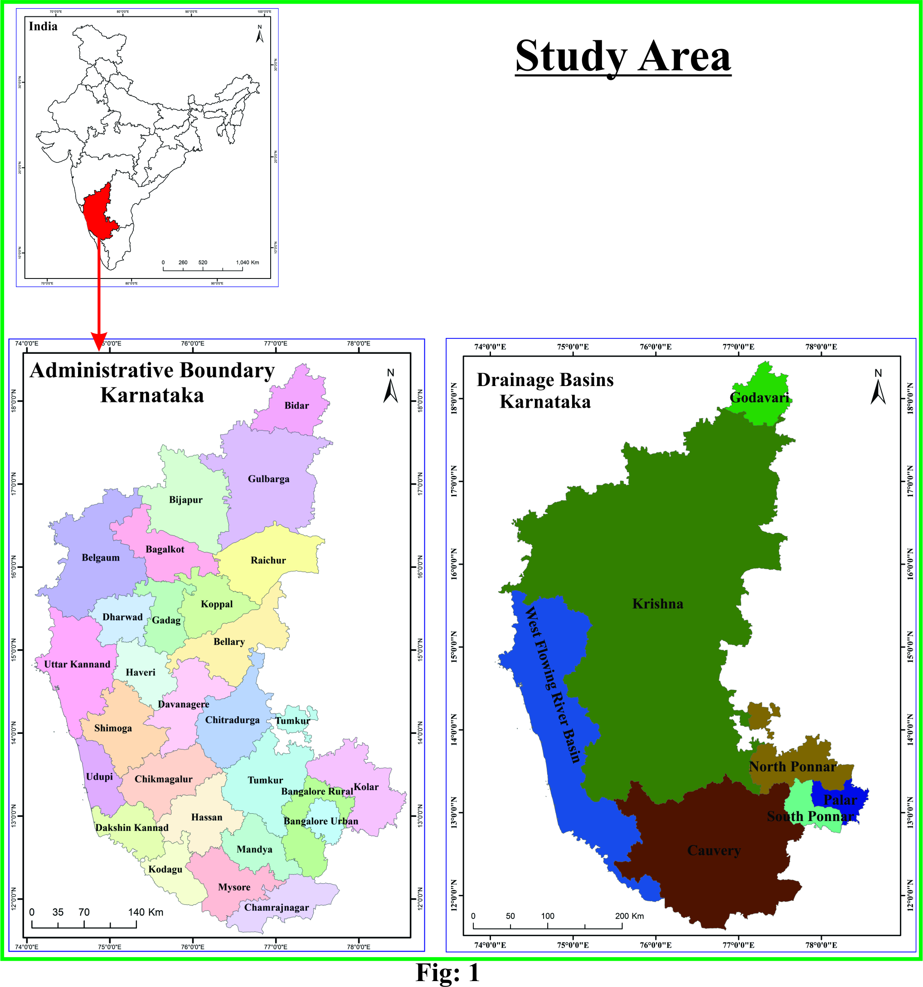
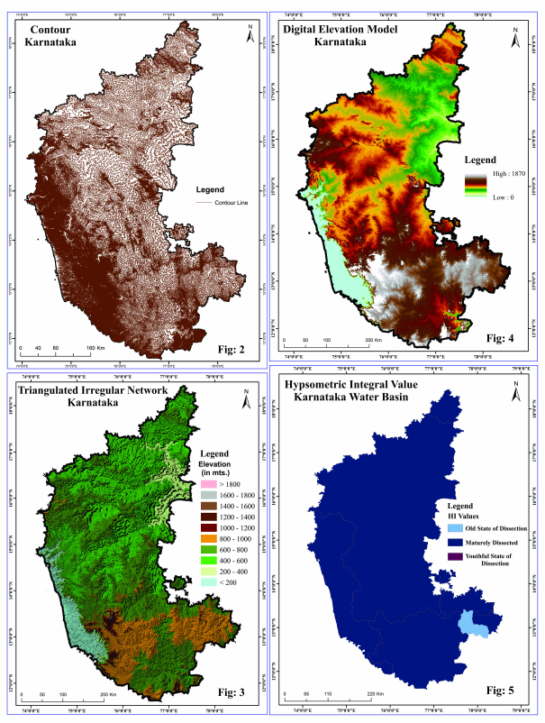
- Results and Discussion
The Hypsometric Integral value is be between 0 to 1, it gives a hypsometric integral which is defined as the proportion lying below the curve to the total square graph, if the result value is between 0.6 and 1.0; it indicates the youthful state of dissection; if the result value is between 0.35 and 0.60, it indicates a maturedly dissected landform; and if the result is less than 0.35, then it indicates an equilibrium or old state of dissection. The formula for calculating the Hypsometric Integral is given below:
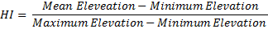

Table:1 Hypsometric Integral – Karnataka Drainage Basins
S.No | Basin Name | Elevation in Meters |  |  | HI
S.No | Basin Name | Max | Min | Mean | HI
1 | Cauvery | 1826 | 245 | 964.88 | 0.46
2 | Godavari | 675 | 411 | 549.81 | 0.53
3 | Krishna | 1870 | 202 | 1023.33 | 0.49
4 | North Ponnar | 1364 | 467 | 891.64 | 0.47
5 | Palar | 1185 | 700 | 897.27 | 0.41
6 | South Ponnar | 1450 | 596 | 854.20 | 0.30
7 | West Flow | 1850 | 0 | 779.00 | 0.42

Hypsometric integral data were derived for each of the seven drainage basin from 300 m DEM shown in Table 1. The result of the Hypsometric Integral shows that all drinage basins come under the Maturedly Dissected Landform, except for the South Ponnar basin which comes in old state of dissection, the result of Hypsometric Integral values have been mapped (Figure 5) to see the visual interpretation of HI values between drainage basins.
The hypsometric curve of a catchment represents the relative area below (or above) a given altitude (Strahler, 1952). A hypsometric curve is essentially a graph that shows the proportion of land area that exists at various elevations by plotting relative area against relative height. These curves have been used to infer the stage of development of the drainage network also it is a powerful tool to differentiate between tectonically active and inactive areas (Keller and Pinter,1996).
The shape of the hypsometric curves and the HI values provide valuable information not only on the erosional stage of the basin, but also on the tectonic, climatic, and lithological factors controlling it (for example, Moglen and Bras, 1995; Willgoose and Hancock, 1998; Huang and Niemann, 2006).
The results of the hypsometric curves of seven drainage basins are shown in Figure 6: the result shows that the drainage basins are significantly different from each other. The Godavari drainage basin shows a convex curve characterizing the basin as eroded less than the other basins. The South Ponnar drainage basin has shown a concave curve shape, characterizing the basin of an old state of dissection. Table 2 shows the spatial relationship between the drainage basins which are retrieved from global Moran’s I statistics technique. The result of -0.05 shows the negative spatial autocorrelation between the drainage basins’ HI values, so this indicates that HI values are random for the study area.
- Conclusion
The study of hypsometric properties of drainage basin using hypsometric integral and curve has been retrieved in that the integral values varies from 0.30 to 0.53. Among the seven drainage basins, six drainage basins are in maturely dissected landform while the South Ponnar drainage basin is in the old state of dissection. No drainage basin comes in youthful state of dissection in the study area. The resultant hypsometric curve graph has shown that ‘S’ shaped, concave and convex hypsometric curve which mean that the erosional process differs from one basin to another. The Moran’s I has shown the negative spatial autocorrelation between the drainage basins showing that HI values are random in the study area.

References
- Ansari, Ziaur Rehman et al., (2012) “GIS based morphometric analysis of Yamuna drainage network in parts of Fatehabad area of Agra district, Uttar Pradesh”, Journal Geological Society of India, 79: 505-514.
- Brocklehurst, S. H. and Whipple, K.H. (2004) “Hypsometry of glaciated landscapes”, 29(7): 907-926.
- Dowling, Trevor I. et al., (1998) “Application of the hypsometric integral and other terrain based metrics as indicators of catchment health: A preliminary analysis” CSIRO Land and Water, Canberra Technical Report 20/98, April 1998.
- Harlin, John M. (1978) “Statistical moments of the hypsometric curve and its density function”, Journal of the International Association for Mathematical Geology, 10(1): 59-72.
- Imran Malik, M. et al., (2011) “Watershed based drainage morphometric analysis of Lidder catchment in Kashmir Valley using Geographical Information Systems”, Recent Research in Science and Technology, 3(4): 118-126.
- Jayappa, K.S. et al., (2012) “Identification of geomorphic signatures of neotectonic activity using DEM in the Precambrian terrain of Western Ghats, India,” International archives of the photogrammetry, Remote Sensing and Spatial Information Science, Volume XXXIX-B8: 215-220.
- Kouli, M. et al., (2006) ‘A GIS example of Morphometric analysis in tectonic structures of western crete, Greece”, Proceedings of the 5th WSEAS International conference on environment, ecosystems and development, venice, Italy: 229-234.
- Mishra, Abha et al., (2011) “Morphometric analysis of Tons basin, Rewa District, Madhya Pradesh, based on watershed approach” Earth Science India, 4(3): 171-180.
- Pal, Babita et al., (2012) “Morphometric and hydrological analysis and mapping for Watut Watershed using Remote Sensing and GIS Techniques” International Journal of Advances in Engineering & Technology, 2(1): 357-368.
- Rao, Liaqat A. K. et al., (2011) “Morphometric analysis of drainage basin using Remote Sensing and GIS techniques: A case study of Etmadpur Tehsil, Agra District,U.P.”, International Journal of Research in Chemistry and Environment, 1(2): 36-45.
- Rekha, V. B. et al., (2011) “Morphometric analysis and micro-watershed prioritization of Peruvanthanam sub-watershed, the Manimala River Basin, Kerala, South India”, Environmental Research, Engineering and Management, 3(57): 6 – 14.
- Strahler, A.N. (1957) “Quantitative analysis of watershed geomorphology”, Transactions, American Geophysical Union, 38(6): 920-930.
- Tiwari, D.R. et al., (2010) “Drainage morphometry analysis through RS & GIS techniques: A case Study in and around Sehore Town, District Sehore (M.P)” International Research Journal, II(11-12): 75-77.
- Walcott, R. C. and Summerfield, M.A. (2008) “Scale dependence of hypsometric integrals: An analysis of southeast African basins”, Geomorphology, Elsevier, 96(1-2):174-186.
- Wilson, J.S. J. et al., (2012) “Morphometric analysis of major sub-watersheds in Aiyar & Karai Pottanar Basin, central Tamil Nadu, India using Remote Sensing & GIS techniques”, Bonfring International Journal of Industrial Engineering and Management Science, 2(1), Special Issue: 8-15.
- Xiao-Ni Huo et al., (2012) “Combining Geostatistics with Moran’s I Analysis for Mapping Soil Heavy Metals in Beijing, China”, Int. J. Environ. Res.public Health, 9:995-1017.

11/9/2012

