Synthesis of Nano-form (PVC/DEHP-TiO₂ (composite as white coating material and printing ink

Abd El-Moniem Abd El-Moniem Mahmoud¹, Emad El-Deen Allam² and Raafat Hassan Morsy Azzam²

¹Consultant of Textile Printing & Finishing, CEO of SPI Company
, ²Textile Printing, Dyeing and Finishing Department, Faculty of Applied Arts, Helwan University
ceo@spi-eg.com

Abstract: Nano-form titanium dioxide has a specified effect either as whitening agent or UV-stabilizer of PVC/DEHP composite, it is easily dissolved into the prepared composite lead to achieve white composite with maximum whiteness value, in addition of titanium dioxide with low ratio the composite opacity was increased while in addition with high concentration 25-30% showing a highly opaque white printing inks with low degradation value of PVC.
[Abd El-Moniem Abd El-Moniem Mahmoud, Emad El-Deen Allam and Raafat Hassan Morsy Azzam. Synthesis of Nano-form (PVC/DEHP-TiO₂ (composite as white coating material and printing ink ] N Y Sci J 2012;5(12):170-
178]. (ISSN: 1554-0200). http://www.sciencepub.net/newyork. 29

Keywords: DEHP (diethyl hexyl phthalate), PNC (polymer nano composite)

1. Introduction
Titanium dioxide
Titanium dioxide is a widely used white pigment because of its brightness. It can also oxidize oxygen or organic materials; therefore, it is added to paints, cements, inks, or other products for sterilizing, deodorizing and anti-fouling properties and when incorporated into outdoor building materials can substantially reduce concentrations of airborne pollutants. Additionally, as TiO2 is exposed to UV light, it becomes increasingly hydrophilic (attractive to water), thus it can be used for anti-fogging coatings or self-cleaning windows. A nano-composite is produced by adding nanoparticles to a bulk material in order to improve the bulk material’s properties. ⁽¹⁾
Polyvinylchloride (PVC) has a linear structure similar to polyethylene but with a chlorine atom replacing a hydrogen atom on alternate carbon atoms. PVC itself is hard and rigid but the addition of phthalate esters as plasticizers makes it soft and pliable and ideal for gloves, photographic dishes and tubing. Polyvinylchloride is generally transparent with a bluish tint. It is attacked by many organic solvents but it has a very good resistance to oils and it has a low permeability to gases. ⁽²⁾
Polymer nano-composites
Polymer nano composite (PNC) are a polymer or copolymer having dispersed in its nanoparticles. These may be of different shape (e.g., platelets, fibers, spheroids), but at least one dimension must be in the range of 1 to 50 nm. These PNC's belong to the category of multi-phase systems (MPS, viz. blends, composites, and foams) that consume nearly 95% of plastics production. ⁽³⁾

2. Experimental
1-Chemicals and materials
1-1-PVC used in a wide range of applications. Paste PVC finds its principal end use in the home, where it is used to make flooring and wall coverings .The other half is spread among consumer goods, artificial leather, industrial and automotive applications, coated fabrics, gloves, sealants, conveyor belts and foams, medium molecular weight.
Supplied by INEOS ChlorVinyls, Sweden www.ineos.com
1-2- DEHP the main plasticizer for EPVC to improve flexibility of PVC resin, Supplied by LG Chem, Ltd. Korea www.lgchem.com
Titanium dioxide DuPont has been a pioneer in titanium dioxide technology for the coatings industry and ranks 1st among titanium dioxide manufacturers in product quality, customer service, and production capacity, supplied by DuPont www2.dupont.co

2- Substrates
100% knit red cotton fabric 150gm/m²
Red cotton sample were scoured; half bleached and dyed with reactive vinyl sulfonyl dyestuff at 60Cº, washed and dried
(All fabrics supplied by Martex clothing company, Egypt)
3-Tools and equipments
3-1- Low speed mixer
www.anatol.com
3-2 -Laboratory high-speed disperser SAII-3
www.sowerchina.com
3-3- Wet Nano Milling machine
www.millgroup.co
3-4-Manul printing machine
6-colors printing machine
www.lancergroup.com

3-5- Flash-cure digital infra-red unit:
Anatol Infrared Panel Flash is an affordable and simple solution that is especially a great option for a startup textile printing shop.
www.anatol.com
3-5- Convert-belt infra-red digital dryer
The Solutions series dryers are perfect for textile printers looking for an efficient and affordable complement to their output demands. www.anatol.com
4- Measuring instruments
4-1-whiteness meter:
Measuring according to ASTM E313 - 10 Standard Practice for Calculating Yellowness and Whiteness Indices from Instrumentally Measured Color Coordinates Significance and Use This practice should be used only to compare specimens of the same material and same general appearance.
4-2- Infra-red digital thermometer:
Infra-red thermometer allows to easily determining the surface temperature of difficult to reach targets, or objects that are moving or fragile.
www.professionalequipment.com
5- Methodology
5-1-Mixing process
Suggested recipes from PVC, plasticizer and additives were mixed with low speed hand mixer for 5 minutes, then dispersed with t high speed disperser for about1minute, the temperature during mixing and dispersing process must be below 60Cº, all samples were kept for 1 hour before testing or further processing.
5-2-Milling process
The dispersed samples were subjected to wet nano mill two times under cooling condition to keep the temperature below 60 Cº; the milled samples were kept for about 1hour before testing or subjected to further processing.
5-3-Printing and coating
The printable pastes were printed or coated upon the substrates which described as mention through screen with mesh count 61/cm using square shape 70Duorometer squeegee using manual screen printing machine, two layers were applied ,flash for 2 seconds in between two layers to dry 1st layer using infra-red flash cure unit.
5-4-Curing and fixation
All coated or printed fabrics were flashed for 2seconds after printing or finishing process was finished then fixed at 150Cºfor 1minuite using infra-red convert belt dryer.
5-6-Measuring and testing
All finished fabrics were subjected to a suitable instrument for measuring and testing according to standard international test method for each test; all instruments were calibrated before testing.
5-7-preparing and testing laboratory
All samples were prepared and tested at SPI production and QC laboratory while productivity study was done at Garo-print shop.
www.spi-eg.com
6-Practical procedure
1-Whitening study of (PVC/DEHP composite)
1-1- Preparing white composite with 10% TiO₂ and PVC/DEHP composites
White pasts were prepared using titanium dioxide R type 10%, TiO₂ with ratios (2, 3, 4, 5, and 6) of PVC/DEHP, the prepared paste were mixed, dispersed, milled and applied upon red cotton fabric with methodology as mention. The whiteness of all printed or coated samples were measured using whiteness meter after and before Nano milling, 10 results were obtained and reported in table 1 and figures 1.
1-2- Preparing white composite with 20% TiO₂ and PVC/DEHP composites
White pasts were prepared using titanium dioxide R type 20%, TiO₂ with ratios (2, 3, 4, 5, and 6) of PVC/DEHP, the prepared paste were mixed, dispersed, milled and applied upon red cotton fabric with methodology as mention. The whiteness of all printed or coated samples were measured using whiteness meter after and before Nano milling, 10 results were obtained and reported in table 2 and figures 2.


1-3- Preparing white composite with 30% TiO₂ and PVC/DEHP composites
White pasts were prepared using titanium dioxide R type 30%, TiO₂ with ratios (2, 3, 4, 5, and 6) of PVC/DEHP, the prepared paste were mixed, dispersed, milled and applied upon red cotton fabric with methodology as mention. The whiteness of all printed or coated samples were measured using whiteness meter after and before Nano milling, 10 results were obtained and reported in table 3 and figures 3.
1-4- Preparing white composite with 40% TiO₂ and PVC/DEHP composites
White pasts were prepared using titanium dioxide R type 40%, TiO₂ with ratios (2, 3, 4, 5, and 6) of PVC/DEHP, the prepared paste were mixed, dispersed, milled and applied upon red cotton fabric with methodology as mention. The whiteness of all printed or coated samples were measured using whiteness meter after and before Nano milling, 10 results were obtained and reported in table 4 and figure 4.
1-5- Studying the relation between TiO₂ % and whiteness for all PVC/DEHP composites after milling
The whiteness was measured for all printed films of all milled white composite using titanium dioxide R type (10%, 20 %, 30% and 40%) TiO2 with ratios (2, 3, 4, 5, and 6) of PVC/DEHP, results were reported in table 5 and figure 5.
3-Microscopic study of white composite
3-1- Microscopic study of white composite with30% titanium dioxide (white PVC/DEHP composite)
Both bulk and Nano composite of the 5 ratios (2, 3, 4, 5, and 6) were applied upon red cotton fabrics with the description methodology as mention, microscopic photos for printed or coated films were studied for bulk and Nano-composite.
3-2- Microscopic study (white PVC/DEHP composite) with30% and 40%titanium dioxide
Both bulk and Nano composite of the 5 ratios (2, 3, 4, 5, and 6) were applied upon red cotton fabrics with the description methodology as mention, microscopic photos for printed or coated films were studied for bulk and Nano-composite.

3. Results and Discussion
1-Whitening study of (PVC/DEHP composite)
Titanium dioxide pigment is a fine white powder, when used in paints, inks and plastics it provides for maximum whiteness and opacity, it gives paint and inks high hiding power, meaning the ability to mask or hide the substrate underneath, it does this more effectively than any other white pigment.
Today, titanium dioxide pigment is by far the most important material used by the paints and inks industry for whiteness and opacity. These unique properties are derived from the refractive index of titanium dioxide.
The refractive index expresses the ability to bend and scatter light, titanium dioxide has the highest refractive index of any material known, greater even than diamond, and to take advantage of this property, and titanium dioxide must be mined, refined and ground to a fine, uniform particle size.⁽⁴⁾
Estimation of particle diameter which achieve maximum whiteness
According to Mie theory the light scattered by single optically isotopic particle or mono disperse suspension particle of low concentration can be calculated from the ratio of particle diameter (D) to the wavelength of light (ƛ) and the ratio of reflective index of the pigment (n_{p}) to that of the medium (n_{m}) a universal function has been derived for estimating the optimum particle diameter (D_{opt)} of white pigment that will give the maximum scattering
D =ƛ / 2.1 (np-nm)*(nm)
If the average wavelength of visible light ƛ=550nm, titanium dioxide rutile with reflective index (n_{p}= 2.7), medium of paints or plastic with reflective index n_{m} =1.5 the optimum particle diameter D_{opt} =220nm ⁽⁵⁾
The photo degradation of poly (vinyl chloride), was improved by addition of nano crystalline rutile or anatas powder white pigment compared with PVC composite itself, the intermediate transfer of oxygen from the TiO₂ surface to the polymer was proved by the Weibull statistical model of failure the rates of PVC photo oxidation.⁽⁶⁾
Permanence and Compatibility
Both rutile and anatase forms of titanium dioxide white are lightfast. However, exposure to light can cause a phototropic color change under certain circumstances. The rutile and anatase pigment forms are both chemically inert, and do not react with airborne pollutants, organic solvents and other pigments. Some suggest that the resistance of titanium dioxide pigments to acids and alkalis is an advantage for their use.
Oil Absorption
Titanium dioxide absorbs a moderate amount of oil. The oil absorption ratio is 15–20 parts by weight of oil to 100 parts by weight of pigment. If the measurement were grams, it would require 15 to 20 grams (by weight) of linseed oil to grind 100 grams (by weight) of pigment to form a stiff paste. It makes average drying oil paint, and forms a soft, brittle film.
Toxicity
Titanium dioxide is not considered to be hazardous, but care should be used in handling the dry powder pigment to avoid inhaling the dust.
According to ASTM density of rutile 4gm/cm³ and refractive index n = 2.72 and maximum light fastness. ⁽⁵⁾
Titanium dioxide is the main raw material which achieve whiteness as in paints, inks and many other applications, two types of TiO₂ were classified according to geometrical shape which are anatas and rutile, rutile type is preferred when dispersing process carried out at room temperature also preferred if the PH of the medium about 5-7 while anatas suitable at high alkaline medium, in solvent-base coating or printing ink rutile TiO₂ is the perfect choice.
Although titanium dioxide (TiO₂) showing a very good whitening agent when applied at particle size from 500-200nm while it loose its whiteness at Particle size: 10 - 60 nm, at this size it cannot used as white pigment but it can be applied as anti-microbial and UV- finishes.
TiO₂-PVC/DEHP composite showing a very good whiteness with high degree of UV-stability which was quiet suitable as textile coating material and printing inks , in this study different composite ratios were studied to achieve the suitable ratios for good whiteness with maximum softness and bleed resist printing inks.
Tables 1, 2, 3, and4, figures1, 2, 3 and 4 showing that the whiteness value increased as the PVC percentage was increased in direction from ratio 2 6 even before or after nano milling that due to the maximum scattered light increased as PVC was increased. After milling the whiteness of all ratios was decreased due to the smaller particle size which achieved by milling below 200nm so lower scattered light obtained and so low whiteness results were achieved ⁽⁷⁾
Although the whiteness values were decreased after nano milling, milling still a must in preparing printing inks and coating material as it has a positive effect in other phenomena as softness , printability and film appearance, so the aim of our whitening study was to achieve maximum whiteness after milling with the suitable titanium dioxide percentage.

1-1- Preparing white composite with 10% TiO₂ and PVC/DEHP composites

Table 1; - Studying the whiteness of prepared composite with 10 % TiO₂ and PVC/DEHP after and before milling
6 | 5 | 4 | 3 | 2 | Ratio
60 | 50 | 40 | 30 | 20 | PVC%
40 | 50 | 60 | 70 | 80 | DEHP %
1% | 2% | 2% | 3% | 4% | Silicon resin%
White past | White past | White past | White past | White paste | appearance
low | low | low | low | low | opacity
81.1 | 73.2 | 72.93 | 72.7 | 67.1 | Whiteness before mill.
76.5 | 73.1 | 67.6 | 65.7 | 60.5 | Whiteness after mill.

Figure1; studying the whiteness of prepared composite with 10 % TiO₂ and PVC/DEHP after and before milling

Table 1 and figure 1 showing that the whiteness of all 10% TiO2-PVC/DEHP composites were decreased after milling, the maximum whiteness value achieved at ratio 6 which was 76 this ratio out of application as printing inks because of its sticky effect while ratio 4 and 5 achieve whiteness values 67.6 and
73 .1 respectively which were low whiteness values.

1-2- Preparing white composite with 20% TiO₂ and PVC/DEHP composites

Table2;- Studying the whiteness of prepared composite with 20 % TiO₂ and PVC/DEHP after and before milling
6 | 5 | 4 | 3 | 2 | Ratio
60 | 50 | 40 | 30 | 20 | PVC%
40 | 50 | 60 | 70 | 80 | DEHP %
1% | 2% | 2% | 3% | 4% | Silicon resin %
White past | White past | White past | White past | White paste | appearance
medium | medium | medium | medium | medium | opacity
87 | 83 | 82.7 | 74.7 | 69.4 | Whiteness before mill.
80 | 80.5 | 80.9 | 72.1 | 68.6 | Whiteness after mill.

Figure 2; - Studying the whiteness of prepared composite with 20 % TiO₂ and PVC/DEHP after and before milling

Table 2 and figure 2 showing that the whiteness of all 20% TiO2-PVC/DEHP composites increased as PVC percentage was increased, the whiteness after milling was decreased at all composite ratios, the maximum whiteness achieved with ratio 6 which cannot applied as printing inks due its sticky effect, while ratios 4 and 5 achieve good whiteness which were 80.9 and 80.5 respectively.

1-3- Preparing white composite with 30% TiO₂ and PVC/DEHP composites

6 | 5 | 4 | 3 | 2 | Ratio
60 | 50 | 40 | 30 | 20 | PVC%
40 | 50 | 60 | 70 | 80 | DEHP %
- | - | - | - | 2% | Silicon resin%
White past | White past | White past | White past | White paste | appearance
good | good | good | good | good | opacity
91 | 84.6 | 83.1 | 76.7 | 72.1 | Whiteness before mill.
88 | 84 | 83 | 76.2 | 72.6 | Whiteness after mill.
Table3- Studying the whiteness of prepared composite with 30 % TiO₂ and PVC/DEHP after and before milling

Figure3-; Studying the whiteness of prepared composite with 30 % TiO₂ and PVC/DEHP after and before milling

Table 3 and figure 3 showing that the whiteness of all 30% TiO2-PVC/DEHP composites increased as PVC percentage was increased, the whiteness after milling was decreased at all composite ratios, the maximum whiteness achieved with ratio 6 which was 88 this ratio cannot applied as printing inks due its sticky effect, while ratios 4 and 5 achieve good whiteness which were 83 and 84 respectively, both these ratios can applied as printing inks successfully.

1-4- Preparing white composite with 40% TiO₂ and PVC/DEHP composites

Table4-; Studying the whiteness of prepared composite with 40 % TiO₂ and PVC/DEHP after and before milling
6 | 5 | 4 | 3 | 2 | Ratio
60 | 50 | 40 | 30 | 20 | PVC%
40 | 50 | 60 | 70 | 80 | DEHP %
- | - | - | - | 2% | Silicon resin%
White past | White past | White past | White past | White paste | appearance
high | high | high | high | high | opacity
- | 90.4 | 84.6 | 83.6 | 78.9 | Whiteness before mill.
- | 81.2 | 81.2 | 79.4 | 72.4 | Whiteness after mill.

Figure4 ;Studying the whiteness of prepared composite with 40 % TiO₂ and PVC/DEHP after and before milling

Table 4 and figure 4 showing that the whiteness of all 40% TiO2-PVC/DEHP composites increased as PVC percentage was increased, the whiteness after milling was decreased at all composite ratios, the maximum whiteness achieved by ratio 4 and 5 which achieve the same whiteness value after milling which was 82.1, ratio 6 out of application due to no sufficient oil to plasticize the composite.

1-5-Staudying the relation between TiO₂ % and whiteness for all PVC/DEHP composites after milling

Table 5; -Relation between TiO₂ % and whiteness of all TiO₂-PVC/DEHP composites after milling
 | Ratio2 | ratio 3 | Ratio4 | ratio 5
10% TiO₂ | 44.1 | 42.3 | 42.7 | 60
20% TiO₂ | 68.6 | 72.1 | 80.9 | 80.5
30% TiO₂ | 72.6 | 76.2 | 83 | 84
40% TiO₂ | 72.4 | 79.4 | 81.2 | 81.2

Figure 5; relation between TiO₂ % and whiteness of all TiO₂-PVC/DEHP composites after milling

Table 5 and figure 5 showing that the whiteness values increased as the titanium dioxide percentage was increased at 10% TiO2-PVC/DEHP composites , 20% TiO2-PVC/DEHP composites and 30% TiO2-PVC/DEHP composites while 40% TiO2-PVC/DEHP composites showing amphoteric character. Finally ratios 5 with 30% TiO2-PVC/DEHP composites achieve the suitable whiteness and other applicable properties.

3-Microscopic study of white composite
3-1- Microscopic study of white composite with30% titanium dioxide (white PVC/DEHP composite)
Before Nano milling after Nano milling
Ratio 6  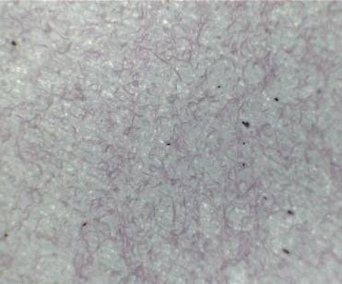 | 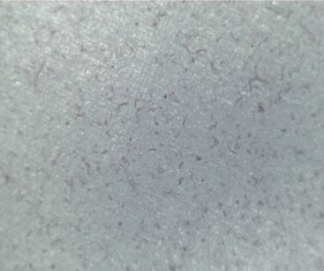
Ratio 5  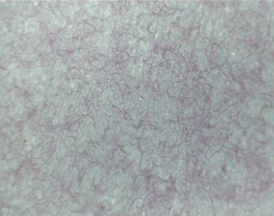 | 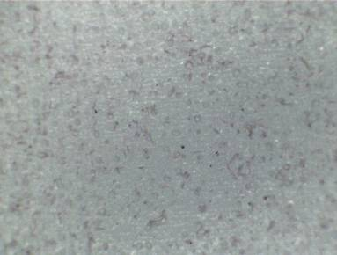
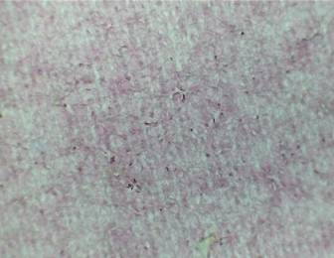  Ratio 4 | 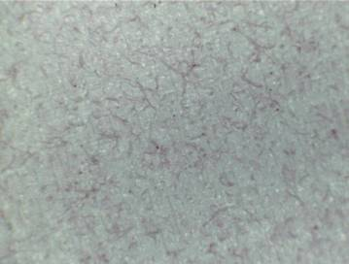
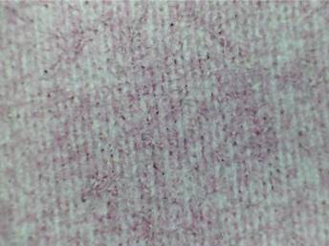  Ratio 3 | 
Ratio 2  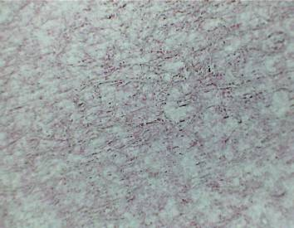 | 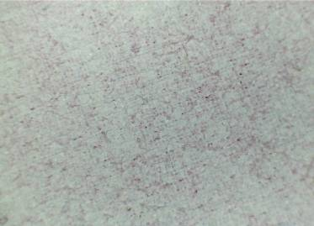

3-2- Microscopic study (white PVC/DEHP composite) with30% and 40%titanium dioxide
Before milling after milling
Ratio 5  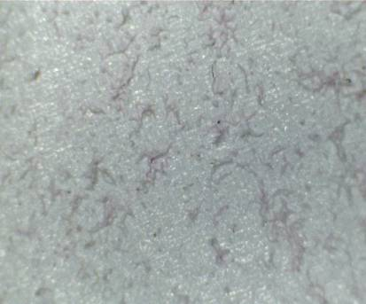 | 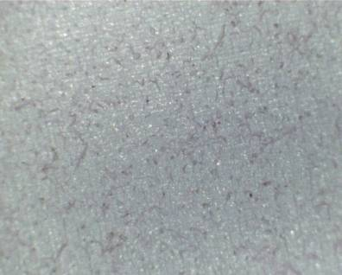
Ratio 4  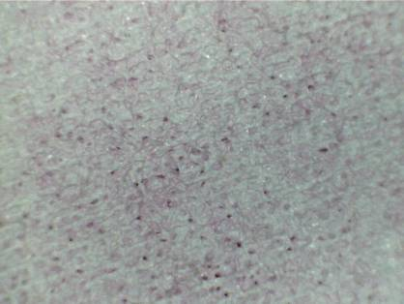 | 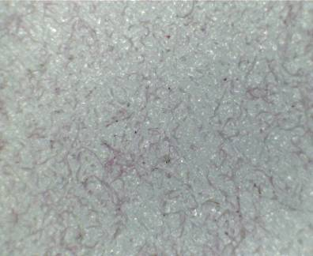
Ratio 3  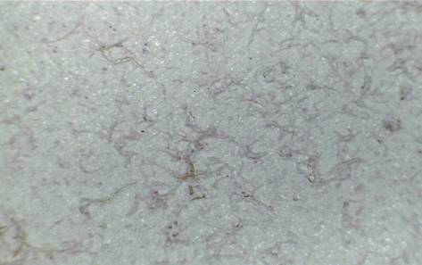 | 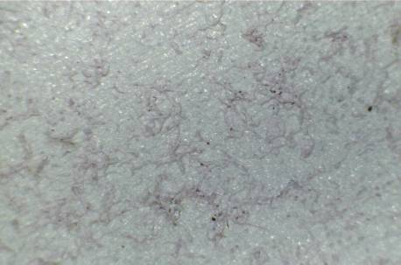
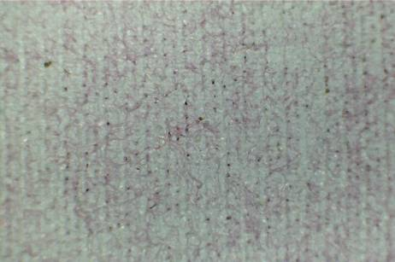  Ratio 2 | 

Microscopic study showing that : in both 30%and 40% TiO2-PVC/DEHP composites, the leveling of all printed film was improved after milling also showed that no aggregates was observed after milling while it was observed before milling process.

4. Conclusion
Nano-form titanium dioxide rutile type showing a very good whitening result with PVC/DEHP composites, 30% titanium dioxide was the successful percentage as it chivies an acceptable whiteness value specially when applied with ratio 5 which contain 50% DEHP and 50% PVC. After milling the whiteness of the (TiO2-DEHP/PVC) composites was decreased that due to that: the titanium dioxide particles were reduced below the size at which the scattered light was the maximum ,actually the size which scattered maximum light was critical point ,it can be detected by MIE theory ,it depend on the wave length of light , the reflective index of the particle itself and the reflective index of the medium ,the specific particle size of titanium dioxide which scattered maximum light when the medium was printing viscous paste found to be about 200-220nm.the reflective index of titanium dioxide rutile type was 2.7
Maximum scattered light depends on reflective index of the particle (np), reflective index of the medium (nm), particle diameter (D) and wavelength of light (ƛ), according to MIE- theory it can be calculated by the equation:
D =ƛ / 2.1 (np-nm)*(nm) .So the particle size which reflect maximum light can be estimated by this equation. (6)

Corresponding author
Abd El-Moniem Abd El-Moniem Mahmoud
Consultant of Textile Printing & Finishing, CEO of SPI Company
ceo@spi-eg.com

References
- Yeo, S.Y., Lee, H.J., and Jeong, S.H., 2003, Preparation of nanocomposite fibers for permanent antibacterial effect, Journal of Materials Science, 38: p. 2143-2147.
- Chanda, Manas; Roy, Salil K. 2006, Plastics technology handbook. CRC Press. pp. 1–6.. ISBN 978-0-8493-7039-7.
- Gudrun Schmidt, Matthew M. Malwitz, 2003 ,Properties of polymer–nanoparticle composites: Current Opinion in Colloid and Interface Science 8, 103–108.
- Rublev Colours Pigment, Natural Pigments, LLC 2012.
- Gunthert P.G .,P.Hauser andV.Radtke . ,1989 ,Rev.prog.coloration vol.19.
- Gesenhues U., April 2000. Science Direct ,Volume 68, Pages 185–196 Issue 2, 25
- Yun Shao, Ph.D. 2011. Kobo Products, Inc. New Jersey, US.

10/12/2012

