Antibiotic resistant-bacteria associated with the cockroach, Periplaneta americana collected from different habitat in Egypt

Kotb M. Hammad ^{1*} and Hesham M. Mahdy ²

^{1.} Zoology and Entomology Dept., Faculty of Science, Al-Azhar University, Nasr City, Cairo, Egypt
^{2.} Biology Dept., Faculty of Science & Arts, Al-Baha University, Saudi Arabia
*aa_hammad2000@yahoo.com

Abstract: An investigation concerning external and midgut bacteria associated with cockroaches isolated from household and sewage was carried out. Blood agar medium was the most suitable medium for isolation of bacteria from household species. On the other hand, several types of media such as blood agar, Littman oxgall agar, brain heart infusion in addition to nutrient agar were good media for isolation of bacteria from swage species. Bacillus and Streptococcus species recorded the highest percentage ratio between isolated bacterial from whole body and midgut of household cockroach; 38 and 36.92%, respectively. Alcaligenes faecalis, Serratia liquefaciens, Streptococcus faecalis, Streptococcus durans and Listeria seeligeri were ecological type isolated from sewage only.
[Kotb M. Hammad and Hesham M. Mahdy. Antibiotic resistant-bacteria associated with the cockroach, Periplaneta americana collected from different habitat in Egypt. N Y Sci J 2012;5(12):198-206]. (ISSN: 1554-0200). http://www.sciencepub.net/newyork. 33

Keywords: Cockroaches; Bacteria; Antibiotic resistant-bacteria; Egypt

1. Introduction
American cockroaches are often found in intimate association with human beings and are present in large numbers in and around houses or hospitals and in urban areas and villages with poor sanitation and insalubrious conditions (Oothuman et al., 1989 and Bouamama et al., 2010). Furthermore, their feeding mechanisms and filthy breeding habits make them the ideal agents for harbouring and transmitting pathogenic bacteria (Cloarec et al., 1992; Rivault et al., 1993 and Graczyk et al., 2001). The American cockroach comes in contact with human sewage through sewer systems where they can live, and from there also are able to get into bathrooms and basements (Elgderi et al., 2005). Various bacteria may simply be carried on the insect’s cuticle or be ingested and, sometime later, regurgitated or excreted. Moreover, several species of bacteria of public health significance have been isolated from, or have passed through, cockroaches (Periplaneta americana) and their digestive tract, such as Staphylococcus aureus, Streptococcus spp., Enterobacteriaceae, Pseudomonas aeruginosa, etc. (Fotedar et al., 1991 and Pai et al., 2005). Cockroaches collected in hospitals and households have been found to harbor multi-drug resistant bacteria and hospital cockroaches with drug-resistant Klebsiella spp. have been suggested to play a role in the epidemiology of nosocomial infections (Fotedar et al., 1991). In addition, a neonatal unit infested with cockroaches (Cotton et al., 2000) suffered an outbreak of nosocomial disease due to extended-spectrum β-lactamase-producing Klebsiella pneumoniae.
In the present study Periplaneta americana cockroaches were collected from residential areas of different districts in Cairo, Kafr Al-Sheikh and Sharqiya governorates and bacteria was isolated from the whole body of these insects. Afterward, we determined the susceptibility of these isolated bacterial strains to different antibiotics and detect responsible plasmid as well.

2. Material and Methods
2.1 Collection of cockroaches
Samples of adult cockroach were collected from urban and rural according to their habitats. Urban samples obtained from municipal sewer in Cairo governorate while rural samples were obtained from different houses in Kafr Al-Sheikh and Sharqiya governorates. Cockroaches were caught in food-baited pit-fall traps following the method described previously by Rivault (1989). Each sample was composed of 5-10 adults or old larvae, depending on how many animals were caught. Enough cockroaches were caught to make bacterial analyses. Clean plastic bags were used to transfer samples to lab for analysis at the same day.

2.2 Preparation of samples
Cockroach samples were mixed with about 5 ml of physiological saline solution and disintegrated with mixer (Model Heidolph, Germany) at 5.000 rpm for 10 min, until it became a suspension (nearly paste).
2.3 Isolation of bacteria
Cockroach suspension was serially diluted in Ringer's solution down to 10⁻¹⁰. Fifty µl of last dilution of each sample were spread onto plates of selective and non-selective media (nutrient agar, starch nitrate, azide blood, Staphylococcus, MacConkey's, brilliant green, stone gelatin, Littman oxgall, brain heart infusion, Dox and blood agar; Oxoid). The plates were incubated at 30°C for 48 hrs. Bacterial count forming units (CFU) were determined and referred per ml.

2.4 Purification of bacterial isolates
The best growing colonies and the most characteristic ones were picked up by sterile loop and subjected to purification in the same isolation medium. Agar streak method was used for purification process. A well separated colony from each isolate was picked up on nutrient agar slopes and incubated at 28.0 $±$ 0.1°C for 24 hrs. Purity was checked by microscopic examination of the isolate using Gram stain. All cultures were maintained under aerobic conditions.

2.5 Identification of bacteria
The best growing colonies and the most characteristic ones were picked up and purified by agar streak method. The identification process was proceeded as follow:-

2.5.1 Morphological identification
Gram stain; Jensen's modified method was applied using crystal violet as a basic dye and safranine as counter stain (Cruickshank et al., 1975).

2.5.2 Physiological and biochemical identification
Many biochemical reactions were proceeded for identification of bacteria according to the keys of Krieg (1984), Sneath (1986) and Holt et al. (1994). Some of these tests were sensitivity to KCN, catalase, oxidase, coagluase, acid production from carbohydrates, IMViC, H₂S production, citrate utilization and growth in triple sugar iron agar medium.

2.6 Antimicrobial susceptibility using disc diffusion method (Kirby-Bauer) test
With a sterile cotton applicator, 4-5 well isolated colonies were transferred to a saline solution tube following sterile techniques. The inoculums were calibrated with a 0.05 McFarland standard. Using another cotton-tipped-sterile applicator, the Müeller Hinton agar plate was inoculated, streaking the entire surface of the plate, rotating the plate 60° between streaks and ultimately rimming the plate to ensure confluent growth to the edges. After 2-3 minutes, a mechanical dispenser was used to apply the discs. All plates were incubated at 37°C for 18-24 hours before final reading by using a caliber to measure the zone of inhibition.
The size of the zone of inhibition (mm) will determine if the bacterium is resistant or susceptible to different antibiotics based on methods recommended by the CLSI (Clinical Laboratory Standards Institute, 2008). Quality control was carried out according to the recommendations of the CLSI using American Type Culture Collection (ATCC) strains as controls. Sixteen antibiotics were tested: amikacin (AK), ampicillin (AMP), ampicillin/sulbactam (SAM), aztreonem (ATM), cefotaxime (CTX), ceftazidime (CAZ), ceftriaxone (CRO), cephalothin (CF), chloramphinicol (C), ciprofloxacin (CIP), gentamycin (CN), imipenem (IPM), nalidixic acid (NA), tetracycline (TE), ticracillin/clavulanic acid (TIM) and trimethoprim/ sulphamethoxazole (SXT).

2.7 Plasmid patterns and analysis of bacterial isolates
Alkaline lysis technique was used to extract plasmid DNA from the selected bacterial strains according to Sambrook et al. (1989). The plasmid solutions were completely analyzed using miniprep gel (0.8 agarose, 1 kb ladder) and phenogrammed at the Regional Center for Mycology and Biotechnology, Al-Azhar University.

2.7.1 Procedure
The isolation of plasmid was carried out using high pure plasmid isolation kit (Qiagen, British) which includes the following components: suspension buffer, RNase A (dry powder), lysis buffer, binding buffer, wash buffer I, wash buffer II, elution buffer, high pure filter tubes and collection tubes.

Media used:- Luria Bertani broth (LB broth):

Formula g/l
Bacto- Tryptone 10.0
Bacto- Yeast Extract 5.0
Sodium Chloride (NaCl) 10.0

Sample material:-
Bacterial cultures were grown for 12 to 16 hours in fluid medium (e.g. LB) to a density of 1.5 to 5.0 A₆₀₀ units/ml (Sambrook et al., 1989).

Isolation protocol:-
1- Pellets of bacterial cells re-suspended in 250 μl Buffer P1 and transferred to a microcentrifuge tube.
2- A 250 μl Buffer P2 added and mix thoroughly by inverting the tube 4–6 times. With using Lyse Blue reagent, (solution turns blue).
3- Added 350 μl Buffer N3 and mixed immediately and thoroughly by inverting the tube 4–6 times, with using Lyse Blue reagent, (solution turns colorless). Centrifuged for 10 min at 13,000 rpm (~17,900 x g) in a table-top microcentrifuge.
4- Applied the supernatant (from step 4) to the QIAprep spin column by decanting or pipetting. Centrifuged for 30–60s.
5- Discarded the flow-through.
6- Washed QIAprep spin column by adding 0.75 ml Buffer PE and centrifuging for 30–60 s. Discarded the flow-through, and centrifuged for an additional 1 min to remove residual wash buffer.
7- Eluted DNA, placed the QIAprep column in a clean 1.5 ml microcentrifuge tube. Added 50 μl Buffer EB or water to the center of each QIAprep spin column, lifted stand for 1 min, and centrifuged for 1 min.

2.7.2 Agarose gel electrophoresis for isolation of plasmid DNA
Ultra-pure agarose; ethiduim bromide; ethylene diamine tetra acetic acid (EDTA); Tris-base; boric acid (Amresco, USA); DNA Step Ladder 50bp (15 fragments with molecular weight ranged from (250–12000) bp precisely 250–1000 bp by 250, to 12000 by 1000) was purchased from Sigma; Tris– borate buffer (10X) and Tris Boric EDTA (TBE) buffer (Tris-base 59 g, Boric acid 27.5 g and EDTA 20ml of 0.5 M (pH: 8.3).
Electrophoresis of plasmid DNA was done on a horizontal gel apparatus. Agarose (1%) in 1X TBE buffer was prepared. Ten microliters of plasmid DNA and 2μl of loading buffer dye were mixed well and loaded into the gel containing 10μl ethiduim bromide (1μg/ml in water). The electrophoresis was conducted for 90–120 min. at constant voltage 75V in tris-borate buffer according to the method of Meyers et al. (1976). The gel was examined on UV transilluminator (Cole-Parmer, USA) at wavelength 312nm. Photography was carried out by a Polaroid Camera (DS–34 Polariod, USA) with Digital 0.01 g balance model SBA 51 (Scaltec, Germany). The data obtained from the scanning process of each gel were analyzed using (Gel documentation system (Alpha-chem Imager, USA) determine the degree of similarity and dissimilarity between the plasmid profile of the different tested isolates.

3. Results and Discussion
American cockroaches have been considered transmitters and spreaders of pathogenic bacteria in hospitals and households or residential areas (Rahuma et al., 2005). Cockroaches can be a real sanitary hazard as they are known to carry bacteria, fungi, helminthes and viruses as well as their capacity for disseminating bacteria.
Cockroaches feed indiscriminately on garbage and sewage and so have copious opportunity to disseminate human pathogens (Cotton et al., 2000 and Pai et al., 2005). Also their nocturnal and filthy habits make them ideal carriers of various pathogenic microorganisms (Graczyk et al., 2005). So far numerous pathogenic bacteria, including Salmonella spp, Shigella spp, Campylobacter spp, Pseudomonas aeruginosa and K. pneumoniae have been isolated from cockroaches. In addition some parasites and fungi have been found in external surfaces or internal parts of body of cockroaches (Fotedar and Banerjee, 1992 and Thyssen et al., 2004) and some study have shown that exposure to cockroach antigens may play an important role in asthma-related health problems (Oishi et al., 2004 and Arruda, 2005).

3.1 Isolation, population and identification of bacteria
Bacteria isolated from the external bodies and whole gut homogenate of cockroaches (Periplaneta Americana), were higher in numbers from sewage than household, for instance starch medium recorded 2.3x10⁵ than 0.7x10⁴ CFU/ml, blood agar medium recorded 3.3x10⁴ than 6.2x10⁵; respectively, (Table 1). Obviously, non-selective media showed higher number of bacteria from both Cockroach whole-gut homogenates and whole body than recorded in selective media.
Rivault et al. (1993) isolated fifty-six species of bacteria on various bacteriological nutritive media. A variety of media used enabled us to isolate large number of bacteria in addition to different types of bacteria resident in or on cockroach. This is in contrast to Bouamama et al. (2010) who used 3 types of media viz. MacConkey agar, Chapman agar, and Bile Esculin agar and isolated few types of bacteria. However, our results of bacterial population, in general, is concomitant with bacterial population obtained from cockroaches trapped from urban environment by Chaichanawongsaroj et al. (2004) and cockroaches (Diploptera punctata) by Tatfeng et al. (2005).
The general trend of bacterial count whether from sewage or whole gut homogenate was 1) increase in bacterial population in enrichment media such as blood agar and nutrient agar than other media, 2) increase in gram positive bacteria than gram negative, and 3) decrease in bacterial population of cockroach whole-gut homogenates from household than sewage.

Table 1. The viable plate count (CFU/ml) of microbial flora for the whole body homogenate and midgut of the cockroach Periplaneta americana isolated from household and sewage on different types of media
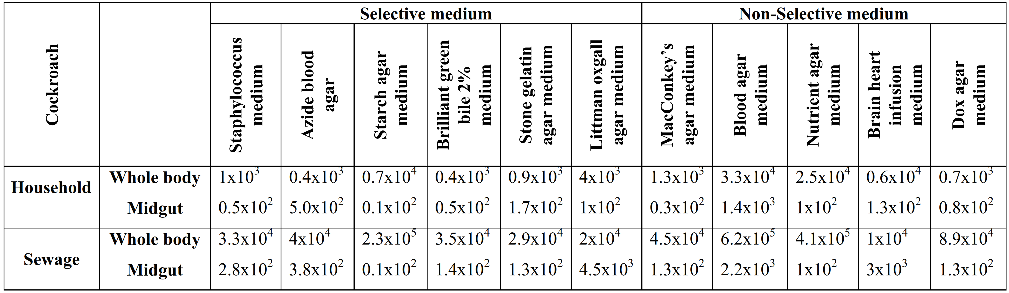

Among the 143 bacteria isolated from American cockroaches, 54 (37.76%) belonged to the group of Gram-negative bacilli, 14 (9.79%) to staphylococci, 26 (18.18%) to streptococci, and 49 (34.27%) to enterococci. On the other hand, percentage of coli form bacteria from household and sewage samples recorded 4.78 and 12.01%, staphylococci recorded 6.6 and 18.05%, streptococci recorded 36.92 and 23.72%, and Bacillus spp. recorded 38 and 15.61% respectively, (Table 2).
The most frequent bacteria isolated from American cockroaches coming from all samples were Escherichia coli, Shigella sonnei, Staphylococcus aureus, Staphylococcus saprophyticus, Staphylococcus saccharolytics and Bacillus subtilis. In addition, Alcaligenes faecalis, Serratia liquefaciens, Streptococcus faecalis, Streptococcus durans, and Listeria seeligeri were more frequently isolated from sewage samples in comparison with household samples, while Neisseria mucosa, Streptococcus pyogenes and Bacillus thuringiensis were more frequently isolated from household, in comparison with sewage samples (Table 3).
Although, Tachbele et al. (2006) captured 1600 adult cockroaches; they isolated only 12 Salmonella, two each of Shigella and E. coli O157, 17 Staphylococcus aureus and 24 Bacillus cereus from all samples. However, the obtained bacteria were similar to those isolated in this study as samples collected from urban.

3.2 Susceptibility to antimicrobial agents
Many authors isolated multi-drug resistant bacteria from cockroaches especially hospital isolates for instance Pai et al. (2004) found that two gram-positive and five gram-negative bacteria resistant to ampicillin (13.7% to 100%), chloramphenicol (14.3% to 71.4%), tetracycline (14.3% to 73.3%), and trimethoprim-sulfamethoxazole (14.3% to 57.1%), Prado et al. (2006) found that among the enterobacteria, 96% were resistant to gentamicin, 84% to ampicillin, 75.3% to caphalothin, 66.7% to ampicillin-sulbactam, 50% to aztreonam, 30% to chloramphenicol. and among the coagulase negative Staphylococcus aureus, 61% were resistant to oxacillin, and finally Saitou et al. (2009) reported that many bacterial strains were resistant to cefotazime and minocycline.
Our results, in general, indicated that Gram-negative bacilli isolated from cockroach were deemed very susceptible to the antibiotics tested. Ampicillin, ciprofloxacin and ticracillin/clavulanic acid were found to be active against 100% of Gram-negative bacilli strains. In addition, the following showed excellent activity, although their effectiveness was not 100%: amikacin, cefotaxime, ceftazidime, gentamycin, imipenem and tetracycline. Only aztreonem showed low activity against these bacterial strains (Alcaligenes faecalis, Shigella sonnei and Serratia liquefaciens strains were found intermediate sensitive to this antibiotic). On the other hand, Gram-positive bacilli from cockroach were significantly more resistant to ceftazidime, ceftriaxone, ciprofloxacin and nalidixic acid than other antibiotics (Table 4).

3.3 Plasmid profiles analysis of the isolated bacteria
Plasmids play a major role in bacterial adaptation to environmental or man-made stress. The rapid dissemination of antibiotic resistance genes in bacterial populations as a consequence of the intensive use of antibiotics in medicine and secretion in sewage can be partly attributed to plasmid-mediated horizontal transfer. Plasmids capable of being transferred and stably maintained in a wide range of bacteria, the so-called broad-host-range plasmids, are of special interest with respect to interspecies gene exchange (Gotz et al., 1996).
According to the results of susceptibility test which showed that the isolation of multidrug resistant bacterial organisms from cockroaches; six different plasmid particles are detected by the scanning process (figures 1 and 2, and table 5) with the following molecular weights 13652.82 (Streptococcus pyogenes, Streptococcus faecalis, Staphylococcus saprophyticus, Staphylococcus aureus, Staphylococcus saccharolytics & Streptococcus durans), 13849.98 (Alcaligenes faecalis, Escherichia coli, Serratia liquefaciens, Neisseria mucosa & Shigella sonnei), 13458.47 (Listeria seeligeri), & 14049.99 (Bacillus thuringiensis & Bacillus subtilis). Manual scoring of the isolated plasmid DNA indicated that only one DNA band are observed for each 14 bacterial strains, out of 14 bacteria have been isolated during the present study.
Plasmid studies have revealed that how dangerous strains of bacterium become resistant to antibiotics. Resistant strains of Staphylococcus aureus, which are called hospital strains (nosocomial infection) because of their prevalence in hospital where they constitute 34% of the clinical isolates in the united states , more than 60 % in Japan, Singapore and Taiwan and more than 50% in Italy and Portugal (HHMI, 2002). Similarly, our results deduced 3 isolates of Staphylococcus (saprophyticus, aureus and saccharolytics) where they were resistant to ampicillin.

Table 2. Percentage ratio (%) of main groups of bacterial flora associated with the cockroach, Periplaneta americana
Group | Cockroach
Group | Household |  | Sewage
Group | Whole body | Midgut | Whole body | Midgut
Staphylococcus spp.  Streptococcus spp.  Bacillus spp.  Gram positive bacteria  Coliform bacteria  Gram negative bacteria | 3.03  1.21  28.0  32.24  1.21  3.94 | 3.57  35.71  10.0  49.28  3.57  2.14 | 5.32  6.45  5.61  17.38  5.65  7.26 | 12.73  17.27  10.0  40  6.36  5.91

Table 3. Bacterial species identified from household and sewage cockroaches, Periplaneta americana

Bacteria | Cockroach
Bacteria | Household | Sewage
Alcaligenes faecalis  Escherichia coli  Shigella sonnei  Serratia liquefaciens  Neisseria mucosa  Staphylococcus aureus  Staphylococcus saprophyticus  Staphylococcus saccharolytics  Streptococcus pyogenes  Streptococcus faecalis  Streptococcus durans  Listeria seeligeri  Bacillus thuringiensis  Bacillus subtilis | -  +  +  -  +  +  +  +  +  -  -  -  +  + | +  +  +  +  -  +  +  +  -  +  +  +  -  +
(+) present; (-) absent

Table 4. Susceptibility test of bacterial isolates

Organism | AK | SAM | AMP | ATM | CTX | CAZ | CRO | CF | C | CIP | CN | IPM | NA | TE | TIM | SXT
A. faecalis | S | S | S | I | S | S | R | S | I | S | S | S | I | S | S | R
E. coli | I | S | S | R | I | S | S | S | S | S | I | S | R | S | S | S
S. sonnei | S | R | S | I | S | S | I | R | I | S | S | S | I | I | S | S
S. liquefaciens | S | S | S | I | S | I | S | S | S | S | S | I | S | S | S | R
N. mucosa | I | S | R | S | S | I | I | R | S | R | S | S | S | S | S | R
S. aureus | S | R | R | R | R | R | I | R | S | S | R | R | S | R | I | S
S. saprophyticus | R | R | R | I | S | R | R | S | R | I | R | R | S | R | R | R
S. saccharolytics | I | R | R | R | R | I | I | R | S | R | R | R | R | R | S | S
S. pyogenes
S. faecalis | R | R | R | R | R | R | R | R | R | R | R | R | R | R | R | R
S. durans | S | R | R | R | R | I | R | I | S | R | R | R | R | I | R | S
L. seeligeri | I | R | R | R | I | R | R | I | S | R | R | S | R | R | R | S
B. thuringiensis | R | R | R | I | R | R | R | R | I | R | S | R | R | I | I | R
B. subtilis | R | S | S | R | S | R | R | R | S | R | R | S | R | R | R | R
AK, amikacin; SAM, ampicillin/sulbactam; AMP, ampicillin; ATM, aztreonem; CTX, cefotaxime; CAZ, ceftazidime; CRO, ceftriaxone; CF, cephalothin; C, chloramphinicol; CIP, ciprofloxacin; CN, gentamycin; IPM, imipenem; NA, nalidixic acid; TE, tetracycline; TIM, ticracillin/clavulanic acid; SXT, trimethoprim/sulphamethoxazole; S, sensitive; I, Intermediate sensitive; R, resistant.

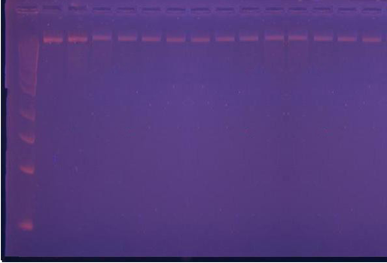

Figure 1. Electrophoretic micrograph of the extracted plasmids DNA from the bacterial organisms, M: DNA Marker. 1= Streptococcus pyogenes; 2= Streptococcus faecalis; 3= Alcaligenes faecalis; 4= Escherichia coli; 5= Staphylococcus saprophyticus; 6= Listeria seeligeri; 7= Shigella sonnei; 8= Staphylococcus aureus; 9= Serratia liquefaciens; 10= Bacillus thuringiensis; 11= Bacillus subtilis; 12= Neisseria mucosa; 13= Staphylococcus saccharolytics; 14= Streptococcus durans.

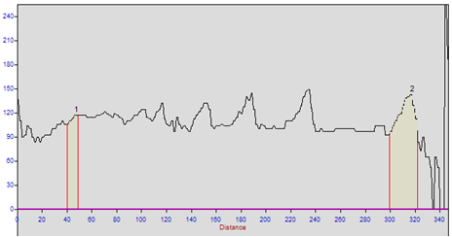
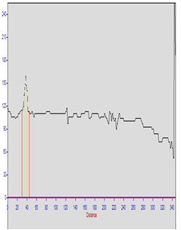
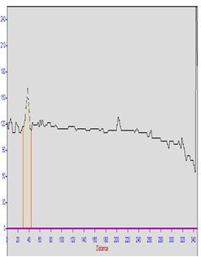
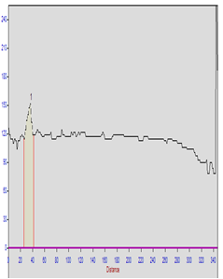
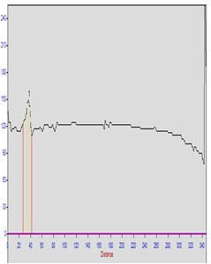
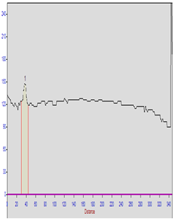
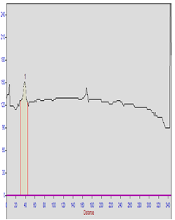
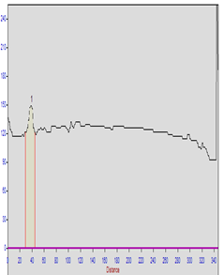
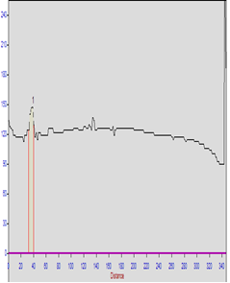
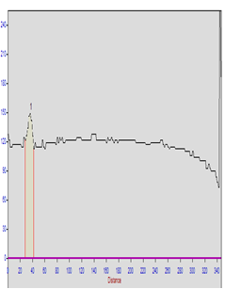
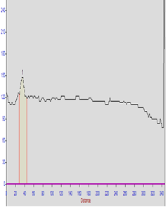
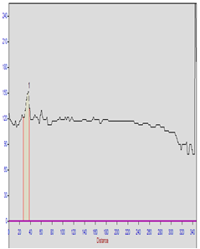
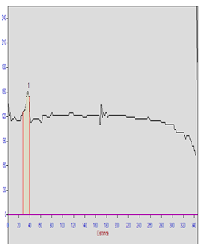
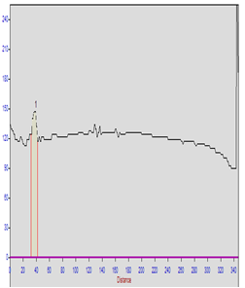
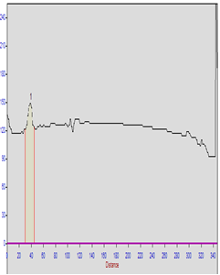
DNA Ladder
Lane Streptococcus pyogenes
Lane Streptococcus faecalis
Lane Alcaligenes faecalis
Lane Escherichia coli
Lane Staphylococcus saprophyticus
Lane Staphylococcus saprophyticus
Lane Listeria seeligeri
Lane Shigella sonnei
Lane Staphylococcus aureus
Lane Bacillus thuringiensis
Lane Bacillus subtilis
Lane Neisseria mucosa
Lane Staphylococcus saccharolytics
Lane Streptococcus durans

Figure 2. Electrograms corresponding to molecular weight of the scanned gel of extracted plasmid from bacterial isolates.

Table 5. Properties of the bacterial isolates according to their plasmid profile analysis and antibiotics resistance
Lane | Bacterial strain | R.F | M.W | Antibiotic resistance
1 | Streptococcus pyogenes | 0.1066 | 13652.82 | Ampicillin
2 | Streptococcus faecalis | 0.1066 | 13652.82 | Ampicillin
3 | Alcaligenes faecalis | 0.1037 | 13849.98 | Ampicillin
4 | Escherichia coli | 0.1037 | 13849.98 | Ampicillin
5 | Staphylococcus saprophyticus | 0.1066 | 13652.82 | Ampicillin
6 | Listeria seeligeri | 0.1095 | 13458.47 | Ampicillin
7 | Shigella sonnei | 0.1095 | 13458.47 | Ampicillin
8 | Staphylococcus aureus | 0.1066 | 13652.82 | Ampicillin
9 | Serratia liquefaciens | 0.1037 | 13849.98 | Ampicillin
10 | Bacillus thuringiensis | 0.1009 | 14049.99 | Ampicillin
11 | Bacillus subtilis | 0.1009 | 14049.99 | Ampicillin
12 | Neisseria mucosa | 0.1037 | 13849.98 | Ampicillin
13 | Staphylococcus saccharolytics | 0.1066 | 13652.82 | Ampicillin
14 | Streptococcus durans | 0.1095 | 13458.47 | Ampicillin

Corresponding Author:
Dr. Kotb M. Hammad
Zoology and Entomology Department
Faculty of Science
Al-Azhar University, Nasr City, Cairo, Egypt
E-mail: aa_hammad2000@yahoo.com

References
- Arruda, L. K. 2005. Cockroach allergens. Curr. Allergy Asthma Rep., 5: 411–416.
- Bouamama, L.; A. Sorlozano; A. Laglaoui; M. Lebbadi; A. Aarab and J. Gutierrez. 2010. Antibiotic resistance patterns of bacterial strains isolated from Periplaneta americana and Musca domestica in Tangier, Morocco. J. Infect. Dev. Ctries., 4: 194-201.
- Chaichanawongsaroj, N.; K. Vanichayatanarak; T. Pipatkullachat; M. Polrojpanya and S. Somkiatcharoen. 2004. Isolation of gram-negative bacteria from cockroaches trapped from urban environment. Southeast Asian J. Trop. Med. Public Health, 35: 681-684.
- Cloarec, A.; C. Rivault; F. Fontaine and A. Leguyader. 1992. Cockroaches as carriers of bacteria in multi-family dwellings. Epidemiol. Infect., 109: 483-490.
- CLSI (Clinical and Laboratory Standards Institute). 2008. Performance standards for antimicrobial susceptibility testing: eighteenth informational supplement. M100-S18. Clinical and Laboratory Standards Institute, Wayne, PA.
- Cotton, M. F.; E. Wasserman; C. H. Pieper; D. C. Theron; D. van Tubbergh; G. Campbell; F. C. Fang and J. Barnes. 2000. Invasive disease due to extended spectrum beta-lactamase-producing Klebsiella pneumoniae in a neonatal unit: the possible role of cockroaches. J. Hosp. Infect., 44: 13-17.
- Cruickshank, R.; J. Duguid; B. Marmion and R. Swain. 1975. Medical Microbiology: the practice of medical microbiology, 12th ed., Vol. II. Chur-chill Livingstone, London.
- Elgderi, R. M.; K. S. Ghenghesh and N. Berbash. 2005. Carriage by the German cockroach (Blattella germanica) of multiple-antibiotic-resistant bacteria that are potentially pathogenic to humans, in hospitals and households in Tripoli, Libya. Ann. Trop. Med. Parasitol., 100: 55-62.
- Fotedar, R. and U. Banerjee. 1992. Nosocomial fungal infections—study of the possible role of cockroaches (Blattella germanica) as vectors. Acta Trop., 50: 339–343.
- Fotedar, R.; U. B. Shriniwas and A. Verma. 1991. Cockroaches (Blattella germanica) as carriers of microorganisms of medical importance in hospitals. Epidemiol. Infect., 107: 181-87.
- Götz, A.; Pukall, R.; Smit, E.; Tietze, E.; Prager, R.; Tschäpe H.; van Elsas, J. D. and Smalla, K. (1996). Detection and characterization of broad-host-range plasmids in environmental bacteria by PCR. Appl. Environ. Microbiol., 62: 2621-2628.
- Graczyk, T. K.; R. Knight and L. Tamang. 2005. Mechanical transmission of human protozoan parasites by insects. Clin. Microbiol. Rev., 18: 128–132.
- Graczyk, T. K.; R. Knight; R. H. Gilman and M. R. Cranfield. 2001. The role of non-biting flies in the epidemiology of human infectious diseases. Microb. Infect., 3: 231-35.
- HHMI. 2002. www.hhmi.org/grants.
- Holt, J.; N. Krieg; P. Sneath; J. Staley and S. Williams. 1994. Bergey's Manual of Determinative Bacteriology, 9th ed., Williams and Wilkins, Baltimore.
- Krieg, W.E. 1984. Bergey's Manual of Systematic Bacteriology. Vol. 1, Williams and Wilkins, Baltimore.
- Oishi, T.; Y. Morisawa; H. Yasueda; K. Akiyama and H. Wakiguchi. 2004. Mother and two siblings with cockroach asthma. Arerugi, 53: 1163–1167.
- Oothuman, P.; J. Jeffery; H. A. Aziz; E. A. Baker and M. Jegathesan. 1989. Bacterial pathogens isolated from cockroaches transported from pediatric wards in peninsular Malaysia. Trans. Roy. Soc. Trop. Med. Hyg., 83: 133-135.
- Pai, H. H.; W. C. Chen and C. F. Peng. 2004. Cockroaches as potential vectors of nosocomial infections. Infect. Control Hosp. Epidemiol., 25: 979-984.
- Pai, H. H.; W. C. Chen and C. F. Peng. 2005. Isolation of bacteria with antibiotic resistance from household cockroaches (Periplaneta americana and Blattella germanica). Acta Trop., 93: 259-65.
- Prado, M. A.; E. Gir; M. S. Pereira; C. Reis and F. C. Pimenta. 2006. Profile of Antimicrobial Resistance of Bacteria Isolated from Cockroaches (Periplaneta americana) in a Brazilian Health Care Institution. Brazil. J. Infect. Dis., 10: 26-32.
- Rahuma, N.; K. S. Ghenghesh; R. Ben Aissa and A. Elamaari. 2005. Carriage by the housefly (Musca domestica) of multiple-antibiotic-resistant bacteria that are potentially pathogenic to humans, in hospital and other urban environments in Misurata, Libya. Ann. Trop. Med. Parasitol., 99: 795-802.
- Rivault, C. 1989. Spatial distribution of the cockroach. Blattella germanica, in a swimming-bath facility. Entomol. Exp. Appl., 53: 247-255.
- Rivault, C.; A. Cloarec and A. Leguyader. 1993. Bacterial load of cockroaches in relation to urban environment. Epidemiol. Infect., 110: 317-25.
- Saitou, K.; K. Furuhata; Y. Kawakami and M. Fukuyama. 2009. Isolation of Pseudomonas aeruginosa from cockroaches captured in hospitals in Japan, and their antibiotic susceptibility. Biocontrol Sci., 14: 155-159.
- Sneath, P. H. A. 1986. Bergey's Manual of Systematic Bacteriology. Vol. 2, Williams and Wilkins, Baltimore.
- Tachbele, E.; W. Erku; T. Gebre-Michael and M. Ashenafi. 2006. Cockroach-associated food-borne bacterial pathogens from some hospitals and restaurants in Addis Ababa, Ethiopia: Distribution and antibiograms. J. Rural Trop. Pub. Health, 5: 34-41.
- Tatfeng, Y. M.; M. U. Usuanlel; A. Orukpe; A. K. Digban; M. Okodua and F. Oviasogie. 2005. Mechanical transmission of pathogenic organisms: the role of cockroaches. J. Vect. Born. Dis., 42:129-134.
- Thyssen, P. J.; T. deC. Moretti; M. T. Ueta and O. B. Ribeiro. 2004. The role of insects (Blattodea, Diptera, and Hymenoptera) as possible mechanical vectors of helminths in the domiciliary and peridomiciliary environment. Cad. Saude. Publica., 20: 1096–1102.

10/13/2012

