Effect of Squeegee Hardness on Deposit Ink Layer, Glossy and Whiteness of Printed Film

Abeer Farouk Ibrahim and Maysa Mohamed Reda

Department of textile printing, Dyeing and Finishing. high institute of Applied Arts,new cairo academy,cairo, egypt

ceo@spi-eg.com

Abstract: Various factors affect the printing quality, squeegee one of the main factors that affect directly on printing film as the deposit layer can be controlled completely not only by choosing mesh count but also by choosing the squeegee shape and hardness, the deposit ink layer has a clear effect on the glossy and design of printed film, this study focused on the relation between squeegee hardness and deposit ink at certain mesh count.
[Abeer Farouk Ibrahim and Maysa Mohamed Reda. Effect of Squeegee Hardness on Deposit Ink Layer, Glossy and Whiteness of Printed Film. N Y Sci J 2012;5(12):247-252]. (ISSN: 1554-0200). http://www.sciencepub.net/newyork. 39

Keywords: squeegee a poly urethane rubber.

1. Introduction:
Squeegees are made from 3 basic types of materials: Rubber, Neoprene, and Polyurethane. The least expensive Squeegees available are those constructed of natural rubber. While commonly used in the education part of the screen printing industry, rubber tends to suffer from poor abrasion resistance and poor resistance to strong solvents. Neoprene, a synthetic rubber compound made from a chlorine derivative of acetylene, is also a popular Squeegee material. Neoprene is slightly more expensive than natural rubber, and it offers better chemical and abrasion resistance.
Polyurethane, a synthetic plastic material, is often used to make Squeegee designed for extended use, and for automatic and semi-automatic equipment. While urethane is more expensive than rubber or neoprene, it offers a much better resistance to both physical and chemical abrasion. Most urethanes used in the screen printing industry are MDI based Polyester. The reason being the MDI urethanes offer the best abrasion resistance of any urethane on the market. Polyurethane Squeegees are the most popular of all Squeegees. They are cast in liquid form in open molds, close molds or centrifuges. The material is a thermoset plastic, and cures when exposed to heat for a period of time. The material is made in sheets or individual sections, and then cut to size for shipping. The most common sizes are the following: 3/8 x 2 for general Screen printing (graphics, textile, glass, and electronics), 3/16 x 1 for bottle, cd, and high speed automatic presses.
Modern textile print tries to simulate offset paper print in quality specially resolution, appearance and productivity so all factors that affecting the printing process must be taken in designer and manufacture mind, squeegee one of the affecting factors that considered as negligible factor in the past, now in order to avoid printing problems and registered all details in the design, squeegee, mesh and inks must be studied. Squeegee is a soft polyurethane polymer which varied in shape and hardness, usually the hardness varied from 60 Durometer to 90 Durometer according to design, inks and deposit layer wanted, also squeegee varied in shape as U shape, V shape and square shape.

2. Experimental and results
Tools and equipments
- Squeegee with different Durometer.
- Convert belt dryer
- Manual printing machine
- Screens with monofilament mesh 61
Measurement instruments.
- Laser thermometer.
- Hardness meter.
- Thickness meter.
- Gloss meter. Paint Test Equipment,3 & 4 The Courtyard,Greenfield Farm Estate,Congleton,Cheshire,CW12 4TR, England
Complies with International Standards:
ISO 2813, ISO 7668, BS 6161-12, BS 3900-D5, ASTM D 523, ASTM D 1455, ASTM D 584, ASTM D4039, DIN 67530, AS 1580-602.2 and ECCA T2.
- Whiteness meter Produced by A & E Technology Import & Export Co., Ltd.
Jiangxi, China.
Media
100% cotton fabric, 150gm/m² from Martex Company.
Chemicals
White oil-based screen printing inks from lancer group international “Canada”
Method and conditions.
5 layers were printed through screen with mesh count 61 under tension 25N, the deposited layers were dried in between using infra-red flash cure unit for about 2 seconds, each layer was printed two strokes, fixation using convert belt dryer for 2minutes at 150Cº.the process was repeated with squeegee hardness 65, 75 and 85 Durometer for both V-shape and square-shape squeegee, Thickness, whiteness and glossy were measured for each squeegee type and reported in illustrated tables and figures.

Table 1: The relation between SQ hardness square shape and “thickness, whiteness, glossy” of printed film.
Squeegee hardness square shape | thickness | whiteness | glossy
65D | 0.8mm | 90.2 | 6.4
75D | 0.77mm | 87.1 | 6.1
85D | 0.65 | 85.1 | 5.3

Figure 1: The relation between SQ hardness”square shape” and thicknessof printed film.
Not: each thickness result was multiplied by factor 10 to be clear at the figure.

Figure 2: The relation between SQ hardness”square shape” and whiteness of printed film.

Figure 3: The relation between SQ hardness”square shape” and glossy of printed film.

Table 2: The relation between V shape SQ hardness and “thickness, whiteness, glossy” of printed film
Squeegee hardness V shape | thickness | whiteness | glossy
65D | 0.85mm | 91.2 | 6.5
75D | 0.81mm | 90.1 | 6.3
85D | 0.78 | 89.5 | 5.9

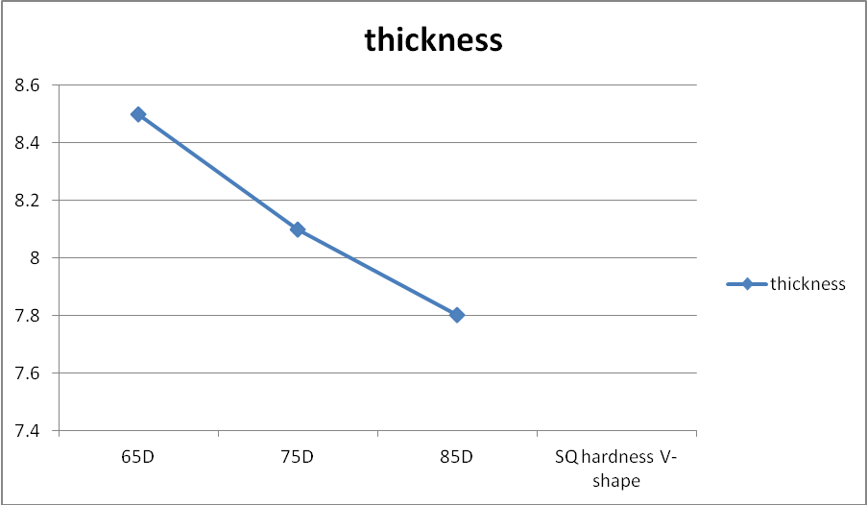
Figure 4: The relation between V shape SQ hardness and thickness of printed film.
Note: all thickness result multiplied by factor 10 to be clear at the illustrated figure.

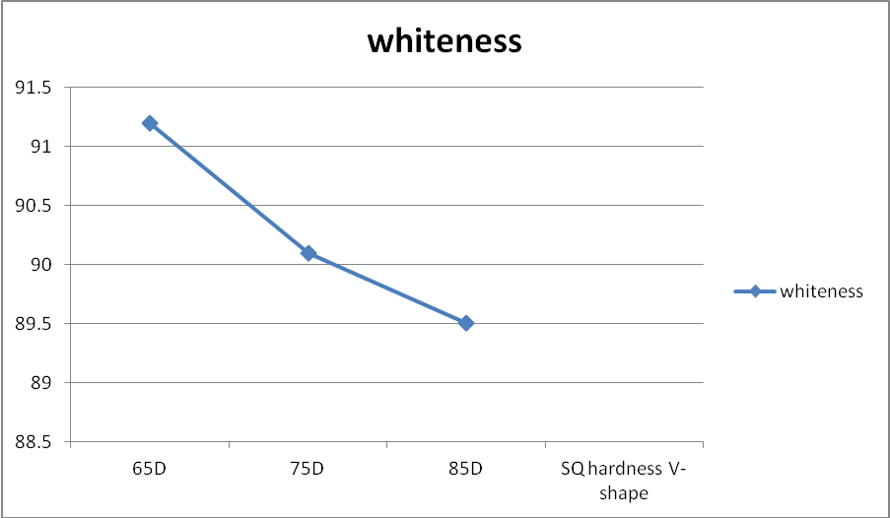
Figure 5: The relation between V shape SQ hardness and whiteness of printed film.

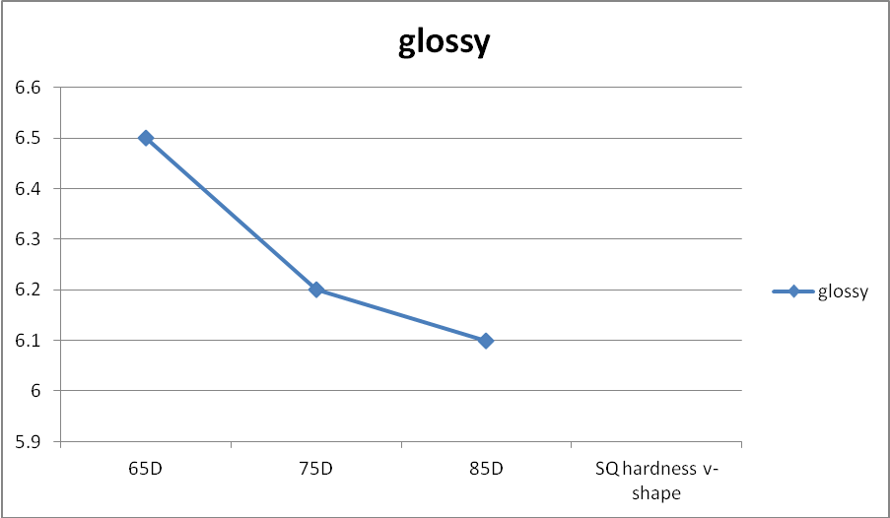
Figure 6: The relation between V shape SQ hardness and glossy of printed film.

3. Discussions and references
In screen-printing, squeegee is used to spread ink evenly across the back of a stencil or silkscreen, making a clean image on the printed surface. Screen-printing squeegees usually have much thicker and less flexible blades than the window cleaning variety. A squeegee is also used in photography printing to dry the photographic paper after it is washed, preventing wrinkles or water spots.

Squeegee shapes
square  Most commonly used profile for general graphics and textiles. Can be used on a variety of substrates with a wide range of inks. Provides medium adaptability and maximum force. Pushes the smallest amount of ink through the screen. Ideal for sharp line and half-tone dot production. The less ink deposited the sharper the printed image. |  | 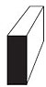
V-shape  Gives excellent control when printing on glass or plastic cylindrical objects and the Land version gives good control of printing angle. Also used for fine printing on textile cloth. |  | 
U-shape  Used for a variety of applications from textile printing to adhesive printing. Will give maximum ink deposit.⁽¹⁾ |  | 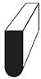
Squeegee has a clear effect in printing as different shape create such effect ,different hardness showing different deposit layers thickness .squeegee affect by indirect way in glossy , whiteness and color strength of printing film .choosing squeegee is one of importance factors the affect the printing quality ,90 Durometer preferred for printing fine details while 65 Durometer was preferred for solid areas ,V-shape was preferred when printing process was don at high temperature as in summer as the contact angle in between inks and screen lower than 45ºthat will keep the ink away from drying in the screen . Squeegee with square-shape was preferred for high resolution printing designs as the ink going into the fabric through angle 90º which is much powerful for printing process colors as photos.

Durometer:
When selecting a Squeegee, the first task is to determine your desired durometer, or hardness. The durometer is the value that reflects the physical hardness of the Squeegee material. The Squeegee durometer values from 50A to 95A. This is measured by a durometer gauge, and measured based on standards established by ASTM procedures. (American Standard Testing materials) . For the sake of simplicity, we will call soft - 60A, medium - 70A, and 80A - a hard Squeegee, and 90A -extra hard. Plastics/Squeegees are measured in various scales of hardness. Shore A scale is the most widely used for measuring Squeegee material. The values are based on readings There are many different styles of durometer gauges available on the market. All of the durometer gauges on the market have a dial indicator with a small needle head that measures the hardness of the Squeegee. A durometer gauge is identical to a tension meter. Like a tension meter, a durometer gauge should be calibrated on a regular basis. (1 time per year). The small needle head penetrates into the material, and indicates the hardness of the rubber.
This is one of those topics that veteran screen printers may be divided over. Some printers believe that squeegee Durometer does not affect ink coverage or opacity. It may not be as important as having the squeegee blade sharp but there are physical properties of squeegee durometers that can affect your print.In general a softer squeegee will transfer less force and tend to leave the ink on top of the fabric rather than pushing it into the knit. Softer squeegees give more and as a result make the printer stroke accordingly. This is a softer stroke to avoid over bending the flexible squeegee.
Even though the squeegee may be soft and flexible, you do not want to bend the squeegee blade at severe angles. It should remain almost straight with a slight curve as you stroke. All of this lends to a heavier ink layer being deposited onto the shirt fabric. Harder squeegees will transfer more of your force to the ink pushing it into the knit much more than a very soft squeegee. Harder squeegees may be easier for beginners to learn with and it is possible to get the same results as with a softer one.
In manual screen printing there are many variables that can affect the print. One of those variables is the manual flooding and stroking of the ink. Whatever squeegee you end up using, it will be your skill in using it that will ultimately be the determining factor in your end results.
Choosing the right durometer...
60 durometer squeegees are the softest available, and are used for more delicate printing. A softer blade flexes more than a hard blade, and works best with thinner inks. 60 durometer squeegees also are great for high density printing since they allow a larger amount of ink to roll through the stencil.
70 durometer squeegees are a medium hardness, and are the most commonly used. A 70 durometer squeegee blade works well with almost any screen printing application, and is a great starter option for the beginning screen printer.
80 durometer squeegees are the stiffest available and are great for more intricate print jobs. 80 durometer screen printing squeegees are great for printing with thicker inks such as whites and other opaque plastisols, and are also commonly used with process printing.
Triple Duro The triple durometer blade offers two print edges by sandwiching a harder center within the squeegee rubber. This minimizes the degree of squeegee flex. This reduced flex yields better print definition and better control of ink deposit by maintaining a correct print angle. The triple durometer squeegee is especially suited for use on high tension screens and critical work such as halftone and process.
The one factor that is very important to the squeegee is the condition of the blade edge. It should be straight, clean, and sharp. There shouldn’t be any nicks, grooves, chips or marks at all. A sharp squeegee blade will “sheer” the ink off in the open mesh, with a better deposit, allowing it to pull nicely through the screen.
Squeegee Durometer is based on a 2 digit number system. The lower the number is, the softer the squeegee will be. 65 Durometer is very soft and 95 Durometer is very hard. 75 Durometer is a common textile squeegee for manual printing.
This study focused on the effect of squeegee hardness in deposited ink layer which affect directly the opacity of the ink which reflect the whiteness result in case of white inks and color strength in case of colored printing inks, also reflect the glossy of printing film.
Table 1, figures 1,2and 3 showing that the squeegee hardness inversely proportional to the deposited ink layer, whiteness and glossy for square shape of squeegee.
Table2, figures 4, 5 and 6 showing the same results as the squeegee hardness was inversely proportional to the deposited in layer, whiteness and glossy for V-shape squeegee.
Both two types of squeegee which were studied reflect the same result. The study showing that the deposited layers thickness was increased with V-shape squeegee more than square-shape squeegee at same Durometer.

Corresponding author
Abeer Farouk Ibrahim
Department of textile printing, Dyeing and Finishing. High institute of Applied Arts, New Cairo Academy, Cairo, Egypt

References
1-. Andreas Willfahrt, John Stephens, Gunter Hubner “Optimizing Stencil Thickness and Ink Film Deposit.(2011)
2- Dietrich E. Riemer. The Theoretical Fundamentals of the Screen Printing Process. Microelectronics International, Vol. 6 Iss: 1, pp.8 – 17, 1993
3- Patrick Liepelt. Schafft man imSiebdruck die Punkthöhe der Brailleschrift, 01, 2009, viewed 30.03.2011.
4-. RkSiebdrucktechnik RKS GmbH. http://www.rk-siebdruck.de/ rkscarbon.html?&L=1, viewed 10.09.2010
5- Ulano. “Direct Indirect method for Building Thick Film Stencils for High Density Printing”, http://www.ulano.com/cdf/QTthickFilmInstruction1.htm, viewed 07.03.201
6- Dirk Oelschläger. 3d-Effekte auf T-Shirts: DickschichtanwendungenimTextildruck. TVP – FachzeitschriftfürTextilveredelung und Promotion, 01(01), 01 2010.viewed 10.09.2010
7- Alicona. Product information Alicona Infinite Focus. http://www2.alicona.com, viewed 30.03.2011
8- Ellis R. Ott. Process Quality Control: Troubleshooting and interpretation of data / Ellis R. Ott. McGraw-Hill, New York, 1975(first received: 12.12.2010)
9-Richard M. Podhajny,.Material Science » Magazine, February 01, 2002.

10/20/2012

