The Synthesis and Characterization of Polyoxyethylene Modified Rotenone derivatives

Lin Hu*, Yuwen Yu, Juan Wang, kui jiang Wang, Yaqin Zhang, Xiancong Yang ,Wenyuan Xu

Institute of Applied Chemistry, East China JiaTong University,Nanchang,330013, PR China
hulin21@hotmail.com

Abstract: Rotenone is an efficient and safety pesticides, neither pollute agricultural ecological environment and agricultural products, nor do harm to the health of humans and animals, and has a broad prospect for development in the effect of the chemical insecticides^{[1]}. Rotenone and most of its derivatives are highly lipophilic compounds. In some case, it is necessary to improve the water solubility for expanding the application of rotenone as a bio-pesticide. It is well known that polyethers are such kind of hydrophilic compounds due to there are polyalkoxy chains in their structures. If a suitable length of polyalkoxy chain is coupled to the rotenone structure, the hydrophilicity of rotenone should be increased significantly. Here, the molecular structure of rotenone was modified by two processes, first, one of the rotenone’s double bound produced to a hydroxyl by both addition reaction and hydrolysis via reacting with 75% sulfuric acid and water successive, then, the new hydroxyl bound of rotenone reacted with different ratio of ethylene oxide to produce rotenone derivatives with different length of polyalkoxy chains. TLC, IR, NMR are employed to identify the properties of the target products. The results of UV determination indicated that the water solubility of polyoxyethylene modified rotenone derivatives have increased greatly depending on the polymer chain length or the ratio of reactants.
[Lin Hu, Yuwen Yu, Juan Wang, kui jiang Wang, Yaqin Zhang, Xiancong Yang, Wenyuan Xu. The Synthesis and Characterization of Polyoxyethylene Modified Rotenone derivatives. N Y Sci J 2013;6(1):9-13]. (ISSN: 1554-0200). http://www.sciencepub.net/newyork. 2

Key words: rotenone, ethylene oxide, polyoxyethylene ether, rotenone hydrolyzate.

1 Introduction
Rotenone is a well-known botanical insecticide with a considerable safety because it neither pollutes the agricultural ecological environment and agricultural products , nor is harmful to the health of humans and domestic animals. Although the insecticidal efficiency of rotenone is above average chemical insecticides, rotenone was limited utilized in the parts of the world such as Southeast Asia, South America and Africa^{[2]}. The intense hydrophobicity of rotenone makes that it is nearly impossible to be dissolved in the water, which leads to the inconvenience and inefficiency^{[3], [4]}. It is well known that polyethers are such kind of hydrophilic compounds due to there are polyalkoxy chains in their structures^{[5],[6]}. If a suitable length of polyalkoxy chain was coupled to the rotenone structure, the hydrophilicity of rotenone should be increased significantly. Here, the molecular structure of rotenone was modified by two processes, first, one of the rotenone’s double bound produced to a hydroxyl by both addition reaction and hydrolysis via reacting with 75% sulfuric acid and water successive, then, the new hydroxyl bound of rotenone reacted with different ratio of ethylene oxide to produce rotenone derivatives with different length of polyalkoxy chains^{[7]}. The reactions routs are displayed on the scheme 1.

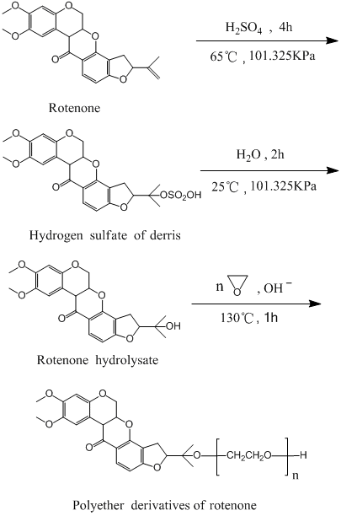
Scheme 1. Synthesis of the rotenone polyether derivatives

2 Experimental Procedures
2.1 Materials & apparatus
The Lambda-35 ultraviolet spectroph-otometer and infrared spectrometer produced by Perkin Eimer Company. DZTW electric jacket, PL203 electronic balance, 79-1 collector magnetic stirrer, A-33 anti-pressure tube was used in this experiment. Sulfuric acid (analytical), trichloromethane (≥99%), ethylene oxide (analytical),sodium bicarbonate (≥96%), anhydrous ethanol (≥99.7%), N, N – dimethyl benzene formamide (≥99.5%), ethyl acetate, n-hexane, analytical purity eight hydrated sodium hydroxide were purchased from Aladdin Reagent Company.
2.2 Synthesis of Rotenone sulfate
Operated under the ice-water bath and nitrogen protection, a 50 mL round-bottom three-neck flask, equipped with 2 cm oval magnetic stir bar and a water condenser, was charged with 1.0 g rotenone and 20 ml chloroform. With stirring, 5 ml of 75% sulfuric acid was slowly dropped in to the flask until the addition was completed. After 10 minutes stirring, an oil bath replaced ice-water bath to heat the flask. Oil bath temperature was set to 65 ºC for 4 hours. The stirring was stopped after the reaction was completed. The mixture was divided into two layers after standing by about 20 minutes. The upper layer was separated and abandoned with a 60 ml separatory funnel. The lower layer was prepared for the next synthesis.
2.3 Synthesis of rotenone hydrolyzate
Ten ml purified water was added into the lower layer at the flask. The hydrolysis reaction suspension was stirred at room temperature for 2 hours. The mixture suspension was then added 20 ml chloroform and transferred to a 50 mL separatory funnel after half an hour stirring. The chloroform layer was separated and collected by separatory funnel. The chloroform extraction perform was repeated for three times before the water layer was abandoned. The chloroform solution was gentle evaporated from an open beaker at room temperature until the chloroform was nearly total out and the green crystal product appeared at the bottom of the beaker (yield 90.1%).
2.4 The polymerization process of rotenone polyether derivatives
A dried 50 mL anti-pressure tube, equipped with 1cm oval magnetic stir, was charged with 0.2 g rotenone hydrolyzate, 0.004g Ba(OH)₂ and 6 ml dried DMF. The anti-pressure tube was freezing under the salt-ice mixture while 0.1, 0.2, 0.3 or 0.4 mL liquid ethylene oxide was transferred in to the tube respectively. The anti-pressure tube was closed tightly, heated to 130 ºC on the oil bath for stirring 1 hour. Reduced pressure distillation was preformed with the oil bath in the temperature of 98 °C to remove DMF solvent. The residue was washed, Si-gel column separated and dried for the analysis. The rotenone polyether product of n=4, 8, 12, 16, 80 were prepared by the rotenone hydrolyzate reacting with 0.1 mL, 0.2, 0.3, 0.4 or 2.0mL liquid ethylene oxide.

3 Results
3.1 Rotenone hydrolyzate product
3.1.1 Infrared spectrum
The dried rotenone or rotenone hydrolyzate were mixed with KBr powder to make IR sample respectively. The analysis was performed at room temperature with measurement range from 350 to 4000 cm⁻¹. The infrared spectrum of rotenone and hydrolyzate of the rotenone displayed in Figure 1.

Fifure 1. The Infrared spectrum of rotenone and rotenone hydrolyzate

Figure 1 indicates that the hydroxyl peak of rotenone hydrolyzate has increased significantly but =C-H absorption peak is weakened obviously. Comparing with the two infrared spectrums, the rest part of the IR peaks have not changed so much, indicating that oxidation reaction has not taken place in the rotenone hydrolysis reaction.
    - H¹-NMR
¹H nuclear magnetic resonance (NMR) spectra were obtained with deuterated chloroform (CDCl₃) with a Mercury-400BB spectrometer (Varian) operating at 400 MHz, and chemical shifts were reported in parts per million relative to tetramethylsilane (TMS) as an internal standard.
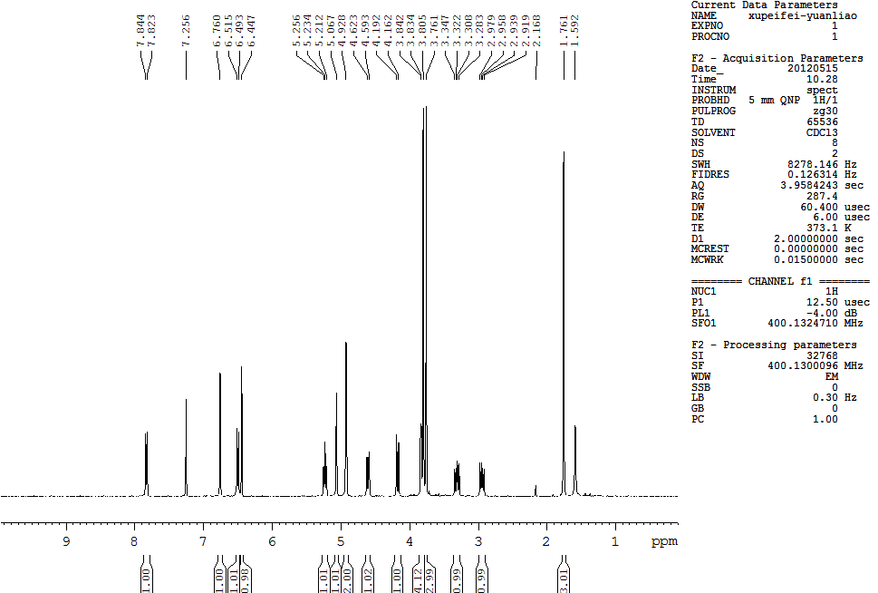
The carbon hydrogen on the number of 27
The carbon hydrogen on the number of 24

The carbon hydrogen on the number of 26

The carbon hydrogen on the number of 8

The carbon hydrogen on the number of 28,29
The carbon hydrogen on the number of 7
The carbon hydrogen on the number of 23

Figure 2. The H¹-NMR spectrum of rotenone
The absorption peak of C=H ofnrotenone
Figure 3. The H¹-NMR spectrum of rotenone

From figure4 compared rotenone hydrolyzate's H-NMR with rotenone's H¹-NMR diagram, the disappeared peak approached about 4.9 and emerge of a new absorption peak in the displacement at 5.8, which is most likely the hydroxyl absorption peak.

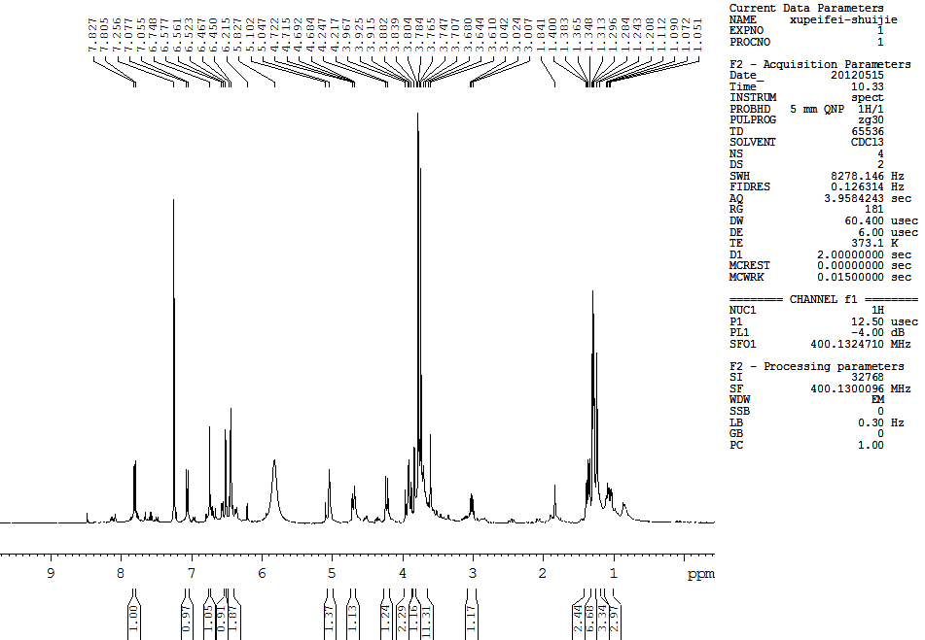
Hydroxyl peak
The disappear of double bond peak at the displacement about 4.9！
Figure 4. The H¹-NMR spectrum of rotenone hydrolyzate

3.2 Rotenone polyether derivatives
3.2.1 TLC analysis
TLC analysis was carried out with a percoated silica gel G plate,and a small spot of solution containing the samples applied onto the plate about 1.5 cm from the bottom edge. The plate was then put into the chamberwith a small amount of the solvent (mobile phase), which was n-hexane: ethyl acetate (5:1, vol/vol). TLC spots were viewed under a UV light at 254 nm, and were then viewed after spraying with H₂SO₄-methanol (MeOH) (10:1,vol/vol) and heating at 110°C.
The R_{f} values were calculated as rotenone is 0.42, Rotenone hydrolyzate is 0.62 and Rotenone hydrolyzate is 0.48 .
3.2.2 FTIR
Comparing different proportion of rotenone polyether derivatives (figure.5), we can see that the infrared absorption peak is different on the hydroxyl and etheyloxyl bond . Rotenone polyether derivatives, rotenone and rotenone hydrolyzate product also show the big change when rotenone were reacted to be rotenone hydrolyzate.
As showing infigure 6 and figure 5, whether rotenone hydrolyzate or rotenone polyether derivatives, their absorption peaks of hydroxyl are higher than that of rotenone.

The disappearance of the double bond about the displacement 4.9！
Figure 5. IR of the rotenone added 4, 46, 80 times EO

Figure 6. IR of the rotenone, rotenone hydrolyzate and rotenone added 80 times EO

3.2.3 H¹-NMR
¹H nuclear magnetic resonance (NMR) spectra were obtained withdeuterated chloroform (CDCl₃) with a Mercury-400BB spectrometer (Varian) operating at 400 MHz, and chemical shifts were reported in parts per million relative to tetramethyl-silane (TMS) as an internal standard.
From the above H¹-NMR diagram, the peak area of rotenone polyether derivatives added 12 EO was 27.19. The peak area of rotenone polyether derivatives added 80 EO was 61.09.

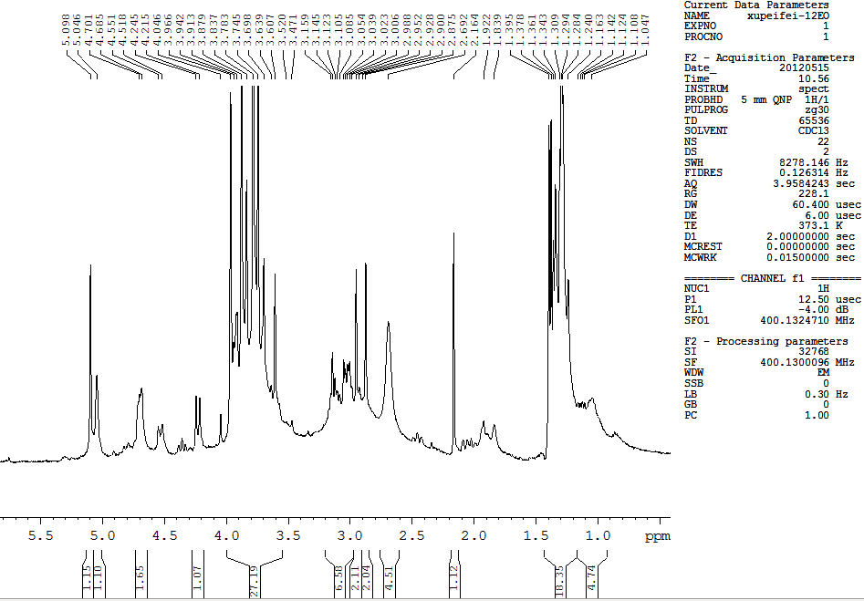
the absorption peak of the
structure
Figure 7. The H¹-NMR spectra of rotenone polyether added 12 times EO

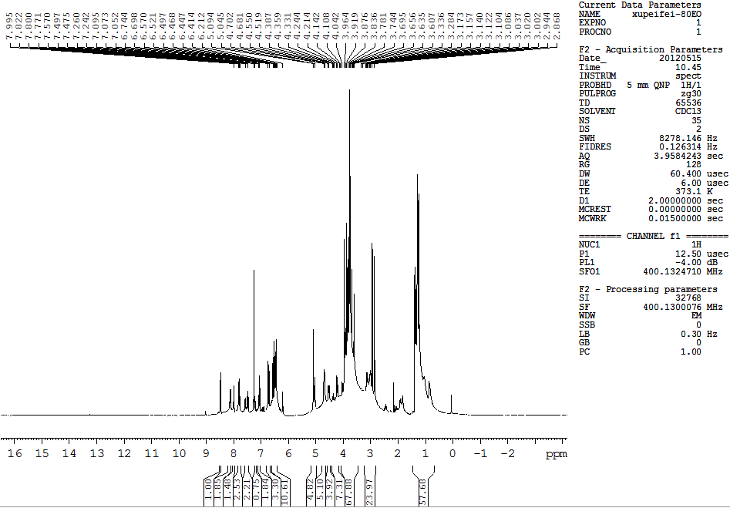
The disappearance of the double bond about the displacement 4.9！

The absorption peak of the
structure
Figure 8. The H¹-NMR spectra of rotenone polyether added 80 times EO

3.2.4 UV-Visible Spectroscopy
The purpose of this study is to find a way to increase the rotenone solubility in the water. The process was taken about 0.008g rotenone hydrolyzate reacted with 4 times, 8 times, 12 times, 16 times, and 80 times EO to obtain rotenone polyether derivatives respectively. Added 8 mL distilled water in the products. After 6000 r/min centrifuge for 5 min, we added 0.1 mL saturated solution and dilute it to 10 mL, then measured its UV absorbance.
Figure 9. UV absorbance showed that rotenone polyethers formation after 4, 8, 12,16 or 80 times EO were added and reacted respectively

As showing in Figure 9, ultraviolet absorption peaks of rotenone hydrolyzate and rotenone derivatives were at about 200 nm and 260 nm. In addition, results obtained from amplification part indicated that the solubility of rotenone polyether derivatives was increased significantly in presence of the EO chain length.

- Conclusions
From the Thin layer chromatography analysis, we can conclude that rotenone, rotenone hydrolyzate and rotenone derivatives of polyether scattered in different position, which provided a monitor to detect the synthetic process. The IR data indicate that the rotenone hydrolyzate, rotenone polyether derivatives and rotenone have changed corresponding to the double bound disappearing and the new hydroxyl formation. The hydroxyl absorption peak are enhanced, and the =C-H absorption peak is abate. Compared the H¹-NMR spectrum of the rotenone hydrolyzate androtenone polyether derivatives ,we can conclude that the chemical shift of rotenone double bond is about 4.9 or so, the chemical shift of hydrolyzate hydroxyl is about 5.8, the structure () of rotenone polyether derivatives of polyether chemical shift is between 3.3 ~ 4, which is the multimodal and peak has a very large area, such as the area of that add 12 derivative of EO is about 27, then 80 derivative of EO is about 67. The UV results show thatrotenone hydrolyzate and rotenone polyether derivatives have a great solubility in the water compared with rotenone. As the number of ethylene oxide increasing, the water solubility of rotenone dramatically increases.
Acknowledgements:
The authors gratefully acknowledge funding of this work by the National Science Foundation of China (31160187, 21163005) , China Post Doctoral Science Foundation (2005037586).
Corresponding Author:
Dr. Lin Hu
Institute of Applied Chemistry,
East China JiaTong University,
Nanchang,330013,PR China
E-mail: hulin21@hotmail.com

References
- Fleming S M, Zhu C, Fernagut P O, et al. Behavioral and immunohistochemical effects of chronic intravenous and subcu-taneous infusions of varying doses of rotenone. ExpNeurol, 2004, 187(2):418-429
- Ming Yang, Yuantao Chen, Jing Ma, Lufeng Huai.Differential pulse voltammetric determination of trace rotenone using molecularly imprinted polymer microspheres. Microchim Acta, 2009,166:95 – 99
- Bashkatova V, Alam M, Vanin A, et al. Chronic administration of rotenone increases levels of nitric oxide and lipid peroxidation products in rat brain. Exp Neurol, 2004, 186(2): 235-241
- Alam M, Mayerhofer A, Schmidt W J. The neurobehavioral changes induced by bilateral rotenone lesion in medial forebrain bundle of rats are reversed by L-DOPA. Behav Brain Res , 2004,151(1-2): 117-124
- Sherer T B, Kim J H, Betarbet R, et al. Subcutaneous rotenone exposure causes highly selective dopaminergic degeneration and alphasynuclein aggregation. Exp Neurol, 2003, 179(1):9-16
- Malherbe F, Depege C, Forano C, et al. Alkoxylation reaction catalysed by layered double hydroxides. Applied Clay Science, 1998.(13):451-466.
- Tinde V A. The diverse uses of fish poison plants in northwest Guyana.Econ Bot, 2000, 54(4): 500-512.

11/15/2012

