Influence of Climate Changes and Geological Features on Water table Changes in Ghir Plain, Iran

Ali Naseri Ghiri¹, Farshid Aref², Bahram Amiri³, Ashkan Khosropour⁴, Reza Naseri Ghiri⁵

- Department of Irrigation and Drainage, Firouzabad Branch, Islamic Azad University, Iran
- Department of Soil Science, Firouzabad Branch, Islamic Azad University, Iran
- Department of Soil Science, Firouzabad Branch, Islamic Azad University, Iran
- Department of Mathematics, Frouzabad Branch, Islamic Azad University, Iran
- Department of Computer and Information Technology, Amirkabir University, Tehran, Iran
ilia_nas@yahoo.com; ilianas2530@gmail.com

Abstract: Groundwater in the south of Iran is the most important and the most widely used water resources. Therefore, it is essential to study about groundwater resources in this region. In order to study the influence of climate changes such as rainfall, temperature and also geology on water table changes in Ghir plain, Iran has conducted an eight-year study from 2004 to 2011. Rainfall, temperature, water table and geological formations were evaluated in this study. Also, the relation between climate (temperature and rainfall) and water table and water table changes were appraised through multiple regressions in SPSS. Using Arc GIS, maps were provided to identify plains of Iran, considered wells, water table and geological formations along statistical period. According to the obtained results, it was clear that temperature is inversely related with water table so that water table showed 1.86 meter decrease per each degree more than 25.07ᵒC. There was a direct relation between rainfall and water table height and its changes so that each 477.7 millimeter increases in rainfall increased 1 meter of water table. Based on the results, when data such as temperature and rainfall are available, water table and water table changes are 90% and 87% predictable respectively. It is worth noting that those areas with Gurpi formation showed less change in water table along statistical period in compare with other formations of the plain.
[Naseri Ghiri A, Aref F, Amiri B, Khosropour, A, Naseri Ghiri R. Influence of Climate Changes and Geological Features on Water table Changes in Ghir Plain, Iran. N Y Sci J 2013;6(1):39-49]. (ISSN: 1554-0200). http://www.sciencepub.net/newyork. 7

Keywords: Climate, Geology, Water table, Correlation, Quantity

1. Introduction
The environment we live in plays a dominant role in our lives. The digerence between rain and sun on a day changes many peoples decisions for that day. But compared to the importance of the atmosphere, our knowledge about it is limited . Many aspects of the atmosphere (temperature, wind, precipitation) may change due to greenhouse gas induced warming. It is expected that the intensity of the hydrological cycle will increase as the climate warms. In particular the intensity of precipitation extremes is expected to increase . Many of the world’s countries already struggle under existing water stress from pressures such as irrigation demands, industrial pollution and water borne sewerage. These pressures will be significantly exacerbated by climate change, which for many regions will result in reduced rainfall and increasing temperatures, further reducing the availability of water for drinking, household use, agriculture and industry . Therefore, any changes in hydrological system and water resources could have a direct effect on the society, environment and economy. There are very complex relations between climate, hydrology and water resources. Water resources are influenced by various social, technical, environmental and economic factors. Climate change is just one of many pressures that hydrological systems and water resources are facing . Many people living either on farms or in hamlets and villages in the interior are dependent upon groundwater resources. The use of groundwater increased sharply with the introduction of large-scale industrialization in recent decades. Cities outgrew their water supplies and the equilibrium of the groundwater supply has been most seriously affected . For example, in Africa’s large catchment basins of Niger, Lake Chad and Senegal, the total available water has already decreased by 40-60 percent, and desertification has been aggravated by lower than average annual rainfall, runoff and soil moisture, especially in Northern, Southern and Western Africa. The consequences for water supply include smaller flows in springs and rivers, and decreasing groundwater levels . Since this resource is limited, conditions dictate that the groundwater resources must be effectively developed, conserved and managed to meet the nation's goals . Water is fundamental to human life and many other social, economic and industrial activities. It is required for agriculture, industry, ecosystems, energy, transportation, recreation and waste disposal . Therefore, any changes in the climatic system or the energy balance in the atmosphere may alter the water balance of the hydrological cycle .
It is worth mentioning that sufficient lengths of water table depth measurements are usually unavailable in developing countries . such countries typically have very few observable wells and lack long-period time-series data due to budget limitations and government policy . This necessitates developing models that are capable of forecasting ground water table depth using limited data. In many other areas, efforts were made to develop neural network based forecasting models with limited data . Keeping it in view, an attempt was made to determine the factors that influence and control the water table fluctuation in a specific geologic situation develop ANN based model and test its potential in predicting ground water table depth with limited climatic and nearby wells data .
Management of water resources requires input from hydrological studies. This is mainly in the form of estimation or forecasting of the magnitude of a hydrological parameter. Many approaches have evolved over the last few decades to make hydrological forecasts which include conceptual and statistical methods. The conceptual or physically-based models try to explain the underlying processes. But these models require a large quantity of good quality data, sophisticated programs for calibration and a detailed understanding of the underlying physical process . A reliable water supply planning policy, specifically during the dry season, necessitates accurately accepTable predictions of water table depth fluctuations. The prediction of groundwater levels in a well, based on continuous monitoring of selected nearby wells is of immense importance in the management of groundwater resources .
mentioned that in advanced level of drought, water resources are involved with severe shortage. In most regions of the world, groundwater resources have been rapidly exploited as resources of public consumption and also agricultural activities. It means that reactions of groundwater toward drought have been too important . Panda et al used Man-Kendall non-parametric statistical method to identify the process of changes in groundwater level in Orissa, India and the efect of drought and human interference. Their results showed that temprature is the reason of water loss due to shortage of rainfall in drought years and human interference has not been able to compensate this loss through nutrition in wet years . Shahid and Harizaka dealt with analysis of groundwater hydrography and time group of rainfall in west north of Bangladesh; their results showed that increase in groundwater withdrawals for irrigation in dry seasons and return of droughts are reason of groundwater loss in this region and if human did not interefere, one of the factor of groundwater loss would be majorly related to decrease of rainfall .
Iran, with an area 1636 x 103 km², relies on surface water resources that derive from rainfall and snowmelt and the ground waters that underlie many part of the country. Historically, water has presented a persistent problem. Water resources in Iran are very unevenly distributed, both spatially and temporally. The magnitude of flood volume resulting from ephemeral rivers is in the order of 65 billion m3 out of 127 billion m³ of the total surface flow from the country, most of which ends up in salt lakes, deserts, swamps and the ocean . Also the influence of geological formations on quantity of water resources is obvious.
Most of the regions in Iran are covered by quaternary sediments. Quaternary sediments, which are the most important reservoir of underground water resources, have been formed from physical and mechanical weathering of upland formations. Properties of sedimentology of quaternary can determine the hydrology and hydrogeology of water of the reservoir. Quaternary sediments are very important in Iran because they covered more than 50% of the area of country . The pesent study has been conducted to study the influence of climate changes and geological features on water table changes in Ghir plain of Iran.
2. Material and Methods
The Ghir Plain, with an area of about 21768 ha, is located between 28°32' and 28°16' latitude, and 52°56' and 53°21' longitude. this Plain has a dry climate and groundwater is the 90% source of water for agricultural, urban and industrial uses. The location of this Plain is shown in Fig. 1. Increase of water demands associated with rapid urban development and expansion of agricultural lands has led to over exploitation of groundwater in this Plain, so groundwater table has declined rapidly. If this uncontrolled water withdrawal continues, water shortage crisis will happen in this area. Water table decline can reverse hydraulic gradient and consequently, saltwater intrusion may take place. In order to monitor water table elevation in this Plain, the data obtained from 41 observation wells during 2004 to 2011.
Topographic maps 1/25000 of the region was provided as basic maps of the study and considered wells were identified on maps through ArcGIS (Fig. 2). Water table changes have been also evaluated through this software by IDW method. This softwar also was used to make and study geological formations. In addition, relations between formation and changes of each region with each formation were identified along statistical period. In order to have more accurate study, Ghir plain was divided in 11 regions quantitavely similar to eachother including: Tangeroen, Shahrepir, Barikhon, Ali abad, Ghalatnahavie, Sarcheshme, Fathabad, Shams abad, Sekeravan, Ghir and Eslamabad.
Level of water table and its changes have been measured and noted each year in compare with last year. Other factors measured in this plain were average of temperature and annual rainfall in statistical period of 2004 to 2011.
Obtained data were analyzed through multiple regressions in SPSS at 95% level of confidence by stepwise method so that the related regression model was identified after identifying independent variables (Xi) and dependent variables (Y). SPSS stands for Statistical Package for the Social Sciences. It is general statistical software tailored to the needs of social scientists and the general public. Compared to other software, it is more intuitive and easier to learn; the trade-off is less flexibility and fewer options in advanced statistics than some other statistical software like S-Plus, R and SAS. SPSS is good for organizing and analyzing data.. Regression analysis was conducted in this study in area of selected independent variables which was included 6 variables. In this regard, stepwise method was used in SPSS. Multiple linear regression is a method of analysis for assessing the strength of the relationship between each of a set of explanatory variables (sometimes known as independent variables, although this is not recommended since the variables are often correlated), and a single response (or dependent) variable . When only a single explanatory variable is involved, we have what is generally referred to as simple linear regression, Applying multiple regression analysis to a set of data results in what are known as regression coefficients, one for each explanatory variable . These coefficients give the estimated change in the response variable associated with a unit change in the corresponding explanatory variable, conditional on the other explanatory variables remaining constant. The fit of a multiple regression model can be judged in various ways . The multiple regression model for a response variable, y, with observed values, y1, y2, …, yn (where n is the sample size) and q explanatory variables, x1, x2, …, xq with observed values, x1i, x2i, …, xqifori= 1, …, n, is:
y = β₀+β₁x₁+β₂x₂+….+β_{(n-1)}x_{n}+ε
The term εis the residual or error for individual i and represents the deviation of the observed value of the response for this individual from that expected by the model . Affandi et al compared the capability of an ANN with five different back propagation (BP) algorithms for estimating groundwater level fluctuation. Seven different types of network architectures and training algorithms were investigated and compared in terms of model prediction efficiency and accuracy . Result showed that accurate predictions were achieved with a standard feed forward neural network trained with the Lavenberg- Marquardt .

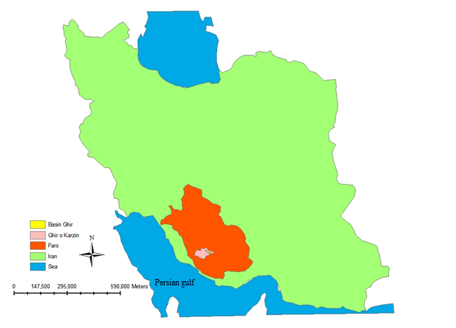
Fig. 1. Ghir Plain location in Iran
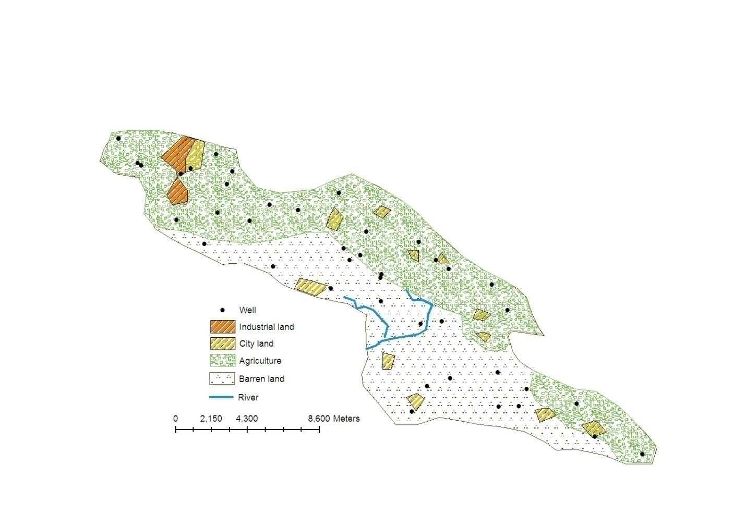
Fig. 2. Location of sampling wells within the Ghir Plain

3. Results
3.1. Rainfall and Temperature
The amount of annual rainfall over the region varies from 138.5 mm in dry years to 477 mm in wet years; long-term average temperature is 25.5 °C and average annual rainfall is 285.5 mm . (Table 1, Fig. 3, 4)

Table 1. Height of rainfall and air temperature in Ghir Plain, 2004-2011
Year | Rain(mm) | Temperature (c )
2004 | 367 | 25.1
2005 | 477 | 25.4
2006 | 186 | 24.9
2007 | 383.5 | 25.6
2008 | 138.5 | 26.1
2009 | 221.3 | 26
2010 | 230.5 | 25.8
2011 | 280 | 25.3
Average | 285.475 | 25.525

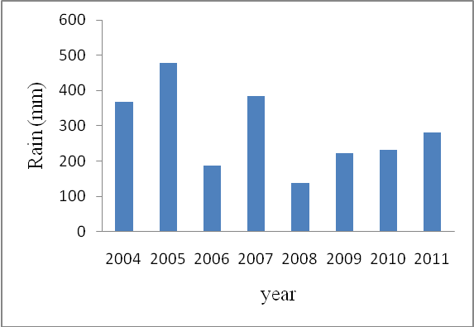
Fig. 3. Height of Rainfall in Ghir Plain, 2004-2011

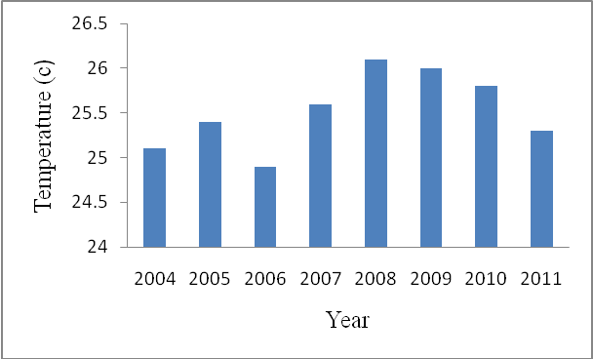
Fig. 4. Air temperature in Ghir Plain, 2004-2011

The highest rainfall happened in 2005 with 477 mm height and the lowest rainfall happened in 2008 with 138.8 mm height. The most annual temperature of the plain in statistical period belonged to 2008 with 26.1ᵒC and the least one belonged to 2004 with 25.1ᵒC. Average of rainfall and temperature of Ghir plain have been compared with those in Fars province , Iran and the world in Table 5. It is clear in the Table that temperature of the plain is very higher than the temperature in Iran and in the world so it is considered among hot areas. In addition, rainfall of this region is very unfavorable in compare with the word rainfall so it is among dry areas in the world level.

Table 2. Average of rain and temperature in Fars province, Iran and World
Temperature (c ) | Rain (mm) | Locations
25.5 | 285 | Ghir Plain
- | 275 | Fars Province
18 | 215 | Iran
8.5 | 880 | World

3.2. Quantitative Statistics of Ground waters
According to the Table 3, the lowest number of wells in the plain belonged to 2004. As the plain is a “forbidden plain”, no wells shall be added in that area but unfortunately the number of its wells has been annually increased. As Table 3 shows, the most slope of well growth was from 2005 to 2007; however there is not significant increase in productivity. From 2009 to 2011, you see the most slope of usage from wells’ waters (Table 4). With regard that 222 wells have been added to the plain in 2005 and according to the increase of water withdrawal, we found 1.24 m decrease in water surface elevation in this year. It means that the plain had a positive balance. However, as there was less increase in the number of wells, balance of the plain was constantly negative and the most balance belonged to 2010 when just 10 wells were added in compare with the previous year. Water withdrawal also had the most rates in 2010. This shows that the number of dug-out wells did not have significant effect on decrease or increase of water table in the plain and amount of withdrawal and other climate condition influenced on elevation of water table in the plain.

Table 3. Withdrawal rate and number of wells in Ghir Plain, 2004-2011
Statistical year | Number of Wells |  |  | Withdrawal rate (MCM)
Statistical year | Deep | Shallow | Total | Withdrawal rate (MCM)
2004 | 373 | 1272 | 1645 | 122.000
2005 | 373 | 1272 | 1645 | 122.427
2006 | 396 | 1471 | 1867 | 122.233
2007 | 401 | 1477 | 1878 | 123.237
2008 | 401 | 1478 | 1879 | 123.302
2009 | 403 | 1480 | 1883 | 123.737
2010 | 410 | 1482 | 1892 | 135.461
2011 | 411 | 1483 | 1894 | 135.942

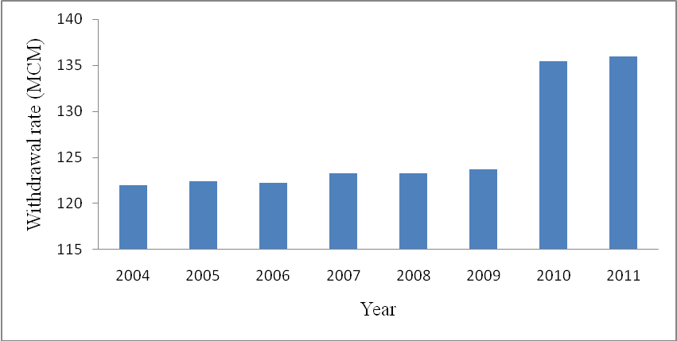
Fig. 5. Rate of water withdrawal in the Ghir Plain

3.3. Water table and its change
Changes in water table have been mentioned in Table 4 and Fig. 6. There is also the elevation of water table in compare with sea level in the Table for years 2004 to 2011.

Table 4. Water table changes over previous year in Ghir Plain: 2004-2011
Location | 2004 | 2005 | 2006 | 2007 | 2008 | 2009 | 2010 | 2011
Tangeroen | 1.18 | 1.26 | -1.12 | -0.30 | -0.60 | -0.32 | -0.19 | 0.79
Shahrepir | 1.18 | 1.26 | -1.12 | -0.30 | -0.60 | -0.32 | -0.19 | 0.79
Barikhon | -0.97 | -0.76 | -1.76 | -1.86 | -2.02 | -1.62 | -0.89 | -6.47
Ali abad | 0.94 | 1.42 | -0.82 | -0.53 | -0.54 | -4.39 | -1.17 | 2.71
Ghalatnahavie | 0.58 | 0.39 | -0.75 | -0.20 | -0.64 | -1.39 | 0.16 | 1.11
Sarcheshme | 0.76 | 1.14 | -0.52 | -0.47 | -0.25 | -3.93 | -0.81 | 1.74
Fathabad | -0.34 | 1.32 | -0.93 | -1.07 | -0.70 | -3.99 | -1.03 | 0.32
Shams abad | -1.54 | 2.61 | -1.14 | 0.08 | -1.50 | -5.43 | 4.23 | 1.29
Sekeravan | 0.87 | 1.56 | -4.36 | -0.26 | -5.12 | -5.47 | -1.51 | -8.52
Ghir | -0.01 | 1.13 | -2.57 | -1.52 | -0.70 | -0.97 | -6.51 | -1.41
Eslamabad | 3.16 | 2.36 | -4.48 | 0.13 | -0.97 | 2.11 | -9.26 | 0.32

Table 5. Elevation of the water table within the Ghir Plain, 2004-2011
Year | 2004 | 2005 | 2006 | 2007 | 2008 | 2009 | 2010 | 2011
Locations | Water table (m)
Tangeroen | 682.81 | 681.74 | 681.44 | 680.84 | 680.52 | 680.34 | 681.12 | 680.01
Shahrepir | 682.86 | 681.74 | 681.44 | 680.84 | 680.52 | 680.34 | 681.12 | 680.01
Barikhon | 672.12 | 670.36 | 668.49 | 666.47 | 664.85 | 663.97 | 657.49 | 657.06
Ali abad | 685.73 | 684.90 | 684.37 | 683.83 | 679.44 | 678.28 | 680.98 | 686.13
Ghalatnahavie | 675.57 | 674.82 | 674.62 | 673.97 | 672.59 | 672.75 | 673.86 | 674.15
Sarcheshme | 684.07 | 683.550 | 683.07 | 682.82 | 678.89 | 678.08 | 679.81 | 683.12
Fathabad | 688.47 | 687.539 | 686.46 | 685.76 | 681.78 | 680.75 | 681.06 | 684.53
Shams abad | 698.58 | 697.441 | 697.51 | 696.01 | 690.58 | 694.82 | 696.11 | 699.08
Sekeravan | 689.65 | 685.290 | 685.02 | 679.90 | 674.44 | 672.93 | 664.41 | 654.94
Ghir | 689.28 | 686.719 | 685.20 | 684.49 | 683.52 | 677.02 | 675.61 | 673.62
Eslamabad | 721.85 | 717.36 | 717.49 | 716.53 | 718.63 | 709.37 | 709.69 | 713
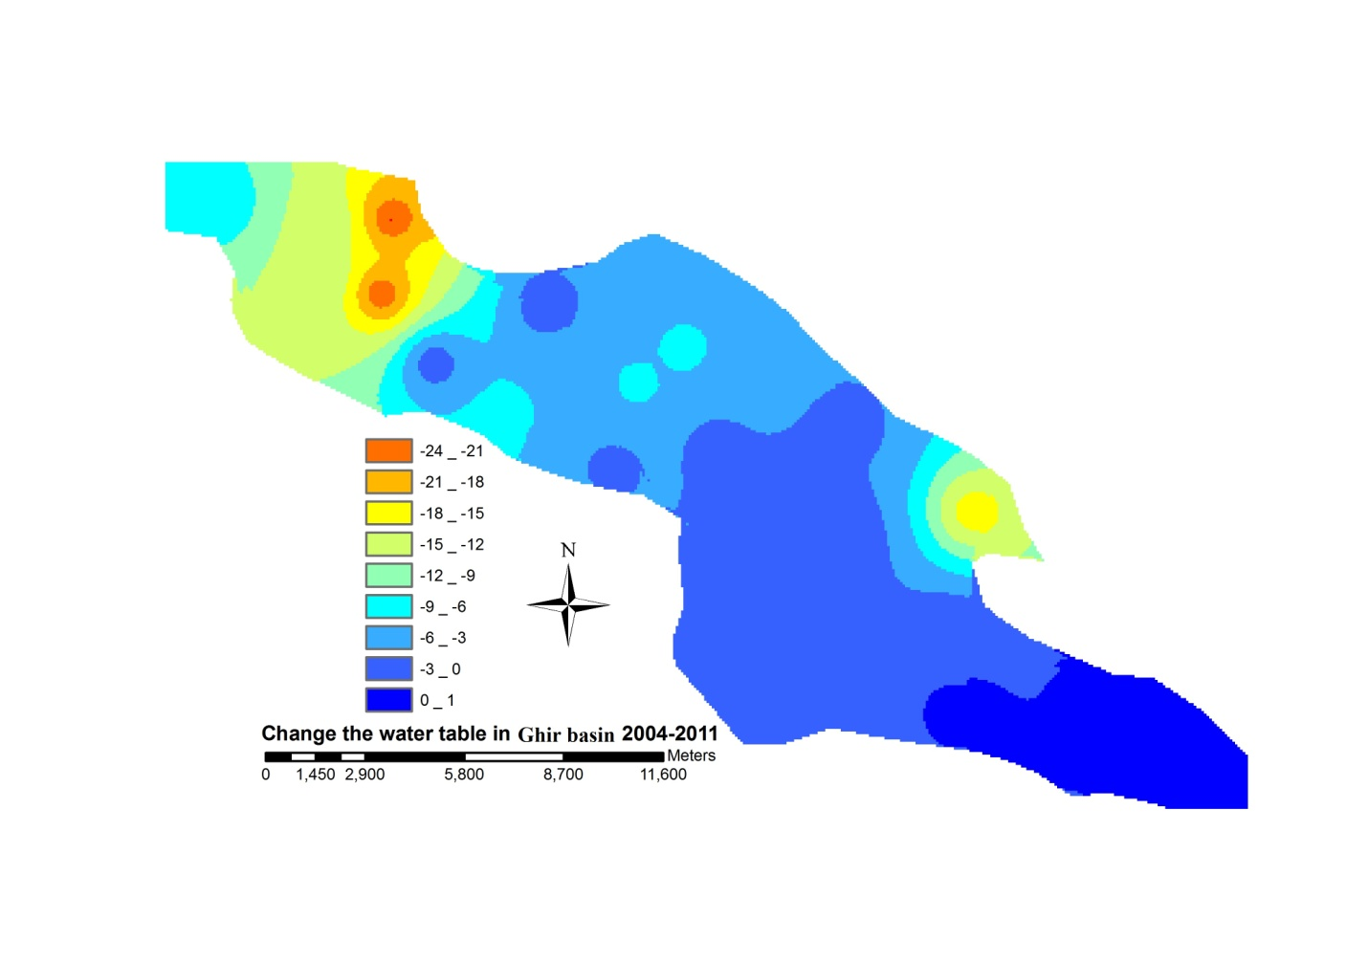
Fig. 6.Change the water table in Ghir Plain, 2004-2011

Downward slope of water table decrease has been severely started from 2007. It is clear that with regard to the increase in the number of wells and also increase in exploitation from wells, level of water table decreased and it is considered that this process will be continued in this way for years. In addition, when withdrawal increases, level of water table will decrease and downward slope of this decrease is in line with withdrawal increase. The average of drop in groundwater level in Iran has been 0.2 m per year and it has been also reported to 8 m in some alluvial aquifers of Iran .
According Investigation the quantitative on the Zahedan aquifer (southeast Iran) revealed that the decline in groundwater level may reach about 15 m in some places . Ground-water withdrawals in the vicinity of the well field caused a large area of water-level declines to develop in the Equus Beds aquifer. Water levels declined from 1940 through the 1950's drought, stabilized in the 1960's and 1970's, continued to decline between the late 1970's and the 1988-92 drought, and reached their maximum to date of as much as 40 feet or more during 1991-93. Loss of ground water in storage since August 1940 followed a pattern similar to water-level declines, with a maximum loss of storage of 255,000 acre-feet reached in January 1993. Water-level declines encompassed an area of about 190 square miles at their maximum in January 1993 and extended from the Arkansas River to the Little Arkansas River in the vicinity of Halstead and Sedgwick. Ground-water levels have since recovered more than 10 feet in some areas and aquifer storage replenished by 79,000 11acre-feet between 1993 and 1998 primarily as a result of decreased city withdrawals . In Kashan basin, according to the data obtained from 53 observation wells, it is found that the mean water table is decreased about 7.93 m between 1990 and 2006, indicating a mean water table decline of 0.496 m/year . This is while that the amount of loss has reached more than 20 m in some regions and it is considered that this process will be continued along years later.

3.4. The Relation between Rainfall and Temperature with Water table Elevation
The relation between rainfall and temperature with water table (ground water elevation toward sea level) has been considered as a two independent variables and one dependent variable so that temperature and rainfall are two independent variables. The relations between rainfall, temperature and water table have been represented in Fig. 7.

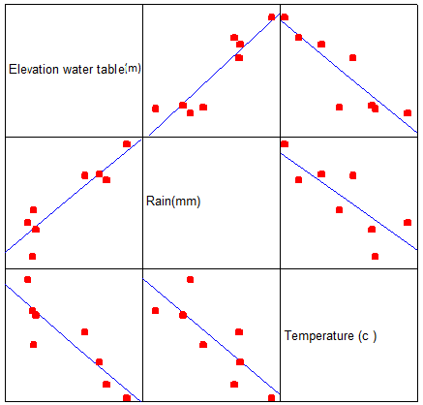
Fig. 7. Relationship of water table by temperature and rainfall in Ghir Plain

According to the Fig. 7, the relations between each component are as follow: Rainfall has a direct relation with water table. It means that as the rainfall exceeds, the water table rises. Temperature and water table are inversely related. It means that even temperature increases, water table declines. Temperature and rainfall are inversely related. Table 6 has numerically represented these relations.

Table 6.Correlation matrix of water table by temperature and rainfall in Ghir Plain
Temperature(c) | Rain(m) | Elevation of water table (m)
 |  | 1 | Elevation of water table (m)
 | 1 | 0.928** | Rain(m)
1 | -0.804* | -0.876** | Temperature(ºC)
**Correlation is significant at the 0.01 level.
*Correlation is significant at the 0.05 level.

As it is clear, degree of correlation between rainfall and water table is very close to 1 and it shows a strong relation between these two components. However, the relations between temperature with water table and rainfall are negative and close to -1 which shows invers relations of these components. In Fig. 6, we have R²=0.90. It means that R is equal to 0.95. Whatever this number is closer to 1, the relations between factors are stronger. If rainfall and temperature data of the plain are available, water table will be 90% predictable. Now, with regard to the above relations and obtained results, β coefficient will be as follow:
β ₀ = 714.256
β ₁ = 0.021
β ₂= -1.461
According to the above numbers, the following equation shows relations between rainfall, temperature and water table.
Elve water table(m)= 714.256+0.021Rain(mm) – 1.461Temp (c)
The periodic pattern of groundwater level fluctuations is investigated for six monitoring wells located in residential areas in Kuwait. Monthly water level measurements obtained from the monitoring wells for periods varying from 8 to 10 years are employed to examine the relationship with monthly-averaged temperature and totaled rainfall. The period grams of the water level, rainfall, and temperature data are also determined. The results reveal that the annual periodicity typically observed in the last two climatological data sets can significantly be identified in all the series of subsurface water level examined here and the model can possibly be used to set a time plan for starting a continuous dewatering process to avoid problems related to groundwater level rise in residential areas .

3.5. The Relation between Rainfalls with Water table Elevation
This model has been represented as a dependent variable and an independent variable. The relation between rainfall and water table has been shown in Fig. 8.

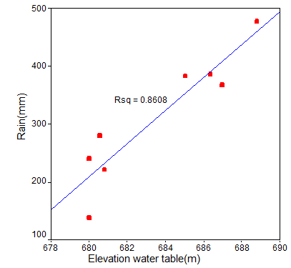
Fig. 8. Relationship of water table by rainfall in Ghir Plain

As it mentioned above, rainfall and water table are directly related. It means that more rainfall increases water table, therefore there is a significant relation at level 1%. According to the Fig., R²=0.86. It means that R is equal to 0.92 which is very close to 1 and it shows a close and strong relation between these two factors. However, according to the statistical analysis, when we have the rainfall data, water table can be 86% predictable. This is while the temperature data make it 90% predictable. In the other words, water table is 4% more predictable when we also have the temperature data.
Now, with regard to the above relations and obtained results, β coefficient will be as follow:
β ₀ = 674.129
β ₁ = 0.03
According to the above numbers, the following equation shows relations between rainfall, temperature and water table.
Elve water table(m)= 674.129+ 0.03(mm)
studied the relations between climate variables and ground water balance in Manitoba State, Canada. They used data such as the average of temperature, the minimum and maximum temperature and rainfall in period of 1900 to 2000. Their results showed that annual rainfall in this region is highly correlated with the level of annual groundwater balance .

3.6. The Relation between Rainfall and Temperature with change Water table
The relation between rainfall and temperature with change water table (Changes the water table from the previous year) has been considered as a two independent variables and one dependent variable so that temperature and rainfall are two independent variables. the relations between each component are as follow: Rainfall has a direct relation with change water table. It means that as the rainfall exceeds, the change water table rises. Temperature and change water table are inversely related. It means that even temperature increases, change water table declines. Table 7 has numerically represented these relations.

Table 7. Correlation matrix of Change of water table by temperature and rainfall in Ghir Plain
Temperature(c) | Rain(m) | Change of water table (m)
 |  | 1 | Change of water table (m)
 | 1 | 0.86** | Rain(m)
1 | -0.89** | -0.93** | Temperature(c)
**Correlation is significant at the 0.01 level.

As it is clear, degree of correlation between rainfall and change water table is very close to 1 and it shows a strong relation between these two components. However, the relations between temperature with change water table and rainfall are negative and close to -1 which shows invers relations of these components. We have R²=0.87. It means that R is equal to 0.93. Whatever this number is closer to 1, the relations between factors are stronger. If rainfall and temperature data of the plain are available, change water table will be 87% predictable. Now, with regard to the above relations and obtained results, β coefficient will be as follow:
β ₀ = 40.27
β ₁ = 0.009
β ₂= -1.62
According to the above numbers, the following equation shows relations between rainfall, temperature and water table.
Change of water table (m)=40.27+ 0.009Rain (mm) -1.62Temp (c)
The aim of this study was to identify and quantify the groundwater level trend of the state Orissa (India) to understand the forcing mechanism of droughts in conjunction with the anthropogenic pressure using the non-parametric Mann–Kendall statistical procedure. The pre- and post-monsoon groundwater level records of 1002 monitoring stations during the period 1994–2003 were analyzed. The results show that the draw downs due to deficient rainfall during dry years, high temperatures, and anthropogenic pressure have not been recovered through the recharge in wet years. However, this study does not determine whether drought, high temperatures or anthropogenic effects have had largest influence on the groundwater levels decline. The cases of significant water table declines are higher in number than those expected to occur by chance. In the pre-monsoon season, 59% of the monitoring stations experienced groundwater declines as against 51% in the post-monsoon season for the study area as a whole. This could be interpreted that the fluctuation is not a part of noise, but that a signal is being identified. Further, the trend result showed wide spatial and seasonal differences. Irrespective of seasons, the consolidated rock formation that covers 80% of the geographical area experienced significant water table decline. However, the semi-consolidated and unconsolidated formations experienced water table decline in the pre-monsoon (summer) season only. The vulnerable sites where the groundwater-level declined significantly were identified so that recharge measures could be taken up . Results of this study are very similar to the results obtained by Panda et al., 2007.

3.7. The Relation between Rainfalls with Change Water table Elevation
This model has been represented as a dependent variable and an independent variable. The relation between rainfall and Change water table has been shown in Fig. 9.
As it mentioned above, rainfall and change water table are directly related. It means that more rainfall increases change water table, therefore there is a significant relation at level 1%. According to the Fig., R²=0.74. It means that R is equal to 0.86 which is very close to 1 and it shows a close and strong relation between these two factors. However, according to the statistical analysis, when we have the rainfall data, change water table can be 74% predictable.

.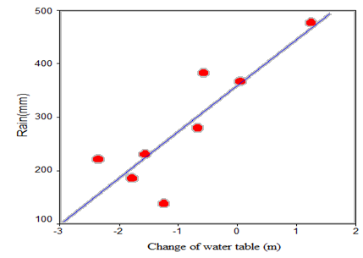
Fig. 9. Relationship of water table by rainfall in Ghir Plain

Now, with regard to the above relations and obtained results, β coefficient will be as follow:
β ₀ = -3.30
β ₁ = 0.009
According to the above numbers, the following equation shows relations between rainfall, temperature and water table.
Change of water table (m)= -3.30+ 0.009Rain (mm)
Jan evaluated the influence of intensity and distribution of rainfall on fluctuations of groundwater balance in Taiwan. They used Piezometric data of two streams in centre of Taiwan and 7 Raingauge Stations. Results showed that groundwater balance are linearly correlated with rainfall . Lloyd-Hughesa showed that decrease of rainfall has a negative effect on soil humidity, water resources, rivers’ surface currents and level of groundwater so that water resources encounter reduction .
Literature showed that feasibility of using artificial neural networks (ANNs) was studied to estimate groundwater level in piezometers in unconfined chalky aquifer of North France to estimate aquifer parameter values to forecast the groundwater level using rainfall, temperature, and stream discharge as inputs , and to evaluate the groundwater level in fractured media .

3.8. The Relation between temperature and Change Water table Elevation
This model has been represented as a dependent variable and an independent variable. The relation between rainfall and Change water table has been shown in Fig. 10.

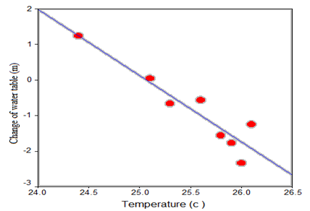
Fig. 10. Relationship of change of water table by temperature in Ghir Plain

As it mentioned above, temperature and change water table are inversely related. It means that even temperature increases, change water table declines, therefore there is a significant relation at level 1%. According to the Fig., R²=0.87. It means that R is equal to 0.93 which is very close to 1 and it shows a close and strong relation between these two factors.
Now, with regard to the above relations and obtained results, β coefficient will be as follow:
β ₀ = 46.63
β ₁ = -1.86
According to the above numbers, the following equation shows relations between rainfall, temperature and water table.
Change of water table (m) = 46.63 – 1.86Temp (c)
Chen studied the relations between climate variables and ground water balance in Manitoba State, Canada. They used data such as the average of temperature, the minimum and maximum temperature and rainfall in period of 1900 to 2000. Their results showed that annual rainfall in this region is highly correlated with the level of annual groundwater balance .

3.9. Geological formations
From the geological point of view the Plain is located in the Alluvium (Fig.11).
The area to the north is formed mainly of resistant formations of the Gachsaran and Gurpi groups, and to the south of the Asmari-jahrom and Bakhtiari formations. The lithological features of the formations in the Plain are presented in Table 8. Unconsolidated deposits in the all of the Ghir Plain are coarse grained materials including pebble gravel and coarse sand .

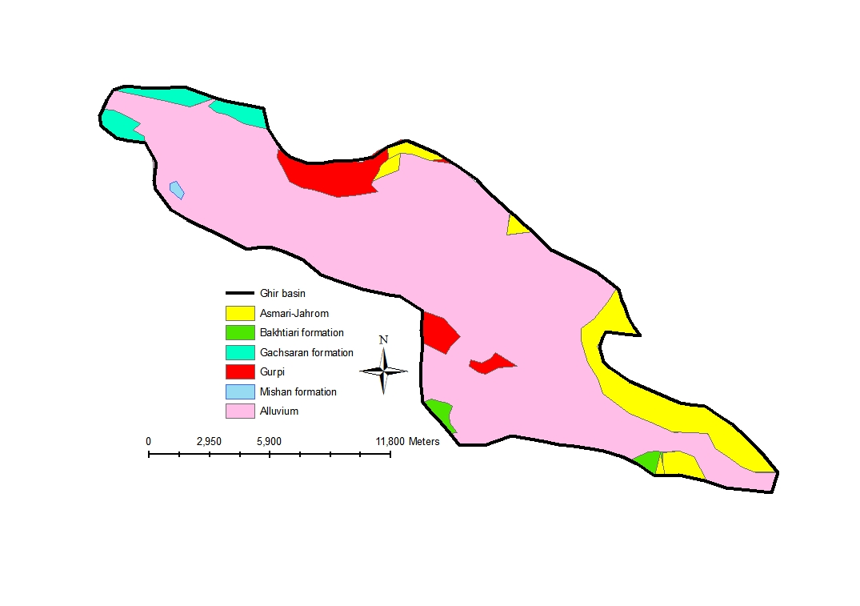
Fig. 11. Geological map of the Ghir Plain (Explanation of abbreviations for geologic units are given in Table 8).

Distribution of alluvium is in all over the plain and it is the dominant formation of the plain. Formations are equal in the regions Tangeroen, Barikhon and Ali Baba but changes in water table level are very different in these regions. For example, changes are 0.71 m in Tangeroen but they are -16.36 in Barikhon. However, it considers that Gachsaran formation which is in the regions Sekeravan, Ghir and Eslamabad, has high influence on water table decrease and enjoys more drop of water table in compare with other formations of the region. Of course, the lowest changes of water table in all over the plain belonged to Bakhtiari formation. This formation exists in Sharepir and Ghalatnahavie regions.
Quaternary sediments, which are the most important reservoir of underground water resources, have been formed from physical and mechanical weathering of upland formations. Properties of sedimentology of quaternary can determine the hydrology and hydrogeology of water of the reservoir. Quaternary sediments are very important in Iran because they covered more than 50% of the area of country .

Table 8. Lithology of geological formations in the Ghir Plain
Geological formation | Lithology | Area (ha) | % | Location of Plain
Alluvium | Erosion of fine and coarse discontinuous alluvial fans and debris without cement as a domain | 18220.5 | 84.2 | All
Asmari-Jahrom | Dolomite and limestone, marl and limestone with thin shale | 1991 | 9.2 | East and Southeast
Bakhtiari | Conglomerate | 102.7 | 0.47 | Southeast
Gachsaran | Between the marl and limestone layers in alternation with red marl containing gypsum | 425.8 | 1.97 | West and Northwest
Mishan | Green marl and marl with limestone floors alternate between layers of shale limited | 36 | 0.16 | West
Gurpi | Alternating layers of marl, argillaceous limestone, marl and limestone and shale | 863.15 | 4 | Central and  North

Table 9. geological formations and change of water table (2004-2011)
Locations | Geological formation | Change of water table (m)
Tangeroen | Alluvium, Asmari-Jahrom | 0.71
Shahrepir | Alluvium, Asmari-Jahrom, Bakhtiari | 0.71
Barikhon | Alluvium, Asmari-Jahrom | -16.36
Ali abad | Alluvium, Asmari-Jahrom | -2.38
Ghalatnahavie | Alluvium, Asmari-Jahrom, Gurpi, Bakhtiari | -0.74
Sarcheshme | Alluvium, Gurpi | -2.35
Fathabad | Alluvium | -6.43
Shams abad | Alluvium, Gurpi | -1.39
Sekeravan | Alluvium, Gachsaran, Gurpi | -22.80
Ghir | Alluvium, Gachsaran | -12.55
Eslamabad | Alluvium, Gachsaran | -6.63

4. Conclusion
Regarding that depth of water table decreases 1.1 m every year, it is recommended that regional authorities to identify dry years with regard to the obtained results by this research in order to decrease groundwater withdrawal or prevent withdrawal in some regions where water drop is very large if necessary (such as Sekeravan and Ghir) and to consider some arrangements for other regions such as prevention from creating new wells and increasing depth of wells.

Corresponding Author:
Mr. Ali Naseri Ghiri
Department of Irrigation and Drainage
Firouzabad Branch
Islamic Azad University, Iran
E-mail: ilia_nas@yahoo.com; ilianas2530@gmail.com

References
1. Affandi, A. K., K. Watanabe, et al. (2007). "Application of an artificial neural network to estimate groundwater level fluctuation." J. Spatial Hydrol 7(2): 23-46.
2. Almedeij, J. and F. Al-Ruwaih (2006). "Periodic behavior of groundwater level fluctuations inresidential areas." Hydrology 328(3-4): 677-684.
3. Aminian, K. and S. Ameri (2005). "Application of artificial neural networks for reservoir characterization with limited data." Petroleum Sci.Eng 49(3-4): 212-222.
4. Aucott, W. R. and N. C. Myers (2000). "Changes in ground-water levels and storage Wichita well area, south-central Kansas." water Resources Investigation 98(4141): 13.
5. Balkhair, K. S. (2002). "Aquifer parameters determination for large diameter wells using neural network approach." Hydrology 265(118-128).
6. Blumenthal, E. (2010). Introduction to SPSS. University of Washington Seattle, WA 98195 USA.
7. Boustani, F. (1994). Evaluation of Artificial Recharge Projects and Their Quantitative Effects on the Groundwater level. Shiraz, Shiraz University. M.Sc: 56-193.
8. Bureau, F. M. (2012). "Climate." Www.Farsmet.ir/Amars.aspx.
9. Calow, R., N. Robins, et al. (1999). Planning for groundwater drought in Africa. Integrated Drought Management, International (Lessons for Sub-Saharan Africa. IHP-V), Technical Documents in Hydrology.
10. Chen, Z., S. Grasby, et al. (2004). "Relation between climate variability and groundwaterlevel in the upper carbonate aquifer, south Manitoba, Canada." Hydrology 290: 43-62.
11. Coulibaly, P., F. Anctil, et al. (2001). "Artificial neural network modeling of water table depth fluctuations." Research Journal of Chemical Sciences 37(4): 885-886.
12. Daliakopoulos, I. N., P. Coulibaly, et al. (2005). "Groundwater level forecasting using artificial neural networks." Hydrology 309: 229-240.
13. Frederick, K. D. and P. H. Gleick (1999). Water and Global Climate Change: Potential Impacts on U.S. Water Resources. Prepared for the Pew Center on Global Climate Change: 48.
14. Hoffmann, J., P, Ed. (2010). Linear Regression Analysis: Applications and Assumptions United States of America Department of Sociology.
15. Holms, J. (2007). "Climate change and water resources.Water Aid. London." SE11 7JD 288701: 1-27.
16. IPCC (2001). Climate Change 2001. Impacts, Adaptation, and Vulnerability. Contribution of WG II to TAR of the Intergovernmental Panel on Climate Change M. C.
17. McCarthy, O.F. Canziani, N.A. Leary, D.J. Dokken and K.S. White (eds.). Cambridge: 1031.
18. Iran, N. G. D. o. (2010). Fars. Shiraz.
19. Jamshidzadeh, Z. and S. A. Mirbagheri (2011). "Evaluation of groundwater quantity and quality in the Kashan Basin, Central Iran." Elsevier, Desalination 270: 23-30.
20. Jan, C. D., T. H. Chen, et al. (2007). "Effects of rainfall intensity and distribution ongroundwaterlevel fluctuations." Hydrology 332(3-4): 348-360.
21. Jankowski, J., I. Acworth, et al. (1994). The Hydrology and Hydrogeochimical Processes Associated With the Occurrence of Dryland Salinity in the Strontium Road Basin, NSW. In proceedings of Water Down Under Conference, Adelaide.
22. Khazai, E. (2001). "Urbanization effects on groundwater quantity and quality in the Zahedan aquifer, an arid region in southeast Iran." Proceedings of a symposium held during the Sixth IAHS Scientific Assembly at Maastricht, The Netherlands IAHS Publ: 269.
23. Khodjini, V. (1995). "Human impacts on groundwater resources in Iran (Man's Influence on Freshwater Ecosystems and Water Use )." Proceedings of a Boulder Symposium 230: 141-146.
24. Lallahem, S., J. Mania, et al. (2005). "On use of neural networks to evaluate groundwater levels in fractured media." Hydrology 307(1-4): 92-111.
25. Landau, S. and B. S. Everitt (2004). A Handbook of Statistical Analyses using SPSS. New york.
26. Lenderink, G. and E. V. Meijgaard (2008). "Increase in hourly precipitation extremes beyond expectations from temperature changes." Nature Geoscience 1: 511-514.
27. Lloyd-Hughesa, B. and M. A. Saundersa (2002). "A DROUGHT CLIMATOLOGY FOR EUROPE." CLIMATOLOGY 22: 1571-1592.
28. Panda, D. K., A. Mishra, et al. (2007). "The influence of drought and anthropogenic effects on groundwater levels in Orissa, India." Hydrology 343(3-4): 140-153.
29. Quayle, A. R. G., T. C. Peterson, et al. (2005). "An operational near real time global temperature index." National Climatic Data Center (NCDC), NOAA/NESDIS, Asheville N.C.
30. Scheidleder, A., J. Grath, et al. (1999). Ground water quality and quantity in Europe. European Environment Agency. Technical report No 22.
31. Sethi, R. R., A. Kumar, et al. (2010). "Prediction of water table depth in a hard rock basin by using artificial neural network." Water Resources and Environmental Engineering 2(4): 95-102.
32. Shahid, S. and M. K. Hazarika (2009). "Groundwater Drought in the Northwestern District of Bangladesh." Water Resources Managment 24(10).
33. Sharifi, F. and A. Ghafouri (1998). "Flood spreading in Iran. An integrated approach." Rain Drop (ICRCS) 2: 1-7.
34. sources, B. s. o. I. w. (2009). "Groundwater.".http://wrs.wrm.ir/tolidat/ab-zirzamini.asp.
35. Sudheer, K. P., A. K. Gosain, et al. (2003). "Estimating actual evapotranspiration from limited climatic data using neural computing technique." Irrigation Drainage Eng 129(3): 214-218.
36. Terkuile, B. J. (2009). The relation between temperature and precipitation, Koninklijk Nederlands Meteorologisch Instituut. M.S.C.
37. Wikipedia. (2012). "Qir." http://en.wikipedia.org/wiki/Qir.

11/20/2012

