Construction Of 2-D Electrical Resistivity Field To Characterize The Subsoil In North-Eastern Part Of Alimosho Area Of Lagos State, Nigeria.

Oseni S.O*, Adebgola R.B, Ometan O.O and Adeboye D.

Department of Physics, Lagos State University, Ojo, Lagos Nigeria
*Corresponding Author, email: husseinsaheed@yahoo.co.uk

ABSTRACT: The Baruwa community of Alimosho Local Government area of Lagos State was surveyed to characterize the subsoil. Results from three (3) 2-D resistivity imaging (tomography) shows a lithologic unit of 3 – 4 geoelctric layers which are clay, clayey sand and coarse sand of resistivity range from 50 -500Ωm with thickness range of 0.5 – 5m. The 2-D resistivity structure shows the subsurface layers, horizontally and vertically up to a depth of 5m clearly indicating the areas of low resistivity that may affect agricultural produce and groundwater development in the study area. It has been shown that geophysical methods are good tools for mapping/imaging subsoil.
[Oseni S.O, Adebgola R.B, Ometan O.O and Adeboye D. Construction Of 2-D Electrical Resistivity Field To Characterize The Subsoil In North-Eastern Part Of Alimosho Area Of Lagos State, Nigeria. N Y Sci J 2013;6(1):50-54]. (ISSN: 1554-0200). http://www.sciencepub.net/newyork. 8

Keywords: Subsurface, Resistivity, Geoelectric layer, Tomography.

INTRODUCTION
For over three decades now the Baruwa community has being experiencing lack of portable water owing to the fact that there was a leakage or perhaps vandalisation of the NNPC pipeline that runs through a part of the community. The petroleum industries produce waste products which give rise to soil contamination from the stages of exploration, production, refining, storage and distribution (Badmus et al., 2010).
Leakages from both underground and surface storage tanks of petroleum products constitute a notable source of pollution within Lagos metropolis, (Malomo and Wint, 2003). Therefore, to have a clearer picture of the subsurface and to map out the effect of the contamination on the structure of the subsoil, a 2-D geoelectrical resistivity survey was conducted. Electrical resistivity imaging has been a veritable tool in delineating bedrock depression, fracture, synclinal water accumulation zone and aquifer layer (Singh et al., 2006,Ayolabi et al., 2008). However, a range of fast automated multi-electrode and multi-channel data acquisition systems now exist that allows flexibility in the acquisition of geoelectrical resistivity data (Barker, 1981; Stummer and Maurer, 2001; Auken et al., 2006). The use of multi-electrode/multi-channel systems for data acquisition in geoelectrical resistivity surveys has led to a dramatic increase in field productivity as well as increased quality and reliability of subsurface resistivity information obtained (Aizebeokhai, 2010).
A number of arrays have been used in recording 2D geoelectrical resistivity field data, each suitable for a particular geological situation. The conventional arrays most commonly used include Wenner, dipole-dipole, pole-pole and pole-dipole. Most of the pioneering works in 2D geoelectrical resistivity surveys were carried out using Wenner array (e.g. Griffiths and Turnbull, 1985; Griffiths et al., 1990; Oldenburg and Li, 1999; Olayinka and Yaramanci, 2000).
Geoelectrical imaging surveys are normally carried out with multi-electrode resistivity system. In this survey, adopting the Wenner technique, 64 electrodes were deployed in a straight line with constant spacing and connected to a multicore cable. A computer-controlled system is then used to select the active electrodes for each measurement.

DESCRIPTION OF THE STUDY AREA
The study area is the pipeline road in Baruwa community (Figure 1), Alimosho local government of Lagos state. It lies between latitudes 6"36.12N and longitude 3"16.40E and bounded by Abesan and Gowon estate. It is drained by Lagos lagoon, Badagry creek and Lekki lagoon. Local geology of the area is made up of soil composed of bedrock, which is mostly sedimentary (alluvial deposits) while reddish and brown soils were noticed in the upland. The Local Council is richly blessed with arable landmass of about 57.621 km² and rivers Owa and Oponu, which are suitable for navigation, fishing and tourism purposes, surround it. The base map of the area is given below:

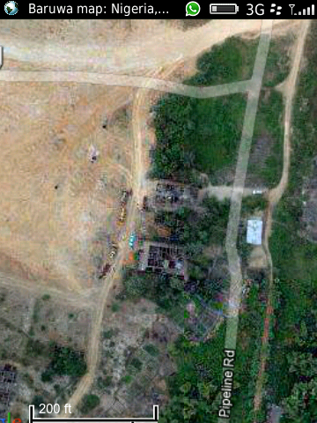
Traverse 1
Traverse 2

TRAVERSE 3
Figure 1: Base map of study area

FIELD TECHNIQUES
A total of three Constant Separation Traverse (CST) were carried out within the study area with the electrodes fixed at a separation of 3m apart in traverses 1and 3, and 2m apart in traverse 2. A maximum of 64 electrodes were used with the above spacing giving a total profile length of 113m in traverse 2 and 172m in traverses 1and 3. ABEM Terrameter SAS 4000 was used to acquire the ground resistivity data. The observed field data were used to produce pseudo sections for each of the traverses that were used as initial model for the computer iteration technique via DIPPRO software to produce model contours.

RESULT AND DISCUSSION
Electrical Resistivity Tomography with continuous imaging along a traverse has been proven to be reliable in depicting the subsurface layers (Ayolabi et al., 2009). Thus, three (3) 2D traverses wildly spread out (Figure 1) in the community was carried out to provide better information of the subsurface. The 2D data was inverted using DIPPRO software. The distribution of resistivity along inverted model resistivity pseudo section showing 3 - 4 geoelectric layers is as shown in figure 2, 3 and 4.

Traverse 1
The first layer designated with blue colour has resistivity values in the range 50 to 150Ωm. this undulated from 0 to 2m in depth with varying thickness between 1 to 3.5m. This layer which is the topmost layer of low resistivity is composed mainly of lateritic/clay materials. It is loose and porous and may possibly be the channel for hydrocarbon contamination. The second layer has resistivity in the range of 150 to 300Ωm which is indicated by green and yellow color. It’s thickness varying from 0.9 to 2.5m except for electrode positions 49 to 63 and 151 to 157 where the thickness extend to 5m.This is indicative of a very loose structure in this regions and probably consists of material made of sandy clay. The third layer is composed of sand, with resistivity value ranging from 200 to 300Ωm with a thickness of about 1.5m. The fourth layer having resistivity in the range 300 to 500Ωm is composed mainly of coarse sand. It has a thickness of about 3m and could be a possible aquiferous zone.

Traverse 2
The 2-D resistivity structure shown in Figure 3 below reveals sediments with resistivity value ranging from 50Ωm to 500Ωm over a spread of 107m which probed to a depth of 5m. The first layer, which is the topsoil, has resistivity value in the range 120Ωm to 180Ωm. It is dominated by sediments composed mainly of clayey materials of varying thickness down the profile. The second layer is composed of sandy clay with resistivity value in the range 220Ωm to 325Ωm and depth of about 5m, the thickness ranges from 0.5 to 2m . The third layer has resistivity value ranging from 250Ωm to 300Ωm. It is composed of sand with varying thicknesses up to 1.5m down the profile. The fourth layer has resistivity in the range of 300 to 500Ωm,it extend to a depth of 5m having varying thickness down the profile as well.

Traverse 3
The resistivity structure and the pseudosection shown in Figure 4, represent the third traverse. It is composed of three geoelectric layers. The first layer has resistivity values ranging from 100 to 150Ωm; It is composed of clayey sand with thickness varying between 0.3 and 3m. The second layer has undulating thickness between 1.5 and 2.5m down the profile with resistivity values between 200Ωm and 350Ωm. However, at electrode position 91 –120 the thickness extends to 5m.The third geoelctric layer extends to a depth of 5m with resistivity values ranging from 350 to 500Ωm indicative of coarse sand. It has varying thicknesses down the profile and could probably serve as a good aquifer.

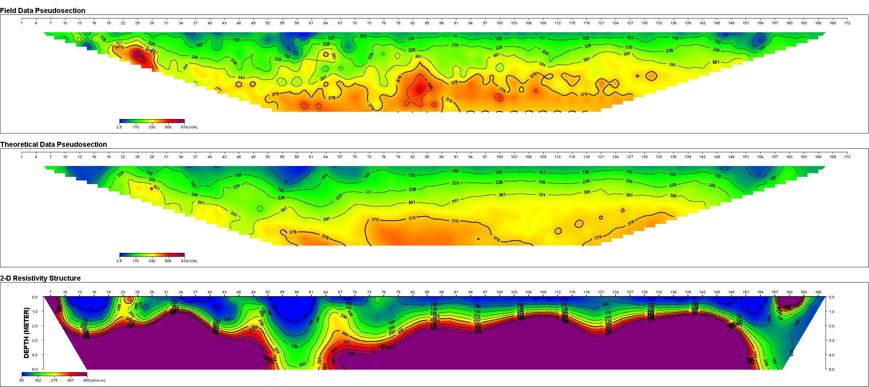

Figure 2a, b, and c: 2-D resistivity structure and pseudosection (Field and theoretical data) for traverse 1.
(a)
(b)
(c)
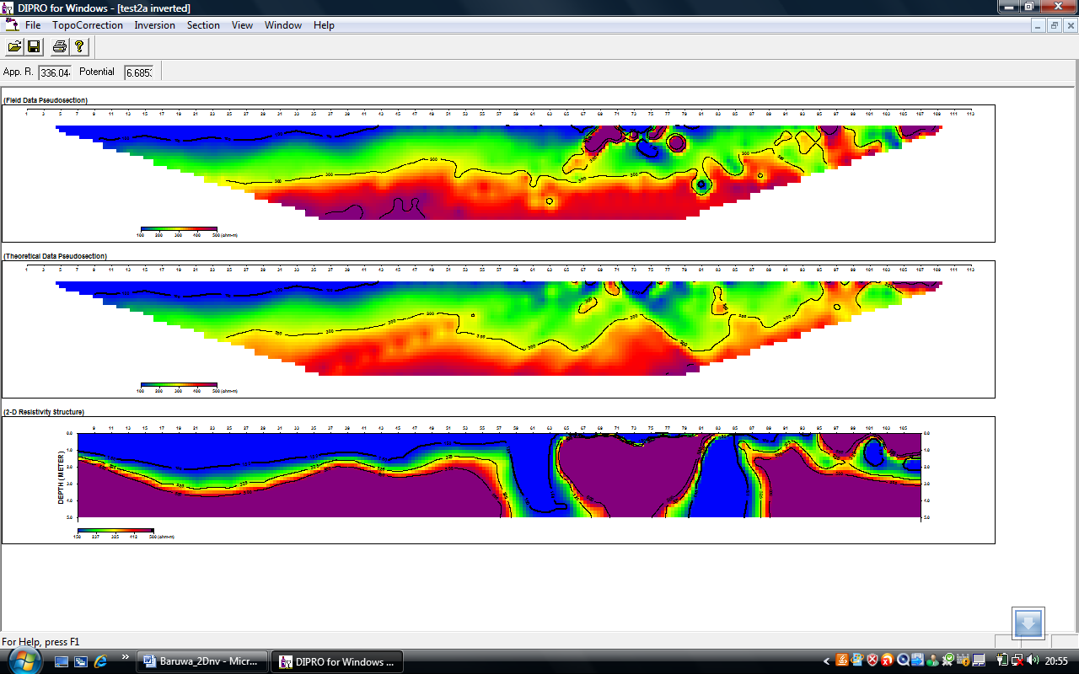Figure 3: 2-D resistivity structures and pseudosection (Field and theoretical data) for traverse 2.

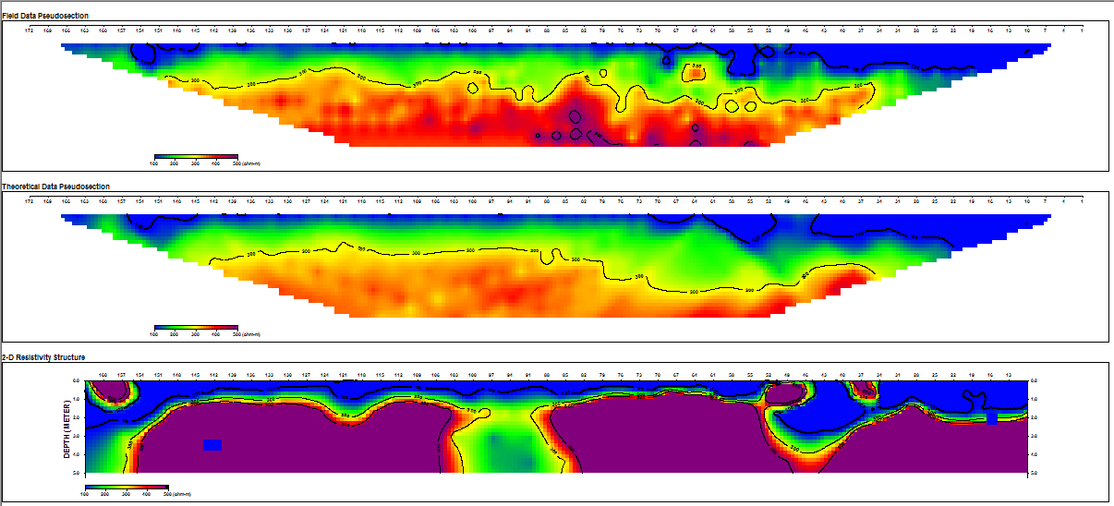

Figure 4: 2-D resistivity structures and pseudosection (Field and theoretical data) for traverse 3.

CONCLUSIONS
2D resistivity surveys of Baruwa community, north-eastern part of Alimosho area of Lagos state have been conducted. The results shows that the area has a lithologic units comprising of probable lateritic clay, clayey sand and coarse sand respectively. This may justify the reason for very low agricultural produce in the study area. It is noteworthy However, that the regions of high resistivity comprising majorly sand and coarse sand respectively, could probably be an aquiferous zone. However, a vertical electrical sounding survey or other geophysical survey may be carried out in the area to further probe the subsurface (vertically) in an attempt to establish aquiferrous region that may be wholesome.

REFERENCES
- Ahzegbobor Philips Aizebeokhai, (2010). 2D and 3D geoelectrical resistivity imaging: Theory and field design. Scientific Research and Essays 5(23), pp. 3592-3605.
- Aizebeokai A.P., Olayinka A.I. and Singh V.S. (2010): application of 2-D and 3-D geoelectrical resistivity imaging for engineering site investigation in a crystalline basement terrain, southwestern Nigeria. Journ. Environ. Earth Scien.
- Auken E, Pellerin L, Christensen NB, Sorensen K. (2006). A survey of current trends in near-surface electrical and electromagnetic methods. Geophys., 71(5): 249-260.
- Ayolabi, E.A, Folorunsho, A.F, Eleyinmi, A.F, Anuyah, E.O (2009). Applications of 1D and 2D electrical resistivity methods to map aquifers in a complex geologic terrain of Foursquare camp, Ajebo,Southwestern Nigeria.Pacific Journal of Science and Technology.10(2):657-666.
- Ayolabi, E.A., Folorunsho, A.F. and Ariyo, S.O. (2008): Resistivity imaging survey for water supply tube wells in a basement complex: a case study of OOU main campus, Ago-Iwoye, south-western Nigeria. Proceedings of international symposium on hydrogeology of volcanic rocks (SHID): Republic of Djibouti. 67-71.
- Badmus, B. S., Obawole, A. O and Ganiyu, S. A. (2010). 2-D Geo-electric Evaluation of Soil Contamination By Surface Oil and Gas Tanks in Sedimentary Formation. Journal of Emerging Trends in Engineering and Applied Sciences (JETEAS) 2 (2): 203-209
- Barker, R.D (1981). The offset system of electrical resistivity sounding and its use with multicore cable. Geophy. Prosp., 29: 128-143.
- Griffiths, D.H, Turnbull, J. (1985). A multi-electrode array for resistivity surveying. First Break, 3: 16-20.
- Griffiths, D. H, Turnbull J, Olayinka, A. I. (1990). Two-dimensional resistivity mapping with a complex controlled array. First Break, 8: 121-29.
- Griffith, D.H., Turnbull, J. and Olayinka, A.I. (1990). Two-dimensional resistivity mapping with a computer controlled array. First Break 8: 121-129.
- Malomo, S. and Wint, H.E. (2003). Reducing groundwater vulnerability in developing commonwealth countries.
- Olayinka, A. I., Yaramanci, U. (1999). Choice of the best model in 2-D geoelectrical imaging: case study from a waste dump site. Eu. J. Environ. Eng. Geophy., 3: 221-244.
- Oldenburg, D.W, Li, Y. (1999). Estimating depth of investigation in dc resistivity and IP surveys. Geophy., 64: 403-416.
- Singh, K.K, Singh A.K, Singh K.B, and Singh, A. (2006). 2D Resistivity imaging survey for siting water supply tube wells in metamorphic terrains: A case study of CMRI Campus, Dhanbad, India. The Leading Edge.25 (12): 1458-1460.
- Stummer, P, and Maurer, H. R (2001). Real-time experimental design applied to high-resolution direct-current resistivity surveys. International Symposium on Optical Science and Technology, Expanded Abstracts, 143-150.

11/20/2012

