The Protective Role of the Royal Jelly against Histological Effects of Endoxan Drug on the Testis of the Male Albino Mice

Nagla Zaky El–Alfy; Mona Isa; Mahmoud Fathy Mahmoud and Asma Emam

Biological and Geological Sciences Department, Faculty of Education, Ain Shams University, Cairo, Egypt
Mahmoudfathy76@yahoo.com

Abstract: The aim of this work is to study the protective role of royal jelly on the mice after endoxan treatment. Mice were divided into three groups. The first group served as control while the other two groups were treated with endoxan doses and with endoxan and royal jelly respectively. Each endoxan treated animal was intraperitoneally injected one day in week for 4 weeks with 200µg/kg body weight while royal jelly treated animals were orally injected daily for 4 weeks with 1g/kg body weight. The damage caused in the testes of mice after endoxan treatment displayed variable changes in both the seminiferous tubules and the interstitial tissue. The histological changes were also significantly increased by time and dose. While treatment with endoxan and royal jelly showed advanced observations.
[Nagla Zaky El–Alfy; Mona Isa; Mahmoud Fathy Mahmoud and Asma Emam. The Protective Role of the Royal Jelly against Histological Effects of Endoxan Drug on the Testis of the Male Albino Mice. N Y Sci J 2013;6(1):96-101]. (ISSN: 1554-0200). http://www.sciencepub.net/newyork. 15

Key words: Endoxan, Histology, Histopathology, Testis and Mice.

1. Introduction:
The cancer is the most serious disease that causes death all over the world; it is also known as malignant tumors and neoplasms. It is defined as an abnormal growth of cells which tend to proliferate in an uncontrolled way (Grandis and Sok, 2004).
Endoxan (EN) is a potent anti-inflammatory and immunosuppressive cytostatic and cytotoxic drug used for such diverse medical problems as neoplasia, tissue transplantation, and inflammatory diseases of uncertain cause. The drug is inactive until converted to active metabolites in the liver. The serum half-life in humans is about 6.5 hours, and both metabolism and toxicity vary with body surface area. EN- treatment kills both rapidly proliferating cells and resting lymphoid cells. This leads to a reduction of circulating small lymphocytes as well as impaired humoral and cellular immune responses. Infectious complications may result. Toxicity is also particularly evident in the urologic system where sterile haemorrhagic cystitis is a common problem. Other reactions include infertility in both sexes, pneumonitis after treatment, and inappropriate secretion of antidiuretic hormone (Gershwin et al., 1974). Intraperitoneal administration of endoxan increased the incidences of lung adenoma and adenocarcinoma, bladder papilloma, and leukaemia in mice (Shimkin et al., 1966; Weisburger et al., 1975 and Mahgoub et al., 1999), and mammary gland adenoma and carcinoma in rats (Weisburger et al., 1975).
Many of the natural substances are used to reduce the mutagenic effect of chemotherapeutic drugs like cyclophosphamide (Endoxan). These substances have antitumor effect beside their protective effect, so they increase the efficiency of the therapy without any side effects on the normal cells (Swellam et al., 2003). Royal jelly, one of honey products, stimulated cell survival, cell growth and cell differentiation and it also had a cytotoxic effect on the carcinoma cells (Salazar-Olivo and Paz-Gonzalez, 2005). Royal jelly has an anti-tumor effect (Bincoletto et al., 2005) and antimetastatic effect (Kimura et al., 2003a).
Sabatini et al. (2009) reported that water content with 60-70 % is the main component of royal jelly. The dry substance is composed of carbohydrates, proteins, amino acids and fats. Smaller quantities of minerals and vitamins are also present. Proteins and peptides of RJ have many effects such as anti-oxidative (Guo et al., 2005, 2009), immuno-modulating, monocyte-proliferation stimulating (Kimura et al., 2003b and Okamoto et al., 2003), antibacterial (Fontana et al., 2004 and Romanelli et al., 2011), anti-inflammatory (Kohno et al., 2004 and Majtan et al., 2010), anti-allergic (Okamoto et al., 2003).
Natural compounds such as RJ with antioxidant and immunomodulatory activity might be useful in the prevention of side effects of EN-induced testes pathology. So, the aim of this study is to investigate the protective role of royal jelly against histological structure of testis induced in mice after endoxan treatment.
2. Material and Methods
In the present study six to eight weeks old mature male mice (CD1) of an average body weight (26-30 g.). Mice were apparently normal, healthy and were kept in animal houses under suitable conditions during the whole period of experiment. Animals were fed on standard rodent pellet diet and supplied with water. These animals were divided into three groups. One group served as control group (group1) and other two groups served as treated groups, one of those treated intraperitoneally with endoxan drug (200µg/kg b.wt.) (Baxter Oncology GmbH Kantstrasse 2 D-33790 Halle, Germany), group 2, and the other (group 3) treated intraperitoneally with endoxan drug (200µg/kg b.wt.) plus oral royal jelly (1000µg/kg b.wt.). The doses were converted from human dose to mice dose by using multiplication factors for dose conversion between different species by Paget and Barnes (1964). After two weeks four animals from each group were chosen for collection of samples and then the experiment completed to four weeks. Testes histology preparations were carried out.
3. Results
Histological observations of testes
Examinations of transverse sections of control testis of adult mouse (Figs. 1 and 2) show that it is covered with a thick fibrous connective tissue, the tunica albuginea. The testis is composed of a large number of seminiferous tubules, which appear as rounded or oval structure. Each tubule is surrounded by a thin basement membrane covered externally by a fibrous connective tissue. In the spaces between the seminiferous tubules, there is an interstitial tissue stroma, consisting of clumps of interstitial cells of Leydig cells . Each seminiferous tubule is lined by a germinal epithelium surrounding a central lumen and lying on a thin basement membrane covered externally by a fibrous connective tissue (Figs. 1 and 2). The epithelium consists of spermatogenic cells and Sertoli cells. The spermatogenic cells include the successive stages of spermatogenesis i.e. spermatogonia, primary spermatocytes, secondary spermatocytes, spermatids and spermatozoa. These are regularly arranged so that the newly formed spermatogonia are next to the basement membrane, while the advanced spermatogenic stages are very close to the lumina (Fig. 2).
Examination of sections of testes obtained from mice treated with endoxan (200µg/kg) for two and four weeks revealed more histopathological lesions in the testicular tissue. The action of endoxan (200µg/kg) resulted in the occurrence of several large vacuoles in the germinal epithelium in the majority of the seminiferous tubules (Fig. 5). In addition, most of the spermatogonia had pyknotic nuclei; lost their reticular pattern and were darkly stained (Figs. 4 and 6). Most tubules showed germ cell hypoplasia, in which the spermatogenic cells are reduced to few discrete layers, so the lumina of the tubules appeared to be wide as compared to control tubules (Figs. 5 and 6). The cytoplasmic mass was also illustrated in (Fig. 3). In addition, the blood vessels in the interstitial tissue and under the tunica albuginea exhibited marked congestion as indicated by their dilation and their engorgement (Fig. 4). The intertubular connective tissue showed distinct signs of hypoplasia and interstitial cells become reduced and scattered between the seminiferous tubules (Fig. 3).
The treatment with both endoxan 200µg/kg and royal jelly for two and four weeks showed that the spermatogenic cells are reduced to few discrete layers, so the lumen of the tubules appeared to be wide as compared to control ones (Figs. 7 and 8). Also spermatogenic arrest at various stages of spermatogenesis was observed in some tubules (Figs. 8 and 9). Exfoliated germ cells are accumulated in the tubular lumina (Figs. 8 and 10).The interstitial tissue became loosely packed around the seminiferous tubules (Figs. 7 and 9). Congestion of blood vessel was noticed in the interstitial spaces (Fig. 9). The intertubular spaces between seminiferous tubules increased (Figs. 7, 8 and 9). Other seminiferous tubules contained several vacuoles scattered among the remaining spermatogenic cells (Figs. 7, 8 and 10). Bi-nucleated cells and multinucleated giant cells were also illustrated (Fig. 7).
4. Discussion
The results of the present study on the testis of different experimental groups showed some histopathological abnormalities as compared with the control group.
The present investigation clearly demonstrates that endoxan induced prominent lesions in testicular tissues. The damage caused in the testis displayed variable degenerative changes. These changes included reduction of the tubular diameter, alternation of the general architecture of the seminiferous tubules and disorganization of the germinal epithelium which showed variable degree of degeneration (hypoplasia of the germinal epithelium and spermatogenic arrest) as well as necrosis of the constituent germ cells especially spermatocytes and spermatids. The histological changes included also, congestion of blood vessels, besides the marked increase in the intertubular spaces. Moreover, the intertubular tissue showed various degrees of degeneration of the interstitial Leydig cells. These changes were severely increased by time in mice injected with endoxan. These results are in agreement with many reports (Rezvanfar et al., 2008; Sabik and Abd El-Rahman, 2009 and Ceribasi et al., 2010).

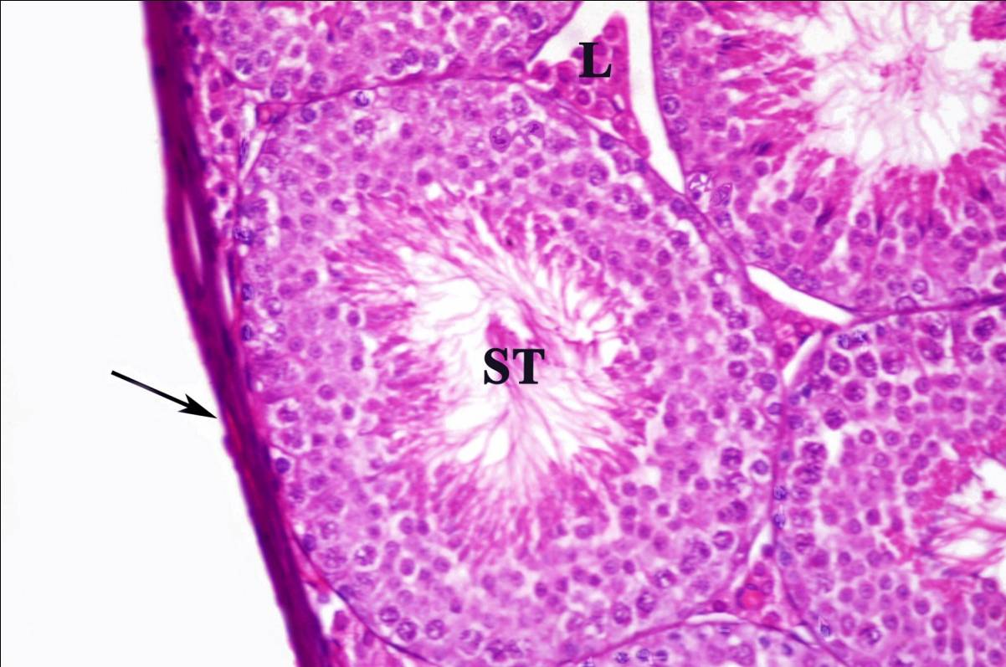  Figure (1): Photomicrograph of T.S. of the testis of control mouse showing tunica albuginea (arrow), seminiferous tubule (ST) and interstitial tissue (L). X: 400 | 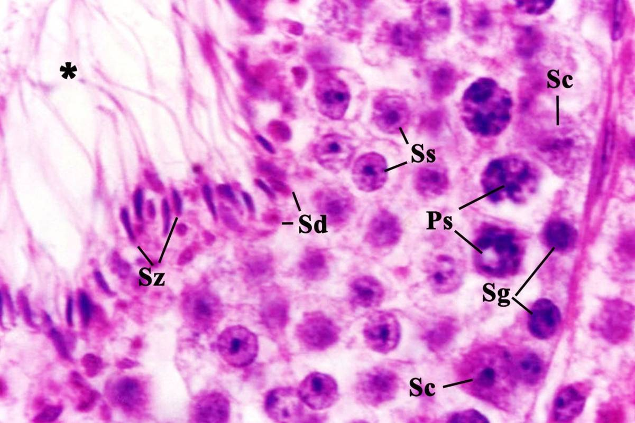  Figure (2): Photomicrograph of T.S. of enlarged portion of the testis of control mouse showing the successive stages of spermatogenesis, which include, the spermatogonia (Sg), primary spermatocytes (Ps), secondary spermatocytes (Ss), spermatids (Sd) and spermatozoa (Sz) surrounding a central lumen (*). The Sertoli cells (Sc) are attached by their bases to the basement membrane. X: 660
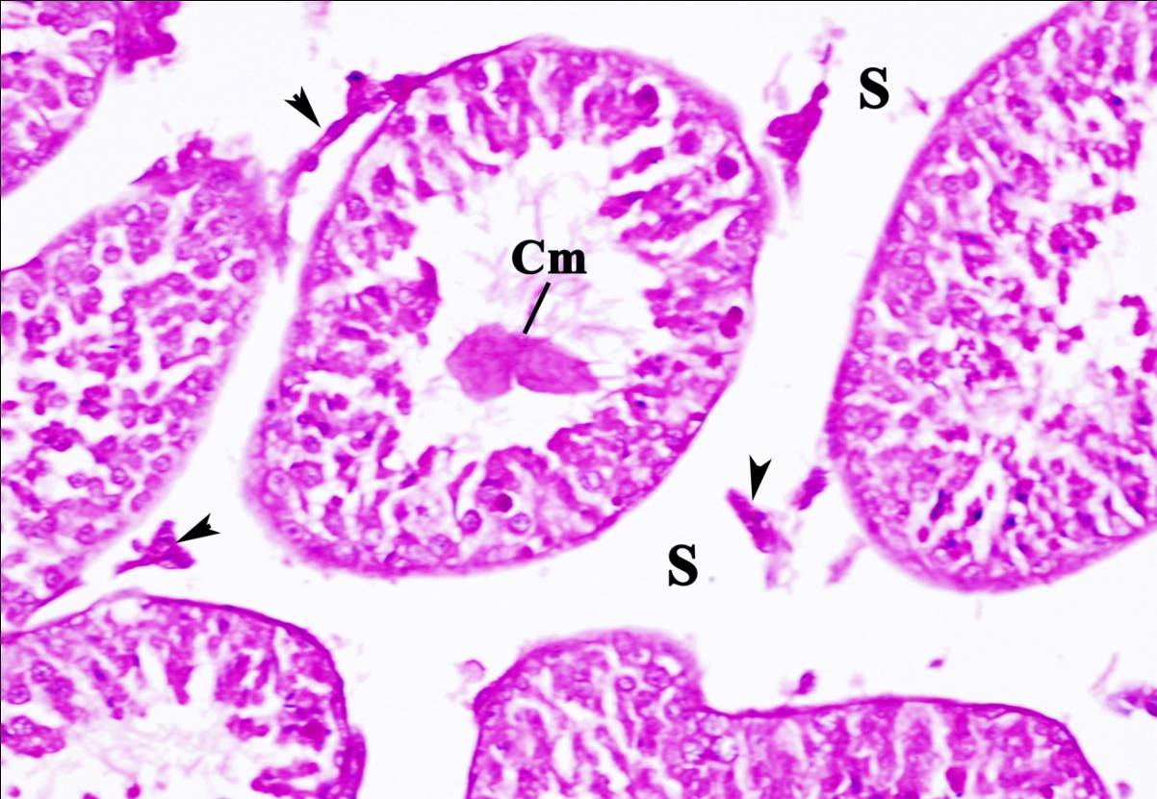  Figure (3): Photomicrograph of T.S. of the testis of mouse treated with endoxan (200µg/kg) for 2weeks showing degeneration of interstitial tissue (arrows heads), large space (S) among seminiferous tubules. Notice cytoplasmic mass (Cm). X: 400 | 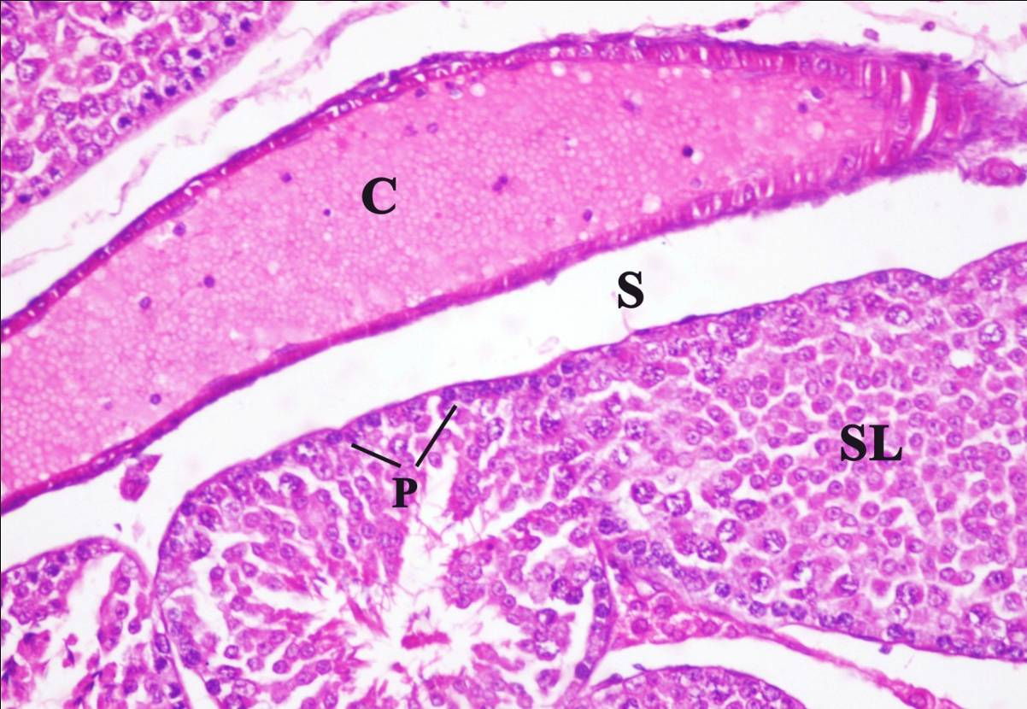  Figure (4): Photomicrograph of T.S. of the testis of mouse treated with endoxan (200µg/kg) for 2weeks illustrating seminiferous tubule with sloughing (SL) and nuclear pyknosis (P). Notice large space (S) among tubules and congestion (C) of blood vessel. X: 400
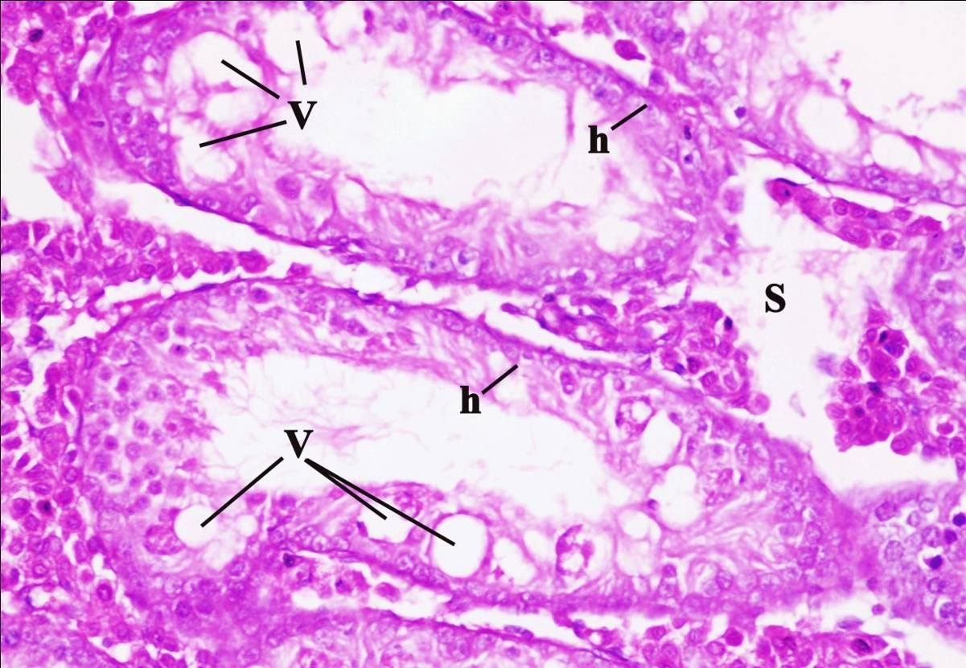  Figure (5): Photomicrograph of T.S. of the testis of mouse treated with treated with endoxan (200µg/kg) for 2weeks showing seminiferous tubules with hypoplasia (h) in its germinal epithelium, vacuoles (V). Notice large space (S) among tubules. X: 400 | 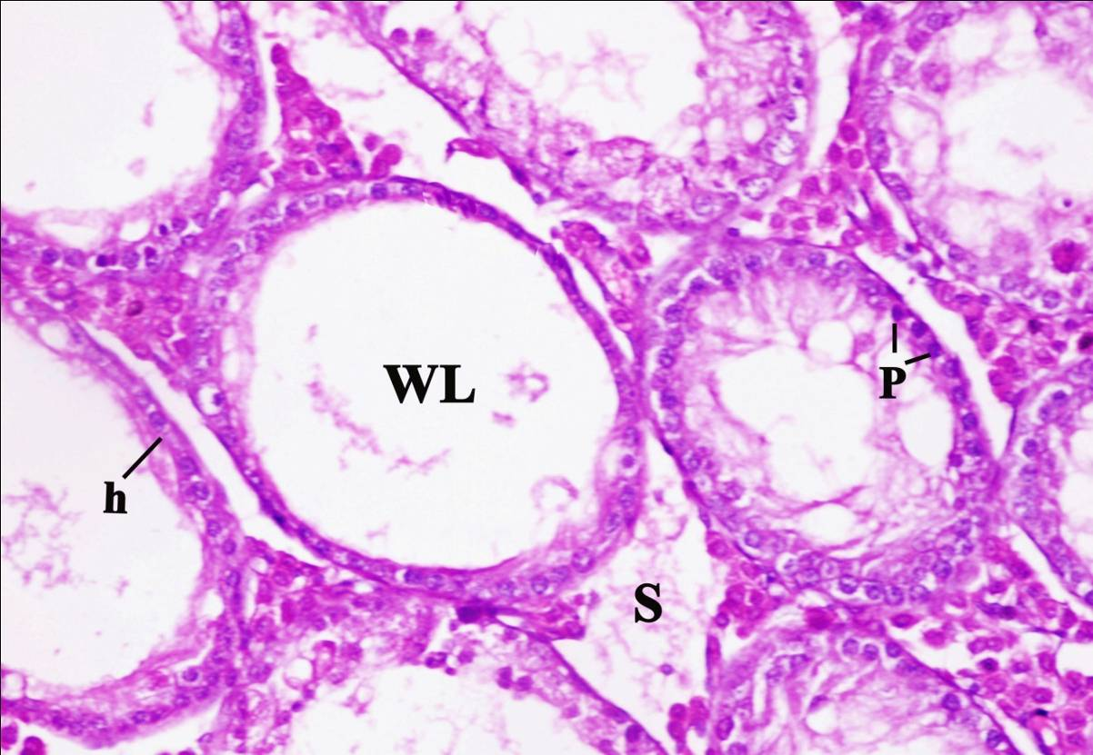  Figure (6): Photomicrograph of T.S. of the testis of mouse treated with endoxan (200µg/kg) for 4weeks showing hypoplasia (h) of germinal epithelium of seminiferous tubules with wide lumen (WL), nuclear pyknosis (P) and large space (S) among tubules. X: 400
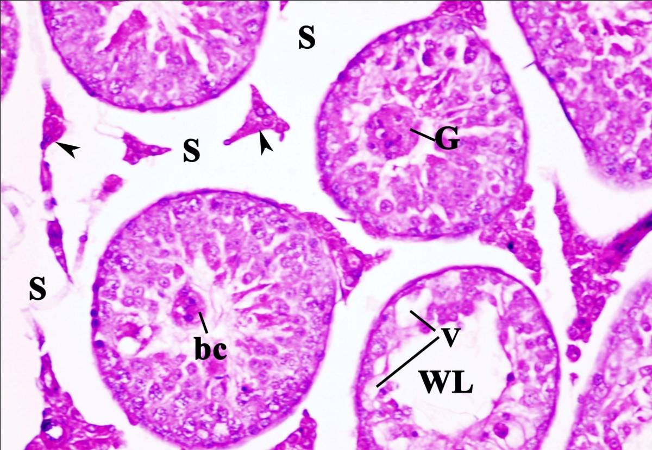  Figure (7): Photomicrograph of T.S. of the testis of mouse treated with endoxan 200µg/kg+RJ for 2weeks showing giant cell (G), binucleated cell (bc), vacuoles (V), wide lumen (WL), large spaces (S) among tubules and degeneration of interstitial tissue (arrows heads). X: 400 | 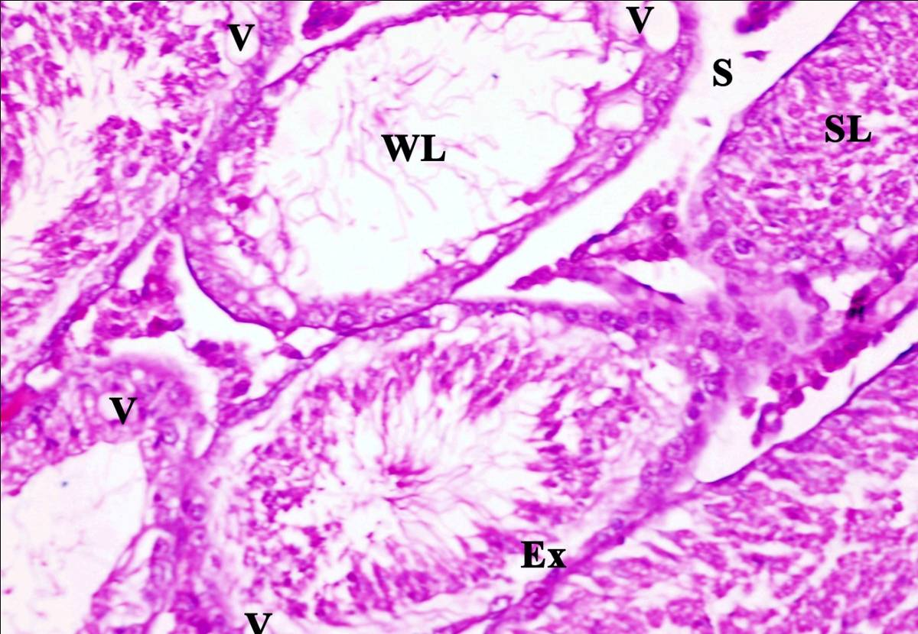  Figure (8): Photomicrograph of T.S. of the testis of mouse treated with endoxan 200µg/kg+RJ for 2weeks showing degeneration of germinal epithelium of some tubules with wide lumen (WL), exfoliated (Ex) tubule and sloughed (SL) tubule. Notice vacuoles (V) and large space (S) among tubules. X: 400
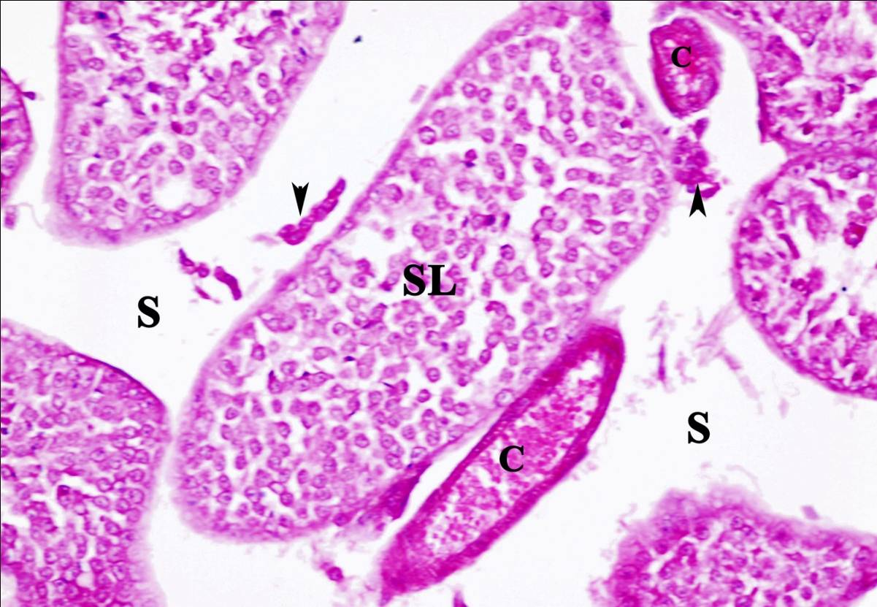  Figure (9): Photomicrograph of T.S. of the testis of mouse treated with endoxan 200µg/kg+RJ for 4weeks showing sloughed (SL) seminiferous tubules and hypoplasia of interstitial tissue (arrows heads). Notice large space (S) among tubules and congestion (C) of blood vessel. X: 400 | 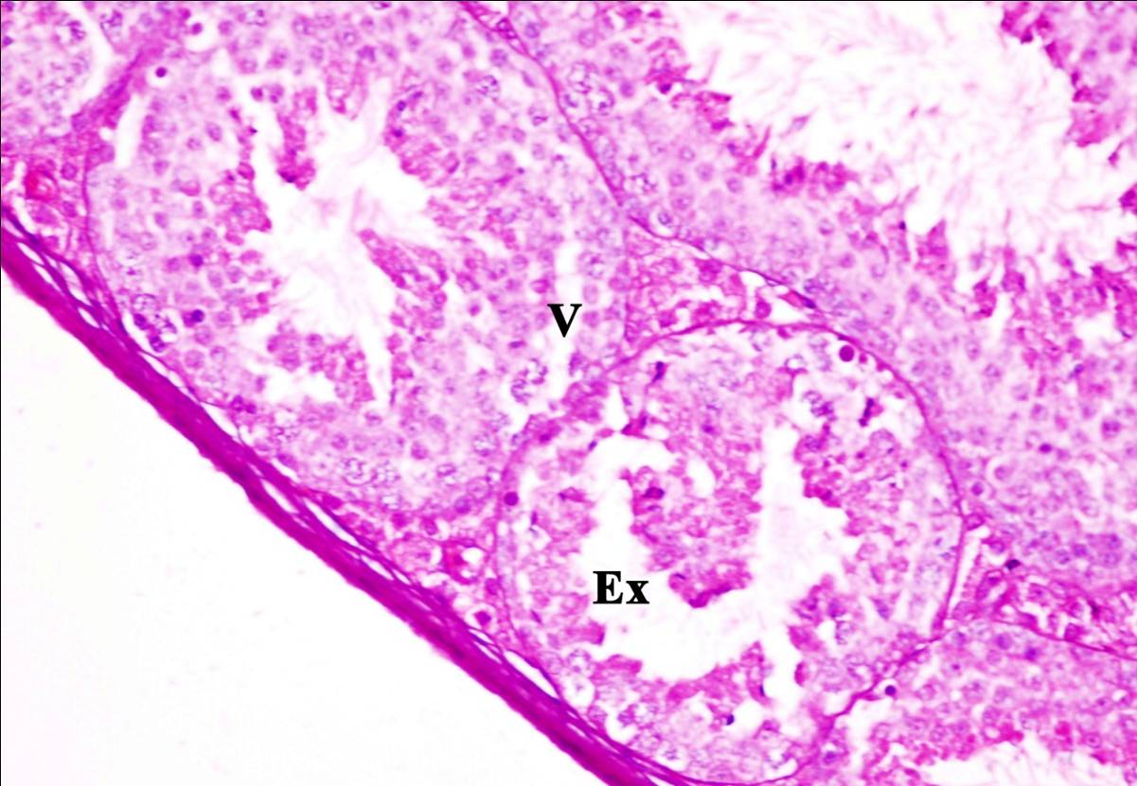  Figure (10): Photomicrograph of T.S. of the testis of mouse treated with endoxan 200µg/kg+RJ for 4weeks showing accumulation of exfoliated (Ex) germ cells within the lumen of the seminiferous tubule. Notice vacuoles (V). X: 400

Royal jelly (RJ) is a honeybee product secreted from the hypopharyngeal and mandibular glands of the worker honeybees mainly between the sixth and twelfth days of their life primarily for developing and maintaining the queen bee. RJ consists mainly of proteins, sugars, lipids, vitamins, and free amino acids (Takenaka, 1982). RJ has been shown to possess several pharmacologic activities, including vasodilative and hypotensive activities, increase in growth rate, disinfectant action, antitumor activity, anti-inflammatory, antioxidative and scavenging ability, hypoglycemic and wound healing activity, immunomodulatory, and estrogenic activity (Shimoda et al., 1978 and Sver et al., 1996).
The protective effect of royal jelly may be due to its component vitamins, antioxidant vitamins A, E, C, vitamin D and vitamin B complex (Leigh, 1999). These vitamins themselves had anticancer effect (Pour and Lawson, 1984; Liu et al., 2000; klaassen and Braakhuis, 2002; Giovannucci et al., 2006 and Zou et al., 2006) and protective effects against the genotoxicity of chemotherapy and radiotherapy (Parchure et al., 1984; Chen and Pan, 1988; Sarma and Kesavan, 1993; Antunes and Takahashi, 1998 and 1999; Tavares et al., 1998; Konopacka et al., 2002; Gulkac et al., 2004 and Kocak et al., 2004). Royal jelly also contained protein fractions (Salazar-Olivo and Paz-Gonzalez, 2005) that they had also anticancer effects.
Corresponding author
Mahmoud Fathy Mahmoud
Biological and Geological Sciences Department, Faculty of Education, Ain Shams University, Cairo, Egypt
Mahmoudfathy76@yahoo.com

References
Antunes, L.M. and Takahashi, C.S. (1998): Effects of high doses of vitamins C and E against doxorubicin-induced chromosomal damage in Wistar rat bone marrow cells. Mutat. Res., 419: 137-143.
Antunes, L.M. and Takahashi, C.S. (1999): Protection and induction of chromosomal damage by vitamin C in human lymphocyte cultures. Teratogenesis Carcinogenesis Mutagenesis, 19: 53-59.
Bincoletto, C.; Eberlin, S.; Figueiredo, C.A.; Luengo, M.B. and Queiroz, M.L. (2005): Effects produced by royal jelly on haematopoiesis: Relation with host resistance against Ehrlich ascites tumour challenge. Int. Immunopharmacol., 5: 679-688.
Ceribasi, A.O.; Turk, G.; Sonmez, M.; Sakin, F. and Atessahin, A. (2010): Toxic effect of cyclophosphamide on sperm morphology, testicular histology and blood oxidant-antioxidant balance, and protective roles of lycopene and ellagic acid. Basic & Clinical Pharmacology & Toxicology, 107: 730-736.
Chen, G. and Pan, Q.C. (1988): Potentiation of the antitumor activity of cisplatin in mice by 3-aminobenzamide and nicotinamide. Cancer Chemother. Pharmacol., 22: 303-307.
Gershwin, M.E.; Edward J. Goetzl and Steinberg, D.A. (1974): Cyclophosphamide: Use in Practice, Review. Annals of Internal Medicine, 80: 531-540.
Fontana, R.; Mendes, M.A.; De Souza, B.M.; Konno, K.; Cesar, L.M.M.; Malaspina, O. and Palma, M.S. (2004): Jelleines: a family of antimicrobial peptides from the Royal Jelly of honeybees (Apis mellifera). Peptides, 25: 919-928.
Giovannucci, E.; Liu, Y.; Rimm, E.B.; Hollis, B.W.; Fuchs, C.S.; Stampfer M.J. and Willett, W.C. (2006): Prospective study of predictors of vitamin D status and cancer incidence and mortality in men. J. Natl. Cancer Inst., 98: 451-459.
Grandis, J.R. and J.C. Sok (2004): Signaling through the epidermal growth factor receptor during the development of malignancy. Pharmacol. Ther., 102: 37-46.
Gulkac, M.D.; Akpinar, G.; Ustun H. and Kanli, A.O. (2004): Effects of vitamin A on doxorubicin-induced chromosomal aberrations in bone marrow cells of rats. Mutagenesis, 19: 231-236.
Guo, H.; Kouzuma, Y. and Yonekura, M. (2005): Isolation and properties of antioxidative peptides from watersoluble royal jelly protein hydrolysate. Food Science and Technology Research, 11: 222-230.
Kimura, M.; Kimura, Y.; Tsumura, K.; Okihara, K.; Sugimoto, H.; Yamada, H. and Yonekura, M. (2003a): 350-kDa royal jelly glycoprotein (apisin), which stimulates proliferation of human monocytes, bears the beta 1-3galactosylated N-glycan: Analysis of the N-glycosylation site. Bioscience, Biotechnology and Biochemistry, 67: 2055-2058.
Kimura, Y.; Takaku T. and Okuda H. (2003b): Antitumor and antimetastatic actions by royal jelly in Lewis lung carcinoma-bearing mice. J. Tradit. Med., 20: 195-200.
Klaassen, I. and Braakhuis, B.J. (2002): Anticancer activity and mechanism of action of retinoids in oral and pharyngeal cancer. Oral Oncol., 38: 532-542.
Kocak, N.; Ustun, H.; Gulkac, M.D.; Kanli, A.O.; Borazan, A. and Yilmaz, A. (2004): Effects of 10alpha, 25-dihydroxyvitamin D3 on doxorubicin-induced chromosomal aberrations in rat bone marrow cells. Acta Oncol., 43: 204-208.
Kohno, K.; Okamoto, I.; Sano, O.; Arai, N.; Iwaki, K.; Ikeda, M. and Kurimoto, M. (2004): Royal jelly inhibits the production of proinflammatory cytokines by activated macrophages. Bioscience Biotechnology and Biochemistry 68: 138-145.
Konopacka, M.; Palyvoda, O. and Rzeszowska-Wolny, J. (2002): Inhibitory effect of ascorbic acid post-treatment on radiation-induced chromosomal damage in human lymphocytes in vitro. Teratogenesis Carcinogenesis Mutagenesis, 22: 443-450.
Leigh, B.C. (1999): Review of bee products: Honey, pollen, propolis and royal jelly. Nutr. Sci. News, 4: 366-368.
Liu, B.; Wu, K. and Zhao, D. (2000): Inhibition of human gastric carcinoma cell growth by vitamin E succinate. Wei Sheng Yan Jiu, 29: 172-174.
Mahgoub, N.; Taylor, B.R. and Le Beau, M.M. (1999): Myeloid malignancies induced by alkylating agents in Nf1 mice. Blood, 93: 3617-3623.
Majtan, J.; Kumar, P.; Majtan, T.; Walls, A.F. and Klaudiny, J. (2010): Effect of honey and its major royal jelly protein 1 on cytokine and MMP-9 mRNA transcripts in human keratinocytes. Experimental Dermatology 19: 73-79.
Okamoto, I.; Taniguchi, Y.; Kunikata, T.; Kohno, K.; Iwaki, K.; Ikeda, M. and Kurimoto, M. (2003): Major royal jelly protein 3 modulates immune responses in vitro and in vivo. Life sciences.Pt.2: Biochemistry, general and molecular biology, 73: 2029-2045.
Paget, G.E. and Barnes, J.M. (1964): Interspecies dosage conversion schem in evaluation of results and quantitative application in different species. In: Evaluation of drug activities: Pharmacometrics, laurence, D.R. and Bacharach, A.L. (Eds), Academic press, London and New York, 1: 160-162.
Parchure, M.; Ambaye, R.Y. and Gokhale, S.V. (1984): Combination of anticancer agents with folic acid in the treatment of murine leukaemia P388. Chemotherapy, 30: 119-124.
Pour, P.M. and Lawson, T. (1984): Modification of pancreatic carcinogenesis in the hamster model. XV. Preventive effect of nicotinamide. J. Natl. Cancer Inst., 73: 767-770.
Rezvanfar, M.A.; Sadrkhanlou, R.A.; Ahmadi, A.; Shojaei-Sadee, H.; Rezvanfar, M.A.; Mohammadirad, A.; Salehnia, A. and Abdollahi, M. (2008): Protection of cyclophosphamide-induced toxicity in reproductive tract histology, sperm characteristics, and DNA damage by an herbal source; evidence for role of free-radical toxic stress. Human & Experimental Toxicology, 27: 901-910.
Romanelli, A.; Moggio, L.; Montella, R.C.; Campiglia, P.; Iannaccone, M.; Capuano, F.; Pedone, C. and Capparelli, R. (2011): Peptides from Royal Jelly: studies on the antimicrobial activity of jelleins, jelleins analogs and synergy with temporins. Journal of Peptide Science, 17: 348-352.
Sabatini, A. G.; Marcazzan, G.; Caboni, M. F.; Bogdanov, S.; Almeida-Muradian, L. B. (2009): Quality and standardisation of royal jelly. J.A.A.S., 1: 1-6.
Sabik, L.M.E. and Abd El-Rahman, S.S. (2009): Alpha-tocopherol and ginger are protective on Cyclophosphamide-induced gonadal toxicity in adult male albino rats. Basic and Applied Pathology, 2: 21-29.
Salazar-Olivo, L.A. and V. Paz-Gonzalez (2005): Screening of biological activities present in honeybee (Apis mellifera) royal jelly. Toxicol. In Vitro, 19: 645-651.
Sarma, L. and Kesavan, P.C. (1993): Protective effects of vitamins C and E against gamma-ray-induced chromosomal damage in mouse. Int. J. Radiat. Biol., 63: 759-764.
Shimkin, M.B.; Weisburger, J.H. and Weisburger, E.K. (1966): Bioassay of 29 Alkylating Chemicals by the Pulmonary-Tumor Response in Strain-A Mice. J. Natl. Cancer. Inst., 36: 915-935.
Shimoda, M.; Nakajin, S. and Oikawa, T. (1978): Biochemical studies on vasodilative factor in royal jelly. Yakugaku Zasshi., 98: 139-145.
Sver, L.; Orsolic, N. and Tadic, Z. (1996): A royal jelly as a new potential immunomodulator in rats and mice. Comp. Immunol. Microbiol. Infect. Dis., 19: 31-38.
Swellam, T.; N. Miyanaga; M. Onozawa; K. Hattori; K. Kawai; T. Shimazui and H. Akaza (2003): Antineoplastic activity of honey in an experimental bladder cancer implantation model: In vivo and in vitro studies. Int. J. Urol., 10: 213-219.
Takenaka, T. (1982): Chemical composition of royal jelly. Honeybee Sci., 3: 69-74.
Tavares, D.C.; Cecchi, A.O.; Antunes, L.M. and Takahashi, C.S. (1998): Protective effects of the amino acid glutamine and of ascorbic acid against chromosomal damage induced by doxorubicin in mammalian cells. Teratogenesis Carcinogenesis Mutagenesis, 18: 153-161.
Weisburger, J.H.; Griswold, D.P. and Prejean, J.D. (1975): The carcinogenic properties of some of the principal drugs used in clinical cancer chemotherapy. Recent Results Cancer Res., 52: 1-17.
Zou, W.; Yue, P.; Lin, N.; He, M. and Zhou, Z. (2006): Vitamin C inactivates the proteasome inhibitor PS-341 in human cancer cells. Clin. Cancer Res., 12: 273-280.

11/22/2012

