Mitigation of Excessive Drawdowns via Rotational Groundwater Withdrawal
(Case study: El Kharga Oases, Egypt)

Safaa M. Soliman

Research Institute for Groundwater, National Water Research Center, El Kanter El Khairia, Kalubia, Egypt
safaa_soliman_m@yahoo.com

Abstract: Groundwater in Egypt plays important roles in the country's water budget. One of these roles is being the sole source of water for the nomads’ communities in the Western Desert. For this role to be sustainable, careful and scientifically based plans for groundwater withdrawal should be developed. This research was initiated with the objective of mitigating the excessive drawdowns by applying rotational groundwater withdrawal. El Kharga Oases was chosen to be studied because it mainly depends on groundwater as the primary source for water and are suffering from continuous increase in groundwater drawdowns due the excessive groundwater withdrawal, so it was necessary to study the aquifer of El Kharga Oases to find a solution to this problem that is accepted from stakeholders.

In this study a numerical groundwater model was constructed to evaluate the effect of switching to rotational groundwater withdrawal on mitigating excessive drawdowns. In this regard, a MODFLOW package Visual MODFLOW 4.2 was utilized to simulate the proposed rotational withdrawal policy. The model was calibrated for steady state flow conditions with acceptable accuracy; the calibrated model has been run under the rotational withdrawal policy for 3 years to predict the rate of change in groundwater drawdowns. The results show sustainable recovery of groundwater levels throughout the prediction run period.
[Safaa M. Soliman. Mitigation of Excessive Drawdowns via Rotational Groundwater Withdrawal (Case study: El Kharga Oases, Egypt). N Y Sci J 2013; 6(1):118-123]. (ISSN: 1554-0200). http://www.sciencepub.net/newyork. 18

Key word: El Kharga, groundwater, drawdowns, sustainability

1. Introduction
The Western Desert encompasses a number of oases that have been mainly inhabited by nomads. The environment of the oases is characterized by land marks constituting of springs around which nomads could survive on scattered agricultural plots. The investigated area lies in the central part of the Western Desert as shown in figure 1. El Kharga extends roughly north-south parallel to the Nile Valley. It is located 140 km to the east of El-Dakhla Oasis and 220 km south of Assiut City. It is bounded by long. 30° 20´ and 30° 40` E and lat. 25° 05` and 25° 30` N (CONOCO, 1987).
El-Kharga depression has the same climatic characteristics of the Western Desert. It has an arid climate; mostly rainless with an annual intensity rainfall of 2.35 mm. The maximum air temperature reaches 40.2 °C in June, while the minimum attains 5.8 °C in January, with average evaporation rate of 413.66 mm/month.
The geology and hydrogeology framework of El Kharga Oases was described in early puplications by Shata (1961), Awad and Ghobrial (1965), Ghobrial (1967), Hermina (1967), Himida (1968), El-Kiki et al (1972), Ezzat (1974), El-Hinnawi (1976), Barthel et al (1978) and Diab (1978). The Nubian Sandstone aquifer in El Kharga Oases belongs to Lower Cretaceous and mainly consist of coarse to medium sands with high permeability (Figure 2). This permeability varied from one area to another depending on the deposition conditions and also by intercalations of silts. The Nubian Sandstone thickness reaches a minimum value in the southern part of the study area and is gradually increasing to the north. The basement rocks appear at the surface in the south and at a depth up to 1100 meters in the north. This aquifer system overlies the Pre-Cambrian basement Complex, thus, ranging in age from Cambrian to the Pre-Upper Cenomanian.
El Kharga Oases has one of the longest continuous records of human use of groundwater in the world. Groundwater in El-Kharga Oases is considered the sole source for water used mainly for irrigation and other purposes. Groundwater in the Kharga is withdrawn from springs as well as shallow and deep artesian wells. Till the 1959, nearly, all the wells were originally flowing. However, with the exploitation of groundwater from deep wells for irrigation, the natural flows declined as more and more closely spaced deep wells were drilled. By the 1975 many deep wells had ceased to flow. The water demand in the area has been met by pumping from both shallow and deep wells. The general direction of groundwater flow is from all the sides to the centre of El Kharga Oases. Intensive groundwater development for irrigation purpose in the Oases started in 1960 with an extraction rate of 51 million m³/year, from naturally flowing 279 shallow wells and springs and 12 deep wells. Extraction was progressively increased to reach about 101 million m³/year in 1963, and then decreased to an average rate of 87 million m³/year during the period 1965-1978. Since 1979, groundwater extraction in the oases started to increase again till it reached an annual rate of 118 million m³/year in 1998 (from 192 deep wells and 16 springs), of which 97% is exploited by pumping (Figure 3).
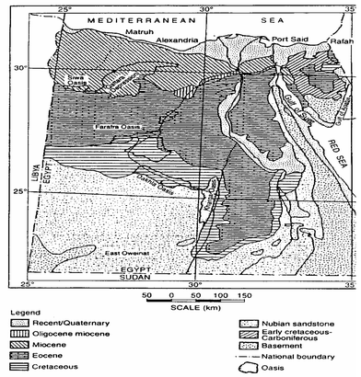
Figure 2: Geological Map of Egypt (modified after RIGW 1999)
El Kharga
Figure 1: General Location map of the study area

Groundwater monitoring of a reasonable number of observation wells, was practiced in the Kharga Oasis compared to other development areas in the Western Desert of Egypt. Monitoring records indicate that during the last 40 years, the water levels have been affected by extraction. Two groundwater depressions are created in the northern part of the oasis around Al Kharga–Malaa extraction zone with a maximum drop in water level of 60 m, and in the surrounding of Bulaq-Garmashin Zone with a maximum drop in the water level of 35 m during the same period. The oases are suffering from continuous increase in groundwater drawdowns due to intensive groundwater withdrawal; so, in this work a numerical groundwater model was constructed to evaluate the effect of switching to rotational groundwater withdrawal on mitigating excessive drawdowns.

Figure 3: Detailed Map of the Study Area

2. Numerical Simulation
To study the groundwater situation of the study area a numerical model is used to represent the region and examine the proposed rotational withdrawal operation policy.

2.1 Modeling Package
To simulate the groundwater flow in the study area a three-dimensional groundwater flow package was used. The used package (Visual Modflow 4.2) is a three-dimensional groundwater flow and contaminant transport model based on the finite difference method with rectangular cells. The model is capable to handle the saturated and unsaturated flow with homogeneous, heterogeneous, isotropic, and anisotropic aquifer system under steady state and transient conditions. The model has the capability to link with GIS system and ARCVIEW software. This fully integrated package combines MODFLOW, MODPATH, MT3D, MT3DMS, RT3D, PESST and SEAWAT with the most intuitive and powerful graphical interface available. The model grid input parameters and results can be visualized in cross-section or plan view at any time during the development of the model or while displaying the results (Anderson and Woessner, 1992; Engesgaard P. and. Kipp K.L.1992).

2.2 Modeling Grid and Boundaries
The model covers an area of about 47600 km². The aquifer west boundary is considered general head boundary, based on the nearest constant head contour (100-120 m) above mean Sea level, depending on the groundwater levels of study area wells. The other boundaries are no flow boundaries perpendicular on groundwater contour lines. The model grid consists of 4186 cells; relatively small cells were used in the significant areas, the model grid and boundaries are shown in figure 4.

2.3 Model Input
The main input data include:
- The ground surface elevation that ranges between zero and 400 above mean Sea level (Figure 5).

- The base of the aquifer that ranges between -200 and 1300 m below mean Sea level. The aquifer was simulated as three hydraulically connected zones, because all wells pump from second and third zones, base levels of zone 2 and zone 3 as shown in figures 6 and 7 respectively.

- The hydraulic conductivity of the aquifer has been measured by pumping test in some locations, and it varies from 1-3 m/day.

- The rate of extraction (about 118 million m³/year).
NO-FLOW BOUNDARY
Generl Head boundary of head (100-120 m.a.m.s.l)
Figure 4: Model Grid and Boundaries

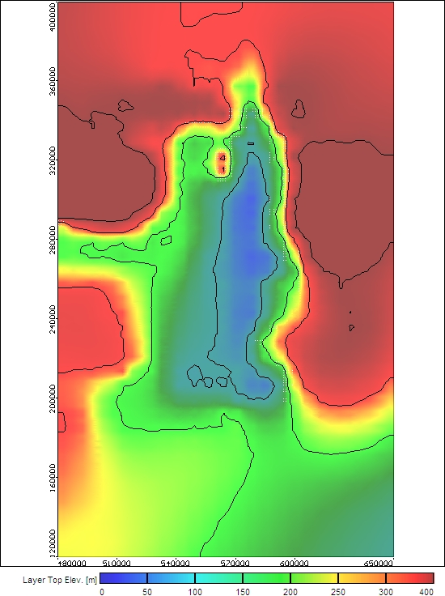
Figure 5: Topographic Contour Map

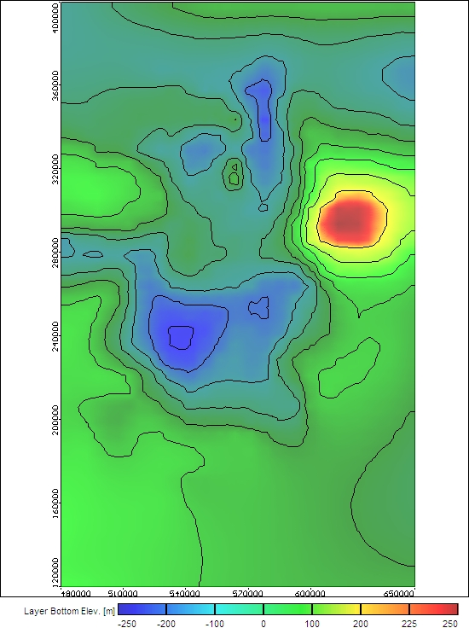
Figure 6: Base Level Contour Map of Zone2

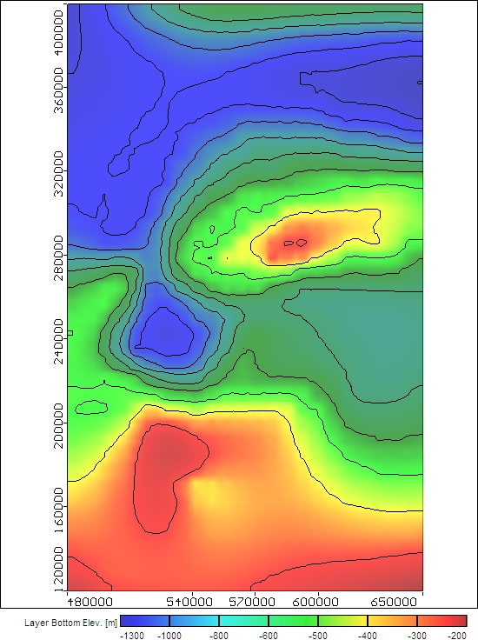
Figure 7: Base Level Contour Map of Zone3

2.4 Calibration
Before the model can perform its tasks in predicting the response of the system to any future activities, it must be calibrated. To use the model in testing the impact of the proposed operation policy, the model calibration was achieved using available hydrogeological data. The model was calibrated for steady state flow conditions. The obtained results were with acceptable accuracy, figure 8. During the calibration process, various inputs were adjusted, especially the hydraulic parameters (i.e. hydraulic conductivity, specific storage or specific yield distribution), taking into consideration available results of aquifer tests, geological studies and geophysical logs. Figure 9 shows the calibrated groundwater head of the study area.

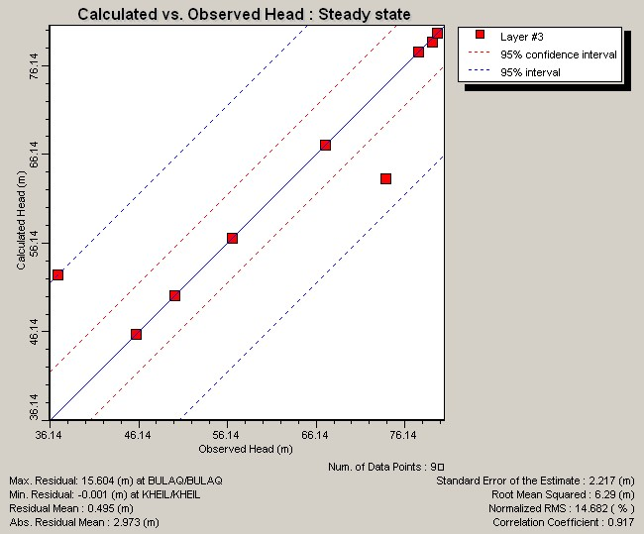
Figure 8: Results of the Steady State Calibration
Observation Wells

3. Proposed Operation Policy
Figure 10: Difference in Drawdown Contour Map of Zone 2
The aim of using the simulation model is to predict the behavior of the aquifer under the influence of proposed future activities and operation policies. Confident with the calibration process, a rotational groundwater withdrawal policy was applied on the calibrated model. The proposed policy was to switch the withdrawal into a rotational withdrawal. In the applied policy, the pumping wells were divided into two groups, each group was`operated alternatingly for half a day and the other group was operated the second half of the day. The calibrated model was run under the effect of switching to rotational groundwater withdrawal for 3 years to predict the rate of change in groundwater drawdowns. The effect of rotational withdrawal on mitigating excessive drawdowns is measured in terms of achieved reduction of groundwater drawdowns due to switching from continuous to rotational withdrawal.
The results of applying the proposed rotational groundwater withdrawal policy on the pumping wells are shown in figures 10 and 11. They indicated that the reduction in groundwater drawdowns varied between 1 and 9 m for the second zone and ranged between 1 and 8.5 m for the third zone.

Figure 11: Difference in Drawdown Contour Map of Zone 3
Figure 9: Calibrated Groundwater Head Map

4. Conclusions and Recommendations
In this study a numerical groundwater model was constructed to evaluate the effect of switching to rotational groundwater withdrawal on mitigating excessive drawdowns. In this regard, a MODFLOW package Visual MODFLOW 4.2 was utilized to simulate the proposed rotational withdrawal policy.
The model was calibrated for steady state flow conditions and acceptable accuracy was achieved. The calibrated model was run under the rotational withdrawal policy for 3 years to predict the rate of change in groundwater drawdowns. The obtained results were analyzed. Consequently, conclusions were deduced. These were:
- Rotational withdrawal is a good policy to be adapted.
- The groundwater levels indicated a sustainable recovery throughout the prediction run period.

According to the achieved results, it is recommended to explore the potential of mitigating excessive drawdowns in the groundwater development areas through operating pumping wells on rotational withdrawal basis.

Corresponding author
Safaa M. Soliman
Research Institute for Groundwater, National Water Research Center, El Kanter El Khairia, Kalubia, Egypt.
safaa_soliman_m@yahoo.com

References
- Anderson, M.P. and Woessner, W.W. (1992): Applied Groundwater Modeling: Simulation of Flow and Advective Transport. Academic Press Inc. San Diego, CA. 381 pp.
- Awad, G. H. and Ghobrial, M. G. (1965): Zonal stratighraphy of Kharga Oasis: Gen. Organ. For Research and Mining. Paper No. 34, 77p.
- Barthel K. W. and Boettcher R (1978): Abu Ballas Formation (Tithonian/Berriasian; Southwestern Desert Egypt) a significant lithostratigraphic unit of the former "Nubian Series" Mitteilungen der Bayerischen Staatssammlung fur Palaontologic und historische Geologie: Vol. 18, pp. 153-166.
- Continental Oil Company (CONOCO) (1987): Geological map of Egypt (scale 1:500,000).
- Diab, M. Sh. (1978): A regional hydrogeological study of artesian water aquifer in the Western Desert of Egypt: Symposium on the geology of Middle East, Anqara, Turkia.
- El-Hinnawi, M.S (1976): Geology of Abu Bayan Bolaq stretch, Western Desert: M. Sc. Thesis, Cairo Unvi., Cairo, 103 p.
- El-Kiki, F.E. and Badawi (1972): "Contribution to the hydrochemical characteristics of water bearing horizons in Kharga Oasis" Rend Berber Geol. Soc.,
- Engesgaard, P., and K.L.Kipp, (1992): A geochemical transport model for redox-controlled movement of mineral fronts in groundwater flow systems: A case of nitrate removal by oxidation of pyrite. Water Resour. Res. ,28:2829-2843.
- Ezzat, M. A. (1974): Groundwater Series in the Arab Republic of Egypt Exploitation of groundwater in El-Wadi El-Gedid project area: General Desert Development Authority, Ministry of Irrigation, Cairo, 149 p.
- Ghobrial, M.G. (1967): The structural geology of Kharga Oasis, Egypt Geol. Survey paper no. 43, 39 p.
- Hermina, M.H. (1967): Geology of the North-Western approach of Kharga, Egyptian: Geol. Survey, Cairo, paper No. pp 44-88.
- Himida, I.H. (1968): Aquantitative study of the artesian water exploitation resources in Kharga and Dakhla Oases, Western Desert of Egypt
- RIGW, (1999): Hydrogeological Map of Egypt
- Shata, A. (1961): Remarks on the geological structure of the groundwater reservoir at El-Kharga and Dakhla Oases (Western Desert of Egypt): Bull. Soc. Geograph. Egypte, Vol. 34, 165 p.

