A Case study of Convex Optimization with Nonlinear Programming

Sachin Kumar Agrawal¹, Navneet Rohela² , Mayank Pawar³

^{1,2}Moradabad Institute of Technology, Moradabad
³Teerthanker Mahaveer University, Moradabad

Abstract: In this paper we can say that nonlinear programming the objective function and constraints are not linear and in convex programming the objective functions admissible set are convex. Convex optimization problems are far more general than linear programming problems, but they share the desirable properties of LP problems: They can be solved quickly and reliably up to very large size up to hundreds of thousands of variables and constraints.
[Sachin Kumar Agrawal, Navneet Rohela, Mayank Pawar.. A Case study of Convex Optimization with Nonlinear Programming. N Y Sci J 2013;6(2):15-16]. (ISSN: 1554-0200). http://www.sciencepub.net/newyork. 3

Keywords: case study; Convex Optimization; Nonlinear

Introduction
Operations research analysts, engineers, managers, and planners are traditionally confronted by problems that need solving. The problems may involve arriving at an optimal design, allocating scarce resources, planning industrial operations, or finding the trajectory of a rocket. One of the principal areas and probably the most developed aspect of operation research is mathematical programming. It is a technique for determining the value of the set of decision. Variables that optimize a mathematical objective function and conform to a given set of mathematical constraints and is of great importance for the practical professions of engineering, economics, etc. The optimum seeking methods are also known as mathematical programming techniques and generally studied as a part of operations research. Operations research is a branch of mathematics concerned with the application to scientific methods and techniques to decision making problems and with establishing the best optimal solutions. The existence of optimization method can be traced to the days of Newton, Lagrange and Cauchy.
In this study we can use the convex optimization, at least conceptually, very much like using least squares or linear programming. If we can formulate a problem as a convex optimization problem, then we can solve it eﬃciently, just as we can solve a least-squares problem eﬃciently. With only a bit of exaggeration, we can say that, if you formulate a practical problem as a convex optimization problem, then you have solved the original problem. [1]
There are also some important deference’s. Recognizing a least-squares problem is straightforward, but recognizing a convex function can be diﬃcult. [3, 4] In addition, there are many more tricks for transforming convex problems than for transforming linear programs. Recognizing convex optimization problems, or those that can be transformed to convex optimization problems, can therefore be challenging. The main goal of this book is to give the reader the background needed to do this. Once the skill of recognizing or formulating convex optimization problems is developed, you will ﬁnd that surprisingly many problems can be solved via convex optimization.
The challenge, and art, in using convex optimization is in recognizing and formulating the problem. Once this formulation is done, solving the problem is, like least-squares or linear programming, (almost) technology. [1]
Nonlinear optimization
Nonlinear optimization (or nonlinear programming) is the term used to describe an optimization problem when the objective or constraint functions are not linear, but not known to be convex. Sadly, there are no eﬀective methods for solving the general nonlinear programming problem. Even simple looking problems with as few as ten variables can be extremely challenging, [2] while problems with a few hundreds of variables can be intractable. Methods for the general nonlinear programming problem therefore take several diﬀerent approaches, each of which involves some compromise. [4]
Consider the following non-linear programming problem
(P) Minimize f(x)
subject to
where f and , j = 1, 2, …, m are real valued functions defined on . Let denote the set of feasible solutions, which is also called the constraint set.
Since 1951, there has been tremendous growth in the field of non-linear programming problems. There is no single method which gives accurate solution of a non-linear programming problem. Some of the well known algorithms used in such situations are Golden section method, Fibonacci search method and conjugate gradient method discussed by Avriel [6]. Many of the non-linear programming problems have been successfully studied by linearizing the function and finding solutions to the corresponding linear programming problems.
Local optimization
In local optimization, the compromise is to give up seeking the optimal x, which minimizes the objective over all feasible points. Instead we seek a point that is only locally optimal, which means that it minimizes the objective function among feasible points that are near it, but is not guaranteed to have a lower objective value than all other feasible points. A large fraction of the research on general nonlinear programming has focused on methods for local optimization, which as a consequence are well developed.[1]
The Study of Interior Point Method for Optimization Problem
The interior - point methods (IPMs) are best suited to solve many convex optimization problems especially with linear constraints. Thus, the SOR is solved using IPMs. In the past two decades the development of IPMs has had a profound impact on the optimization theory and practice. [5]
LOCAL vs. GLOBAL OPTIMUM
Geometrically, nonlinear programs can behave much differently from linear programs, even for problems with linear constraints. As shows, the optimal solution can occur:
a) at an interior point of the feasible region;
b) on the boundary of the feasible region, which is not an extreme point; or
c) at an extreme point of the feasible region.
As a consequence, procedures, such as the simplex method, that search only extreme points may not determine an optimal solution.

Conclusion
In this paper we study the convex programming is the non linear Optimization problem can be defined as the process of finding the conditions that give the maximum or minimum value of a function. Optimization, in its broadest sense, can be applied to solve any engineering problem.

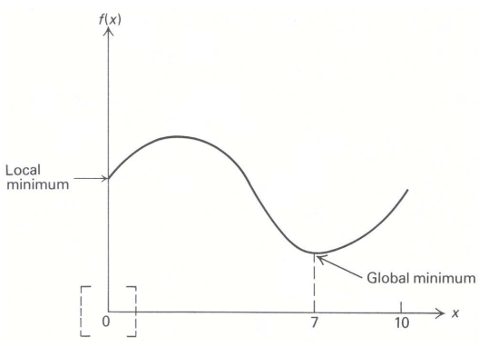
Figure (a): Local or Global Optimum

References
- Stephen Boyd and Lieven Vandenberghe, “ Convex Optimization”, cambridge university press.
- M.P. Bendsøe, A. Ben-Tal and J. Zowe, “Optimization methods for truss geometry and topology design,” Structural Optimization, vol. 7, pp. 141–159, 1994.
- A.V. Fiacco and G.P. McCormick, “Nonlinear Programming: Sequential Unconstrainted Minimization Techniques,” Research Analysis Corporation, McLean Virginia, 1968 (Republished in 1990 by SIAM, Philadelphia).
- J. M. Borwein and A. S. Lewis. Convex Analysis and Nonlinear Optimization. Springer, 2000.
- Goran Lesaja And Verlynda N. Slaughter, Interior-Point Algorithms For A Class Of Convex Optimization Problems, Yugoslav Journal Of Operations Research Volume 19 (2009) Number 2, 239-248.
- M. Avriel Non-linear Programming: Analysis and Methods, Prentice Hall, Inc, Englewood Cliffs, New Jersey 1976,

12/18/2012

