Kinetic Studies Of Wastewater Treatment From Rubber Factory Using Snail Shell

^{1⃰}Jatto, Ejeomo.Osazuwa. Asia, Imohimi.Ohioma. Egharevba, Felix. Odia, Ariaburie

Department of Chemistry, Ambrose Alli University, P.M.B 14, Ekpoma, Nigeria.
ejey2010@gmail.com

ABSTRACT: The kinetics studies of the treatment of wastewater from rubber industry, shows that the treatment fit the pseudo-second order kinetic model, as compared to the other two kinetic models (Pseudo-first order or Lagergrien kinetic and intraparticle diffusions model) studied, since the correlation coefficient (R²) values of most parameters were ≥ 0.99. Moreover, the food composition (Nitrogen free extract, protein, fibre, fat and ash content), the mineral compositions (Fe, Mn, Zn and Cu ) as well as the surface area and pH were analysed for the four species of snail shell ( Archatina archatia, Archtina marginata, Achatina fulica and limucularia species ). In addition, the physicochemical properties (pH, temperature, alkalinity, turbidity, total solids, suspended solids, dissolved solids, dissolved oxygen, biochemical oxygen demand, chemical oxygen demand, electrical conductivity, and phosphate, Nitrate-Nitrogen, Sulphate, Pb, Cd and Hg) were analysed for wastewater from rubber industry. The data derived from the physicochemical properties were treated with three kinetic models (Pseudo-first order- Lagergrien, Psuedo-second order and intraparticle diffusion). From the kinetic models, the results show that for the wastewater from the rubber industry, the correlation coefficient (R²) of the pseudo-second order was approximately 1, indicating that the treatment fit the pseudo-second order kinetics.
[Jatto, Ejeomo.Osazuwa. Asia, Imohimi.Ohioma. Egharevba, Felix. Odia, Ariaburie. Kinetic Studies Of Wastewater Treatment From Rubber Factory Using Snail Shell. N Y Sci J 2013;6(2):25-33]. (ISSN: 1554-0200). http://www.sciencepub.net/newyork. 5

KEYWORDS: Rubber, snail shell, kinetics, pseudo-second order.

INTRODUCTION
Many methods are available for the treatment of wastewater.
Biosorption, a process whereby certain types of inactive dead biomass (such as snail shell, peat, rice husk, fruit peels etc.) may bind and concentrate heavy metals from aqueous solution is considered as an alternative technology for the removal of these heavy metals and other pollutants from wastewater and industrial effluents, Naja et al (2003), Volesky (1990). Biosorption technology is advantageous due to the cost effectiveness of biosorbent (biomass) since they are derived from cheap sources.
A range of adsorbents had been examined, such as clay, charcoal, cassava waste etc.
In general, there are various technological methods existing for the treatment of wastewater, such methods include, chemical precipitation, ion exchange, adsorption, membrane processes, supercritical fluid extraction, bioremediation and oxidation with oxidizing agent Asia and Oladoja (2003). However, most of these technologies are either extremely expensive or too inefficient in the treatment of water and wastewater.
Efficient and environment friendly methods are
thus needed to be developed. It is observed that adsorption among other methods is a cost effective technique and simple to operate.
Adsorption involves the accumulation of substances on the surface of a solid or liquid. The Surface area of the adsorbent plays an important role. The larger the surface area the greater the extent of adsorption.
Adsorption is of two types, which are physical, or van der waal’s adsorption and chemical or activated adsorption or chemisorptions, Negi and Anad, (2007).
It is also important to study the rate at which this adsorption process can take place. This is possible by studying the kinetics at which there will be efficient treatment as regard adsorption.
KINETICS OF ADSORPTION: In adsorption, kinetic study is very important; this is to know the detail about the performance and mechanism of the adsorption. The solute uptake rate which determines the residence time required for the completion of adsorption can be obtained from kinetic analysis Qiu., et al( 2009).
Adsorption kinetics is the base to determine the performance of fixed bed or any flow-through systems. Several mathematical models have been proposed to describe adsorption data, these models can be classified as adsorption reaction models and adsorption diffusion models. Both models are used to describe the kinetic process of adsorption.
These models are however different naturally. Adsorption diffusion models are always constructed on the basis of the following three consecutive steps Lazaridis and Asouhidou, (2003):
- Diffusion across the liquid film surrounding the adsorbent particles, i.e., external diffusion or film diffusion; (2) diffusion of the liquid contained in the pores and/or along the pore walls which is so-called internal diffusion or intra-particle diffusion; and (3) adsorption and desorption between the adsorbate and active sites, i.e., mass action.
Adsorption reaction models originating from chemical reaction kinetics are based on the whole process of adsorption without considering the steps mentioned above.
Presently adsorption reaction models have been widely developed to describe kinetic process of adsorption Banart et al (2003); Sun and Yang., (2003); Aksu and Kabasakal (2003).
Three kinetic models, that is Lagergran first- order, pseudo-second order and intraparticle diffusion equations were considered to interpret the time dependent of the experimental data.
The Lagergren first- order equation is given as log ($q_{e}−q_{t}$) = log$q_{e}$-$\frac{k_{p1}}{2\text{.}\text{303}}t$----- (1) Lagergren (1898). Where $q_{e}$and $q_{t}$(mg/g) are the adsorption capacity at equilibrium and time t (min), respectively. $kp^{1}$(min⁻¹) is the pseudo-first order rate constant for the kinetic model.
Pseudo-second order kinetic model equations Ho and Mckay (1998) is giving as $\frac{t}{q_{t}}=\frac{1}{v_{o}}+\frac{1}{q_{e}}t$-----(2) and $v_{o}={\text{kp}q_{e}^{2}}_{}$where $v_{o}$ (mg/g.min) means the initial adsorption rate and the constant can be determine experimentally by plotting $\frac{t}{q_{t}}$ against $t$.
The intraparticle diffusion model equations Chien and Clayton (1980) is given as $q_{t}=k_{\text{int}}$t^{½} ----- (3), where $k_{\text{int}}$ is the intraparticle diffusion rate constant.
According to the above equation a plot of qt vs t^{½} should be a straight line with a slope $k_{\text{int}}$ when the intraparticle diffusion is the rate limiting step.
Due to its particular significant in adsorbent evaluations and applications, adsorption kinetic studies still attract considerable interest today, more deliberate and complicated models will be proposed on the basis of adsorption mechanism and diffusion analysis.
Contrast to the study of adsorption using activated carbon and different agricultural and animal by products the study of snail shell as an adsorbent is scarce, and the kinetic study of the treatment using this animal product is new. The only close information is on the use of chitosan in the treatment of wastewater
Snail shell is one of the most astonishing wonders of evolutions in all of the animal kingdom. The name snail though applies to all gastropods; it commonly means only those species with an external shell large enough that the soft part can withdraw into. This hard and fleshless shell protects the visceral hump that is, the soft and flexible body which is absent of skeleton both internal and external. The shell is not however permanently attached to the body of the snail.
The snail belongs to the phylum Mollusk and class Gastropods. The gastropods are the largest class of the phylum Mollusk Brunt et al , (1999), a group of animals commonly known as snails and slugs.
The snail’s soft body consists of a head, a foot, and a visceral mass or lump, which remains permanently inside a hard protective shell Poppe et al (2006). Gastropods have worldwide distributions from near Arctic and Antarctic zone to the tropics. They are found predominately in West Africa.
The shell of the large land snail is brownish yellow in colour with dark markings and is up to 10cm or more in length, it is very hard. Snail shell has several important uses, which results from the hard nature of the shell. The shell protects the snail from physical damage, predators and dehydration.
Recent development involves its application in the treatment of water and wastewater resulting from its chemical composition and large surface area; this composition includes proteins, carbohydrates, fats, and minerals such as iron, zinc, copper, etc.Botkin and Edward, (1988).
The shell is made up of protein known as the concholin which is related to keratin found in hair or tortoise and dentin found in teeth.
The main shell layer which consist of a hard mineral aragonite (CaCO₃) is mechanically very hard and is very susceptible to chemical corrosion, on the other hand the skin shell though mechanically weak is quite unsusceptible to chemical corrosion and hence protect the shell layer below.
In contrary to those two shell layers produced in the apertural layer of the shell, there is another which is made all over the pallium (mantle) on the inside of the shell. This shell matter is responsible for the thickening of the shell wall. This consists mainly of amorphous calcium carbonate materials.

MATERIALS AND METHODS
COLLECTION OF SNAIL SHELL: Four different species of snail shell were collected from the environment within Ekpoma. The shells were washed with hot water to remove sand and dirt, it was then sun dried.
ANALYSIS OF SNAIL SHELL: The snail shells were homogenized to fine powder, and sieved using a sieve of 0.5μm pore size to obtain a fine powder. Stability test was carried out on the snail shell powder to know the pH at which the snail shell will dissolve in acid or alkali medium; this was done by preparing acid solution using CH₃COOH and alkali solution using NaOH.
Analyses carried out on snail shell are:
protein estimation was done by the determination of total nitrogen using the micro Kjeldahl procedure, hence the amount of protein is obtained by multiplying the nitrogen content by 6.25 (a constant factor), this factor is based on the assumption that all feed protein contain 16% nitrogen and that all the nitrogen in the tissue is present as protein.
Ash content was determined using the method described by Pearson (1976).
The crude fat was estimated by extraction with petroleum ether using soxhlet apparatus.
Nitrogen free extract was not determine directly but was obtained as difference between 100 percent and the sum of% ash, protein crude fat and crude fibre. N.F.E = 100- (%ash + %crude fibre + %crude fat + %crude protein).
The crude fibre was determined by removing the fat from or defatting the sample by boiling the sample with tetraoxosulphate (VI) acid and sodium hydroxide repeatedly.
Heavy metals were determined using atomic absorption spectrophotometer (AAS).

WASTEWATER SAMPLE COLLECTION
The wastewater sample used for this study was collected from the discharge unit of rubber processing factory.
SAMPLING TECHNIQUE
Grab sampling method was the mode of collecting the wastewater for this study and all analysis were done in triplicate to ensure representative and reproducible results. The can for the collection of wastewater was properly washed using distilled water, it was allowed to dry and some quantity of Manganeous sulphate salt was poured into the container for collection, this was to fix the dissolved oxygen, since its determination was not carried out on site during collection.
ANALYSIS OF WASTEWATER
pH and temperature were determine on site and the wastewater was preserved at a temperature of 4⁰C for more analysis.
Analysis of the sample was done immediately as describe in the standard methods for the examination of water and wastewater APHA (1995), and standard methods for water and effluent analysis Ademoroti (1996).
Where analysis was not immediately possible, the wastewater was preserved in a refrigerator maintained at 4⁰C, at this temperature, bacteria are inactive and biodegradation is inhibited Ademoroti (1996).

KINETIC STUDY EXPERIMENT
Glass wool was placed at the bottom of a column and was packed with 50g of snail shell, 100ml of the wastewater was introduced into the column with the aid of a dropping funnel, this was allowed to stay for a maximum of three months, sample was withdrawn for analysis at every 24 hrs for the first one week, every three days for the second week and third week and every week for three months. Physicochemical parameters of the treated wastewater were determined.

RESULTS AND DISCUSSION
The pH value of snail shell in solution is 8.84, which shows that its solution is alkaline, which may results from the presence of Calcium carbonate and protein as some of the composition of the shell Aboua (1995).
It was easy to homogenise the snail shell into fine powder, hence giving a large surface area of 40.29, it serves as a good adsorbent for the removal of pollutants from wastewater.
The analysis of the various food compositions of different species of snail shell is presented in table 1 below.
Nitrogen free extract is also referred to as the soluble carbohydrate, analysis showed that Archatina archatina (Africa giant snail) had the highest carbohydrate value; hence it can be added to some food materials to enhance their carbohydrate content Gaman and Sherington, (1977)
Since carbohydrate has oxygen and hydrogen elements as some of its chemical composition, there is the tendency of the formation of charges such as hydrogen and oxygen ions. The oxygen ion is negatively charge and can attract metallic ions and possibly remove them from solution Harold (1963).
The ash content is an indication of the presence of carbon compounds and inorganic components in the form of salts and oxides in the snail shell, Usman, (2006), carbon plays a vital role in the adsorption of substances due to its porous nature, this is an indication that snail shell in its granular or ash form can play a vital role in the removal of metals and other particles from solution, it can remove colour and some other precursors of gaseous substances that generate odour and smell in wastewater, and as such can remove smell or odour from water and other solution.
The fibre content of each species enhanced the strength of the snail shell; hence gave the shell its toughness and hardness Ihekoronye and Ngoddy,( 1985).
Apart from its hardness and toughness, it was observed that the fibrous content of the snail shell contributed immensely to its ability of removing insoluble particles from solution, hence serving as a semi permeable medium; it can also remove some heavy particle from solution.
The analysis of the composition of metals or minerals of snail shell shows that all the species consist of manganese, Zinc, Copper and Iron in different amounts. However the amount of Iron is the highest in all the species. Sample A, Archatina archatina has the highest amount of iron; the value is 251.23 mg/l as unveiled in Table 2, below.

Table I: Various Food Compositions of different Species of Snail shell
Sample | %  Protein | %  Fibre | %  Fat | %  Ash | %  N.F.E
Archatina archatina | 0.12 | 4.06 | 0.79 | 2.00 | 93.04
Archatina maginata | 0.42 | 3.37 | 0.75 | 10.00 | 85.46
Archatina fulica | 0.30 | 3.96 | 0.38 | 10.00 | 82.36
Limucularia Species | 0.23 | 4.14 | 0.48 | 13.00 | 82.15

Table 2: Heavy metal Composition of four Different Species of Snail Shell
Samples | Zinc mg/l | Manganese mg/l | Copper mg/l | Iron mg/l
Archatina archatina | 9.85 | 4.31 | 6.47 | 251.23
Archatina maginata | 2.50 | 6.71 | 5.33 | 57.45
Archatina fulica | 8.02 | 16.98 | 5.51 | 37.04
Limucolaria species | 6.30 | 1.99 | 4.46 | 208.58

A similar study was carried out by Ogbonde Chukwu cited by Ademoroti, (1996), shows a similar trend. Iron is one of the most abundant metals on earth. It ranked 9th most abundant metal Ademoroti, (1996), and are used in a variety of ways, example, Iron (III) chloride is use as a coagulant in the treatment of water and wastewater especially in the removal of heavy metals and particles. The mechanism of this reaction is that when in solution that is in water, it forms hydroxide, example Fe(OH)₃; this is one of the possibilities of the relevance of snail shell as a coagulant in treatment of water and wastewater Ademoroti, (1996).
From the result of the analysis, it is possible for snail shell to liberate or release Iron in the form of Iron (III) ion, to form Iron (III) hydroxide which is effective as a coagulant in water and wastewater treatment. A study of the treatment of municipal sewage containing some heavy metals, when treated with Iron (III) chloride at pH4.1 and optimum dosage of 300mg/l shows effective treatment. Hence, there is a correlation between this and the above report.
Other metals present in snail shell from this analysis are also useful in various ways, though they could be toxic when in large amount or at high concentration.
Due to the high content of iron in the archatina archatina (giant snail), the large surface area and less absorption of water, it was chosen as a best species in the treatment study.

TREATMENT OF WASTEWATER FROM RUBBER INDUSTRY AT DIFFERENT TIME (DAYS):
The wastewater from the rubber factory was treated within the duration of 120 days using snail shell. The results of the physicochemical analysis of the wastewater are presented in the figures below.
From figure 1and 2 , it could be observed that there was increased in the pH values, the wastewater from the rubber factory contains some compounds such as sulphite which is generated from the acid used in coagulating skim latex, and however these compounds were removed after treatment with snail shell powder. However there was increase in the value towards alkalinity though the value is within the acceptable limit for safe water discharged, but the increase may be due to the snail shell.

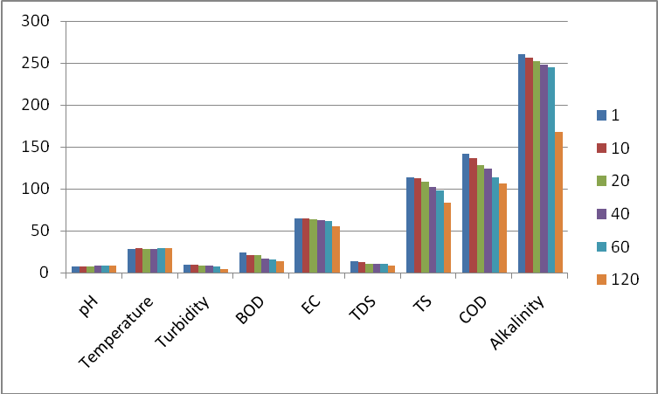
Fig 1: Physicochemical parameters of treated wastewater from Rubber Factory at different time

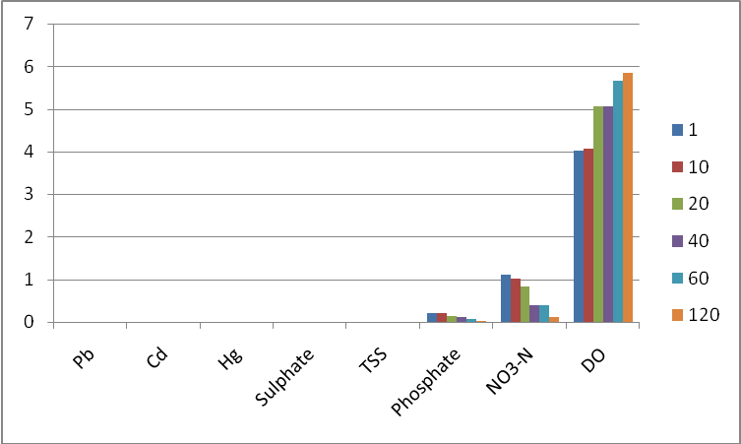
Fig 2: Physicochemical parameters of treated wastewater from rubber Factory at different time.

There was no significant change in temperature of the treated wastewater; the temperature value was within the safe discharged limit for wastewater disposal.
There was reduction of the alkalinity value which reduces as the treatment time increases; this is an indication that most of the substances used in the preservation of the rubber such as ammonia which dissolves in water to increase the alkalinity of the wastewater have been reduced.
However the carbonate(iv) ion can combine or react with the ammonium ion in the wastewater and removed it from the solution, hence the reduction in the alkaline value of the treated wastewater.
Turbidity value reduces from 13mg/l to 9.42mg/l at the first day of treatment; this reduces gradually as the treatment time increases. The value was 4.62mg/l at the 120days of the treatment.
This reduction in the value of turbidity shows that the colloidal materials that contribute to the turbidity of the wastewater have been reduced by the snail shell powder.
There was also reduction in the value of electrical conductivity, which indicates that most of the solids in suspended and dissolved form have been reduced when the wastewater is treated with the snail shell.
Total solids and the total suspended solids were reduced after treatment with the snail shell, the total suspended solid was 0.001mg/l at 120 days of treatment this indicate that most of the suspended solids were removed by the snail shell during treatment.
There was 96 percent COD and BOD reductions after treatment with the snail shell, this means that the treatment was physicochemical process. Similar result was reported by Chua Sze Ye., et al (2010) in the effect of ultrasonic irradiation on COD and TSS in raw rubber mill effluent.
The dissolved oxygen values increases as the treatment time increases, this is an indication that most of the waste that consume the dissolved oxygen in the wastewater have been reduced. Wastewater from the rubber industry contains a variety of substances such as rubber hydrocarbon, proteins, minerals, non rubber hydrocarbons and carbohydrates, these substances are highly biodegradable hence they consume dissolved oxygen, however after treatment with snail shell these substances were reduced hence the increase in the dissolved oxygen value.
There was 99 percent of nitrogen, phosphate and sulphate reduction, this indicates that the nitrogenous and sulphate substances that are used as anticoagulants that find themselves into the wastewater during processing have been reduced by snail shell after treatment.

KINETIC STUDIES OF THE TREATMENT OF WASTEWATER FROM RUBBER INDUSTRY:
The results of the treatment of the wastewater obtained at different times were subjected to kinetic studies, using the Lagargrein (pseudo-first order) kinetic model, pseudo-second order kinetic model as proposed by Ho and Mckay.(1999) and the intraparticle diffusion model. The results obtained are presented in the table below:

TABLE3: KINETIC STUDIES OF WASTEWATER FROM RUBBER INDUSTRY
PARAMETERS | PSUEDO-FIRST ORDER |  | PSUEDO SECOND ORDER |  | INTRAPATICLE,DIFUSSIONS
 | K₁ | R² | K₂ | R² | K_{int} | R²
pH | - | - | 0.1845 | 0.999 | 0.7059 | 0.840
TEMP. | - | - | 0.0155 | 0.999 | 0.0810 | 0.271
ALKALINITY | 0.0012 | 0.893 | -0.0406 | 0.971 | -8.264 | 0.700
TURBIDITY | 0.0029 | 0.903 | -1.916 | 0.958 | -0.470 | 0.888
EC | 0.00049 | 0.954 | -0.0416 | 0.996 | -0.928 | 0.798
TS | 0.0046 | 0.926 | -0.0508 | 0.993 | -3.205 | 0.949
TSS | 2.04x10⁻⁶ | 0.068 | -13624.5 | 0.923 | -0.00077 | 0.836
TDS | 5.06x10⁻⁵ | 0.783 | -0.4856 | 0.994 | -0.5248 | 0.935
BOD | 4.3x10⁻⁵ | 0.763 | -0.3706 | 0.993 | -1.027 | 0.944
COD | 8.8x10⁻⁵ | 0.929 | -0.0287 | 0.997 | -3.773 | 0.980
DO | - | - | 0.4686 | 0.998 | 0.2116 | 0.815
NO₃-N | 0.0021 | 0.789 | -133.79 | 0.875 | -0.109 | 0.937
PO₄²⁻ | 0.00094 | 0.864 | -863.246 | 0.851 | -0.020 | 0.938
S0₄²⁻ | 0 | - | 9.09x10⁻¹³ | 1 | 0 | -
Pb²⁻ | 0 | - | -310.13 | 0.999 | -1.2x10⁻⁵ | 0.675

The values of K₁ and R² for the pseudo-first order, K₂ and R² for the pseudo-second order kinetics and the values of K_{int} and R² for the intra particle diffusion were obtained by a plot of log (q_{e} – q_{t}) against time, t/q_{t} against time and q_{t} against t^{½} respectively as shown below.
The correlation coefficient (R²) value of most of the parameters did not fit into the pseudo-first order rate kinetic model, since their correlation coefficient (R²) value is less than 0.99.

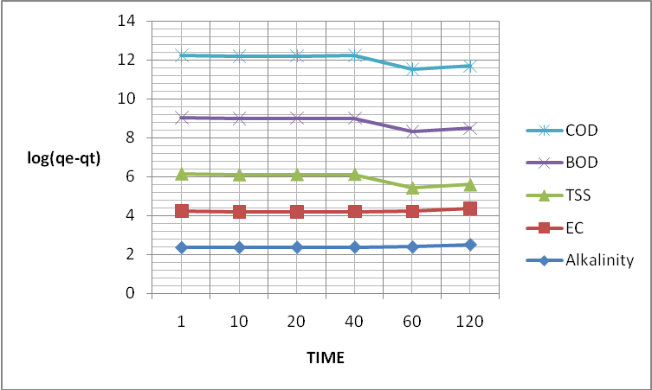
Fig 3: plot of log (q_{e} – q_{t}) against time of treated wastewater from Rubber Factory.
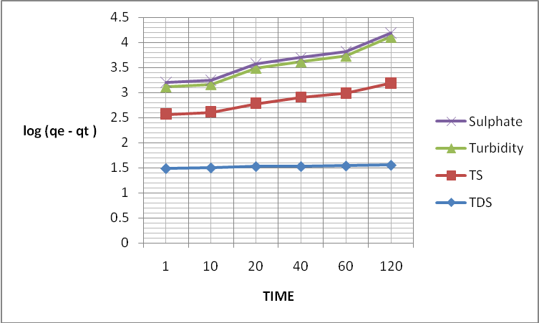
Fig 4: Plot of log (q_{e} – q_{t} ) against Time of treated wastewater from Rubber Factory

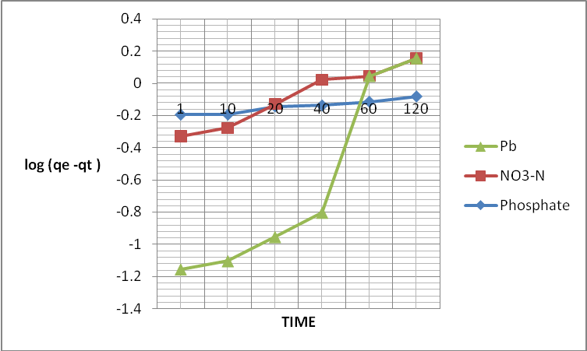
Fig 5: Plot of log (q_{e} – q_{t} ) against Time of treated wastewater from Rubber Factory:

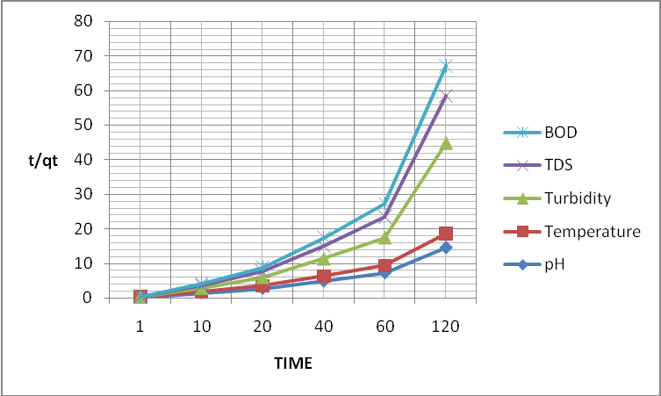
Fig 6: Plot of t/q_{t} against Time of treated wastewater from Rubber Factory

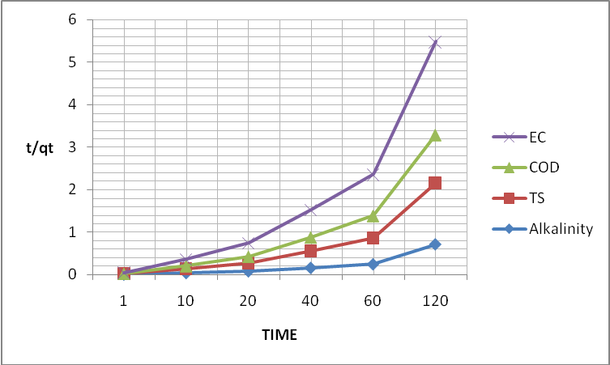
Fig 7 : Plot of t/q_{t} against Time of treated wastewater from Rubber Factory

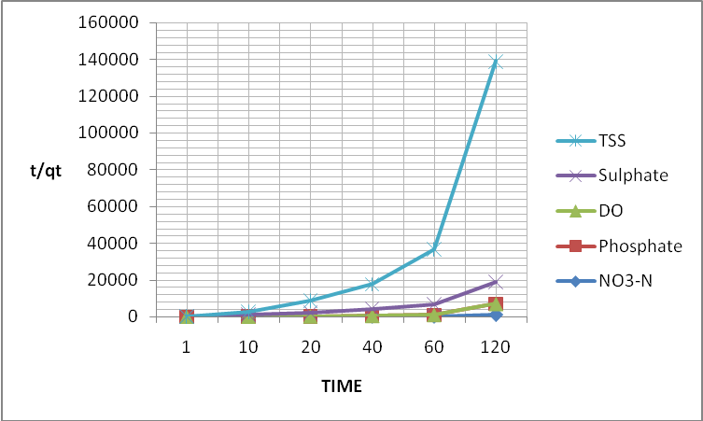
Fig 8: Plot of t/q_{t} against Time of treated wastewater from Rubber Factory

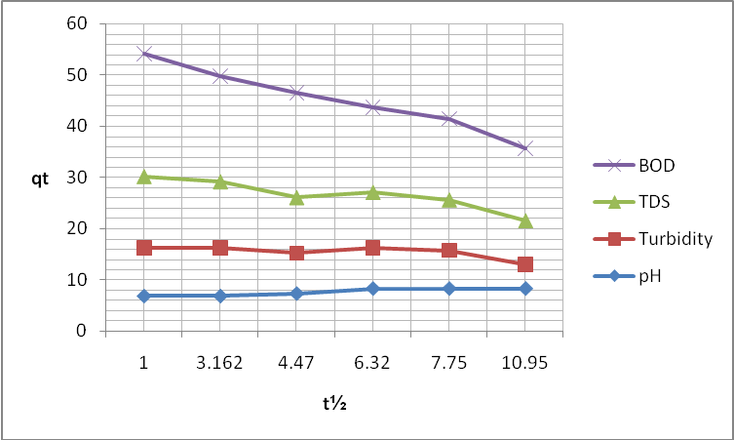
Fig 9: Plot of q_{t} against t½ of treated wastewater from Rubber Factory

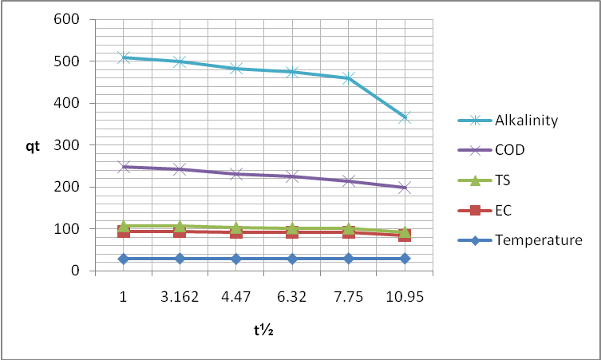
Fig 10: Plot of q_{t} against t½ of treated wastewater from Rubber Factory

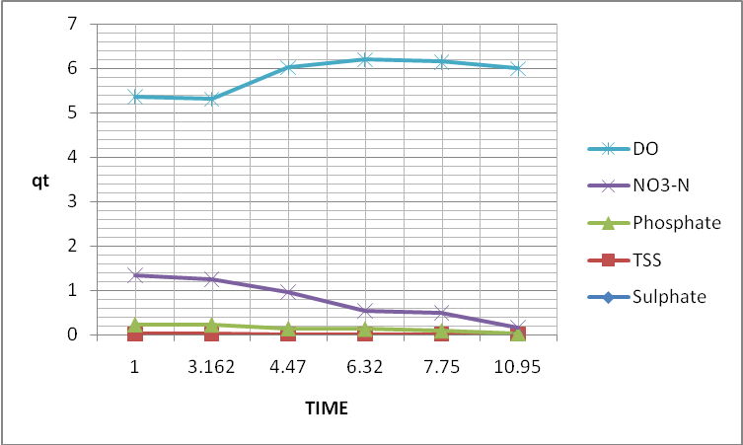
Fig 11: Plot of q_{t} against t½ of treated wastewater from Rubber Factory

Some parameters like turbidity, electrical conductivity, total solids and chemical oxygen demand have a correlation coefficient (R²) value of (R² > 0.99), when they were subjected to pseudo-first order kinetic model, this suggest that their determination can fit into the model, however their reduction during treatment is more of chemical process or reactions than physical. It could be also observed from the table that the R² values are greater than 0.99, when the results were subjected to pseudo-second order kinetics, this is a clear indications that most of the parameters determination is a second order process which is based on the assumption that the rate limiting of the treatment may be chemisorptions involving valence forces through sharing of electrons or exchange of electrons between the adsorbent and the adsorbate Ho et al (1998).
Multiple pseudo-first order kinetics have been reported in some adsorption system such as the adsorption of protein on silica Sarker et al., (1993), mercury(ll) on kaolinte Singh et al (1996) and persostent on kaolinite Atun et al (1996).
A multi pseudo-first order process means a plot of ln (q_{e} – q_{t}) versus time can be divided into two or three linear sections, each linear section representing a multi pseudo-first order mechanism.
In the multiple first order kinetic adsorption process, one stage correspond to the initial binding or anchorage of the adsorbate molecules with the active spot of the adsorbent by removal and reorganisation of surface bound water Ho et al (1999). Atun and Sismanoglu (1996) reported that in case of two kinetics, the first step of adsorption was more rapid than the second step and the adsorption rate is either controlled by a film diffusion or an intraparticle diffusion mechanism.

CONCLUSION
The results of these studies show that snail shell powder can be used effectively in the treatment of wastewater from different industries. The shell is common in these part of the world, is cheap to obtain since it is waste generated from the consumption of the snail.
The proximate analysis of the different species of snail shell reveals that the shells of the giant African snail (Achatina achatina) is more effective in the treatment of wastewater, since the shell is easy to homogenised into fine powder giving it a large surface area for adsorption. It has the highest iron content which equally makes it to have a high coagulating property; hence the shell can function as good adsorbent and a coagulant or coagulant aid.
From these studies it was observed that the treatment of wastewater using snail shell is more effective as the time of treatment increases, this is evidenced from the decrease in the physicochemical parameters and the increase in the values of dissolved oxygen as the treatment time increases.
However, the longer the wastewater spent with the adsorbent the better the treatment.
There is the need to change the adsorbent by either regeneration or replacing it with fresh one, since at a longer time all the active sites of the adsorbent may have been occupied by water and possibly be saturated with the adsorbate and water.
The kinetic studies of the treatment of the wastewater revealed that most of the parameters fitted the pseudo-second order kinetics, since their correlation coefficient values (R²) is greater than (0.99).
In comparison to that reported by Ho and Mckay (1999), shows that the kinetic of sorption of Victorian blue, Aromatic compounds, p-nitro-phenol, o-nitro-phenol, a chrome dye, Omega Chrome Red ME (OCRME) on fly ash, copper (II) on peat and bottom ash, bicarbonate- treated peanut hull (PHC) and activated carbon, the kinetic of sorption of Cadmium (II) on wollastonite, of chromium (VI) on Bi₂O_{3,} of Cadmium on beech and reed leaves, of Lead (II) on cypress leaves and bottom ash and phosphate on tamarind nut shell activated carbon (TNSAC) were analysed on the basis of the pseudo-second order rate mechanism.
They reported that the pseudo- second order chemical reaction kinetics provide the best correlation of the experimental data.
The pseudo-first order model proposed fits the experimental data well for an initial period of the first reaction step only. However, over a long period of treatment the pseudo-second order provides the best correlations for all the system studied.

CORRESPONDING AUTHOR
Jatto, Ejeomo. Osazuwa department of Chemistry
Faculty of Natural Sciences, Ambrose Alli University, Ekpoma. E-mail: ejey2010@gmail.com

REFERENCES
1.Ademoroti, C.M.A (1996). “Standard methods for water and effluents analysis”. Foludex press ltd, Ibadan, Nigeria. Pp 102-104. 159-161.
2.Ademoroti, C.M.A (1996). “Environmental chemistry and toxicology”. Foludex press ltd, Ibadan, Nigeria. Pp38-45.
3.Aksu, Z., Kabasakai, E (2003). “Batch adsorption of 2,4-dichlorophenoxyl-acetic acid (2,4-D) from aqueous solution by granular activated carbon”. Sep purif. Technol. 35: 223-240.
4.APHA: standard methods for the examination of water and wastewater . APHA-AWWA-WPCF (1998). Washington.D.C
5.Atun,G., Sismanoglu, T. (1996) “ Adsorption of 4,4/- Isopropylidene diphenol and diphynolol propane 4,4/ - dioxyacetic acid from aqueous solution on kaolinte.” J .Environ sci Health part A Environ sci Eng 31:2055-2069.
6.Asia, I.O., Oladoja, N.A (2003). “Determination of optimum dosage of chemical coagulants/flocculants needed for sludge treatment”. Journal of science, engineering and technology.10 (3). 5031-5042.
7.Banat,F., Al-Asheh, S.,Makhadmeh,L (2005) “Preparation and examination of activated carbons from date.pits impregnated with Potassium Hydroxide for the removal of methylene blue from aqueous solutions”. Adsorption Science and technology.21 (6):597-606.
8.Bouchet,P., Rocroi, J.P (2005) “Classification and Nomenclator of Gastropod families”. Malacologia: international journal of malacology, 47(1-2).397-403.
9.Botkin, D.E., Edward, A.K (1988). Enviromental science, 2nd Edition . John Wiley and sons: Montreal, Canada. 392.
10.Brunt, J., Engel, B.K., Rapp,G (1999). Giant African snail plant protection service. Secretariat of the pacific community: Fiji Pg 4.
11.Brusca, R.C., Brusca, G.J “Phyllum mollusc”. Invertebrates Scnaller Associates, Inc. Pp701-769
12.Chien, S.H., Clayton, W.R (1980). “Application of Elovich equation to the kinetics of phosphate release and sorption in soil”. Soil Sci. Soc Amj. 44:265-268.
13.Chua, S. YE., Puziah, A.L., Shaharin, I., Nurliza, R., Sidek, A (2010) “ Effect of ultrasonic irradiation on COD and TSS in Raw rubber mill effluent.” Environmental Asian, 3: 32-35
14.Dague, R.R., Urul, R.F., Krieger, E.R (1990) “ Treatment of pork processing wastewater in a covered anaerobic lagoon with gas recovery.” In proceedings of the 44th industrial waste conference, 815-823. Ann Arbour, MI: Ann Arbour Sciences:
15.Gaman, P.M., sherington,K.B (1977): The science of food. Pergamom press Ltd. London. UK, Pp62-79, 80-87, 92-95, 134-139.
16.Harold,V (1963). Practical chemical biochemistry. 3rd edition, William Heinemann medical books, Ltd. New York, NY. Pp 22, 184.
17.Ho, Y.S., Mckay, G. (1999). “Pseudo-second order for sorption processes.” Process Biochemistry, Elsevier science Ireland Ltd. 34: 452-465.
18.Ho,Y.S., Mckay, C, (1998). “A comparison of chemisorptions, kinetics model applied to pollutant removal on various sorbents”. Process safety and environmental protection”.76(4): 332-340.
19.Hoang ,N.T.V., Dang, T.T.D., Nguyen, T.M., Imastini, D., Subarna, S., Huynh, M.K., Tran, N.Q.H (2007) “Waste Abatement and management in Natural Rubber processing sector.” Asians institute of technology. School of environment, resources and development. Pp 1-29
20.Ihekhoronye, A.I., Ngoddy, P.O (1985). Integrated food science for the tropics, first edition, Macmillian publishers, Ltd. London, UK. P 28.
21.Lagergren, S.(1898) “About the theory of so-called adsorption of soluble substances”. Kungliga Svenska Vetenskapsa-kademiens. Handlinger, 24(40): 1-39.
22.Lazaridis, N.K., Asouhidou, D.D (2003). “Kinetics of sorptive removal of chromium (VI) from aqueous solutions by calcined Mg-Al-CO₃ hydrocalcite”. Water Research, 37(12): 2875-2882
23.Naja, G, and Mustin, C (2003). “Use of activated carbons prepared from saw dust and rice husk for adsorption of acid dyes, a case study of acid yellow 36”. Journal of dyes and pigments.56: 239-249
24.Negi,A.S., Anand ,S.C, (2007), A textbook of physical chemistry, New age international publisher ltd. New Delhi, 2nd edition. Pp 727-728
25.Pandey, S.K., Prasad, G., Singh, V.N (1986) “ Use of wallastonite for the treatment of Cu(II) rich effluents”. Water, air and soil pollution. 27: 287-296.
26.Pearson,D., (1976). The Chemical Analysis of Foods. 7th Edition.Church livingstone, pp 6-12, 107-122.
27.Poppe, G.T., Tagaro, S.P (2006). The new classification of Gastropods according to Bouchet and Rocrei, 2005. Visaya Fevrier.10:68-74
28.Qui,H., Pan,B., Zhang,Q., Zhang, W., Zhang, Q.J (2009), “Critical review in adsorption kinetics models”. Journal of Zhejieng university of science, 10(5): 716-724.
29.Volesky,B.J, (1990), “ Biosorption of heavy metals; Environmental impact of heavy metals”.CRC press ,inc, Boca Patin; Fl Pp95-102
30.Sarker, D., Chattoraj, D.K (1993) “Activation parameters for kinetics of protein adsorption at silica water interface. J .colloid interface Sci. 157:206-219
31.Singh,J., Huang, P.M., Hammer, U.T., Liaw, W.K (1996) “ Influence of citric acid and glycine on the adsorptiom of mercury (II) by kaolinte under various pH conditions.” Clays clay miner 44: 41-48.
32.Sun, Q.Y., Yang,L.Z. (2003) “The adsorption of basic dyes from aqueous solution on modified peat-resin particle. Water Research, 37(7): 1535-1544.
33.Usman, A (2006). Standard operating procedure; national agency for food and drug administration and control (NAFDAC), Boriki, PortHacourt, Nigeria. Heinemann, Medical books Ltd. NewYork. NY. Pp 7-14.

12/27/2012

