The Effect of Marine Probionts on the Growth of Fish and Shellfish Pathogens

Caroline Nchedo Ariole and Niabari Blessing Kanee

Department of Microbiology, University of Port Harcourt, P.M.B. 5323, Port Harcourt, Nigeria. cnariole@yahoo.com

Abstract: Four isolates of Pseudomonas spp. from brackish water were screened for antimicrobial activity against ten fish and shellfish pathogens (Vibrio sp., Salmonella spp., Staphylococcus spp., Escherichia coli and Aeromonas spp.) by agar well diffusion assay. Two isolates of Pseudomonas spp.(P2 and P3) were found active against all the bacterial strains. The challenging experiment showed that Pseudomonas P2 with 1.0 x 10⁶ cfu/ml was enough to suppress Salmonella SM1 within 12 hours. The isolated strains Pseudomonas P2 and Pseudomonas P3 could have potential against Salmonella SM1 under in vitro condition and might be useful as biological control agents in fish and shellfish culture.
[Ariole CN and Kanee NB. The Effect of Marine Probionts on the Growth of Fish and Shellfish Pathogens. N Y Sci J 2013;6(2):49-52]. (ISSN: 1554-0200). http://www.sciencepub.net/newyork. 8

Keywords: Bacterial growth; fish and shellfish pathogens; marine probiont; antimicrobial activity

1. Introduction
Fish and shellfish farming are the fastest growing food-protein producing sector in the world. (Qi et al., 2009). An important issue affecting production is the loss of stock through disease. When faced with disease problems the common response has been to turn to antimicrobial drugs (antibiotics). Nevertheless, the continuous use of antibiotic has contributed to the occurrence of antibiotic-resistant bacteria population (Rahman et al., 2009) and to an increase in more virulent pathogens. Furthermore, some chemicals used in fish and shellfish such as organotin compounds, copper compounds and other compounds, with a high affinity to sediment, leave persistent, toxic residues and are likely to have a negative impact on the environment (Graslund et al., 2003).
The problem of antibiotic resistance and its epidemiological consequences led to the exploration of several alternative approaches for disease management in aquaculture systems. The research of probiotics for aquatic animals is increasing with the demand for environment-friendly aquaculture. Some probiotics were designed to treat the rearing medium, like biocontrol when the treatment is antagonistic to pathogens or bioremediation when water quality is improved. Probiotics have also found use in aquaculture as a means of disease control, supplementing or even in some cases replacing the use of antimicrobial compounds (Irianto and Austin, 2002; Sahu et al., 2008).
In Nigeria, probiotics research is still at its infancy and data on aquatic indigenous probiotics are lacking. Therefore, the present study was aimed at isolating indigenous strains of Pseudomonas from brackish water and evaluating their probiotics effect on some isolated pathogenic bacteria of fish and shellfish.

2. Materials and Methods
2.1. Sample Collection
Brackish water was collected in sterile plastic bottle from Sombriero River in Buguma, Rivers State of Nigeria. Moribund shrimp (Penaeus monodon) and fish (Tilapia guineensis) were collected from the same river through the assistance of local fishermen.

2.2. Bacterial Isolation
The Brackish water sample was diluted in a range 1:10 to 1:100. Sub samples of 0.1ml of both the diluted and the undiluted brackish water samples were plated on Pseudomonas cetrimide agar (Oxoid). The moribund fish and shrimp were cleaned externally with ethanol and their gastro-intestinal tracts dissected under sterile conditions. The gut contents were weighed and placed in a physiological solution and then diluted in a range 1:10 to 1:1000. Sub samples of 0.1ml of the dilutions were plated on five different media. The media chosen were: Thiosulphate citrate bile salt sucrose (TCBS) agar (Oxoid) (for Vibrio species), Salmonella Shigella agar (Fluka) (for Salmonella species), Mannitol salt agar (Lab M) (for Staphylococcus species), MacConkey agar (BioTech) (for Escherichia coli) and Aeromonas medium with supplement (Ryan) (Oxoid) (for Aeromonas species). All the media were supplemented with 1.0 % sodium chloride and incubated at 37^{O}C for 24 – 48hours. Isolates with distinct colony morphology were picked and streaked repeatedly on nutrient agar plates until pure. The purified isolates were identified to generic level based on their morphological and physiological characteristics (Holt et al., 1994).

2.3. Determination of Antimicrobial Activity
The antimicrobial activity was first determined by agar diffusion method (Baydar et al., 2004 and Dobner et al., 2003). Further study was made by broth assay where Pseudomonas P2 and Salmonella SM1 were mixed and survival determined by plate counting at various time intervals from 0 to 48hours (Chythanya et al., 2002).

2.4. Agar diffusion assay
Antimicrobial activity of four isolates of Pseudomonas spp. was carried out against ten target strains. Wells were punched with a cork borer (6mm, diameter) in plates of nutrient agar freshly seeded with 0.1ml of 24 hour old broth culture of each tested bacterial stains. Exactly 0.1ml of a 24 hour old broth culture of each of the Pseudomonas strains and the control (nutrient broth containing 1.0% sodium chloride) were put into the wells. The plates were incubated for 24hours at 37^{O}C. The diameter of clear zones surrounding the wells were measured and recorded expressing the antibacterial activity.

2.5. Effect of Pseudomonas P2 on growth of Salmonella SM1 in sterile nutrient broth.
Two 250mL flasks containing 100mL of nutrient broth containing 1.0% sodium chloride was sterilized at 121^{O}C for 15 minutes. Cell suspension of Salmonella SM1 was then added to all flasks to get a cell density of approximately 1.0 x 10⁵ cfu/ml. Cell suspensions of Pseudomonas P2 adjusted to 1.0 x 10⁶ cfu/ml final cell concentration were added to one flask while the other flask without Pseudomonas P2 added served as control. The cultures were incubated at 37^{O}C for 48 hours with manual shaking at intervals. Pseudomonas and Salmonella SM1 were enumerated at 0, 12, 24 36 and 48 hour on Pseudomonas cetrimide agar (Oxoid) and Salmonella Shigella agar (Fluka) respectively by standard spread plate method.
Table 1: Antibacterial activity of Pseudomonas spp. against fish and shellfish pathogens

Pseudomonas spp. | Inhibition zone (cm) ± S. D.
Pseudomonas spp. | Vibrio sp. V2 | Salmonella sp. SM1 | Salmonella sp. SM2 | Staphylococcus sp. ST1 | Staphylococcus sp. ST2 | Escherichia coli E1 | Aeromonas sp. AP1 | Aeromonas sp. A5 | Aeromonas sp. A6 | Aeromonas sp. A8
P1 | - | - | - | - | - | - | - | - | - | -
P2 | 1.7±0.00 | 1.8±0.00 | 1.0±0.01 | 1.8±0.00 | 0.9±0.03 | 1.2±0.01 | 1.2±0.01 | 2.1±0.00 | 2.0±0.02 | 1.4±0.00
P3 | 1.6±0.01 | 1.0±0.00 | 1.2±0.00 | 1.2±0.02 | 1.2±0.01 | 1.6±0.02 | 1.0±0.00 | 2.3±0.01 | 2.0±0.03 | 1.0±0.00
P4 | - | - | - | - | - | - | - | - | - | -

3. Results Analysis
The antibacterial activity of fish and shellfish pathogens by Pseudomonas spp. are shown in Table 1 and Figure 1.

A total of four bacterial strains identified as Pseudomonas P1, Pseudomonas P2, Pseudomonas P3 and Pseudomonas P4 were isolated from brackish water. Seven pathogenic isolates from moribund shrimp (Penaeus monodon) were identified as Vibrio sp. V2 Salmonella sp. SM1, Salmonella sp. SM2, Staphylococcus sp. ST1, Staphylococcus sp. ST2, Escherichia coli E1 and Aeromonas sp. AS1 while three pathogenic isolates from moribund fish (Tilapia guineensis) were identified as Aeromonas sp. A5, Aeromonas sp. A6 and Aeromonas sp. A8. Pseudomonas sp. P2 and Pseudomonas sp. P3 produced inhibition zones higher than 8mm and against all the pathogenic strains employed while Pseudomonas P1 and Pseudomonas P4 had no antibacterial activity against the pathogens.
The inhibition of Salmonella SM1 (1.0 x 10⁵) cfu/ml) by Pseudomonas P2 (adjusted to 1.0 x 10⁶ cfu/ml final cell concentration) in nutrient broth containing 1.0% sodium chloride is shown in Figure 2. The Pseudomonas P2 could inhibit Salmonella SM1 growth within 12 hours. It was found that the concentration of Salmonella SM1 was constant (about 10³ cfu/ml) until 48hours. For the control, an increase of Salmonella SMI was observed from about 10⁵ to 10⁶ cfu/ml.

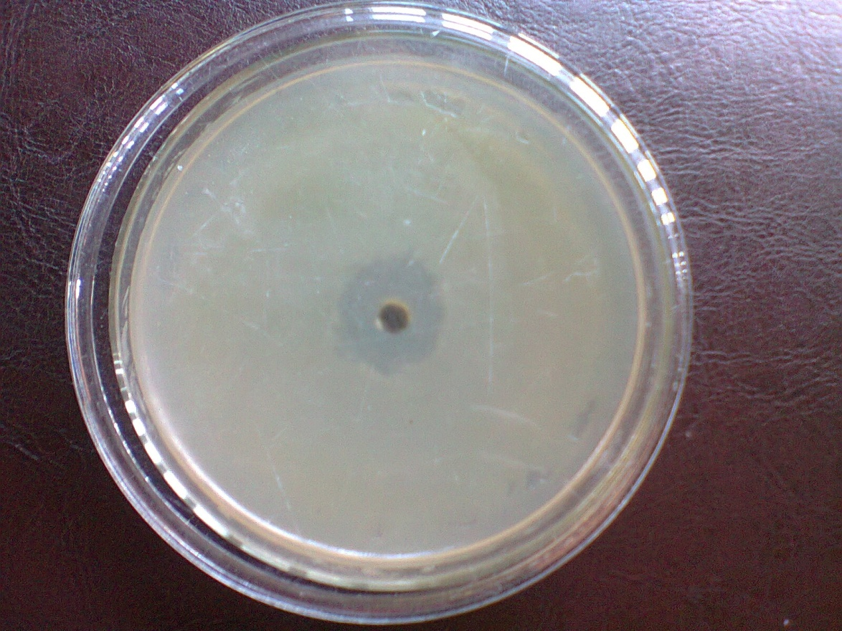
Figure 1. Inhibition zone of Pseudomonas sp. P2 against Salmonella SM1
Total Viable cell (cfu/ml)
Pseudomonas P2
Salmonella SM1
Control
0
10¹
10²
10³
10⁴
10⁵
10⁶
10⁷
0
12
24
36
48
Time (hour)

Figure 2: Effect of Pseudomonas P2 at 1.0 x 10⁶ cfu/ml on growth of Salmonella SM1 in nutrient broth containing 1.0% sodium chloride

4. Discussion
The present study reports two marine probionts, Pseudomonas P2 and Pseudomonas P3, isolated from brackish water from Sombriero River in the Niger Delta which showed antimicrobial activity against a range of pathogenic bacteria isolated from moribund fish and shellfish from the same river (Table 1, Figure 1 and 2).
The growth of Salmonella SM1 and other fish and shellfish pathogens used in this study were inhibited by Pseudomonas spp. because Pseudomonas can secret antimicrobial compounds. Numerous studies have implicated siderophores as bacteriostatic substances produced by Pseudomonas species (Guerinot, 1994; Raaijmakers et al., 1997; Vijayan, 2000). Various strains of Pseudomonas spp. have been reported as effective against Vibrio harveyi and other Vibrio species determined by using agar diffusion technique (Torrento and Torres, 1996: Chythanya et al., 2002; Vijayan et al., 2006). Chythanya et al. (2002) reported that Pseudomonas 1-2 strain displayed antimicrobial activity against shrimp pathogen, Vibrio harveyi (diameter 1.7cm). This result is similar to the one obtained in this study where Pseudomonas P2 displayed antimicrobial activity against shrimp pathogen, Vibrio sp, V2, with inhibition zone diameter of 1.7 cm (Table 1).
A number of earlier studies have also shown that bacteria produce inhibitory substances that inhibit the bacterial pathogens in aquaculture systems (Austin et al., 1995; Rengpipat et al., 1998; Gram et al., 1999). The use of such bacteria to inhibit pathogens by release of antimicrobial substances is now gaining importance in fish and shrimp farming as a better and more effective alternative than administering antibiotics to manage the health of fish and shrimp (Verschuere et al., 2000; Vine et al., 2004). Therefore, the isolated indigenous strains of Pseudomonas P2 and P3 had the inhibitory property of a biocontrol agent for use in control of fish and shellfish pathogens and might be useful for replacing the commercial antibiotics. Further co-culture experiments to determine the minimum inhibitory concentration of the antagonists against the pathogenic strains, the species identification and optimization of Pseudomonas growth are going on in our laboratory. Furthermore, the in vivo effect on pathogen in fish will be a further course of work.

Correspondence to:
Dr. (Mrs) Caroline Nchedo Ariole
Department of Microbiology,
University of Port Harcourt,
P. M. B. 5323, Choba, Port Harcourt, Nigeria
GSM: +2348033172536
E-Mail: cnariole@yahoo.com

References
- Ausin B, Stuckey LF, Berton PAW, Effendi I, Griffith DRW. A probiotic strain of Vibrio alginolyticus effective in reducing diseases caused by Aeromonas salmonicida, Vibrio anguillarum and Vibrio ordali. Journal of Fish Diseases 1995; 18: 93-96.
- Baydar NG, Ozkan G, Sagdie O. Total phenolic contents and antibacterial activities of grape (Vitis vinifera L.) extracts Food Control 2004;15(5): 335-339.
- Chythany R., Karunasagar I, Karunasagar I. Inhibition of shrimp pathogenic Vibrios by a marine Pseudomonas 1-2. Aquaculture 2002;208:1-10.
- Dobner MJ, Schwaiger S, Jenewein IH, Stuppner H. Antibacterial activity of Leontopodium alpinum (Edelweiss). J. Ethnopharmacol. 2003;89: 301-303.
- Gram L, Melchiorsen J, Spanggaard B, Huber L, Nielsen JF. Inhibition of Vibrio anguillarum by Pseudomonas fluorescens AH2, a possible probiotic treatment of fish. Appl. Environ. Microbiol. 1999; 65: 969-973.
- Graslund S, Holmstrom K, Wahlstrom A. A field survey of chemicals and biological products used in shrimp farming. Mar. Pollut. Bull. 2003; 46: 81-90.
- Guerinot ML. Microbial iron transport. Annu. Rev. Microbiol. 1994;48: 743-772.
- Holt JG, Krieg NR., Sneath PHA, Stanley JT, Williams ST. (eds). Bergey’s manual of determinative Bacteriology 9th ed. Williams and Wilkins Baltimore, Maryland, U. S. A. 1994.
- Irianto A, Austin B. Probiotics in aquaculture. J. Fish Dis. 2002; 25: 633 -642.
- Qi Z, Zhang XH, Boon N, Bossier P. Probiotics in aquaculture of China-Current state, problems and prospect. Aquaculture 2009;290: 15-21.
- Rahman S, Khan SN, Naser MN, Karim MM. Application of probiotic bacteria: A novel approach towards ensuring food safety in shrimp aquaculture. J. Bangladesh Acad. Sci. 2009;33: 139-144.
- Rengpipat S, Phianphak W, Piyatiratitivorakul S, Menasveta P. Effects of a probiotic bacterium on black tiger shrimp Penaeus monodon survival and growth. Aquaculture 1998;167: 301-313.
- Sahu MK, Swarnakumar NS, Sivakumar K, Thangaradjou T, Kannan L. Probiotics in aquaculture: Importance and future perspectives. Indian J. Microbiol. 2008;48: 299-308.
- Torrento M, Torres J. In vitro inhibitor of Vibrio harveyi by Pseudomonas spp. isolated from aquatic environment. UPV J. Nat. Sci. 1996;1: 130-138.
- Verschuere L, Rombaut G, Sorgeloos P, Verstraete W. Probiotic bacteria as biological control agent in aquaculture. Microbiol. Mol. Biol. Rev. 2000; 64:655-671.
- Vijayan KK, Singh BIS, Jayaprakash NS, Alavandi SV, Pai SS, Preetha R, Pajan JJS, Santiago TC. A brackish water isolate of Pseudomonas PS–102, a potential antagonistic bacterium against pathogenic Vibrio in penaeid and non-penaeid rearing systems. Aquaculture 2006;251: 192-200.
- Vine NG, Leukes WD, Kaiser H. In vitro growth characteristics of five candidate aquaculture probiotics and two fish pathogens grown in fish intestinal mucus. FEMS Microbiol. Lett. 2004;231:145-152.

1/23/2013

