Production of Bioethanol from Palm Oil Mill Effluent using Starter Cultures

*Wakil, Sherifah Monilola; Adelabu, Adebola Blessing; Fasiku, Samuel Adedayo and Onilude, Anthony Abiodun

Department of Microbiology, University of Ibadan, Ibadan. Nigeria
shemowak@yahoo.com

Abstract: Palm Oil Mill Effluent (POME) has great potential as a substrate for acetone, butanol and ethanol fermentation because it contains a mixture of carbohydrates including starch, hemicellulose, sucrose and other carbohydrates that can be utilized by microorganisms. Hence microorganisms were isolated from spontaneously fermenting POME, the predominant strains were selected as starters and the effect of starters singly and in combination for bioethanol production was evaluated/determined. POME was spontaneously fermented for 21 days from which samples were taken every 3 days for analyses of pH, microbial quality, ethanol content, free fatty acid and lipase activity. Microorganisms isolated were characterized and identified. Moulds isolated were strains of Aspergillus and Penicillum genera, yeast were Yarrowia lipolytica, Saccharomyces cerevisiae and Candida spp., while bacteria were strains of Bacillus spp. and Micrococus sp. Sterile palm oil mill effluent was fermented with the starter cultures for 12 days and analyzed every 3 days for bioethanol production. Saccharomyces cerevisiae, while used singly, produced the highest bioethanol (3.70%) concentration. Statistical analysis shows that bioethanol and percentage free fatty acid production by single and combined starter fermented POME is significantly different (P ≤0.05) while lipase production was not significantly different (P≥0.05). The study reveals that fermentation of POME for 12days at room temperature (30+2⁰C) using Saccharomyces cerevisiae singly gives the highest bioethanol concentration. Therefore, the use of starter cultures for fermentation of POME for the production of bioethanol is a potential solution for the control of pollution generated from the annual disposal of POME.
[Wakil, Sherifah Monilola; Adelabu, Adebola Blessing; Fasiku, Samuel Adedayo and Onilude, Anthony Abiodun. Production of Bioethanol from Palm Oil Mill Effluent using Starter Cultures. N Y Sci J 2013;6(3):77-85]. (ISSN: 1554-0200). http://www.sciencepub.net/newyork. 11

Keywords: Palm-oil mill effluent (POME), fermentation, Bioethanol, Starter culture, Saccharomyces cerevisiae

1. Introduction
The energy requirements for all activities of mankind mainly depended on fossil resources such as petroleum, natural gas and coal. Unfortunately, these fossil resources that deposited and formed over billions of years were limited in stock. Therefore, the exhaustion of these non-renewable fossil fuel stocks in the near future has prompted widespread global efforts for the development of renewable energy resources. Bioethanol is an ethanol synthesized from biomass and it is renewable. Therefore bioethanol has some advantages over petrol as fuel. As the biomass grows, it consumes as much carbon dioxide as it forms during the combustion of bioethanol, which makes the net contribution to the green house effect zero (www. wikipedia.com, March, 2012). Bioethanol is fermented from sugars, starches and cellulosic materials. The current technology in industry is able to convert carbohydrates from dedicated crops such as corn, wheat, sorghum, potato, sugarcane, sugar beet and cassava to ethanol (Luo et al., 2009; Mielenz, 2001). However, the land use requirement of such an application causes the competition with food and nature, which has become the main driving force of the development and implementation of advanced process technologies to produce ethanol from low value agricultural co-products/residues or wastes such as empty fruit bunches and palm oil mill effluent (Olofsson et al., 2008). Thus promoting biomass for energy would encourage the use of a local resource thus reducing dependence on imported fossil fuels, increasing the energy security and hopefully also contributing to a reduction in climate change-inducing, anthropogenic GHG emissions (Silalertruksa and Gheewala, 2010).
Palm-oil mill effluent (POME) is an abundant organic residue that is generated by palm-oil mills during the process of extracting palm oil from fresh fruit bunches of oil palms. POME has little inhibiting effect on microbial growth due to certain content of lignin and phenolic compounds (Wattanapenpaiboon and Wahlqvis, 2003). It is estimated that 0.5-0.75 t of POME can be discharged from every tonne of oil palm fresh fruit. Palm oil mill effluent is an acidic, thick, brownish colloidal suspension with 95 to 96% of water, 0.6 to 0.7% of oil and 2 to 4% total suspended solids (TSS). It has a temperature range of 80ºC to 90ºC and consists of various component including cell walls, organelles, short fibres, a spectrum of carbohydrate, ranging from hemicelluloses to simple sugar, a wide range of nitrogenous compound from protein to amino acid and free organic acid (Ugoji, 1997). POME contains useful material used as biomass for bio-energy conversion through fermentation. It is used as a substrate to produce biofuel such as ethanol, acetone and butanol (Mun et al., 1995). Owing to increasing amount of POME generated, annual disposal remains a challenge as such bioconversion has been considered as an alternative for pollution control (Hipolito et al., 2008). Bioconversion process is achieved by using this rich organic residue as a medium where some microbial species grow, consume the organic components and at the same time, produce biomass and other valuable products. Recently, many processing technologies for converting POME into value added products have been realized. These include carotenoid, which can be further utilized for vitamins A and E (tocopherols) production (Ahmad et al., 2008), citric acid (Alam et al., 2008), fertilizer (Basiron and Weng, 2004), biohydrogen (Chong et al., 2009) and bioethanol (Alam et al., 2009).
Although Okwete and Isu, (2006) had determine total aerobic bacterial populations counts from POME soil, different researchers had also enhanced the production of bioethanol from palm oil mill effluent using various microorganisms as starter, but literature has been silent about isolation of microorganisms spontaneously from fermented palm oil mill effluent(POME). The aim of this study, hence, was to isolate microorganisms from spontaneously fermenting POME, select predominant isolates as starters and used them singly and in combinations for bioethanol production.

2. Materials and Methods
Sample collection
Palm oil mill effluent (POME) was collected during processing from one of the local palm oil industry located at Oyedeji village, Igbo-Elerin, Ibadan, Oyo State. It was transported in a clean covered sterile plastic container to the laboratory, allowed to cool to room temperature (30±2^{O}C) before analysis.

Fermentation of sample
Three liter (3L) of POME sample was aseptically transferred into clean sterile 5L conical flask. The flask was properly corked with cutting wool wrapped with aluminum foil and allowed to ferment spontaneously for 21 days. Sampling was carried out every 3 days (72 hours) for analysis of microbial quality.

Isolation and characterization of microorganisms
Four different growth media were used for isolation; which were Nutrient Agar (NA), Potato Dextrose Agar (PDA), Yeast Extract Agar (YEA) and de Man Rogosa Sharpe Agar (MRS). Isolation was by serial dilution using pour plate method (Harrigan and Mc Cance, 1966). 1 mil of appropriate dilutions was mixed with molten agar which were aseptically poured in duplicate. NA and MRS plates were incubated at 35±2ºC for 18 -24 hours, MRS plates were incubated under anaerobic condition. PDA and YEA plates were incubated at 28±2ºC for 72-120 hours. The isolates were purified by repeated sub culturing and preserved on slants of the same media at 4ºC. Bacteria isolates were characterize and identified by reference to the Bergey, s Manual of Systematic Bacteriology (Sneath et al., 1986). Mould isolates were subjected to morphological observation as well as lactophenol blue staining to determine the probable fungi. They were identified as described by Onions et al. (1981) while yeast isolates were characterized using the procedures described by Barnett et al., (2000). Predominant mould isolates and the best screened ethanol producing yeast were used as starter cultures, both in single and combinations.

Experimental set-up for starter fermentation
A total of five strains, four moulds and one yeast, were used. The moulds strains were A. flavus, A. niger, A. ocraceous and Penicillum spp. and the yeast, S. cerevisae. The isolates were used singly and in combination. Five combinations were used: A. flavus (AF) and A. niger (AN) as AF-AN; A. niger (AN) and A. ocraceous (AO) as AN-AO; A. niger (AN) and P. spp (PS) as AN-PS; A. flavus (AF), A. niger (AN), A. ocraceous (AO) and P. spp (PS) as AF-AN-AO-PS and A. flavus (AF), A. niger (AN), A. ocraceous (AO); P. spp (PS) and S. cerevisiea (SC) as AF-AN-AO-PS-SC. Based on the combination strategy, five experiments designated as runs were carried out to determine bioethanol production (Table 1).

Fermentation of sample with starters
Five 1L Erlenmeryer flasks containing 700ml of POME were covered and sterilized for 15min at 121ºC. Sterilized POME was allowed to cool to room temperature and inoculated with 1% inoculums. 1ml of each mould inoculum starters contains 10⁷spores/ml and 10⁶cfu/ml of S. cerevisiea (yeast). This was followed by proper mixing with sterile glass rod and incubated at 28±2ºC for 12days while the uninoculated sterile POME serves as control. Sampling was done every 72hours to analyze for pH, lipase activity, free fatty acid and ethanol contents.

Table 1. Microbial combination for bioconversion of palm oil mill effluent into bioethanol
Run | Microbes
1 | A. niger and A. flavus (AN-AF)
2 | A. niger and A. ocraceous (AN-AO)
3 | A. niger and Penicillum spp (AN- PS)
4 | A. flavus, A. niger, A. ocraceous and Penicillum.spp (AF-AN-AO-PS)
5 | A. flavus, A. niger, A. ocraceous, P.spp and S.cerevisiae (AF-AN-AO-PS-SC)

Determination of pH
The pH of the sample was determined by direct insertion of the pH meter electrode into the fermenting POME and the reading was recorded.

Determination of lipase activity
Lipase activity was assayed by monitoring the release of fatty acid librated from palm oil mill effluent. 25ml of starter-fermented POME was then titrated against the prepared NaOH. Lipase activity was measured in µg/ml using the method of Onilude et al., (2010) as modified by Kanimozhi et al., (2011).
Lipase activity was calculated using the following formula

Determination of free fatty acid
The amount of free fatty acids was determined using the procedure of Kanimozhi et al., (2011). This was carried out by titrating fermenting POME against 0.1M NaOH using a Brand digital Burette. 25ml of POME was titrated against the prepared NaOH.
Free fatty acid was calculated using the following formula

Determination of quantity of ethanol produced
Fermented sample was distilled following the procedure of Oyeleke and Jibrin (2009). The quantity of ethanol obtained from the distillation was determined using specific gravity method. Specific gravity bottle was rinsed with ethanol to ensure that no liquid is remained in the bottle. The distillate collected over a slow heat at 78ºC was dispensed inside the specific gravity bottle which was allowed to full to the brim, the stopper was then placed and excess distillate was wiped off with a cotton wool. The weight of the bottle and its content was recorded as W₂ using a digital weighing balance. The bottle was emptied and rinsed several times with ethanol after which the bottle was filled with distilled water to the brim, the stopper was placed and excess water was wiped off with a cotton wool, the weight of the bottle and its content was recorded as W₃. The weight of the empty bottle was also recorded as W₁.

The quantity of ethanol produced was calculated using the following formula (Priya et al., 2010)

Specific gravity = W₂ - W₁
W₃ – W₁
Where,
W _{I}: Weight of empty specific gravity bottle.
W ₂: Weight of sample + specific gravity bottle.
W₃: Weight of distilled water + specific gravity bottle

The percentage ethanol by volume was determined from the table correlating percentage volume of ethanol with specific gravity according to the methods of A.O.A.C (1990).

Analysis of Data
Data were analyzed by SPSS (version 17). The data were analyzed by one way ANOVA and DUNCAN as post Hoc test. The level of significance was considered at P < 0.05. The data were presented in mean ± SEM.

3. Results
A total of twenty-six (26) microorganisms were obtained after isolation and were identified as Bacillus carotarum, Bacillus stearothermophillus, Bacillus lentus, Bacillus pumilis, Micrococcus luteus, Micrococcus spp., Aspergillus spp, Aspergillus flavus, Aspergillus niger, Aspergillus ochraceus, Penicillum sp., Yarrowa lipolytical, Candida tropicalis, Candida intermedia, Clavispora lusitaneae and Saccharomyces cerevisiae.

Bioethanol produced from single starter-fermented POME samples
Effect of fermentation time on bioethanol production using single starters is shown in figure 1. The concentration of bioethanol increased with increased fermentation time with each of the organism used. Saccharomyces cerevisae fermented POME was shown to be the best, yielding a higher amount of bioethanol on the 12th day compared to others (3.70% or 29.7g/l), while the least was observed in Aspergillus ohcraceus and Penicillum sp. fermented POME (1.80% or 14.46g/l).
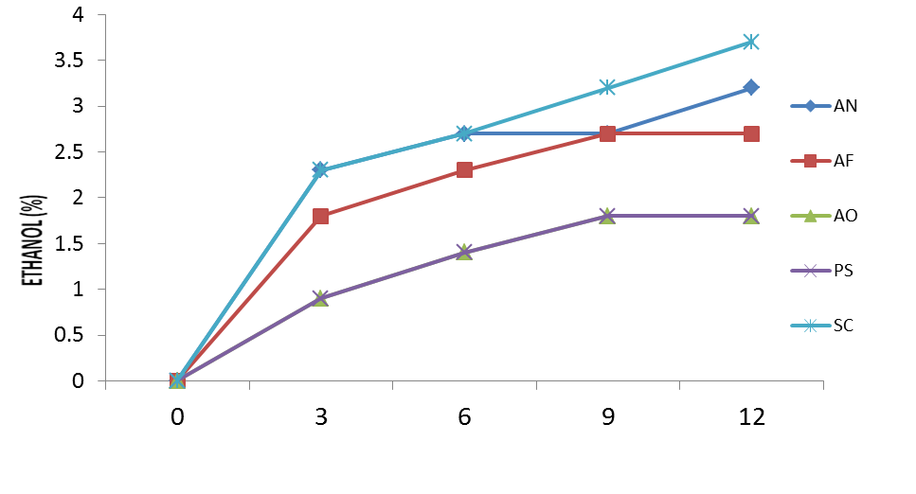
FERMENTATION TIME (DAY)
AN- A. niger, AF- A. flavus, AO-A. ochraceus, PS- Penicillum. sp., SC- S. cerevisiae
Figure 1: Effect of fermentation time on bioethanol Production of single starter-fermented POME samples

pH of single-starter fermented POME samples
From figure 2, pH of the organisms decreased throughout the fermentation period with the lowest pH value (3.80) observed in Saccharomyces cerevisae fermented POME (SC). An unusual observation can be seen at day 9 of Saccharomyces cerevisae fermented POME, where there was a slight increase in pH (4.40).

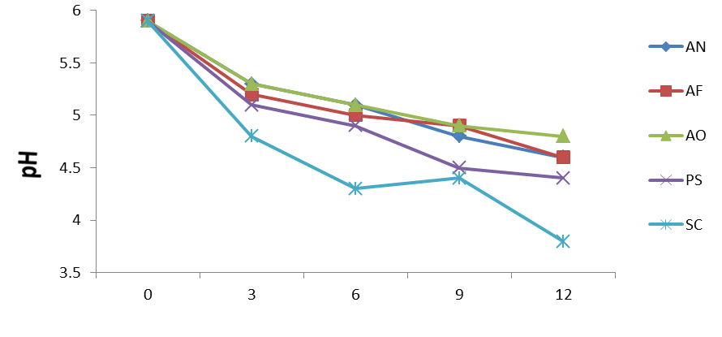
FERMENTATION TIME (DAY)
AN- A. niger, AF- A. flavus, AO-A. ochraceus, PS- Penicillum. sp., SC- S. cerevisiae
Figure 2:Effect of fermentation time on pH of single starter-fermented POME sample
Free fatty acid of single-starter fermented POME samples
Figure 3 shows that free fatty acid content of single-starter fermented POME samples increase with fermentation time. It was observed that Saccharomyces cerevisiae fermented POME had the highest free fatty acid (3.61%) on 12th day while the least value of free fatty acid (2.26%) was observed in Aspergillus flavus (AF) and Aspergillus ochraceus (AO ) fermented POME.

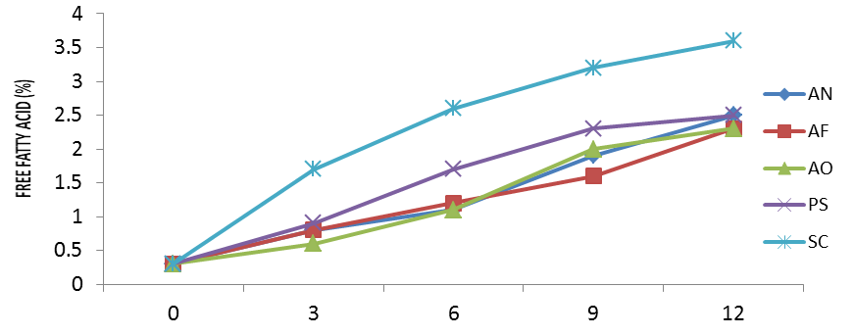
FERMENTATION TIME (DAY)
AN- A. niger, AF- A. flavus, AO-A. ochraceus, PS- Penicillum sp., SC- S. cerevisiae
Figure 3: Effect of fermentation time on free fatty acid content of single starter-fermented POME samples

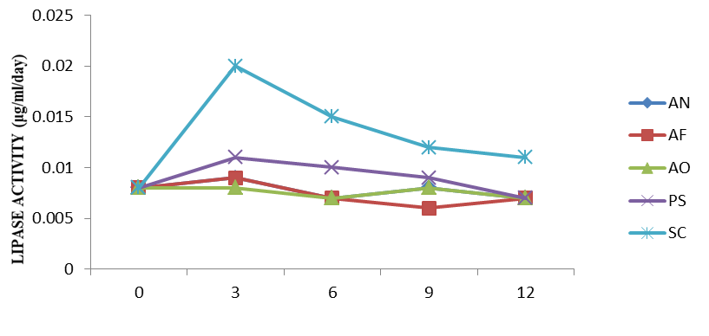
FERMENTATION TIME (DAY)
AN- A. niger, AF- A. flavus, AO-A. ochraceus, PS- Penicillum sp., SC- S. cerevisiae
Figure 4. Effect of fermentation time on lipase activity of single starter-produced POME samples

Lipase activity of single-starter fermented POME samples
We observed that lipase activity of all the organisms fluctuate throughout the fermentation days. (Fig4). The maximum lipase activity was observed at 3rd day with Saccharomyces cerevisae (SC) fermented POME, while the least activity (0.006µg/ml/day) was observed at 9th day in Aspergillus flavus (AF) fermented POME.

Bioethanol production from combined starter-fermented POME samples.
The concentration of bioethanol of all combined starter fermented POME increased with increase in fermentation time except for a decrease (1.40% or 11.22g/l) observed in AN-AF-AO-PS combined starter fermented POME at 12th day. AN-AF-AO-PS-SC combined starter fermented POME was shown to be the best combination, yielding the highest amount of bioethanol (2.70% or 21.70g/l) at day 12, while the least was observed in AN-PS and AN-AF-AO-PS combined starter fermented POME (1.40% or 11.22g/l). Statistical analysis shows that the bioethanol produced by all the combination is significantly different (p ≤ 0.05) from each other at the different fermentation time (Table 2).

Table 2. Effect of starter combination on bioethanol (%) production from fermented POME
Fermentation Time/(days) | AN-AF | AN-AO | AN-PS | AN-AF-AO-PS | AN-AF-AO-PS-SC
0 | 0.00±0.000ª | 0.00±0.000ª | 0.00±0.000ª | 0.00 ±0.000ª | 0.00 ±0.000ª
3 | 0.90±0.031^{b} | 0.90±0.021^{b} | 0.90±0.015^{b} | 0.90 ±0.025^{b} | 1.80 ±0.012^{b}
6 | 0.90±0.025^{b} | 1.40±0.023^{c} | 0.90±0.006^{c} | 1.40 ±0.010^{c} | 2.30 ±0.025^{c}
9 | 1.40±0.025^{c} | 1.80±0.021^{d} | 1.40±0.015^{d} | 1.80 ±0.021^{d} | 2.30 ±0.015^{c}
12 | 1.80±0.015^{d} | 1.80±0.012^{d} | 1.40±0.025^{d} | 1.40 ±0.015^{d} | 2.70 ±0.031^{d}
Note: each value is a mean of 3 readings ± standard deviation. Values in the same column followed by the same letter (or subscripts) are not significantly different (p ≤ 0.05) according to Duncan’s multiple range test.

Free fatty acid of combined-starter fermented POME samples
Fermentation time was observed to increase the free fatty acid content of the combined starter fermented POME with an increase in value as fermentation time increases (Table 3). The highest free fatty acid content (2.49%) on 12th day was recorded in AN-AF-AO-PS combined starter-fermented POME and the least free fatty acid content (0.26%) in the unfermented samples (0day).

Lipase activity of combined-starter fermented POME sample
Table 4 shows that Lipase activity of all starter combined fermented POME fluctuate throughout the fermentation days. The highest lipolytic activity for the combined starter fermented POME was recorded on the 6th day, but that of AN-AF-AO-PS-SC combined starter-fermented POME was on the 3rd day. Statistical analysis showed that there is little or no significant difference (p ≥ 0.05) in the lipase produced by all combinations at most of the fermentation time.

Bioethanol (%), free fatty (%) acid and lipase (µ/ml/day) produced from starter-fermented POME
The effect of starter used on bioethanol, free fatty acid, and lipase activity of single and combined starter-fermented POME is shown in Table 5. Saccharomyces cerevisiae (SC) fermented POME had the highest ethanol concentration (3.70%), the highest free fatty acid content (2.27%) and highest lipolytic activity (0.013µ/ml/day) throughout the fermentation period. The least values of ethanol production, free fatty acid and lipolytic activity were found in Penicillium sp (PS) and AN-AF-AO-PS (1.18%), Aspergillus flavus (AF) (1.23%), and Aspergillus ochraceus (AO) (0.005 µ/ml/day), respectively.

Table 3. Effect of starter combination on free fatty acid (%) produced from fermented POME
Fermentation Time/ (days) | AN-AF | AN-AO | AN-PS | AN-AF-AO-PS | AN-AF-AO-PS-SC
0 | 0.26 ±0.020ª | 0.26 ±0.020ª | 0.26 ±0.020ª | 0.26 ±0.020ª | 0.26 ±0.020ª
3 | 0.56 ±0.020^{b} | 0.79 ±0.015^{b} | 0.57 ±0.020^{b} | 0.79 ±0.015^{ab} | 0.79 ±0.015^{b}
6 | 1.72 ±0.012^{c} | 1.81 ±0.015^{c} | 1.92 ±0.010^{c} | 2.03 ±0.015^{b} | 1.36 ±0.020^{c}
9 | 1.78 ±0.015^{d} | 2.26 ±0.020^{d} | 2.03 ±0.015^{d} | 2.26 ±0.020^{bc} | 1.70 ±0.015^{d}
12 | 2.43 ±0.015e | 1.69 ±0.015e | 2.26 ±0.015e | 2.49 ±0.010^{c} | 2.37 ±0.020e
Note: each value is a mean of 3 readings ± standard deviation. Values in the same column followed by the same letter (or subscripts) are not significantly different (p ≤ 0.05) according to Duncan’s multiple range test.

Table 4. Effect of starter combination on Lipase (µ/ml/day) produced from fermented POME
Fermentation Time/ (days) | AN-AF | AN-AO | AN-PS | AN-AF-AO-PS | AN-AF-AO- PS-SC
0 | 0.008 ±0.002^{ab} | 0.008 ±0.001^{ab} | 0.008 ±0.002^{ab} | 0.008 ±0.001ª | 0.008 ±0.002ª
3 | 0.006 ±0.002^{b} | 0.009 ±0.002^{b} | 0.007 ±0.002ª | 0.009 ±0.002^{ab} | 0.009 ±0.002ª
6 | 0.010 ±0.002ª | 0.011 ±0.002^{b} | 0.011 ±0.002^{b} | 0.012 ±0.002^{b} | 0.008 ±0.001ª
9 | 0.007 ±0.001^{ab} | 0.009 ±0.002^{b} | 0.008 ±0.001^{ab} | 0.009 ±0.002^{ab} | 0.007 ±0.002ª
12 | 0.006 ±0.002ª | 0.005 ±0.002ª | 0.007 ±0.002ª | 0.007 ±0.002ª | 0.007 ±0.001ª
Note: each value is a mean of 3 readings ± standard deviation. Values in the same column followed by the same letter (or subscripts) are not significantly different (p ≤ 0.05) according to Duncan’s multiple range test.

Table 5. Effect of starters on ethanol (%), free fatty (%) acid and lipase (µ/ml/day) produced from fermented POME
STARTER  CODE | ETHANOL (%) | FREE  FATTY ACID (%) | LIPASEACTIVITY (µg/ml/day)
AF | 1.90 ±0.010^{cd} | 1.23 ±0.012ª | 0.006 ±0.001^{ab}
AN | 2.18 ±0.006^{d} | 1.32 ±0.006^{d} | 0.008 ±0.002^{ab}
AO | 1.40 ±0.200^{abc} | 1.27 ±0.010^{b} | 0.005 ±0.001ª
PS | 1.18 ±0.006^{ab} | 1.53 ±0.017^{h} | 0.009 ±0.001^{ab}
SC | 3.70 ±0.020e | 2.27 ±0.001^{j} | 0.013 ±0.002^{c}
AN-AF | 1.46 ±0.015^{bc} | 1.35 ±0.006e | 0.007 ±0.001^{ab}
AN-AO | 1.18 ±0.006^{ab} | 1.36 ±0.006^{f} | 0.008 ±0.002^{ab}
AN-PS | 0.92 ±0.015ª | 1.41 ±0.011^{g} | 0.009 ±0.001^{ab}
AN-AF-AO-PS | 1.18 ±0.006^{ab} | 1.57 ±0.006^{i} | 0.010 ±0.002^{bc}
AN-AF-AO-PS-SC | 1.82 ±0.006^{cd} | 1.29 ±0.012^{c} | 0.008 ±0.002^{ab}
Note: each value is a mean of 3 readings ± standard deviation. Values in the same column followed by the same letter (or subscripts) are not significantly different (p ≤ 0.05) according to Duncan’s multiple range test.

4. Discussion
Moulds were the predominant organisms isolated from spontaneously fermented POME with few bacteria and yeast isolates. One factor that could have been responsible for the predominance of mould is the nature of the sample. Moulds are known to adapt best in oily environment with very low water activity and low pH (4-5). These observations are in agreement with earlier studies by (Nwuche and Ogbonna, 2011). Moulds isolated were identical to those earlier reported by Namboodiri and Chattopadhaya (2000) and Onilude et al. (2010). Few bacteria isolates were encountered. This finding could probably be due to the fact that palm oil mill effluent (POME) being slightly acidic does not support the growth of bacteria. The ability of the spores of Bacillus to resist desiccation allows their survival in POME. This has earlier been reported by Onilude et al. (2010) and Kanimozhi et al. (2011) From the studies conducted by Odunfa (1989), Bacillus spp was one of the organisms that is strongly lipolytic on palm oil. Also, Yarrowia lipolytica has been studied for many years as a lipolytic, non-pathogenic aerobes which has the ability to grow on hydrophobic substrates like oil (Letzel et al., 2003). Saccharomyces cerevisiae isolated in the fermenting substrates agreed with the report of Pongthep et al. (2011).
The concentration of bioethanol produced increased with increase in fermentation time. Aspergillus niger produced the highest concentration of bioethanol of the four moulds used (3.20% or 25.73 g/l). Similar observation was made by Nzelibe and Okafoagu (2007) and Oyeleke and Jibrin (2009) where bioethanol production increased throughout the days of fermention. Maximum bioethanol production (3.70 % or 29.71 g/l) was recorded with the use of Saccharomyces cerevisiae for POME fermentation. Similar value has been reported by Mazmanci (2011) during the fermentation of fruits of Washingtonia robusta by Saccharomyces cerevisiae and Ponghtep et al. (2011) where bioethanol production from fermentation of sweet sorghum juice by Saccharomyces cerevisiae increased throughout 50 hours of fermentation. The concentration of bioethanol increased with increase fermentation time for combined starter-fermented POME except for AN-AF-AO-PS where a decrease is observed at day 12. This is an observation similar to the findings of Alam et al. (2009). AN-AF-AO-PS-SC fermented POME was shown to be the best combination because it yielded the highest amount of bioethanol when compared to other combinations. In another study, Oyeleke and Jibrin (2009) reported that an ethanol concentration of 3.20% or 26.83g/l was obtained during 7-hour fermentation of guinea corn husk in a mixed culture of Aspergillus niger and Zymomonas mobilis.
All the five fungi (Aspergillus niger, Aspergillus flavus, Aspergillus ochraceus, Penicillium species and Saccharomyces cerevisiae) in single starter-fermented POME produced lipase ranging from 0.006µg/ml/day to 0.020µg/ml/day. This conformed to the work of Nwuche and Ogbonna (2011) where Aspergillus niger and Penicillium sp. isolated from POME has different lipase activity value. Onilude et al. (2010) reported that the most important lipolytic moulds belong to the general of Aspergillus, Penicillum, Rhizopus and Trichodema. From this study Saccharomyces cerevisiae has the highest lipase activity value of 0.020µg/ml/day at day 3. Salihu et al. (2011) reported lipase activity value of 7.02µg/ml for the yeast Candida cylindraca. Several workers have reported lipase production from bacteria such as Bacillus subtilis (Eltaweel et al., 2005; Singh et al., 2010; Kanimozhi et al., 2011).
The pH of the single-starter fermenting palm oil mill effluent decreased throughout the fermentation time with each of the starter. Generally, fermentation has been recorded by several workers to result in decrease in pH (Sanni et al., 1999; Onilude et al., 2004; Wakil and Onilude 2011; Wakil and Osamwonyi, 2012). The decrease in pH indicated that fermentation occurred in the fermenting POME. Among the starters used, POME inoculated with Saccharomyces cerevisiae has the lowest pH (3.80) at day 12. Decrease in pH in all the fermenting samples leads to increase in bioethanol production. This is in agreement with the work of Alam et al. (2009). Decrease in pH during combined-starter fermentation could be due to the production of organic acid which was as a result of microbial metabolism. This is in agreement with the work of Wakil and Onilude (2011) where a decrease in pH was observed in fermented formulated weaning blends. Also decrease in pH observed in this study has been reported to be the characteristics of fermentation which is in line with the findings of Wakil and Osamwonyi (2012).
Free fatty acid content of single-starter fermented POME increased with fermentation days. Similar observation has been given by Onilude et al. (2010). Effect of fermentation time on free fatty acid content of combined starter-fermented POME samples shows that free fatty acid content of combined-starter fermented POME for all runs increased with fermentation time except for POME fermented with Aspergillus niger and Aspergillus ochraceous where there is a decrease in percentage free fatty acid at day 12 from 2.26% to 1.69%. This is in agreement with the work of Onilude et al. (2010) where free fatty acid content of cashew oil was determined. %). The free fatty acid of POME in all the five runs is similar. In another study, Canakci and Van Gerpa (1999) reported high free fatty acid production from Rapeseed oil, Safflower oil and soybeans oil.

5. Conclusion
In conclusion, palm oil mill effluent can be used for the production of bioethanol. The results reveal that all the isolates produced bioethanol with Saccharomyces cerevisiae, when used singly producing the highest bioethanol concentration of 3.70% at day 12 of fermentation. This study shows that the use of starter cultures isolated from POME for the production of bioethanol is a potential solution for the control of pollution generated from the annual disposal of POME. Similarly, considering the cost effectiveness, availability, in addition to the little inhibitory effect on microbial growth, the use of palm oil mill effluent for ethanol production is a promising substrate.

Corresponding Author:
Dr Sherifah M. Wakil
Department of Microbiology,
University of Ibadan, Ibadan. Nigeria.
+2348034129496.
E-mail: Shemowak@yahoo.com

References
- Ahmad, A. L., Chan, C.Y., Abd Shuko, S. R. and Mashitah, M. D. Recovery of oil and carotenes from palm oil mill effluent (POME). Chemical Engineering Journal, 2008;141: 383-386.
- Alam M. Z., Kabbashi, N. A., Nahdatul, S. C. and Hussin, I. S. Production of bioethanol by direct bioconversion of oil-palm industrial efﬂuent in a stirred-tank bioreactor. Journal of Industrial Microbiology and Biotechnology, 2009;36: 801–808.
- Alam, M., Jamal, P. and Nadzir, M. Bioconversion of palm oil mill effluent for citric acid production: statistical optimization of fermentation media and time by central composite design. World Journal of Microbiology Biotechnology, 2008;24: 1177-1185.
- AOAC. Official Methods of Analysis 11th Edn. Association of Official Analytical Chemist Washington D. C. 1990;23-34.
- Barnett, J., Payne, R. and Yarrow, D. Yeasts characteristics and identification. (3rd edition). Cambridge University Press. 2000;11-39.
- Basiron, Y. and Weng, CThe oil palm and its sustainability. Journal of Oil Palm Resourses, . 2004; 16 (1): 1-10.
- Canakci, M. and Van Gerpen, J. Biodiesel production from oils and fats with high free fatty acids. Trans. ASAE, 1999;42 (5): 1203–1210.
- Chong, M., Abdul Rahman, N., Abdul Rahim, R., Abdul Aziz, S., Shirai, Y. and Hassan, M. Optimization of biohydrogen production by Clostridium butyricum EB6 from palm oil mill effluent using response surface methodology. International Journal of Hydrogen Energy, 2009;34: 7475-7482.
- Eltaweel, M. A., Rahman, R. N., Salleh, A. B. and Basri, M. H. An organic solvent stable lipase from Bacillus sp. Strain 42. Annals of Microbiology, 2005; 55 (3): 187-192.
- Harrigan, W. F. and McCance, M. E. Laboratory Methods in Microbiology, Academy Journal of Cleaner Production press 342. New York 1966.
- Hipolito, C. N., Crabbe, E., Badillo, C. M., Zarrabal, O. C., Mora, M. A., Flores, G. B., Cortazar, M. H. and Ishizaki, A. F. Bioconversion of industrial wastewater from palm oil processing to butanol by Clostridium saccharoperbutylacetonicum N 1-4 (ATCC 13564). 2008;16: 632-638.
- Kanimozhi, K., Wesely, E., Devairrakam, J. and Jegadeeshkumar, D. Production and optimization of lipase from Bacillus subtilis. International Journal of Biological Technology, 2011;2 (3): 6-10.
- Letzel, S., Goen, T., Bader, M., Angerer, J., Kraus, T. Exposure to nitroaromatic explosives and health eﬀects during disposal of military waste. Environmental Science and Technology, 2003;60: 483–488.
- Luo, L., Van Der Voet, E. and Huppes, G. Life cycle assessment and life cycle costing of bioethanol from sugarcane in Brazil. Renewable and Sustainable Energy, 2009;13: 1613-1619.
- Mazmanci, M. A.. Ethanol production from Washingtonia robusta fruits by using commercial yeast. African Journal of Biotechnology, 2011;10 (1): 48-53.
- Mielenz, J.. Ethanol production from biomass: technology and commercialization status. Microbiology and Biotechnology, 2001;4: 324-329.
- Mun, L., Ishizaki, A., Yoshino, S. and Furukawa, K. Production of acetone butanol and ethanol from palm oil waste by Clostridium saccharoperbutylacetonicum N1-4. Biotechnology Journal, 1995;17: 649-654.
- Namboodiri, V. and Chattopadhaya, R. Purification and characterization of a novel thermostable lipase from Aspergillus niger. Lipids: Letters in Applied Microbiology, 2000;48 (5): 529–535.
- Nwuche, O. C. and Ogbonna, J. C. Isolation of lipase producing fungi from palm oil mill effluent (POME) Dump Sites at Nsukka. Brazilian Archives of Biology and Technology, 2011; 54 (1): 113-116.
- Nzelibe, H. C. And Okafoagu, C. U. Optimization of ethanol production from Garcinia kola (bitter kola) pulp agrowaste. African Journal of Biotechnology, 2007;6 (17): 2033-2037.
- Odunfa, S. A. Bacteria involved in the deterioration of Nigerian palm oil under storage. International Biodeterioration, 1989;25: 393-405.
- Okwute, O. L. and Isu, N. R. Impact analysis of palm oil mill effluent on the aerobic bacterial density and ammonium oxidizers in a dumpsite in Anyigba, Kogi State. African Journal of Biotechnology, 2006;6 (2): 116-119.
- Olofsson, K., Bertilsson, M. and Liden, G. Simultaneous saccharification and co-fermentation—an interesting process option for ethanol production from lignocellulosic feedstocks. Biotechnology Biofuels, 2008;1:7.
- Onilude, A. A., Wakil, S.M. and Igbinadolor, R. O. Effect of varying relative humidity on the rancidity of cashew (Anacardium occidentale L.) kernel oil by lipolytic organisms. African Journal of Biotechnology, 2010;9 (31): 4890-4896.
- Onilude, A. A., Sanni, A. I. and Ighalo M. I. Process upgrade and the microbiological, nutritional and consumer acceptability of infant weaning food from fermented composite blends of cereals and soybean. Journal of Food, Agriculture and Environment, 2004;.2: 64-68.
- Onions, A., Allsopp, D. and Eggins, H. Smith’s introduction to industrial mycology. 7th Edition. Edward Arnold, London, UK. 1981;398.
- Oyeleke, S. B. and Jibrin, N. M. Production of bioethanol from guinea cornhusk and millet husk. African Journal of Microbiology Research, 2009; 3 (4): 147-152.
- Pongthep, A., Lakkana, L., Prasit, J. and Pattana, L. Repeated-batch ethanol fermentation from sweet sorghum juice by free cells of Saccharomyces cerevisiae NP 01. African Journal of Biotechnology, 2011;10 (63): 13909-13918.
- Priya, R. M., Ghasghase, N. V. and Mayuri, K. K. Study of Saccharomyces cerevisiae 3282 for the production of tomato wine. International Journal of Chemical Sciences and Applications, 2010;1 (1): 5-15.
- Salihu, A., Alam, Z., Ismail Abdul Karim, M., Hamzah, M. and Salleh, H. Characterization of Candida cylindracea lipase produced from Palm oil mill effluent based medium. African Journal of Biotechnology, 2011;10 (11): 2044-2052.
- Sanni, A., Onilude, A. and Ibidapo, T. Biochemical composition of infant weaning food fabricated from fermented blends of cereal and soybean. Journal of food chemistry, 1999;65: 35-39.
- Silalertruksa, T. and Gheewala, S. Security of feed stocks supply for future bioethanol production in Thailand, Energy Policy, 2010; 38: 7476-7486.
- Singh, M., Saurav, K., Srivastava, N. and Kannabiran, K. Lipase production by Bacillus subtilis OCR-4 in solid state fermentation using ground nut oil cakes as substrate. Current Research Journal of Biological Sciences, 2010;2 (4): 241-245. V9), pp. 390-394, Vol.29), pp. 390-394.
- Sneath, P. H. A. (ed.), Bergey’s manual of systematic Bacteriology. Willams and Wilkins. Baltimore/ London, 1986;2: 965-1581.
- www.wekepedia. com. March 2012.
- Wakil, S. M. and Onilude, A. A. Time related total lactic acid bacteria population diversity and dominance in cowpea-fortified fermented cereal-weaning food. African Journal of Biotechnology, 2011;10 (6): 887-895.
- Wakil, S. M. and Osamwonyi, U. O. Isolation and screening of antimicrobial producing lactic acid bacteria from fermentating millet gruel. International Research Journal of Microbiology, 2012; 3 (2): 072-079.
- Wattanapenpaiboon, N. and Wahlqvist, M. Phytonutrient deficiency: the place of palm fruit. Asia Pac Journal of Clinical Nutrition, 2003;12: 363–368.
- Ugoji, E. O. Anaerobic digestion of palm oil mill effluent and its utilization as fertilizer for environmental protection. Renewable Energy, 1997;10: 291-94.

3/2/2013

