Molecular Characterization of Salt Tolerant Rhizobial Strains Induced by Gamma Rays Using RAPD Markers

Mohamed M. Hassan^{1,2} and Ragaa A. Eissa²

¹Biotechnology and Genetic Engineering Research Unit, Scientific Research Center,
Taif University, KSA.
² Genetics Department, Faculty of Agriculture, Minufiya University, Egypt.
khyate_99@yahoo.com

Abstract: Rhizobia are soil-borne bacteria that form nodules with legume roots and convert nitrogen into ammonia. Legume plants are often a major part of native or agricultural ecosystems, which increas nitrogen in low fertility soils, e.g. saline soils. The major target of this study was to characterize salt-tolerant rhizobial strains with high symbiotic efficiency. We choose ten strains of rhizobia that were previously mutagenized. Obtained results showed that 40 krad was the highest dose of gamma rays supported by tested strains. The irradiated clones at 50 krad were more tolerant to salt stress compared to control strains, which proved that gamma irradiation was effective in changing physiological and phenotypic characteristics via random mutations. The rhizobial strains treated with gamma rays were investigated using randomly amplified polymorphic DNA profiles to differentiate the DNA patterns among gamma treated rhizobia and parental strains. The RAPD profiles showed different, similar or even the same RAPD patterns for both types of rhizobial strains. The increase of N₂ fixation parameters with some mutants was related to tolerance acquisition that protects effective symbiosis against damage induced by abiotic stresses. Inoculation with mutant isolates resulted in higher total nitrogen content than parental strains. According to the results of this study it can be recommended that inoculation of Vicia faba with effective Rhizobium strains can result in significant increase in yield due to higher nitrogen fixation ability.
[Mohamed M. Hassan and Ragaa A. Eissa. Molecular Characterization of Salt Tolerant Rhizobial Strains Induced by Gamma Rays Using RAPD Markers. N Y Sci J 2013;6(4):36-41]. (ISSN: 1554-0200). http://www.sciencepub.net/newyork.

Keywords: Rhizobium leguminosarium, gamma rays, salinity, RAPD marker.

1. Introduction
Legumes are the major source of proteins in human and animal nutrition mainly in developing countries (Meuelenberg and Dakora, 2007). The symbiotic relationship between legumes and nitrogen fixing-bacteria, commonly known as rhizobia, has been the subject of practical and basic studies for over 120 years (Orrillo et al., 2012). Nitrogen-fixing mechanism, which may have the potential to increase nitrogen input in arid and semi-arid ecosystems. However, biotic stress (i.e., pests or diseases), and abiotic stress (i.e., salinity, drought, high temperature or heavy metals constraints limit legume crop production in arid and semi-arid lands, which are often located in developing countries (Zahran, 1999 and Payakapong et al., 2006) Both drought and salinity impose osmotic stress, as a result of large concentrations of either salt or non-ionic solutes in the surrounding medium, with the resulting deficit of water (Zheng et al., 2009; Fahmi et al., 2011). The Rhizobium-legume symbiosis is highly sensitive to osmotic stress. Therefore strategies to improve the symbiotic efficiency and legume production under this constraint should target both symbiotic partners, together with appropriate crop and soil management (Matiru and Dakora 2004; Fernandez et al., 2010; Sharma et al., 2013). Rhizospheric rhizobia are subjected to frequent fluctuations in the osmolarity of their environment due to the succession of drought and rain periods, the exclusion of salts like NaCl from root tissues, the release of plant exudates, or the production of exopolymers by plant roots and rhizobacteria. In addition, rhizobia must also adapt to the osmotic situation during the infection process and in a nodule exchanging nutrients with the host plant (Fahmi et al., 2011; Orrillo et al., 2012). Unsuccessful symbiosis under salt-stress may be due to failure in the infection process because of the effect of salinity on the establishment of rhizobia (Palmer et. al., 2000; Fauvart et al., 2008). It is well known that radiation from gamma ray has effects on the genetic material of the cell, possibly leading to cell death and permanent changes within daughter cells (Min et al. 2003). The types of DNA damage experienced may be a) the direct physical effects of ionizing radiation with primary free radicals and the indirect biochemical effects from reactive oxygen species (ROS) resulting in double-strand breaks (DSBs), which in turn lead to chromosomal aberrations including deletions and translocations, b) single-strand breaks (SSBs), and c) base pair substituting mutations due to the conversion of pyramiding bases to 5-hydroxymethyl uracil, 5-formyluracil, 5-hydroxycytosine, and 5-hydroxyuracil (Min et al. 2003; Vilenchik and Knudson, 2006; Chitchanok et al., 2011). The randomly amplified polymorphic DNA (RAPD) technique has been used to compare rhizobial communities previously, and to show the level of genetic polymorphism among strains of Rhizobium leguminosarum bv. viciae (Mutch and Yong, 2004; Berrada et al., 2012). In this study, we describe the screening of random mutant of Rhizobium that able to grow at salinity conditions by gamma rays and determined the genetic variation caused by treated with gamma rays.

2. Material and Methods
Media: Yeast Extract Mannitol (YEM) (Vincent, 1970), was used as growing and maintenance medium for Rhizobial cultures. It contains the following components per liter: Yeast extract, 0.5 g; mannitol, 10 g; MgSO₄.7H₂O, 0.2 g; NaCl, 0.1 g; K₂HPO₄, 0.5 g and Agar, 15 g.
Isolation of Rhizobium strains from nodules: Nodules from healthy plants different geographical sites were collected and surface sterilized with 70 % ethanol for 5 min and exhaustively washed in sterile distilled water. Afterwards, they were crushed and bacteroids from the nodule cytosol isolated on Yeast Extract-Mannitol (Mutch and Yong 2004) agar plates containing 250 μg cycloheximide ml⁻¹.
Mutagen: The wild type strains of Rhizobium were irradiated in the National Center for Radiation Research and Technology of Atomic Energy Authority (AEA) with; 5, 10, 20, 30, 40, and 50 k rad of gamma ray, using Indian gamma cell dose rate (1.o876 K Gy/h Co⁶⁰ ) to induce salt tolerant mutants (Fahmi et al., 2011).
Determination of Nitrogen content in Vicia faba: Nitrogen content of plant materials was determined by the wet digestion of dried and finely pulverized plant material using the semi-microkjeldahl method. Nitrogen percentage was calculated on dry weight basis. Total N₂ were assayed in the shoot by the Kjeldahl methods described by Eissa et al., (2009). Total nitrogen content = N₂ % × dry weight of plants.
RAPD analysis of the genomic DNA: The rhizobial genomic DNA was extracted from ten strains and their mutants using the procedure explained by Jose et al., (2004). Seven random primers (OP-A1, OP-A2, OP-A5, OP-B5, OP-A22, CC1 and PRIM239) were used for RAPD fingerprinting. The PCR amplification for RAPD reactions was performed according to Moschetti et al., (2005) in a 20 μl reaction mixture containing 2 μl 10 X amplification buffer, 200 μM dNTPs mix, 10 pmole of primers, 40 ng template DNA, 1 unit Taq polymerase (Go taq polymerase, Promega, USA) and the volume was completed to 20 μl using sterilized distilled water. The reaction mixture was assembled on ice and was conducted for 35 cycles using preheated thermal cycler of eppendorf (Germany). The following temperature profiles was followed: denaturation at 94ºC for 1.5 min, annealing at 35ºC for 1.5 min and extension at 72ºC for 2 min and finally incubated at 72ºC for 5 min. Amplification products was separated in 1 % agarose using TAE buffer, for 30 min at 100 volt, visualized under UV light after staining in 0.2 μg/ml ethidium bromide and photographed using Bio-Rad Gel documentation system (Germany).

3. Results and Discussion
Isolation of Rhizobium strains from nodules: Ten isolates of Rhizobium leguminosarum were obtained from healthy Vicia faba nodules collected from six different geographic areas from north Egypt. This ten isolates were tested by Congo red technique (Eissa et al., 2009), to ensure that all strains were Rhizobia and did not contaminated with Agrobacteria. The growth characteristics and cell morphology of the strains of faba bean Rhizobia were examined to insure their purity and indicate probable differences between them. The tested strains were found to be microscopically similar and showed normal cell morphology and are identified as Rhizobium leguminosarium biovar. vicia. Firstly, gram stained rhizobial cells developed after 72 hours on yeast extract mannitol agar (YEM) showed negative reaction. Strains were found to be motile in hanging drop preparations from three days old YEM broth cultures. On YEM agar slant, the growth was generally moist, whitish, smooth and gummy. The culture on YEM broth showed uniform turbidity and white sediment, and need 8-10 days or longer time to attain maximal growth. The similar results obtained by (Fahmi, et al., 2000; Berrada et al., 2012 and Sharma et al., 2013). They isolated strains from root nodules collected from different sites in Egypt; Morocco and United Arab Emirates, respectively. Their isolates were subjected to Gram staining and microscopic observation and they found that studied isolates were Gram negative; the majority of rhizobial isolates had the same colony morphology and growth rate on YMA medium. They formed transparent to creamy colonies with 2 to 4 mm in diameter after 1 to 3 days incubation on petri YMA plates.
Induced rhizobial salt tolerant mutant using gamma rays: Several gamma rays doses 5, 10, 20, 30, 40 and 50 k rad were used in induce mutation in Rhizobium leguminosarum isolates. The results obtained show that cell survival was gradually decreased by increasing the doses of gamma rays. The responses to different doses of gamma rays in Rhizobium leguminosarium differ greatly in relation
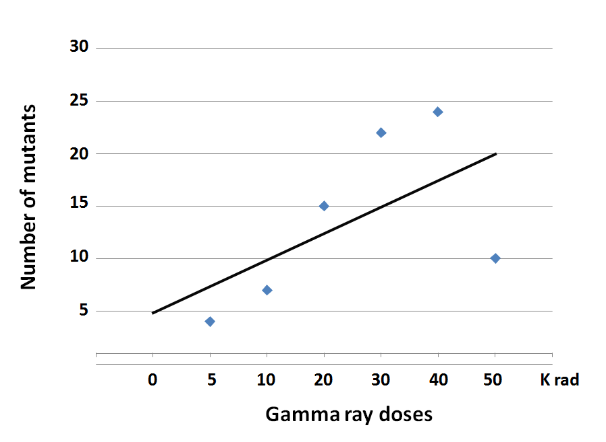
Figure 1. Number of high salt tolerance mutants induced by different doses of gamma rays to higher frequency of specific chromosome lesions in cells that had been irradiated. In addition, radiation at 50 k rad caused lowest survival rate of mutants.

These results are in agreement with those obtained by (Zaied et al., 2005; Fahmi et al., 2011). They reported that more than 100 genetic loci are thought to be involved in the repair of mutation damages to DNA in Rhizobium. In addition, mutation percent was gradually increased with increasing gamma rays doses. Several studies suggested that gamma rays produce genetic damage in rhizobial DNA. Actually, gamma irradiation mutants could not reverse to wild type in any mutant loci (Min et al. 2003). Moreover, the results obtained in Fig.ure 1. Show that, we obtained 82 mutants by gamma rays could grow at different concentrations of sea water. We obtained 4, 7, 15, 22, 24 and 10 mutants at 5, 10, 20, 30, 40 and 50 K rad of gamma rays, respectively. The most isolate that give us mutants about 13 mutants was strain 2, thin strain 3 and strain 8, they given about 11 mutants for each. However, strains 4 and 6 were the lowest mutants they given about four mutants only. We selected 10 mutants could grow at high sea water concentrations from all parental strains. Ten mutants were tested for Sea water tolerance by growing on YEM media supplemented with different sea water concentration Figure 2. we observed that, mutant strain could grow at high concentrations of sea water than parental strains. Our results agree with report of Fahmi et al. (2011). It indicated that DNA damage due to gamma-ray radiation also increased with increasing dose rates. The biological effects of ionizing radiation are closely correlated with the energy absorbed per unit mass (i.e. the dose). For a given dose, the biological effects also depend on the pattern of energy deposition at the microscopic level, i.e. the quality of the radiation, which is usually expressed in terms of linear energy transfer, and on the rate of energy deposition, i.e. the dose-rate (Chitchanok et al., 2011). It has been reported that the severity of biological effects such as mutations, increases with increasing dose rates (Min et al. 2003). This phenomenon, called the dose-rate effect, may have important implications for genetics and radioprotection. The risk of detrimental genetic effects due to ionizing radiation for organisms decreases with decreasing dose rate, known as direct dose-rate effects (Vilenchik and Knudson, 2006).

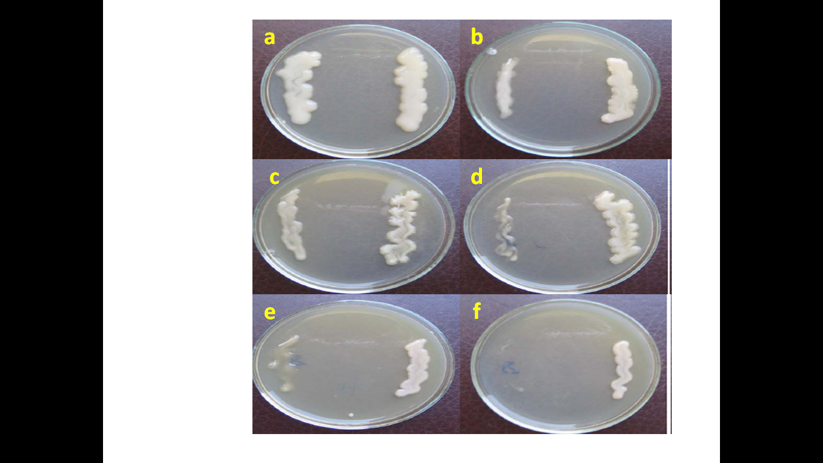
Figure. 2. Growth of salt tolerant rhizobial strain 8 and its mutant on YMA medium supplemented with concentrations; a = 0 %, b = 20 %, c = 25 %, d = 30 %, e = 40 % and f = 50 % of Sea water.

N₂ content in Vicia faba under salinity condition:
The shoots and roots total nitrogen accumulated through the vegetative growth after seven weeks of planting are presented in table (1) and Fig. (3). Data show that all these parameters are governed by the number of active nodules formed on the roots of Vicia faba plants. Inoculation plants with mutant strains shown more nitrogen fixed in plants than inoculated plants with parental mutants. Moreover it increased about two times with mutant 1 and mutant 5 compared with non-inoculated plants. And it increased about three times with mutant 2, 9 and mutant 10. On the other hand, Plants treated with sea water improved the accumulation of biomass with less total nitrogen than inoculated plants with parental strains. N₂ content at 20 % of sea water ranged from 20.37 mg/plant with mutant 6 to 47.25 mg/plant with mutant 10, Comparing with plants inoculated with parental strains at the same concentrations of sea water.

Table 1. Effect of induced mutants on total nitrogen content in faba bean after seven weeks.
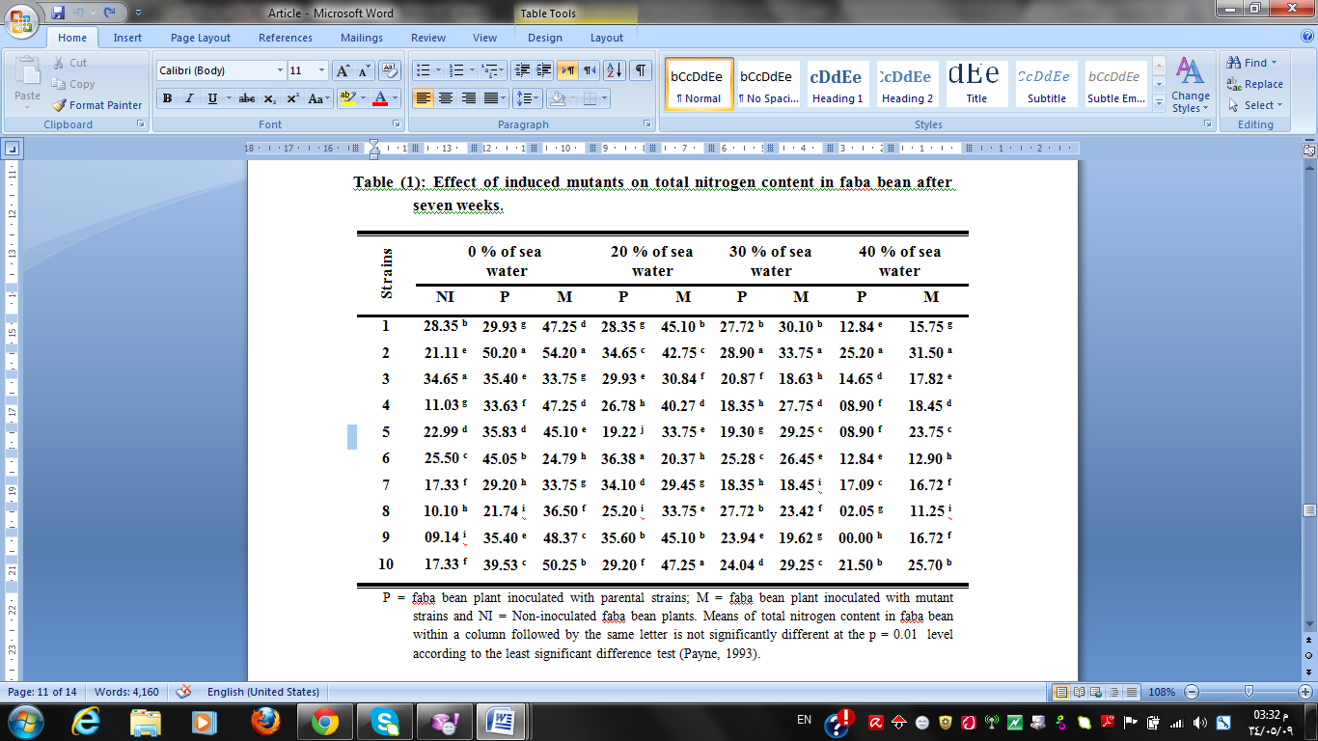
P = faba bean plant inoculated with parental strains; M = faba bean plant inoculated with mutant strains and NI = Non-inoculated faba bean plants. Means of total nitrogen content in faba bean within a column followed by the same letter is not significantly different at the p = 0.01 level according to the least significant difference test
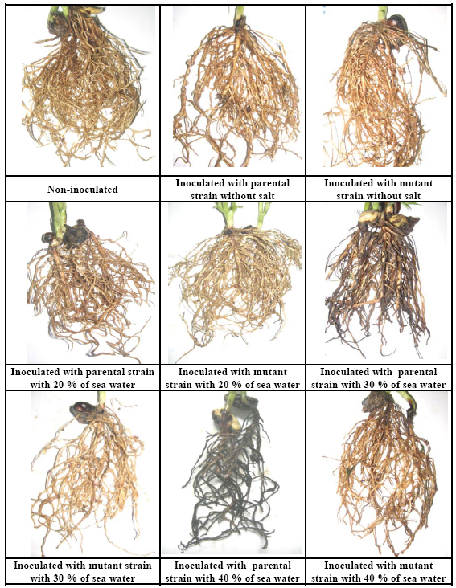
Figure 3. Effect of salinity on Vicea faba inoculated with Rhizobium (parental and mutant strains) at different concentrations of sea water.

This ranged from 19.22 mg/plant with parental strain 5 to 35.60 mg/plant with parental strain 9. Moreover, N₂ content at concentrations 30 and 40 % of sea water ranged from 18.45 and 11.25 mg/plant to 33.75 and 31.5 mg/plant, comparing with plants inoculated with parental strains at the same concentrations of sea water. That ranged from 0 and 18.35mg/plant to 27.72 and 25.20 mg/plant, respectively. Legumes have immense value due to their capacity to enhance soil fertility by fixing atmospheric nitrogen through the symbiotic relationship with rhizobia. However, salinity, water deficit and temperatures stress are serious threats to rhizobium-legume symbiosis. Thus, while strategies to improve legume production in saline environments include selection of host genotypes that are tolerant to high salt conditions, inoculation with salt-tolerant strains of rhizobia could constitute another approach to improve legume productivity under symbiosis (Zheng et al., 2009 and Sharma et al., 2013). The rhizobia isolated in this study were able to grow at high salt concentration in in vitro cultures and formed nodules on seedlings irrigated with saline water. (Matiru and Dakora 2004; Zheng et al., 2009), suggested that high salinity levels decreased nitrogen content. Some of the inoculated plants with the parental strain of Rhizobium leguminosarium and mutant strains derived from the treatment by gamma rays were significantly successful in nodulation. Most mutant strains were more effective in nodulation and N₂ fixation than the parental strains (Fahmi et al., 2011 and Sharma et al., 2013).
Effects of gamma rays on rhizobial DNA: The RAPD method was tested as a means to find genetic markers for gamma rays treated rhizobia. DNA was extracted from ten strains and their induced mutants. Those DNA were tested against seven 10-mer random primer. Four primers OP-A1, OP-A5, OP-A2 and OP-B5 did not have any product with DNA extracted but the other three primers OP-A22, CC1 and PRIM239 showed different banding patterns as presented in Figs. (4), these bands used as positive or negative molecular marker for DNA damage by gamma rays. Our results achieved that, the three primers given total number of 49 different bands. Primer OP-A22 given about 19 different bands. Bands with size 1000, 900 bp presented in Parental strains 9, but they absented in mutant 9. The same results observed between Parental strain 4 and mutant 4. Moreover, band with size 600 bp found in mutant 7 and absented in parental strain 7. For primer CC1, bands with size 900, 1000, 1150 found in parental strain 4 but it absent in mutant 4 and bands with size 990 and 1420 found in mutant 6 and they absent in parental strain 6. For primer PRIM239, bands with size 1000, 1600 bp found in parental strain 1 and absent in mutant 1, bands with size 1500 bp found in mutant strain 5 and absent in parental 5. Finally, there is not different among pattern strains from 6 to 10 and their mutants strains. RAPD profiles showed different and mixed patterns for both types of rhizobial strains and therefore it was not possible to discriminate gamma rays mutants from parental strains rhizobia (palmer et al., 2000).

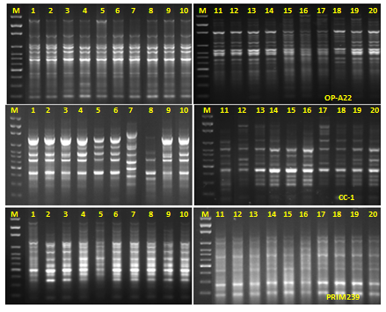
Fig. (4): RAPD profile of ten rhizobial strains after and before the treatment with different doses of gamma rays, whereas, 1= Untreated strain 1, 2= Treated strain 1 , 3= Untreated strain 2, 4= Treated strain 2, 5= Untreated strain 3, 6= Treated strain3, 7= Untreated strain 4, 8= Treated strain 4, 9= Untreated strain 5, 10 = Treated strain 5, 11= Untreated strain 6, 12= Treated strain 6, 13 = Untreated strain 7, 14 = Treated strain 7, 15= Untreated strain 8, 16 = Treated strain 8, 17 = Untreated strain 9, 18 = Treated strain 9, 19 = Untreated strain 10, 20 = Treated strain10 and M = 100 pb. DNA marker.

Either any genes involved in stress existed in both types of rhizobia and were expressed differently with regard to gamma rays treatment or the primers did not bind to relevant parts of the DNA involved in mutants. Those three sets of RAPD primers were therefore not sufficient to find genetic markers for mutants DNA from those strains of rhizobia, but may be useful for their information on genetic diversity in general. (Jose et al., 2004; Moschetti et al., 2005). The randomly amplified polymorphic DNA (RAPD) technique has been used to compare rhizobial communities previously. (Mutch and Yong, 2004; Berrada et al., 2012). Individual strains treated with gamma rays contain different DNA sequences that are amplified and discriminated by electrophoresis in that a primer attaches to some DNA but not others. For example, the RAPD profiles were used to show a high level of genetic polymorphism among isolates of Rhizobium leguminosarum bv. viciae and to discriminate their genetic differences (Mostchetti et al., 2005 and Berrada et al., 2012).
Conclusions
Salt-stress is the major constraints to plant productivity in salt environments and isolation of effective rhizobia to inoculate the leguminous crop plants could be an important strategy to improve the efficiency of rhizobium-legume symbiosis and thereby productivity. The results from this study showed that the rhizobia isolated from the salt soils are able to survive, grow and effectively nodulate faba bean even at high salt concentrations induced by gamma rays. Additional research to precisely identify the rhizobial strains through molecular characterization (16S-rDNA gene sequencing) and evaluate their growth performance, symbiotic efficiency and nodulating ability against other important environmental stresses such as temperature, pH and heavy metals is currently in progress.

Corresponding Author:
Dr. Mohamed M. Hassan
Genetics Department
Faculty of Agriculture
Minufiya University, Egypt.
E-mail: khyate_99@yahoo.com

References
- Berrada H., I. Nouioui, M. Iraqui, N. El-Ghachtouli, M. Gtari and K. Fikri. 2012. Phenotypic and genotypic characterizations of rhizobia isolated from root nodules of multiple legume species native of Fez, Morocco. Afr. J. Microbiol. Res. 6(25):5314-5324.
- Chitchanok. A., P. Rattasaritt,, S. Suthatip, P. Suphaporn,, P. Nattayana and T. Yanee. 2011. Improvement of Vitamin B6 Production from Rhizobium sp. 6-1C1 by Random Mutation. KKU Res. J. 16(8): 911-918.
- Eissa, A.R., M.E. Abd-El-Bary, A.I. Fahmi, H.H. Nagaty and M.M. Hassan, 2009. Evaluation and characterization of γ induced mutants of Rhizobium leguminosarum in Vicia faba. Proceedings of the 1st Nile Delta Conference, (NDC'09), Minufiya University, Egypt, pp: 157-170.
- Fahmi A.I., H.H. Nagaty, R.A. Eissa and M.M. Hassan. 2011. Effects of Salt Stress on Some Nitrogen Fixation Parameters in Faba Bean. Pak. J. Biol. Sci., 14: 385-391.
- Fauvart M. and J. Michiels. 2008. Rhizobial secreted proteins as determinants of host specificity in the rhizobium-legume symbiosis. FEMS Microbiol. Lett. 285: 1–9.
- Fernandez A.C., T.B. Hamouda, I.G. Fernando, M. Argandoña, M. Reina-Bueno, J.J Nieto, ME. Aouani and C. Vargas. 2010. Biosynthesis of compatible solutes in rhizobial strains isolated from Phaseolus vulgaris nodules in Tunisian fields. BMC Microbiol. 10: 192-208.
- Jose, A.C., P. Armario, E. Pajuelo, A. Burgos, M.A. Caviedes, R. Lopez, M.A. Chmber and J.P. Antonio. 2004. Isolation and characterization of symbiotically effective Rhizobium resistant to arsenic and heavy metals after the toxic spill at the Aznalcollar pyrite mine. Soil Biol. Biochem. 37: 1131-1140.
- Matiru V.N, and F.D. Dakora. 2004. Potential use of rhizobial bacteria as promoters of plant growth for increased yield in landraces of African cereal crops. Afr. J. Biotechnol. 3(1):1-7.
- Meuelenberg F. P. and F. D. Dakora. 2007. Assessing the biological potential of N₂-fixing Leguminosae in Botswana for increased crop yields and commercial exploitation. Afr. J. Biotechnol. 6 (4): 325-334.
- Min J., C.W. Lee and M.B. Gu. 2003. Gamma radiation dose-rate effects on DNA damage and toxicity in bacterial cells. Radiat Environ Biophys. 42: 189-92.
- Moschetti, G., A. Peluso, A. Protopapa, M. Anastasio, O. Pepe, and R. Defez. 2005. Use of nodulation pattern, stress tolerance, nodC gene amplification, RAPD-PCR and RFLP-16S rDNA analysis to discriminate genotypes of Rhizobium leguminosarum biovar viciae. Syst. Appl. Microbiol. 28: 619-631.
- Mutch L.A. and J. W.Yong, 2004. Diversity and specificity of Rhizobium leguminosarum biovar viciae on wild and cultivated legumes. Molecul. Ecol. 13: 2435–2444.
- Orrillo E.O., P. Menna, L. Gonzaga, P. Almeida, F.J. Ollero, M.F. Nicolás, E.P. Rodrigues, A.S. Nakatani, J.S. Batista, L.M.O. Chueire, R.C. Souza, A.T.R.Vasconcelos, M.M. Hungria and E.M. Romero. 2012. Genomic basis of broad host range and environmental adaptability of Rhizobium tropici CIAT 899 and Rhizobium sp. PRF 81 which are used in inoculants for common bean (Phaseolus vulgaris L.). Genomics, 13:735-761.
- Palmer K.M. and J.P.W Young. 2000. Higher diversity of Rhizobium leguminosarum biovar viciae populations in arable soils than in grass soils. Applied and Environmental Microbiology, 66, 2445–2450.
- Payakapong, W., P. Tittabutr, N. Teaumroong, N. Boonkerd, P. Singleton and D. Borthakur. 2006. Identification of two clusters of genes involved in salt tolerance in Sinorhizobium sp. Strain BL3. Symbiosis, 41: 47-53.
- Sharma S.R., N.K. Rao, T.S. Gokhale and S. Ismail. 2013. Isolation and characterization of salt-tolerant rhizobia native to the desert soils of United Arab Emirates. Emir. J. Food Agric. 25 (2): 102-108.
- Vilenchik M.M. and A.G. Knudson. 2006. Radiation dose-rate effects, endogenous DNA damage, and signaling resonance. roc Natl Acad Sci U S A. 103(47):17874-9
- Vincent, J.M. (1970). A manual for the practical study of root nodule bacteria. Blackwell, Oxford.
- Zahran H.H. 1999. Rhizobium-legume symbiosis and nitrogen fixation under severe conditions and in an arid climate. Microbiol. Mol. Biol. Rev. 63: 968-989.
- Zaied, K.A., F.S. Faris and A.M. Assar, 2005. Effect of gamma irradiation on physiological and biochemical traits in cowpea, Vigna unguiculata (L.) Walp inoculated with new recombinant isolates of Bradyrhizobium. Pak. J. Biol. Sci., 8: 1173-1191.
- Zheng, C., D. Jiang, F. Liu, T. Dai, Q. Jing and W. Cao. 2009. Effects of salt and water logging stresses and their combination on leaf photosynthesis, chloroplast ATP synthesis and antioxidant capacity in wheat. Plant Sci., 176: 575-582.

3/20/2013

