Investigating the Development Challenges to Siwa Oasis, Northwestern Desert, Egypt

Mohamed Fahmy M. El Hossary

RIGW, NWRC
melhossary62@ymail.com

Abstract: This research was initiated with the objective of developing water management strategies to Siwa Oasis to ensure its sustainable development. This is carried out by proposing and testing chain water management scenarios that makes use of suitable water (multiple reuses) before it reaches the last disposal point. The results indicated that this specific type of water management can add about 9,000 feddans to the presently cultivated area in Siwa Oasis as a result of water saving without any additional groundwater. Accordingly, the productivity of each unit of groundwater will be achieved along with reducing the non-productive area which is presently occupied by the salt lakes.
[Mohamed Fahmy M. El Hossary. Investigating the Development Challenges to Siwa Oasis, Northwestern Desert, Egypt. N Y Sci J 2013;6(4):55-61]. (ISSN: 1554-0200). http://www.sciencepub.net/newyork. 10

Keywords: Development; Challenges; Siwa Oasis, Desert; Egypt

1. Introduction
Groundwater is a very important source of water especially in arid and semi-arid regions. It is considered as the only source of water in the Eastern and Western Deserts of Egypt. Siwa Oasis is a natural depression about 18m below sea level. It is located in the northern part of the Western Desert of Egypt (about 90 kilometers east of the Libyan border) and 300 kilometers south of the Mediterranean Sea. It covers an area of about 250,000 Feddans of which about 15,000 Feddans are currently cultivated.
The total number of inhabitants in Siwa is 21,000 residents in 2006 (Siwa Information Center, 2009). The main activity in Siwa Oasis is agriculture totally based on groundwater available from both dug wells and naturally flowing springs.
The total number of hand dug wells and springs are about 1100 giving a total discharge of about 130 million m³/year. From this water, about 79 million m³/year is productive (consumed through evapotranspiration) while the rest is lost to the lakes where it partially evaporates (RIGW, 2012). This has led to a continuous loss of productive lands and drainage problems in the surroundings of the lakes.
This research was initiated with the objective of developing water management strategies to Siwa Oasis to ensure its sustainable development. This investigation is presented in this paper under the following headlines:
- Describing the location and physical setting of the study area
- Describing the historical development to the study area
- Describing the hydrogeological features of the study area
- Determining the factors that constrain the development of Siwa
- Proposing solutions

2. Describing the Location and Physical Setting of the Study Area
Siwa depression is an isolated closed basin located in the northern part of the Western Desert of Egypt, about 90 kilometers east of the Libyan border and 300 kilometers south of the Mediterranean Sea, figure (1). The topographic features of the Oasis show a depression divided into four major catchments (i.e. El Maraqi, Siwa, Aghourmi and Zeitoun). Each catchment is characterized by its own drainage natural lake, which receives the agricultural drainage water and the excess flowing groundwater from the natural springs and the private wells.

Figure (1); Location Map of the Study Area

3. Describing the Historical Development of the Study Area
Ancient Writers reported that Siwa once contained thousands of naturally flowing springs. In 1963 there were less than 200 developed springs of any importance with a maximum depth of 12 meters (Parsons 1963). In the period 1981- 1996, farmers invented their own drilling machine that enabled them to drill thousands of poorly designed wells in the fractured limestone aquifer. This led to a surplus of water supply which resulted in the formation of lakes at the lowest part of each catchment along with continuous loss of productive lands.
The existing wells are shallow in depth ranging between 10 and 120 m deep. All these shallow wells are poorly designed with no casing or control valves. The field investigation conducted by the Research Institute for Ground Water (RIGW, 1996) started by identifying the location of wells and springs, ground surface elevation, well depth, flow rate measurements, complete chemical analysis and the cultivated area served by each well and spring. The well inventory indicated that 400,000 m³/d were flowing continuously and only about 60 % of this water was used for irrigation and the rest was diverted to the poor drainage network ending finally in the lakes.
Actions taken in the period 1996 – 2001 concentrated on the rehabilitation of approximately 400 poorly designed wells; while some others (865 wells) were considered to be of low priority. However, the problem was not completely solved due to the continuous addition of new wells. At present directly losses from shallow wells that reaches the lakes is estimated to be 51 million m³ /year (RIGW, 2012), in addition to about 22 million m³/year from natural agricultural drainage.
4. Describing the Hydrogeology of the Study Area
This section introduces the hydrogeological features of the study area, as follows:
4. A. Aquifer Systems
In Siwa Oasis the strata of hydrogeological interest are composed of 450-600 m thick of fractured dolomite and limestone overlaying the Nubian sandstone aquifer. The fractured carbonate zones are separated from the underlying Nubian sandstone by the low permeability shale and clay layer. This layer acts as aquitard and its thickness varies between 60 in the west and 250 m in the east figure (2).
The Nubian aquifer has a thickness of about 2600 m and belongs to the Mesozoic and Paleozoic age. The upper zone of the Nubian Sandstone aquifer in Siwa Oasis has a thickness of about 500m and is saturated with fresh water with salinity less than 500 ppm. The net sand thickness of this aquifer decreases northward and westward. The water pressure head of the Nubian Sandstone aquifer ranges between 80m in the western part of the Siwa area (where shallow wells and springs exist) and 120 meters in the east.
Geologically, the carbonate aquifer system in the study area is predominantly hard limestone with chalky limestone in some localities. This change in the aquifer facies leads to a possible change in the water quality while passing through it. The chemical analysis of the water samples discharged from the fractured carbonate aquifer showed that the total dissolved solids vary between 1500 and 8000 ppm.

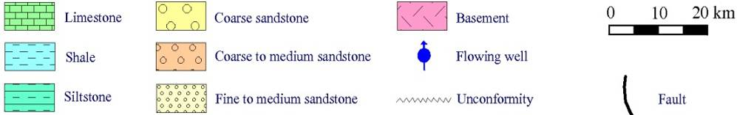
Figure (2): Hydrogeological cross section of Siwa area

Figure (3) Well location map for Siwa Oasis

4. B. Groundwater Discharge
In 1996, the Research Institute for Groundwater (RIGW) started intervening in the oasis. This intervention included the identification of water points location (x and y), ground surface elevation, well depth, flow rate measurements, complete chemical analysis and the cultivated area served by each well and spring. The results indicated that the total discharge is 146 million m³/year, table (1).
Based on the inventory, 400 wells were considered of high priority for rehabilitation due to their high flow rate. As a result of the rehabilitation, which took place during the period 1996-2001, the total groundwater discharge reached 130 million m³/year, table (2). However, due to the continuous unlicensed drillings 51 million m³/year are lost to the lakes, Ground Water Sector (2012).

Table (1): Daily and Annual Flow from wells and springs (RIGW 1996)
Catchment Area | Discharge rate (m³/day) | Discharge rate (m³/year)
El Maraqi | 60,000 | 21,900,000
Siwa | 140,000 | 51,100,000
Aghourmi | 120,000 | 43,800,000
Zeitoun | 80,000 | 29,200,000
 | 400,000 | 146,000,000

Table (2): Daily and Annual Flow from wells and springs GWS (2012)
% Losses to the Lake related to total discharge | Demand (m³/y) | Cult. Area (Fed.) | Total discharge rate (m³/ y) | Catchment Area
49 % | 10,597,500 | 1413 | 25,820,940 | El Maraqi
42 % | 38,000,000 | 5066 | 65,208,600 | Siwa
22 % | 20,632,500 | 2751 | 26,417,820 | Aghurmy
22 % | 9,622,500 | 1283 | 12,249,120 | Zeitun
39 % | 78,847,500 | 10,513 | 129,696,480 | Total

5. Determining the Factors Constraining Sustainable Development of Siwa Oasis
5. A. Groundwater Quality
The groundwater potential (sustainable) of the Siwa Oasis is estimated to be 500,000 m³/d (El Hossary, 1999). This amount is obtained, either directly from wells tapping the Nubian Sandstone aquifer only or from both the Nubian and the fractured limestone formation through the fractures which serve as paths to the groundwater contained in the Nubian.
The groundwater quality in the Nubian aquifer, in terms of TDS, varies from 200 ppm (the upper zone of the aquifer which is about 500 m thick) to more than 1,500 ppm in the lower portion of the aquifer. Moreover, during its path in the limestone, groundwater salinity increases due to the leaching of carbonate salts.
5. B. Sustainable Groundwater Flow
Table (2) summarizes the present discharge of groundwater, cultivated area, water requirements and percent losses to the drainage lakes. It can be concluded from the table that, irrespective to the rehabilitation program and replacement of wells, still the percent of losses to the lakes is high.
Due to the habits of the oasis people, a quick change can be harmful and thus resisted by the majority. However, introducing the sustainability factor and the effect of uncontrolled flow of wells can be understood, especially that the people have monitored the continuous decrease in flow and increased salinity.
6. Proposing Solutions
Based on the above conditions of the study area, solutions were proposed. Basically, the inhabitants of the oasis reuse flowing groundwater, especially those located at the end of a well/spring command. Moreover, the topography of the oasis within each catchment has a general slope which can facilitate downstream reuse of water. This situation can facilitate the introduction of down slope reuse of water.
6.a. Proposing Multiple-Reuse Schemes
Multiple-reuse is a localized method within a hydraulic basin, whereby a portion of available drainage water is reused several times, while for each consecutive time, crops are grown with a higher salt tolerance. Once the water salinity becomes too high for any crop production, the next stage in reuse is fish farming in brackish water. The ultimate drainage effluent from the fishponds is then discharged into evaporation ponds, where the salt precipitates and will be removed mechanically.
The benefit of multiple-reuse is that a maximum productivity from a unit of water is achieved, while it simultaneously reduces the accumulation of salt towards the downstream reaches of the Siwa lakes system. Application of multiple-reuse is limited to minor drains and branch open drains at Siwa depression that are not affected by domestic or industrial pollution.
The feasibility of applying multiple-reuse and salt disposal in evaporation ponds depend mainly on the availability of a suitable local depression where safe storage or safe disposal of a brine or precipitation of salts is possible. Figures (4), (5) and (6) show surface geological and geomorphological conditions available at Siwa area since the four local Lakes (El Maraqi, Siwa, Aghurmi and Zeitun) and reclaimable lands of highly permeable sandy soils lie several meters higher than the Lakes are suitable to apply the strategy of Multiple reuse of drainage water.

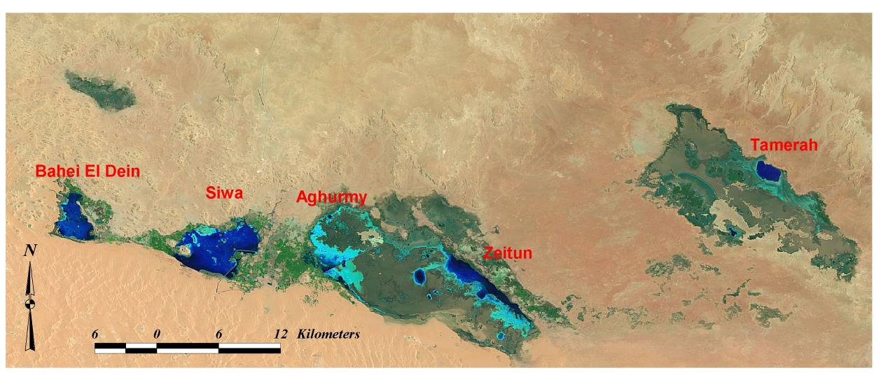
El Maraqi

Figure (4): Landsat Image for the Study Area

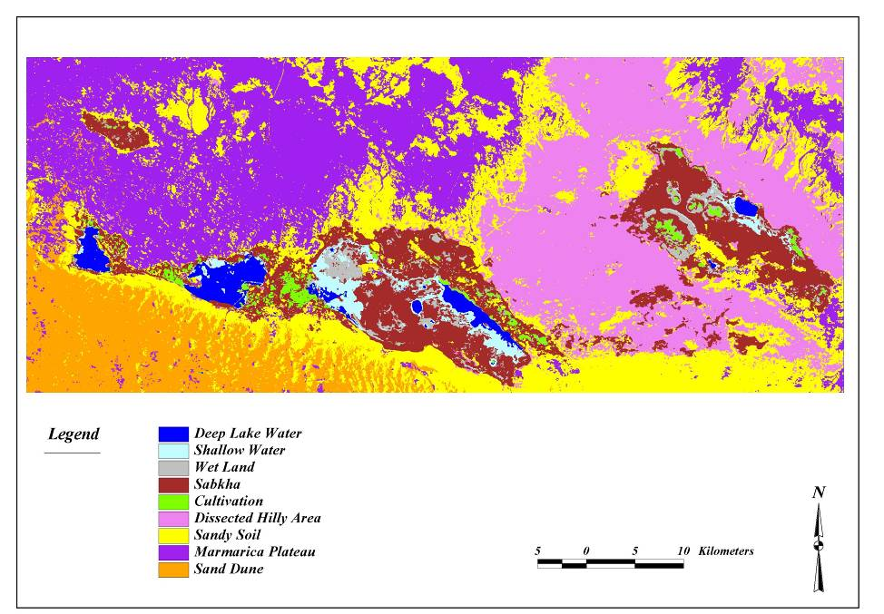

Figure (5): Land use map of Siwa area

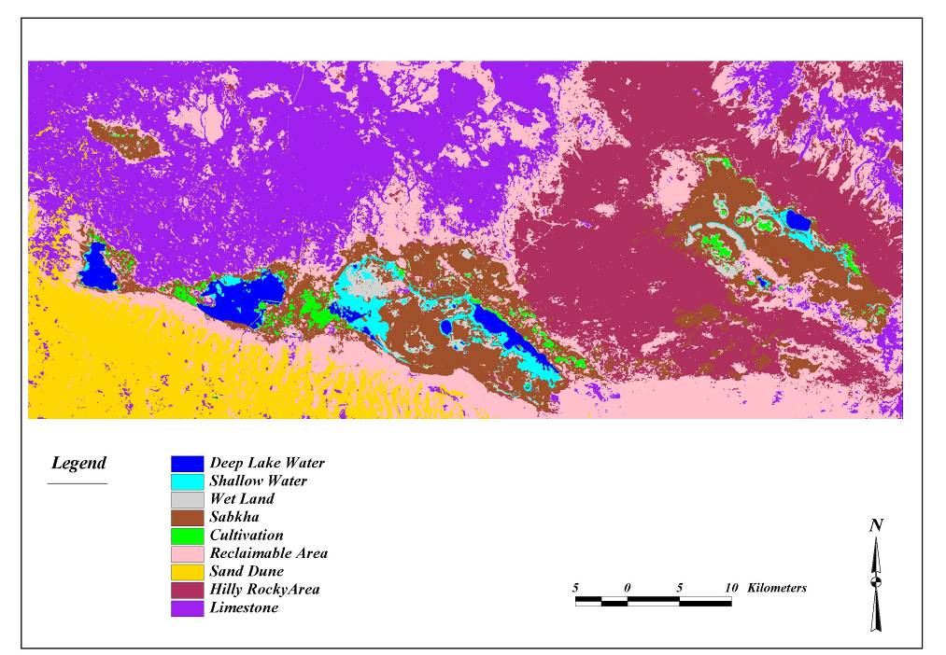

Figure (6) :Geomorphologic map of Siwa area

Research results from India, Pakistan, Central Asia and Egypt, where surface irrigation methods are applied, showed that drainage water can be used directly for irrigation purposes without severe crop yield reductions where the salinity of the drainage water does not exceed the threshold salinity value for the crops grown and good drainage conditions exist. As crops are often more sensitive to salinity during the initial growth stages, research in India has revealed the importance of pre-irrigation with good quality irrigation water. Higher crop yields were attained when freshwater pre-irrigation was applied with only drainage water being applied there after. Under these conditions, drainage water with salinity levels exceeding the threshold value, could be used whilst maintaining acceptable crop yields. The long-term sustainability of direct use of drainage water depends on maintaining a favorable salt balance and preventing soil degradation due to sodicity problems.
Figure (7) is a schematic presentation of the proposed scheme; taking into consideration that domestic water is separate. The scheme illustrates the type of uses at each stage:
- The first stage, with appropriate groundwater quality, would be cultivated with medical crops of high value
- Drainage water can either be mixed with good groundwater or directly reused for wood farms or alike
- The third stage can be for fish farms
- The fourth stage for salt production

Salt
Direction of calculation of water & salt balances
Evaporation pond
Fish pond
Cout = 9000 mg/l

Wood farm
Cout = 4000 mg/l
Non-food farm
Cout = 2500-3000 mg/l
Water Balance:
Qout = Qin – ET

Salt balance (assume storage = 0) :
Sin = Qin x Cin = Qout x Cout = Sout
Q_{in}
Q_{in}
Q_{out}

Figure (7): Principle of multiple reuse and procedure of calculations

Conclusions
The development of the Siwa depression is presented in two parts: the presently-developed agriculture areas around the four Lakes where brackish groundwater from shallow wells is the main source of water supply for irrigation and the new areas proposed for reclamation and development (i.e. to the east of Siwa depression along Siwa- El Bahariya road [Abu Shrouf, El Zeitun, Munqar El Talh and El- Khashby]).
Water supply for new reclaimable areas will be generated essentially from the Nubian sandstone aquifer of salinity less than 300 ppm. Such a development program has many implications, including a continuous decline of the piezometric head of the Nubian sandstone aquifer. However, within the Siwa Oasis has itself, actions should be taken to maximize the return from available water. The solution cannot be implemented without a prior discussion with the inhabitants.
The proposed scheme of multiple reuse is expected to about 9,000 feddans will be added to the presently cultivated area without any addition of well points. The benefit of multiple reuses is that a maximum productivity from a unit of water is achieved, while it simultaneously reduces the accumulation of salt towards the downstream reaches of the Siwa Lakes system.

Recommendations
Based on the above, the following aspects are recommended to be taken into consideration:
- Discussion of the proposed scheme with the local inhabitant of the oasis.
- If successful results from the discussion are achieved, implementation of a pilot scheme is recommended, monitored and evaluated.
- Domestic water should be given a first priority.
- Use of agriculture chemicals should be prevented (which is the tradition in the oasis).
- Various types of water uses/allocation can be practiced and evaluated.

Corresponding author
Mohamed Fahmy M. El Hossary
Rigw, Nwrc,
Melhossary62@Ymail.Com

References
- Arab Organization for Agricultural Development (AOAD) (1977). Feasibility study for economic and agricultural development in Siwa. Internal report, 457p (In Arabic).
- CEDARE (2001). Regional strategy for the utilization of the Nubian Sandstone Aquifer System (groundwater model). Center for the Environment and Development for the Arab Region and Europe, Cairo, Egypt.
- El Hossary, M. F. (1999). Evaluation and management of groundwater resources in Siwa area with emphasis on the Nubia Sandstone aquifer. Ph. D. Thesis, Fac. of Sci., Ain Shams Univ., Egypt.
- Gad, M. I. (1999). Water budget analysis for topmost aquifer for some cultivated areas in the central part of Siwa Oasis, Western Desert, Egypt. Ph. D. Thesis; Fac. of Science; Al Azhar University; Egypt.
- Misak, R. F., Abdel Baki, A. A., El Hakim, M. S. (1997). On the causes and control of water-logging phenomenon, Siwa Oasis, Northern Western Desert, Egypt. Jor. Of Arid Environments; 37: 23-32.
- Parson, R. M. (1963). Studies of Siwa Area. Final report.
- RIGW (2012). Technical report for Siwa water points survey.
- Sakr, Sameh A., M. F. El Hossary and Fatma A. Attia. 1996. Simulation of regional flow in a multi layer aquifer system: Siwa Oasis. International conference on integrated management of water resources in the 21st Century. Cairo, Egypt.

2/22/2013

