The floristic composition of Rocky habitat of Al Mansora in Al- Jabal Al- Akhdar- Libya

Abusaief, H. M. A.¹ and Dakhil, A. H²

¹Agron. Fac. Agric., Omar Al-Mukhtar Univ. ²Bot. Fac. Sci. Omar Al-Mukhtar Univ
Bossef_mohamed@yahoo.com

Abstract: Due to the absence of a survey on all species in Al Mansora habitat, So conducted Floristic composition, to study the number of species and the families, order and life forms of the species found in the rocky habitat during four seasons of autumn 2010 to summer 2011 of Al Mansora site in Al Jabal Al Akhdar in Libya. The research area is located latitude 32̊, 50′ ,44.8″ N and longitude ,50َ ,21ْ 30.3″ E. Used Raunkiaer׳s system to classify in life-forms the vascular plants present in 12 random 25 m² quadrate. Founded about 175 species belonging to 43 families and 142 genera were recorded in Al-Mansora area. They are represented by 78 perennial, 92 annual and 5 biennial species. The most characteristic families in rocky habitat are Asteraceae (15.4%) containing 27, Poaceae (12.6%) represented by 22 species, Fabaceae (12%) represented by 21, Lamiaceae (6.9%) 12 species. Noticed that 53% of species was annuals, 3% was biennials and 45% was perennials. In autumn and summer season increase perennials of 85.7% and 75%, respectively, wherein spring and winter increase annuals species by 54.1% and 40.7%, respectively. The life forms the vascular plants were Therophytes 59.4%, is represented by the largest number of species, Chamaephytes has 13.1%, Hemicryptophytes has a moderate value of 11.4%, Geophytes represents about (10.3%). Relationship the life forms with seasons increase Therophytes in spring and autumn, respectively. Chamaephytes highly during season autumn and summer. Hemicryptophytes low in all seasons except spring season. Geophytes highest in autumn and winter, lowest during summer and spring season. Phanerophytes high during summer and autumn season. Also, founded 22 order were recorded, given the order Asterales of the largest number of species Arrived to 27 species (15%), followed by Lamiales, Poales and Fabales order.
[Abusaief, H. M. A. and Dakhil, A. H. The floristic composition of Rocky habitat of Al Mansora in Al- Jabal Al- Akhdar- Libya. N Y Sci J 2013;6(5):34-45]. (ISSN: 1554-0200). http://www.sciencepub.net/newyork. 7

Keyword: Rocky habitat, floristic composition and life forms

1. Introduction
The systematical analysis of the flora, by the families, is of great importance especially to the comparative analysis of the flora. In the Green Mountain area includes natural vegetation on a variety of plant associations, including plants annual and other perennial. Habitats are classified as scree or rock habitat types even if characteristic higher plant species are missing as long as characteristic moss and lichen species are present and the habitats are sufficiently natural (Schröder et al. 2006).
A life-form is characterized by plant adaptation to certain ecological conditions (Mera et al. 1999). In Raunkiaer׳s (1934) system, the more pronounced the unfavorable season, the more protected the renewing buds. In his classification to there are five major classes, arranged according to increased protection of the renewing buds: phanerophytes, chamaephytes, hemicryptophytes, cryptophytes and therophytes. Raunkiaer׳s classification was modified, by Mueller-Dombois and Ellenberg (1974), to include plant features in the favorable season. Inland rocky habitats of particular conservation value include natural rocks and cliffs, scree and limestone pavements. Each of these habitats is characterised by grasses, dwarf-shrubs and/or herbs growing in restricted crevices. In many cases the result of this is that competition for light is less of an issue than in closed grassland canopies, so that the interaction with air pollutants may also differ. Currently, there is a lack of data on these interactions, and expected effects must be derived from experience with other habitat types (APIS, 2011). Dwarf-shrub formations linked to soils with rocky emergences and characterized (especially near Benghazi) (Brullo and Furnari, 1981).
The main objective of the present work is to examine the survey and study plant species to the flora of Al Jabal Al Akhdar of Al Mansora site in Libya, Our aim is to answer the following question with respect to different families and the life-forms of vascular species between seasons found in the rocky habitat of Al Mansora site.

Study area
The study area is located in the Mediterranean Coast of Libya-Al Jabal Al Akhdar. The Rocky habitat Al-Mansora between latitude 32̊, 50′ ,44.8″ N and longitude ,50َ ,21ْ 30.3″ E. Al-Mansora distance 11 Km east Al Baida city (Figure 1). Three transect were investigated from north to south. Distance Al Mansora 6.5 km of the Mediterranean sea with altitude at 309.4 m.

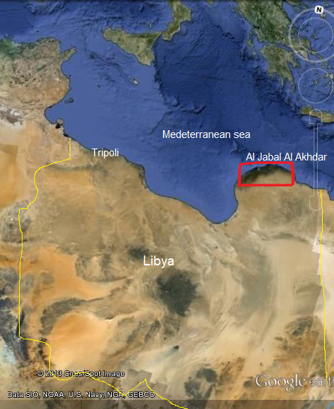 | 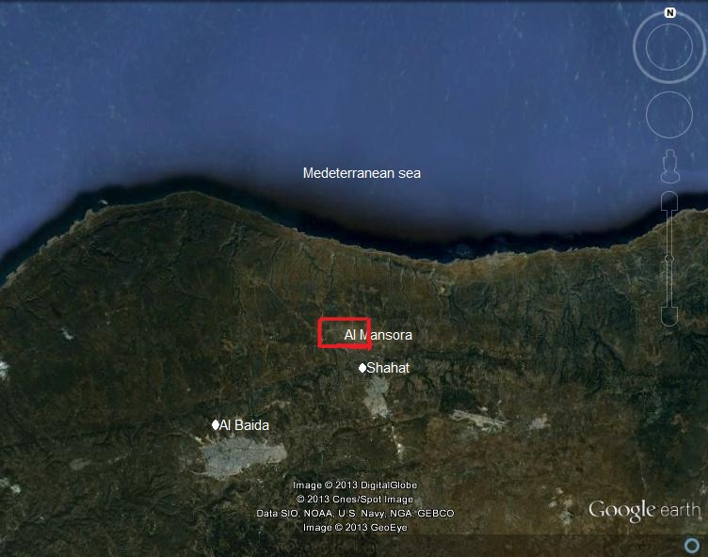
Fig. 1. The location of Al Mansora area located in the Mediterranean region of Libya (by Google earth).

Although the world's vegetation distribution is determined largely by climate (Woodward, 1987). Generally climate the Mediterranean zone has a semi-arid but not arid as often stated. Mediterranean climate has in effect three different definitions: (1) climate of the Mediterranean Sea and bordering land areas; (2) climate that favors broad-leaved, evergreen, sclerophyllous shrubs and trees; (3) winter-wet, summer-dry climate (Blumler, 2005). The Green Mountain region more areas of Libya precipitation, with an average annual precipitation 400 mm/year and maximum of rainfall reaches 650 mm/year belt area (Messa- Al Baida- Shahat). The average relative humidity of about 60% in the period from April until the end of September and about 90% during the months of December and January. The highest mean temperature meteorogical station Shahat imitation Al Mansora region for years 1999 to 2009 about 24 C˚ through Augustus month.
Characterized land area Green Mountain generally high proportion of gravel and reveal the original material rock where he found that more than 45% of the soils Green Mountain severe rocky and nearly 50% of which has been characterized by shallow soil sector where less soil depth effective 50 cm due to high viability of soil erosion runoff water especially if they removed their natural vegetation cover (Al-Jabal Al-Akhdar south project, 2005).
2. Material and Methods
Vegetation study was undertaken during the autumn 2010 and winter, spring and summer 2011. A total of 24 stands in all season were sampled from Al Mansora (Figure 1). Stands and sites were selected as to represent the variation of vegetational, climatic and edaphic characteristics prevailing in the study area so that the location of stands was based on visual changes in plant communities along the transect. The floristic categories of species recorded in the study area were made with their characteristic distribution terms, the plant life forms, length of life, families and order. The species were identified according to Boulos (1999, 2000, 2002 and 2005) and Jafri and El-Gadi (1977-1993).
Three line transects at Al Mansora were chosen for this study. The take 500 meters for each transect the number of three transects and all transect four stands with an area of ​​5 5 m². In these stands, the quadrate method was used and the size of each analytic quadrate area was 1 m². The stands were selected on the basis of visual difference and change in their vegetation coverage.
Used Raunkiaer׳s system to classify in life-forms the vascular plants present in random 25 m² quadrats of Al Mansora site (Raunkiaer׳s, 1934). The species in each quadrate were listed. The number of individual of each species was counted.
Statistical analysis
Classification and ordination of communities (stands) followed two trends of multivariate analysis. The applied classification technique here was the Two-Way Indicator Species Analysis (TWINSPAN), a CAP Program (Henderson and Seaby, 1999). Excel program 2007 was used in the organization and presentation of data statistically.
3. Results
a. Characteristic families
Table (1) and Figure (2) show the floristic analysis of recorded survey and classification. A total of 175 taxa were determined species at the level of species which belong to 43 families and 142 genera were recorded in Al-Mansora area. They are represented by 78 perennial, 92 annual and 5 biennial species.
As shown in figure (2), the most characteristic families in rocky habitat are Asteraceae (15.4%) containing 27 species such as Bellis sylvestris var.cyrenaica Beguinot, Leontedon tuberosus L., Crepis senecioides ssp senecioides Delile, Onopordum cyrenaicum Maire & Weiller, Phaganlon rupestre (L.) Dc. and Senecio leucanthemifolius Poiret. Poaceae (12.6%) represented by 22 species, from these species Avena barbata Pott ex Link, Catapodium rigidum (L.) C.E. Hubbard, Stipa capensis Thunb., Trachynia distachya (L.) Link. and Trisetaria macrochaeta (Boiss.) Maire. Fabaceae (12%) represented by 21 species including Anthyllis vulneraria L., Calicotome villosa (Poir.) Link, Lotus cytisoides L. and Medicago minima (L.) Bart. Lamiaceae (6.9%) 12 species that are Thymus capitatus (L.) Hoffm .& Link, Micromeria juliana (L.) Benth. Ex Reichenb., Micromeria nervosa (Desf.) Benth., Phlomis floccosa D. Don, Prasium majus L. and Teucrium apollinis Maire et Weiller. The family Apiaceae (5.1%) containing 9 species and represented by Scandix australis L. and Thapsia garganica Lag. Caryophyllaceae (5%) 8 species Herniaria glabra Linn, Polycarpon tetraphyllum (L.) L. and Silene apetala Willd. Brassicaceae (3%) 6 species contains Biscutella didyma L. and Sinapis alba L. Important families Anacardiaceae contains Pistacia lentiscus L. and Araceae Arisarum vulgare Targ. Tozz and Cistaceae by Cistus parviflorus Lam. and Fumana laevipes (L.) Spach and Colchicaceae Colchium palaestinum and Crassulaceae Sedum sediforme (Jacq.) Pau and Umbilicus horizontalis and Cupressaceae Juniperus phoenicea L. Ericaceae Erica multiflora L. and Plantaginaceae Globularia alypum L. and Iridaceae Moraea sisyrinchium and Rumelea cyrenaica and Rhamnaceae Rhamnus lycioides L. Jahandez and Rosaceae Sarcopoterium spinosum (L.) Spach and Xanthorrhoaeceae Asphodelus microcarpus Salzm. & Viv. The landscape of Rocky habitat Al-Mansora in Figs. 8 a and b.

Fig. 2. Families percentage recorded in Al-Mansora site (Rocky habitat) during four seasons of autumn 2010 to summer 2011.

b. Length of Life
Figs. (3 and 4). It was noticed that 53% of species was annuals, 3% was biennials and 45% was perennials in Al Mansora region. In autumn and summer season increase perennials of 85.7% and 75%, respectively, wherein spring and winter increase annuals species by 54.1% and 40.7%, respectively, which disappear biennial in autumn and summer seasons.

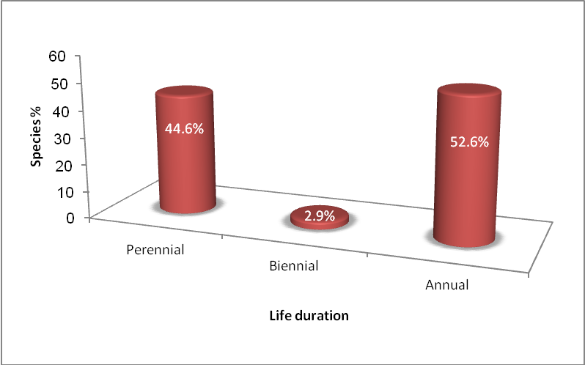
Fig. 3. Length of life of plant species recorded in Al Mansora site (Rocky habitat) during four seasons of autumn 2010 to summer 2011.

Fig. 4. Length of life percentage of plant species recorded during four seasons in Al Mansora site (Rocky habitat) during four seasons of autumn 2010 to summer 2011.

c. Life forms
Figure 5 shows the life forms of the recorded species according to Raunkiaer (1934). The recorded species belongs to five different life forms in Al Mansora.
Therophytes (59.4%), is represented by the largest number of species, of these are Galium verrucosum Huds., Medicago polymorpha L., Mercurialis annua L., Anagallis arvensis L., Plantago coronopus L., Avena barbata Pott ex Link, Bromus rigidus Roth, Lolium rigidum Guad., Phalaris minor Retz., Fedia cornucopiae (L.) Gaetner and Papaver rhoeas var. rhoeas. Chamaephytes has 23 species representing about (13.1%) of the flora Al Mansora, from these; Thymus capitatus (L.) Hoffm. & Link, Cistus parviflorus Lam., Sarcopoterium spinosum (L.) Spach, Sedum sediforme (Jacq.) Pau, Teucrium apollinis Maire et Weiller, Globularia alypum L., Phuopsis stylosa Trin (L.f.) DC., Satureja thymbra L. Hemicryptophytes has a moderate value of (11.4%) that includes 20 species, of these are, Bellis sylvestris var. cyrenaica Beguinot, Viola scorpiuroides Coss., Paronychia argentea Lamk., Anthyllis vulneraria L., Poa bulbosa L., Glaucium flavum, Polygonum equisetiforme. Geophytes represents about (10.3%) of the flora that includes 18 species, from these species are; Bellevalia sessiliflora (Viv.) Kunth, Arisarum vulgare Targ. Tozz, Asphodelus microcarpus Salzm.& Viv., Colchium palaestinum, Drimia maritima (L.) Baker, Rumelea cyrenaica Beguinot, Cyclamen rohlfsianum Aschers., Ranunculus asiaticus L. Allium negrianum Maire & Weiller. Phanerophytes contains 10 species, which are Pistacia lentiscus L., Juniperus phoenicea L., Rhamnus lycioides L. Jahandez, Daphne jasminea Sibth. et Sm., Erica multiflora L. and Ceratonia siliqua L.
Figure 6 shows relationship the life forms with seasons in Al Mansora habitat increase therophytes with 61.2 and 41.6% in spring and autumn, respectively. Chamaephytes highly during season autumn and summer of 35-37%. Hemicryptophytes low in all seasons except spring season. Geophytes highest in autumn and winter, lowest during summer and spring season. Phanerophytes high during summer and autumn season.

d. The order
In this investigation, 22 order were recorded, given the order Asterales of the largest number of species Arrived to 27 species (15%), followed by Lamiales, Poales and Fabales with 25, 22 and 21 species respectively.

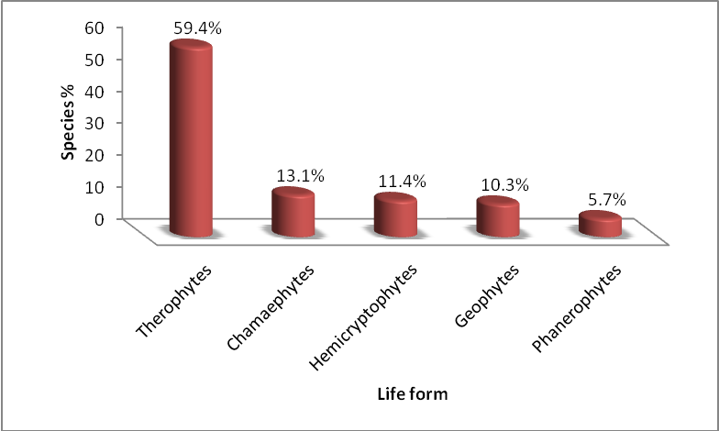
Fig. 5. Plant life forms category of the recorded species in rocky habitat of Al Mansora site.

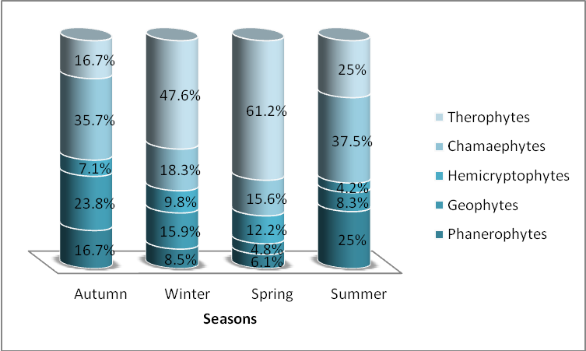
Fig.6. Plant life forms category of the recorded species of four seasons into rocky habitat of Al Mansora site during four seasons of autumn 2010 to summer 2011.

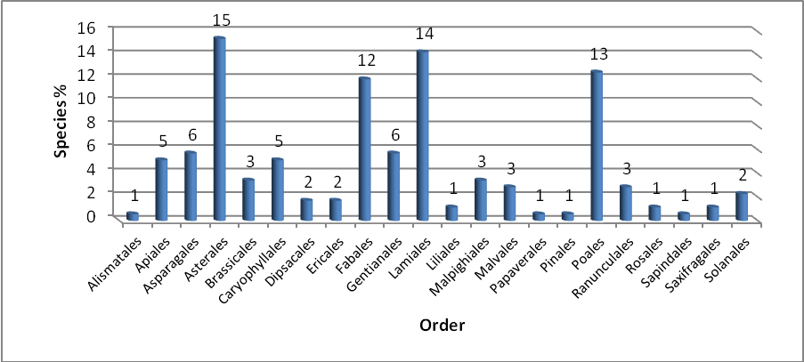
Fig.7. The order of plant species recorded in Al Mansora site (Rocky habitat) during four seasons of autumn 2010 to summer 2011.

Table 1. Botanical composition of plant species recorded in Al Mansora site (Rocky habitat) during four seasons of autumn 2010 to summer 2011.
No. | Family | Scientific name | *Length of Life | **Life forms | Order
1 | Amaryllidaceae | Allium negrianum Maire & Weiller | Per. | G | Asparagales
2 |  | Allium nigrum L. | Per. | G
3 |  | Narcissus elegans (Haw). Spach. | Per. | G
4 | Anacardiaceae | Pistacia lentiscus L. | Per. | Ph | Sapindales
5 | Apiaceae | Ammi majus L. | Ann. | Th | Apiales
6 |  | Ammi visnaga (L.) Lam | Ann. | Th
7 |  | Malabaila suaveolens (Dcl.) Coss | Per. | Th
8 |  | Scandix australis L. | Ann. | Th
9 |  | Thapsia garganica Lag. | Per. | Th
10 |  | Tordylium apulum L. | Ann. | Th
11 |  | Torilis arvensis (Huds.) Link. | Ann. | Th
12 |  | Torilis leptophylla ( L.) Reichb. | Ann. | Th
13 |  | Torilis nodosa (L.) Gaertn. | Ann. | Th
14 | Araceae | Arisarum vulgare Targ. Tozz | Per. | G | Alismatales
15 | Asparagaceae | Bellevalia sessiliflora (Viv.) Kunth | Per. | G | Asparagales
16 |  | Dipcadi serotinum (L.) Medic. | Per. | G
17 |  | Drimia maritima (L.) Stearn | Per. | G
18 | Asteraceae | Anthemis secundiramea Biv. | Ann. | H | Asterales
19 |  | Bellis sylvestris var.cyrenaica Beguinot | Per. | H
20 |  | Calendula arvensis L. | Ann. | Th
21 |  | Carlina lanata L. | Ann. | Th
22 |  | Carthamus lanatus L. | Ann. | Th
23 |  | Centaurea alexandrina Delile | Bien. | Th
24 |  | Chrysanthemum segetum L. | Ann. | Th
25 |  | Cicerbita haimanniana (Ascherson) Beauverd | Per. | Th
26 |  | Cichorium endivia L. | Ann. | Th
27 |  | Cichorium spinosum L. | Per. | Th
28 |  | Crepis senecioides ssp.senecioides Delile | Ann. | Th
29 |  | Dittrichia viscosa (L.) W. Greuter | Per. | Ch
30 |  | Filago contracta Boiss. | Ann. | Th
31 |  | Hedypnois cretica (L.) Dum. - Courset | Ann. | Th
32 |  | Helichrysum stoechas (L.) Moench | Per. | H
33 |  | Hyoseries scabra L. | Ann. | Th
34 |  | Jasonia rupestris Pomel | Per. | Th
35 |  | Leontedon tuberosus L. | Per. | H
36 |  | Matricaria aurea( Loefl.) Sch. Bip. | Ann. | Th
37 |  | Onopordum cyrenaicum Maire & Weiller | Per. | Th
38 |  | Onopordum espinae Cosson ex Bonnet | Bien. | H
39 |  | Pallenis spinosa (L.) Cass. | Per. | H
40 |  | Phagnlon rupestre (L.) Dc. | Per. | Ch
41 |  | Rhagadiolus stellatus (L.) Gaertner | Ann. | Th
42 |  | Scolymus hispanicus L. | Bien. | H
43 |  | Senecio leucanthemifolius Poiret | Ann. | Th
44 |  | Tragopogon L. | Per. | H
45 | Boraginaceae | Borago officinalis L. | Ann. | Th | Lamiales
46 |  | Cynoglossum cheirifolium L. | Bien. | Th
47 |  | Echium angustifolium Mill. | Per. | Ch
48 |  | Echium sabulicola Pomel | Bien. | Th
49 | Brassicaceae | Alyssum minus (L.) Rothm. | Ann. | Th | Brassicales
50 |  | Biscutella didyma L. | Ann. | Th
51 |  | Enarthrocarpus pterocarpus | Ann. | Th
52 |  | Rapistrum rugosum (L.) All. | Ann. | Th
53 |  | Sinapis alba L. | Ann. | Th
54 |  | Sinapis pubescens L. | Per. | Th
55 | Caryophyllaceae | Herniaria glabra Linn. | Per. | Th | Caryophyllales
56 |  | Paronychia argentea Lamk. | Per. | H
57 |  | Petrorhagia cyrenaica (Durand & Barratte) Ball & Heywood | Ann. | Th
58 |  | Petrorhagia velutina (Guss.) Ball & Heywood | Ann. | Th
59 |  | Polycarpon tetraphyllum (L.) L. | Ann. | Th
60 |  | Silene apetala Willd. | Ann. | Th
61 |  | Silene colorata Poiret | Ann. | Th
62 |  | Silene cyrenaica Maire & Weiller | Ann. | Th
63 | Cistaceae | Cistus parviflorus Lam. | Per. | Ch | Malvales
64 |  | Fumana laevipes (L.) Spach | Per. | Ch
65 |  | Fumana thymifolia (L.) Spach | Per. | Ch
66 | Colchicaceae | Colchium palaestinum | Per. | G | Liliales
67 | Convovulaceae | Convolvulus althaeoides L. | Per. | G | Solanales
68 |  | Cuscuta epithymum L. | Ann. | Th
69 | Crassulaceae | Sedum sediforme (Jacq.) Pau | Ann. | Ch | Saxifragales
70 |  | Umbilicus horizontalis | Per. | G
71 | Cupressaceae | Juniperus phoenicea L. | Per. | Ph | Pinales
72 | Dipsacaceae | Scabiosa arenaria Forskal | Ann. | Th | Dipsacales
73 | Ericaceae | Erica multiflora L. | Per. | Ph | Ericales
74 | Euphorbiaceae | Euphorbia falcata L. | Ann. | Th | Malpighiales
75 |  | Euphorbia parvula Del. | Ann. | Th
76 |  | Mercurialis annua L. | Ann. | Th
77 | Fabaceae | Anthyllis tetraphylla L. | Ann. | Th | Fabales
78 |  | Anthyllis vulneraria L. | Ann. | H
79 |  | Bituminaria bituminosa | Per. | H
80 |  | Calicotome villosa (Poir.) Link | Per. | Ph
81 |  | Ceratonia siliqua L. | Per. | Ph
82 |  | Hippocrepis cyclocarpa Murb. | Ann. | Th
83 |  | Lotus cytisoides L. | Per. | Ch
84 |  | Lotus ornithopodioides L. | Ann. | Th
85 |  | Lotus tetragonolobus L. | Ann. | Th
86 |  | Medicago coronata (L.) Bart | Ann. | Th
87 |  | Medicago minima (L.) Bart. | Ann. | Th
88 |  | Medicago orbicularis(L.) Bart. | Ann. | Th
89 |  | Medicago polymorpha L. | Ann. | Th
90 |  | Medicago truncatula Gaertn. | Ann. | Th
91 |  | Melilotus indicus (L.) All. | Ann. | Th
92 |  | Ononis reclinata L. | Ann. | Th
93 |  | Ononis vaginalis Vahl. | Per. | Ch
94 |  | Scorpiurus muricatus L. | Ann. | Th
95 |  | Trifolium campestre Schreb. | Ann. | Th
96 |  | Trifolium scabrum L. | Ann. | Th
97 |  | Trifolium uniflorum L. | Ann. | Th
98 | Gentianaceae | Centaurium pulchellum (Swartz) Druce | Per. | Th | Gentianales
99 | Geraniaceae | Erodium malacoides (L.) L’Herit. | Ann. | Th | Geraniales
100 |  | Erodium moschatum (L.) L’Herit. | Ann. | Th
101 |  | Erodium touchyanum Delile | Ann. | Th
102 |  | Geranium molle L. | Ann | Th
103 | Hypericaceae | Hypericum triquetrifolium Turra | Per. | H | Malpighiales
104 | Iridaceae | Moraea sisyrinchium (L.)Ker Gaweler (Europe) | Per. | G | Asparagales
105 |  | Rumelea cyrenaica Beguinot | Per. | G
106 | Lamiaceae | Ballota pseudo-dictamnus (L.) Benth. | Per. | Ch | Lamiales
107 |  | Marrubium vulgare L. | Per. | Ch
108 |  | Micromeria juliana (L.) Benth. ex eichenb. | Per. | Ch
109 |  | Micromeria nervosa ( Desf.) Benth. | Per. | Ch
110 |  | Origanum cyrenaicum Beg. et Vaccari | Per. | Ch
111 |  | Phlomis floccosa D. Don | Per. | Ch
112 |  | Prasium majus L. | Per. | Ch
113 |  | Satureja thymbra L. | Per. | Ch
114 |  | Siderites curvidens Stapf. | Ann. | Th
115 |  | Teucrium apollinis Maire et Weiller | Per. | Ch
116 |  | Teucrium brevifolium Schreber | Per. | Ch
117 |  | Thymus capitatus (L.) Hoffm. & Link | Per. | Ch
118 | Liliaceae | Gagea reticulata (Pall.) Schult. | Per. | G | Liliales
119 | Linaceae | Linum usitatissimum L. | Ann. | Th | Malpighiales
120 | Malvaceae | Malva parviflora L. | Ann. | Th | Malvales
121 | Myrsinaceae | Anagallis arvensis L. | Ann. | Th | Ericales
122 |  | Cyclamen rohlfsianum Aschers. | Per. | G
123 | Oleaceae | Olea europaea var. oleaster (Hoffmg.&Link)Dc. | Per. | Ph | Lamiales
124 |  | Phillyrea latifolia L. | Per. | Ph
125 | Orchidaceae | Anacamptis collina (Banks & Sol. ex Russell) R.M. Bateman, Pridgeon & M.W.Chase | Per. | G | Asparagales
126 | Papaveraceae | Glaucium flavum Crantz | Per. | H | Ranunculales
127 |  | Papaver rhoeas var. rhoeas | Ann. | Th | Papaverales
128 | Plantaginaceae | Globularia alypum L. | Per. | Ch | Lamiales
129 |  | Linaria triphylla (L.) Mill. | Ann. | Th
130 |  | Linaria virgata (poir) Desf. | Ann. | Th
131 |  | Misopates orontium (L.) Rafin. | Ann. | Th
132 |  | Plantago coronopus L. | Per. | Th
133 |  | Plantago lagopus L. | Ann. | Th
134 | Poaceae | Avena barbata Pott ex Link | Ann. | Th | Poales
135 |  | Briza maxima L. | Ann. | Th
136 |  | Bromus alopecuros Poir. | Ann. | Th
137 |  | Bromus madritensis L. | Ann. | Th
138 |  | Bromus rigidus Roth | Ann. | Th
139 |  | Catapodium rigidum (L.) C.E. Hubbard | Ann. | Th
140 |  | Crithopsis delileana (Schultes) Rozhev. | Ann. | Th
141 |  | Cynosurus elegans Desf. | Ann. | Th
142 |  | Dactylis glomerata L. | Per. | H
143 |  | Gastridium ventricosum (Gouan) schinz et Thell. | Ann. | Th
144 |  | Hyparrhenia hirta (L.) Stapf | Per. | H
145 |  | Lolium loliaceum (Bory et Chaub.) Hand.-Mazz. | Ann. | Th
146 |  | Lolium rigidum Guad. | Ann. | Th
147 |  | Melica minuta L. | Per. | Th
148 |  | Oryzopsis miliacea (L.) Asch. & Schweinf. | Per. | H
149 |  | Parapholis incurva (L.) C.E. Hubbard | Ann. | Th
150 |  | Paspalidium geminatum (Forsk.) Stapf | Per. | H
151 |  | Phalaris minor Retz. | Ann. | Th
152 |  | Poa bulbosa L. | Per. | H
153 |  | Stipa capensis Thunb. | Ann. | Th
154 |  | Trachynia distachya (L.) Link. | Ann. | Th
155 |  | Trisetaria macrochaeta (Boiss.) Maire | Ann. | Th
156 | Polygonaceae | Polygonum equisetiforme sm. | Per. | H | Caryophyllales
157 | Ranunculaceae | Adonis microcarpa DC. | Ann. | Th | Ranunculales
158 |  | Nigella damascena L. | Ann. | Th
159 |  | Ranunculus asiaticus L. | Per. | G
160 |  | Ranunculus bullatus L. | Per. | G
161 | Rhamnaceae | Rhamnus lycioides L. Jahandez | Per. | Ph | Rosales
162 | Rosaceae | Sarcopoterium spinosum (L.) Spach | Per. | Ch | Rosales
163 | Rubiaceae | Galium verrucosum Huds. | Ann. | Th | Gentianales
164 |  | Phuopsis stylosa Trin. | Per. | Ch
165 |  | Sherardia arvensis L. | Ann. | Th
166 |  | Theligonum cynocrambe L. | Ann. | Th
167 |  | Valantia lanata Del. ex Coss. | Ann. | Th
168 | Scrophulariaceae | Scrophularia canina L. | Per. | H | Lamiales
169 | Solanaceae | Datura innoxia Mill. | Ann. | Th | Solanales
170 |  | Nicotiana glauca R.C.Graham | Per. | Ph
171 | Thymelaeceae | Daphne jasminea Sibth. et Sm. | Per. | Ph | Malvales
172 | Valerianaceae | Centranthus calcitrapae (L.) Dufresne | Ann. | Th | Dipsacales
173 |  | Fedia cornucopiae (L.) Gaetner | Ann. | Th
174 | Violaceae | Viola scorpiuroides Coss. | Per. | H | Malpighiales
175 | Xanthorrhoaeceae | Asphodelus microcarpus Salzm.& Viv. | Per. | G | Asparagales

*Per.=Perennial, Bien.=Biennial, Ann. = Annual, **G= Geophytes, Ph= Phanerophytes, Th= Therophytes, H= Hemicryptophytes, Ch= Chamaephytes

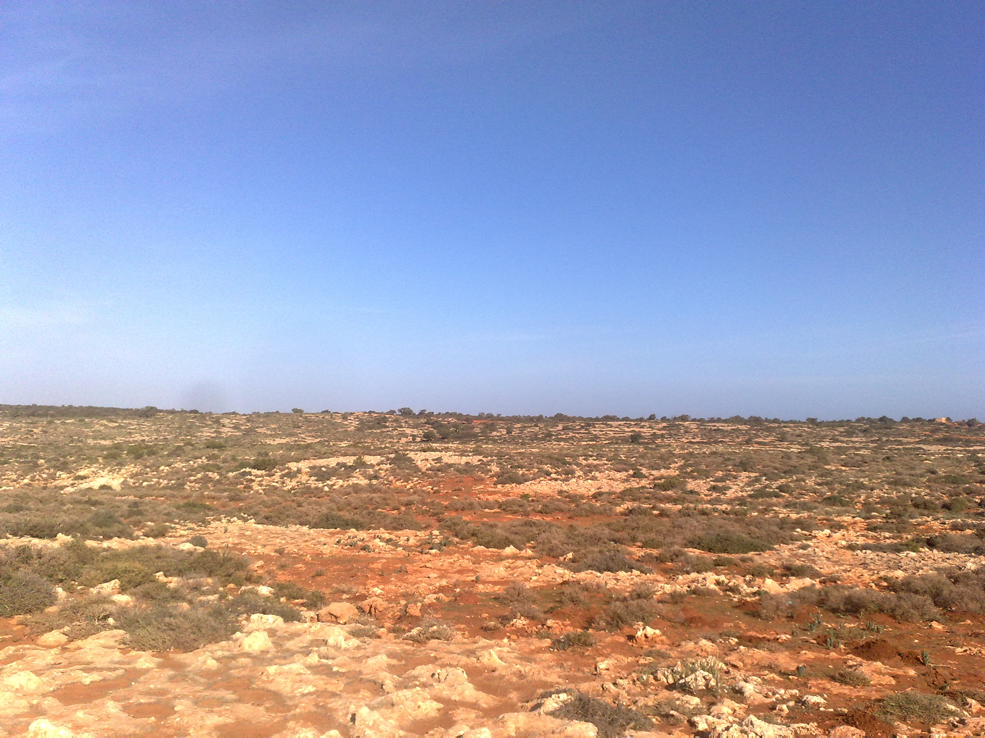
a.
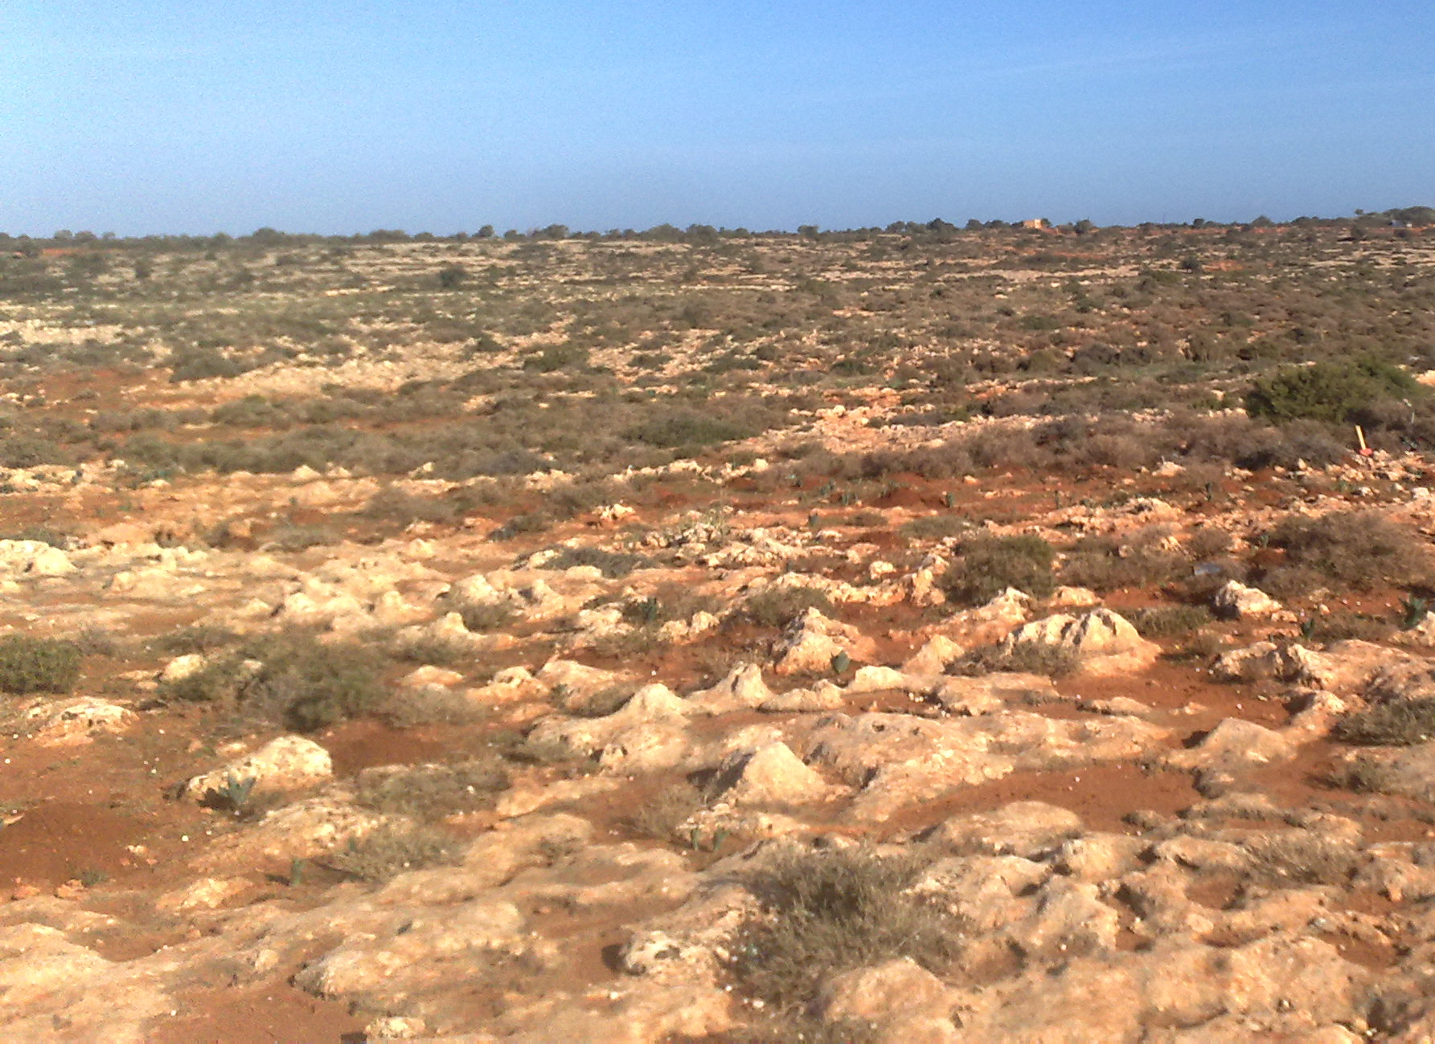
b.
Figs. 8a and b. Landscape in Rocky habitat Al Mansora area.

4. Discussion
This study examined botanical composition, to species and the families, order and life forms of the species found in the rocky habitat, The communities on rocky habitats and special types rocky habitat be Cistus parviflorus Lam. and Erica multiflora L. Globularia alypum L. Rumelea cyrenaica, Satureja thymbra L., Thymus capitatus (L.) Hoffm .& Link, Daphne jasminea Sibth. et Sm. And Viola scorpiuroides Coss. It is characterized by its ability to resist the shallowness of the soil and grow among the rocks. The analysis of vegetation of rocky ridges and similar areas of shallow soils by the ecological profile technique indicate a general group of species: Plantago albicans, Asphodelus microcarpus, Thymelaea hirsute, Reaumuria mucronata, Thymus capitatus, Globularia arabica, Dactylis glomerata, Noaea mucronata, Atractylis carduus, Limonium pruinosum and Limonium tubiflorum (Kamal, 1982). From the ecological-structural point of view, the association of Limonium cyrenaicum corresponds to the belt of Limonium sp. Pl. and Crithmum maritimum which characterizes the Mediterranean rocky coasts (Brullo and Furnari, 1981). The most families in rocky habitat Al mansora are Asteraceae, Poaceae, Fabaceae and Lamiaceae, Most members of Asteraceae are herbaceous, but a significant number are also shrubs, vines and trees, the family has a worldwide distribution, and is most common in the arid and semi-arid regions of subtropical and lower temperate latitudes (Barkely et al., 2006). Also, given the order Asterales of the largest number of species in rocky habitat Al Mansora. Spread lamiaceae family in rocky habitat (Klopper et al., 2006).

Different life forms are regularly associated with special climate (Richkleffs, 1973). Phanerophytes usually correspond to tropical climates, chamaephytes mainly relate to cold, dry climates, hemicryptophytes and geophytes mostly associate with coldm moist climates (Richkleffs, 1973). These have been confirmed by many previous studies, for example Wang et al. (2002) and DaCosta et al. (2007) found that therophytes were the most dominant life forms in arid or semi arid area, and therefore, overall, camaephytes and therophytes are the rarest life forms, while phanerophytes, geophytes and himicryptophytes are the most dominant life forms.

References
- Al-Jabal Al-Akhdar south project. (2005). Study and evaluation natural vegetation in Al-Jabal Al-Akhdar area. (In Arabic). Omar Al-Mokhtar Univ., Libya. 12 p.
- APIS. (2011). Air Pollution Information System. Cited in http://www.apis.ac.uk/overview/ecosystems/ov.
- Barkely, T.M., Brouillet, L., Strother, J.L. (2006) Flora of North America - Asteraceae"http://www.efloras.org/florataxon.aspx?flora_id=1&taxon_id=10074.
- Blumler, A. Mark. (2005). Three conflated definitions of Mediterranean climates. middle states geographer, 38:52-60.
- Boulos, L., (1972). Our present knowledge of the flora and vegetation of Libya. Webbia, 26: 366-400.
- Boulos, L. (1999). Flora of Egypt (Azollaceae-Oxalidaceae). Vol. 1, Al-Hadara Pub., Cairo, Egypt.
- Boulos, L. (2000). Flora of Egypt (Geraiaceae-Boraginaceae). Vol. 2, Al- Hadara Pub., Cairo, Egypt.
- Boulos, L. (2002). Flora of Egypt (Verbenaceae-Compositae). Vol. 3, Al-Hadara Pub., Cairo, Egypt.
- Boulos, L. (2005). Flora of Egypt (Monocotyledons). Vol. 4, Al-Hadara Pub., Cairo, Egypt.
- Brullo, S. and Furnari, F. (1981). Phytogeographical considerations on the coastal vegetation of Cyrenaica. Actas III Congr. OPTIMA. Anales Jard. Bot. Madrid 37 (2): 765-772.
- Da Costa RC, De Araujo FS, Lima-Verde LW (2007). Flora and life form spectrum in an area of deciduous thorn woodland (caatinga) in northeastern, Brazil. J. Arid Environ., 68: 237-247.
- Devecl, M. (2012). An investigation on plant species diversity in Colchic province (Turkey). African J. of Agric. Research Vol. 7(5). 820-843.
- Henderson, P. A. and Seaby, R. M. H. (1999). Community analysis package, version 1.2. Pisces conservation Ltd, IRC House, Pennington, Lymington, S041 8GN, UK.
- Jafri, S. M. and El-Gadi, A., (Eds). (1977-1993). Flora of Libya. Bot. Department, Faculty of Sci., Tripoli Univ., Libya.
- Kamal, S. A. (1982). A study of the vegetation-environmental relationships of the western Mediterranean desert of Egypt. M. Sc. Thesis Fac. Sci., Univ. Alex. 205 p.
- Klopper, R.R., Chatelain, C., Bänninger, V., Habashi, C., Steyn, H.M., De Wet, B.C., Arnold, T.H., Gautier, L., Smith, G.F. & Spichiger, R. (2006). Checklist of the flowering plants of Sub-Saharan Africa. An index of accepted names and synonyms. Southern African Botanical Diversity Network Report No. 42. SABONET, Pretoria.
- Ludwig, J. A. and Reynolds, J. F. (1988). Statistical ecology: a Primer on Methods and Computing. John Wiley and Sons Inc., New York, U. S. A, 337 p.
- Mera, A, G., Hagen, M. A. and Orellana, J. A. V. (1999). Aerophyte, a new life form in Raunkiaer׳s classification? J. Veg. Sci., 10: 65-68.
- Mueller-Dombois, D. and Ellenberg, H. (1974). Aims and methods of veg. ecology. John Willey and sons, New York, 547p.
- Raunkiaer׳s, C. (1934). The life forms of plants and statistical geography. Claredon, Oxford, 632 p.
- Richkleffs, R. E. (1973). Ecology. Thomas Wilson and Sons, London.
- Wang, GH, Zhou GS, Yang LM, Li ZQ (2002). Distribution, species diversity and life form spectra of plant communities along an altitudinal gradient in the northern slopes of Qilianshan Mountains, Gansu, China. Plant Ecol., 165:169-181.
- Woodward, F. I. (1987). Climate and plant distribution. Cambridge univ. press, 174 p.

4/2/2013

