Prevalence of Listeria Species in Fresh and Frozen Pigeon Carcasses with Studying Effect of Nigella Sativa Oil on Isolated L. monocytogenes

*S. Shafik; Rizk, M.K. and El-Dosoky H.F.A.

Animal Health Research Institute, Mansoura Provincial Lab., Egypt.
Saleh-shafik@yahoo.com

Abstract: A total of 250 examined samples from 100 pigeon carcasses "50 fresh and 50 frozen" representing 150 fresh pigeon samples (50 skin, 50 muscles and 50 liver) and 100 frozen pigeon samples (50 skin and 50 muscles) were randomly purchased from poultry shops as well as supermarkets in Dakahlia Governorate, Egypt, and examined for the presence of Listeria species. The overall prevalence rate of Listeria species were 21.3% and 35% in fresh and frozen pigeon samples, meanwhile L. monocytogenes were 4% and 9% respectively. The other Listeria species (L. innocea, L. grayi, L. murri and L. wellshomeri) were isolated in an incidence of 8%, 4%, 3.3% and 2% respectively from fresh pigeon samples. From frozen pigeon samples, same listeria species were isolated in addition to L. ivanovi in an incidence of 14%, 6%, 3%, 2% and 1% respectively. The highest incidence of Listeria species was recorded in skin samples of both fresh and frozen pigeon samples as 30% and 44% respectively. The most predominant isolates was L. innocea 8.79% and 14% from fresh and frozen samples respectively. Fifty isolate of L. monocytogones were confirmed by PCR test, and pathogenisity to white mice of these isolate proved to be fetal for all inoculated experimental animals. Effect of Nigella sativa oil in a concentration of 10% after immersion for 2 minutes result in reduction CF 68% of inoculated L. monocytogenes in pigeon carcasses. The public health importance was discussed.
[S. Shafik; Rizk, M.K. and El-Dosoky H.F.A.Prevalence of Listeria Species in Fresh and Frozen Pigeon Carcasses with Studying Effect of Nigella Sativa Oil on Isolated L. Monocytogenes. . N Y Sci J 2013;6(5):61-65]. (ISSN: 1554-0200). http://www.sciencepub.net/newyork 10

Key words: Frozen Pigeon, Fresh and Frozen Pigeon, L. monocytogenes, Nigella Sativa Oil

1. Introduction:
Poultry meat are considered a good source of tasty easily digested and high biological value protein fat, minerals which are essential for growth and health of human being. Although most poultry meat come from chickens, significant amount of meat are produced from pigeon in Egypt and other countries in addition to the pigeons are acceptable and palatable to the most population. Listeriosis in human poses a risk to pregnant women, new born (called prenatal liseriosis) and immunocompromised individuals compresses two third of human listeriosis and has a high mortality rate in these individuals of 20% to 30% (Rocourt et al., 2000 and Gracieux et al., 2003). Healthy individuals also could develop milder from of gastrointestinal illness (Dalton et al., 1997).
Listeria species are gram-positive, short, non-sporing small rods, catalase positive and facultative anaerobes non capsulated, all closely related including L. monocytogenes, L. innocua, L. ivanovii, L. grayi, L. welshimeri, L. murrayi and L. seeligeri (ICMSF, 1996).
L. monocytogenes was the major pathogenic species in both man and animal (Mclauchlin and Jones, 1999). Although Cocolin et al. (2002) recorded that haemolytic species of listeria (L. ivanovii and L. selligeri) in addition to L. welshimeri were pathogenic to human. Recent outbreaks occur in Canada and Denmark due to ingestion of ready to eat meat and beef meat.
Pigeon Carcasses can be contaminated with some food borne bacteria during slaughtering defeathering, evisceration and other preparation process. One of the most important incriminated pathogens is listeria species.
Nigella sativa is a herbeceouse plant, whose seeds (black seed) have been used as spice and condiment in foods in the Middle East. Nigella sativa oil (black seed oil) could potentially be used to inhibit L. monocytogenes (Manojkumar, 2005).
The present study was done to determine prevalence of listeria species in pigeon meat (fresh and frozen) and effect of Nigella sativa oil on the isolated L. monocytogenes strains.

2. Material and Methods:
Collection and preparation of samples:
A total of 250 samples from 100 pigeon carcasses (50 fresh and 50 frozen) representing 150 fresh pigeon samples (skin, muscles and liver "50 for each") and 100 frozen pigeon samples (skin and muscles "50 for each") were randomly purchased from poultry shops and supermarkets in Dakahlia Governorate, Egypt.
Collected samples were well identified and separately packed in a sterile package and transported under refrigeration in ice box to the laboratory, without undue delay where they were screened for isolation and identification of exited listeria species. Skin samples including inner and outer surface of neck and coloca, meanwhile muscle samples were taken from breast and thigh muscle.
Isolation of listeria spp.:
The technique recommended by USDA, FSIS (1989) and FAO (1992) was adapted as following:
Enrichment procedures:
A portion of 25gm of each sample was homogenized with 255 ml of UVM, enrichment broth using mixer at high speed for 2 minutes and incubated for 24 hours, subsequently 0.1ml of incubated UVM I broth was transferred to 10ml UVM II broth then incubated at 30ºC for 24 hours.
A loopful from each of enrichment cultured (UVM₁ and UVM₂) broth were streaked onto PALCAM agar plates then incubated at 30ºC for 24 hrs. (Vannetten et al., 1998). Typical colonies were removed for further testing by inoculation on either trepticase soya agar or semisolid agar medium and kept in refrigerators at 4ºC.
Identification of isolates:
Pure presumptive isolates were identified according to FAO (1992) by using Gram's stain, motility, catalase, oxidase, blood haemolysis sugar fermentation (Xylose, rhammna).
DNA extraction:
DNA extraction of the suspected colonies was performed according to the manufacturer guidelines using Bacterial DNA Extraction Kit (Spin-column) (Bio Teke Corporation). The suspected colonies obtained by cultural methods were re-suspended in nutrient broth and incubated at 37°C for 24 hours, according to Kit Manufacture's instruction.
Multiplex PCR for detection of virulence factors of L. monocytogenes genes:
Purified DNA of the suspected colonies was subjected to a multiplex PCR for the identification of L. monocytogenes and also for the detection of Internalin virulence factors according to Liu et al., (2007). Oligonucleotide primers synthesized by BioTeke Corporation (Canada) were used for the amplification of L. monocytogenes Internalin genes in lA, in lC and in lJ. The in lA primers were intended for species-specific recognition, and the in lC and in lJ primers were designed for virulence determination of L. monocytogenes. Table (1) shows the sequence of the primers and the expected product sizes. The reaction was performed in 25 µl reaction volume containing 12.5 µl of readymade 2 x PCR master mix (Bio Teke Corporation) and 40 pmol each in lA, 30 pmol each in lC and 20 pmol each in lJ primers and 2 µl of the purified DNA. A reaction mixture with no added DNA was run in the PCR as a negative control.
The reaction conditions consisted of one cycle of 95°C for 2 min followed by 30 cycles of 94°C for 20 sec, 55°C for 20 second 72°C for 50 sec and a final cycle of 72°C for 2 min. The reaction was carried out in Primus, MWG-Biotech Thermal Cycler. Amplification products were resolved in 1.2% (w/v) agarose gels along with 100 bp molecular weight ladder (BioTeke Corporation). The agarose gel was prepared in 1 x TBE (89 mM Tris- Borate, 2 mM EDTA, and pH 8.3) stained with 5 uM ethidium bromide. The gels were run in IxTBE, 5 µM ethidium bromide for at least 45 minutes at 100 volts and then visualized under Ultra Violet light of ultraviolet transilluminator (Spectroline).

Table (1): Primer sequences and expected product sizes of the multiplex PCR (Liu et al., 2007)
Gene | Primer sequence (5'→3') |  | Expected product size (bp)
inlA | inlA-Forward | ACGAGTAACGGGACAAATGC | 800 bp
inlA | inlA-Reverse | CCCGACAGTGGTGCTAGATT | 800 bp
inlC | inlC-Forward | AATTCCCACAGGACACAACC | 517bp
inlC | inlC-Reverse | CGGGAATGCAATTTTTCACTA | 517bp
InlJ | inlJ-Forward | TGTAACCCCGCTTACACAGTT | 238 bp
InlJ | inlJ-Reverse | AGCGGCTTGGCAGTCTAATA | 238 bp

Pathogenicity test:
Female Swiss white mice weighting 18-20 gm were inoculated intraperitonealy with 0.1 ml of bacteria (suspensions)(10⁸ m.o/ ml), control one were inoculated with 0.1ml phosphatase saline. Inoculated mice were maintained under observation for evaluation of clinical signs and mortalities. The dead mice were scarified and from each one, liver spleen and brain were collected and screened for listeria using PALCAM medium.
Effect of Nigella sativa oil 10% on isolated L. monocytogenes in experimentally contaminated pigeon carcasses:
The well morphological, microscopical, biochemical and tested by both PCR test and pathogenicity test strain of L. monocytogenes isolated from previous samples used for carrying out these experiment.
Experimental inoculation of L. monocytogenes:
Ten pigeon carcasses free from listeria were inoculated by dipping in bacterial suspension contain 10⁷ cell/ml for 5 minutes then allow to dry and attachment with Bacterial cell in refrigerators for 10 minutes.
These inoculated samples were immersed in 10% Nigella sativa oil for 2 minutes (obtained from El-Gomheria Company for Chemical, Mansoura City). Control samples were immersed in distilled water for 2 minutes.
Listeria monocytogenes count was done immediately after treatment using plat count technique according to APHA, (1992).

3. Results:

Table (2): Prevalence of listeria species among the examined fresh pigeon carcasses
Type of samples | No. of collected  samples | No. of listeria isolates |  | Typing of isolated Listeria species
Type of samples | No. of collected  samples |  |  | Listeria monocytogenes |  | Listeria innocaua |  | Listeria grayi |  | Listeria murri |  | Listeria welshemari
Type of samples | No. of collected  samples | No | % | No | % | No | % | No | % | No | % | No | %
Skin | 50 | 15 | 30 | 3 | 6 | 5 | 10 | 3 | 6 | 2 | 4 | 2 | 4
Muscle | 50 | 8 | 16 | 2 | 4 | 3 | 6 | 1 | 2 | 1 | 2 | 1 | 2
Liver* | 50 | 9 | 18 | 1 | 2 | 5 | 10 | 2 | 4 | 2 | 4 | 1 | 2
Total | 150 | 32 | 21.3 | 6 | 4 | 13 | 8.1 | 6 | 4 | 5 | 3.3 | 4 | 2.6
*One of sample in liver contain mixed infection with L. innocoua + L. welshemari

Table (3): Prevalence of listeria species among the examined frozen pigeon carcasses
Type of samples | No. of collected  Samples | No. of listeria isolates |  | Typing of isolated Listeria species
Type of samples | No. of collected  Samples |  |  | L. monocytogenes |  | L. innocaua |  | L. grayi |  | L. murri |  | L. welshemari |  | L. ivanovii
Type of samples | No. of collected  Samples | No | % | No | % | No | % | No | % | No | % | No | % | No | %
Skin | 50 | 22 | 44 | 6 | 12 | 7 | 14 | 3 | 6 | 2 | 4 | 3 | 6 | 1 | 2
Muscle | 50 | 13 | 26 | 3 | 6 | 4 | 8 | 3 | 6 | 1 | 2 | 2 | 4 | - | -
Total | 100 | 35 | 35 | 9 | 9 | 11 | 11 | 6 | 6 | 3 | 3 | 5 | 5 | 1 | 1

Table (4): Effect of 10% Nigella sativa on isolated L. monocytogenes
Before  Treatment | After treatment |  |  |  | Reduction
Before  Treatment | Minimum | Maximum | Mean | SE* | Count | %
10⁷ | 3.5 x 10⁶ | 5.3 x 10⁶ | 3.2 x 10⁶ | 4.1 x 10⁶ | 6.8 x 10⁶ | 68
*Standard error

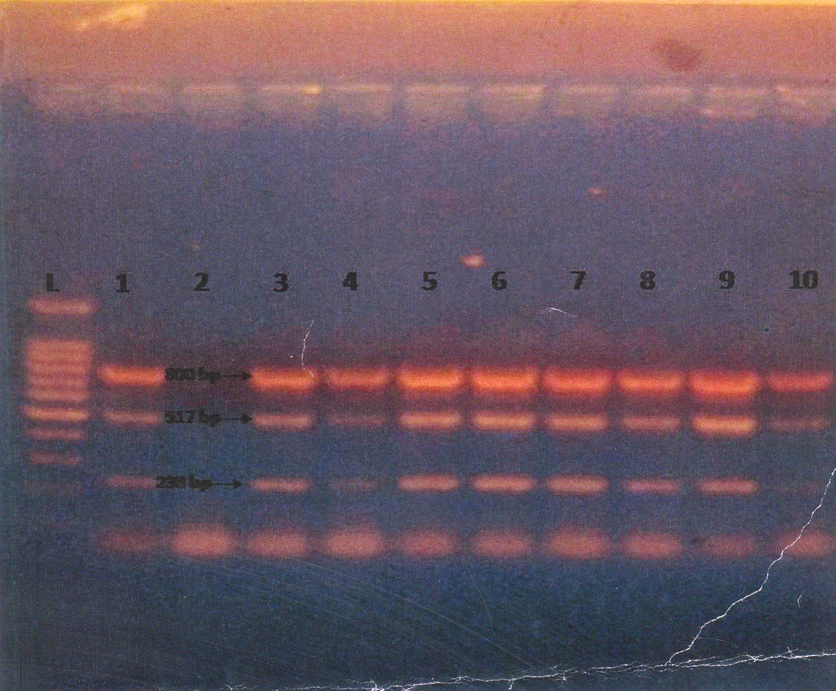
Figure (1): Agarose gel electrophoresis of inlA, inlC and inlJ amplicons obtained from L. monocytogenes suspected isolates (L: 100bp ladder, 1: positive control of L. monocytogenes, 2: negative control, 3 – 10: suspected L. monocytogenes DNA from the examined samples)

4. Discussion:
Listeria is a serious threat to food safety and ranks them among the food born microorganisms that most concern the food industry. Listeria is widely distributed in the environment and frequently contaminated the food. Among all species in the genous listeria, only L. monocytogenes has been implicated in serious human illness (Blakova et al., 2004).
The results reported in table (2) revealed that Listeria species were isolated from 32 (21.3%) out of 150 examined samples of skin, muscle and liver of fresh pigeon carcasses. These results were higher than the reported by Rahimi et al.,(2012) and lower than that reported by Proietti et al., (2000). L. monocytogenes were identified from 6 (4%) of these samples. The most predominant isolated were L. innocua 13 (8.1%) followed by L. grayi 6 (4%), L. murri 5 (3.3%) and L. wellshemeri 4 (2.6%).
The highest prevalence rate of Liseria species and L. monocytogenes were isolated from skin samples 15 (30%) and 3 (6%) respectively. Furthermore, L. innocoua, L. grayia, L. murri and L. wellshemery were isolated from 5 (10%), 3 (6%), 2 (4%) and 2 (4%) respectively.
The obtained results declared that 8 (16%) and 9 (18%) of muscles and liver samples harbored Listeria species, while 2 (4%) and 1 (2%) were harbored L. monocytogenes respectively. Other listeria species could be isolated and identified as L. innocua (6%), L. grayi (2%) and L. murri (2%) in examined muscle samples; meanwhile in liver samples L. innocua, L. grayi, L. murri and L. welshemari were 10%, 4% and 2% respectively.
The occurrence of lisetria species in frozen pigeon samples are present in table (3) which declared that Lisreria species and L. monocytogenes more frequently isolated from skin (44%) and (12%) followed by liver samples (26%) and (6%), furthermore other Listeria species including L. innocoua, L. grayi, L. murri, L. wellshemari and L. ivanovii were recovered from 14%,6%,4%,6% and 2% from skin samples, meanwhile, in muscle samples they were 8%, 6%, 2%, 4% and 0% respectively. It is obevious from the aforementioned results of the examined frozen pigeon samples were more contaminated than that of fresh pigeon samples, these may be attributed to ability of Listeria species to grow and multiple in refrigeration temperature (Blakova et al., 2004).
The high prevalence rate of L. species from skin samples then both liver and muscle may be attributed that presence of wrinkles and irregulation of the skin provide physical protection to bacteria (Ellerbroke et al., 1996).while Capita et al., (2002) reported that poultry can harbour L. monocytogenes in their intestinal tract and as such are potential source of contamination.
In the present study it is evident that all isolated and identified L. monocytogenes caused 100% mortality of inoculated white mice at 3rd and 4th day post inoculation. On postmortem examination hemorrhagic foci in liver, spleen and brain of all dead mice. Also the organism was reisolated from these organs. These findings were in harmony with the reported by Lammerding et al., (1992).
The wide application of nucleic acid amplification techniques and the increasing industrial interest lowered rapid method has led to the development and application of PCR based methods for detection of microbial pathogens is food (Germini et al., 2009). Analyzing the PCR profiles 15 Listeria monocytogones isolates showed inlA, inlC and inlJ (100bp) which is specific for L. monocytogenes. Thus L. monocytogenes were confirmed in previously examined samples in Figure (1).
From the results presented in table (4) its evident that L. monocytogenes population were reduce from 10⁷ cfu/cm² of the inoculated chicken skin samples by Nigella sativa oil 10% for 2 minutes to 3.2× 10⁶ with a percentage of 68%. It is clear that 10% Nigella sativa oil had a significant influence on isolated L. monocytogenes, such results adequately consistent with Manojkumar, (2005).
Listeria in human and animal usually associated with Listeria monocytogenes and Listeria seeligeri (Mclauchlin et al., 2004). However there is some evidence for very rare infections caused Listeria innocuain in domestic animals (Walker et al., 1994). The other species of Listeria have not been reported to cause disease. The widely distribution of Listeria species in nature due to its ability to tolerate high concentration of salts and relatively low pH and multiply at refrigeration temperature are considered a serious thereat to food safety and rank them among the microorganisms that most concern the food industry. Listeria monocytogenes is the only species of the genus Listeria that involved in known food born out break of serious diseases.
The public health importance of Listeria monocytogenes has been recorded by many authors (Hof, 2001 and Longhi et al., 2003). In order to minimize human Listeriosis, foods should be cooked to an internal Temperature of 70◦C for more then 20 minutes to ensure distraction of L. monocytogenes. Reheat cooked food thoroughly (70◦C) immediate aseptic packaging of the finished product to avoid post processing environmental contamination. Proper cold storage of meat and meat products (freezing -18◦C) and proper personal hygiene of food handlers is advisable (Mahmoud et al., 2003).In concentration 10% and immersion for 2 minutes results in reduction CP 68 % of inoculated L. monocytogenes in pigeon carcasses.

References:
- APHA (American Public Health Association) (1992): Compensation of method for microbiological examination of foods. 3rd ed; Vanderzant, C and Splittstoessor, F. (Eds.) APHA, Washington D.C.
- Blazkova, M.; Karamonova, L.; Rauch, P. and Wyatt, G.M. (2004): Enzyme-linked immunosorbent assay for general and specific detection of Listeria spp. And L. monocytogenes in dairy products. Czech. J. of Food Sci. 22 (Special Issue): 242 – 245.
- Capita R.; Alonseo–Calleja C.; Mereghetti L.; Moreno, B. and Del Camino Garcia–Fernandez M. (2002): Evaluation of the international phage typing set and some experimental phages for typing of Listeria monocytogenes from poultry in Spain. J. Appl. Microbiol., 92: 90 - 96.
- Cocolin, L.; Rantsion, K.; Tacumin L.; Cantoni, C. and Corni, G. (2002): Direct identification in food samples of listeria spp. and L. monocytogens by molecular methods. Appl. Environ. Microbiol.; 68 (12): 6273 - 6282.
- Dalton, C.B.; Austin, C.C.; Sobel, J.; Hayes, P.S.; Bibb, W.F.; Graves, L.M.; Swamination, B.; Proctor, M.E. and Griffin, P.M. (1997): An outbreak of gastroenteritis and fever due to Listeria monocytogenes in milk. N. Engl. J. Med., 336: 100 – 106.
- Ellerbrock, L.; Okolocha, E.M. and Weise, E. (1996): Lactic acid and trisodium phosphate for decontamination of poultry meat. P. 187 – 195 in Minton, M.H. and Owlling, C.R. (ed.) factors affecting the microbial quality of meat. Vol. 4, Microbial methods for the meat industry concerted action CT 94 – 1456 University of Bristol, Press Bristol, UK.
- FAO (1992): Manual of food quality control. 4 Rev. Chapter 11, pp. 119 – 129. J. Microbiological Analysis of Food and Agriculture Organization of the United Nations, Rome.
- FSIS "United State Department of Agriculture, Food Safety Inspection Service" (1989): Method for the isolation and identification of Listeria monocytogenes from meat and poultry products. Laboratory Communities, No. 57, US Department of Agriculture, Washington, D.C.
- Germini, A.; Masola, A.; carnevali, P. and Marchelli, R.E. (2009): Simultaneous detection of Escherichia coli O157:H7, Salmonella spp. and Listeria monocytogenes by Multiplex PCR. Food Control. 20 (8): 733 – 738.
- Gracieux, P.; Roche, S.M.; Pardon, P. and Velge, P. (2003): Hypovirulent Listeria monocytogens strains are less frequently recovered than virulent strains on PALCAM and rapid, L. monoytogens media. Int. J. Food Microbial. 83: 133 – 145.
- Hof, H. (2001): L. monocytogenes: a causative agent of gastroenteritis. Euro. J. Clin. Infect. Diseases. 20: 369 – 373.
- ICMSF (1996): Microorganisms in foods, microbiological specification of food pathogens. Blackie Academic and Professional. London, Weinhaim, New York
- Lammerding, A.M.; Glass, K.A.; Gendron-Fitzatric, A.; Doyle, M.P. (1992): Determination of virulence of different strains of Listeria monocytogenes and Listeria innocua by oral inoculation of pregnant mice. Appl. Environ. Microbial., 58: 3991 – 4000.
- Liu, D.; Lawrence, M.L.; Austin, F.W. and Ainsworth, A.J. (2007): A multiplex PCR for species – and virulence – specific determination of Listeria monocytogenes. Journal of Microbiological Methods. 71: 133 – 140.
- Longhi, C.; Maffeo, A.; Penta, M.; Petrone, G.; Segant, L. and Conte, M.P. (2003): Detection of L. monocytogenes in Italian style soft cheeses. J. Appl. Microbiol., 94: 879 – 885.
- Mahmoud, M.S.; Ahmed, A. N. and Hussain I. (2003): Prevalence of Listeria monocytogenes in poultry meat, poultry meat products and other related inanimate at Faisalabad Pakistan. Journal of Nutrition, 2 (6): 346 – 349.
- Manojkumar, M. (2005): Antibacterial effect of black seed oil on Listeria monocytogenes. Food Control A, 16 (5): 395 – 398.
- Mclauchlin, J.; Mitchell, R.T.; Smerdon, W.J. and Jewell, K. (2004): Listeria monocytogenes and listeriosis: a review of hazard characterization for use in microbiological studies. International Journal Food Microbiology. 92: 15 – 33.
- Mclauchlin, Y. and Jones, d. (1999): Erysiperothrix and listeria. In: Borriello, S.P. Duerden, B.I (Eds.). Toplay, 9th ed. Systematic Bacteriology (2) up date the CD. Rom London, Amold.
- Proietti, P.C.; Passamenti, F. and Asdrubali, G. (2000): Hygienic aspects of meat pigeons slaughtering. Rivista di Avico ltura, 69(2): 36 – 39.
- Rahimi, Ebrahim; Yazdi, Forzad; Forzinezhad, Hussein (2012): Prevalence and antimicrobial resistance of listeria species isolated from different types of raw meat in Iran. J. of Food Protection. 12 (75): 2223 – 2227.
- Recourt, J.; Jacquet, Ch. and Reilly, A. (2000): Epidemiology of human listeriosis and sea foods. Int. J. Food Microbiol., 62: 197 - 209.
- Vannetten, P.; Perales, I.; Vandemossdij, K.A.; Curtis, G.D.W. and Moosal, D.A.A. (1998): Liquid and solid selective differential media for the detection and enumeration of Listeria monocytogenes and other listeria species. Int. J. Food Microbiol., 8: 299 – 316.
- Walker, J.K.; Morgan, J.H.; Mclauchlin, J.; Grantsk, Shallcross, J.A. (1994): Listeria innocua isolated from a case of ovine meningoencephalitis. Vet. Microbiol., 42: 245 – 253.

3/28/2013

