Effect of Polypropylene Fibers on Development of Fresh and Hardened Properties of Recycled Self-compacting Concrete

Mounir M. Kamal¹, Mohamed A. Safan¹, Zeinab A. Etman¹ and Mahmoud A. Abd-elbaki²

¹Department of Civil Engineering, Faculty of Engineering, Menoufia University, Egypt.
²Civil Engineer and Postgraduate Fellow
E-mail: dr_zeinab_2006@yahoo.com
Cell Phone: 00201009727355, Tel: 0020 482 238232

Abstract: The current research intends to study the possibility of producing fiber recycled self-compacting concrete (FRSCC) using demolitions as a coarse aggregate (crushed red brick and crushed ceramic). Polypropylene fibers were used in recycled self-compacting concrete (RSCC) to improve fresh and hardened properties of this type of concrete. Thirty one concrete mixes were prepared to achieve the aim proposed in this paper. Polypropylene fiber volume fraction varied from 0 to 1.5% of the volume of concrete with aspect ratio 12.5. The fresh properties of FRSCC were evaluated using slump flow, J-ring and V-funnel tests. Compressive strength, tensile strength, flexural strength and density tests were performed in order to investigate mechanical properties. The optimum volume fraction of polypropylene fibers was 0.19% and 0.75% for the mixes contained crushed red break broken and ceramic as a coarse aggregate respectively. At optimum volume fraction of polypropylene fibers; the mixes with 25, 50, 75 and 100% crushed ceramic yields to improve in the compressive strength by 18.4, 26.3, 21.2 and 14.8%, respectively compared to the mixes with crushed red brick as a recycled aggregate was observed.
[Kamal M.M., Safan M. A., Etman Z. A. and Abd-elbaki M. A. Effect of Polypropylene Fibers on Development of Fresh and Hardened Properties of Recycled Self-compacting Concrete. N Y Sci J 2013;6(6):64-73]. (ISSN: 1554-0200). http://www.sciencepub.net/newyork. 11

Keywords: self-compacted concrete; red brick; ceramic; recycled materials; steel fibers; polypropylene fibers.

1. Introduction
The use of SCC with its improving production techniques is increasing every day in concrete production was reported by Felekoğlu et al [1]. However, mix design methods and testing procedures are still developing. The application of self compacted concrete was investigated by Domone [2]. He carried out an analysis of sixty eight case studies. He reported that 31.2 % by volume of concrete was coarse aggregate; 34.8% paste content; 500 kg/m³ was the powder content; 0.34 by weight was water/powder ratio and the 47.5% by volume was fine aggregate/mortar. Zhu and Bartos [3] studied that Permeation properties, which include permeability, absorption, diffusivity etc.. These parameters have been widely used to quantify durability characteristics of SCC. The results indicated that the SCC mixes had significantly lower oxygen permeability and captivity than the vibrated normal reference concretes of the same strength grades. The SCC mixes containing no additional powder but using a viscosity agent were found to have considerably higher diffusivity than the reference mixes and the other SCC. The fresh and hardened properties of self-compacted concrete (SCC) due to the effect of using different types of mineral admixtures were studied by Uysal and Yilma [4]. They noticed the fresh properties of SCC were enhanced especially when used marble powder. On the other hand, Khaleel, et al [5] illustrated that maximum nominal size, texture and type of coarse aggregate have a direct effect on improving SCC. They found that; decreasing in the flow-ability of SCC increasing in the maximum nominal size of coarse aggregate. Also the flowabiltiy of SCC decreases as using crushed aggregate. The effects of using mineral admixtures were evaluated by Uysalet et al [6]. Fly ash (FA), granulated blast furnace slag (GBFS), limestone powder (LP), basalt powder (BP) and marble powder (MP) were used in producing SCC mixes. Significant increased in the workability of SCC was noticed by using FA and GBFS. Using GBFS by 20% as a replacement of Portland cement (PC) strength was more than 78 MPa at 28 days. The possibility of reusing the demolition as a coarse aggregate in producing concrete was studied by Rao et al [7].
Reuse of waste aggregate was especially in lower level applications. The effect of the use of waste as a coarse aggregate on the fresh and hardened properties was summarized. Major factor was considered in the use of recycled aggregate (RA) for as non specifications/codes for reusing these aggregates in concrete. Grdic et al [8] reported environmental advantages of SCC in comparison to the normal concrete. For producing SCC; coarse recycled aggregate obtained from crushed concrete was researched. In this research, three types of concrete mixtures were made. The percentages of recycled aggregated were 0%, 50% and 100% as a replacement of coarse aggregate. The results indicated that recycled aggregate can be used for making SCC. A significant amount of research has been done in the last two decades to establish proper guidelines for SCC mixes [9-13].
Fiber-reinforced SCC (FRSCC) should spread into a place under its own weight and achieve consolidation without internal or external vibration, ensure proper dispersion of fibers, and undergo minimum entrapment of air voids and loss of homogeneity until hardening [9]. The effect of fibers depends on several parameters including type, size, geometry, aspect ratio, volume fraction, tensile strength stiffness, surface properties and fiber matrix bond [14, 15]. Qian et al [16] used hybrid polypropylene-steel fiber in concrete. They investigated the optimization of fiber content, fiber size, and fly ash content. Mechanical properties of this concrete were investigated. The results notice fly ash is necessary to use to distribute disperse fibers. The differences in mechanical properties due to different sizes of steel fibers. Also the effect of additions of a small fiber type was a significant influence on the compressive strength, but slightly effects on the splitting tensile strength.
2. Experimental Program
To achieve the aim of the research, thirty one mixes were prepared using demolition (crushed red brick and crushed ceramic) as a coarse aggregate. Different percentages (25, 50, 75 and 100 %) of recycled materials were used as a replacement of coarse aggregate (dolomite). Steel and polypropylene fibers were used to improve the properties of RSCC. The optimum content of fibers used in the fresh state of SCC was investigated. A total of 234 cubes 10×10×10 cm were tested to determine the compressive strength and density of the mixes at 7 and 28 days. Cylinders of 10 cm in diameter and 20 cm in length were studied to determine the splitting tensile strength of the mixes. To determine the flexural strength of mixes; 10×10 × 50-cm prisms were used.
2.1. Materials
Well graded siliceous sand was used with a specific gravity of 2.60, absorption of 0.78 %, and a fineness modulus of 2.61. Coarse aggregate of crushed dolomite with maximum nominal sizes of 10 mm was used, with a specific gravity 2.65 and absorption of 2%. Crushed red brick and ceramic from the demolition of buildings were used as a coarse aggregate. Crushed red brick with maximum nominal size of 10 mm was used, with specific gravity 1.64 and absorption of 4%. Crushed ceramic with maximum nominal size of 10 mm was used, with specific gravity 2.66 and absorption of 1.9%. Grading of recycled materials was shown in figure (1). Locally produced Portland cement (CEMI: 42.5 N) conforming to the requirements Egyptian Standard Specifications (373/2007) was used. Imported class (F) fly ash meeting the requirements of ASTM C618 [17] with a specific gravity of 2.1 was used. The cement content was 400 kg/m³ and the water powder ratio (W/P) ranged from (0.5-0.55). Tap water was used for mixing the concrete. A high range water reducer (HRWR) with trade name; Addicrete BVF was used as superplasticizer meeting the requirements of ASTM C494 (type A and F) [18]. The admixture is a brown liquid having a density of 1.18 kg/liter at room temperature. The amount of HRWR ranged from (2.0-2.5%) of the cement weight. Polypropylene fibers with aspect ratio (L/D) 12.5 were used.
2.2. Casting and testing procedures
Coarse aggregate, fine aggregate, cement and the fibers were mixed for at least 1 minute in the dry state before the water and admixtures have been added. The mixing time after slurry (water, fly ash, and HRWR) was added for (3-4) minutes to insure full mixing of the SCC. Based on the results reported in paper [19], the control mixes (L) were selected in this research based on the technical requirements of SCC this mixes contains dolomite as coarse aggregate. RSCC was made using recycled aggregate with a maximum nominal size of 10 mm (red brick and ceramic) replaced by crushing dolomite. The replacement levels by weight of dolomite were 25%, 50%, 75%and 100%. Steel and polypropylene fibers were used to improve the properties of RSCC. The properties of RSCC and fibers RSCC were determined by different methods which included the normal slump test, V-funnel test and J-ring test. Table (1) shows the mix proportions of RSCC. The concrete specimens were cast and kept at the steel molds for 24 hours. After 24 hours they removed from the molds and submerged in clean water at 20°C& until taken out for testing. Compressive strength testing machine with 2000 KN capacity was used in the determination of the compressive strength and splitting tensile strength. Flexural strength testing machine with 100 KN capacities was used in the determination of the flexural strength of the prism. The flexural strength was determined by the four point loading. The test specimens were designed by letter C for crushed ceramic aggregate or R for crushed red brick aggregated followed by the percentage of recycled, followed by the letter S denotes the Specimens of steel fibers.

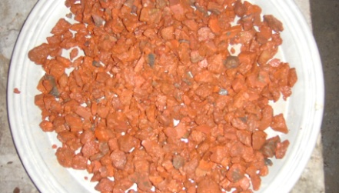
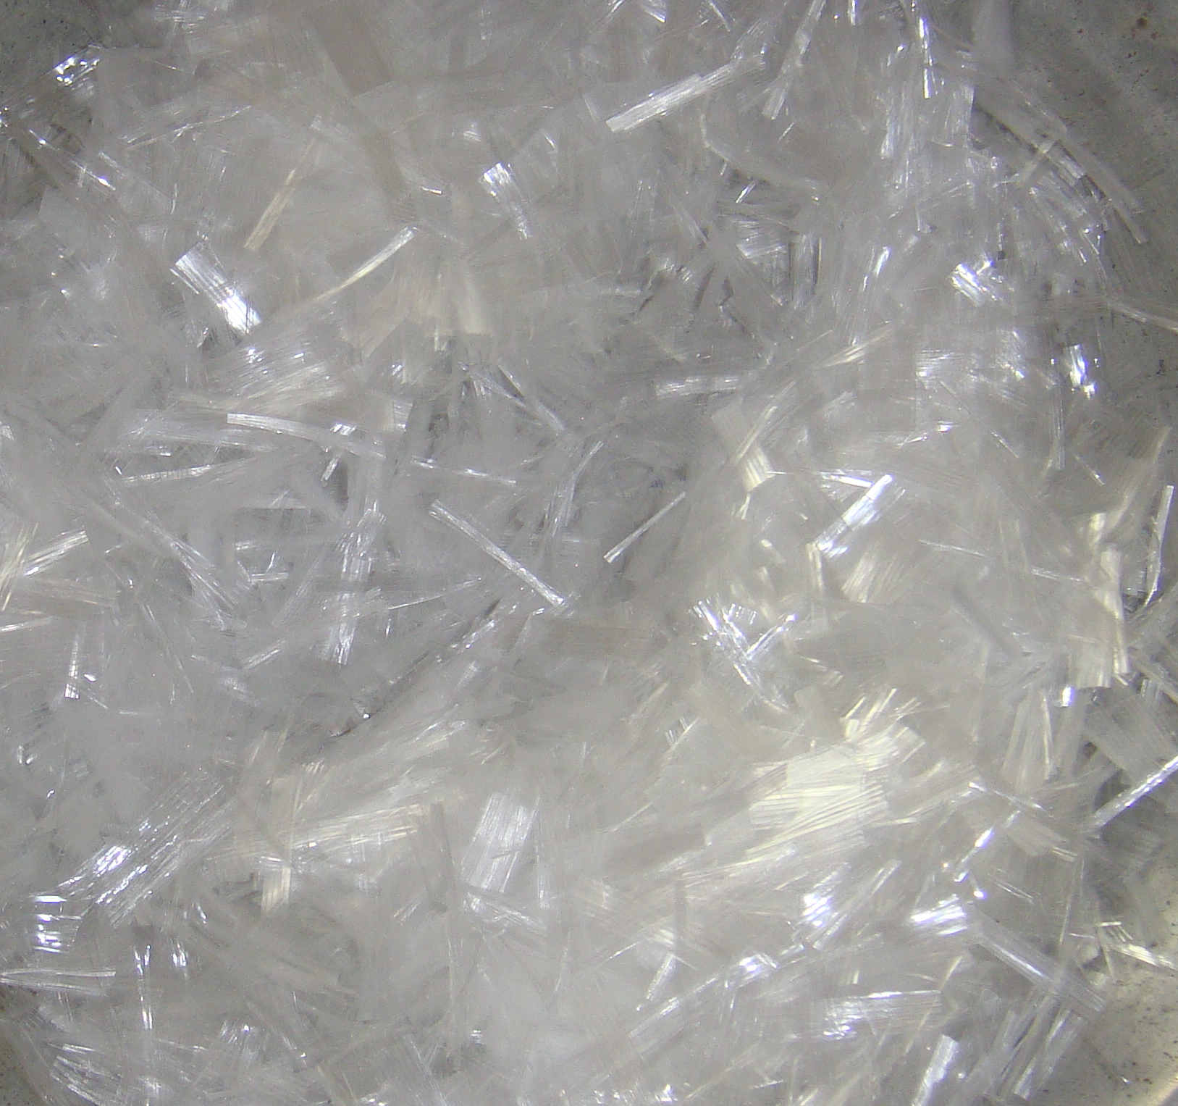

(a) Polypropylene Fibers | (b) Red Brick Aggregate
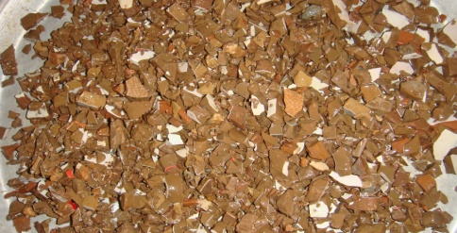

(c) Ceramic Aggregate

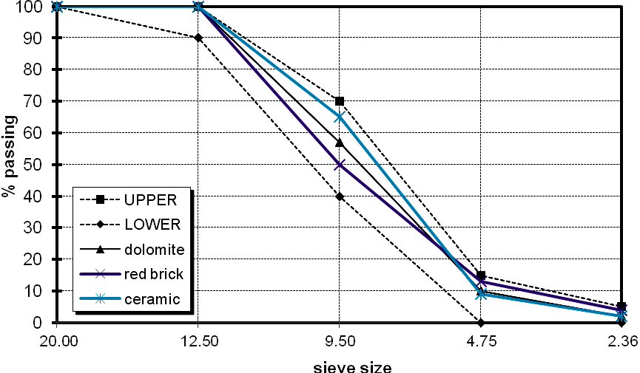

(d) Grading of Aggregate
Figure 1. Recycled materials as a coarse aggregate, [19]

Table [1] Concrete proportions of recycled self-compacted concrete mixes (kg/m³), [19].
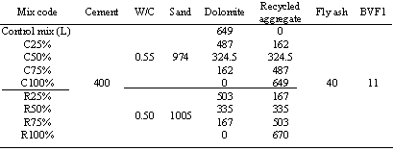

Phytosociological analysis of the herb species in each forest site was carried out by randomly placed 20, 1×1 m² quadrats during the peak.
Figures (2) and (3) show the effect of percentage of recycled materials on the flow diameter and flow time (T_{50cm}). Figure (2) cleared that an increase in flow diameter as a percentage of recycled aggregate increase for both crushed red brick and crushed ceramic. All mixtures using crushed ceramic or crushed red brick as recycled aggregate show a slump flow diameter between 705-1020 mm and achieve the requirements of SCC, [20]. This shows that all mixtures have enough deformability under their own weight. Figure (3) illustrated that an increase of T_{50cm} as percentage of recycled aggregate increase on both crushed red brick and crushed ceramic. When using When using ceramic as a recycled aggregate T_{50cm} ranged from 2 –3 sec. While in mixes with crushed red brick _{T50cm} ranged from 2.5 –3.6 sec. The basic requirements of flow ability as specified by technical specification for SCC, [20] are satisfied for the control mix (L). Where the slump flow diameter and T_{50cm} was 705 mm and 2.0 sec, respectively. The v-funnel flow time was 7.86 sec. The values of blocking ratio (H2-H1) were 5mm for mix L. The details of these results were reported by Kamal et al. [19].

Figure 2. Effect of percentage of recycled as a coarse aggregate on the flow diameter.

Figure 3. Effect of percentage of recycled as a coarse aggregate on the flow time.

As presented in Figures (4) and (5) show the effect of percentage of recycled aggregate on the compressive strength of the RSCC. At 28 days, decrease in the compressive strength with the increases in the percentage of the recycle aggregate. This is supported by a previous study conducted by Cachim, (2009) and Grdic et al. (2010). This is due to the type, the manufacturing process and properties of the recycle aggregated used in concrete mix. Figure (4) shows higher compressive strength for the concrete mixtures with crushed ceramic than for the concrete mixtures with crushed red brick for the same percentage of recycling. Moreover the reduction in the compressive strength for mixes with ceramic was lower that that concrete with crushed red brick. The maximum compressive strength was (19.7 and 28.3 MPa) obtained for concrete mixture with 25% crushed ceramic at 7 and 28 days respectively. The maximum compressive strength was (19.5 and 29 MPa) was obtained for concrete mixture with 25% crushed red brick at 7 and 28 days respectively. Reduction in compressive strength was about 24.4% for concrete mixtures with ceramic has been observed at 100 percentage of recycled aggregate, whereas for crushed red brick was 45% at 100 percentage of recycled aggregate.

Figure 4. Compressive strength for recycled self-compacting concrete

Figure 5. Reduction in compressive strength of recycled self-compacting concrete

3. Effect of Polypropylene Fibers on Fresh and Hardened Properties of Recycled Self-Compacted Concrete:
Polypropylene fibers with aspect ratio 12.5 and volume fraction ranged from (0.0 to 1.5%) were used to improve the properties of RSCC mixes. A total of 14 RSCC mixtures with 25% recycled aggregate were developed. At the end of this stage the optimum volume fraction of polypropylene fibers was assigned. Table (2) shows mix proportions of PRSCC mixes, respectively.

Table 2. Concrete Proportions of Polypropylene Fibers Recycled Self-Compacted Concrete Mixes (kg/m³).
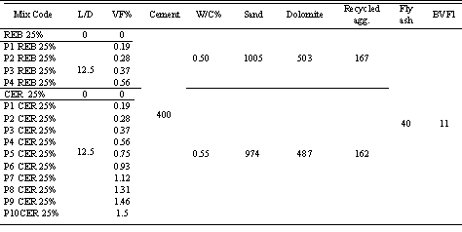

3.1 Workability of recycled self-compacted concrete mixes with polypropylene fiber
Figure (7) shows a decrease in slump flow diameter as polypropylene fiber volume fraction increases for PRSCC. The volume fraction for the PRSCC mixes with crushed ceramics was ranged from (0.0 to 1.5%). The optimum volume fraction that obtained from the results was 0.75% after this point the flow diameter decreases. The flow diameter for the PRSCC mixes with crushed ceramic ranged from (585 to 765 mm). In fact, a significant decrease in flow diameter has been observed beyond 0.75% fiber volume fraction. This might be due to the effect of the higher amount of polypropylene fibers as well as higher internal resistance of the polypropylene fibers in fresh concrete mixtures. For the PRSCC mixes with crushed red brick; the volume fraction changed from (0.0 to 0.56%). The flow diameter for theses mixes decreases due to polypropylene fibers volume fraction increases. The optimum volume fraction that obtained from the results was 0.19%. The flow diameter for theses mixes ranged from (490 to 695 mm). Also flow diameter decrease beyond 0.19% fiber volume fraction. It is noticed that the optimum volume fraction for PRSCC with crushed ceramic was higher than that of PRSCC with crushed red brick. Moreover the flow diameter for PRSCC with crushed ceramic was higher than that of PRSCC with red brick. The reduction in flow diameter for PRSCC with crushed ceramic was lower than that of PRSCC with crushed red brick. All theses noticed were due to the mechanical and physical properties of the aggregate used.

Figure 7. Effect of Polypropylene Fiber Volume Fraction on the Flow Diameter

During the slump flow test, the time required to reach the 500mm diameter was also measured and recorded as T_{50cm} (sec), which indicates the viscosity of the concrete. Figure (8) shows the effect of polypropylene fiber volume fraction on T50cm compared to the control mixture (with 25% recycled aggregate and without fibers). Increase in volume fraction increases the T_{50cm} measurement. T_{50cm} for the PRSCC mixes with crushed red brick ranged from (2.28 to 2.7 sec). The optimum volume fraction was 0.19% at T_{50cm} 2.61 sec. The T_{50cm} for the PRSCC mixes with crushed ceramic ranged from (1.93 to 3.9 sec). The optimum volume fraction was 0.75% at T_{50cm} 2.5 sec.

Figure 8. Effect of Polypropylene Fiber Volume Fraction on the Flow Time (T_{50cm})

Figure (9) shows the increment of T_{50cm} measurement with the flow diameter for PRSCC mixes. It cleared that as a flow diameter decrease as flow time increases.

Figure (9) Relationship between Flow Time and Flow Diameter of Slump Test.

Figures (10) and (11) show that an increase in the fiber volume fraction increases V-funnel time and V-funnel time at 5min for PRSCC mixes. A significant increase in V-funnel time beyond 0.75% of fiber volume has been observed in PRSCC mixtures with crushed ceramic as a recycled aggregate. While a slight increase in V-funnel time was observed for PRSCC with crushed red brick. This shows the effect of the higher amounts of polypropylene fibers and also illustrates the effect of polypropylene fibers in the narrow opening of the V-Funnel at the bottom beyond 0.19% and 0.75% of the fiber volume fraction for crushed red brick and crushed ceramic. Moreover, the trend lines in the figures show that V-funnel time for the crushed ceramic is higher than that of the crushed red brick for the same fiber volume fraction. This may be because of the difference in properties of the type of aggregate ones in the narrow opening at the bottom of the V-funnel. For the mixes which containing crushed red brick, the v-funnel time ranged from (6.18–6.4sec) at (0.0-0.56%) polypropylene fibers volume fraction. For the mixes with crushed ceramic, the v-funnel time ranged from (6.29 – 8.9 Sec) at (0.0%-1.5%) polypropylene fiber volume fraction. Figure (12) shows the same trends that were noticed at slump flow diameter. The figure illustrates that the flowability for the mixes with recycled crushed ceramic higher than that for crushed red brick.

Figure 10. Effect of Polypropylene Fiber Volume Fraction on V-Funnel Time

Figure 11. Effect of Polypropylene Fiber Volume Fraction on V-Funnel Time after 5 Min.

Figure 12. Effect of the Polypropylene Fiber Volume Fraction on the Flow Diameter of J-Ring test.

Figure (13) shows the flow time for all PRSCC mixes. The flow time for the J-ring test indicates the rate of deformation with specified flow distance. In general, T50cm for j-ring is higher than the normal slump flow time T_{50cm}, as flow is restricted by the reinforcing bars. Like the T_{50cm} time for slump flow test, the T_{50cm} time measurement for J-ring test gets longer with increased fiber volume fraction for all concrete mixtures. In addition, the mixes with crushed ceramic have lower T_{50cm} than the mixes with crushed red brick for the same percentage of fiber volume fraction, as expected. The H2-H1 for the PRSCC with crushed red brick was higher than PRSCC with crushed ceramic mixtures as shown in figure (14).

Figure 13. Effect of the Polypropylene Fiber Volume Fraction on the Flow Time For J-Ring Test

Figure 14. Effect of Polypropylene Fiber Volume Fraction on the Blocking Ratio for J-Ring Test

3.2 Mechanical properties of polypropylene recycled self-compacted concrete mixes
After investigating the compressive strength of mixtures with PRSCC, the results showed that the concrete mixtures without polypropylene fibers exhibited sudden brittle failure, while the concrete mixtures with polypropylene fibers exhibited a ductile failure because of the energy absorbing capacity of the fibrous concrete. Figure (15) represents the 7 days and 28 days compressive strength of PRSCC mixtures. 7 days compressive strength of mixtures with crushed red brick varies from 26.8 MPa to 32 MPa while those with crushed ceramic are between 27.5 MPa to 38.0 MPa. 28 days compressive strength of mixtures with crushed red brick varies from 29.5 MPa to 41.5 MPa while those with recycled ceramic are between 36.7 MPa to 49 MPa. An improving in the compressive strength by 54% and 48% for the mixes with crushed ceramic and crushed red brick, respectively compared to the mixes without polypropylene fibers. It is noticed that the compressive strength for the mixtures with crushed ceramics more than that with crushed red brick by 23%.

Figure 15. Effect of polypropylene Volume Fraction on the Compressive Strength.

Figures (16) to (18) show the other mechanical properties (tensile strength, flexural strength and density). The same trend was noticed for the other mechanical properties. Where, the mixtures with crushed ceramics the tensile strength more than mixtures with crushed red brick by 15%. The mixtures with crushed ceramics the flexural strength more than mixtures with crushed red brick by 22%.

Figure 16. Effect of Polypropylene Volume Fraction on the Tensile Strength.

At different percentage of recycled material, fresh properties for PRSCC were evaluated at optimum volume friction for polypropylene fibers. The different percentages of recycled Aggregated were (50%, 75% and 100%) as a replacement of coarse aggregate (dolomite). The optimum volume fraction for PRSCC was 0.19 % and 0.75% for crushed red brick and crushed ceramic, respectively. Table 3. gives the fresh properties of these mixes.

Figure 17. Effect of Polypropylene Volume Fraction on the Flexural Strength

Figure 18. Effect of Polypropylene Volume Fraction on the Density

Figures (19) and (20) show the relationship between the flow diameter and the T_{50cm} with the percentage of recycling material. Figure (19) represents that as the percentage of recycled aggregate increases as the flow diameter increase for the RSCC with and without polypropylene fibers. Also the flow diameter for the mixes without polypropylene fibers was higher than that with steel fibers. This due to the amount of polypropylene fibers as well as higher internal resistance of the polypropylene fibers in fresh concrete mixtures. T_{50cm} for theses mixes illustrated in figure (20). It is clear that as the percentage of recycled aggregate increases as the T50cm increase for the RSCC with and without polypropylene fibers. Also T_{50cm} for the mixes with polypropylene fibers was higher than that without polypropylene fibers.

Table 4. Rheological Properties of Fresh Polypropylene Fibers SRSCC Mixes at Optimum Volume Fraction
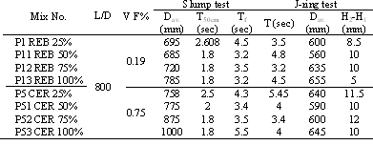

Figure 19. Flow Diameter and % Recycling Relationship for Slump Test

Figure 20. Flow Time and % Recycling Relationship for Slump Test

Figures (21) and (22) show the relationship between the flow diameter and the H2-H1 with the percentage of recycling Aggregate for J-ring test. The same trend was observed.
Figure (23) presents the compressive strength for the PRSCC with the optimum volume fraction of polypropylene fibers. It was noticed that 28-day compressive strength for the mixes with crushed ceramic varied from (23 MPa to 36.7MPa) and varied from (27 MPa to 45 MPa) for the mixtures with crushed red brick as a recycled aggregate. The density for the mixtures was shown in figure (24).

Figure 21. Flow diameter and % recycling relationship for J-ring test

Figure 22. Flow Time and % Recycling Relationship for J-Ring Test.

Figure 23. Compressive Strength of SRSCC

Figure 24. Density of SRSCC

5. Conclusions:-
The following conclusions can be drawn:
1. The concrete mixtures with crushed ceramic having fiber volume fraction of polypropylene fibers more than 1.46% shows no passing ability while up to 1.46% of polypropylene fiber volume fraction behave as PRSCC.
2. The concrete mixtures with crushed red brick having a fiber volume fraction of polypropylene fibers more than 0.37% shows no passing ability while up to 0.37% by volume of the polypropylene fibers behave as PRSCC.
3. The optimum content for volume fraction of polypropylene fibers was 0.75% and 0.19% of the concrete mixture with crushed ceramic and red brick respectively.
4. The compressive strength of the dolomite mix was 36 MPa at 28 days. The use of 25, 50, 75 and 100% of crushed red brick as a coarse aggregate replacement; decreased the compressive strength by 38.9%, 37.5%, 33.33% and 45%, respectively. Moreover, the use of 25, 50, 75 and 100% of the crushed ceramic of coarse aggregate replacement decreased the compressive strength by 21.4%, 31.4%, 27.8% and 24.2%, respectively
5. At optimum dosage of PRSCC mixes with 25, 50, 75 and 100% crushed ceramic yields to improve the compressive strength by 77.7, 27, 11.7 and 1.5%, respectively compared to the mixes with crushed red brick as a recycled aggregate. This leads to improving in the tensile and flexural strength.
6. At optimum dosage of PRSCC mixes with 25, 50, 75 and 100% crushed red brick yields to improve the compressive strength by 46.7, 18, 10.3 and 2.5%, respectively compared to the mixes with crushed red brick as a recycled aggregate. This leads to improving in the tensile and flexural strength.
7. At optimum dosage of PRSCC mixes with 25, 50, 75 and 100% crushed ceramic yields to improve the compressive strength by 18.4, 26.3, 21.2 and 14.8%, respectively compared to the mixes with crushed red brick as a recycled aggregate.

Corresponding Author:
Dr. Zeinab A. Etman
Department of Civil Engineering, Faculty of Engineering, Menoufia University, Egypt.
E-mail: : dr_zeinab_2006@yahoo.com
Cell Phone: 00201009727355,
Tel: 0020 482 238232

References
[1] Felekoglu B., Turkel S. and Baradan B. Effect of water/cement ratio on the fresh and hardened properties of self-compacting concrete. Building and Environment, 2007; 42.
[2] Domone P., Self-compacting Concrete: An Analysis of 11 Years of Case Studies. Cement & Concrete Composites, 2006; 28 (2), 197-208.
[3] Zhu W. and Bartos P. J. M., Permeation properties of self compacting concrete. Cement and Concrete Research, June 2003; 33 (6), 921-926.
[4] Uysal M., and Yilmaz K., effect of mineral admixtures on properties of self-compacting concrete. Cement & Concrete Composties, 2011; 33.
[5] Khaleel O. R., Al-Mishhadani S. A., and Abdual Razak H., The effect of coarse aggregate on fresh and hardened properties of self-compacting concrete (SCC). Procedia Engineering, 2011; 14.
[6] Uysal M., Yilmaz K. and Ipek M., The effect of mineral admixtures on mechanical properties, chloride ion permeability and impermeability of SCC. Construction and Building Materials, February 2012; 27 (1), 263-270.
[7] Rao A., Jha K. N. and Misra S., Use of Aggregates from Recycled Construction and Demolition Waste in Concrete. Resources Conservation and Recycling, March 2007; 50 (1), 71-81.
[8] Khayat K. and Roussel Y., Testing and Performance of Fiber-Reinforced, Self Consolidating Concrete. Material & Structure, 2000, 33 (6), 391-397.
[9] Grdic Z. J., Toplicic-Curcic G. A., Despotovic I. M. and Ristic N. S., Properties of Self Compacting Concrete Prepared with Coarse Recycled Concrete Aggregate. Construction and Building Materials, July 2010; 24 (7), 1129-1133.
[10] Corinaldesi V. and Morconi G., Characterization of Self-Compacting Concretes Prepared with Different Fibers and Mineral Additions. Cement & Concrete Composites, 2011; 33 (5), 596-601.
[11] Greenough T. and Nehdi M., Shear Behavior of Fiber-Reinforced Self-Consolidating Concrete Slender Beams. ACI Materials Journal, 2008; 105 (5), 468-477.
[12] Dhonde H. B., Mo Y., Hsu T. T. and Vogel J., Fresh and Hardened Properties of Self-Consolidating Fiber Reinforced Concrete. ACI Materials Journal, 2007; 104 (5), 491-500.
[13] Ozbay E., Cassagnebere F. and Lachemi M., Effect of Fiber Types on the Fresh and Rhelogical Properties of Self-Compacting Concrete. In K. H. Khayat, & D. Feys (Ed.), 6th International RILEM Symposium of Self-Compacting Concrete and 4th North American Conference on the Design and use of SCC, Montreal, Sep.2010; 26-29 (2), 435-443
[14] Yildirim H., Tezel O., Sengul O. and Guner P., Design, Production and Placement of Self-Consolidating Concrete. In K. H. Khayat, & F. Dimitri (Ed.), 6th International RIlEM Symposium on Self-Compacting Concrete, Montreal: RILEM Publication s.a.r.l, 2010; 26-29 (2), 1333-1340.
[15] European SCC Guidelines (2005) The European Guidelines for Self-compacting Concrete, Specification, Production and Use. Retrieved May 1, 2011, www.efca.info
[16] Qian C.X. and Stroeven P., Development of Hybrid Polypropylene-Steel Fibers-Reinforced Concrete. Cement and Concrete Research, January 2000, 30 (1), 63-69.
[17] ASTM C618: Specification for Fly Ash and Raw Calcined Natural Pozzolan for Use as a Mineral Admixture in Portland Cement Concrete, Annual Book for ASTM Stand, 4, 2002, 4 p.
[18] ASTMC 494/C 494M: Standard Specification for Chemical Admixtures for Concrete, Annual Book of ASTM Standards, 04.02, 2001, 9 p.
[19 Kamal M. M., Safan M. A., Etman Z. A. and El-daboly E. A. Behavior of Recycled Self-Compacting Concrete. Engineering Research Journal, 2013; 36 (2).
[20] Technical Specifications for Self-Compacted Concrete, National Building Research Center, Cairo, Egypt, 2007.

5/11/2013

