Isolation and Characterization of an Oxime from the n-Hexane Extract of Azadirachta indica A. juss (Neem) Leaves

Azra Akpuaka¹, M.M. Ekwenchi¹, D.A. Dashak¹, A. Dildar²

. ¹Department of Chemistry, Faculty of Natural Sciences, University of Jos, Jos, Plateau State, Nigeria.
²Department of Chemistry, Forman Christian College (A Chartered University), Lahore, Pakistan.
aakpuaka33@gmail.com

Abstract: The isolation and characterization of an Oxime from n-Hexane extract of Azadirachta indica (Neem) leaves was done, using Urea and Thiourea adduction and Gas Chromatography Mass Spectroscopy techniques. The isolation was really accidental because in the analysis, the medium in which Oxime was isolated was supposed to be a waste, it could have been discarded and thrown away. Through curiosity the medium was evaluated for organic components in the medium. The analysis that followed using this medium now showed the presence of an Oxime. The analysis involved the dissolution of the crystal of the Thiourea adduct in distill water, followed by solvent extraction of the component with n-Hexane. This resulted in obtaining two immiscible solvents, n-Hexane and water. The upper layer solvent which is n-Hexane contains the Thiourea adduct while the water is supposed to contain nothing and supposed to be a waste. The two immiscible solvents were now poured into a separating funnel and were shaken vigoursly and allowed to stand. The Oxime was found in distil water which was separated with separating funnel. This accidental evaluation is a novel contribution to knowledge.
[Akpuaka A., Ekwenchi M.M., Dashak D.A., Dildar A. Isolation and Characterization of an Oxime from the n-Hexane Extract of Azadirachta indica A. juss (Neem) Leaves. N Y Sci J 2013;6(6):86-90]. (ISSN: 1554-0200). http://www.sciencepub.net/newyork. 13

Key words: Azadirachta indica, Oxime, Urea and Thiourea Adduction, Separating funnel, Gas Chromatography, Mass Spectroscopy

1. Introduction
Oximes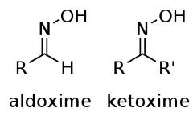

Oximes are usually generated by the reaction of “hydroxylamine” and “aldehydes” or “ketones’’. The term oxime dates back to 19th century, a portmanteau of the words oxygen and imide.[Victor M. et al.,].
An Oxime is a chemical compound belonging to the “imines” with the general
Formula:
R1R2C=NOH, where R1 is an organic side chain and R2 may be hydrogen, forming an Aldoxime or another organic group forming Ketoxime.
O - substituted Oxime form closely related family of compounds.
Generally oximes exist as colorless crystals, soluable in water though poorly and are used for identification of aldehydes and ketones.
Oximes are potent antifungal and antimicrobial agents against human pathogens.[Micheal H. et al., 2002]. Oxime a bioactive compound, possesses antibacterial, anticancer and antitumor activities.[Rahdary A.A. et al., 2012]
Urea and Thiourea Adduction Technique was used for separation of n-alkanes, isoalkanes and cycloalkanes from the n-Hexane extract of Neem leaves. As a complementary technique it pinpointed co-eluting peaks of the isolates as Urea adducts and Thiourea adducts respectively.

2. Material and Methods
500grams of fresh leaves of Azadirachta indica A. Juss were sourced from the National Research Institute for Chemical Technology, Zaria Kaduna State, Nigeria. Leaves were washed and dried at 30°C in an oven and ground to powder with an electric blender. Powdered leaves were extracted with n-Hexane for 4 days, filtered and dried to constant weight. Urea and Thiourea adduction was carried out with fraction 1 of Column Chromatography of the n-Hexane extract of the Neem leaves as given. Urea and Thiourea Adduction is a micro analytical technique used for isolating n-alkanes, isoalkane and cycloalkanes from a natural medium may it be petroleum products or others. 22mg of the dried n-Hexane fraction 1 of Column Chromatography was dissolved in the n-Hexane. To this solution, gradually a saturated solution of Urea in acetone was added till a crystalline precipitate was obtained. The precipitated solution was filtered and precipitate was washed with n-Hexane and dried. The precipitate was dissolved in little distil water and and the aqueous solution was extracted with n-Hexane in a separating funnel for determination of n-alkanes. The crystalline precipitate was further dried and dissolved in little benzene and to this was added a saturated solution of Thiourea in methanol by v/v 1:1. The resulting solution was left for four days for crystal formation. The crystal were washed with benzene and dissolved in little distil water. The aqueous solution is now extracted with n-Hexane for determination of isoalkanes. The aqueous solution was bioassayed against Candida albicans and zones of inhibition recorded. The analysis involved the dissolution of the crystal of the Thiourea adduct in distill water, followed by solvent extraction of the component with n-Hexane. This resulted in obtaining two immiscible solvents, n-Hexane and water. The upper layer solvent which is n-Hexane contains the Thiourea adduct while the water is supposed to contain nothing and supposed to be a waste. The two immiscible solvents were now poured into a separating funnel and were shaken vigoursly and allowed to stand. The Oxime was found in distill water which was separated with a separating funnel.
For Gas Chromatography and Mass Spectroscopy analysis 1μl of the aqueous solution of the was injected in the injection port. GC/MS of the Urea and Thiourea adducts and non adducts fractions were carried out using Agilent Technologies 7890A GC System. The detector was Agilent Technologies 5975C inert MSD with Triple-axis Detector, with (polysiloxanes) column 30m × 0.25m fused capillary silica tubing. Software adopted to handle mass spectra and chromatograms was National Institute of Standard and Technology MS. 2005 Library.
The temperature protocol for GC/MS detection was as follows: Injection port temperature 200°C and Helium flow rate was 1ml/min. Oven temperature was programmed from 50°C with an increase of 8°C/min to 300°C and this temperature was held for 9 minutes. The ionization voltage was 70ev. The sample was injected in splitless mode and spectral scan range was set at 45-500(MHZ). The GC/MS characterized the isolates of the n-Hexane extract of Azadirachta indica in Urea and Thiourea adduction fractions.
The fragmentation pattern of the mass spectra were compared (Head to tail) with those of the known compounds stored in the NIST Library. Total GC running time was 36mins.

3. Results
Gas Chromatogram and Mass spectra result from analysis of aqueous layer of Thiourea adduct obtained from separating funnel, separating two immiscible solvents n-Hexane and distill water are given in Table 1., Chart 1., Figure 1 and 2., Table 2,. and Plate 1. respectively.

Table 1. Thiourea adduction of CC F1 as shown by GC/MS
S/N | Fraction | GC Rt of Phthalate | Remarks
1. | Thiourea adduct | 4.806 | Single peak

Oxime

Chart 1 shows the Oxime and other isolates which resulted from this micro-analytical technique. The Phthalate’s findings have already been published.

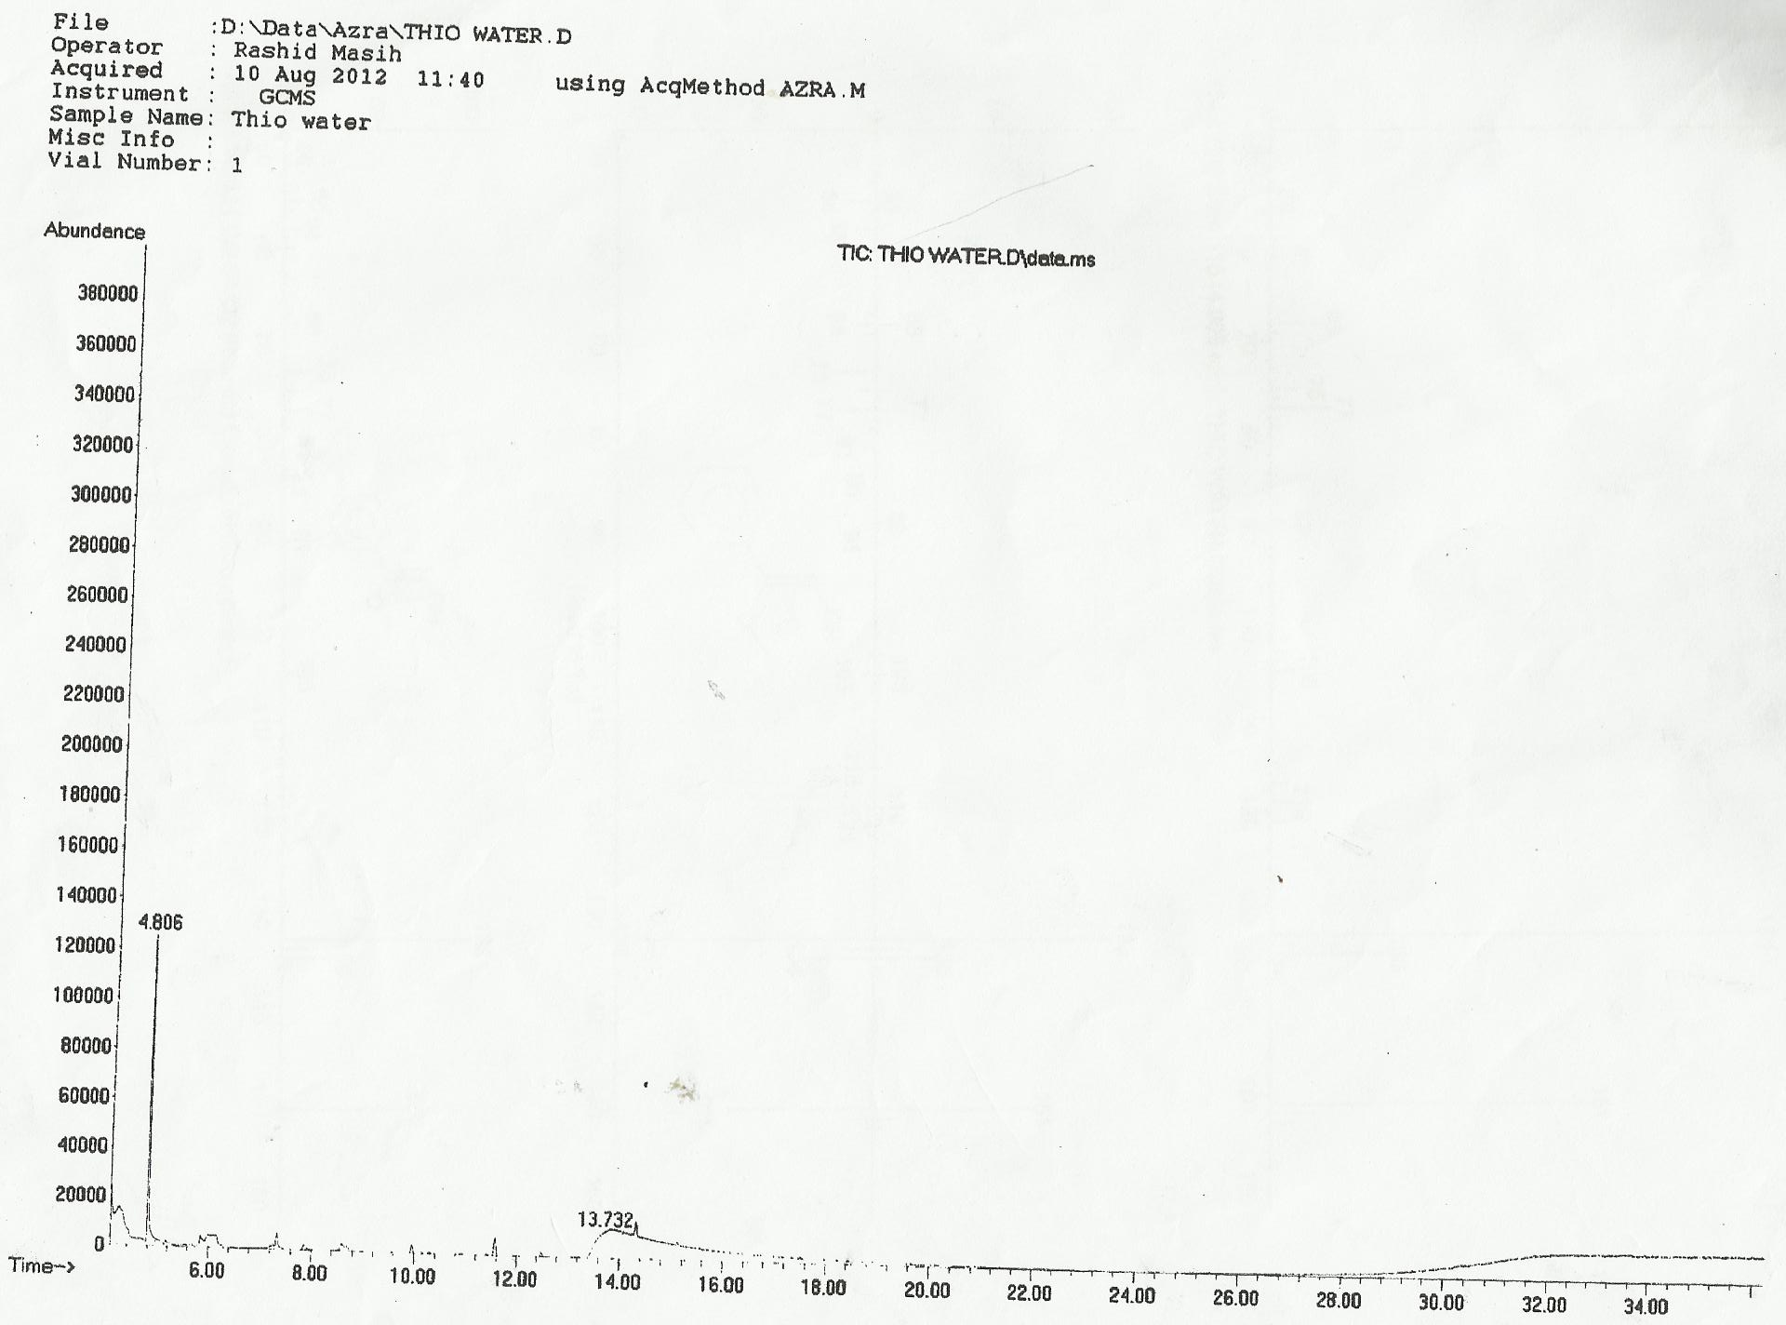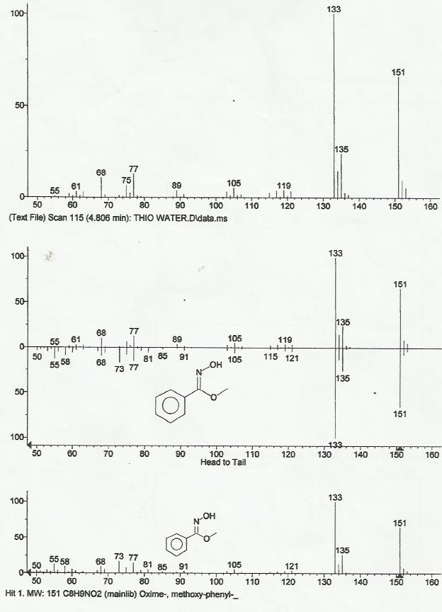

Fig 1. Gas Chromatogram of Aqueous Layer of Thiourea Adduct
Fig 2. Mass Spectrum of Aqueous Layer of Thiourea Adduct

Table 2. Bioassay of n-Hexane fraction 1 of Column Chromatography with Candida albicans

S/N | SOLVENT SYSTEM | Column Chromatography Fraction | Zone of inhibition (mm)
1. | 100% n-Hexane | (CCF1) | 25
Petri dish diameter = 10cms. Positive control, Antifungal Drug Fluconazol 2mg/ml

Plate 1. Inhibition zone of Candida albicans with Column Chromatography Fraction 1
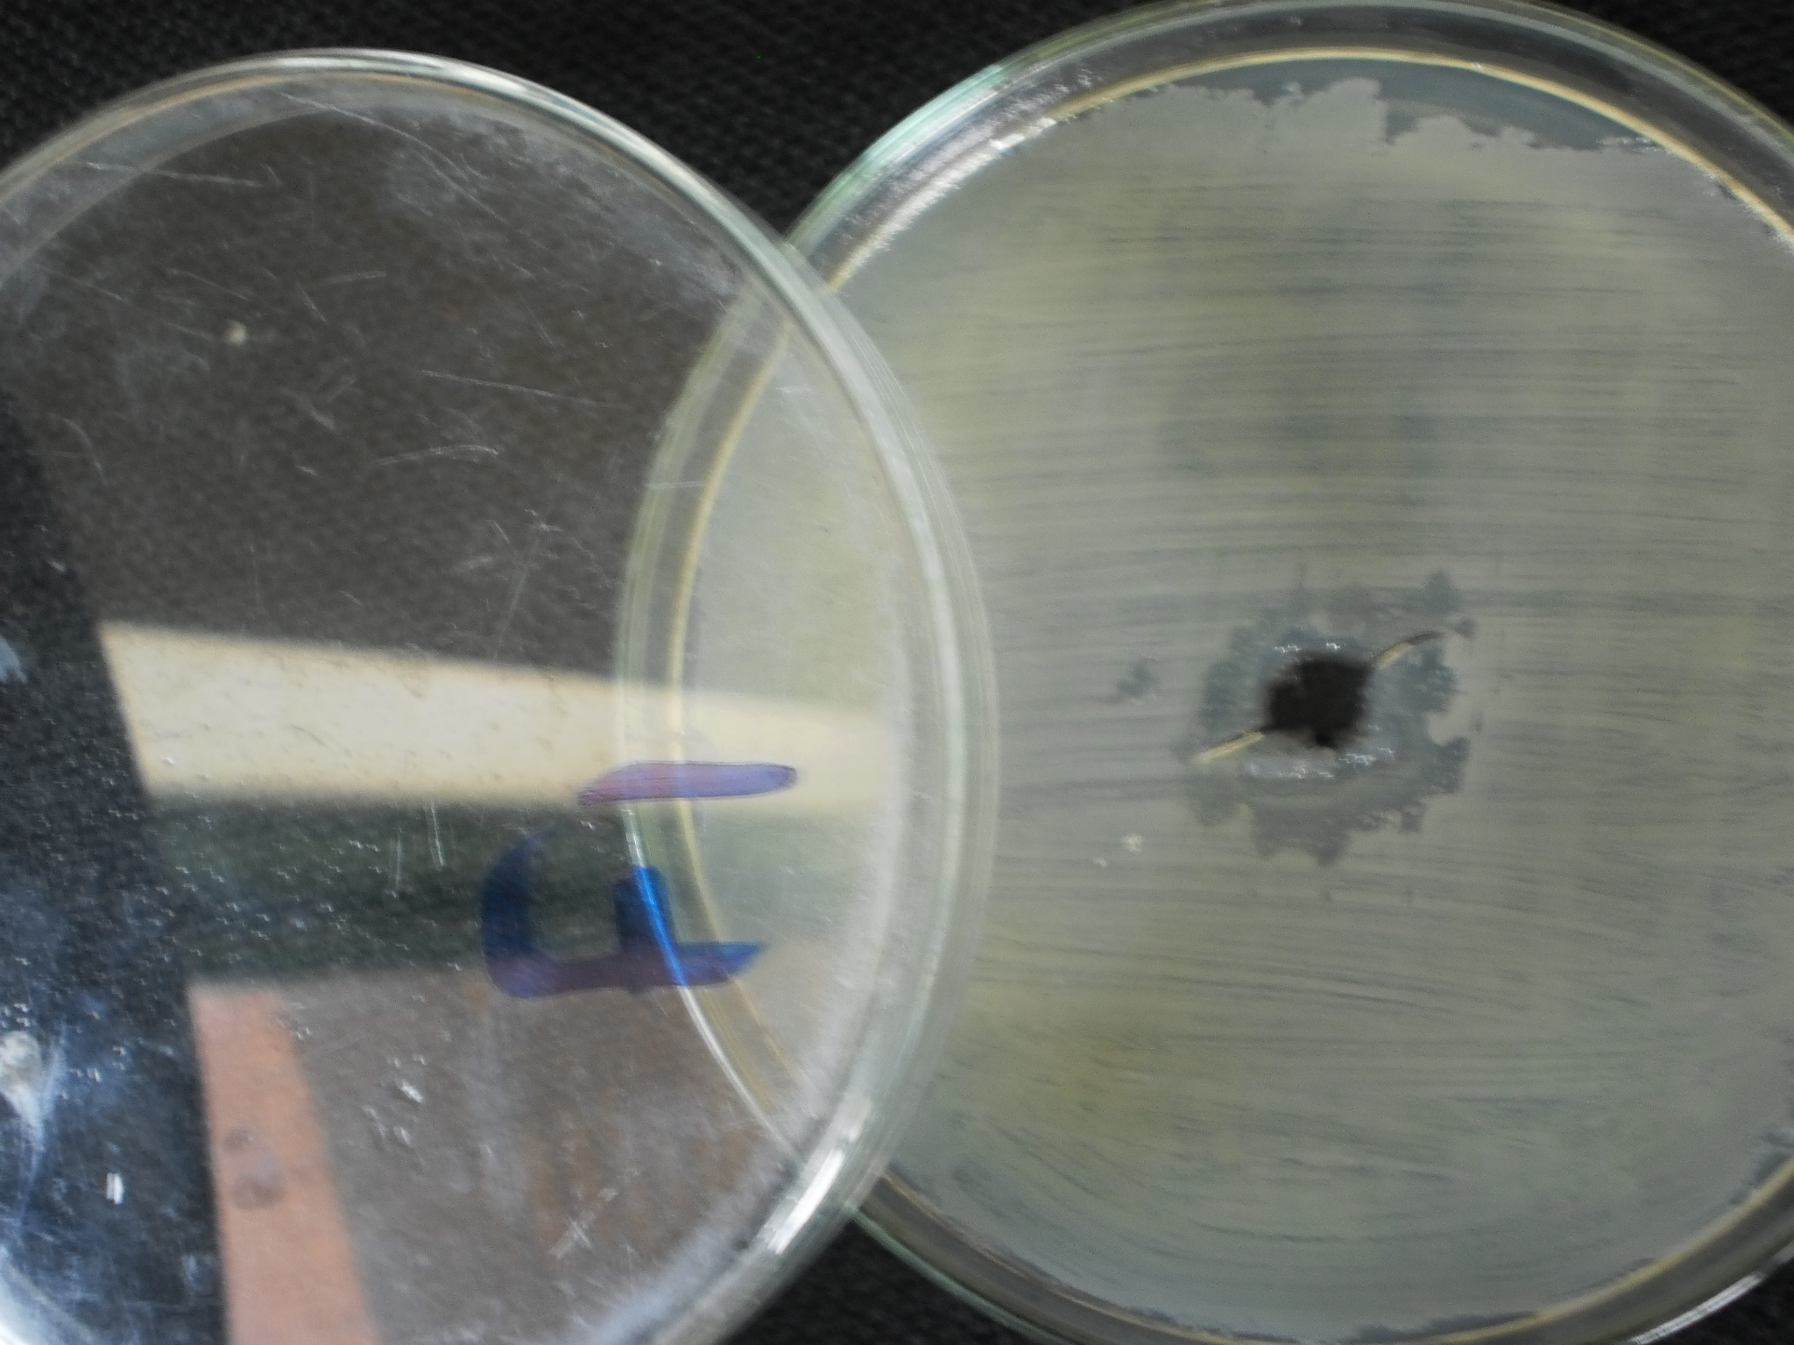

Pl 1. Fraction 1 (100% n-Hexane)
of Column Chromatography of Neem Leaves

4. Discussions
In the chromatogram of aqueous layer of Thiourea Adduct, one can see a distinct single peak of oxime at Rt. 4.806 mins. The mass spectra of the oxime shows base peak at 133 and molecular ion 151. if we can recall during GC/MS process, the ion source chamber fragments the fast moving molecules and each fragment bear characteristics of the molecules from which it fragments. The MS detector reads these fragments and produces the mass spectra which is matched in head to tail manner with the compounds present in NIST Library. It is obvious that the aqueous layer of the Thiourea Adduct was not empty as shown by their respective chromatograms and mass spectra and contained oxime. We bioassayed water and have zone of inhibition 25mm as shown in Table 2.
This is oxime from aqueous layer it was adducted in Thiourea and not extracted when separated with separating funnel and stayed in aqueous layer and therefore it is a novel compound in the Neem leaves and an addition to knowledge.

Acknowledgement
I am grateful to the Department of Chemistry, University of Jos for their Laboratory facilities extended to me for carrying out my research work.
I thank the Chairman and all staff of the Department of Chemistry, Foreman Christian College Lahore, Pakistan for their Instrumentation facilities extended to me for this research work.

Corresponding Author:
Azra Akpuaka
Department of Chemistry
University of Jos, Jos, Nigeria
aakpuaka33@gmail.com

References
- Victor M. and Alois J. (1882a). Üeber stickstoffhaltige Acetonderivate”(On nitrogenous derivatives of acetone. Berichte der Deutschen chemischen Geselischaft. 15: 1164-1167.
- Micheal H. Serrano-Wu, Denis R. St. Laurent, Charles E. M. Terry M.S. John F.B., Dolatrai M. V.and Balu N.B. (2002). Oxime Derivatives of Sordaricin as Potent Antifungal Agent. Bioorganic and medicinal Chemistry letters 12:943-946.
- Rahdary, A.A. and Sobati, Z. (2012). Chemical composition of essential oil, antibacterial activity and brine shrimp lethality of ethanol extracts from Sedum pallidum. Journal of Medicinal Plants Research, 6(16), 3105-3109.
- Clark M.A., Barret E.L., (June, 1987)
- Ryan K.J. and Ray C.G. (2004). Sherris Medical Microbiology (4th ed.) Mc Graw Hill. 362-8. ISBN 0-8385-8529-9
- Ramasany, H., Man, C.K., Ju, S.K., Chellam, B., Sundaram, J., and Moon, S.H., (2010). Identification and Antimicrobial Activity of combined extract from Azadirachta indica and Ocimum Sanctum. The Israeli Journal of Aquaculture-Baidgeh, 62(2), 85-95.
- Badam L., Joshi S.P., (1999). “Invitro antifungal activity of neem (Azadirachta indica A. Juss) leaf extract against group B coxsackie viruses” J. Commun Dis., 31: 79-90. Medicinal Properties of Neem (http://www.infinity foundation.com/mandala/t_es/t_e ograw_neem.htm
- Syeda, F.A, Habib-Ur- Rehman, Choudahry, M.I., and Atta-Ur-Rahman. (2011). Gas Chromatography-Mass Spectrometry (GC-MS) analysis of petroleum ether extract (oil) and bioassays of crude extract of Iris germanica. International Journal of Genetics and Molecular Biology, 3(7), 95-100.
- Sewanu, S.O., Opoku, A.R., Oyedeji, A.O (2012). The chemical composition, antimicrobial and antioxidant properties of the essential oils of Tulbaghia violacea Hary and Eucalyptus grandis W.Hill ex Maiden. En US. University of Zululand South Africa.
- Okeie, W., Ogunlesi, M., Ofor, E., and Osibote, E.A.S (2009). Analysis of essential oil constituents in hydro-distillates of calotropis procera (oil). R.Br Res. Journal of phytochestry 3, 44-53.
- Yogeswari, S., Ramalakshmi, S.N., and Muthu, J.M. (2012) identification and
- comparative studies of different volatile fractions from Monochaetia kansensis by GC-MS. Global Journal of Pharmacology, 6(2): 65-71.10.
- Hsouna, A.B., Trigie, M., Mansour, R.B., Jarraya, R.M., Damak, M., and Jaoua, S., (2011). Chemical composition, cytotoxicity effect and antimicrobial activity of Ceratonia silisqua essential oil with preservative effects against listeria inoculated in minced beef meat. International Journal of Food Microbiology, 148(1), 66-72.
- Pavlović, M., Petrović, S., Milenković, M., Couladis, M., Tzakou, O., and Niketić, M. (2011). Chemical composition and antimicrobial activity of Athriscus nemorosa root essential oil. J. Nat. Prod. Commun., 6(2):271-273.
- Gholamreza, A., Mohamad, J. and Ehsan, S. (2012). Antimicrobial activity and chemical composition of essential oil from the seeds of Artemisia aucheri Boiss. J. Nat Pharm. Prod., 7(1):11-15.
- Harami, M., Adamu, E.O., Ekanem and Suleiman, B. (2010). Identification of Essential oil components from Nigella sativa seed by Gas Chromatography-mass Spectroscopy. Pak. J.Nutr., 9(10):966-967.
- David, P.E. and Patrick, J.C. (2012). Antimicrobial preservatives Part Two: Choosing a preservative. GlaxoSmithKline Pharmaceuticals Callum Consultancy.
- Nurettin, Y., Canan, G., Osman, U., Ahmet, Y., Serdar, U., Kamil, C., and Salih, T., (2006). Composition and antimicrobial activities of volatile components of Minuaritia meyeri. Turk, J. Chem., 30; 70-76.
- López, A., Ming, D.S., Towers, G.H., (2002). Antifungal activity of benzoic acid derivatives from Piper lanceaefolium. J. Nat. Prod., 65(1):62-64.
- Cheila, D.O.S., Fabricio, M.C., Fabricio, A.O., Evandro, P., Carmen, B.B.F. Susana, M.W.S., Maria, L.S. (2012). Antimicrobial activity [2-methacryloyloxy)ethyl]trimethylammonium chloride against Candida spp,1-4.
- Ozdemir, G., Karabay, N.U., Dalay, M.C. Pzarbasi, B. (2004). Antibacterial activity of volatile component and various extracts of Spirulina platensis. Journal of Phytother Res, 18(9):744-757.
- Gurdip, S. and Palanisamy, M. (2006). Chemical constituents, antifungal and antioxidative effects of ajwain essential oil and its acetone extract. Journal of Agricultural and food chemistry, 54(1):174-81.
- Madhumitha, G., Rajakumar, G., Roopan, S.M., Rahuman, A.A., Priya, K.M., Khan, F.R., Khanna, V.G., Velayutham, k., Jayaseelan, C., Kamarai, C., Elango, G., (2011). Acaricidal, Insecticidal, and larvicidal efficacy of fruit peel aqueous extract of Annona Squamosa and its compounds against blood-feeding parasites.
- Akhari M., Batooli, H., and Kashi, F.J., (2012). Composition of essential oil and biological activity of extracts of Viola odoranta L. from central Iran. Journal of Nat. Prod. Res, 26(9): 802-9.
- Yang, W.D., Liu, Y.R., Liu, J.S., Liu, Z., (2008). Inhibitory effects and chemical basis of Eucalyptus orelliana wood meals on the growth of Alexanrium tamarense. Journal of Huan Jing ke xue, 29(8):2296-2301.
- Yanping, H., Suhua, H., Jincheng, W.U., Shunquan, L. (2010). Identification of essential oils from the leaves of 11 species of Eriobotrya, 4379-4382.
- Bashir, A. Ibrar, K. Shumaila, B. and Sadiq, Azam. (2012). Chemical composition and antifungal, phytotoxic, brine shrimp cytotoxicity, insecticidal, and antibacterial activities of the essential oils of Acacia modesta. Journal of Medicinal plants Research, 6(31), 4653-4659.
- Hema, R., Kumaravel, S., and Alagusundaram. (2011). GC/MS Determination of Bioactive components of Murraya koenigii. Journal of American Science, 7 (1).
- Pietro, Z., Maurizio, S., Maurizio, B., Antonella, M., Sergio, R., Carmen, F. and Felice, S., (2010). Essential oil composition of stems and fruits of Caralluma europaea N.E.Br. (Apocynaceae). Molecules, 15, 627-638.
- Elija, K., Vaishali, B., Adsul, M.K., Deshpande, N.R. and Kashalkar, R.V. (2012). Antibacterial activity of Dibutyl Phthalate : A secondary metabolite isolated from Ipomoea carnea stem. Journal of Pharmacy Research, 5, No 1.
- Laila, S.A.H, Mohammad, A.H., Afaf, Mohammed, W. Qasim, A., Jamal N.A. (2012). Gas chromatography-mass spectrometry analysis of different organic crude extracts from the local medicinal plant of thymus vulgaris L.
- Sahayaraj, K. and Ravi, C., (2008). Preliminary phytochemistry of ipomea carnea jacq and vitex negundo linn leaves. Int. J. Chem. Sci, 6-1.
- Praveen P.K., Kumaravel, S., and Lalitha, C. (2010). Screening of antioxidant activity, total phenolics and GC-MS study of Vitex negundo. African Journal of Biochemistry Research, 4(7), 191-195.
- Gehan, M.A., Hanan, A.E., Hassan, A.H.I., and Okbah, M.A., (2009). Marine natural products and their potential applications as antiinfective agents. World Sciences Journal, 7(7): 872-880.
- Uma, B., and Parvathavarthini, R. (2010). Antibacterial effect of Hexane Extract of sea urchin, Temnopleurus alexandri (Bell, 1884). International Journal of Pharm. Tech. Research CODEN (USA), 2(3) 1677-1680.
- Balachandran, C., Lakshmi, R.S., Duraipandiyan, V., and Ignacimuthu S., (2012). Antimicrobial activity of Streptomyces sp. (ERI-CPDA-1) isolated from oil contaminated soil from Chennai, India. Bioresource Technology, 129.
- Bagavathi, P.E., and Ramasamy, N., (2012). GC-MS analysis of phytocomponents in the ethanol extract of Polygonum chinense L. Pharmacognosy Research, l 4, 11-14.
- Fethi B.J.K., Mohamed, A.M., Samia, A.M., Karima, B.S., Ahmed, N.H., and Zine, M., (2012). Antioxidant activities of essential oil from Cotula coronopifolia L. growing in Tunisia.
- Rani, P.S. and Agrawal, R. (2006). Volatile compounds of therapeutic importance produced by leuconostoc paramesenteroidses, a native laboratory isolate.
- Atolani, O., Olatunji, A.G., Adeyemi, O.S., and Fayemi O.S., (2009). Antioxidant and Antimicrobial Activity of Cuticular Wax from kigelia africana. FABAD J. Pharm. Sci., 34, 187-194.
- Viviane, G.C.A., Jacqueline, A.T., Lucienir, P.D., Dorila, P., Policarpo, A.S.,J., Rosana, O.A.., Alvaro, J.R., Antonio, F.C.A. (2011). Evaluation of the bactericidal and trypanocidal activities of triterpenes isolated from the leaves, stems and flowers of Lychnophora pinaster. Brazillian journal of Pharmacognosy, 21(4): 615-621.
- Goyal, M.M., Gupta, A. (1987). Antibacterial activity of some active principles of polyathia longifolia leaves, 19(3): 216-220.
- Venkata, R., Samuel, L., Pardha, S.M., Narashimha, R. Naga, V.K.A., Sudhakar, M., and Radhakrishnan, T.M. (2012). Antibacterial, antioxidant activity and GC-MS Analysis of Eupatorium odoratum. Asian J. Pharm. Clin. Res., 5. Suppl 2, 0974-2441.
- Moorthy, V. Boominath, M. (2011). “The Antimicrobial Activities of Crude Extracts and fraction of Psidium Guajava and Azadirachta indica against Staphylococcus aureus in chronic disease affected patients”. International Journal of universal pharmacy and life sciences, 1(2): September-October, 2011.

