Investigation the Military Castles of Baneh in the Parthian and Sasanian Era

Mohammad Rashidi (Corresponding author), Ahmad Heydari
MSc of archaeology study, BuAli Sina, Hamadan
sayan233@yahoo.com

Abstract: Iran due to being in a particular geographical area was always in the focus of neighbors and adjacent communities that have in some cases led to armed conflict. Specific measures to protect and defend the government thought that the castle is one of the fundamental ways. More information about Parthian and Sasanian periods of historical data relative to previous periods, especially the western part is available. Baneh city located in Kurdistan province and west of Iran and is near the border with Iraq. Based on investigation in this study area, the dramatic increase of sites and particularly in the castles of the Parthian and Sasanian eras can be seen. These castles have common features such as use of rigid stone, oval plans, placed in strategic locations that are tall and overlook the routes of communication. Frequency of castles in specific geographic area represents importance of the region and its communication paths and military functions that the preservation and defense of the governments was important which historical texts confirm this issue as well.
[Mohammad Rashidi, Ahmad Heydari. Investigation the Military Castles of Baneh in the Parthian and Sasanian Era. N Y Sci J 2013; 6(6): 91-98]. (ISSN: 1554-0200). http://www.sciencepub.net/newyork.
Keywords: military castles, Parthian, Sasanian, Baneh region

Introduction:
Man in his life, was always thinking to protect him against the various threats and protect all belongs, so thought for the provision. This issue has also been addressed in different periods of governments and also building castles, particularly in sensitive areas has been carried out. In a fortified building housing three thousand BC started with a different plan (Clise, 1999:68). Process of building castles was continued which examples related to the period of Orartoei is present in North West of Iran. During the historic period, especially castles built to defend against invading enemies the Parthian and Sassanian periods, especially in the South-West and North-West are left with many examples.
In general, the castle can be divided into two categories: the mountains and the plains which based on the terms of works, military and border castles, castles toll, the political and religious minorities, the predominantly rural and ... could be considered (Mollazadeh and Mohammadi, 2000).
Baneh city is located in the North West province of Kurdistan. The city center consists of four parts, namely the centrality of the Baneh, Alout region by the center of Armadeh, Namshir region by the center of Kanisour, Nanoor region by the center of Booein Sofla. Baneh is limited to Saqhez in the East, and also reaches to West Azerbaijan province in north and west and is limited to Iraq in south and southwest part (Armed Forces Geographical Organisation, 2006). With the move from East to West side of the city, the relative height is reduced. (Map 1)
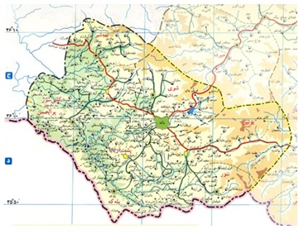
Map 1: Baneh city

Archaeological investigations in the city's Baneh, in cooperation with the Department of Cultural Heritage, Handicrafts and Tourism took the city landscaping in 2007, 2008 and 2009, hills works are identified and recorded. Parts of central and Namshir led by one of the authors (Salah Nasrollahi) and the Alout (Armardeh) were led by Mr. Nader Nouri (Nouri, 2009). Notable instance of this investigation is that there are many castles in the region and the purpose of this series is to introduce them.

Research method:
As mentioned, sites identified during Baneh project investigation. After identification and record of any features of the castle and cultural materials (especially ceramics) was in order to compare the relative areas and historian has been studied.

Literature review:
Prior to conducting the survey area, organized labor was not conducted in order to identify sites and artifacts and so castles in this region are also unknown.

Historic castles of Baneh city
Archaeological survey in the field of endeavor and discovery, identification, registration and distribution of archeological sites scattered on the ground and in relation to geographical areas and the natural environment (Fagan, 2003:303). Archaeological studies point that we should always consider is that modern political boundaries and divisions to discuss the past, do not generalize. The review should also note that the Bane because Bane city shares a border with another country (Iraq), provinces (West Azarbaijan) and other city (Saghez) and make castles recorded in city politics Baneh have identified and because the present political divisions of the project are defined and implemented, we must always consider the possibility of the same style castles in Iraq and Azerbaijan of Saghez, and there are Marivan and to get a comprehensive view of the Castle District (West Azerbaijan) should also be considered in the future it is hoped to happen.
The survey of 141 cities Baneh is identified and recorded on the pre-Islamic history and requirements. The effects of copper ore on very limited period (Dalma) and then trace record are not the Parthian and Sassanin era. Increased substantially during the Parthian and Sassanin relics can be seen in the Islamic era, this trend will continue.
Showing 31 of 27 Alout The monument is identified and recorded their castle is 4 (Nouri, 2009). The central portion 54 of the 13 castles and Namshir Section 56 of 8 fortresses recorded there.
A total of 22 so far Castle area is identified and recorded. Relative dating more castles in the pottery and ceramics compared with the known neighboring areas is performed. It has more castles Everyday pottery and carving designs and adds more decorations to be included.
Known in the city of Baneh castle has some common features, in one instance, if plane is oval stone materials used for making them which have been established. The dimensions are not large and are stuck with daily use.
The castle overlooks the areas where they are located and more on individual mountains are tall or full visibility on roads that are related. Note that the communication paths in the mountainous regions (Zagros Mountains) where there is no possibility of traffic directions are clear and so can be adapted to modern communication paths and the expression of pre-existing and current directions in historical periods is also likely to have the same situation today. Castle overlooking the communication paths is also discussed. It's forts in strategically sensitive areas that even in the modern era have been used depending on the circumstances, for example, during the Iran-Iraq war, some of these castles have been used to establish military bases. In the following discussion, it will be introduce the features of each of the castles and the first part Alout, then the central part and Nanour and at the end part Namshir is studied.

Castles of Alout Region
Goureh Ghala (The Great Castle) Sardav
Sardav village is located in 20 kilometers of southeast of Armardeh and in 32 kilometers from the city of Baneh. The village is located in the deep and narrow valleys. Goureh Ghala lied on natural embankments over 1500 meters from the west Sardav village, which overlooks the east and west of Balehkeh valley. The altitude of region is1755 meters above sea level. Dirt road leading into the mountains (the natural border between Iran and Iraq) from the eastern edge of passes and access to the west side of the path is plainly. The nearest water source is a spring seasonal effect is 50 yards. The castle is oval in plan, 20 meters north-south and east-west length of 18 meters. The wall thickness is about 80 cm to a meter in some parts of it are left. Building a dry stone it is made ​​in stones. South, East and North of the castle are steep and the only access is from the west. Cultural material is obtained from the clay; they can be studied and compared with the Sassanian era considered.

Soleymaneh Castle
Sisark village is located in 29 km from Baneh city. Soleymaneh castle was overlooking on the west - east valley of the village. Choman the southern edge of the seasonal river flows. The altitude of region is 1364 meters above sea level. It is located at 2,000 meters north of the village and along the access road of Balehkeh and Dehkohneh (oldvillage). Rule impact on the natural oval is located along the north - south and 40 meters east - west 25 meters. Remnants of the fortress walls at the northern and southern sectors remain healthy and up to about one meter. Castle Rock as rigid materials that have been set up from clay and stones. Pottery, mostly related to the history of the castle (Parthia - Sasanian).

Ghalati Goureh (The Great Castle) Tazhban
Tazhban village is located 25 km of south-west of Baneh city. Ghalati Goureh is located in 2000 m and elevation 1155 meters above sea level in the north of the village is located on a cliff overlooking the valley floor east - west. Tazhban seasonal river flows through the northern part. The only access road is Tazhban to Tazhan that passes of 50 yards west. The plan is oval shaped and east - west and 50 meters north - south 35 meters. In the northern and western sections of the wall to a height of about a meter left. The castle was built as rigid aggregates.

Ghalay Goureh (The Great Castle) Tazhan
Tazhan village is located 20 km south west of Baneh city. The castle overlooks the village in the eastern highlands and onto a rock bed located at an altitude of 1757 meters above sea level. There are waters in 100 meters from castle. The only access road to the castle is 300 meters east of Malrau continues. Plan of castle is oval shape and the north - south length is 50 meters and east - west length is 20 meters. Building and is made ​​in a dry stone. Surface area is covered with slate. The walls about a meter remains in the northern and eastern parts and based on environmental characteristics, the entrance most likely was in the northern part.

Castles of central parts and Nanour
Douzin Castle
This castle is located on the Douzin Mountain in the northern part of Baneh which the castle overlooking the city is. The highest point is about 1970 meters above sea level. From the North, South, East and West steep and access is easier. The nearest source of water is in a kilometer further the west and as a fountain. The castle has an irregular plan and the topography of the mountain on which it is located (Figure 1). The castle was damaged and it was a lot of unauthorized excavation. Roughly east - west length is 300 meters and north – south length is 90 meters. Inside the castle is a concrete pool that small part of it remains but it can be considered as a circular diameter of 3 meters. Castle of cultural materials is including ceramics, glass and metal slag. Objects can be considered more Sasanian and Parthian. Sasanian glass items like glass, but it certainly can not be dating. Steel slag can be indicative of metal products, due to the presence of iron ore in the nearby castle and more likely to be raised.

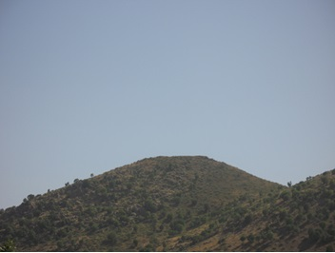
Figure 1: Douzin Castle outlook, Photos by authors

Shargeh Castle:
Shargeh village is located in 12 km from northwest of Baneh city. This castle is known as Goureh Ghala (The Great Castle) and also Changizkhan castle and also is located in 1.5 km from northwest village and in 1905 m from sea level. The remains of castles' wall show that its plan is oval shape and its east-west length is 90 m and its north-south length is 60 m. The components of castle are big stones, brick and clay. The thickness of wall is about 2 m. in west side slope of castle, there are clay pipes. In addition, the bricks belong to Sassanian era. It seems that castle was built in Sassanian era and was rebuilt in middle Islamic era (Figure 2).

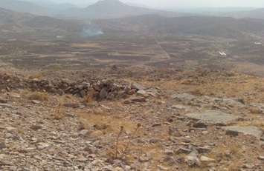
Figure 2: Shargeh Castle, Photos by authors

Nazhou Castle
Nazhou village is located in 13 km from northwest of Baneh city. There are three separated buildings namely Benshakh, Ghalay Goureh and Oghlibeig in 1.5 km from village and in hard access road which Benshakh and Ghalay Goureh are natural and Oghlibeig is a castle. Oghlibeig is located in south side of this field and 1900 above sea level. Its plan is rectangle shape which its east-west length is 45 m and its north-south length is 35 m. There are steep slopes around of castle which the thickness of its walls is about 2 m. The north side walls did not damaged and about 3 m of its height is remaining. The components of this castle are stone. The bricks of castle show that it's belong to Sassanian era (Figure 3).

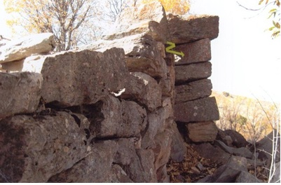
Figure 3: Oghlibeig Castle, Photos by authors

The castle in the Nazhou village
This castle is built in the north of village and overlook of it and located in 1640 m above sea level. In the time of war between Iran and Iraq, a base was built on it which made huge damage in this castle. The castle is oval shape and was created by stones. Separated bricks are belonging to Sassanian era.

Kaninav Castle
Kaninav castle is located in 9 km from Baneh city. Kaninav castle is located in 1.4 km from the east of village and above 1713 m from sea level and surrounded 57 m of near fields. The east-west length is 100 m and its north-south length is 80 m which overlooked the region. This castle was built in hard access road of mountain. Its components are stones. The cultural components are pottery. Based on the style of castle, certainly it's belonging to Sassanian era (Figure 4).

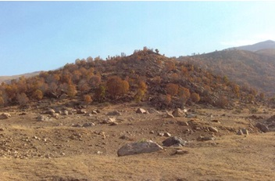
Figure 4: Kaninav Castle outlook, Photos by authors

Bademjan Castle
Bademjan village is located in 42 km from southeast of Baneh city. Its name was originated from using big stones. The castle is located in 1.3 km from village and its position is low slope of north side of mountain, but is hard access road in other parts. The height of castle from sea level is 1931. The wall of castle is oval shape and its east-west length is 28 m and its north-south length is 14 m and the thickness of wall is 1.5 m (Figure 5). The castle was built on stone base. In outer and inner outlook, the cutter stone was used, but among them, there is uncoated stone. The collected pottery was belonging to Parthian and especially Sassanian era.

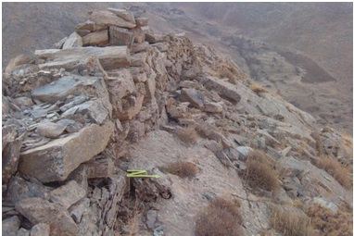
Figure 5: Bademjan Castle wall, Photos by authors

Ghoujileh Biandareh Castle
Ghoujileh Biandareh castle is located in 29 km from southeast of Baneh city. This castle is located in 950 m from west of village and in access road to Haftash village and on the height hills which overlook about 50 m of surrounded fields. This castle is above 1970 m from sea level. Its plan is oval shape and its east-west length is 27 m and its north-south length is 60 m. this castle was built by stones. The pottery of castle is belonging to Sassanian era.
Sourian Castle
Saurian village is located in 14 km from southwest of Baneh city. The castle is located on the height and across with the village and its distance from village is 1.2 km. The height of castle from the sea level is 1838 m and also is 176 m higher than surrounded fields. The plan of castle is oval shape which the east-west length is 36 m and north-south length is 32 m. The thickness of walls is about one meter which in north part did not damaged and its entrance is from west. Its pottery is belonging to the Parthian and Sassanian era.

Dousineh Castle
Dousineh castle is located in 15 km from southeast of Baneh city. Dousineh castle is known as base cvastle. This castle is located in 550 m from northwest of village and is 100 m higher than the surrounded fields. Its plan is oval shape and the east-west length is 48 m and the north-south length is 30 m. the castle was built by stones. In this castle, there's inner wall in addition to the outer wall. The outer wall thickness is 2.6 m and the inner wall thickness is 1 m. Water pipes which were built in the wall were enhanced drink water. In the time of war between Iran and Iraq, it was used as a military base. Its potteries is as like as Sassanian pottery style.

Dargah Sheikhn Castle
Dargah Sheikhn village is located in 7 km of southeast of Baneh city. This castle was built in 650 m from east of village and is 1602 m above sea level. This castle surrounded the region and in three directions – north, south and east – has steep slope and just in one direction has smooth slope which surrounded the nearest field. Its plam is oval shape and its components are stones. The east-west length of it is 40 m and the north-south length of it is 37 m. the pieces of pottery of this area show that it's belonging to the Sassanian era.

Brouishkani Castle (Borj Kani)
Brouishkani village is located in 21 km from southeast of Baneh city. This castle is located in 520 m from southwest of village and built on the mountain which has steep slope in four directions. The height of castle from sea level is 1821 m and is 110 m higher than surrounded field. Its plan is oval shape and its north-south length is 60 m and the east-west length is 34 m. Diameter of outer wall is 2.5 m and in west part is healthier and remaining about 1.5 m. The remaining of a room which is 3*4 was discovered in the castle which was built by big stone and applied stone in it is smaller than main wall. The discovered pottery from castle was belonging to the Sassanian era.
Namashir Castles
Siouch castle
Siouch village is located in 15 km from Baneh city. Siouch castle which is based castle and located in 450 km from the north of village on the mountain with 121 m height from surrounded fields and 1706 m above sea level. The plan of castle is oval and south, east and west wall damaged and just foundation and north side wall was not damaged. The components of castle are stones and mortar. Pottery and designs is belonging to the Parthian and Sassanian era.

Yaghoob abad Castle
Yaghoob abad village is located in 16 km to Baneh city and 6 km from southwest of Kanisour city. The hill which this castle was built on it has 420 m east – west length and 350 m north – south length. 70 m in 40 m was flatted to build the castle and located in 800 m of east of village. The castle is 1521 m above sea level. The castle is oval and was built by stones. Potteries belong to Parthian and Sassanian era.

Ghalay Kohneh (Old Castle) in Kani Halouche
Kani Halouche village located in 20 km of northwest of Baneh and 9 km of Kanisour city. Castle had built in one kilometer of south of village on the hill and its height is 1491 m above sea level and is 16 m higher than surrounded farms. In the south of castle, a seasonal river namely Hamzehlan is available. The plan of castle is oval and its west-east length is 95 m and its north-south length is 50 m. castle is made by stones. The discovered potteries belong to the Parthian and Sassanian era.

Sokan Sartkeh Castle
Sarkeh village is located in 21 km from southwest of Baneh city. Sokan castle position is 900 m from northwest of village on the mountain which its slope from north, east and west is high and from south side has smooth sleep and reach to the mountains. Its height from sea level is 1153 m and also is 46 m higher than surrounded fields. Its plan is oval and the north-south length is 80 m and east-west length is 70 m. The components of castle are stones. Potteries show that they are historical.

Gardi Ghalat Najneh (Najneh Castle)
Najneh village is located in 33 km of northwest of Baneh city. This castle is located in 610 m of south of village and 1493 m above sea level and is 35 m higher than surrounded fields. Its plan is oval shape and its north – south length is 120 m and east – west length is 80 m. castle is built by stones. Potteries belong to Sassanian era.

Ghalat Mar (Snake Castle) in Soutu
Soutu village is located in 27 km from northwest of Baneh city. Castle is located in 1 km over a mountain which surrounded 140 m of fields and is 1812 m above sea level. From west reach to Sheikhsour, from east reach to farm areas, from north reasch smooth slope and from south reach seasonal river of Gheytaran Avi. Its plan is oval and built by stones. The separation of potteries in this area is high and potteries are historical and especially belong to the Sassanian era.
Ghalay Kaferan (Kaferan Castle) in Sarsoul
Sarsoul village is located in 29 km from west of Baneh city. This castle is located in 1.2 km from northeast of village on the mountain which is 250 m higher than fields and 50 m higher than surrounded farms and 1541 above sea level. From north, east and west side, its slope is high and just from south side has access road. Its plan is trapezoid. The length of east section is 300 m. The length of west section is 330 m and 2 m diameter with 0.5 m height. The length of north side is 80 m with 2 m diameter. The south side was not damaged which has 20 m length and 2 m diameter of thickness. Castle was built by stones and its components are stones. The potteries of this castle belong to Sassanian era.

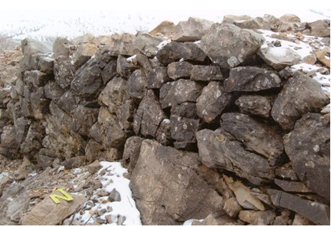
Figure 6: Berivishkani Castle wall, Photos by authors

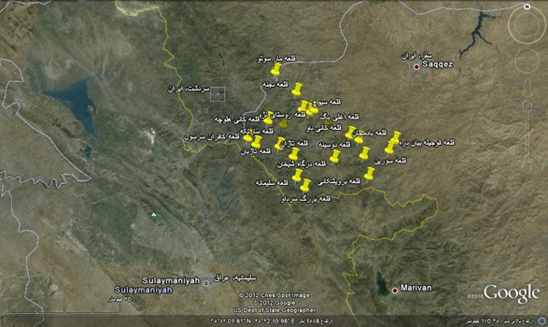
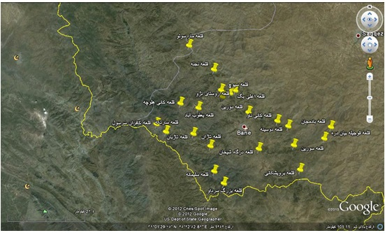
Placement of historic castles of Baneh on the satellite map

Conclusion:
The investigated castles in Baneh region have same charateristics. Oval plan, use of stones and mortar, cultural material, especially pottery which belong to historical era with daily use are the main similarity. To build these castles, do not see any good outlook and delicate work and is not big enough based on length and width. The user can not be considered for special or ceremonial. According to their location which uilt in special spots and in heights and strategic region and overlooking to the connection ways, they were military base which used as protection of west sides in two historical eras (Parthian and Sassanian). The west side of castle was so important to avoid the attack of enemies. Finally, it's rational that it should change to have more defensive actions. Based on historical point of view, it's belonging to the second part of Parthian and Sassanian and first part of Islamic era.
References:
- Armed Forces Geographical Organisation (2006), the geographical culture of villages of Kurdestan provience, cities like Baneh, Kamyaran, Sarvabad. Publication of Armed Forces Geographical Organisation, Tehran.
- Fagan, Brayan (2003). Preface, translator: Shamlou Gh., First Edition, Tehran.
- Klise, Voulfram (2008). The architechture of Iran in Islamic era, by Kiani M. Y., Translator: Mahini, A., SAMT, Tehran, p:169-178.
- Nasrollahi, Salah (2008). Unpublished report to review and identify of castles, area and antiquities of Namashir in Baneh city, Archives Administration of Cultural Heritage, Handicrafts and Tourism Baneh city
- Nasrollahi, Salah (2007). Unpublished report to review and identify of castles, area and antiquities of Markazi and Nanour section in Baneh city, Archives Administration of Cultural Heritage, Handicrafts and Tourism Baneh city
- Nouri, Nader (2009). Unpublished report to review and identify of castles, area and antiquities of Alout (Armardeh), Archives Administration of Cultural Heritage, Handicrafts and Tourism Baneh city
- Mollazadeh, Kazem; Mohammadi, Maryam (2000). Islamic monuments Encyclopedia, Volume III, Soureh, Tehran

