Bioactive Secondary Metabolites from Streptomyces sp: Taxonomy, Fermentation, Purification and Biological Activities

Houssam M. Atta
Botany and Microbiology Department, Faculty of Science (Boys), Al-Azhar University, Cairo, Egypt. The present address: Biotechnology Department. Faculty of Science and Education. Al-Khurmah, Taif University- KSA.
houssamatta@yahoo.com and houssamatta@hotmail.com

ABSTRACT: This work was carried out in the course of a screening program for specific the bioactive substances that demonstrated inhibitory affects against microbial pathogenic, from actinomycetes strains. Ninety-seven actinomycete strains were isolated from fifty soil samples collected from Al-Khurmah governorate, kingdom of Saudi Arabia. Only one actinomycete culture from thirteen cultures was found exhibited to produce wide spectrum antimicrobial activities. The nucleotide sequence of the 16s RNA gene (1.5 Kb) of the most potent strain evidenced an 98% similarity with Streptomyces torulosus. From the taxonomic features, the actinomycetes isolate matches with Streptomyces torulosus in the morphological, physiological and biochemical characters. Thus, it was given the suggested name Streptomyces torulosus. The parameters controlling the biosynthetic process of antimicrobial agent formation including: different inoculum size, pH values, temperatures, incubation period and different carbon and nitrogen sources were fully investigates. The active metabolite was extracted using n-Butanol (1:1, v/v) at pH 7.0. The separation of the active ingredient and its purification was performed using both thin layer chromatography and column chromatography techniques. The physico-chemical characteristics of the purified antibiotic viz. color, melting point, solubility, elemental analysis, spectroscopic characteristics and chemical reactions have been investigated. This analysis indicates a suggested empirical formula of C₃₈H₆₂N₄O₁₆. The minimum inhibition concentrations "MICs" of the purified antimicrobial agent were also determined. The purified antimicrobial agent was suggestive of being belonging to Tunicamycin antibiotic produced by Streptomyces torulosus.
[Atta HM. Bioactive Secondary Metabolites from Streptomyces sp: Taxonomy, Fermentation, Purification and Biological Activities. N Y Sci J 2013;6(6):99-110]. (ISSN: 1554-0200). http://www.sciencepub.net/newyork. 15

Keywords: Streptomyces sp., 16s RNA, Taxonomy, Fermentation, Purification Biological Activities and Tunicamycin antibiotic.

1. INTRODUCTION

Actinomycetes are the most economically and biotechnologically valuable prokaryotes. They are responsible for the production of about half of the discovered bioactive secondary metabolites [Berdy, 2005], notably antibiotics [Strohl, 2004] antitumor agents [Cragg et al., 2005] immunosuppressive agents [Mann, 2001] and enzymes [Oldfield, 1998].
Actinomycetes play an important ecological role in biodegradation ,many are commercially important, either in the production of bioactive compounds such as antibiotics and enzymes or in useful biological processes such as biodegradation and waste treatment [Williams, 1985].
Streptomycetes have the potentiality to degrade naturally occurring polymers such as chitin [Evangelos et al., 2001], pectin and fungal cell wall material [Beg et al., 2000], plastics [Claessen et al ., 2002], hemicelluloses [Yaseen,1987] keratin [Ivanko et al., 2002] and humic acids [Khadija et al., 1995].
Streptomyces produce a wide range of secondary metabolites, including antibiotics, many of which are clinical importance in the treatment of infectious disease or diseases caused by proliferation of maliganant cells [Innes and Allan, 2001].
Tunicamycin (Tn) is an antibiotic that was first discovered in the early 1970s [Takatsuki et al., 1971]. Tunicamycin is a mixture of homologous nucleoside antibiotics that inhibits the UDP-HexNAc: polyprenol-P HexNAc-1-P family of enzymes. In eukaryotes, this includes the enzyme GlcNAc phosphotransferase (GPT), which catalyzes the transfer of N-actelyglucosamine-1-phosphate from UDP-N-acetylglucosamine to dolichol phosphate in the first step of glycoprotein synthesis [Radha et al., 1983].
Tunicamycin blocks the synthesis of all N-linked glycoproteins (N-glycans) and causes cell cycle arrest in G1 phase. It is used as an experimental tool in biology, e.g. to induce unfolded protein response [Heifetz et al., 1979]. Tunicamycin is an inhibitor of bacterial and eukaryote N-acetylglucosamine transferases; preventing formation of N-acetylglucosamine lipid intermediates and glycosylation of newly synthesized glycoproteins.7 Tunicamycin blocks the formation of protein N-glycosidic linkages by inhibiting the transfer of N-acetylglycosamine 1-phosphate to dilichol monophosphate.8 Several reviews have been written on the effects of tunicamycin on glycoproteins [King and Tabiowo, 1981].
In the present work were describe the isolation of an actinomycete strain from water sample collected from Al-Khurmah governorate, KSA, which generates an antimicrobial compound. The identification of this strain, based on the cultural, morphology, physiology and biochemical characteristics, as well as 16s rRNA methodology, is also reported. The primary bioactive substance was isolated, purified and biological activities were determined.

2. MATERIALS AND METHODS
2.1. Microorganism:
The actinomycete strain was isolated from soil sample collected from Al-Khurmah governorate. It was purified using the soil dilution plate technique described by [Williams and Davis, 1965].

2.2. Screening for antimicrobial activity:
The anti- microbial activity was determined by cup method assay according to [Kavanagh, 1972].

2.3. Taxonomic studies of actinomycete isolate:
Morphological characteristics of the most potent produce strain KH-4 grown on starch nitrate agar medium at 35 ºC for 5 days was examined under scanning electron microscopy (JEOL Technics Ltd.,). Physiological and biochemical characteristics: Lecithinase was conducted on egg–yolk medium according to the method of [Nitsh and Kutzner, 1969]; Lipase [Elwan et al., 1977]; Protease [Chapman, 1952]; Pectinase [Hankin et al., 1971]; α-amylase [Cowan, 1974] and Catalase test [Jones, 1949]. Melanin pigment [Pridham, et al., 1957]. Degradation of Esculin and xanthine [Gordon et al., 1974]. Nitrate reduction [Gordon, 1966]. Hydrogen sulphide production and oxidase test [Cowan, 1974]. The utilization of different carbon and nitrogen sources [Pridham and Gottlieb, 1948]. Cell wall was performed by the method of [Becker et al., 1964 and Lechevalier and Lechevaier, 1968]. The cultural characteristics were studied in accordance with the guidelines established by the International Streptomyces Project [Shirling and Gottlieb, 1966]. Colors characteristics were assessed on the scale developed by [Kenneth and Deane, 1955].

2.4. DNA isolation and manipulation:
The locally isolated actinomycete strain was grown for 5 days on a starch agar slant at 35°C. Two ml of a spore suspension were inoculated into the starch- nitrate broth and incubated for 3 days on a shaker incubator at 200 rpm and 30°C to form a pellet of vegetative cells (pre-sporulation). The preparation of total genomic DNA was conducted in accordance with the methods described by [Sambrook et al., 1989].

2.5. Amplification and sequencing of the 16S rRNA gene:
PCR amplification of the 16S rRNA gene of the local actinomycete strain was conducted using two primers, StrepF; 5.-ACGTGTGCAGCCCAAGACA-3. and Strep R; 5.ACAAGCCCTGGAAACGGGGT-3., in accordance with the method described by [Edwards et al., 1989]. The PCR mixture consisted of 30 pmol of each primer, 100 ng of chromosomal DNA, 200 μM dNTPs, and 2.5 units of Taq polymerase, in 50 μl of polymerase buffer. Amplification was conducted for 30 cycles of 1 min at 94°C, 1 min of annealing at 53°C, and 2 min of extension at 72°C. The PCR reaction mixture was then analyzed via agarose gel electro phoresis, and the remaining mixture was purified using QIA quick PCR purification reagents (Qiagen, USA). The 16S rRNA gene was sequenced on both strands via the dideoxy chain termination method, as described by [Sanger et al., 1977]. The 16S rRNA gene (1.5 kb) sequence of the PCR product was acquired using a Terminator Cycle Sequencing kit (ABI Prism 310 Genetic Analyzer, Applied Biosystems, USA).

2.6. Sequence similarities and phylogenetic analysis
The BLAST program (www.ncbi.nlm.nih. gov/blst) was employed in order to assess the degree of DNA similarity. Multiple sequence alignment and molecular phylogeny were evaluating using BioEdit software [Hall, 1999]. The phylogenetic tree was displayed using the TREE VIEW program.

2.7. Factors effecting on the biosynthesis of the antimicrobial agent:
These included inoculum size, incubation period, pH values, incubation temperatures; different carbon and nitrogen sources, have been determine by the standard methods.

2.8. Fermentation:
The Streptomyces torulosus inoculum was introduced aseptically into each sterile flask containing the following ingredients (g/l): glucose, 20; KNO₃, 2.0; K₂HPO₄, 0.8; MgSO₄.7H₂O, 0.7 and KCl, 0.5. The pH was adjusted at 7.0 before sterilization. After 5 days of incubation at 35 ^{O}C. Filtration was carried out through cotton wool and followed by centrifugation at 5000 rpm for 15 minutes.

2.9. Extraction:
The clear filtrate was adjusted at different pH values (4 to 9) and extraction process was carried out using different solvents separately at the level of 1:1 (v/v). The organic phase was concentrated to dryness under vacuum using a rotary evaporator at a temperature not exceeding 50°C.

2.10. Precipitation:
The precipitation process of the crude compound was carried out using petroleum ether (b.p 60-80 °C) followed by centrifugation at 5000 r.p.m for 15 min.
2.11. Purification by TLC:
Separation of the antimicrobial compound into its individual components was conducted by thin layer chromatography using chloroform and methanol (24: 1, v/v) as a solvent system.

2.12. Purification by column chromatography:
The purification of the antimicrobial compound was carried out using silica gel column (2.5 X 50) chromatography Chloroform and Methanol 10:2 (v/v), was used as an eluting solvent. The column was left overnight until the silica gel (Prolabo) was completely settled. One-ml crude extract to be fractionated was added on the silica gel column surface and the extract was adsorbed on top of silica gel. Fifty fractions were collected (each of 5 ml) and tested for their antimicrobial activities.

2.13. Physico-chemical properties:
2.13.1. Elemental analysis:
The elemental analysis C, H, O, N, and S was carried out at the microanalytical center, Cairo University, Egypt.

2.13.2. Spectroscopic analysis:
The IR, UV and Mass spectrum were determined at the micro analytical center of Cairo University, Egypt.

2.14. Biological activity:
The minimum inhibitory concentration (MIC) has been determined by the cup method assay [Kavanagh, 1972].

2.15. Characterization of the antimicrobial agent:
The antibiotic produced by Streptomyces torulosus was identified according to the recommended international references of [Umezawa, 1977 and Berdy, 1974, 1980a, b, c].

3. RESULTS
3.1. Screening for the antimicrobial activities:
One of the actinomycete cultures from thirteen cultures were found exhibited various degrees of activities against Gram-positive and Gram-negative bacteria and unicellular and filamentous fungi (Table 1).

3.2. Identification of the actinomycete isolate: Morphological characteristics:
The vegetative mycelia grew abundantly on both synthetic and complex media. The aerial mycelia grew abundantly on Starch- nitrate agar medium and Oatmeal agar medium (ISP-3). The Spore chains were spiral, and had a warty surface (plate 1). Neither both sclerotic granules and sporangia nor flagellated spores were observed.

3.3. Cell wall hydrolysate:
The cell wall hydrolysate contains LL-diaminopimelic acid (LL-DAP) and sugar pattern not detected.

3.4. Physiological and biochemical characteristics
The actinomycete isolate could hydrolyze starch, protein, and cellulose, whereas lipid, pectin Lecithin and catalase are negative Melanin pigment is positive, degradation of xanthine, esculine, production of H₂S, nitrate reduction, decomposition of urea and utilization of citrate and KCN are positive. The isolate under study utilizes D- xylose, D- mannose, D- glucose, D- fructose, D- galactose, mannitol, meso-inositol, sucrose, rhamnose, L-arabinose, raffinose, starch and trehalose, but do not utilize lactose, maltose, and Ribose. Good growth on L-glycine, L- asparagines, L-leucine L-histidine, L- phenyl alanine and L-lysine. No growth on L- valine, and L-methionine. Growth in the presence of up to (5 %) NaCl. The growth is not inhibited in the presence of phenol and 45ºC. The actinomycete isolate KH-4 not sensitive to Ampicillin (25ug/ml) Nalidixic acid (30 ug/ml) Cefoperazone (75ug/ml) and Fusidic acid (10 ug/ml, Gentamicin (10 ug/ml) and Kanamycin (30 ug/ml) (Table 2).

3.5. Color and culture characteristics:
The actinomycete isolate shows the aerial mycelium is light gray; substrate mycelium is light brown, and the diffusible pigment moderate yellowish brown or not produced diffusible (Table 3).

3.6. Taxonomy of actinomycete isolate
This was performed basically according to the recommended international Key’s viz. [Buchanan and Gibsons, 1974; Williams, 1989; and Hensyl, 1994] and Numerical taxonomy of Streptomyces species program. On the basis of the previously collected data and in view of the comparative study of the recorded properties of actinomycete isolate in relation to the closest reference strain, viz. Streptomyces torulosus, it could be stated that actinomycetes isolate is suggestive of being likely belonging to Streptomyces torulosus (Table 4).

3.7. Amplification of the 16S rDNA gene:
The 16S rDNA gene was amplified by polymerase chain reaction (PCR) using the universal primers. The primers that was used to 16S rDNA sequencing were 16F357 of the sequence strepF; 5'-ACGTGTGCAGCCCAAGACA-3' and strpR; 5'-ACAAGCCCTGGAAACGGGGT-3', the product of the PCR was analyzed on 1.5% ethidium bromide gel.

3.8. Molecular phylogeny of the selected isolate
The 16S rDNA sequence of the local isolate was compared to the sequences of Streptomyces spp. In order to determine the relatedness of the local isolate to these Streptomyces strains. The phylogenetic tree (as displayed by the Tree View program) revealed that the locally isolated strain is closely related to Streptomyces sp., rather related related to Streptomyces sp., rather than to Streptomyces torulosus (Fig. 1). Multiple sequence alignment was conducted the sequences of the 16_{S} rDNA gene of Streptomyces torulosus. Computer assisted DNA searches against bacterial database similarly revealed that the 16_{S} rDNA sequence was 98% identical Streptomyces torulosus (Fig. 1).

3.9. Factors effecting on the biosynthesis of the antimicrobial agent:
Maximum antimicrobial activity biosynthesis could be recorded that a different inoculum sizes for four discs; incubation period for 5 days; pH 7.0; temperature 35ºC.; glucose best carbon source; potassium nitrate best nitrogen source.

3.10. Fermentation, Extraction and Purification:
The fermentation process was carried out for five days at 35°C. After incubation period, the filtration was conducted followed by centrifugation at 4000 r.p.m. for 15 minutes. The clear filtrates containing the active metabolite (20 liters), was adjusted to pH 7.0 then extraction process was carried out using n-Butanol at the level of 1:1 (v/v). The organic phase was collected, and evaporated under reduced pressure using rotary evaporator. The antimicrobial compound was precipitated by petroleum ether (b.p. 60-80°C) and centrifuged at 4000 r.p.m for 15 minute. Its color is yellowish. Separation of antimicrobial agent into individual components was carried out by thin-layer chromatography using a solvent system composed of chloroform and methanol (24: 1, v/v). Only one band at R_{f} = 0.55 showed antimicrobial activity. The purification process through column chromatography packed with silica gel, revealed that the most active fractions against the tested organisms ranged between 14 to 23.

3.11. Physicochemical characteristics:
The purified antimicrobial agent produced by Streptomyces torulosus are produces characteristic odour, their melting points are 235°C. The compound is freely soluble in chloroform, ethyl acetate, n-butanol, acetone, ethyl alcohol, methanol and 10 % isopropyl alcohol, but insoluble in petroleum ether, hexan and benzene.

3.12. Elemental analysis:
The elemental analytical data of the antimicrobial agent produced by Streptomyces torulosus, showed the following: C=53.30; H=6.87; N= 6.61., O = 29.51 and S=0.0. This analysis indicates a suggested empirical formula of C₃₈H₆₂N₄O₁₆.

3.13. Spectroscopic characteristics:
The spectroscopic analysis of the purified of antimicrobial compound produced by Streptomyces torulosus, the infrared (IR) spectrum of showed characteristic band corresponding to 26 peaks 551.9, 669.2, 770.1, 847.1, 910.8, 956.3, 980.2, 1039.2, 1091.4, 1110.9, 1204.8, 1254.1, 1264.1, 1380.2, 1461.7, 1547.7, 1666.2, 1708.4, 2333.8, 2306.0, 2872.5, 2954.2, 3280.8, 3341.8, 3668.9 and 3731.5 (Fig. 2). The ultraviolet (UV) absorption spectrum are recorded a maximum absorption peak at 260 nm (Fig. 3). The Mass spectrum showed that the molecular weight at 865 (Fig. 4).

3.14. Biological activities of the antimicrobial agent:
Data of the antimicrobial agent spectrum indicated that the agent is active against Gram-positive and Gram-negative bacterial and unicellular and filamentous fungi (Table 5).

3.15. Identification of the antimicrobial agent:
On the basis of the recommended keys for the identification of antibiotics and in view of the comparative study of the recorded properties of the antimicrobial agent, it could be stated that the antimicrobial compound is suggestive of being belonging to tunicamycin antibiotic [Umezawa, 1977; Berdy, 1974, 1980a, b, c and Billyana et al., 2002] (Table 6)

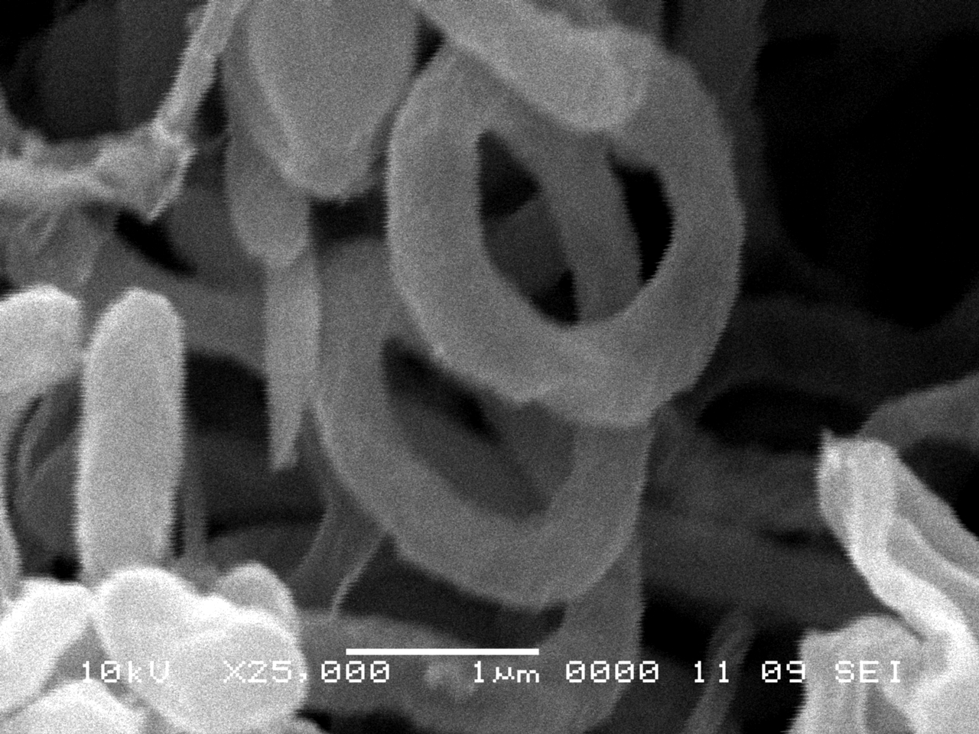
Plate 1. Scanning electron micrograph of the actinomycete isolate growing on starch nitrate agar medium showing spore chain spiral shape and spore surfaces warty (X25,000).

Table 1. Antimicrobial potentialities of the antibiotic-producing microorganisms isolated from various localities in Al-Khurmah governorate
* Mean values of inhibition zones (in mm) against |  |  |  |  |  |  |  |  |  |  |  |  |  | *Organism  number
Fungi |  |  |  |  |  |  | Bacteria |  |  |  |  |  |  | *Organism  number
P. chrysogenum | Fusarium oxysporum | Asp. flavus, IMI 111023 | Asp.  fumigatus | Asp. niger, IMI 31276 | S. cervicea ATCC 9763 | Candida albicans, IMRU 3669 | Pseudomonas aeruginosa, ATCC 10145 | Klebsiella pneumonia, NCIMB 9111 | E. coli  NCTC 10416 | Micrococcus luteus, ATCC 9341 | Bacillus pumilus, NCTC 8214 | Bacillus subtilis, NCTC 1040 | S. aureus, NCTC 7447 | *Organism  number
25.0 | 27.0 | 29.0 | 28.0 | 30.0 | 23.0 | 022. | 20.0 | 21.0 | 22.0 | 22.0 | 22.5 | 22.0 | 24.0 | KH-4
0.0 | 0.0 | 0.0 | 0.0 | 0.0 | 0.0 | 0.0 | 0.0 | 0.0 | 0.0 | 25.5 | 23.0 | 24.0 | 25.0 | KH-5
23.0 | 25.0 | 26.0 | 27.0 | 30.0 | 18.0 | 018. | 12.0 | 15.0 | 17.0 | 18.0 | 18.0 | 18.0 | 20.0 | KH-6
0.0 | 0.0 | 0.0 | 0.0 | 0.0 | 0.0 | 0.0 | 0.0 | 0.0 | 0.0 | 0 .0 | 12.0 | 12.0 | 13.0 | KH-7
0.0 | 0.0 | 0.0 | 0.0 | 0.0 | 15.0 | 015. | 16.0 | 19.0 | 20.0 | 22.0 | 20.0 | 20.0 | 21.0 | KH-16
23.0 | 25.0 | 26.0 | 27.0 | 30.0 | 0.0 | 0.0 | 0.0 | 0.0 | 0.0 | 0.0 | 0.0 | 0.0 | 0.0 | KH-18
19.0 | 21.0 | 23.0 | 22.0 | 25.0 | 19.0 | 018. | 0.0 | 17.0 | 22.0 | 22.0 | 21.0 | 22.0 | 19.0 | KH-19
25.0 | 26.0 | 28.0 | 27.0 | 30.0 | 20.0 | 019. | 16.0 | 18.0 | 21.0 | 20.0 | 20.0 | 21.0 | 23.0 | KH-27
0.0 | 0.0 | 0.0 | 0.0 | 0.0 | 0.0 | 0.0 | 0.0 | 0.0 | 0.0 | 27.0 | 29.5 | 30.0 | 30.0 | KH-30
0.0 | 0.0 | 0.0 | 0.0 | 0.0 | 0.0 | 0.0 | 0.0 | 15.0 | 18.0 | 20.0 | 21.0 | 21.0 | 20.0 | KH-32
0.0 | 0.0 | 0.0 | 0.0 | 0.0 | 0.0 | 0.0 | 0.0 | 0.0 | 13.0 | 17.0 | 17.0 | 17.0 | 18.0 | KH-35
0.0 | 0.0 | 0.0 | 0.0 | 0.0 | 0.0 | 0.0 | 0.0 | 0.0 | 0.0 | 0.0 | 12.0 | 13.0 | 14. 0 | KH-72
0.0 | 0.0 | 0.0 | 0.0 | 0.0 | 0.0 | 0.0 | 0.0 | 0.0 | 0.0 | 12.0 | 14.0 | 14.0 | 15.0 | KH-88

Table 3. Culture characteristics of the actinomycete isolate.
Medium | Growth | Aerial mycelium | Substrate mycelium | Diffusible pigments
1-Starch- nitrate agar medium | Good | 264-L .Gray  Light gray | 57-1.br  light brown | 77-m.ybr  moderate yellowish brown
2-Tryptone yeast extract broth (ISP-1) | No growth | - | - | -
3-Yeast extract malt extract agar medium (ISP-2) | No growth | - | - | -
4-Oatmeal agar medium (ISP-3) | Good | 264-L .Gray  Light gray | 57-1.br  light brown | -
5- Glycero Asparagine agar medium (ISP-4) | Poor | 264-L .Gray  Light gray | 57-1.br  light brown | -
6- Inorganic salts starch agar medium (ISP-5) | moderate | 264-L .Gray  Light gray | 86-I. yellow  Light yellow | -
7-Peptone yeast extract- iron agar medium (ISP-6) | moderate | 264-L .Gray  Light gray | 57-1.br  light brown | 59-d.Br  Deep brown
8-Tyrosine agar medium (ISP-7) | moderate | 264-L .Gray  Light gray | 57-1.br  light brown | 59-d.Br  Deep brown
*The color of the organism under investigation was consulted with the ISCC-NBS color –name charts illustrated with centroid color

Table 2. The morphological, physiological and biochemical characteristics of the actinomycete isolate KH-4
Characteristic | Result | Characteristic | Result
Morphological characteristics: |  | Mannitol | ++
Spore chains | Spiral | L- Arabinose | +
Spore mass | gray | meso-Insitol | ++
Spore surface | Warty | Lactose | -
Color of substrate mycelium | Light brown- deep brown | Maltose | -
Diffusible pigment | Yellowish brown | Trehalose | ++
Motility | Non-motile | D- Ribose | -
Cell wall hydrolysate |  | D-fructose | ++
Diaminopimelic acid (DAP) | LL-DAP | Utilization of amino acids:
Sugar Pattern | Not-detected | L-Glycine | +
Physiological and biochemical properties:  Hydrolysis of: |  | L-Leucine | +
 |  | L-Histidine | +
Starch | + | L-Phenylalanine | +
Protein | + | L-Asparagine | +
Lipid | - | L-Methionine | -
Pectin & Lecithin | - | L- Lysine | +
Cellulose | + | L-Valine | -
Catalase test | - | Growth with (%w/v):
Production of melanin pigment on: |  | Sodium azide ( 0.01) | -
Peptone yeast- extract iron agar | + | Phenol (0.1) | +
Tyrosine agar medium | + | Thallous acetate (0.001) | -
Tryptone – yeast extract broth | - | Growth at different temperatures (˚C):
Degradation of: |  | 10 | -
Xanthin | + | 30 - 45 | ++
Esculin | + | 50 | ±
H₂S Production | + | 55 | -
Nitrate reduction | + | Growth at different pH values:
Citrate utilization | + | 6-8 | +
Urea test | + | 9 | -
KCN test | + | Growth at different concentration of NaCl (%)
Utilization of: carbon sources |  | 1-5 | +
D-Xylose | + | 7 | -
D- Mannose | + | Resistance to:
D- Glucose | +++ | Ampicillin (25ug/ml) and | +
D- Galactose | + | Nalidixic acid (30 ug/ml) | +
Sucrose | ++ | Cefoperazone (75ug/ml) | +
L-Rhamnose | ++ | Gentamicin (10 ug/ml) | +
Raffinose | ++ | Kanamycin (30ug/ml) | +
Starch | +++ | Fusidic acid (10 ug/ml) | +
+ =Positive , - = Negative , ± = doubtful results, , ++ = moderate growth & +++ = good growth.

Table 4. A comparative study of the characteristic properties of KH-4 in relation to reference strain, Streptomyces torulosus. ( C.F. Bergey’s 1989, page 2448 & table 29-12 )
Characteristics | KH-4 | Streptomyces torulosus
Morphological characteristics:
- Spore mass | Gray | gray
- Reverse color | Light yellow/ light brown | Light yellow
- Spore chain | Spiral | Spiral
- Spore surface | Warty | Warty and Spiny
- Motility | non-motile | non-motile
Cell wall hydrolysate:
- Diaminopimelic acid (DAP) | LL-DAP | LL-DAP
- Sugar pattern | not-detected | not-detected
Melanin pigment | + | +
Utilization of carbon sources
L-Arabinose | + | +
D-Fructose | + | +
- D-Galactose | + | +
D-Glucose | + | +
meso-Inositol | + | +
- D-Mannitol | + | +
- - Raffinose | + | +
- - Sucrose | + | ND
D-Xylose | + | +
ND= No data.

Table 5. A comparative study of the characteristic properties of the antimicrobial agent produced by Streptomyces torulosus in relation to Reference antibiotic (Tunicamycin antibiotic)
Characteristic | purified antimicrobial agent | Tunicamycin antibiotic
- Melting point | 235°C | 234°C - 235°C
- Molecular weight | 865 | 865.4
Chemical analysis:
C | 53.30 | 53.31
H | 6.87 | 6.86
N | 6.61 | 6.61
O | 29.51 | 29.51
S | 0.0 | 0.0
- Ultra violet | 260 | 205 and 260
- Formula | C₃₈H₆₂N₄O₁₆ | C₃₈H₆₂N₄O₁₆
- Active against | Active against Gram positive and Gram negative bacteria and unicellular and filamentous fungi. | Active against Gram positive and Gram negative bacteria and unicellular and filamentous fungi.

Table 6. Antimicrobial spectrum of the antimicrobial agent(s) by adding paper disc diffusion method (Kavanagh, 1972).
Test organisms | MIC (ug/ml) concentration
Test organisms | antimicrobial agent produced by Streptomyces torulosus, KH-4
A- Bacteria
a. Gram positive cocci
Staph. aureus, NCTC 7447 | 52.7
Micrococcus luteus, ATCC 9341 | 52.7
b. Gram positive bacilli
Bacillus subtilis, NCTC 10400 | 73.78
Bacillus pumilus, NCTC 8214 | 73.78
c. Gram negative bacteria
Escherichia coli, NCTC 10416 | 73.78
Klebsiella pneumonia, NCIMB 9111 | 100 <
Pseudomonas aeruginosa, ATCC 10145 | 100 <
B- Fungi
a- unicellular fungi
Candida albicans, IMRU 3669 | 73.78
Saccharomyces cervisiae ATCC 9763 | 46.9
b- filamentous fungi
Aspergillus niger IMI 31276 | 15.73
Aspergillus fumigatus ATCC 16424 | 31.25
Aspergillus flavus IMI 111023 | 22.32
Fusarium oxysporum | 46.9
Rhizoctonia solani. | 52.7
Alternaria alternata | 46.9
Botrytis fabae | 46.9
Penicillium chrysogenium | 52.7

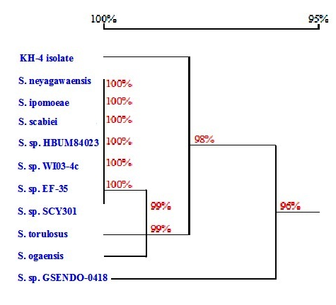
Fig. 1. The phylogenetic position of the local Streptomyces sp. strain among neighboring species. The phylogenetic tree was based on the pairwise comparisons of 16_{S} rDNA sequences.

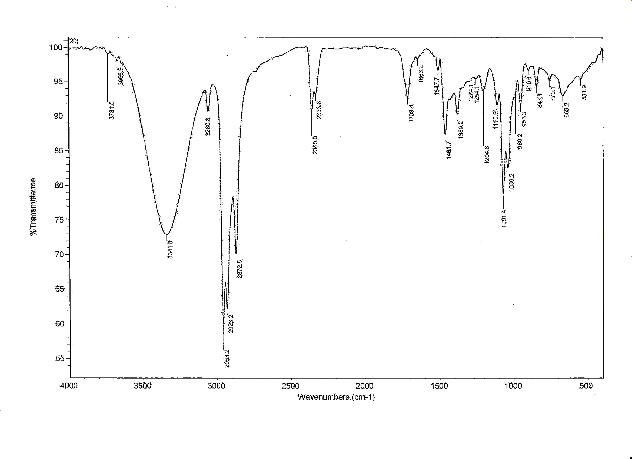
Fig. 2. I.R spectrum of antimicrobial agent produced by Streptomyces torulosus

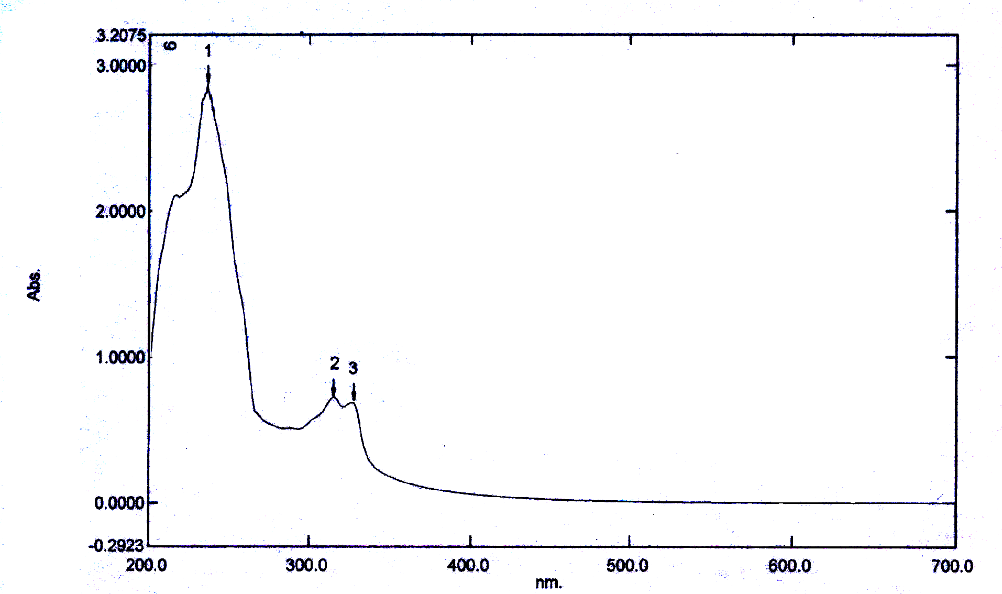
Fig. 3. Ultraviolet absorbance of antimicrobial agent produced by Streptomyces torulosus.

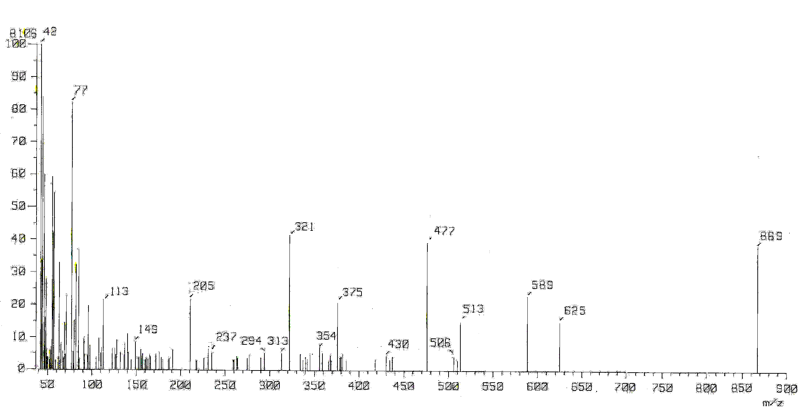
Fig. 4. Mass spectrum of antimicrobial agent produced by Streptomyces torulosus

4. DISCUSSION
The Streptomyces torulosus was isolated from Al-Khurmah governorate. The isolate was growing on starch nitrate agar medium for investigating its potency to produce antimicrobial agents. The actinomycete isolate, exhibited a wide spectrum antimicrobial agent [Kavanagh, 1972]. Identification process has been carried out according to [Williams, 1989, Hensyl, 1994 and Numerical taxonomy program, 1989]. For the purpose of identification of actinomycete isolate, the morphological characteristics and microscopic examination emphasized that the spore chain is spiral. Spore mass is light gray; while spore surface is warty, substrate mycelium is light yellowish brown and no diffusible pigment was produced on ISP-media No. 3, 4 & 5. The results of physiological, biochemical characteristics and cell wall hydrolysate of actinomycetes isolate, exhibited that the cell wall containing LL-diaminopimelic acid (DAP) and sugar pattern of cell wall hydrolysate could not detected. These results emphasized that the actinomycetes isolate related to a group of Streptomyces. In view of all the previously recorded data, the identification of actinomycete isolate was suggestive of being belonging to Streptomyces torulosus. The resulted sequence was aligned with available almost compete sequence of type strains of family streptomycetaeae. The phylogenetic tree (diagram) revealed that the local isolate is closely related Streptomyces torulosus, similarity matrix is 98%.
Maximum antimicrobial activity biosynthesis could be recorded that a different inoculum sizes for four discs; incubation period for five days [Adinarayana et al., 2002]; pH 7.0 [Atta, 2010]; temperature 35ºC [Kunnari et al., 1997 and Atta, 1999]; glucose best carbon source [Yasutaka et al., 2004]; KNO₃ best nitrogen source [Hosokawa et al., 2001 and Khalifa, 2008].
The active metabolites were extracted by n-Butanol at pH 7.0 [Atta, 2010].
The organic phase was collected and evaporated under reduced pressure using a rotary evaporator. The extract was concentrated and treated with petroleum ether (b.p. 40-60°C) for precipitation process where only one fraction was obtained in the form of yellowish ppt. and then tested for their antimicrobial activity. Separation of antibiotic into individual components has been tried by thin-layer chromatography using a solvent system composed of chloroform and methanol (24:1, v/v) as developing solvent [Zhang et al, 2007 and Atta et al., 2009]. The band with an R_{f} value at 0.55 which indicated that presence of one compound [Atta, 2010]. For the purpose of purification process, the antibiotic were allowed to pass through a column chromatography packed with silica gel and eluting solvent was composed of chloroform and methanol (10:2 v/v), fifty fractions were collected and tested for their activities. the most active fractions against the tested organisms ranged between 14 to 23. Similarly, many workers used a column chromatography packed with silica gel and an eluting solvent composed of various ratios of chloroform and methanol [Criswell et al. 2006 and Sekiguchi, et al., 2007].
The physico-chemical characteristics of the purified antibiotic revealed that, 235°C. The compound is freely soluble in chloroform, ethyl acetate, n-butanol, acetone, ethyl alcohol, methanol and 10 % isopropyl alcohol, but insoluble in petroleum ether, hexan and benzene; similar results were recorded by [Lotfi et al., 2003; El-Tayeb et al., 2004c and Atta et al., 2010].
A study of the elemental analysis of the antibiotic showed the following C=53.30; H=6.87; N= 6.61., O= 29.51 and S=0.0: lead to an imperical formula of: C₃₈H₆₂N₄O₁₆. The spectroscopic characteristics of antibiotic revealed the presence of the maximum absorption peak in UV. at 260 nm, infra-red absorption spectrum showed characteristic band corresponding to 26 peaks 551.9, 669.2, 770.1, 847.1, 910.8, 956.3, 980.2, 1039.2, 1091.4, 1110.9, 1204.8, 1254.1, 1264.1, 1380.2, 1461.7, 1547.7, 1666.2, 1708.4, 2333.8, 2306.0, 2872.5, 2954.2, 3280.8, 3341.8, 3668.9 and 3731.5. Mass-spectrum showed that the molecular weight is 865 [Billyana et al., 2002]. The MIC of antibiotic under study exhibited fairly active against both Gram positive and Gram negative bacteria and unicellular and filamentous fungi. Similar investigations and results were attained by [Imnagaki et al., 2006; Sekiguchi, et al., 2007 and Atta, 2009]. Identification of antibiotic according to recommended international keys indicated that the antibiotic is suggestive of being belonging to tunicamycin antibiotic [Umezawa, 1967 and 1977 and Berdy, 1979 and 1980a, b & c and Billyana et al., 2002].

5. CONCLUSION
The present study mainly involved in the isolation of Actinomyces based on the cultural, morphology, physiology and biochemical characteristics, as well as 16s rRNA methodology. Further work should be focused in most potent Streptomyces isolate for production the antimicrobial activities against bacterial Gram positive and Bacteria Gram negative and unicellular and filamentous Fungi and studies parameters controlling the biosynthetic process of antimicrobial agent formation. The bioactive substance was suggestive of being belonging to tunicamycin antibiotic.

6. CORRESPONDENCE TO:
Prof. Dr. Houssam M. Atta
Botany and Microbiology Department, Faculty of Science (Boys), Al-Azhar University, Cairo, Egypt. The present address: Biotechnology Department. Faculty of Science and Education. Al-Khurmah, Taif University; KSA.
E-mail: houssamatta@yahoo.com
houssamatta@hotmail.com

7. REFERENCES
Adinarayana K.; P. Ellaiah; B. Srinivasulu; R. Bhavani and G. Adinarayana, 2002. Response surface methodological approach to optimize the nutritional parameters for neomycin production by Streptomyces marinensis under solid-state fermentation. Andhra University, Process Biochemistry 38, 1565-1572
Atta, H. M. 2010. Production, Purification, Physico-Chemical Characteristics and Biological Activities of Antifungal Antibiotic Produced by Streptomyces antibioticus, AZ-Z710. American-Eurasian Journal of Scientific Research. 5 (1): 39-49, 2010.
Atta, H. M.; A. T. Abul-hamd and H. G. Radwan, 2009. Production of Destomycin-A antibiotic by Streptomyces sp. using rice straw as fermented substrate. Comm. Appl. Biol. Sci, Ghent University, 74 (3) : 879-897, 2009.
Atta, H.M. 1999. Application of biotechnology in search for antibiotics from environmental polutents under solid state fermentation conditions; Ph.D thesis, Faculty of Science, Al-Azhar University, Cairo, Egypt.
Becker, B.; M. P . Lechevalier ; R. E. Gordon and H. A. Lechevalier, 1964. Rapid Differentiation between Nocardia and Streptomyces by paper chromatography of whole cell hydrolysates. APPl. Microbiol., 12: 421 – 423.
Beg, Q. K.; Bhushan, B.; Kapoor, M. and Hoondal, G. S., 2000. Production and characterization of thermostable xylanase and pectinase from Streptomyces sp. Qg-11-3. J. of Industrial Microbiol. and Biotech. 24 (6): 396-402.
Berdy, J. 2005. Bioactive microbial metabolites. J Antibiot (Tokyo) 58: 1-26.
Berdy, J. 1974. Recent development of antibiotic research and classification of antibiotic according to chemical structure. Adv. App. Microbiol., 14: 309-406.
Berdy, J. 1980a. Recent advances in and prospects of antibiotics research. Proc. Biochem., 15: 28-35.
Berdy, J. 1980b. CRC Handbook of antibiotic compounds. Vol I.
Berdy, J. 1980c. CRC Handbook of antibiotic compounds. Vol II.
Billyana C. T.; J. K. David and P. J. Neil, 2002. Biosynthesis of Tunicamycin and Metabolic Origin of the 11-Carbon Dialdose Sugar, Tunicamine. Journal of biological. Vol. 277, No. 38, pp. 35289–35296.
Buchanan, R. E. and N. E Gibbson, 1974. Bergey's Manual of Determinative bacteriology 8th edition. The Williams & Wilkins company/ Baltimore.
Chapman, G.S. 1952. A simple method for making multiple tests on a microorganism. J. Bacteriol. 63:147.
Claessen, D.; Wosten, H. A.; Van Keulen, G.; Faber, O. G.; Alves, A. M.; Meijer, W. G. & Dijkhuizen, l. 2002. Two novol homologous proteins of Streptomyces coelicolor and Streptomyces lividans are involved in the formation of the rodlet layer and mediate attachment to a hydrophopic surface. Mol. Microbiol. 44(6): 1483-92.
Cowan, S .T. 1974. Cowan and Steel, s Manual For The Identification Of Medical Bacteria 2 ^{nd}. Edition Cambridge, Univ. Press.
Cragg, G. M.; Kingston, D. G. I.; Newman, D. J. & Taylor F. 2005. Anticancer Agents from Natural Products.
Criswell, D.; V. L.Tobiason; J. S. Lodmell, and D. S. Samuels, 2006. Mutations Conferring Aminoglycoside and Spectinomycin Resistance in Borrelia burgdorferi. Antimicrob. Agents Chemother. 50: 445-452.
Edwardss, U.; T. Rogall; H. Bocker; M. Emade and E. Bottger, 1989. Isolation and direct complete nucleotide determination of entire genes. Characterization of a gene coding for 16s ribosomal DNA. Nucleic Acid Res. 17: 7843-7853.
El-Tayeb, O.M.; A. Salama, M. Hussein and H.F. El-Sedawy, 2004c. Optimization of industrial production of rifamycin B by Amycolatopsis mediterranei I. The role of colony morphology and nitrogen sources in productivity. Afr. J. Biotechnol. 3: 266-272.
Elwan, S .H.; M. R. El-Nagar and M. S. Ammar, 1977. Characteristics of Lipase(s) in the growth filtrate dialystate of Bacillus stearothermophilus grown at 55 ºC using a tributryin- cup plate assay. Bull. Of the Fac. of Sci ., Riyadh Univ ., vol .8 : 105 – 119.
Evangelos, C.; Fiona, D. & Constantinos, E. V. 2001. Overexpression purification, and characterization of a thermostable chitinase (chi 40) from Streptomyces thermoviolaceus OPC-520. Protein expression and purification 23 (1): 97-105.
Gordon, R.E. 1966. Some Criteria for The Recognition of Nocardia madura (Vincent) Blanchord. J. General Microbiology, 45:355-364.
Gordon, R.E.; D.A. Barnett; J.E. Handehan and C.H. Pang, 1974. Nocardia coeliaca , Nocardia autotrophica and Nocardia Strain. International Journal of Systematic Bacteriology. 24:54-63.
Hall, T. A. 1999. BioEdit: a user-friendly biological sequence alignment editor and analysis program for Windows 95/98/NT. Nucleic Acid Symp. Ser 41: 95-98.
Hankin, L.; M. Zucker and D.C. Sands, 1971. Improved solid medium for the detection and enumeralion of proteolytic bacteria. Appl. Microbiol., 22:205-509.
Heifetz A, Keenan RW, Elbein AD. 1979. Mechanism of action of tunicamycin on the UDP-GlcNAc:dolichyl-phosphate Glc-NAc-1-phosphate transferase. Biochemistry. 1979 May 29;18(11):2186–2192.
Hensyl, W. R. 1994. Bergey’s Manual of Systematic Bacteriology 9 ^{th} Edition. John. G. Holt and Stanley, T. Williams (Eds.) Williams and Wilkins, Baltimore, Philadeiphia, Hong kong, London, Munich.
Hosokawa, N.; H. Naganawa; M. Hamada and T. Takeuchi, 2001. Hydroxymycotrienins A and B, new ansamycin group antibiotics. J. of Antibiotics, 49(5): 425-431.
Imnagaki, T.; K. Kaneda; Y. Suzuki; H. Hirai; E. Nomura; T. Sakakibara; Y. Yamauchi; L.H. huang; M. Norcia; L.M. Wondrack and N. Kojima, 2006. CJ-12, 373, a novel topoisomerase II inhibitor: Fermentation, isolation, structure, elucidation and biological activities. J. of Antibiotics, 51 :( 2): 112-116.
Innes, C. M. G. and Allan, E. J. 2001. Induction, growth and antibiotic production of streptomyces viridifa-ciens l- from bacteria. J. of Applied Microbiology, 90(3): 301-308.
Ivanko, O. V.; Varbanest, L. D.; Valahurova, O. V.; Nahorna, S. S.; Redchys, T. I. & Zhdanova, N. M. 2002. screening of collagenase and keratinase producers. Microbial. Z. 64(1): 31-36.
Jones, K. 1949. Fresh isolates of actinomycetes in which the presence of sporogenous aerial mycelia is a fluctuating characteristics. J. Bacteriol., 57: 141-145.
Kavanagh, F. 1972. Analytical Microbiology. Vol. 2, Acad. Press, New York.
Kenneth, L.K. and B.J. Deane, 1955. Color universal language and dictionary of names. United States Department of Commerce. National Bureau of standards. Washington, D.C., 20234.
Khadija, D.; Max, B. & Roland, B. 1995. Isolation of soil Streptomyces strains capable of degrading humic acids and analysis of their peroxidase activity. FEMS Microbiology Ecology, vol. 16(2): 115-121.
Khalifa, M. A. 2008. Bioprocess Development for the biosynthesis of bioactive compounds from microbial origin. MSc thesis, Faculty of Science, Al-Azhar University, Cairo, Egypt.
King, I.A., and Tabiowo, A. 1981. Effect on tunicamycin on epidermal glycoprotein and glycosaminoglycan synthesis in vitro. Biochem. J., (2), 331-338 (1981).
Kunnari, T.; J.Tuikkanen; A. Hautala; J. Hakala; K. Ylihonko, and P. Mantsala, 1997. Isolation and characterization of 8-Demethoxy steffimycins and Generation of 2, 8- Demethoxy steffimycins in Streptomyces streffisburgensis by the Nogalamycin biosynthesis genes. J. of Antibitics, 50(6): 496-501.
Lechevalier, M.P and H.A. Lechevalier, 1968. Chemical composition as a criterion in the classification of aerobic actinomycetes. J. Systematic Bacteriology . 20 : 435-443 .
Lotfi, M. O.; B. Raoudha; A. Ameur-Mehdi; S. Samiha; S. B. Mansour and B. Samir, 2003. Isolation, purification and partial characterization of antibacterial activities produced by a newly isolated Streptomyces sp. US24 strain. Research in Microbiology 154, 345–352.
Mann, J. 2001. Natural products as immunosuppressive agents. Nat Prod Rep, 18: 417-430.
Nitsh, B. and H.J. Kutzner, 1969. Egg-Yolk agar as diagnostic medium for Streptomyces. sp., 25:113.
Numerical taxonomy program 1989. Numerical taxonomy of Streptomyces species program (PIB WIN) (Streptomyces species J. Gen Microbiol. 1989 13512-133.
Oldfield, C.; Wood, N. T.; Gilbert, S. C.; Murray, F. D. & Faure, F. R. 1998. Desulphurisation of benzothiophene and dibenzothiophene by actinomycete organisms belonging to the genus Rhodococcus, and related taxa. Antonie Van Leeuwenhoek 74: 119-132.
Pridham, T.G. and D. Gottlieb, 1948. The utilization of carbon compounds by some actinomycetes as an aid for species determination. J. Bacteriol., 56(1):107-114.
Pridham, T.G.; P. Anderson; C. Foley; L.A. Lindenfelser; C.W. Hesselting and R.G. Benedict, 1957. A section of media for maintenance and taxonomic study of Streptomycetes. Antibiotics Ann. pp. 947-953.
Radha K. Maheshwari; T. Sreevalsan; Robert H. Silverman; John Hay; Robert M. Friedman 1983. Tunicamycin enhances the antiviral and anticellular activity of interferon, Science, 219, 1339-1341
Sambrook, J.; E. F. Fritsch and T. Maniaties, 1989. Molecular cloning. A laboratory Manual Cold Spring Harbor Laboratory press, Cold Spring Harbor, New York, USA.
Sanger, F.; S. Nicklen, and A.R. Coulson, 1977. DNA sequencing with chain terminator inhibitors. Proc. Natl.Acad. Sci. 74: 5463-5467.
Sekiguchi, M.; N. Shiraish; K. Kobinata; T. Kudo; I. Yamaguchi; H. Osada and K. Isono, 2007. RS-22A and C: new macrolide antibiotics from Streptomyces violaceusniger, Taxonomy, fermentation, isolation and biological activities. Journal of Antibiotics 48(4): 289-292.
Shirling, E. B. and D. Gottlieb, 1966. Methods for characterization of Streptomyces species. Int. J. Syst Bacteriol. 16: 313-340.
Strohl, W. R. 2004. Antimicrobials. In Microbial Diversity and Bioprospecting. Edited by Bull AT. ASM Press; 336-355.
Umezawa, H. 1977. Recent advances in bio-active microbial secondary metabolites. Jap. J. Antibiotic. Suppl., 30: 138-163.
Williams, S. T. 1985. Actinomycetes ecology: a critcal evalution. In sixth International Symposium on Actinomycete Biology ed. Szabo, G., Biro, S. and Goodfellow, M., New York: Elsevier 693-700.
Williams, S.T. 1989. Bergey’s Manual of Systematic bacteriology Vol. 4, Stanley T., Williams. Williams and Wilkins (Eds.), Baltimore, Hong kong, London, Sydney.
Williams, S.T. and F. L. Davies, 1965. Use of antibiotics for selective isolation and enumeration of actinomycetes in soil. J. Gen. Microbiol., 38:251-262.
Yaseen, M. H. 1987. Biological aspects of the utilization of rice hull black liquor Ph.D, Agriculture, Ain Shams University.
Yasutaka, H.; M. Akira; Y. Katsukiyo; U. Jun; I. Jun; A. Akikazu; F.Toshio, and M. Yuzuru, 2004. Transvalencin A, a Thiazolidine Zinc Complex Antibiotic Produced by a Clinical Isolate of Nocardia transvalensis. Chiba University, Japan. The Journal of antibiotics, pp. 797 - 802.
Zhang, L.; K. Yan; Y. Zhang; R. Huang; J. Bian; C. Zheng; H. Sun; Z. Chen; N. Sun; R. An; F. Min; W. Zhao; Y. Zhuo; J. You; Y. Song; Z. Yu; Z. Liu; K. Yang; H. Gao; H. Dai; X. Zhang; J. Wang; C. Fu; G. Pei; J. Liu; S. Zhang; M. Goodfellow; Y. Jiang; J. Kuai; G. Zhou; and X. Chen, 2007. High-throughput synergy screening identifies microbial metabolites as combination agents for the treatment of microbial infections. Proc. Natl. Acad. Sci. USA 104: 4606-4611.

4/1 5/2013

