Apiosoma spp. and Scopulata epibranchialis infesting Nile perch fish Lates niloticus in Dakahlia Province, Egypt

S.A.M. El-Tantawy¹, E.S.A. Reda¹, A. Abdel-Aziz², M.F. Abou El-Nour^{2*} and I. Rady²

^{1.} Zoology Department, Faculty of Science, Mansoura University, Egypt.
^{2.} Zoology Department, Faculty of Science, Al-Azhar University, Cairo, Egypt.
*fathallahaziz@yahoo.com

Abstract: Four species of Apiosoma (A. amoebae, A. doliaris, A. piscicola and A. poteriformis) and one of Scopulata (S. epibranchialis) were detected from Lates niloticus collected from some localities in Damietta branch of River Nile. A. poteriformis was recorded in Egypt for the first time and all the above parasites were recorded from this Nile fish for the first time. Morphometric parameters were used to describe these protozoan parasites in detail and a discussion with the previous studies was carried out as well.
[El-Tantawy SAM, Reda ESA, Abdel-Aziz A, Abou El-Nour MF and Rady I. Apiosoma spp. and Scopulata epibranchialis infesting Nile perch fish Lates niloticus in Dakahlia Province, Egypt. N Y Sci J 2013;6(6):111-118]. (ISSN: 1554-0200). http://www.sciencepub.net/newyork. 16

Keywords: Apiosoma; Scopulata; Nile perch fish; Lates niloticus

1. Introduction
Among fish parasites, protozoa are the most dangerous group that probably cause more diseases in fish cultures than any other ones (Hoffman, 1970). Ciliates, particularly sessilines such as Apiosoma, Scopulata, Ambiphrya and Epistylisare obligate parasites which utilize gills and skin merely as a substrate for attachment, causing massive destruction. Even moderate infection of these parasites on small fish may prove a fatal disease, since the infection may cause the fish to stop feeding (Hoffman, 1970).
Li et al. (2008) elucidated that the first member of genus Apiosoma was originally described by Kent (1882) with the name Spirochona tintinnabulum. Bütschli (1889) separated genus Apiosoma from genus Spirochona and renamed it Glossatella tintinnabulum under his newly erected generic name. Thereafter, the term Glossatella was widely used for a long time to describe new species of this genus until the priority of Apiosoma (created by Blanchard, 1885) was adopted by Lom (1966) and Corliss (1979) in their authoritative work. The generic name Apiosoma is now accepted as the valid one with Glossatella being merely a synonym. Li et al. (2008) summarized 72 species and one subspecies of Apiosoma, among which many members had synonyms mainly caused by the problem of generic nomenclature and redenomination of the same species. On the other hand, Viljoen and Van As (1985) created genus Scopulata which includes only three species; S. constrica, S. epibranchialis and S. dermata.
In Egypt, some studies have been carried out on these ciliate parasites. Abu El-Wafa (1984) recorded Apiosoma spp. from both Tilapia and Clarias spp. and Glossatella sp. from Tilapia spp. from River Nile, Behera Province. Ali (1992) also described Apiosoma piscicola, A. amoebae, A. doliaris and Apiosoma sp. from Tilapia spp. at Serow Farm, Damietta Province. Whereas, Reda (2011) recorded Apiosoma piscicola and A. conica from Tilapia zillii and Scopulata epibranchialis from Sarotherodon galilaeus from Damietta branch of River Nile.
The present study tries to complete the morphometric description of Apiosoma and Scopulata spp. to record an available mode for data measurements of these species, seek constant features for specific identification in view of their great variability and attempts to increase the knowledge about these ciliate parasites.

2. Material and Methods
Nile perch fish Lates niloticus were collected from June 2012 to February 2013 from Damietta branch of River Nile, Dakahlia. The collected fish were transported in tank with a good aeration to Laboratory of Parasitology, Faculty of Science, Mansoura University. Fish skin, fins and gills were firstly examined by the naked eye for detection of any macroscopical visible lesions. Samples of mucus were gently scraped from skin, fins and gills, then spread on a clean slide and freshly examined microscopically for the presence of ectoparasitic protozoa. The positive slides were air-dried. Some of them were impregnated with 2% aqueous solution of AgNo3 for 10-15 minutes, followed by rinsing in distled water. Slides were then placed in a white clean dish, covered with distilled water and exposed to UV (diffused day light) for about 2 hours (modification of Klein's dry silver impregnation method). Other slides were fixed with absolute

recorded by Reda (2011), but the latter methanol and stained with 10% Giemsa stain. Images were taken using Eyepiece Camera USB. All measurements were taken in μm mean ± SD (range).

3. Results and Discussion
Among 61 examined fish, only sixteen (26.2%) were found natural hosts of four apiosomes and one Scopulata which detected from gills, skin and fins. Atotal of fourteen fish (87.5%) were found parasitized with Apiosoma and nine (56.2%) were found infected with Scopulata. Both single as well as mixed infections with these parasites were observed.

1- Apiosoma amoebae Grenfell, 1887 (Figs. 1-3)
Eleven fish (68.7%) were found to be infested with Apiosoma amoebae. It was solitary, stalkless parasite collected from gills and distinguished by its peculiar, conical body shape which gradually tapering to the scopula. The body measured 35.5±7.7 (25.7-48.6) μm in length and 28.8±5.8 (17.4-43.9) μm in width. It was divided by equatorial girdle to an oral body part measured 16.5±3.8 (12.6-21.6) μm and a basal part measured 18.3±2.5 (13.3-25.4) μm. The contractile vacuole was large. The peristomial lip was narrow, while peristomial disc was flat and slightly slanted. The epistomial disc was linguiform and elevated over cilia of peristomial disc. Infundibulum was short and extended towards the non-ciliated groove. The compact macronucleus was rounded to oval in shape. It was situated below the groove and measuring 18.4±2.8 (15.1-21.3) μm in diameter and 17.6±1.9 (14.7-20.5) μm in length, respectively, while micronucleus was rounded, measuring 5.1 μm in diameter, situated below the macronucleus and sometimes wedging into the macronucleus. The scopula (the holdfast organelle) with its curved borders was firmly attached to the host surface. Scopula was broad, sucker-like disc with undulant margin and measured 18.7 μm in width.
According to the available data of A. amoebae (Table 1), the present parasite was closely resembling to A. conica reported by Shulman (1984), but the latter apiosome differed in the infection site (skin), host (9-spined sticklebacks) and locality (Neva Gulf). The parasite studied herein was also closely resembling in body shape to A. conica differed in body size (Table 1). Also, the macronucleus of A. conica studied by Reda (2011) had a round shape differed from polymorphic macronucleus (rounded to oval) of the present apiosome. Moreover, the equatorial girdle of A. conica studied by Reda (2011) was always non-ciliated groove differing from equatorial girdle of the present Apiosoma which was often ciliated. This non-ciliated groove of A. conica investigated by Reda (2011) didn’t exceed one third of the body length from the peristome, differing from the equatorial groove in the present study as well. The present ciliate showed closely resembling in shape to Apiosoma sp. recorded by Abu El-Wafa (1984), while the latter was longer and its macronucleus was usually rounded in shape (Table 1). Also, the present parasite showed closely resembling in general description to A. amoebae described by Ali (1992). However, macronucleus of A. amoebae reported by Ali (1992) was smaller in size (Table 1).

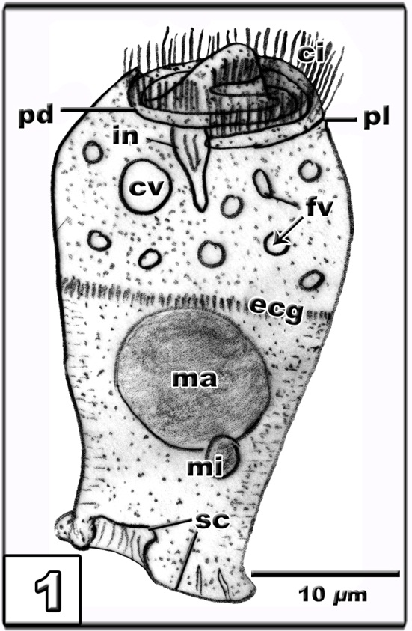
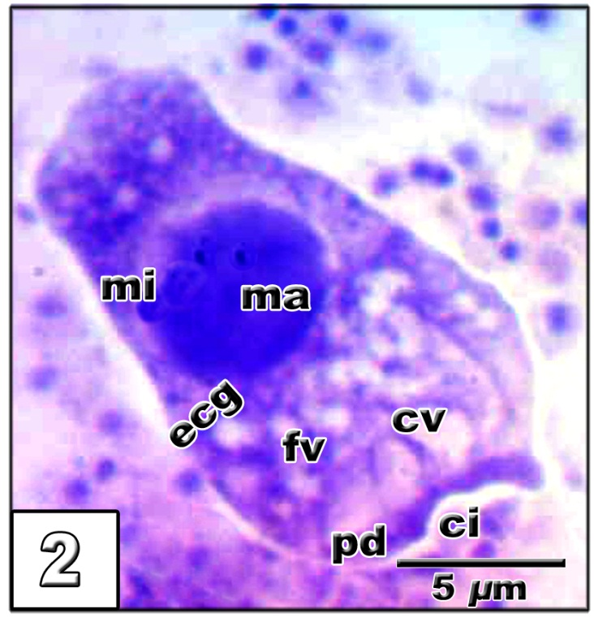
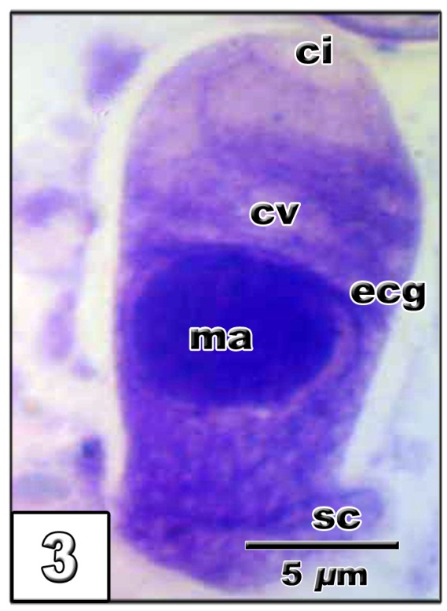

Fig. (1): Schematic drawing of Apiosoma amoebae.
Figs. (2&3): Photomicrographs of Giemsa-stained specimens of A. amoebae; ci, cilia; cv, contractile vacuole; ecg, equatorial cillary girdle; fv, food vacuoles; in, infundibulum; ma, macronucleus; mi, micronucleus; pd, pristomial disc; pl, prestomial lip; sc, scopula.

2- Apiosoma doliaris Timofeev, 1962 (Figs. 4-6)
Seven fish (43.7%) were founded to harbor A. doliaris. This parasite was stalkless inhabiting gills with barrel-shaped body gradually tapering from the equatorial region towards ciliated peristomial disc and scopula. The body measured 30.6±6.3 (26.7-37.1) μm in length and 19.8±4.7 (17.4-25.9) μm in width. It was divided by a non-ciliated groove into an oral body part measuring 16.7±3.6 (14.1-18.4) μm in length and a basal part measuring 12.8±2.8 (11.2-14.2) μm in length. Contractile and food vacuoles were distributed in the oral part and the infundibulum extended towards the non-ciliated groove. The compact macronucleus was rounded to oval in shape and situated below the groove measuring 13.3±2.1 (12.7-14.1) μm in length and 12.7±1.9 (12.3-13.2) μm in width. Micronucleus was also rounded, situated adjacent to, or wedging into the macronucleus and measuring 1.9 μm in diameter. Scopula was broad, sucker-like disc with an undulant margin measuring 13.8 μm in width.
A. amoebae had a conical body shape, gradually tapering to the scopula. A. doliaris had the same body shape but gradually tapering from the equatorial region towards the ciliated peristomial disc and scopula. The equatorial girdle was sometimes ciliated in A. amoebae but in A. doliaris, it was always non-ciliated groove. The present A. doliaris showed a similarity in shape to A. doliaris recorded by Shulman (1984), whereas the latter was larger in size (Table1). The author didn`t describe the micronucleus, which was deeply wedging into the macronucleus in the original description of Shulman and Stein (1962), as sometimes appeared in the present parasite. The first record of A. doliaris in Egypt was represented from cultured fish in Serow Farm (Ali, 1992), micronucleus of this Apiosoma was difficult to be observed, but its original description seemed to be closely resembling to the present investigated parasite (Table 1).

3- Apiosoma piscicola Blanchard, 1885 (Figs. 7-10)
This peritrich infected only four fish (25%). It was a solitary parasite inhabiting gills. Body had a goblet- like shape, gradually tapering from the peristome disc to scopula by a narrow stalk showing variations in both form and size. The body measured 65.2 ±13.4 (32.4-101.7) μm in length and 37.6±5.5 (21.8-50.3) μm in width. It was divided by a transverse band or groove sometimes with cilia, into an oral body part measuring 22.7±5.6 (10.2-39.3) μm and a basal body part measuring 31.5±6.1 (11-47.9) μm. The peristomial lip was narrow and the peristomial disc (adoralspiral) was flat winding counterclockwise and plunged into the infundibulum which slightly curved to extend towards the groove. Contractile vacuole was large and food vacuoles were distributed in the oral part. The compact triangular macronucleus was observed at the level of or just below the groove, measuring 25.3±5.3 (10.8-35.7) μm in length and 16.8±2.3 (10.1-25.9) μm in width. Micronucleus was oval, situated above or alongside the macronucleus, measuring 6.1±1.2 (4.3-8.6) μm in length and 3.3±0.4 (2.2-4) μm in width. Scopula was broader than stalk and sucker-like disc with undulant margin. Length of scopula with a stalk from the pointed end of macronucleus to the end of scopula, measured 23.7±5.2 (9.8-39.7) μm, while width from the broadest region of this part measured10.2±2.4 (7.8-19.3) μm.
The present apiosome showed a quite similarity to A. piscicola reported by Viljoen and Van As (1985) and Lom and Dykova (1992). However, the great variability of A. pisicola in shape, in size and in wide occurrence on several hosts and in different localities (Table 1) result in its several synonyms. However, fixation may changes both the shape and size of the ciliate, especially the shape of macronucleus, which may became rounded instead of retaining the normal triangular form (Lom 1966). In China, Chen (1955) observed a peritrich ciliate infecting Ctenopharyngodon idella and named it Glossatella cylindriformis. According to Chen’s description, the specimens in average dimensions, were smaller than those of the present study (Table 1). Furthermore, the other morphological data, however, were impossible to be compared with the present results due to their absence in Chen’s study. However, according to his description and drawings of the important taxonomic features such as host, morphology of peristome, transverse ciliary band and stalk, body form, and nuclei shape, dimensions and their positions, confirmed that this parasite (Glossatella cylindriformis) was just a synonym of A. piscicola. The present apiosome was larger than that described by Ali (1992) from cultured tilapians in Serow Farm (Table 1), however there was a similarity between the two parasites in the conical shape of macronucleus and the oval to rod-like shape of micronucleus. A. piscicola described by Li et al.(2008) showed that the transverse band (which divided the body into oral and basal parts) was always with cilia. Contrarily, Reda (2011) recorded transverse groove without cilia. The present parasite showed the groove without cilia in some individuals and appeared as a transverse ciliary band in others. It was worthy to mention that in the present described species, the micronucleus was oval to rounded in shape, whereas A. piscicola had a rod-like shape in the description of Shulman and Stein (1962) for A. piscicola.

A. piscicola can be distinguished from A. amoebae and A. doliaris by two fundamental features: by having triangular macronucleus and by the presence of stalk.

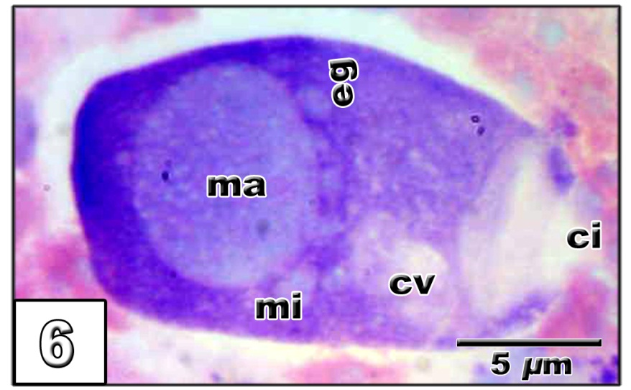
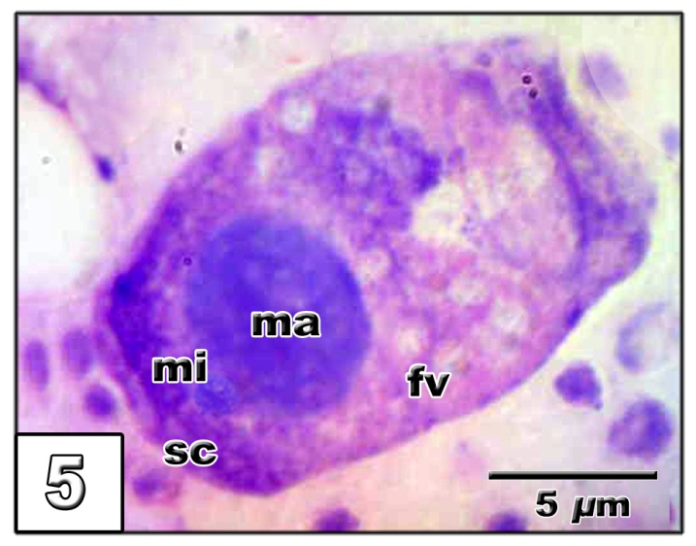
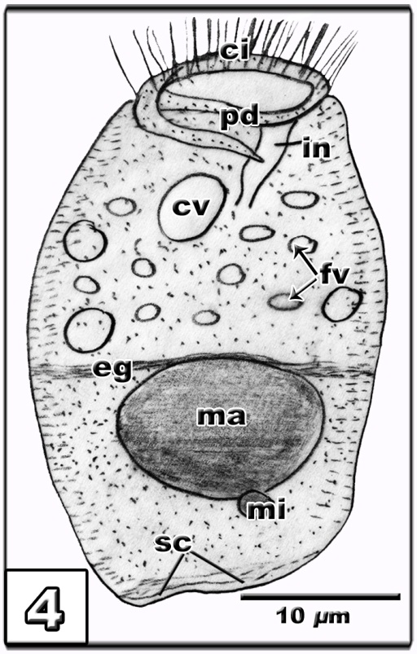

Fig. (4): Schematic drawing of Apiosoma doliaris.
Figs. (5&6): Photomicrographs of Giemsa-stained specimens of A. doliaris; ci, cilia; cv, contractile vacuole; eg, equatorial girdle; fv, food vacuoles; in, infundibulum; ma, macronucleus; mi, micronucleus; pd, pristomial disc; sc, scopula.
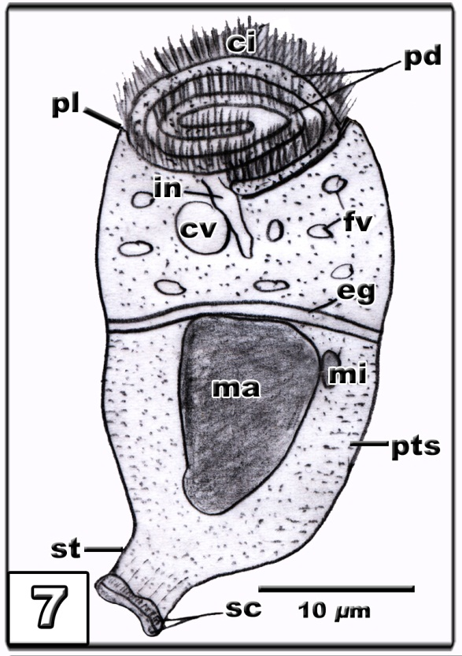
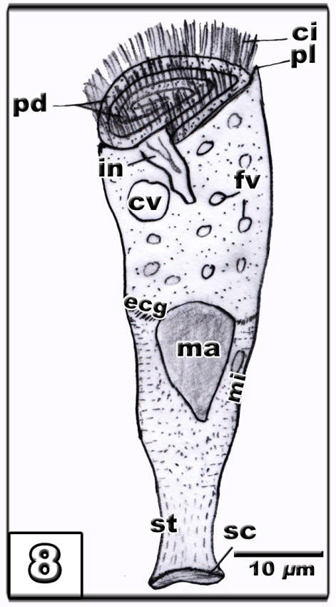
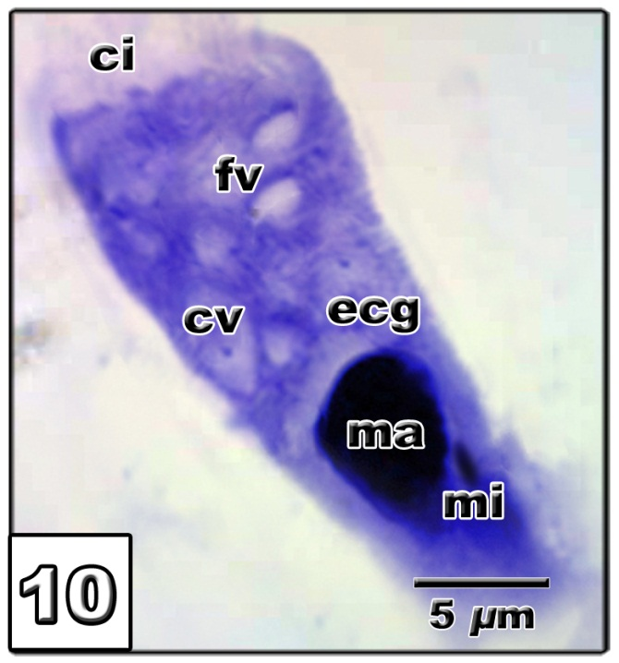
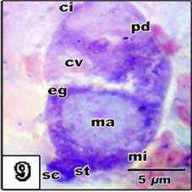

Figs. (7&8): Schematic drawings of Apiosoma piscicola.
Figs. (9&10): Photomicrographs of Giemsa-stained specimens of A. piscicola; ci, cilia; cv, contractile vacuole; ecg, equatorial cillary girdle;eg, equatorial girdle; fv, food vacuoles; in, infundibulum; ma, macronucleus; mi, micronucleus; pd, pristomial disc; pl, prestomial lip; sc, scopula; st, stalk.

4- Apiosoma poteriformis Timofeev, 1962 (Figs. 11-13)
This ciliate was obtained from five fish (31.2%) out of sixteen. It was solitary and stalkless parasite, isolated from gills and skin. It had an elongated body, measured 47.2 ±10.6 (40.6-57.4) μm in length and 19.6±6.5 (16.5-22.3) μm in width. Body was divided by a transverse non-ciliated groove into an oral part measuring 16.7±5.6 (13.4-19.1) μm in length and a basal part measuring 26.5±6.3 (21.7-30.5) μm in length. Infundibulum extended towards the groove. Contractile vacuole was large, while food vacuoles were distributed in the oral part. The compact rounded macronucleus was observed at the level of or just below the groove, measuring 11.3±4.2 (6.7-13.4) μm in diameter. Micronucleus was oval in shape and situated adjacent to the macronucleus measuring 2.2 μm in length and 1.1 μm in width. Scopula was broad, sucker-like disc with an undulant margin measuring 19.2 μm in width.
According to the available data of Apiosoma spp. (Table 1), the present ciliate was in general similar to the body shape and size of A. poteriformis described by Shulman (1984). The present parasite also showed a similarity to Glossatella sp. described by Abu El-Wafa (1984), but having a smaller size (Table 1). Abu El-Wafa (1984) regarded Glossatella and Apiosoma as two different parasites. Ali (1992) corrected this discrepancy, as the two genera were synonyms. Moreover, Ali (1992) described Glossatella sp. described by Abu El-Wafa (1984) as A. piscicola. However, the measurements (Table 1) in addition to, the general body shape, especially the shape of scopula, cilia disc and the absence of stalk-like structure in Glossatella sp. recorded by Abu El-Wafa (1984), pointed out that it was A. poteriformis.

5- Scopulata epibranchialis Viljoen and Van As, 1983 (Figs. 14-16)
This ciliate was barrel in shape isolated from gills and divided externally by a non-ciliated groove. The body measured 45.3±5.6 (39.4-49.3) μm in length and 31.4±4.5 (27.5-37.4) μm in width. The non-ciliated groove divided the body into nearly equal halves, an oral part measured 19.9±1.1 (18.6-21.4) μm length and a basal one measured 21±7.2 (15.3-29.8) μm length. The peristomial disc was broad and flat. Infundibulum was strongly curved and extended towards the groove. Macronucleus was frequently ellipsoidal to round in shape, measuring 18.4±4.8 (16.1-23.3) μm in length and 22.7±3.6 (20.7-23.4) μm in width. It situated just below the groove. Micronucleus had an oval shape, situated just below the groove and alongside the macronucleus, measuring 7.3±0.8 (5.7-8.4) μm in length and 6.5±0.9 (5.1-7.2) μm in width. Scopula was broad and flat but almost slightly narrower than the body, it sometimes bilobed measuring 6.2 μm in length.
Viljoen and Van As (1985) created genus Scopulata which includes three species only: S. constrica, S. epibranchialis and S. dermata. However, some distinct differences were observed between the present Scopulata and both S. constrica and S. dermata. S. constrica differed from the present parasite by having a markedly constricted body at the groove, while S. dermata differed from it by having a triangular macronucleus. Moreover, the present Scopulata was similar to S. epibranchialis described by Reda (2011) in body shape, position and shape of both macronucleus and micronucleus (Table 2). Thus the present specimens were comfortably identified as S. epibranchialis.

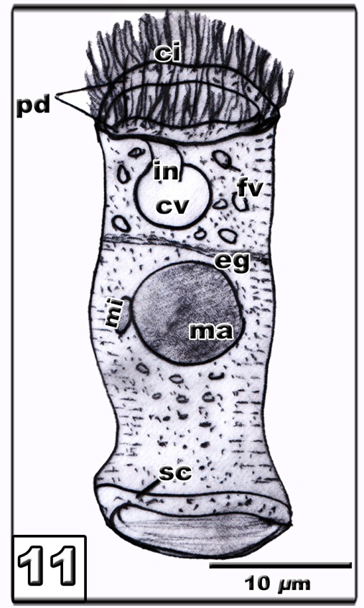
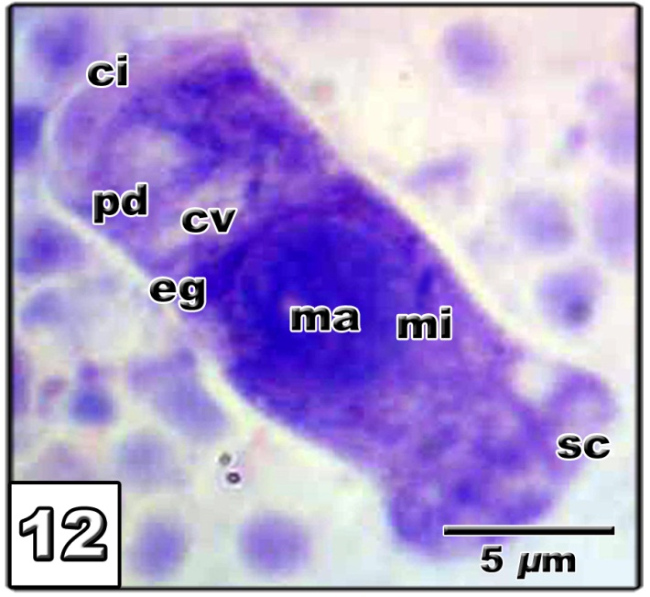
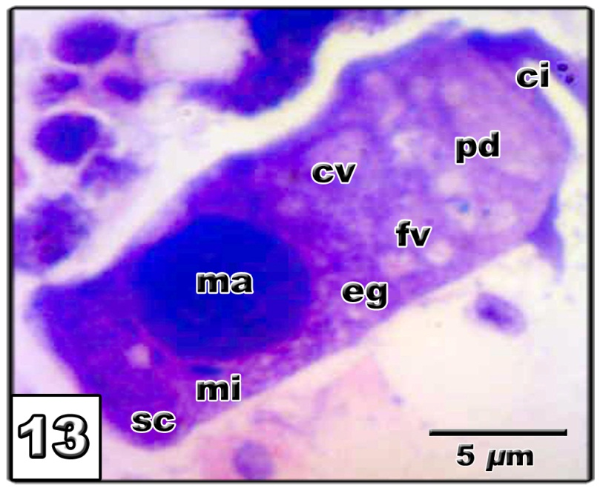

Fig. (11): Schematic drawing of Apiosoma poteriformis.
Figs. (12&13): Photomicrographs of Giemsa-stained specimens of A. poteriformis; ci, cilia; cv, contractile vacuole; eg, equatorial girdle; fv, food vacuoles; in, infundibulum; ma, macronucleus; mi, micronucleus; pd, pristomial disc; sc, scopula.
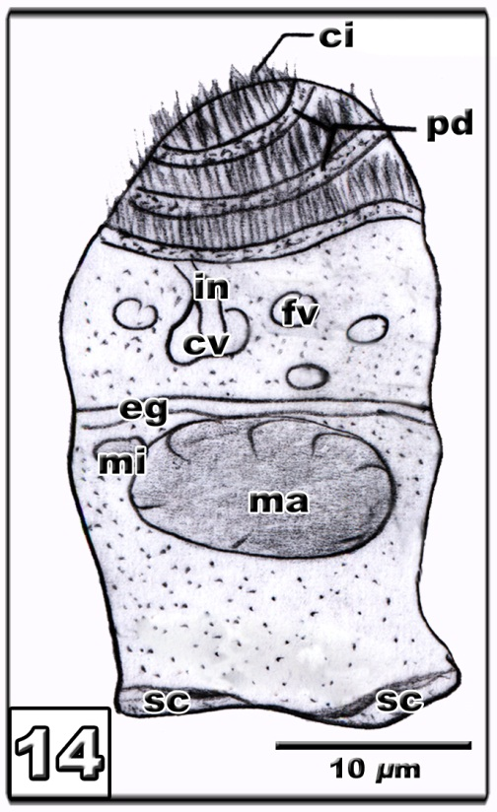
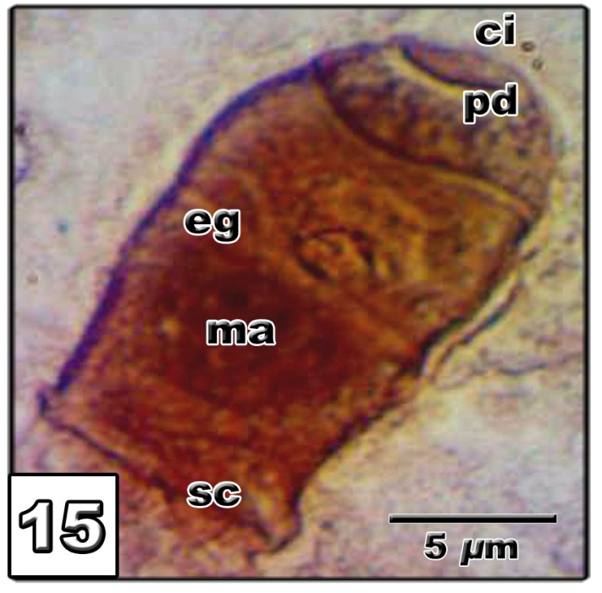
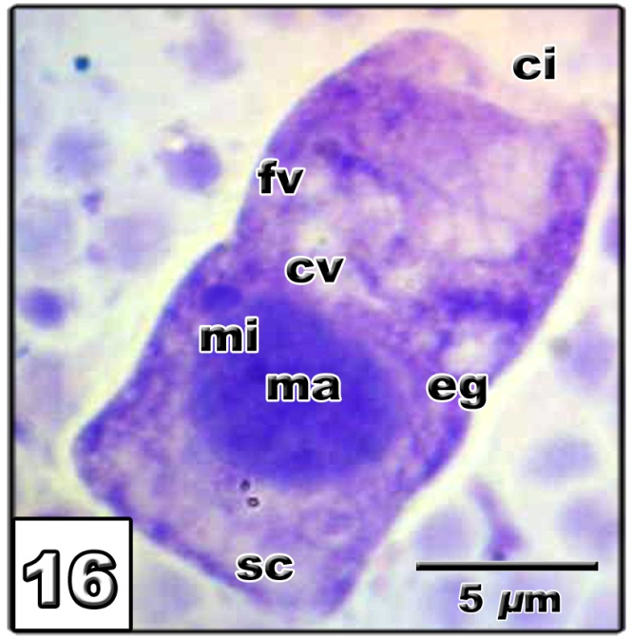

Fig. (14): Schematic drawing of Scopulata epibranchialis.
Figs. (15&16): Photomicrographs of stained specimens of S. epibranchialis. Fig.(15):With silver staining. Fig.(16): Withgiemsa staining;ci, cilia; cv, contractile vacuole; eg, equatorial girdle; fv, food vacuoles; in, infundibulum; ma, macronucleus; mi, micronucleus; pd, pristomial disc; sc, scopula.

Table 1. Comparative data of the present Apiosoma spp. with the previously described ones.

Table 2. Comparative data of the present Scopulata epibranchialis with the previously described ones.

Corresponding Author:
Dr. Mohamed F. Abou El-Nour²
Zoology Department
Faculty of Science
Al-Azhar University, Cairo, Egypt.
E-mail: fathallahaziz@yahoo.com

References
- Abu El-Wafa, S.A.O. (1984): Protozoan parasites of some fresh-water fishes in Behera Governorate. M.V. Sc. Thesis, Fac. Vet. Med. Alexandria Univ. , Egypt.
- Ali, M.A. (1992): Biological and ecological studies on protozoan parasites infecting cultured Tilapia in Serow fish farm M.Sc. Thesis, Fac. Sci., Cairo Univ., Egypt.
- Banina, N.N. (1968): Apiosoma from fresh-water fishes in the European part of the Soviet-Union. Acta. Protozool. 21:245–262.
- Blanchard, R. (1885): Sur uninfusoire peritriche ectoparasite des poissonsd’eaudouce. Bull Soc. Zool. 10:277–280.
- Bütschli, O. (1889): Protozoa. Abt. III. Infusoria und system der radiolaria. In: Bronn HG (ed) Klassen und Ordnungen des Their- Reichs I. C. F. Winter, Leipzig, pp 1098–2035.
- Chen, C.L. (1955): The protozoan parasites from four species of Chinese pond fishes: Ctenopharyngodon idellus, Mylopharyngodon piceus, Aristhicthys nobillis and Hypophthalmichthys molithaix. I. The protozoan parasites of Ctenopharyngodon idellus. Acta Hydrobiol. Sin. 1:148–150.
- Cone, D.K. and Odense, P.H. (1987): Occurrence of Heteropolaria lwoffi and Apiosoma piscicola on Salvelinus fontinalis (Mitchill) in Nova Scotia, Canada. Can. J. Zool./ J. Can. Zool. 65:2426–2429.
- Corliss, J.O. (1979): The ciliated protozoa: Characterization, classification and guide to the literature, 2nd edition. Peragmon Press, pp 455.
- Grenfell, J.G. (1887): On a new species of Scyphidia and Dinophysis. Trans. Roy. Micr. Soc. II: 558–560.
- Hoffman, G.L. (1970): Parasites of North American freshwater fishes. Univ. California Press, Los Angeles.
- Kent,W.S. (1882): A manual of the infusoria I–III. Bogue, London.
- Li, M.; Wang, J.; Zhu, D.; Gu., Z.; Zhang, J.; and Gong, X. (2008): Study of Apiosoma piscicola (Blanchard 1885) occurring on fry of freshwater fishes in Hongze, China with consideration of the genus Apiosoma. Parasitol. Res. 102: 931–937.
- Lom, J. (1966): Sessiline peritrichs from the surface of some freshwater fishes. Folia Parasitol., (Praha). 18:36–56.
- Lom, J. and Dykova, I. (1992): Protozoan parasites of fishes Elsevier, Amsterdam and London pp 315.
- Reda E.S.A. (2011): A Review of some ecto- and endo-protozoan parasites infecting Sarotherodon galilaeus and Tilapia zillii from Damietta branch of River Nile, Egypt. J. Amer. Sci. 7:362-373.
- Shulman, S.S. (1984): Key to Parasites of freshwater fish of the U.S.S.R. pp 430.
- Shulman, S.S. and Stein, G.A. (1962): Protozoa. In key to prarasites of freshwater fish of USSR. (ed. By Bykhovskaya-Pavloskaya, I. E. et al. Translated by Israel Program for Scientific Translations, Jerusalem, 1964).
- Timofeev, V.A. (1962): Some parasitic protozoa of fishes from the basin of the River Amur and the Neva Bay. Mag. Univ.
- Viljoen, S. and Van As, J.G., (1985): Sessile peritrichs (Ciliophora: Peritricha) from freshwater fish in the Transvaal, South Africa. S. Afr. Tydskr. Dierk. 20: 79-96.

4/12/2013

